University of Minnesota Law School

Scholarship Repository

Minnesota Law Review

1930

The Promissory Note as a Substitute for Money

J.S. Waterman

Follow this and additional works at: https://scholarship.law.umn.edu/mlr  Part of the Law Commons

Recommended Citation

Waterman, J.S., "The Promissory Note as a Substitute for Money" (1930). Minnesota Law Review. 1536.

https://scholarship.law.umn.edu/mlr/1536

This Article is brought to you for free and open access by the University of Minnesota Law School. It has been accepted for inclusion in Minnesota Law Review collection by an authorized administrator of the Scholarship Repository. For more information, please contact lenzx009@umn.edu.

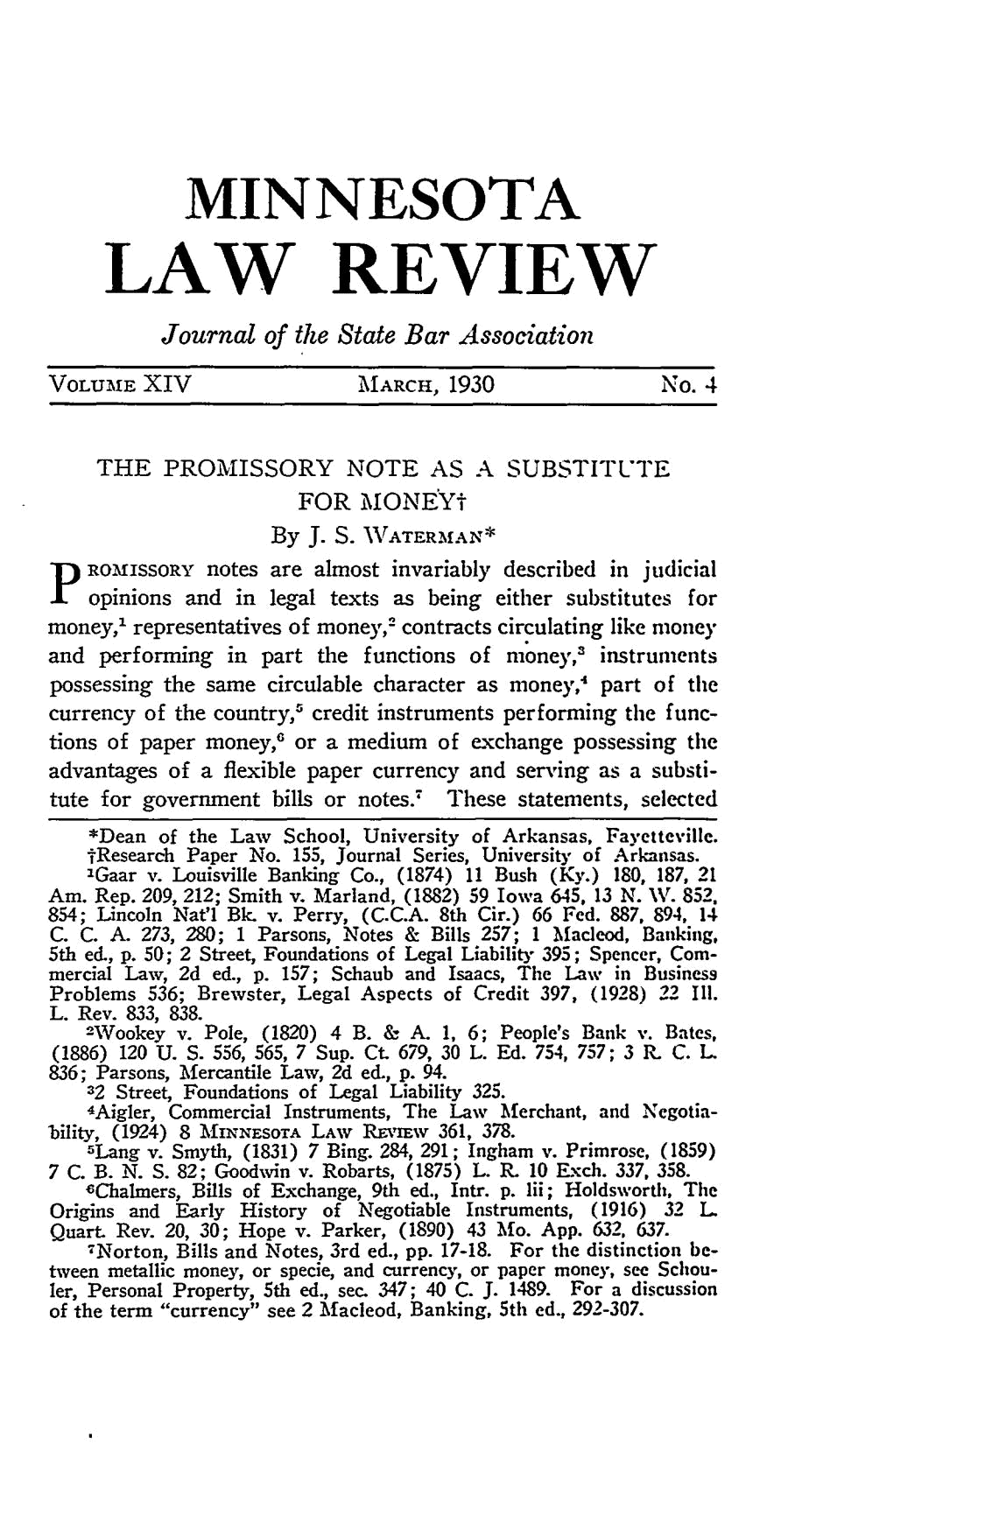
MINNESOTA
LAW REVIEW

Journal of the State Bar Association

VOLUME XIV MARCH, 1930 No. 4

THE PROMISSORY NOTE AS A SUBSTITUTE

FOR MONEY-

By J. S. WATER.MAN*
P ROMISSORY notes are almost invariably described in judicial opinions and in legal texts as being either substitutes for money,' representatives of money,² contracts circulating like money and performing in part the functions of money,' instruments possessing the same circulable character as money,⁴ part of the currency of the country,' credit instruments performing the func-tions of paper money,' or a medium of exchange possessing the advantages of a flexible paper currency and serving as a substi-tute for government bills or notes.- These statements, selected

*Dean of the Law School, University of Arkansas, Fayettevillc.

tResearch Paper No. 155, Journal Series, University of Arkansas. lGaar v. Louisville Banking Co., (1874) 11 Bush (Ky.) 180, 187, 21

Am. Rep. 209, 212; Smith v. Marland, (1882) 59 Iowa 645, 13 N. IV. 852. 854; Lincoln Nat'l Bk. v. Perry, (C.C.A. 8th Cir.) 66 Fed. 887, 894, 14 C. C. A. 273, 280; 1 Parsons, Notes & Bills 257; 1 Macleod, Banking, 5th ed., p. 50; 2 Street, Foundations of Legal Liability 395; Spencer, Com-mercial Law, 2d ed., p. 157; Schaub and Isaacs, The Law in Business Problems 536; Brewster, Legal Aspects of Credit 397, (1928) 22 I11. L. Rev. 833, 838.

²Wookey v. Pole, (1820) 4 B. & A. 1, 6; People's Bank v. Bates, (1886) 120 U. S. 556, 565, 7 Sup. Ct. 679, 30 L. Ed. 754, 757; 3 R. C. L. 836; Parsons, Mercantile Law, 2d ed., p. 94.
32 Street, Foundations of Legal Liability 325.
4Aigler, Commercial Instruments, The Law Merchant, and Negotia-bility, (1924) 8 MVIINNESOTA LAW REvmw 361, 378.

SLang v. Smyth, (1831) 7 Bing. 284, 291; Ingham v. Primrose, (1859) 7 C. B. N. S. 82; Goodwin v. Robarts, (1875) L. R. 10 Exch. 337, 358.
sChalmers, Bills of Exchange, 9th ed., Intr. p. lii; Holdsworth, The
Origins and Early History of Negotiable Instruments, (1916) 32 L Quart. Rev. 20, 30; Hope v. Parker, (1890) 43 Mo. App. 632, 637.
⁷Norton, Bills and Notes, 3rd ed., pp. 17-18. For the distinction be-tween metallic money, or specie, and currency, or paper money, see Schou-ler, Personal Property, 5th ed., sec. 347; 40 C. J. 1489. For a discussion of the term "currency" see 2 Macleod, Banking, 5th ed., 292-307.
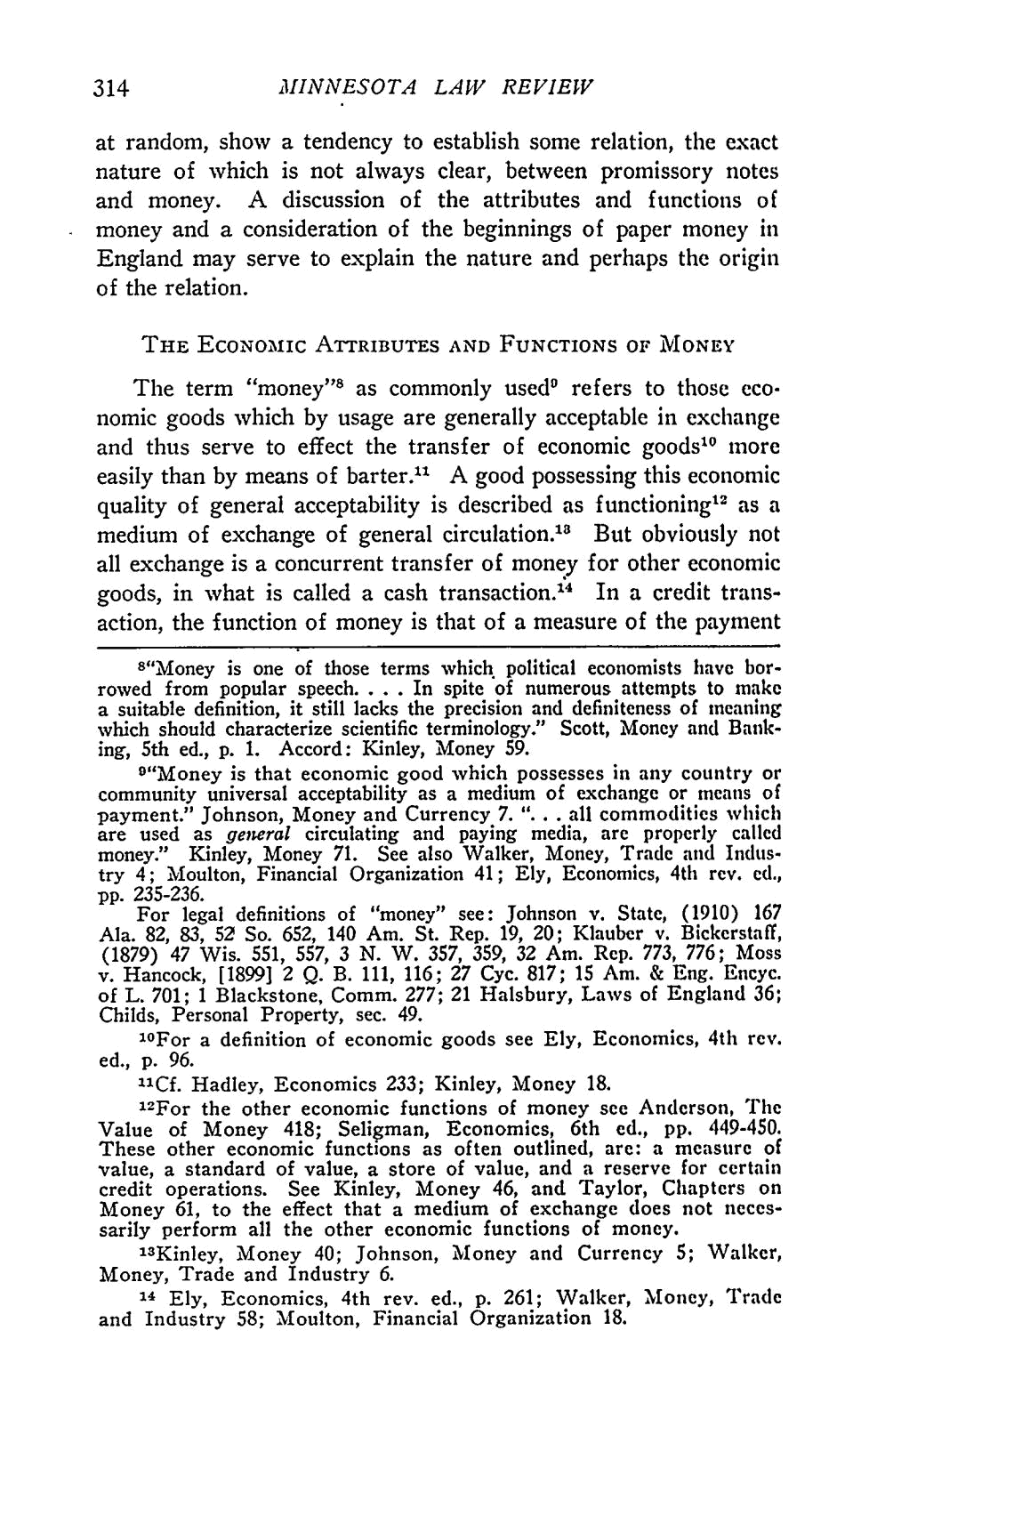
MINNESOTA LAW REVIEW

at random, show a tendency to establish some relation, the exact nature of which is not always clear, between promissory notes and money. A discussion of the attributes and functions of money and a consideration of the beginnings of paper money in England may serve to explain the nature and perhaps the origin of the relation.

THE ECONoMIc ATTRIBUTES AND FUNCTIONS OF MONEY

The term "money"" as commonly used" refers to those eco-nomic goods which by usage are generally acceptable in exchange and thus serve to effect the transfer of economic goods¹⁰ more easily than by means of barter." A good possessing this economic quality of general acceptability is described as functioning ² as a medium of exchange of general circulation. ³ But obviously not all exchange is a concurrent transfer of money for other economic goods, in what is called a cash transaction.' ⁴ In a credit trans-action, the function of money is that of a measure of the payment

- "Money is one of those terms which, political economists have bor-
rowed from popular speech .... In spite of numerous attempts to make

a suitable definition, it still lacks the precision and definiteness of meaning which should characterize scientific terminology." Scott, Money and Bank-ing, 5th ed., p. 1. Accord: Kinley, Money 59.

⁹"Money is that economic good which possesses in any country or community universal acceptability as a medium of exchange or means of
payment." Johnson, Money and Currency 7. ". . . all commodities which
are used as genieral circulating and paying media, are properly called money." Kinley, Money 71. See also Walker, Money, Trade and Indus-try 4; Moulton, Financial Organization 41; Ely, Economics, 4th rev. ed.,
- 235-236.
For legal definitions of "money" see: Johnson v. State, (1910) 167 Ala. 82, 83, 52 So. 652, 140 Am. St. Rep. 19, 20; Klauber v. Bickerstaff, (1879) 47 Wis. 551, 557, 3 N. W. 357, 359, 32 Am. Rep. 773, 776; Moss v. Hancock, [1899] 2 Q. B. 111, 116; 27 Cyc. 817; 15 Am. & Eng. Encyc. of L. 701; 1 Blackstone, Comm. 277; 21 Halsbury, Laws of England 36; Childs, Personal Property, sec. 49.
0 | a definition of | economic goods see Ely, Economics, 4th rev.
2 For | a definition of | economic goods see Ely, Economics, 4th rev.
ed., p. 96.
"Cf. Hadley, Economics 233; Kinley, Money 18.

12For the other economic functions of money see Anderson, The Value of Money 418; Seligman, Economics, 6th ed., pp. 449-450.
These other economic functions as often outlined, are: a measure of
value, a standard of value, a store of value, and a reserve for certain credit operations. See Kinley, Money 46, and Taylor, Chapters on Money 61, to the effect that a medium of exchange does not neces-sarily perform all the other economic functions of money.

"3Kinley, Money 40; Johnson, Money and Currency 5; Walker, Money, Trade and Industry 6.
'4 Ely, Economics, 4th rev. ed., p. 261; Walker, Money, Trade and Industry 58; Moulton, Financial Organization 18.
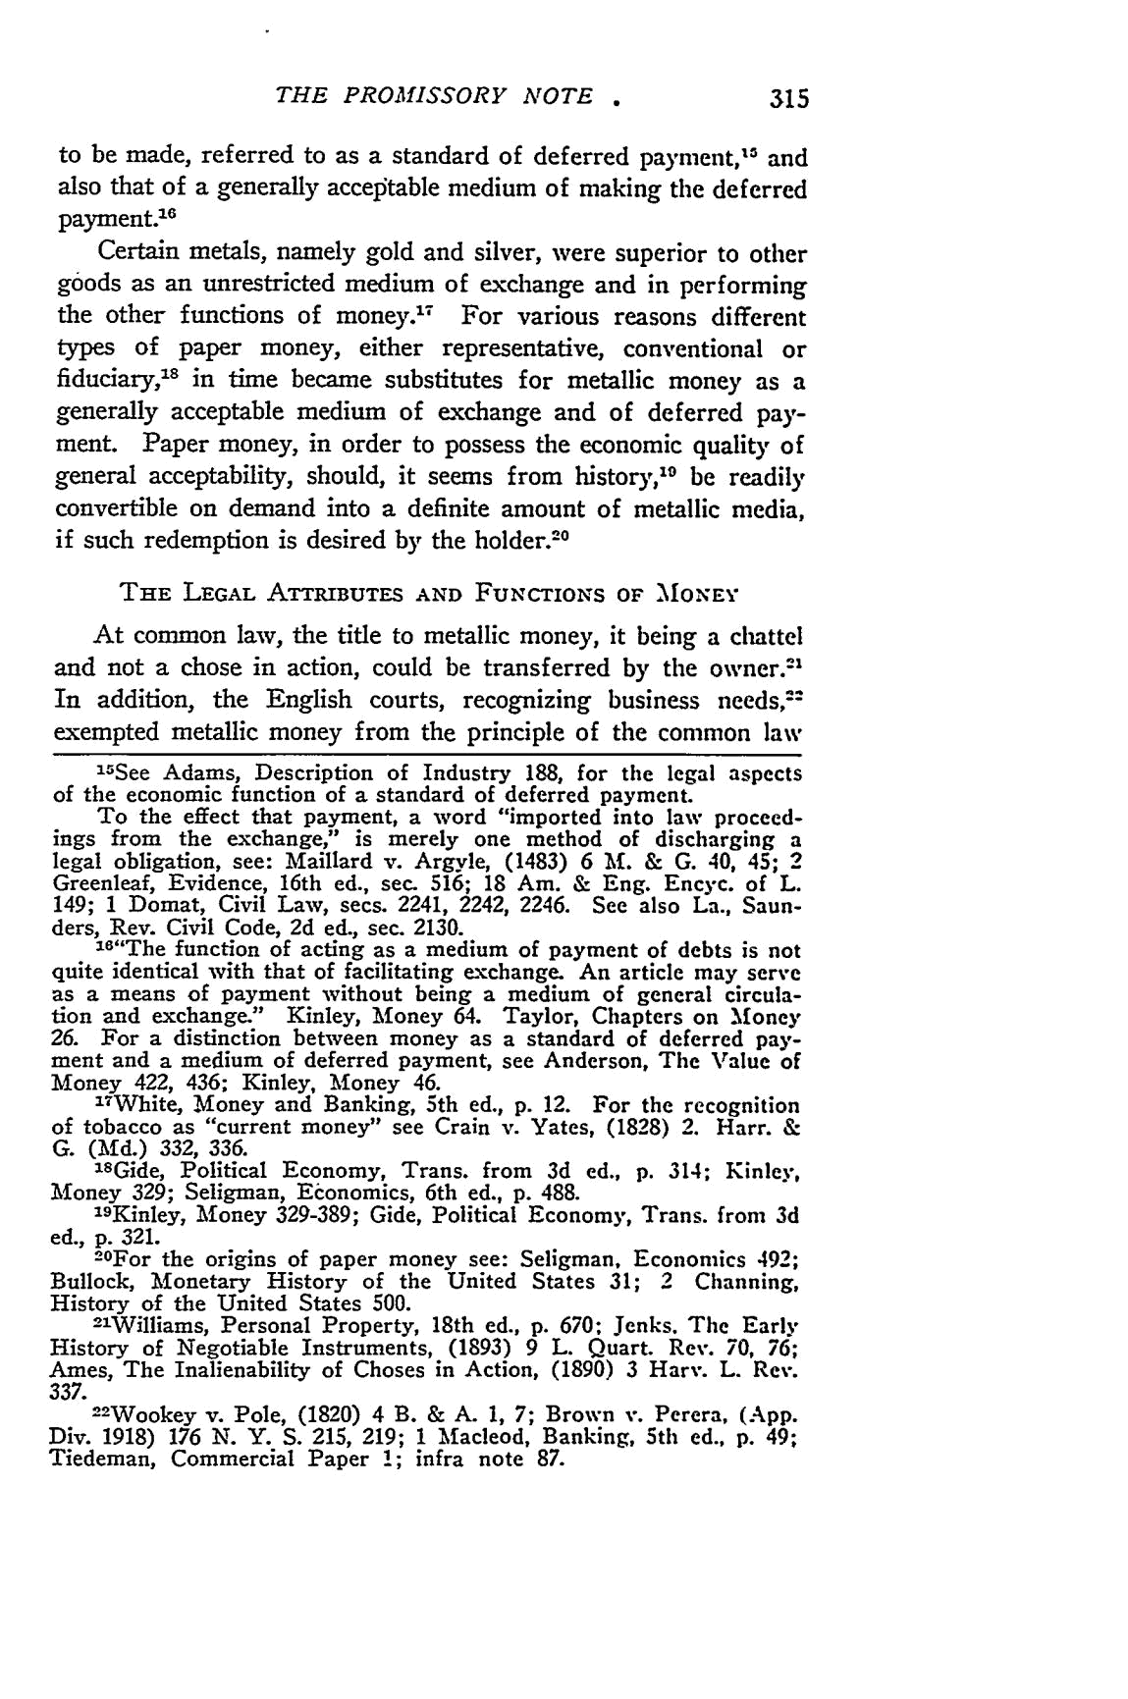
THE PROMISSORY NOTE .

to be made, referred to as a standard of deferred payment,¹ 5 and also that of a generally acceiitable medium of making the deferred payment.' ⁶

Certain metals, namely gold and silver, were superior to other goods as an unrestricted medium of exchange and in performing the other functions of money.'⁷ For various reasons different types of paper money, either representative, conventional or fiduciary,' ^{s} in time became substitutes for metallic money as a generally acceptable medium of exchange and of deferred pay-ment. Paper money, in order to possess the economic quality of general acceptability, should, it seems from history, ⁹ be readily
convertible on demand into a definite amount of metallic media, if such redemption is desired by the holder. ²⁰

THE LEGAL ATTRIBUTES AND FUNCTIONS OF MONEY

At common law, the title to metallic money, it being a chattel and not a chose in action, could be transferred by the owner.-' In addition, the English courts, recognizing business needs,-"

exempted metallic money from the principle of the common law

"5See Adams, Description of Industry 188, for the legal aspects of the economic function of a standard of deferred payment.

To the effect that payment, a word "imported into law proceed-ings from the exchange," is merely one method of discharging a legal obligation, see: Maillard v. Argyle, (1483) 6 Mf. & G. 40, 45; 2 Greenleaf, Evidence, 16th ed., sec. 516; 18 Am. & Eng. Encyc. of L. 149; 1 Domat, Civil Law, secs. 2241, 2242, 2246. See also La., Saun-ders, Rev. Civil Code, 2d ed., sec. 2130.

  - ⁶ "The function of acting as a medium of payment of debts is not quite identical with that of facilitating exchange. An article may serve as a means of payment without being a medium of general circula-tion and exchange." Kinley, Money 64. Taylor, Chapters on Money
- For a distinction between money as a standard of deferred pay-ment and a medium of deferred payment, see Anderson, The Value of
Money 422, 436; Kinley, Money 46.
"White, Money and Banking, 5th ed., p. 12. For the recognition of tobacco as "current money" see Crain v. Yates, (1828) 2. Harr. & G. (Md.) 332, 336.

- ⁸ Gide, Political Economy, Trans. from 3d ed., p. 314; Kinley, Money 329; Seligman, Economics, 6th ed., p. 488.
"9Kinley, Money 329-389; Gide, Political Economy, Trans. from 3d ed., p. 321.
2⁰For the origins of paper money see: Seligman, Economics 492; Bullock, Monetary History of the United States 31; 2 Channing, History of the United States 500.

-"Williams, Personal Property, 18th ed., p. 670; Jenks. The Early History of Negotiable Instruments, (1893) 9 L. Quart. Rev. 70, 76; Ames, The Inalienability of Choses in Action, (1890) 3 Harv. L. Rev.

337.

-2Wookey v. Pole, (1820) 4 B. & A. 1, 7; Brown v. Perera, (App. Div. 1918) 176 N. Y. S. 215, 219; 1 Macleod, Banking, 5th ed., p. 49; Tiedeman, Commercial Paper 1; infra note 87.

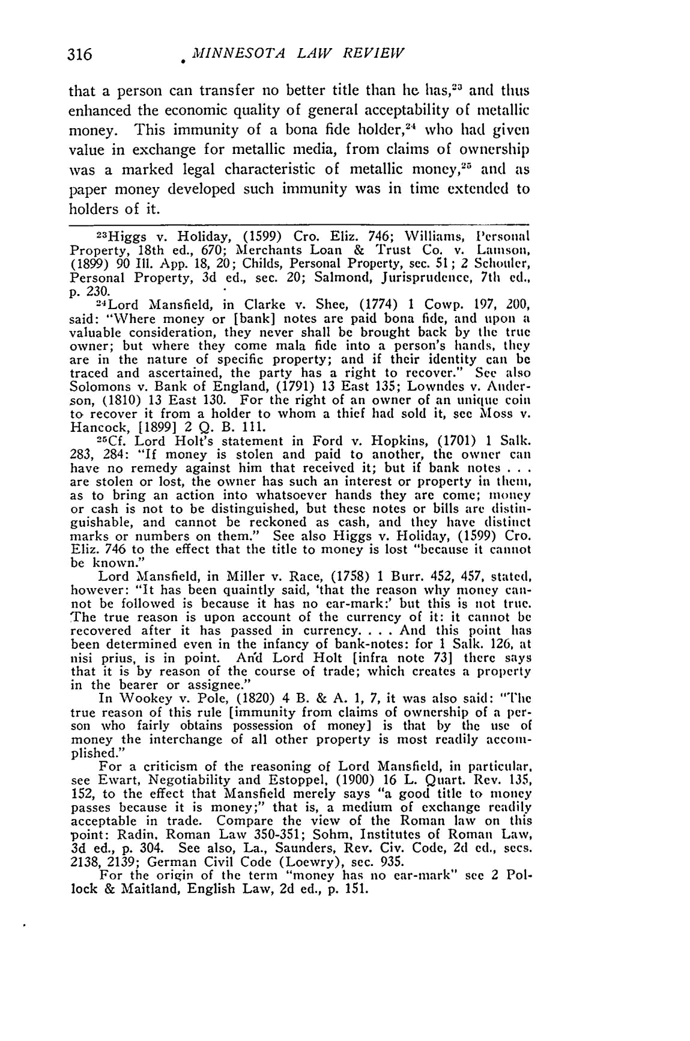
MINNESOTA LAW REVIEW

that a person can transfer no better title than he has,- ³ and thus enhanced the economic quality of general acceptability of metallic money. This immunity of a bona fide holder,²⁴ who had given value in exchange for metallic media, from claims of ownership
was a marked legal characteristic of metallic money,² 5 and as

paper money developed such immunity was in time extended to holders of it.

23Higgs v. Holiday, (1599) Cro. Eliz. 746; Williams, Personal Property, 18th ed., 670; Merchants Loan & Trust Co. v. Lamson, (1899) 90 Ill. App. 18, 20; Childs, Personal Property, sec. 51; 2 Schouler, Personal Property, 3d ed., sec. 20; Salmond, Jurisprudence, 7th ed.,
p. 230.
² ⁴Lord Mansfield, in Clarke v. Shee, (1774) 1 Cowp. 197, 200,

said: "Where money or [bank] notes are paid bona fide, and upon a valuable consideration, they never shall be brought back by the true owner; but where they come mala fide into a person's hands, they are in the nature of specific property; and if their identity can be traced and ascertained, the party has a right to recover." See also Solomons v. Bank of England, (1791) 13 East 135; Lowndes v. Ander-son, (1810) 13 East 130. For the right of an owner of an unique coin to recover it from a holder to whom a thief had sold it, see Moss v.

Hancock, [1899] 2 Q. B. 111.
2-Cf. Lord Holt's statement in Ford v. Hopkins, (1701) 1 Salk. 283, 284: "If money is stolen and paid to another, the owner can have no remedy against him that received it; but if bank notes . . .

are stolen or lost, the owner has such an interest or property in them, as to bring an action into whatsoever hands they are come; money or cash is not to be distinguished, but these notes or bills are distin-guishable, and cannot be reckoned as cash, and they have distinct marks or numbers on them." See also Higgs v. Holiday, (1599) Cro. Eliz. 746 to the effect that the title to money is lost "because it cannot be known."

Lord Mansfield, in Miller v. Race, (1758) 1 Burr. 452, 457, stated, however: "It has been quaintly said, 'that the reason why money can-not be followed is because it has no ear-mark:' but this is not true. The true reason is upon account of the currency of it: it cannot be recovered after it has passed in currency. . . . And this point has been determined even in the infancy of bank-notes: for I Salk. 126, at nisi prius, is in point. An'd Lord Holt [infra note 73] there says that it is by reason of the course of trade; which creates a property in the bearer or assignee."

In Wookey v. Pole, (1820) 4 B. & A. 1, 7, it was also said: "The true reason of this rule [immunity from claims of ownership of a per-son who fairly obtains possession of money] is that by the use of money the interchange of all other property is most readily acconi-plished."

For a criticism of the reasoning of Lord Mansfield, in particular. see Ewart, Negotiability and Estoppel, (1900) 16 L. Quart. Rev. 135, 152, to the effect that Mansfield merely says "a good title to money passes because it is money;" that is, a medium of exchange readily acceptable in trade. Compare the view of the Roman law on this point: Radin. Roman Law 350-351; Sohm, Institutes of Roman Law, 3d ed., p. 304. See also, La., Saunders, Rev. Civ. Code, 2d ed., sees. 2138, 2139; German Civil Code (Loewry), sec. 935.

For the origin of the term "money has no ear-mark" see 2 Pol-lock & Maitland, English Law, 2d ed., p. 151.
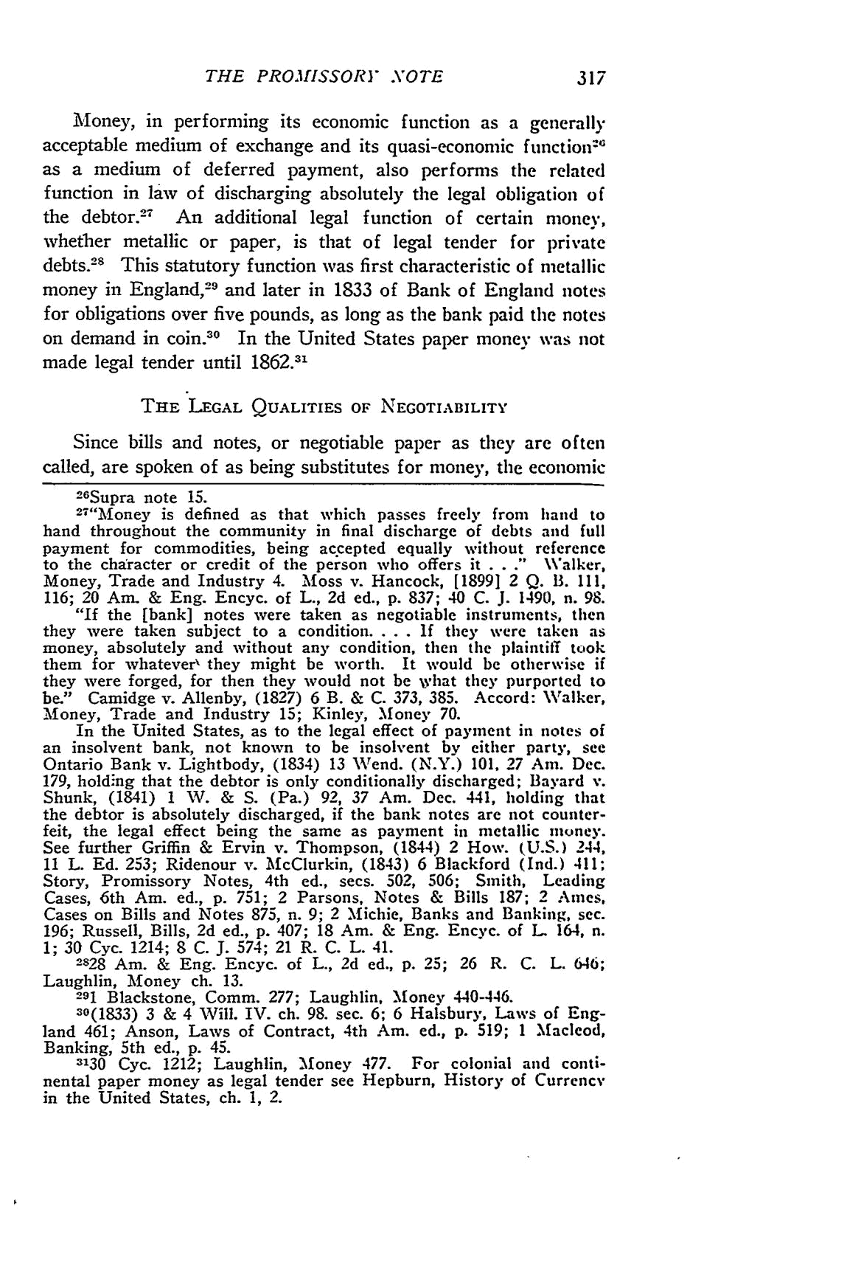
THE PROISSORY NOTE

Money, in performing its economic function as a generally acceptable medium of exchange and its quasi-economic function ⁻ as a medium of deferred payment, also performs the related function in law of discharging absolutely the legal obligation of the debtor.² ⁷ An additional legal function of certain money, whether metallic or paper, is that of legal tender for private debts.²⁸ This statutory function was first characteristic of metallic money in England,² ⁹ and later in 1833 of Bank of England notes for obligations over five pounds, as long as the bank paid the notes on demand in coin. ⁰ In the United States paper money was not made legal tender until 1862.31

THE LEGAL QUALITIES OF NEGOTIABILITY

Since bills and notes, or negotiable paper as they are often

called, are spoken of as being substitutes for money, the economic
²⁶ Supra note _{15.}
² ⁷"Money is defined as that which passes freely from hand to

hand throughout the community in final discharge of debts and full payment for commodities, being ac.cepted equally without reference to the character or credit of the person who offers it . . ." Walker, Money, Trade and Industry 4. Moss v. Hancock, [1899] 2 Q. B. 111, 116; 20 Arm & Eng. Encyc. of L., 2d ed., p. 837; 40 C. J. 1490, n. 98.

"If the [bank] notes were taken as negotiable instruments, then they were taken subject to a condition. . . . If they were taken as money, absolutely and without any condition, then the plaintiff took them for whatever' they might be worth. It would be otherwise if they were forged, for then they would not be what they purported to be." Camidge v. Allenby, (1827) 6 B. & C. 373, 385. Accord: Walker, Money, Trade and Industry 15; Kinley, Money 70.

In the United States, as to the legal effect of payment in notes of an insolvent bank, not known to be insolvent by either party, see Ontario Bank v. Lightbody, (1834) 13 Wend. (N.Y.) 101, 27 Am. Dec. 179, holding that the debtor is only conditionally discharged; Bayard v. Shunk, (1841) 1 W. & S. (Pa.) 92, 37 Am. Dec. 441, holding that the debtor is absolutely discharged, if the bank notes are not counter-feit, the legal effect being the same as payment in metallic money. See further Griffin & Ervin v. Thompson, (1844) 2 How. (U.S.) 244, 11 L. Ed. 253; Ridenour v. McClurkin, (1843) 6 Blackford (Ind.) 411; Story, Promissory Notes, 4th ed., sees. 502, 506; Smith, Leading Cases, 6th Am. ed., p. 751; 2 Parsons, Notes & Bills 187; 2 Ames, Cases on Bills and Notes 875, n. 9; 2 Michie, Banks and Banking, sec. 196; Russell, Bills, 2d ed., p. 407; 18 Am. & Eng. Encyc. of L 164, n. 1; 30 Cyc. 1214; 8 C. J. 574; 21 R. C. L. 41.

2828 Am. & Eng. Encyc. of L., 2d ed., p. 25; 26 R. C. L. 646;
Laughlin, Money ch. 13.
291 Blackstone, Comm. 277; Laughlin, Money 440-446.
30(1833) 3 & 4 Will. IV. ch. 98. sec. 6; 6 Halsbury, Laws of Eng-

land 461; Anson, Laws of Contract, 4th Am. ed., p. 519; 1 Macleod, Banking, 5th ed., p. 45.

3130 Cyc. 1212; Laughlin, Money 477. For colonial and conti-nental paper money as legal tender see Hepburn, History of Currency in the United States, ch. 1, 2.
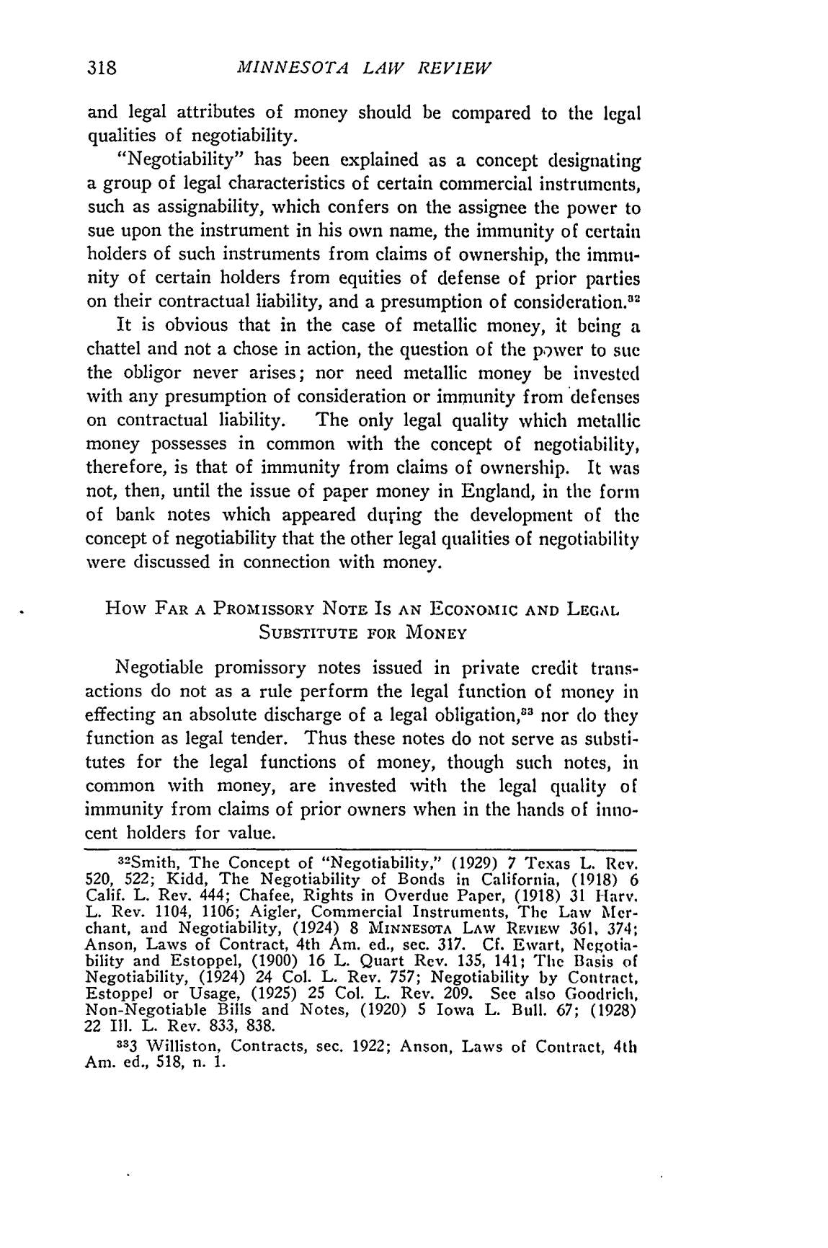
MINNESOTA LAW REVIEW

and legal attributes of money should be compared to the legal qualities of negotiability.

"Negotiability" has been explained as a concept designating a group of legal characteristics of certain commercial instruments, such as assignability, which confers on the assignee the power to sue upon the instrument in his own name, the immunity of certain holders of such instruments from claims of ownership, the immu-

nity of certain holders from equities of defense of prior parties on their contractual liability, and a presumption of consideration.2 It is obvious that in the case of metallic money, it being a chattel and not a chose in action, the question of the power to sue the obligor never arises; nor need metallic money be invested with any presumption of consideration or immunity from defenses

on contractual liability. The only legal quality which metallic money possesses in common with the concept of negotiability, therefore, is that of immunity from claims of ownership. It was not, then, until the issue of paper money in England, in the form of bank notes which appeared during the development of the concept of negotiability that the other legal qualities of negotiability were discussed in connection with money.

How FAR A PROMISSORY NOTE IS AN EcoNoMIc AND LEGAL

SUBSTITUTE FOR MONEY

Negotiable promissory notes issued in private credit trans-actions do not as a rule perform the legal function of money in effecting an absolute discharge of a legal obligation 83 nor do they function as legal tender. Thus these notes do not serve as substi-tutes for the legal functions of money, though such notes, in common with money, are invested with the legal quality of immunity from claims of prior owners when in the hands of inno-cent holders for value.

3²Smith, The Concept of "Negotiability," (1929) 7 Texas L. Rev. 520, 522; Kidd, The Negotiability of Bonds in California, (1918) 6 Calif. L. Rev. 444; Chafee, Rights in Overdue Paper, (1918) 31 Harv. L. Rev. 1104, 1106; Aigler, Commercial Instruments, The Law Mer-chant, and Negotiability, (1924) 8 MINNESOTA LAW RF.v EW 361, 374; Anson, Laws of Contract, 4th Am. ed., sec. 317. Cf. Ewart, Negotia-bility and Estoppel, (1900) 16 L. Quart Rev. 135, 141; The Basis of Negotiability, (1924) 24 Col. L. Rev. 757; Negotiability by Contract, Estoppel or Usage, (1925) 25 Col. L. Rev. 209. See also Goodrich, Non-Negotiable Bills and Notes, (1920) 5 Iowa L. Bull. 67; (1928)

22 Ill. L. Rev. 833, 838.

333 Williston, Contracts, sec. 1922; Anson, Laws of Contract, 4th Am. ed., 518, n. 1.
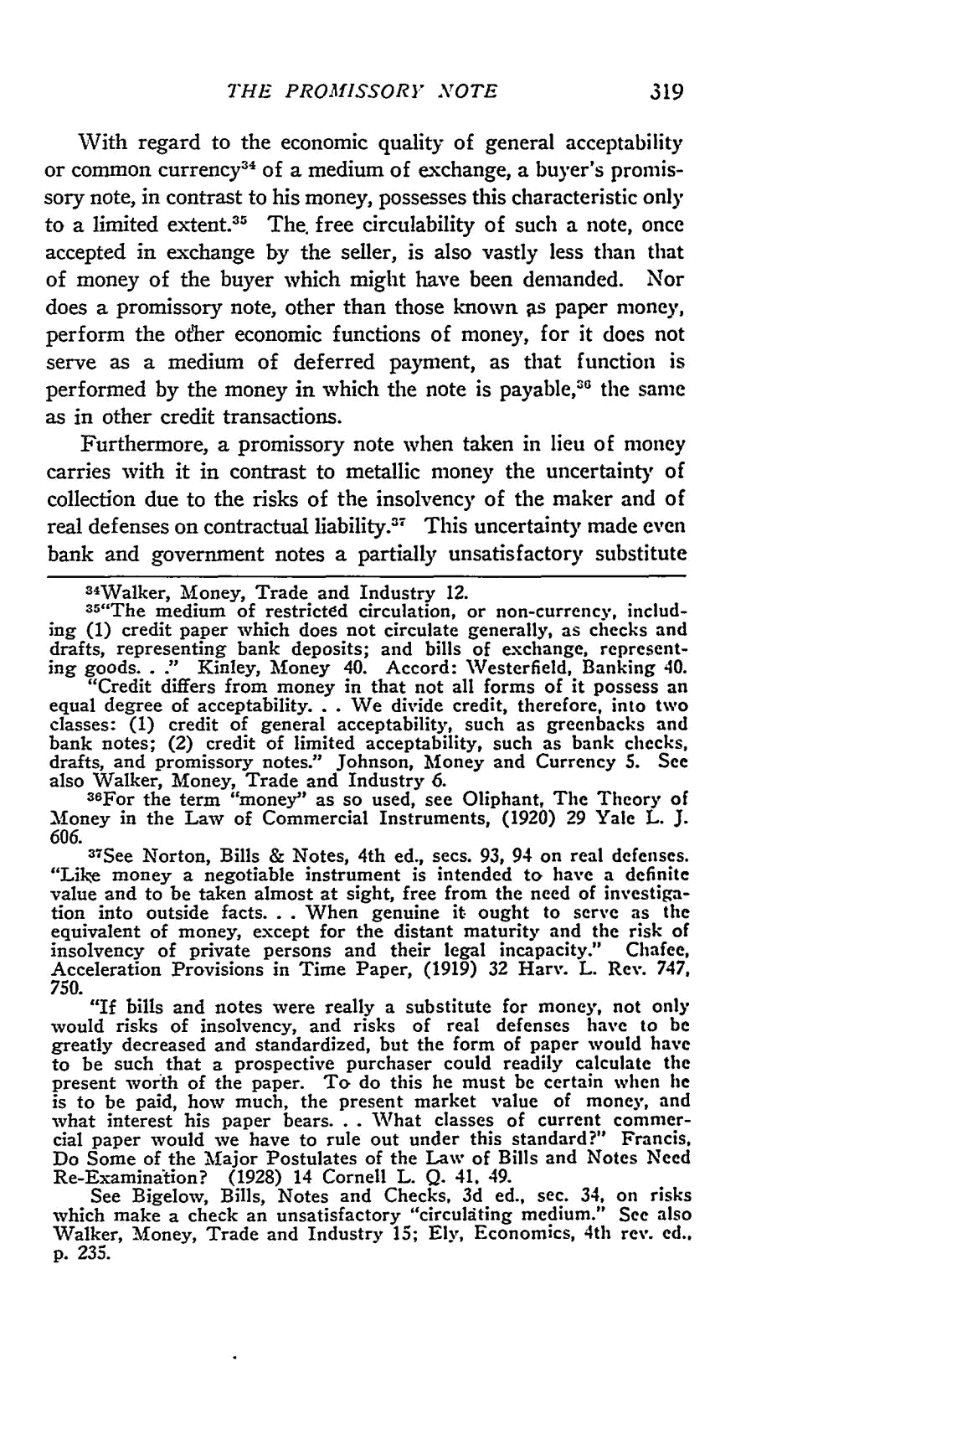
THE PROMISSORY" NOTE

With regard to the economic quality of general acceptability or common currency ⁴ of a medium of exchange, a buyer's promis-sory note, in contrast to his money, possesses this characteristic only to a limited extent.³5 The. free circulability of such a note, once accepted in exchange by the seller, is also vastly less than that of money of the buyer which might have been demanded. Nor does a promissory note, other than those known as paper money, perform the other economic functions of money, for it does not serve as a medium of deferred payment, as that function is
5
performed by the money in which the note is payable," the same as in other credit transactions.

Furthermore, a promissory note when taken in lieu of money carries with it in contrast to metallic money the uncertainty of collection due to the risks of the insolvency of the maker and of
real defenses on contractual liabilityY⁷ This uncertainty made even
bank and government notes a partially unsatisfactory substitute

34Walker, Money, Trade and Industry 12.
³⁵"The medium of restricted circulation, or non-currency, includ-ing (1) credit paper which does not circulate generally, as checks and drafts, representing bank deposits; and bills of exchange, represent-ing goods.. ." Kinley, Money 40. Accord: Westerfield, Banking 40.
"Credit differs from money in that not all forms of it possess an
equal degree of acceptability... We divide credit, therefore, into two classes: (1) credit of general acceptability, such as greenbacks and bank notes; (2) credit of limited acceptability, such as bank checks, drafts, and promissory notes." Johnson, Money and Currency 5. See also Walker, Money, Trade and Industry 6.

³⁸For the term "money" as so used, see Oliphant, The Theory of Money in the Law of Commercial Instruments, (1920) 29 Yale L. J. 606.

- See Norton, Bills & Notes, 4th ed., secs. 93, 94 on real defenses. "Like money a negotiable instrument is intended to have a definite value and to be taken almost at sight, free from the need of investiga-tion into outside facts... When genuine it ought to serve as the equivalent of money, except for the distant maturity and the risk of insolvency of private persons and their legal incapacity." Chafee, Acceleration Provisions in Time Paper, (1919) 32 Harv. L. Rev. 747,

- "If bills and notes were really a substitute for money, _{not only} would risks of insolvency, and risks of real defenses have to be greatly decreased and standardized, but the form of paper would have to be such that a prospective purchaser could readily calculate the present worth of the paper. To do this he must be certain when lie is to be paid, how much, the present market value of money, and what interest his paper bears. . . What classes of current commer-cial paper would we have to rule out under this standard?" Francis, Do Some of the Major Postulates of the Law of Bills and Notes Need Re-Examination? (1928) 14 Cornell L. Q. 41, 49.
See Bigelow, Bills, Notes and Checks, 3d ed., sec. 34, on risks which make a check an unsatisfactory "circulating medium." See also Walker, Money, Trade and Industry 15; Ely, Economics, 4th rev. ed., p. 235.
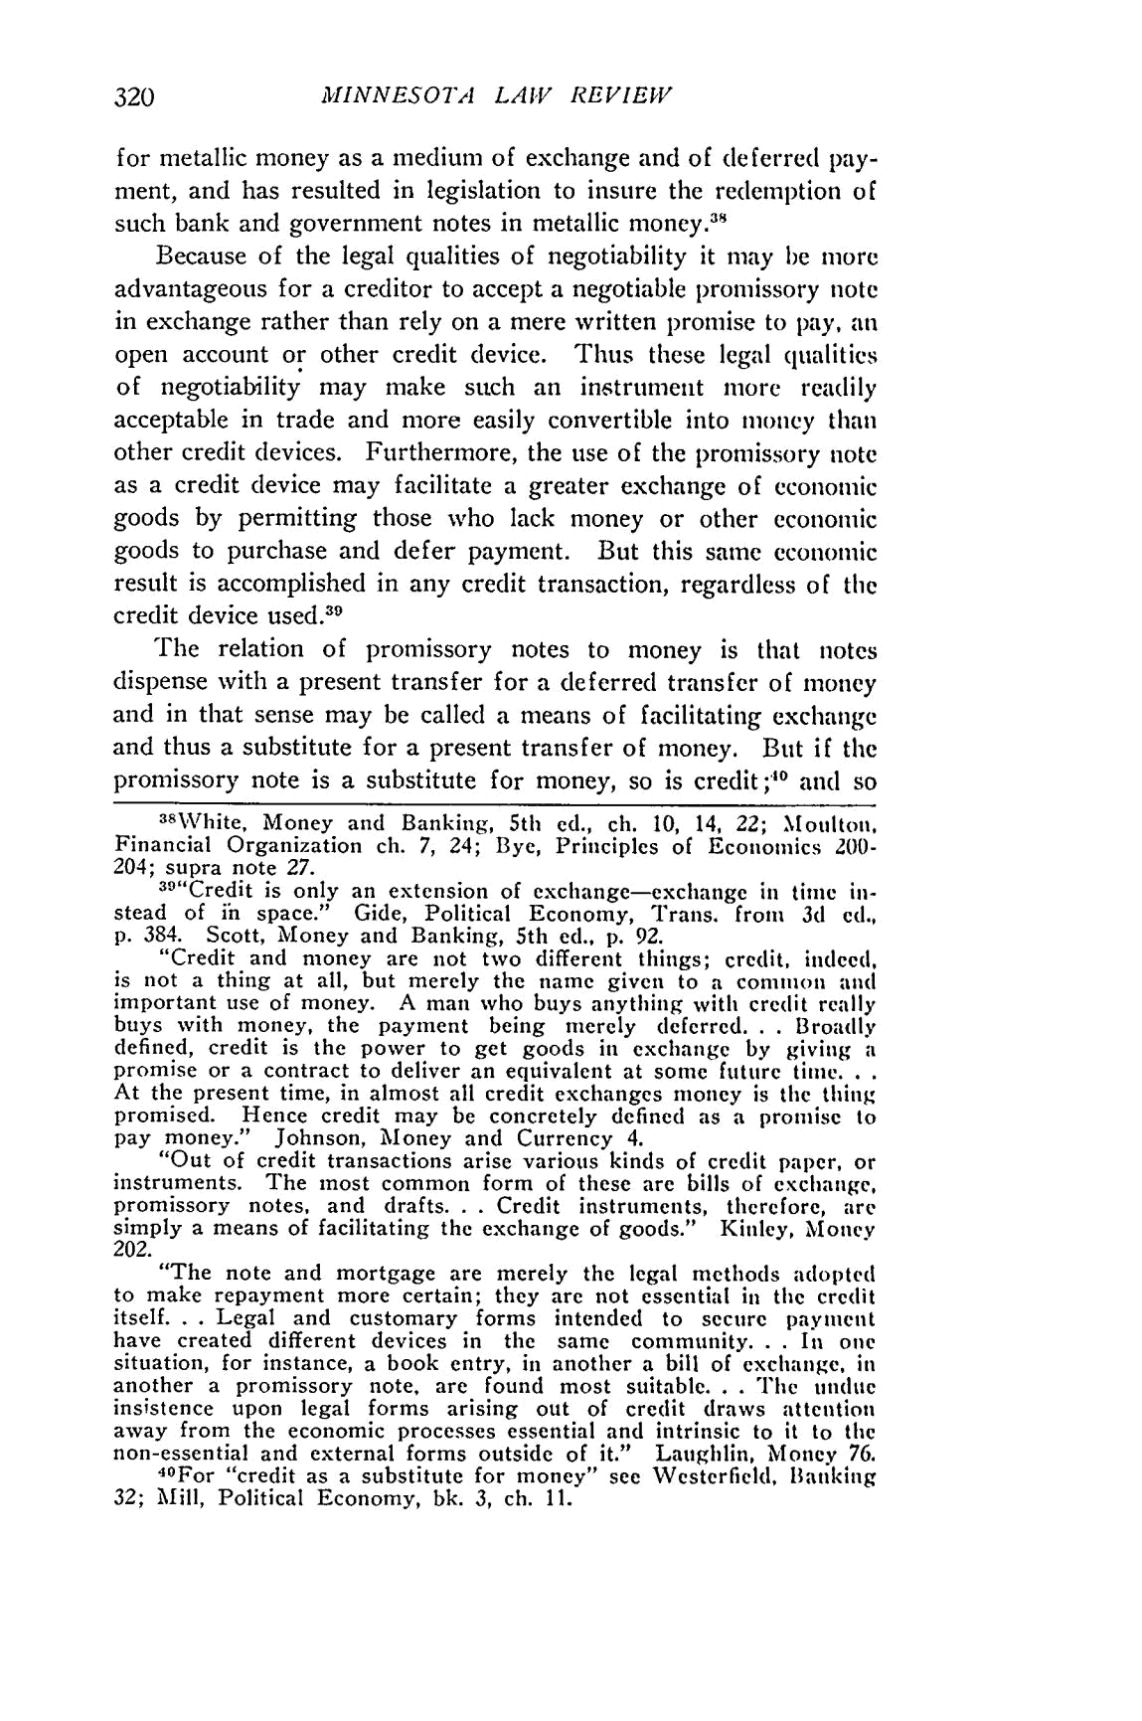
MINNESOTA LAW REVIEW

for metallic money as a medium of exchange and of deferred pay-

ment, and has resulted in legislation to insure the redemption of _{such} bank and government notes in metallic money ^{.3}

Because of the legal qualities of negotiability it may be more advantageous for a creditor to accept a negotiable promissory note in exchange rather than rely on a mere written promise to pay, an open account or other credit device. Thus these legal qualities of negotiability may make such an instrument more readily acceptable in trade and more easily convertible into money than other credit devices. Furthermore, the use of the promissory note as a credit device may facilitate a greater exchange of economic goods by permitting those who lack money or other economic goods to purchase and defer payment. But this same economic result is accomplished in any credit transaction, regardless of the
_{credit} device used. ³⁹

The relation of promissory notes to money is that notes dispense with a present transfer for a deferred transfer of money and in that sense may be called a means of facilitating exchange and thus a substitute for a present transfer of money. But if the promissory note is a substitute for money, so is credit ;40 and so

³⁸White, Money and Banking, 5th ed., ch. 10, 14, 22; Moulton, Financial Organization ch. 7, 24; Bye, Principles of Economics 200-
204; supra note 27.

³⁹"Credit is only an extension of exchange-exchange in time in-stead of ih space." Gide, Political Economy, Trans. from 3d cd., p. 384. Scott, Money and Banking, 5th ed., p. 92.

"Credit and money are not two different things; credit, indeed, is not a thing at all, but merely the name given to a common and important use of money. A man who buys anything with credit really

buys with money, the payment being merely deferred. . . Broadly defined, credit is the power to get goods in exchange by giving a promise or a contract to deliver an equivalent at some future time...

At the present time, in almost all credit exchanges money is the thing promised. Hence credit may be concretely defined as a promise to pay money." Johnson, Money and Currency 4.

"Out of credit transactions arise various kinds of credit paper, or instruments. The most common form of these are bills of exchange,
promissory notes, and drafts. . . Credit instruments, therefore, are
simply a means of facilitating the exchange of goods." Kinley, Money
- "The note and mortgage are merely the legal _{methods adopted} to make repayment more certain; they are not essential in the credit itself. . . Legal and customary forms intended to secure payment have created different devices in the same community. . . In one situation, for instance, a book entry, in another a bill of exchange, in another a promissory note, are found most suitable. . . The undue insistence upon legal forms arising out of credit draws attention away from the economic processes essential and intrinsic to it to the non-essential and external forms outside of it." Laughlin, Money 76.

⁴ ⁰For "credit as a substitute for money" see Westerfield, Banking 32; Mill, Political Economy, bk. 3, ch. 11.
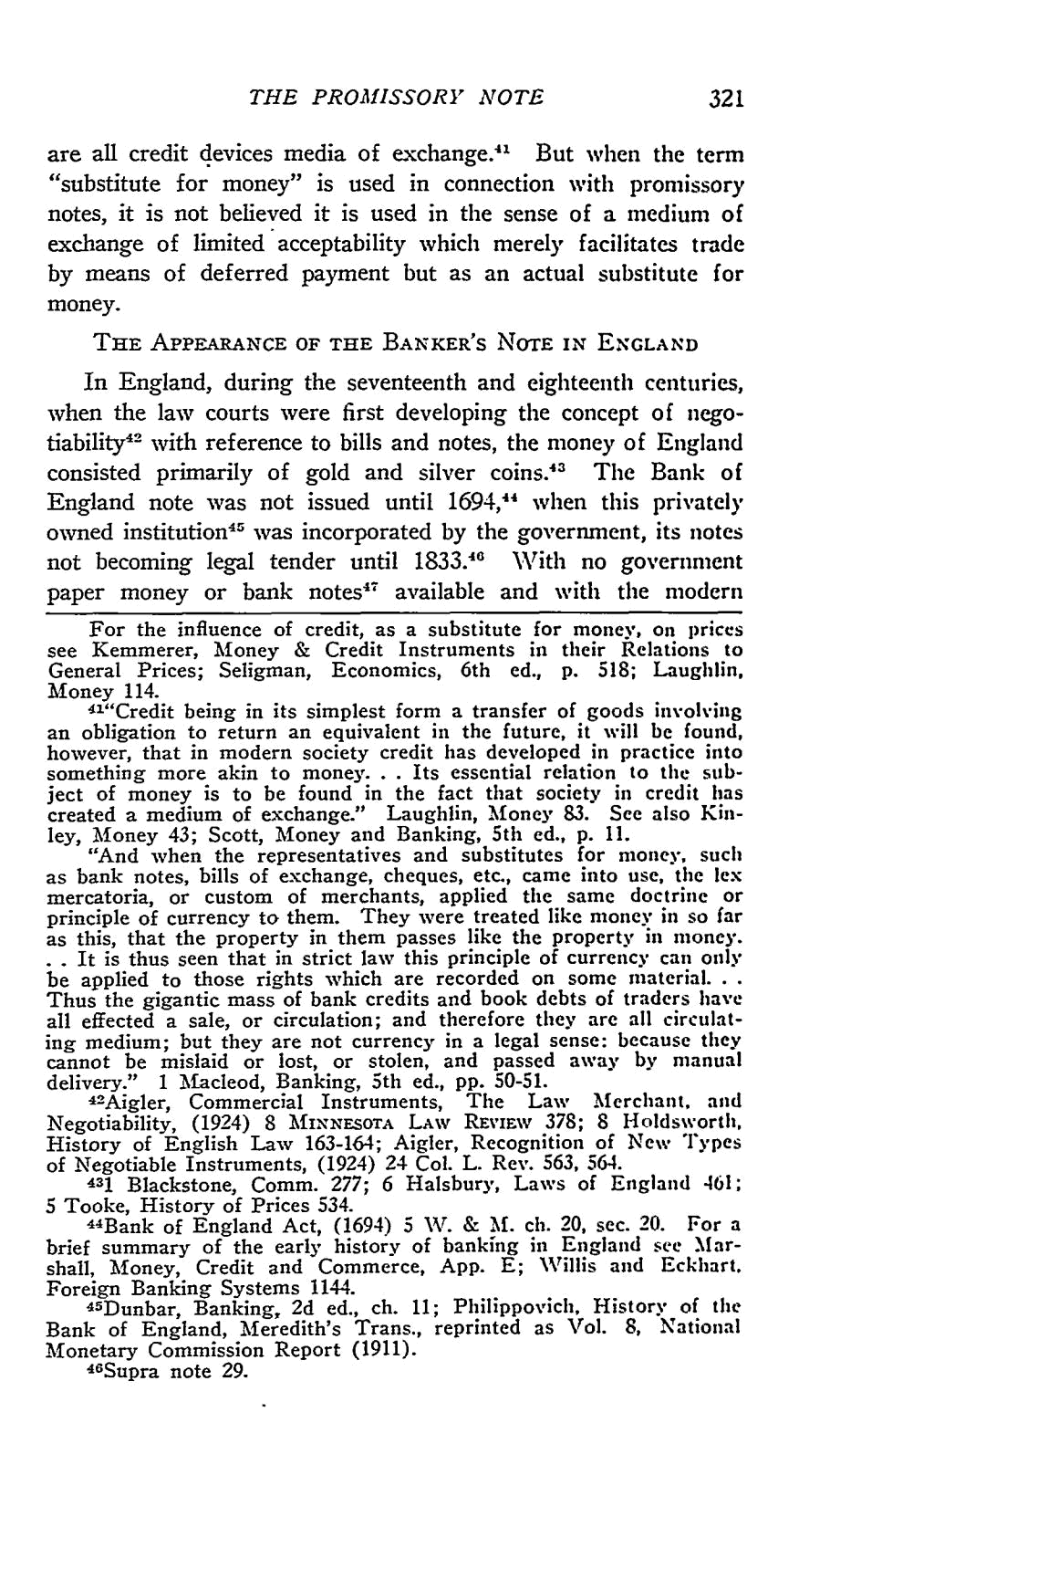
THE PROMISSORY NOTE

1 | But when the term
are all credit devices media of exchange." | But when the term
^{"substitute} for money" is used in connection with _{promissory} notes, it is not believed it is used in the sense of a medium of exchange of limited acceptability which merely facilitates trade by means of deferred payment but as an actual substitute for money.

THE APPEARANCE OF THE BANKER'S NOTE IN ENGLAND

In England, during the seventeenth and eighteenth centuries, when the law courts were first developing the concept of nego-tiability⁴ ² with reference to bills and notes, the money of England

consisted primarily of gold and silver coins.⁴ The Bank of England note was not issued until 1694,1⁴ when this privately owned institution ⁴⁵ was incorporated by the government, its notes

not becoming legal tender until 1833.1 With no government paper money or bank notes"⁷ available and with the modern

For the influence of credit, as a substitute for money, onl prices

see Kemmerer, Money & Credit Instruments in their Relations to General Prices; Seligman, Economics, 6th ed., p. 518; Laughlin, Money 114.

⁴¹"Credit being in its simplest form a transfer of goods involving an obligation to return an equivalent in the future, it will be found, however, that in modern society credit has developed in practice into something more akin to money... Its essential relation to the sub-ject of money is to be found in the fact that society in credit has
created a medium of exchange." Laughlin, Money 83. See also Kin-
ley, Money 43; Scott, Money and Banking, 5th ed., p. 11.
"And when the representatives and substitutes for money, such as bank notes, bills of exchange, cheques, etc., came into use, the lex mercatoria, or custom of merchants, applied the same doctrine or principle of currency to them. They were treated like money in so far as this, that the property in them passes like the property in money.

. . It is thus seen that in strict law this principle of currency can only be applied to those rights which are recorded on some material...

Thus the gigantic mass of bank credits and book debts of traders have all effected a sale, or circulation; and therefore they are all circulat-ing medium; but they are not currency in a legal sense: because they cannot be mislaid or lost, or stolen, and passed away by manual delivery." 1 Macleod, Banking, 5th ed., pp. 50-51.

4²Aigler, Commercial Instruments, The Law Merchant, and Negotiability, (1924) 8 MINNESOrA LAW REviEw 378; 8 Holdsworth, History of English Law 163-164; Aigler, Recognition of New Types
of Negotiable Instruments, (1924) 24 Col. L. Rev. 563, 564.
431 Blackstone, Comm. 277; 6 Halsbury, Laws of England 461;
5 Tooke, History of Prices 534.
4⁴ Bank of England Act, (1694) 5 W. & M. ch. 20, sec. 20. For a brief summary of the early history of banking in England see Mar-shall, Money, Credit and Commerce, App. E; Willis and Eckhart. Foreign Banking Systems 1144.

4⁵Dunbar, Banking, 2d ed., ch. 11; Philippovich, History of the Bank of England, Meredith's Trans., reprinted as Vol. 8, National Monetary Commission Report (1911).

4⁶ Supra note 29.
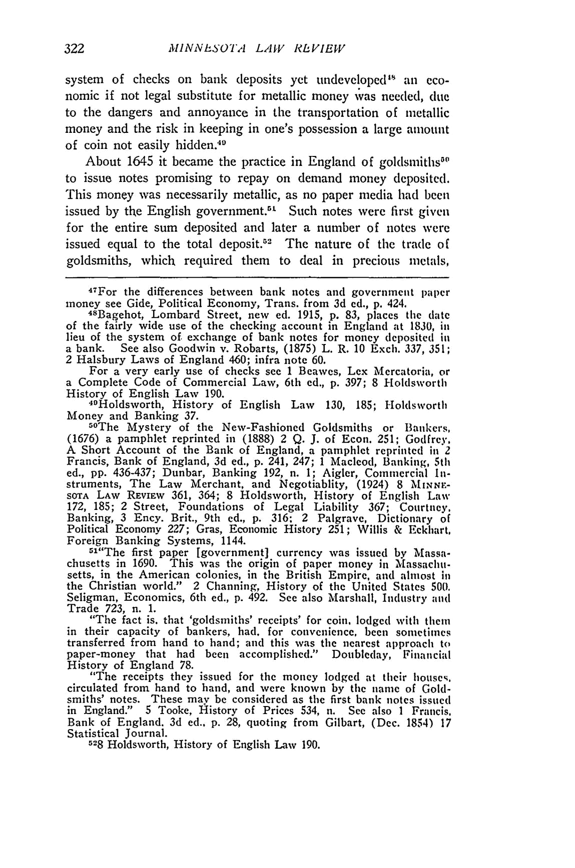
MINNE.SOTA LAW RLVIEW

system of checks on bank deposits yet undeveloped" an eco-nomic if not legal substitute for metallic money was needed, due to the dangers and annoyance in the transportation of metallic money and the risk in keeping in one's possession a large amount of coin not easily hidden.⁴"

About 1645 it became the practice in England of goldsmiths"' to issue notes promising to repay on demand money deposited. This money was necessarily metallic, as no paper media had been issued by the English government. " - Such notes were first given for the entire sum deposited and later a number of notes were issued equal to the total deposit.5² The nature of the trade of goldsmiths, which required them to deal in precious metals,

4⁷For the differences between bank notes and government paper
money see Gide, Political Economy, Trans. from 3d ed., p. 424. 48Bagehot, Lombard Street, new ed. 1915, p. 83, places the date

of the fairly wide use of the checking account in England at 1830, in lieu of the system of. exchange of bank notes for money deposited in
a bank. See also Goodwin v. Robarts, (1875) L. R. 10 Exch. 337, 351; 2 Halsbury Laws of England 460; infra note 60.

For a very early use of checks see 1 Beawes, Lex Mercatoria, or a Complete Code of Commercial Law, 6th ed., p. 397; 8 Holdsworth
History of English Law 190.
49Holdsworth, History of English Law 130, 185; Holdsworth Money and Banking 37.

5⁰The Mystery of the New-Fashioned Goldsmiths or Bankers, (1676) a pamphlet reprinted in (1888) 2 Q. J. of Econ. 251; Godfrey. A Short Account of the Bank of England, a pamphlet reprinted in 2 Francis, Bank of England, 3d ed., p. 241, 247; 1 Macleod, Banking, 5th ed., pp. 436-437; Dunbar, Banking 192, n. 1; Aigler, Commercial In-struments, The Law Merchant, and Negotiablity, (1924) 8 MINNE-
SOTA LAW REVIEw 361, 364; 8 Holdsworth, History of English Law
172, 185; 2 Street, Foundations of Legal Liability 367; Courtney, Banking, 3 Ency. Brit., 9th ed., p. 316; 2 Palgrave, Dictionary of Political Economy 227; Gras, Economic History 251; Willis & Eckhart, Foreign Banking Systems, 1144.

5¹"The first paper [government] currency was issued by Massa-chusetts in 1690. This was the origin of paper money in Massachu-setts, in the American colonies, in the British Empire, and almost in the Christian world." 2 Channing, History of the United States 500. Seligman, Economics, 6th ed., p. 492. See also Marshall, Industry and Trade 723, n. 1.

"The fact is. that 'goldsmiths' receipts' for coin, lodged with them in their capacity of bankers, had. for convenience, been sometimes transferred from hand to hand; and this was the nearest approach to paper-money that had been accomplished." Doubleday, Financial History of England 78.

"The receipts they issued for the money lodged at their house%. circulated from hand to hand, and were known by the name of Gold-smiths' notes. These may be considered as the first bank notes issued in England." 5 Tooke, History of Prices 534, n. See also 1 Francis. Bank of England. 3d ed.. p. 28, quoting from Gilbart, (Dec. 1854) 17

Statistical Journal.
528 Holdsworth, History of English Law 190.
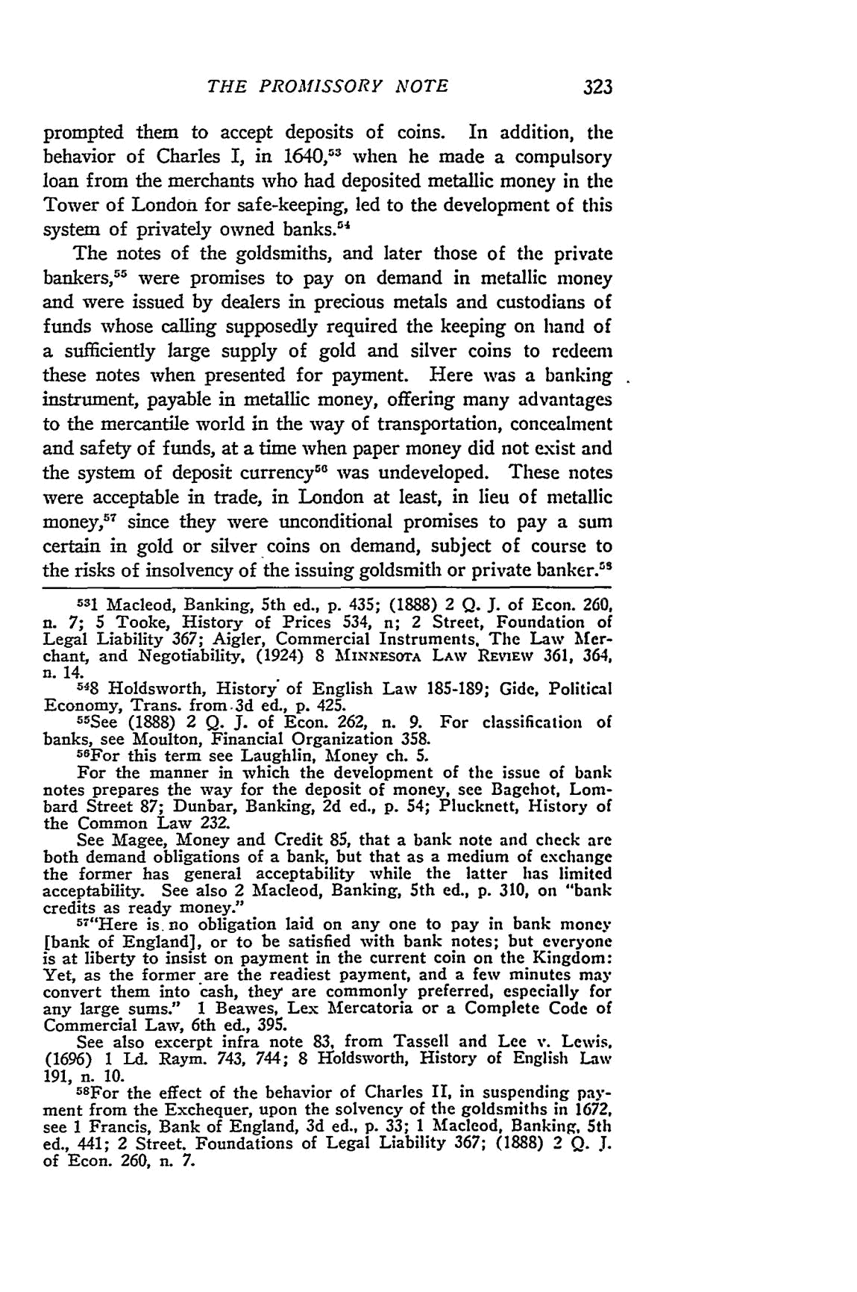
THE PROMISSORY NOTE

prompted them to accept deposits of coins. In addition, the behavior of Charles I, in 1640,13 when he made a compulsory loan from the merchants who had deposited metallic money in the Tower of London for safe-keeping, led to the development of this system of privately owned banks."⁴

The notes of the goldsmiths, and later those of the private bankers,⁵ ⁵ were promises to pay on demand in metallic money and were issued by dealers in precious metals and custodians of funds whose calling supposedly required the keeping on hand of a sufficiently large supply of gold and silver coins to redeem these notes when presented for payment. Here was a banking instrument, payable in metallic money, offering many advantages to the mercantile world in the way of transportation, concealment and safety of funds, at a time when paper money did not exist and the system of deposit currency⁵⁰ was undeveloped. These notes were acceptable in trade, in London at least, in lieu of metallic money,⁵⁷ since they were unconditional promises to pay a sum certain in gold or silver coins on demand, subject of course to the risks of insolvency of the issuing goldsmith or private banker.' ^{s}

531 Macleod, Banking, 5th ed., p. 435; (1888) 2 Q. J. of Econ. 260,
n. 7; 5 Tooke, History of Prices 534, n; 2 Street, Foundation of Legal Liability 367; Aigler, Commercial Instruments. The Law Mer-chant, and Negotiability, (1924) 8 MINNfEsor LAw REvIEW 361, 364, n. 14.

548 Holdsworth, History' of English Law 185-189; Gide, Political Economy, Trans. from.3d ed., p. 425.
⁵5See (1888) 2 Q. J. of Econ. 262, n. 9. For classification of banks, see Moulton, Financial Organization 358.
5 6
"For this term see Laughlin, Money ch. 5.

For the manner in which the development of the issue of bank notes prepares the way for the deposit of money, see Bagehot, Lom-bard Street 87; Dunbar, Banking, 2d ed., p. 54; Plucknett, History of the Common Law 232.

See Magee, Money and Credit 85, that a bank note and check are both demand obligations of a bank, but that as a medium of exchange the former has general acceptability while the latter has limited acceptability. See also 2 Macleod, Banking, 5th ed., p. 310, on "bank
credits as ready money."
57"Here is. no obligation laid on any one to pay in bank money
[bank of England], or to be satisfied with bank notes; but everyone is at liberty to insist on payment in the current coin on the Kingdom: Yet, as the former are the readiest payment, and a few minutes may convert them into cash, they are commonly preferred, especially for any large sums." 1 Beawes, Lex Mercatoria or a Complete Code of Commercial Law, 6th ed., 395.

See also excerpt infra note 83, from Tassell and Lee v. Lewis, (1696) 1 Ld. Raym. 743, 744; 8 -roldsworth, History of English Law 191, n. 10.

5⁸For the effect of the behavior of Charles II, in suspending pay-ment from the Exchequer, upon the solvency of the goldsmiths in 1672, see 1 Francis, Bank of England, 3d ed., p. 33; 1 Macleod, Banking, 5th ed., 441; 2 Street. Foundations of Legal Liability 367; (1888) 2 Q. J. of Econ. 260, n. 7.
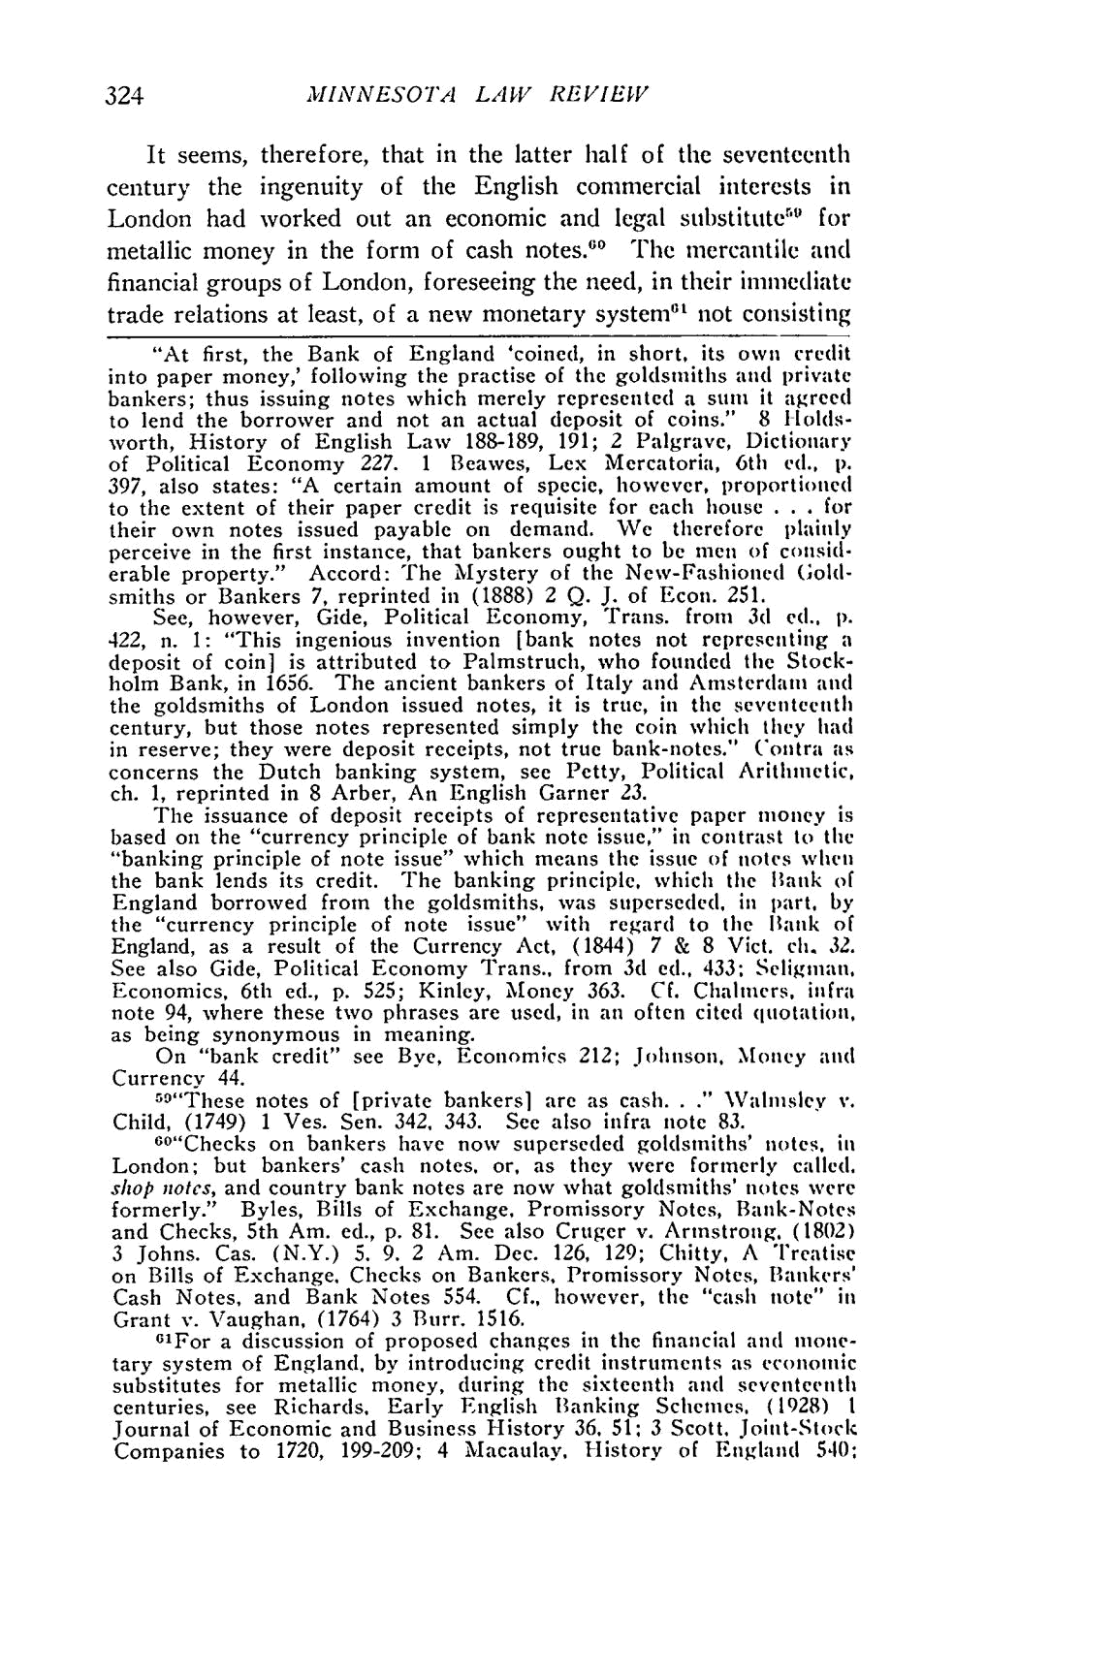
MINNESOTA LAW REVIEW

It seems, therefore, that in the latter half of the seventeenth century the ingenuity of the English commercial interests in London had worked out an economic and legal substitute'" for metallic money in the form of cash notes." The mercantile and financial groups of London, foreseeing the need, in their immediate trade relations at least, of a new monetary system"' not consisting

"At first, the Bank of England 'coined, in short, its own credit into paper money,' following the practise of the goldsmiths and private bankers; thus issuing notes which merely represented a sum it agreed to lend the borrower and not an actual deposit of coins." 8 Holds-worth, History of English Law 188-189, 191; 2 Palgrave, Dictionary of Political Economy 227. 1 Beawes, Lex Mercatoria, 6th ed., p. 397, also states: "A certain amount of specie, however, proportioned to the extent of their paper credit is requisite for each house . . . for their own notes issued payable on demand. We therefore plainly perceive in the first instance, that bankers ought to be men of consid-erable property." Accord: The Mystery of the New-Fashioned Gold-

smiths or Bankers 7, reprinted in (1888) 2 Q. J. of Econ. 251.

See, however, Gide, Political Economy, Trans. from 3d ed., p. 422, n. 1: "This ingenious invention [bank notes not representing a

deposit of coin] is attributed to Palmstruch, who founded the Stock-holm Bank, in 1656. The ancient bankers of Italy and Amsterdam and
the goldsmiths of London issued notes, it is true, in the seventeenth century, but those notes represented simply the coin which they had in reserve; they were deposit receipts, not true bank-notes." Contra as concerns the Dutch banking system, see Petty, Political Arithmetic, ch. 1, reprinted in 8 Arber, An English Garner 23.

The issuance of deposit receipts of representative paper money is based on the "currency principle of bank note issue," in contrast to the "banking principle of note issue" which means the issue of notes when the bank lends its credit. The banking principle, which the Hank of England borrowed from the goldsmiths, was superseded, in part, by the "currency principle of note issue" with regard to the Bank of England, as a result of the Currency Act, (1844) 7 & 8 Vict. ch. 32. See also Gide, Political Economy Trans., from 3d ed., 433; Selignian, Economics, 6th ed., p. 525; Kinley, Money 363. Cf. Chalmers. infra note 94, where these two phrases are used, in an often cited quotation, as being synonymous in meaning.

On "bank credit" see Bye, Economics 212; Johnson, Money an(d
Currency 44. | Vahnsley v.
59"These notes of [private bankers] are as cash.. | Vahnsley v.
Child, (1749) 1 Ves. Sen. 342, 343. See also infra note 83.

6o"Checks on bankers have now superseded goldsmiths' notes, in London; but bankers' cash notes, or, as they were formerly called. shop notes, and country bank notes are now what goldsmiths' notes were formerly." Byles, Bills of Exchange, Promissory Notes, Bank-Notes and Checks, 5th Am. ed., p. 81. See also Cruger v. Armstrong. (1802)

3 Johns. Cas. (N.Y.) 5. 9. 2 Am. Dec. 126, 129; Chitty, A Treatise on Bills of Exchange, Checks on Bankers, Promissory Notes, Bankers' Cash Notes, and Bank Notes 554. Cf., however, the "cash note" in Grant v. Vaughan, (1764) 3 Burr. 1516.

O¹For a discussion of proposed changes in the financial and mone-tary system of England. by introducing credit instruments as economic substitutes for metallic money, during the sixteenth and seventeenth centuries, see Richards. Early English Banking Schemes, (1928) 1 Journal of Economic and Business History 36. 51: 3 Scott, Joint-Stock Companies to 1720, 199-209; 4 Macaulay. History of England 540:
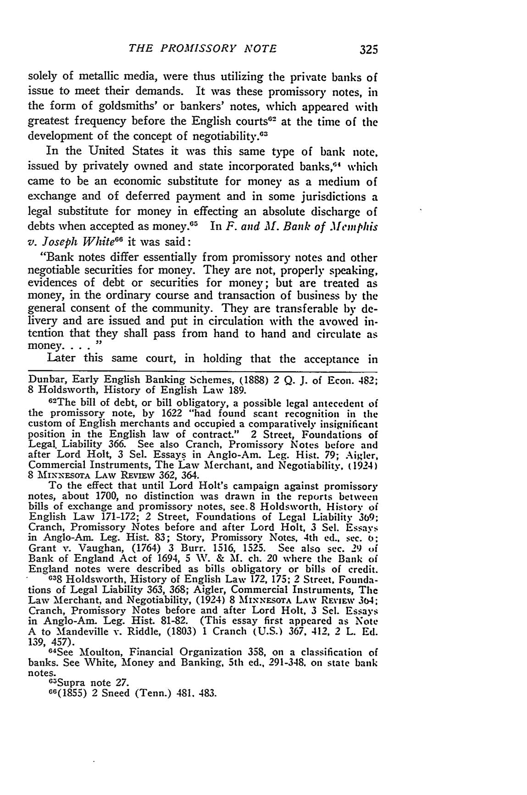
THE PROMISSORY NOTE

solely of metallic media, were thus utilizing the private banks of issue to meet their demands. It was these promissory notes, in the form of goldsmiths' or bankers' notes, which appeared with greatest frequency before the English courts ² at the time of the
development | 2
development | of the concept of negotiability."
In the United States it was this same type of batik note, issued by privately owned and state incorporated banks,"' which came to be an economic substitute for money as a medium of exchange and of deferred payment and in some jurisdictions a legal substitute for money in effecting an absolute discharge of debts when accepted as money.⁶⁵ In F. and JI. Bank of .1femphis
66
v. Joseph White it was said:

"Bank notes differ essentially from promissory notes and other negotiable securities for money. They are not, properly speaking, evidences of debt or securities for money; but are treated as money, in the ordinary course and transaction of business by the general consent of the community. They are transferable by de-livery and are issued and put in circulation with the avowed in-tention that they shall pass from hand to hand and circulate as money ..

Later this same court, in holding that the acceptance in

Dunbar, Early English Banking Schemes, (1888) 2 Q. J. of Econ. 482; 8 Holdsworth, History of English Law 189.

- The bill of debt, or bill obligatory, a possible legal antecedent of the promissory note, by 1622 "had found scant recognition in the custom of English merchants and occupied a comparatively insignificant position in the English law of contract." 2 Street, Foundations of Legal. Liability 366. See also Cranch, Promissory Notes before and after Lord Holt, 3 Sel. Essays in Anglo-Am. Leg. Hist. 79; Aigler, Commercial Instruments, The Law Merchant, and Negotiability, (1924)

8 MixxFoTA LAW REviaw 362, 364.
To the effect that until Lord Holt's campaign against promissory notes, about 1700, no distinction was drawn in the reports between bills of exchange and promissory notes, see. 8 Holdsworth, History of English Law 171-172; 2 Street, Foundations of Legal Liability 309; Cranch, Promissory Notes before and after Lord Holt, 3 Sel. Essays in Anglo-Am. Leg. Hist. 83; Story, Promissory Notes, 4th ed., Sec. o: Grant v. Vaughan, (1764) 3 Burr. 1516, 1525. See also sec. 29 of Bank of England Act of 1694, 5 \. & Ma.ch. 20 where the Bank of England notes were described as bills obligatory or bills of credit.

- Holdsworth, History of English Law 172, 175; 2 Street, Founda-tions of Legal Liability 363, 368; Aigler, Commercial Instruments, Thc Law Merchant, and Negotiability, (1924) 8 MINNESOTA LAw RE\iEw 304; Cranch, Promissory Notes before and after Lord Holt, 3 Sel. Essays in Anglo-Am. Leg. Hist. 81-82. (This essay first appeared as Note A to Mandeville v. Riddle, (1803) 1 Cranch (U.S.) 367, 412, 2 L. Ed. 139, 457).

- See Moulton, Financial Organization 358, on a classification of banks. See White, Money and Banking, 5th ed., 291-348. on state bank notes.

- 3Supra note 27.
66(1855) 2 Sneed (Tenn.) 481. 483.
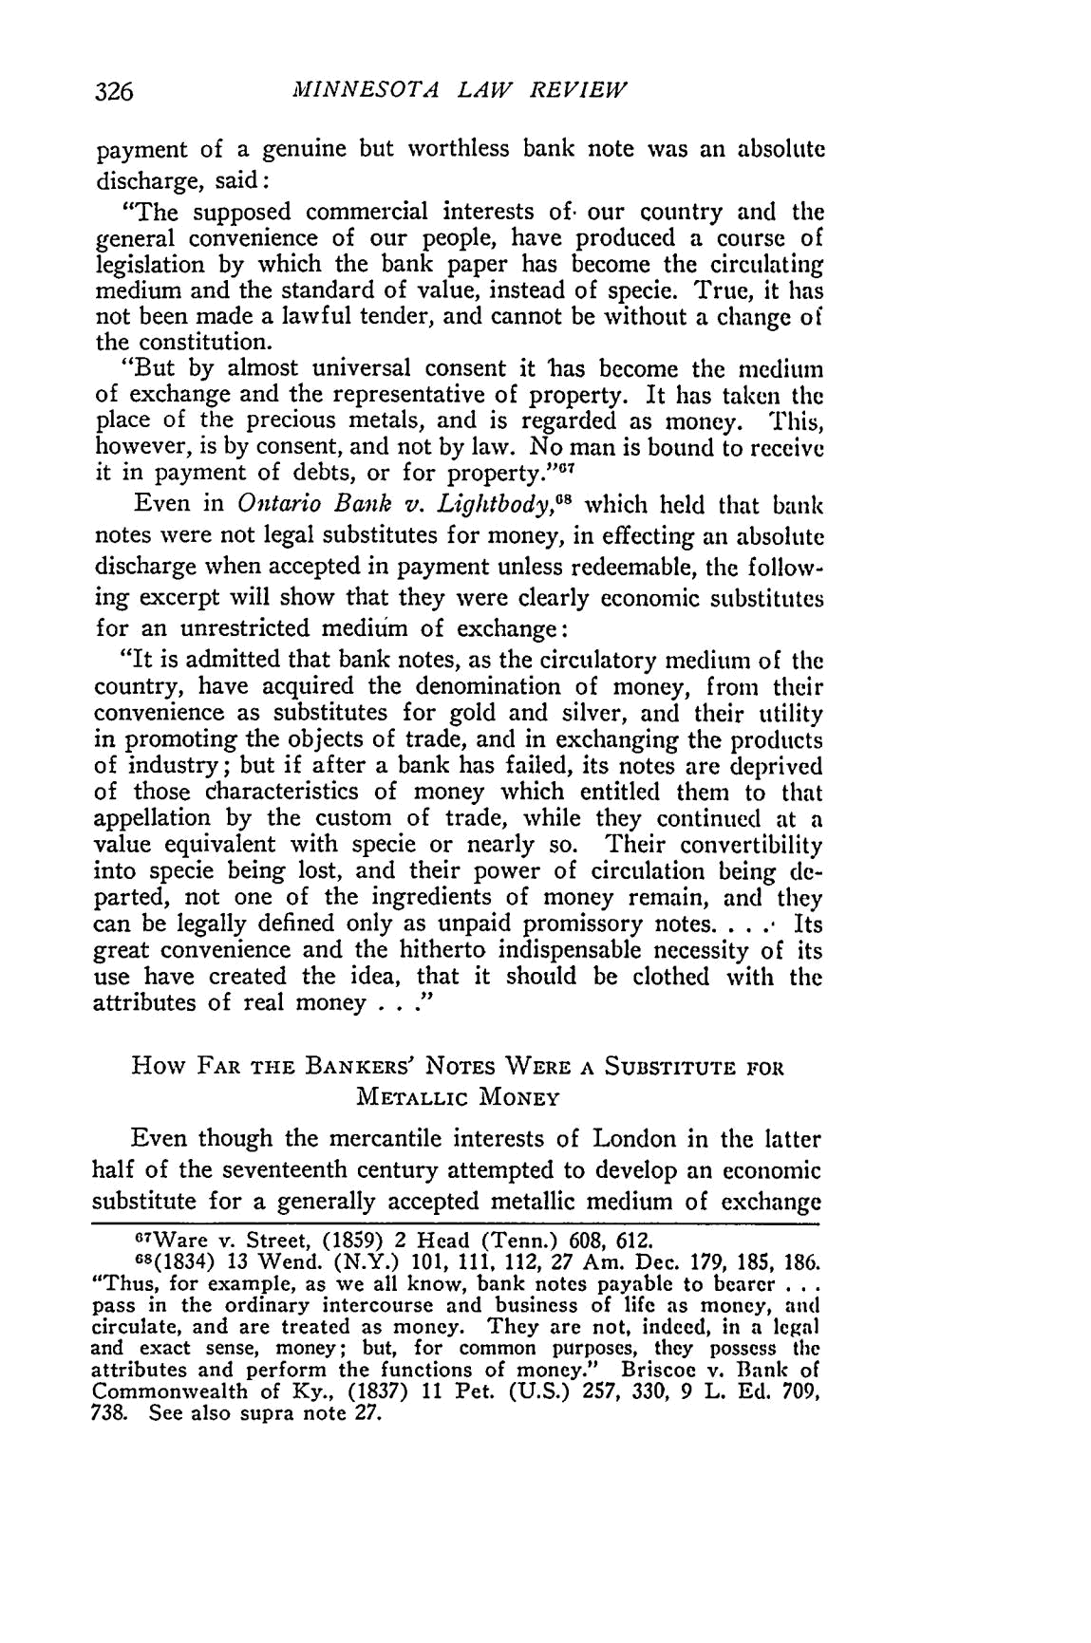
MINNESOTA LAW REVIEW

payment of a genuine but worthless bank note was an absolute discharge, said:

"The supposed commercial interests of. our country and the general convenience of our people, have produced a course of legislation by which the bank paper has become the circulating medium and the standard of value, instead of specie. True, it has not been made a lawful tender, and cannot be without a change of the constitution.

"But by almost universal consent it has become the medium of exchange and the representative of property. It has taken the place of the precious metals, and is regarded as money. This,

however, is by consent, and not by law. No man is bound to receive _{it} in payment of debts, or for property. ^{'1 7}

Even in Ontario Bank v. Lightbody, ^{s} which held that bank notes were not legal substitutes for money, in effecting an absolute discharge when accepted in payment unless redeemable, the follow-ing excerpt will show that they were clearly economic substitutes for an unrestricted medium of exchange:

"It is admitted that bank notes, as the circulatory medium of the country, have acquired the denomination of money, from their convenience as substitutes for gold and silver, and their utility in promoting the objects of trade, and in exchanging the products of industry; but if after a bank has failed, its notes are deprived of those characteristics of money which entitled them to that appellation by the custom of trade, while they continued at a value equivalent with specie or nearly so. Their convertibility into specie being lost, and their power of circulation being de-parted, not one of the ingredients of money remain, and they
can be legally defined only as unpaid promissory notes. . . . Its
great convenience and the hitherto indispensable necessity of its use have created the idea, that it should be clothed with the attributes of real money . . ."

How FAR THE BANKERS' NOTES WERE A SUBSTITUTE FOR

METALLIC MONEY

Even though the mercantile interests of London in the latter half of the seventeenth century attempted to develop an economic

substitute for a generally accepted metallic medium of exchange
⁶⁷Ware v. Street, (1859) 2 Head (Tenn.) 608, 612.
6s(1834) 13 Wend. (N.Y.) 101, 111, 112, 27 Am. Dec. 179, 185, 186.
"Thus, for example, as we all know, bank notes payable to bearer ...

pass in the ordinary intercourse and business of life as money, and circulate, and are treated as money. They are not, indeed, in a legal and exact sense, money; but, for common purposes, they possess the
attributes and perform the functions of money." Briscoe v. Bank of Commonwealth of Ky., (1837) 11 Pet. (U.S.) 257, 330, 9 L. Ed. 709, 738. See also supra note 27.
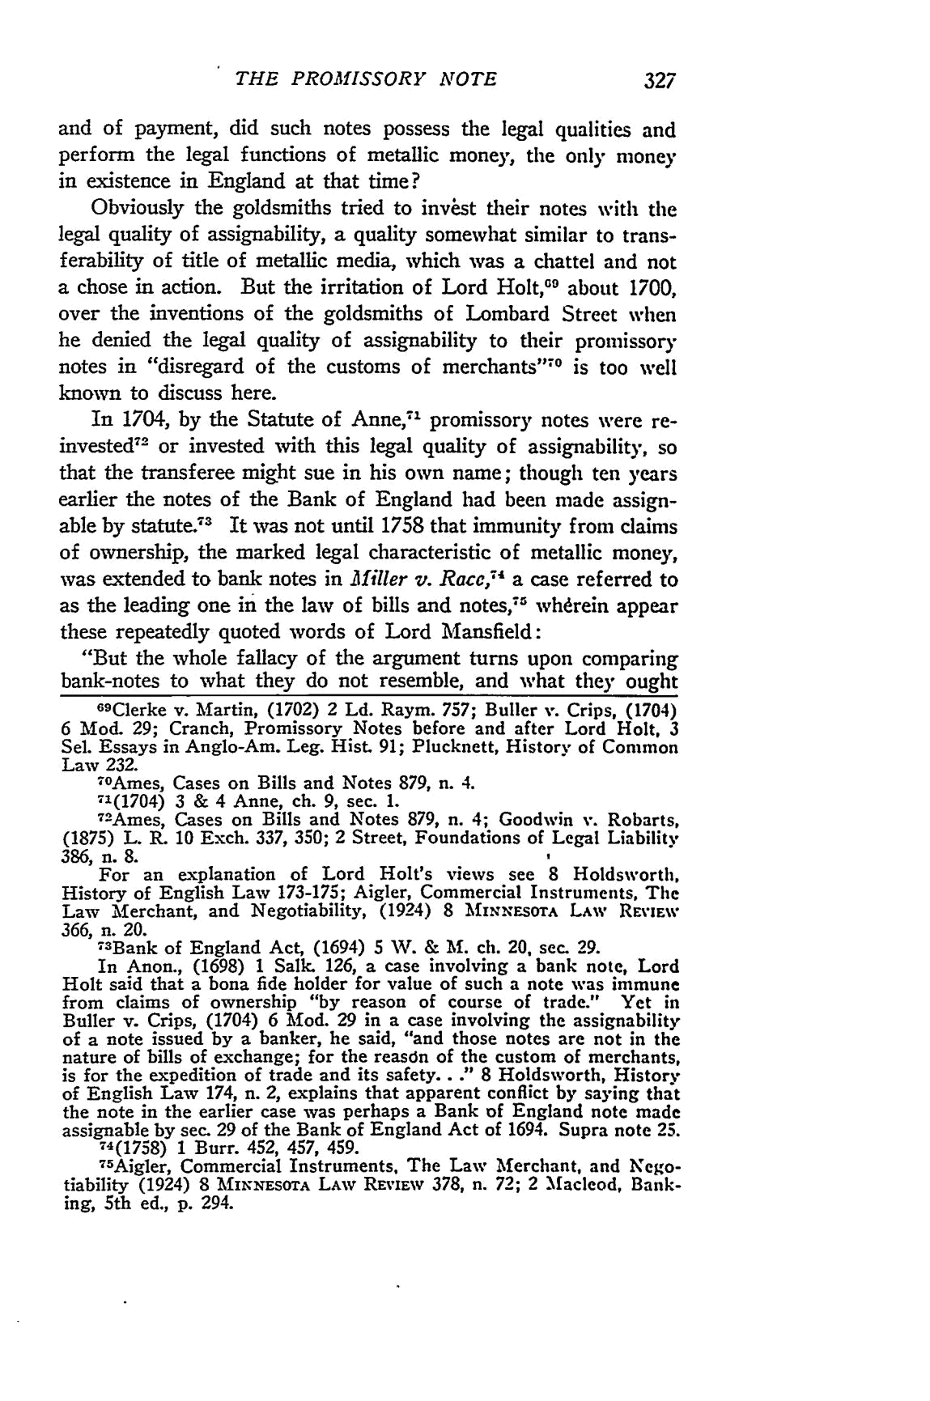
THE PROMISSORY NOTE

and of payment, did such notes possess the legal qualities and perform the legal functions of metallic money, the only money in existence in England at that time?

Obviously the goldsmiths tried to invbst their notes with the legal quality of assignability, a quality somewhat similar to trans-ferability of title of metallic media, which was a chattel and not a chose in action. But the irritation of Lord Holt,"' about 1700, over the inventions of the goldsmiths of Lombard Street when he denied the legal quality of assignability to their promissory
_{notes} in "disregard of the customs of merchants1⁷ ⁰ is too well

known to discuss here.

In 1704, by the Statute of Anne,-' promissory notes were re-invested ² or invested with this legal quality of assignability, so that the transferee might sue in his own name; though ten years earlier the notes of the Bank of England had been made assign-able by statute.⁷³ It was not until 1758 that immunity from claims of ownership, the marked legal characteristic of metallic money, was extended to bank notes in Miller v. Race,-- a case referred to as the leading one in the law of bills and notes, ² whdrein appear these repeatedly quoted words of Lord Mansfield:

"But the whole fallacy of the argument turns upon comparing bank-notes to what they do not resemble, and what they ought

- Clerke v. Martin, (1702) 2 Ld. Raym. 757; Buller v. Crips, (1704) 6 Mod. 29; Cranch, Promissory Notes before and after Lord Holt, 3 Sel. Essays in Anglo-Am. Leg. Hist. 91; Plucknett, History of Common Law 232.
-OAmes, Cases on Bills and Notes 879, n. 4.
71(1704) 3 & 4 Anne, ch. 9, sec. 1.
⁷ ²Ames, Cases on Bills and Notes 879, n. 4; Goodwin v. Robarts,

386, n. 8.
For an explanation of Lord Holt's views see 8 Holdsworth, History of English Law 173-175; Aigler, Commercial Instruments, The Law Merchant, and Negotiability, (1924) 8 MNxExsoTA LAW REVIEW 366, n. 20.
7³ Bank of England Act, (1694) 5 W. & M. ch. 20, sec. 29.
In Anon., (1698) 1 Salk. 126, a case involving a bank note, Lord Holt said that a bona fide holder for value of such a note was immune from claims of ownership "by reason of course of trade." Yet in Buller v. Crips, (1704) 6 Mod. 29 in a case involving the assignability
of a note issued by a banker, he said, "and those notes are not in the nature of bills of exchange; for the reasdn of the custom of merchants, is for the expedition of trade and its safety. . ." 8 Holdsworth, History of English Law 174, n. 2, explains that apparent conflict by saying that the note in the earlier case was perhaps a Bank of England note made
assignable by sec. 29 of the Bank of England Act of 1694. Supra note 25.
'4(1758) 1 Burr. 452, 457, 459.

- Aigler, Commercial Instruments, The Law Merchant, and Nego-tiability (1924) 8 MiNNESOTA LAw REvIEW 378, n. 72; 2 Macleod, Bank-ing, 5th ed., p. 294.
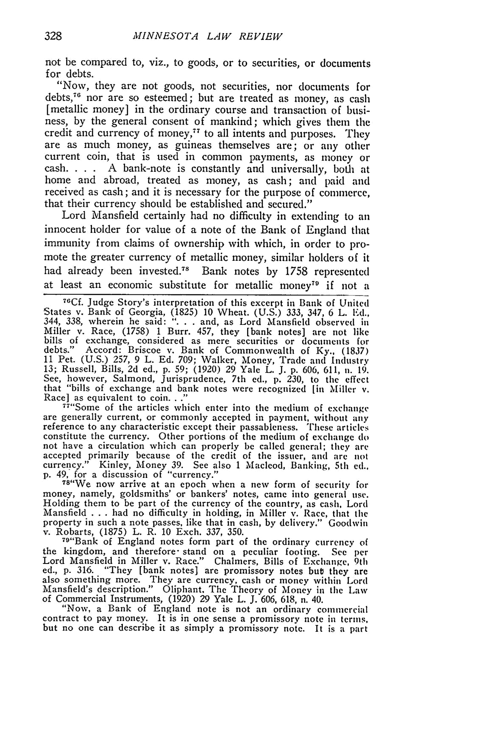
MINNESOTA LAW REVIEW

not be compared to, viz., to goods, or to securities, or documents for debts.

"Now, they are not goods, not securities, nor documents for debts,7 nor are so esteemed; but are treated as money, as cash
[metallic money] in the ordinary course and transaction of busi-ness, by the general consent of mankind; which gives them the
credit and currency of money, ⁷ to all intents and purposes. They are as much money, as guineas themselves are; or any other current coin, that is used in common payments, as money or
cash. . . . A bank-note is constantly and universally, both at
home and abroad, treated as money, as cash; and paid and received as cash; and it is necessary for the purpose of commerce, that their currency should be established and secured."
Lord Mansfield certainly had no difficulty in extending to an innocent holder for value of a note of the Bank of England that immunity from claims of ownership with which, in order to pro-mote the greater currency of metallic money, similar holders of it had already been invested.⁷ ⁸ Bank notes by 1758 represented at least an economic substitute for metallic money7D if not a

⁷⁶ Cf. Judge Story's interpretation of this excerpt in Bank of United States v. Bank of Georgia, (1825) 10 Wheat. (U.S.) 333, 347, 6 L. Ed.,
344, 338, wherein he said: ". . . and, as Lord Mansfield observed in
Miller v. Race, (1758) 1 Burr. 457, they [bank notes] are not like bills of exchange, considered as mere securities or documcnts for debts." Accord: Briscoe v. Bank of Commonwealth of Ky., (1837) 11 Pet. (U.S.) 257, 9 L. Ed. 709; Walker, Money, Trade and Industry 13; Russell, Bills, 2d ed., p. 59; (1920) 29 Yale L. J. p. 606, 611, n1.19. See, however, Salmond, Jurisprudence, 7th ed., p. 230, to the effect that "bills of exchange and bank notes were recognized [in Miller v. Race] as equivalent to coin..."

⁷ ⁷"Some of the articles which enter into the medium of exchange are generally current, or commonly accepted in payment, without any reference to any characteristic except their passableness. These articles constitute the currency. Other portions of the medium of exchange do not have a circulation which can properly be called general; they are accepted primarily because of the credit of the issuer, and are not currency." Kinley, Money 39. See also 1 Macleod, Banking, 5th ed., p. 49, for a discussion of "currency."
⁷⁸"We now arrive at an epoch when a new form of security for

money, namely, goldsmiths' or bankers' notes, came into general use. Holding them to be part of the currency of the country, as cash, Lord
Mansfield . . . had no difficulty in holding, in Miller v. Race, that the
property in such a note passes, like that in cash, by delivery." Goodwin v. Robarts, (1875) L. R. 10 Exch. 337, 350.

- "Bank of England notes form part of the ordinary currency of the kingdom, and therefore- stand on a peculiar footing. See per Lord Mansfield in Miller v. Race." Chalmers, Bills of Exchange, 9th ed., p. 316. "They [bank notes] are promissory notes but they are also something more. They are currency, cash or money within Lord Mansfield's description." Oliphant. The Theory of Money in the Law of Commercial Instruments, (1920) 29 Yale L. J. 606, 618, n. 40.

"Now, a Bank of England note is not an ordinary commercial contract to pay money. It is in one sense a promissory note in terms, but no one can describe it as simply a promissory note. It is a part
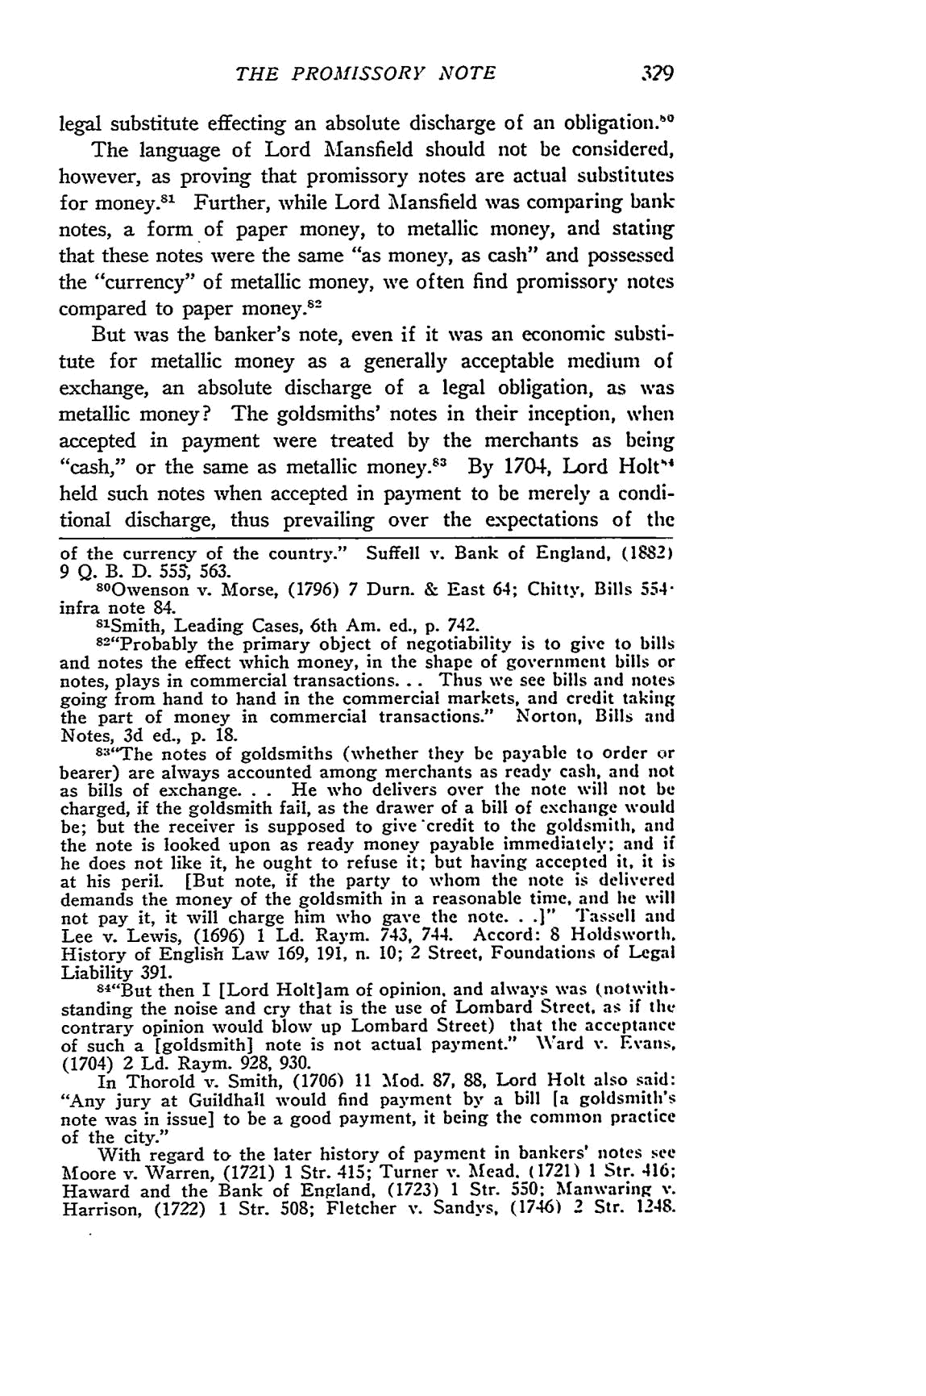
THE PROMHSSORY NOTE

legal substitute effecting an absolute discharge of an obligation.,, The language of Lord Mansfield should not be considered, however, as proving that promissory notes are actual substitutes for money."' Further, while Lord Mansfield was comparing bank notes, a form of paper money, to metallic money, and stating that these notes were the same "as money, as cash" and possessed the "currency" of metallic money, we often find promissory notes
compared to paper money. ²

But was the banker's note, even if it was an economic substi-tute for metallic money as a generally acceptable medium of exchange, an absolute discharge of a legal obligation, as was metallic money? The goldsmiths' notes in their inception, when

accepted in payment were treated by the merchants as being "cash," or the same as metallic money.8³ By 1704, _{Lord Holt"}⁴

held such notes when accepted in payment to be merely a condi-tional discharge, thus prevailing over the expectations of the

of the currency of the country." Suffell v. Bank of England, (1882) 9 Q. B. D. 553, 563.
- Owenson v. Morse, (1796) 7 Durn. & East 64; Chitty, Bills 554" infra note 84.

8'Smith, Leading Cases, 6th Am. ed., p. 742.
- "Probably the primary object of negotiability is to give to bills and notes the effect which money, in the shape of government bills or notes, plays in commercial transactions.. . Thus we see bills and notes going from hand to hand in the commercial markets, and credit taking the part of money in commercial transactions." Norton, Bills and Notes, 3d ed., p. 18.
⁸³"The notes of goldsmiths (whether they be payable to order or

bearer) are always accounted among merchants as ready cash, and not as bills of exchange. . . He who delivers over the note will not be charged, if the goldsmith fail, as the drawer of a bill of exchange would be; but the receiver is supposed to give credit to the goldsmith, and the note is looked upon as ready money payable immediately; and if he does not like it, he ought to refuse it; but having accepted it, it is at his peril. [But note, if the party to whom the note is delivered demands the money of the goldsmith in a reasonable time, and le will not pay it, it will charge him who gave the note...]" Tassell and Lee v. Lewis, (1696) 1 Ld. Raym. 743, 744. Accord: 8 Holdsworth. History of English Law 169, 191, n. 10; 2 Street, Foundations of Legal Liability 391.
84"But then I [Lord Holtiam of opinion, and always was (notwith-

standing the noise and cry that is the use of Lombard Street, as if the contrary opinion would blow up Lombard Street) that the acceptance of such a [goldsmith] note is not actual payment." Ward v. Evans, (1704) 2 Ld. Raym. 928, 930.
In Thorold v. Smith, (1706) 11 Mod. 87, 88, Lord Holt also said: "Any jury at Guildhall would find payment by a bill [a goldsmith's note was in issue] to be a good payment, it being the common practice of the city."

With regard to the later history of payment in bankers' notes see
Moore v. Warren, (1721) 1 Str. 415; Turner v. Mead. (1721) 1 Str. 416;
Haward and the Bank of England, (1723) 1 Str. 550; Manwaring v.
Harrison, (1722) 1 Str. 508; Fletcher v. Sandys, (1746) 2 Str. 1248.
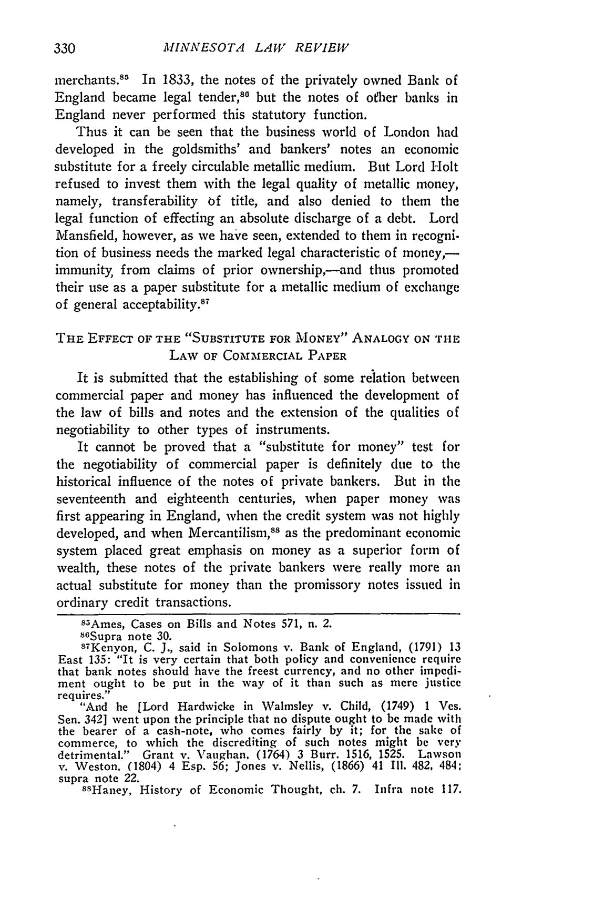
MINNESOTA LAW REVIEW

merchants⁸ 1 In 1833, the notes of the privately owned Bank of England became legal tender," but the notes of other banks in England never performed this statutory function.

Thus it can be seen that the business world of London had developed in the goldsmiths' and bankers' notes an economic substitute for a freely circulable metallic medium. But Lord Holt refused to invest them with the legal quality of metallic money, namely, transferability of title, and also denied to them the legal function of effecting an absolute discharge of a debt. Lord Mansfield, however, as we have seen, extended to them in recogni-tion of business needs the marked legal characteristic of money,-immunity, from claims of prior ownership,-and thus promoted their use as a paper substitute for a metallic medium of exchange of general acceptability.⁸⁷

THE EFFECT OF THE "SUBSTITUTE FOR MONEY" ANALOGY ON THE LAW OF COMMERCIAL PAPER

It is submitted that the establishing of some relation between commercial paper and money has influenced the development of the law of bills and notes and the extension of the qualities of negotiability to other types of instruments.

It cannot be proved that a "substitute for money" test for the negotiability of commercial paper is definitely due to the historical influence of the notes of private bankers. But in the seventeenth and eighteenth centuries, when paper money was first appearing in England, when the credit system was not highly developed, and when Mercantilism,"⁸ as the predominant economic system placed great emphasis on money as a superior form of wealth, these notes of the private bankers were really more an actual substitute for money than the promissory notes issued in ordinary credit transactions.

⁸5Ames, Cases on Bills and Notes 571, n. 2.
86Supra note 30.

S⁷Kenyon, C. J., said in Solomons v. Bank of England, (1791) 13 East 135: "It is very certain that both policy and convenience require that bank notes should have the freest currency, and no other impedi-ment ought to be put in the way of it than such as mere justice

requires."
"And he [Lord Hardwicke in Walmsley v. Child, (1749) 1 Ves.
Sen. 342] went upon the principle that no dispute ought to be made with the bearer of a cash-note, who comes fairly by it; for the sake of commerce, to which the discrediting of such notes might be very detrimental." Grant v. Vaughan, (1764) 3 Burr. 1516, 1525. Lawson v. Weston. (1804) 4 Esp. 56; Jones v. Nellis, (1866) 41 Ill. 482, 484;
supra note 22.
⁸sHaney, History of Economic Thought, ch. 7. Infra note 117.
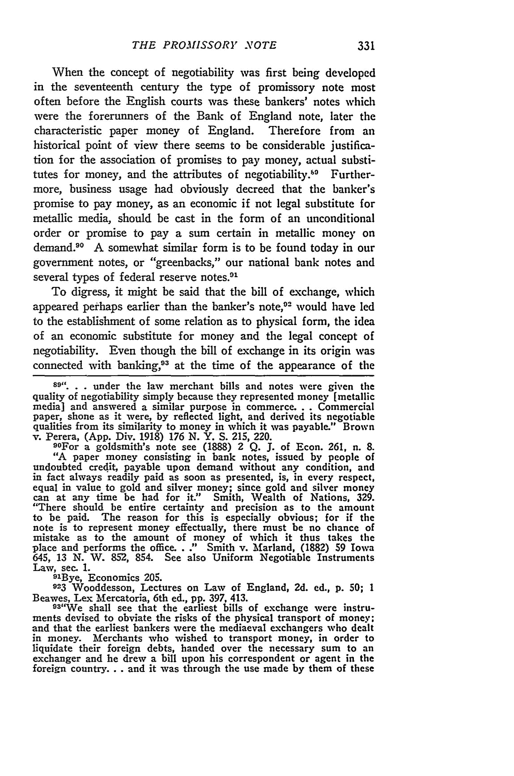
THE PROMISSORY NOTE

When the concept of negotiability was first being developed in the seventeenth century the type of promissory note most often before the English courts was these bankers' notes which were the forerunners of the Bank of England note, later the characteristic paper money of England. Therefore from an historical point of view there seems to be considerable justifica-tion for the association of promises to pay money, actual substi-tutes for money, and the attributes of negotiability.-" Further-more, business usage had obviously decreed that the banker's promise to pay money, as an economic if not legal substitute for metallic media, should be cast in the form of an unconditional order or promise to pay a sum certain in metallic money on demand.⁹⁰ A somewhat similar form is to be found today in our government notes, or "greenbacks," our national bank notes and several types of federal reserve notes.9'

To digress, it might be said that the bill of exchange, which appeared perhaps earlier than the banker's note, ⁰²⁻ would have led to the establishment of some relation as to physical form, the idea of an economic substitute for money and the legal concept of negotiability. Even though the bill of exchange in its origin was connected with banking, ³ at the time of the appearance of the

89". . .under the law merchant bills and notes were given the quality of negotiability simply because they represented money [metallic media] and answered a similar purpose in commerce.. . Commercial

paper, shone as it were, by reflected light, and derived its negotiable qualities from its similarity to money in which it was payable." Brown
v. Perera, (App. Div. 1918) 176 N. Y. S. 215, 220.

⁹⁰For a goldsmith's note see (1888) 2 Q. J. of Econ. 261, n. 8. "A paper money consisting in bank notes, issued by people of undoubted credit, payable upon demand without any condition, and in fact always readily paid as soon as presented, is, in every respect, equal in value to gold and silver money; since gold and silver money can at any time be had for it." Smith, Wealth of Nations, 329. "There should be entire certainty and precision as to the amount to be paid. The reason for this is especially obvious; for if the note is to represent money effectually, there must be no chance of mistake as to the amount of money of which it thus takes the place and performs the office. . ." Smith v. Marland, (1882) 59 Iowa 645, 13 N. W. 852, 854. See also Uniform Negotiable Instruments
Law, sec. 1.
⁹¹Bye, Economics 205.
923 Wooddesson, Lectures on Law of England, 2d. ed., p. 50; 1
Beawes, Lex Mercatoria, 6th ed., pp. 397, 413.
⁹ ³"We shall see that the earliest bills of exchange were instru-

ments devised to obviate the risks of the physical transport of money; and that the earliest bankers were the mediaeval exchangers who dealt

in money. Merchants who wished to transport money, in order to liquidate their foreign debts, handed over the necessary sum to an exchanger and he drew a bill upon his correspondent or agent in the foreign country.., and it was through the use made by them of these
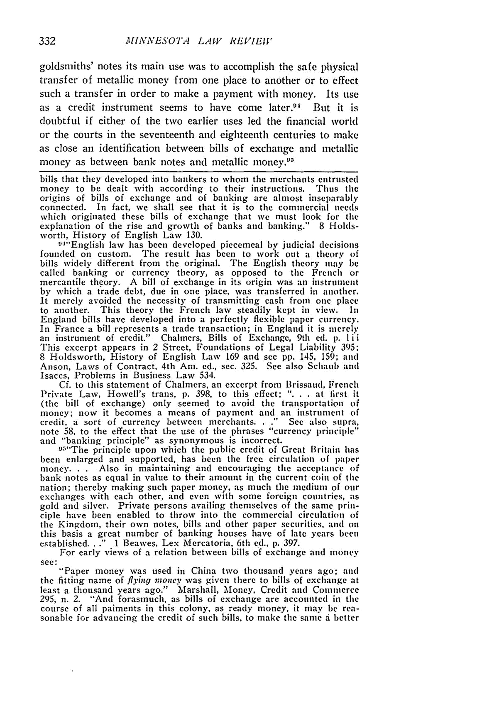
MINNESOTA LAW REVIEW

goldsmiths' notes its main use was to accomplish the safe physical transfer of metallic money from one place to another or to effect

such a transfer in order to make a payment with money. Its use

as a credit instrument seems to have come laterY' But it is doubtful if either of the two earlier uses led the financial worcl

or the courts in the seventeenth and eighteenth centuries to make as close an identification between bills of exchange and metallic money as between bank notes and metallic money.11

bills that they developed into bankers to whom the merchants entrusted money to be dealt with according to their instructions. Thus the origins of bills of exchange and of banking are almost inseparably connected. In fact, we shall see that it is to the commercial needs which originated these bills of exchange that we must look for tile explanation of the rise and growth of banks and banking." 8 Holds-worth, History of English Law 130.

91"English law has been developed piecemeal by judicial decisions founded on custom. The result has been to work out a theory of bills widely different from the original. The English theory may be called banking or currency theory, as opposed to the French or mercantile theory. A bill of exchange in its origin was an instrument by which a trade debt, due in one place, was transferred in another. It merely avoided the necessity of transmitting cash from one place to another. This theory the French law steadily kept in view. In England bills have developed into a perfectly flexible paper currency.
In France a bill represents a trade transaction; in England it is merely an instrument of credit." Chalmers, Bills of Exchange, 9th ed. p. l ii This excerpt appears in 2 Street, Foundations of Legal Liability 395:
8 Holdsworth, History of English Law 169 and see pp. 145, 159; and Anson, Laws of Contract, 4th Am. ed., sec. 325. See also Schaub and Isaccs, Problems in Business Law 534.

Cf. to this statement of Chalmers, an excerpt from Brissaud, French Private Law, Howell's trans, p. 398, to this effect; "... at first it (the bill of exchange) only seemed to avoid the transportation of money; now it becomes a means of payment and an instrument of credit, a sort of currency between merchants. . ." See also supra, note 58, to the effect that the use of the phrases "currency principle" and "banking principle" as synonymous is incorrect.
95"The principle upon which the public credit of Great Britain has
been enlarged and supported, has been the free circulation of paper money. . . Also in maintaining and encouraging the acceptance of
bank notes as equal in value to their amount in the current coin of the nation; thereby making such paper money, as much the medium of our exchanges with each other, and even with some foreign countries, as gold and silver. Private persons availing themselves of the same prin-ciple have been enabled to throw into the commercial circulation of the Kingdom, their own notes, bills and other paper securities, and on this basis a great number of banking houses have of late years been
established. . ." 1 Beawes, Lex Mercatoria. 6th ed.. p. 397.
For early views of a relation between bills of exchange and money

^{see:} "Paper money was used in China two thousand _{years ago; and} the fitting name of flying money was given there to bills of exchange at least a thousand years ago." Marshall, Money, Credit and Commerce 295, n. 2. "And forasmuch, as bills of exchange are accounted in the course of all paiments in this colony, as ready money, it may be rea-sonable for advancing the credit of such bills, to make the same i better
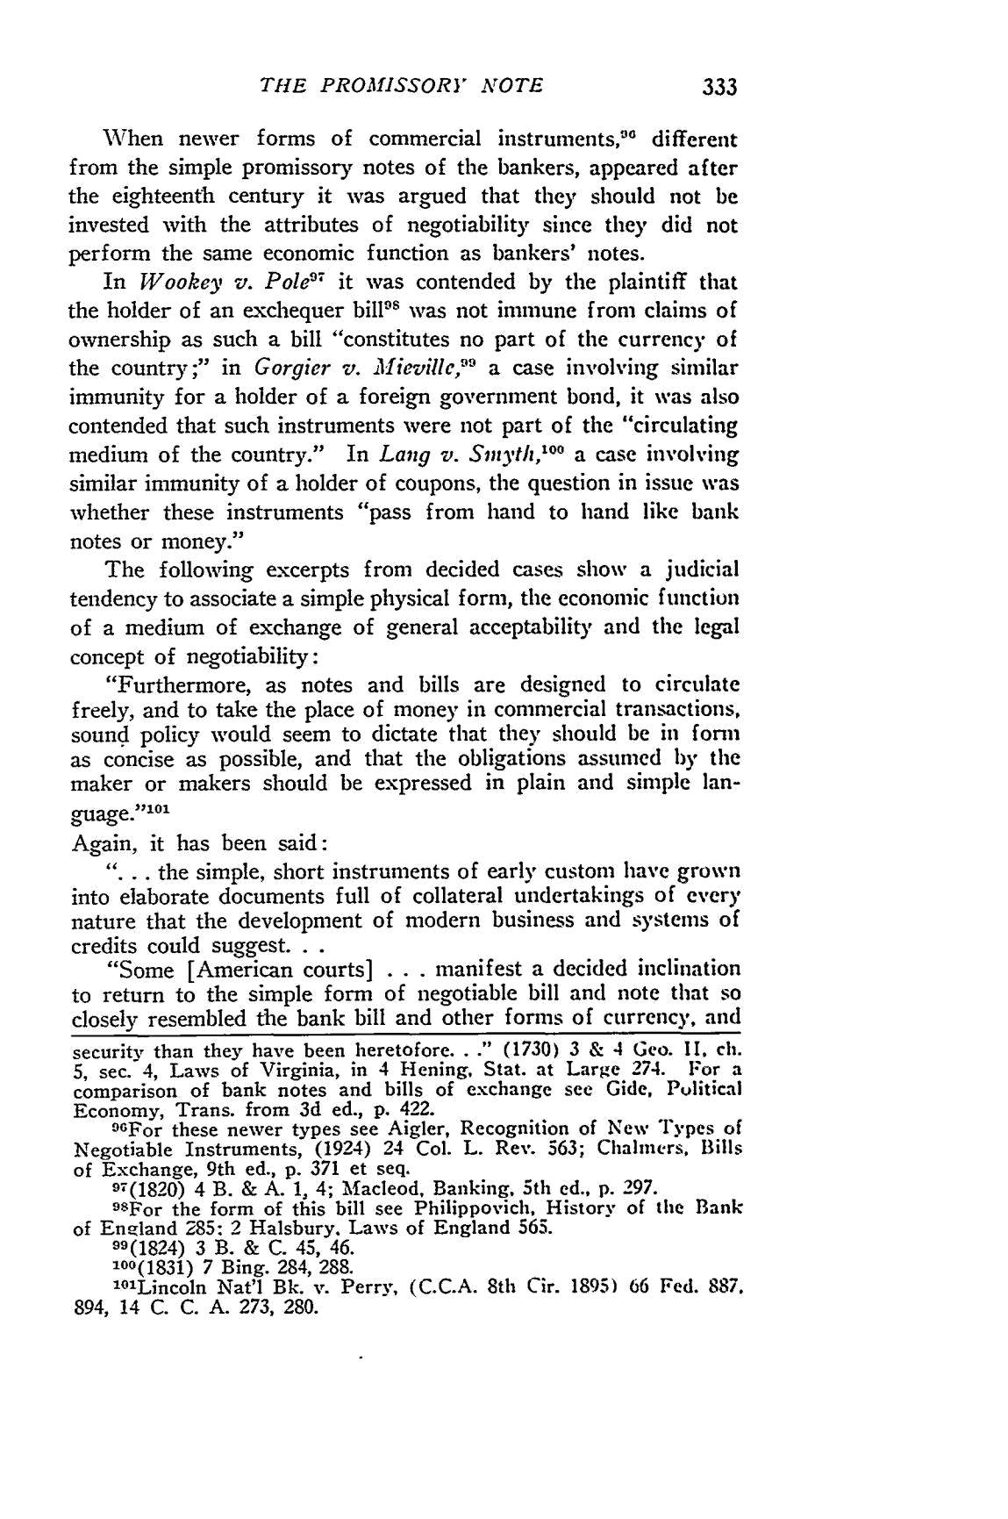
THE PROMISSORY NOTE

When newer forms of commercial instruments, ^{"0} different from the simple promissory notes of the bankers, appeared after the eighteenth century it was argued that they should not be invested with the attributes of negotiability since they did not perform the same economic function as bankers' notes.

7 by the _{plaintiff that} In Wookey v. Pole1 it was contended

the holder of an exchequer bill's was not immune from claims of ownership as such a bill "constitutes no part of the currency of the country;" in Gorgier v. 31 ieville," a case involving similar immunity for a holder of a foreign government bond, it was also contended that such instruments were not part of the "circulating medium of the country." In Lang v. Simyth, ⁰⁰ a case involving similar immunity of a holder of coupons, the question in issue was whether these instruments "pass from hand to hand like batik notes or money."

The following excerpts from decided cases show a judicial tendency to associate a simple physical form, the economic function of a medium of exchange of general acceptability and the legal concept of negotiability:
"Furthermore, as notes and bills are designed to circulate freely, and to take the place of money in commercial transactions, sound policy would seem to dictate that they should be in form as concise as possible, and that the obligations assumed by the maker or makers should be expressed in plain and simple lan-

guage.''

Again, it has been said:

"... the simple, short instruments of early custom have grown into elaborate documents full of collateral undertakings of every nature that the development of modern business and systems of credits could suggest...
"Some [American courts] . . . manifest a decided inclination

to return to the simple form of negotiable bill and note that so closely resembled the bank bill and other forms of currency, and

security than they have been heretofore. . ." (1730) 3 & 4 Geo. II ch. 5, sec. 4, Laws of Virginia, in 4 Hening, Stat. at Large 274. For a comparison of bank notes and bills of exchange see Gide, Political Economy, Trans. from 3d ed., p. 422.

9GFor these newer types see Aigler, Recognition of New Types of Negotiable Instruments, (1924) 24 Col. L. Rev. 563; Chalmers, Bills of Exchange, 9th ed., p. 371 et seq.
97(1820) 4 B. & A. 1, 4; Macleod, Banking. 5th ed., p. 297.
⁹ ⁵For the form of this bill see Philippovich, History of the Bank
of Eneland 285: 2 Halsbury. Laws of England 565.
99(1824) 3 B. & C. 45, 46.
100(1831) 7 Bing. 284, 288.
¹ Lincoln Nat'l Bk. v. Perry, (C.C.A. 8th Cir. 1895) 66 Fed. 887.
894, 14 C. C. A. 273, 280.
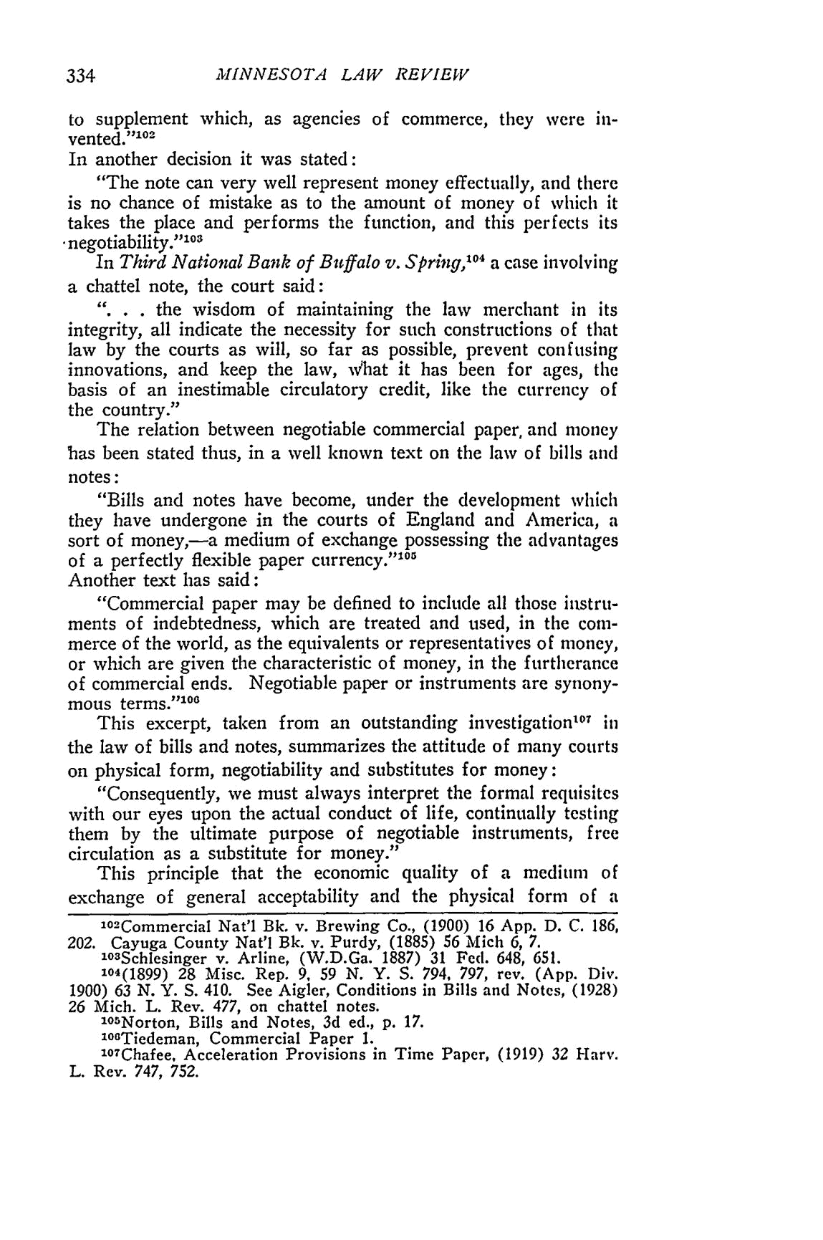
MINNESOTA LAW REVIEW

to supplement which, as agencies of commerce, they were in-
2
vented."
In another decision it was stated:

"The note can very well represent money effectually, and there is no chance of mistake as to the amount of money of which it takes the place and performs the function, and this perfects its •negotiability."1⁰o
⁰ ⁴ a case involving
In Third National Bank of Buffalo v. Spring, a chattel note, the court said:

". .. the wisdom of maintaining the law merchant in its integrity, all indicate the necessity for such constructions of that law by the courts as will, so far as possible, prevent confusing innovations, and keep the law, what it has been for ages, the basis of an inestimable circulatory credit, like the currency of the country."

The relation between negotiable commercial paper, and money has been stated thus, in a well known text on the law of bills and notes:

"Bills and notes have become, under the development which they have undergone in the courts of England and America, a sort of money,-a medium of exchange possessing the advantages of a perfectly flexible paper currency."' ⁰¹
Another text has said:

"Commercial paper may be defined to include all those iistru-ments of indebtedness, which are treated and used, in the com-merce of the world, as the equivalents or representatives of money, or which are given the characteristic of money, in the furtherance of commercial ends. Negotiable paper or instruments are synony-mous terms."'¹⁰

This excerpt, taken from an outstanding investigation""' in the law of bills and notes, summarizes the attitude of many courts on physical form, negotiability and substitutes for money:

"Consequently, we must always interpret the formal requisites with our eyes upon the actual conduct of life, continually testing them by the ultimate purpose of negotiable instruments, free circulation as a substitute for money."

This principle that the economic quality of a medium of exchange of general acceptability and the physical form of a
1⁰ Commercial Nat'l Bk. v. Brewing Co., (1900) 16 App. D. C. 186,

- Cayuga County Nat'l Bk. v. Purdy, (1885) 56 Mich 6, 7. l03Schlesinger v. Arline, (W.D.Ga. 1887) 31 Fed. 648, 651.
104(1899) 28 Misc. Rep. 9. 59 N. Y. S. 794, 797, rev. (App. Div.
1900) 63 N. Y. S. 410. See Aigler, Conditions in Bills and Notes, (1928)
26 Mich. L. Rev. 477, on chattel notes.
1⁰⁵ Norton, Bills and Notes, 3d ed., p. 17.
lOOTiedeman, Commercial Paper 1.

  - Chafee, Acceleration Provisions in Time Paper, (1919) 32 Harv. L. Rev. 747, 752.
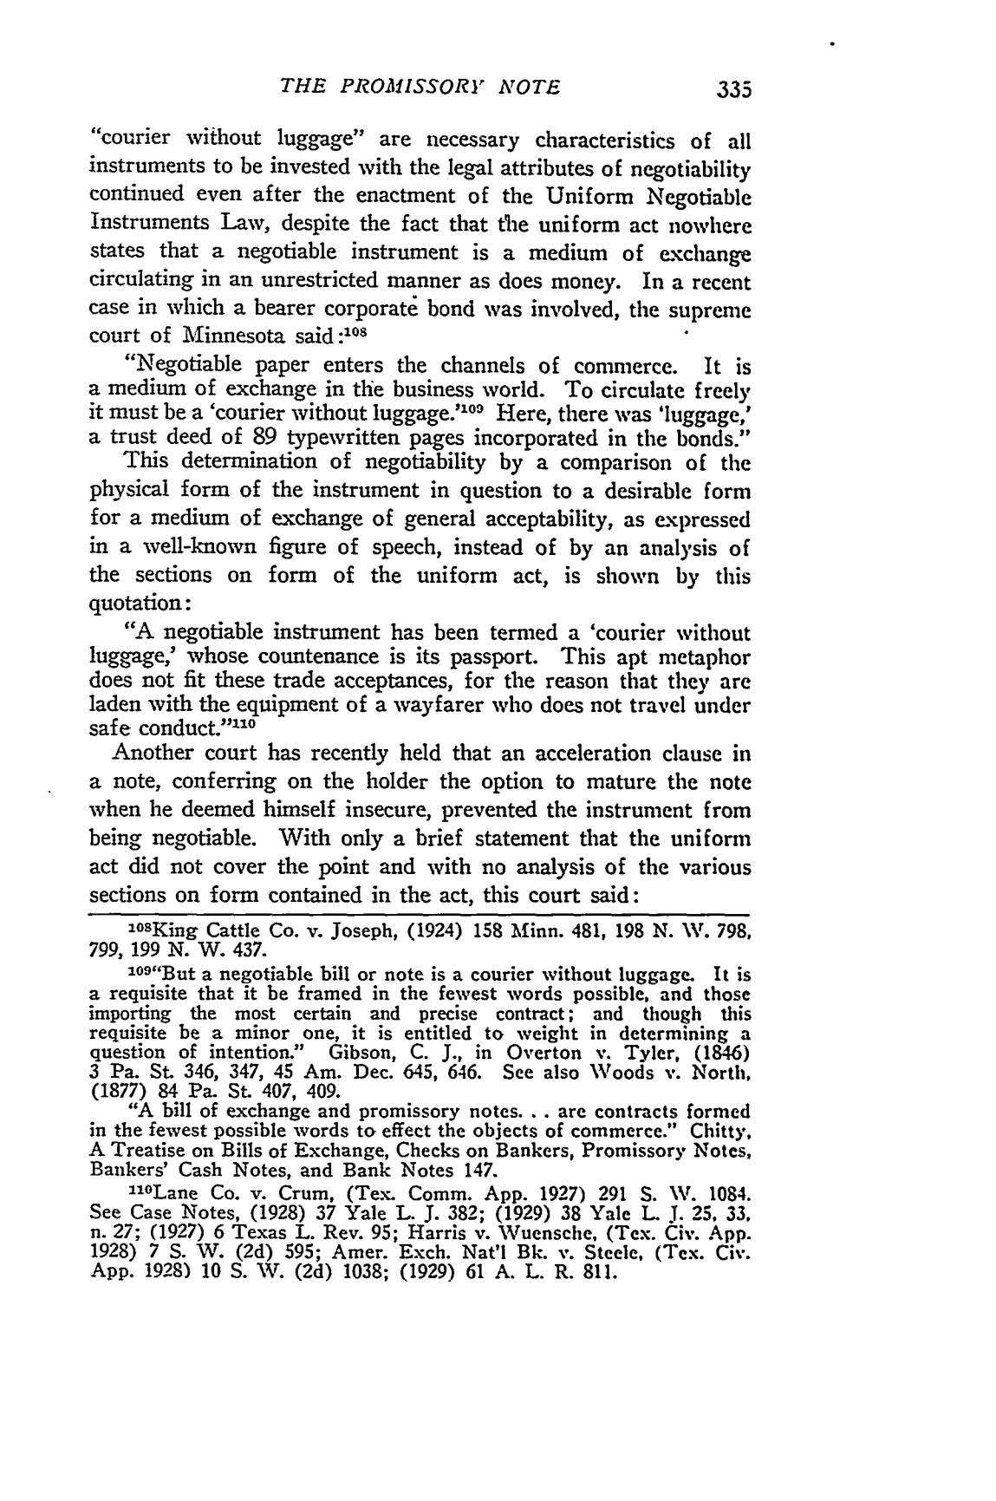
THE PROMISSORY" NOTE

"courier without luggage" are necessary characteristics of all instruments to be invested with the legal attributes of negotiability continued even after the enactment of the Uniform Negotiable Instruments Law, despite the fact that the uniform act nowhere states that a negotiable instrument is a medium of exchange circulating in an unrestricted manner as does money. In a recent case in which a bearer corporate bond was involved, the supreme court of Minnesota said :108

"Negotiable paper enters the channels of commerce. It is a medium of exchange in the business world. To circulate freely it must be a 'courier without luggage."⁰⁰ Here, there was 'luggage,' a trust deed of 89 typewritten pages incorporated in the bonds."

This determination of negotiability by a comparison of the physical form of the instrument in question to a desirable form for a medium of exchange of general acceptability, as expressed in a well-known figure of speech, instead of by an analysis of the sections on form of the uniform act, is shown by this quotation:

"A negotiable instrument has been termed a 'courier without luggage,' whose countenance is its passport. This apt metaphor

does not fit these trade acceptances, for the reason that they are laden with the equipment of a wayfarer who does not travel under
safe conduct." ¹⁰
Another court has recently held that an acceleration clause in a note, conferring on the holder the option to mature the note when he deemed himself insecure, prevented the instrument from being negotiable. With only a brief statement that the uniform act did not cover the point and with no analysis of the various sections on form contained in the act, this court said:
⁰⁸King Cattle Co. v. Joseph, (1924) 158 Minn. 481, 198 N. W. 798,
799, 199 N. W. 437.
9
10 "But a negotiable bill or note is a courier without luggage. It is
a requisite that it be framed in the fewest words possible, and those
importing the most certain and precise contract; and though this
requisite be a minor one, it is entitled to weight in determining a
question of intention." Gibson, C. J., in Overton v. Tyler, (1846) 3 Pa. St. 346, 347, 45 Am. Dec. 645, 646. See also Woods v.North,
(1877) 84 Pa. St. 407, 409.
"A bill of exchange and promissory notes... are contracts formed

in the fewest possible words to effect the objects of commerce." Chitty. A Treatise on Bills of Exchange, Checks on Bankers, Promissory Notes,
Bankers' Cash Notes, and Bank Notes 147.
"°Lane Co. v. Crum, (Tex. Comm. App. 1927) 291 S. W. 1084.
See Case Notes, (1928) 37 Yale L. J.382; (1929) 38 Yale L J. 25, 33.
n. 27; (1927) 6 Texas L. Rev. 95; Harris v. Wuensehe, (Tex. Civ. App.
1928) 7 S. W. (2d) 595; Amer. Exch. Nat'l Bk. v. Steele, (Tex. Civ.
App. 1928) 10 S.AV. (2d) 1038; (1929) 61 A. L. R. 811.
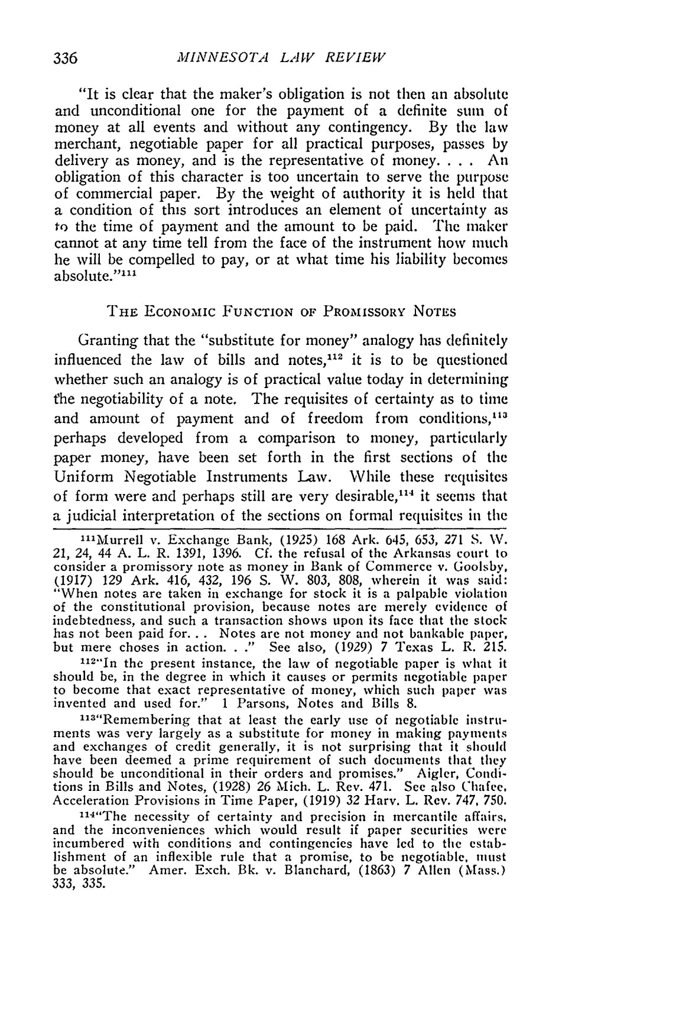
MINNESOTA LAW REVIEW

"It is clear that the maker's obligation is not then an absolute and unconditional one for the payment of a definite sum of money at all events and without any contingency. By the law merchant, negotiable paper for all practical purposes, passes by

delivery as money, and is the representative of money. . . . An

obligation of this character is too uncertain to serve the purpose of commercial paper. By the weight of authority it is held that a condition of this sort introduces an element of uncertainty as to the time of payment and the amount to be paid. The maker cannot at any time tell from the face of the instrument how much he will be compelled to pay, or at what time his liability becomes absolute.""'

THE ECONOMIc FUNCTION OF PROMISSORY NOTS

Granting that the "substitute for money" analogy has definitely influenced the law of bills and notes," ² it is to be questioned whether such an analogy is of practical value today in determining the negotiability of a note. The requisites of certainty as to time and amount of payment and of freedom from conditions, ¹³ perhaps developed from a comparison to money, particularly paper money, have been set forth in the first sections of the Uniform Negotiable Instruments Law. While these requisites of form were and perhaps still are very desirable,"' it seems that a judicial interpretation of the sections on formal requisites in the

"'Murrell v. Exchange Bank, (1925) 168 Ark. 645, 653, 271 S. WN. 21, 24, 44 A. L. R. 1391, 1396. Cf. the refusal of the Arkansas court to
consider a promissory note as money in Bank of Commerce v. Goolsby,
(1917) 129 Ark. 416, 432, 196 S. W. 803, 808, wherein it was said:
"When notes are taken in exchange for stock it is a palpable violation of the constitutional provision, because notes are merely evidence of indebtedness, and such a transaction shows upon its face that the stock has not been paid for... Notes are not money and not bankable paper, but mere choses in action. . ." See also, (1929) 7 Texas L. R. 215.

"12"In the present instance, the law of negotiable paper is what it should be, in the degree in which it causes or permits negotiable paper to become that exact representative of money, which such paper was invented and used for." 1 Parsons, Notes and Bills 8.

"13"Remembering that at least the early use of negotiable instru-

ments was very largely as a substitute for money in making payments and exchanges of credit generally, it is not surprising that it should have been deemed a prime requirement of such documents that they should be unconditional in their orders and promises." Aigler, Condi-tions in Bills and Notes, (1928) 26 Mich. L. Rev. 471. See also Chafee, Acceleration Provisions in Time Paper, (1919) 32 Harv. L. Rev. 747, 750.

"l⁴ "The necessity of certainty and precision in mercantile affairs,
and the inconveniences which would result if paper securities were incumbered with conditions and contingencies have led to the estab-lishment of an inflexible rule that a promise, to be negotiable, mtst be absolute." Amer. Exch. Bk. v. Blanchard, (1863) 7 Allen (Mass.) 333, 335.
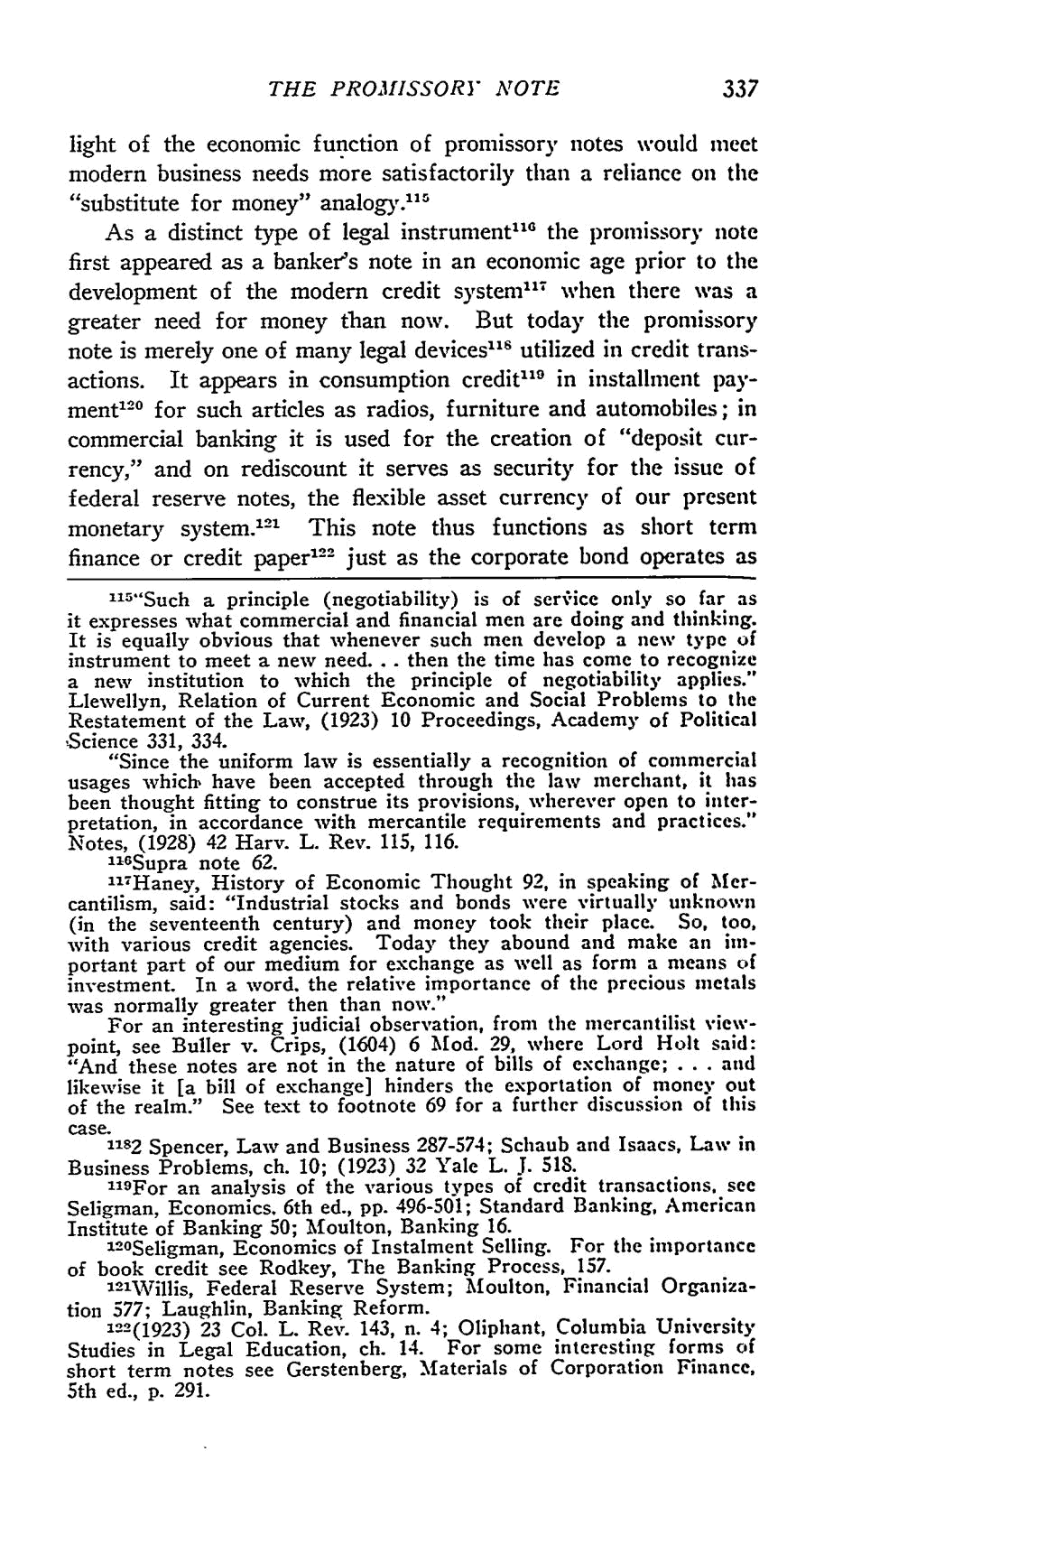
THE PROMISSORY NOTE

light of the economic function of promissory notes would meet

modern business needs more satisfactorily than a reliance on the "substitute for money" _{analogy."'}

As a distinct type of legal instrument" ⁰ the l)romissory note first appeared as a banker's note in an economic age prior to the development of the modem credit system"- when there was a greater need for money than now. But today the promissory note is merely one of many legal devices' utilized in credit trans-actions. It appears in consumption credit' ¹⁹ in installment pay-ment ² ⁰ for such articles as radios, furniture and automobiles; in commercial banking it is used for the creation of "deposit cur-rency," and on rediscount it serves as security for the issue of federal reserve notes, the flexible asset currency of our present monetary system. ¹² ' This note thus functions as short term finance or credit paper ¹²2 just as the corporate bond operates as

"' "Such a principle (negotiability) is of ser, ice only so far as it expresses what commercial and financial men are doing and thinking. It is equally obvious that whenever such men develop a new type of instrument to meet a new need... then the time has come to recognize a new institution to which the principle of negotiability applies." Llewellyn, Relation of Current Economic and Social Problems to the Restatement of the Law, (1923) 10 Proceedings, Academy of Political
,Science 331, 334.
"Since the uniform law is essentially a recognition of commercial

usages which' have been accepted through the law merchant, it has been thought fitting to construe its provisions, wherever open to inter-pretation, in accordance with mercantile requirements and practices." Notes, (1928) 42 Harv. L. Rev. 115, 116.
1i6Supra note 62.
"'7Haney, History of Economic Thought 92, in speaking of Mer-
cantilism, said: "Industrial stocks and bonds were virtually unknown (in the seventeenth century) and money took their place. So. too,

with various credit agencies. Today they abound and make an im-portant part of our medium for exchange as well as form a means of investment. In a word. the relative importance of the precious metals was normally greater then than now."
For an interesting judicial observation, from the mercantilist view-point, see Buller v. Crips, (1604) 6 Mod. 29, where Lord Holt said: "And these notes are not in the nature of bills of exchange; . . . and likewise it [a bill of exchange] hinders the exportation of money out of the realm." See text to footnote 69 for a further discussion of this
case.

1182 Spencer, Law and Business 287-574; Schaub and Isaacs, Law in Business Problems, ch. 10; (1923) 32 Yale L. J. 518.
"1⁹ For an analysis of the various types of credit transactions. see

Seligman, Economics. 6th ed., pp. 496-501; Standard Banking, American Institute of Banking 50; Moulton, Banking 16.
0
12 Seligman, Economics of Instalment Selling. For the importance
of book credit see Rodkey, The Banking Process, 157.
- Willis, Federal Reserve System; Moulton, Financial Organiza-
tion 577; Laughlin, Banking Reform.
122(1923) 23 Col. L. Rev. 143, n. 4; Oliphant, Columbia University
Studies in Legal Education, ch. 14. For some interesting forms of short term notes see Gerstenberg, Materials of Corporation Finance, 5th ed., p. 291.
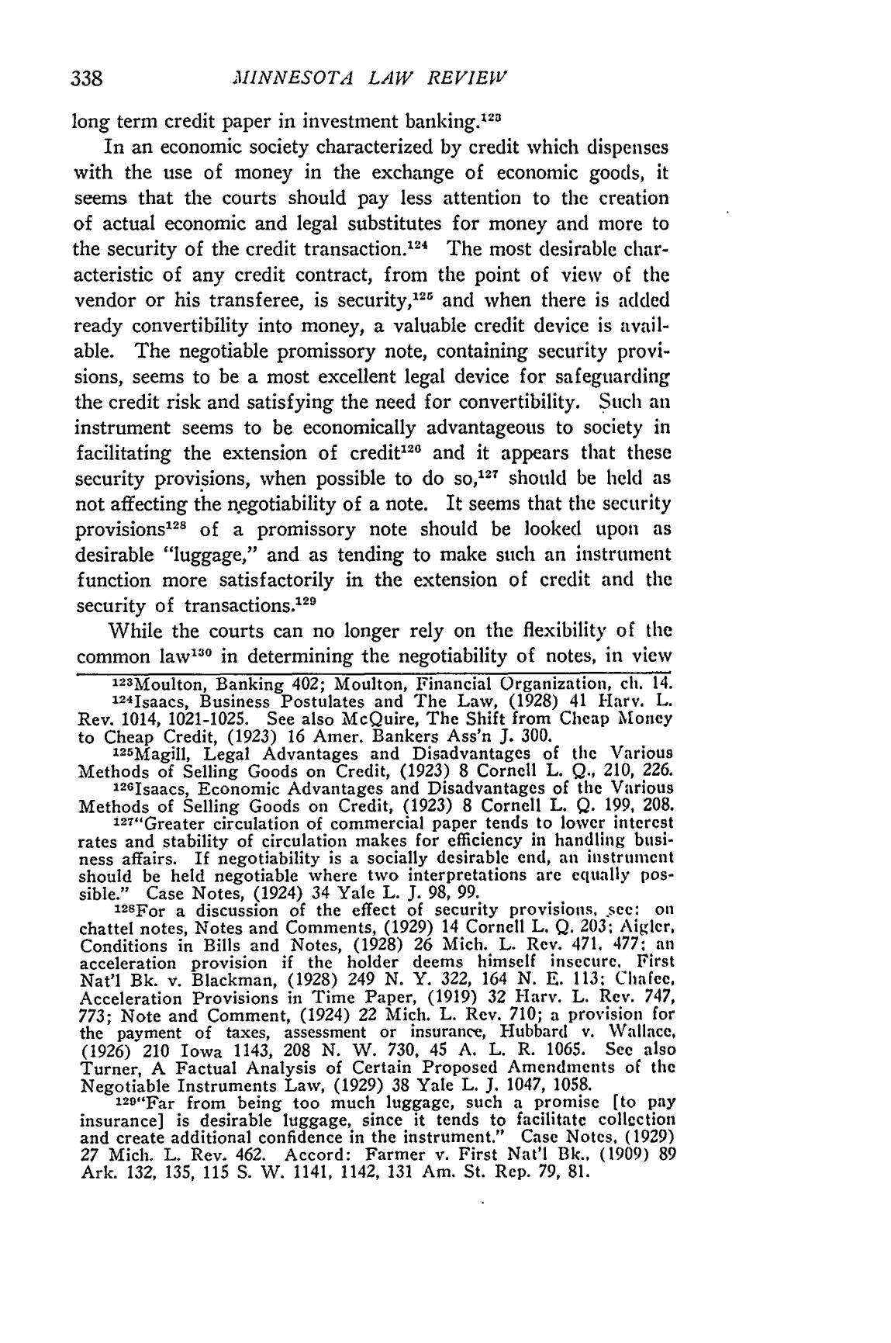
MINNESOTA LAW REVIEW

long term credit paper in investment banking.¹²⁸
In an economic society characterized by credit which dispenses with the use of money in the exchange of economic goods, it seems that the courts should pay less attention to the creation

of actual economic and legal substitutes for money and more to the security of the credit transaction. ¹² ⁴ The most desirable char-acteristic of any credit contract, from the point of view of the vendor or his transferee, is security, ²1 and when there is added ready convertibility into money, a valuable credit device is avail-able. The negotiable promissory note, containing security provi-sions, seems to be a most excellent legal device for safeguarding the credit risk and satisfying the need for convertibility. Such an instrument seems to be economically advantageous to society in facilitating the extension of credit' ²⁶ and it appears that these security provisions, when possible to do so, ¹²⁷ should be held as not affecting the negotiability of a note. It seems that the security

provisions of a promissory note should be looked upon as

desirable "luggage," and as tending to make such an instrument function more satisfactorily in the extension of credit and the security of transactions.'"

While the courts can no longer rely on the flexibility of the common law ¹³⁰ in determining the negotiability of notes, in view

123Moulton, Banking 402; Moulton, Financial Organization, ch. 14.
1241saacs, Business Postulates and The Law, (1928) 41 Harv. L.
Rev. 1014, 1021-1025. See also McQuire, The Shift from Cheap Money
to Cheap Credit, (1923) 16 Amer. Bankers Ass'n J. 300.
"25Magill, Legal Advantages and Disadvantages of the Various

Methods of Selling Goods on Credit, (1923) 8 Cornell L. Q., 210, 226. 12GIsaacs, Economic Advantages and Disadvantages of the Various

Methods of Selling Goods on Credit, (1923) 8 Cornell L. Q. 199, 208. 127"Greater circulation of commercial paper tends to lower interest
rates and stability of circulation makes for efficiency in handling busi-ness affairs. If negotiability is a socially desirable end, an instrument should be held negotiable where two interpretations are equally pos-
sible." Case Notes, (1924) 34 Yale L. J. 98, 99.
l2SFor a discussion of the effect of security provisions, ,sec: on
chattel notes, Notes and Comments, (1929) 14 Cornell L. Q. 203; Aigler, Conditions in Bills and Notes, (1928) 26 Mich. L. Rev. 471. 477; an acceleration provision if the holder deems himself insecure. First Nat'l Bk. v. Blackman, (1928) 249 N. Y. 322, 164 N. E. 113. Chafee, Acceleration Provisions in Time Paper, (1919) 32 Harv. L. Rev. 747, 773; Note and Comment, (1924) 22 Mich. L. Rev. 710; a provision for the payment of taxes, assessment or insurance, Hubbard v. Wallace. (1926) 210 Iowa 1143, 208 N. W. 730, 45 A. L. R. 1065. See also Turner, A Factual Analysis of Certain Proposed Amendments of the
Negotiable Instruments Law, (1929) 38 Yale L. J. 1047, 1058.

129"Far from being too much luggage, such a promise [to pay insurance] is desirable luggage, since it tends to facilitate collection and create additional confidence in the instrument." Case Notes, (1929)

27 Mich. L. Rev. 462. Accord: Farmer v. First Nat'l Bk., (1909) 89 Ark. 132, 135, 115 S. W. 1141, 1142, 131 Am. St. Rep. 79, 81.
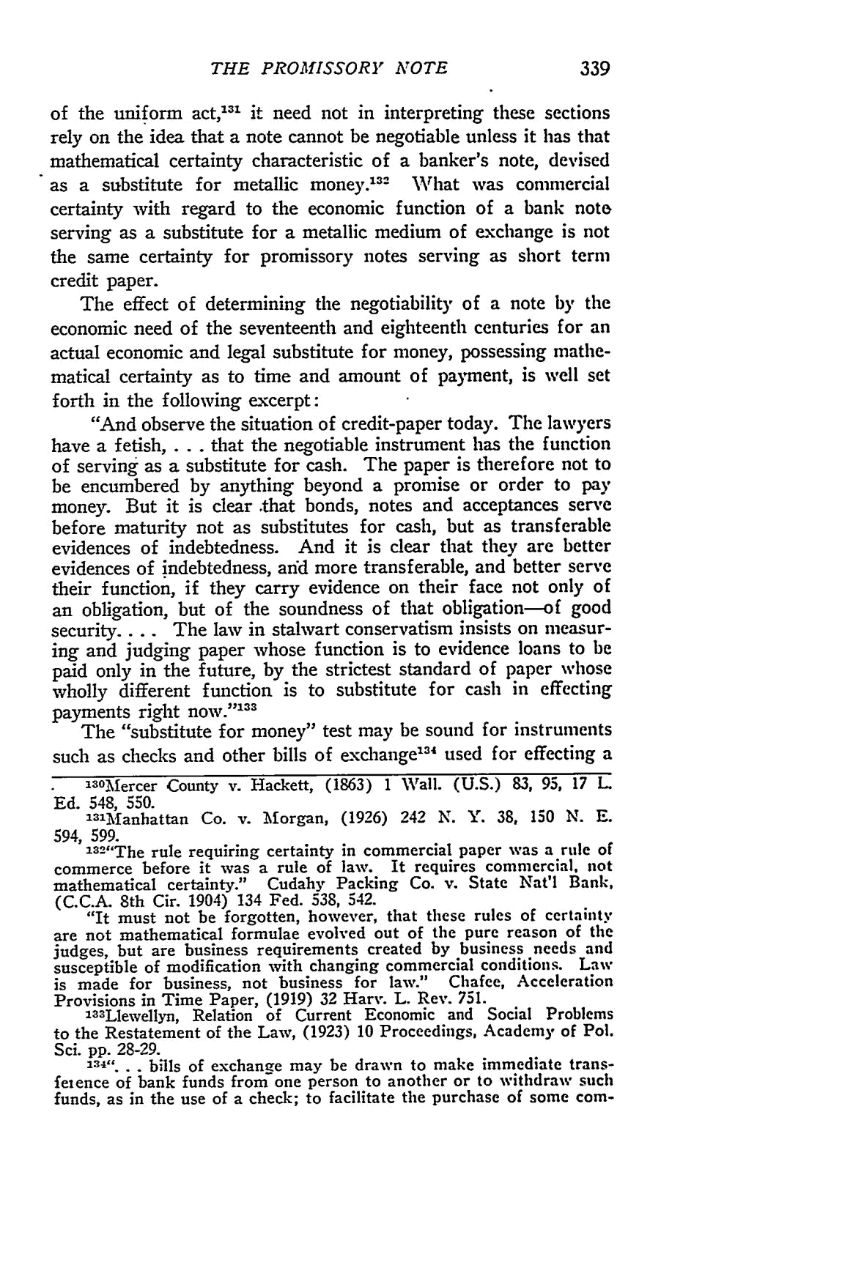
THE PROMISSORY NOTE

of the uniform act,'-" it need not in interpreting these sections rely on the idea that a note cannot be negotiable unless it has that mathematical certainty characteristic of a banker's note, devised as a substitute for metallic money. ³² What was commercial certainty with regard to the economic function of a bank note serving as a substitute for a metallic medium of exchange is not the same certainty for promissory notes serving as short term credit paper.

The effect of determining the negotiability of a note by the economic need of the seventeenth and eighteenth centuries for an actual economic and legal substitute for money, possessing mathe-matical certainty as to time and amount of payment, is well set forth in the following excerpt:

"And observe the situation of credit-paper today. The lawyers

have a fetish,... that the negotiable instrument has the function

of serving as a substitute for cash. The paper is therefore not to be encumbered by anything beyond a promise or order to pay money. But it is clear that bonds, notes and acceptances serve before maturity not as substitutes for cash, but as transferable evidences of indebtedness. And it is clear that they are better evidences of indebtedness, and more transferable, and better serve their function, if they carry evidence on their face not only of an obligation, but of the soundness of that obligation-of good security.... The law in stalwart conservatism insists on measur-

ing and judging paper whose function is to evidence loans to be paid only in the future, by the strictest standard of paper whose wholly different function is to substitute for cash in effecting _{payments} right now.' ³³

The "substitute for money" test may be sound for instruments such as checks and other bills of exchange' ³⁴ used for effecting a
- County v. Hackett, (1863) 1 Wall. (U.S.) 83, 95, 17 L
"3 Mercer
Ed. 548, 550.
3³'Manhattan Co. v. Morgan, (1926) 242 N. Y. 38, 150 N. E.
594, 599.
332"The rule requiring certainty in commercial paper was a rule of

commerce before it was a rule of law. It requires commercial, not mathematical certainty." Cudahy Packing Co. v. State Nat'l Bank, (C.C.A. 8th Cir. 1904) 134 Fed. 538, 542.
"It must not be forgotten, however, that these rules of certainty are not mathematical formulae evolved out of the pure reason of the judges, but are business requirements created by business needs and susceptible of modification with changing commercial conditions. Law is made for business, not business for law." Chafee, Acceleration Provisions in Time Paper, (1919) 32 Harv. L. Rev. 751.

1³³Llewellyn, Relation of Current Economic and Social Problems to the Restatement of the Law, (1923) 10 Proceedings, Academy of Pol.
Sci. pp. 28-29.
134".... bills of exchange may be drawn to make immediate trans-

feience of bank funds from one person to another or to withdraw such funds, as in the use of a check; to facilitate the purchase of some com-
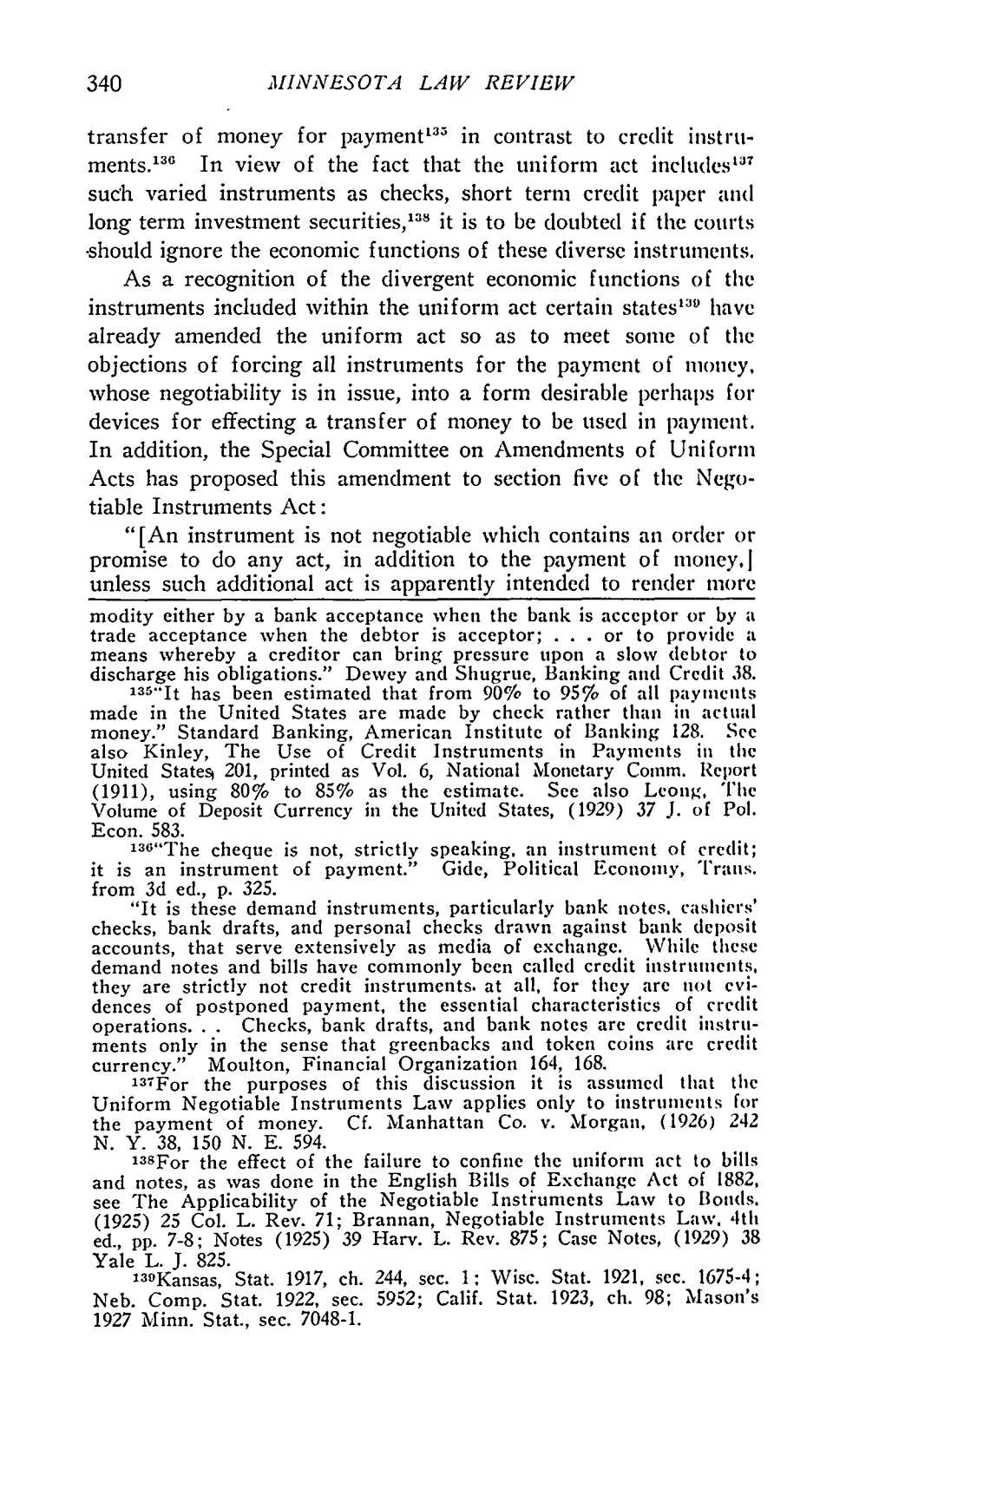
340 MINNESOTA LAW REVIEW

transfer of money for payment"' in contrast to credit instru-ments. ¹³⁶ In view of the fact that the uniform act includes "' ⁷ such varied instruments as checks, short term credit paper and long term investment securities,""^{s} it is to be doubted if the courts -should ignore the economic functions of these diverse instruments.

As a recognition of the divergent economic functions of the instruments included within the uniform act certain states' have already amended the uniform act so as to meet some of the objections of forcing all instruments for the payment of money, whose negotiability is in issue, into a form desirable perhaps for devices for effecting a transfer of money to be used in payment. In addition, the Special Committee on Amendments of Uniform Acts has proposed this amendment to section five of the Nego-tiable Instruments Act:

"[An instrument is not negotiable which contains an order or promise to do any act, in addition to the payment of moneyJ unless such additional act is apparently intended to render more

modity either by a bank acceptance when the bank is acceptor or by a

trade acceptance when the debtor is acceptor; . . . or to provide a means whereby a creditor can bring pressure upon a slow debtor to
discharge his obligations." Dewey and Shugrue, Banking and Credit 38. ¹ ³ "It has been estimated that from 90% to 95% of all payments
made in the United States are made by check rather than in actual money." Standard Banking, American Institute of Banking 128. See
also Kinley, The Use of Credit Instruments in Payments in the United States 201, printed as Vol. 6, National Monetary Comm. Report

(1911), using 80% to 85% as the estimate. See also Leong, The Volume of Deposit Currency in the United States, (1929) 37 J. of Pol.
Econ. 583.
136"The cheque is not, strictly speaking, an instrument of credit; it is an instrument of payment." Gide, Political Economy, Trans. from 3d ed., p. 325.

"It is these demand instruments, particularly bank notes,. cashiers' checks, bank drafts, and personal checks drawn against bank deposit accounts, that serve extensively as media of exchange. While these demand notes and bills have commonly been called credit instrnments, they are strictly not credit instruments, at all, for they are not evi-dences of postponed payment, the essential characteristics of credit operations. . . Checks, bank drafts, and bank notes are credit instru-ments only in the sense that greenbacks and token coins are credit
currency." Moulton, Financial Organization 164, 168.
laTFor the purposes of this discussion it is assumed that the Uniform Negotiable Instruments Law applies only to instruments for the payment of money. Cf. Manhattan Co. v. Morgan, (1926) 242 N. Y. 38, 150 N. E. 594.

iasFor the effect of the failure to confine the uniform act to bills and notes, as was done in the English Bills of Exchange Act of 1882, see The Applicability of the Negotiable Instiuments Law to Bonds. (1925) 25 Col. L. Rev. 71; Brannan, Negotiable Instruments Law. 4th ed., pp. 7-8; Notes (1925) 39 Harv. L. Rev. 875; Case Notes, (1929) 38
Yale L. J. 825.
139Kansas, Stat. 1917, ch. 244, sec. 1: Wisc. Stat. 1921, sec. 1675-4; Neb. Comp. Stat. 1922, sec. 5952; Calif. Stat. 1923, ch. 98; Mason's 1927 Minn. Stat., sec. 7048-1.
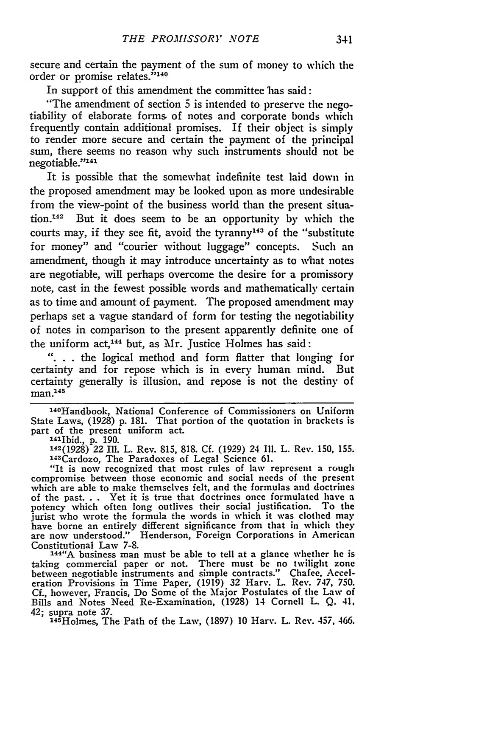
THE PROMISSORY NOTE

secure and certain the payment of the sum of money to which the
order or promise relates.' ^{4 °}
In support of this amendment the committee hias said:

"The amendment of section 5 is intended to preserve the nego-tiability of elaborate forms of notes and corporate bonds which frequently contain additional promises. If their object is simply to render more secure and certain the payment of the principal sum, there seems no reason why such instruments should not be
1 1
negotiable.''

It is possible that the somewhat indefinite test laid down in the proposed amendment may be looked upon as more undesirable from the view-point of the business world than the present situa-

tion.¹ ' But it does seem to be an opportunity by which the
courts may, if they see fit, avoid the tyranny" ³ of the "substitute for money" and "courier without luggage" concepts. Such an amendment, though it may introduce uncertainty as to what notes are negotiable, will perhaps overcome the desire for a promissory note, cast in the fewest possible words and mathematically certain as to time and amount of payment. The proposed amendment may perhaps set a vague standard of form for testing the negotiability of notes in comparison to the present apparently definite one of
4 4
the uniform act,1 but, as Mr. Justice Holmes has said:

". .. the logical method and form flatter that longing for certainty and for repose which is in every human mind. But

certainty generally is illusion, and repose is not the destiny of man. ⁴⁵

1⁴⁰Handbook, National Conference of Commissioners on Uniform
State Laws, (1928) p. 181. That portion of the quotation in brackets is part of the present uniform act.
'4'Ibid., p. 190.
142(1928) 22 Ill. L. Rev. 815, 818. Cf. (1929) 24 11. L. Rev. 150, 155.
143Cardozo, The Paradoxes of Legal Science 61.
"It is now recognized that most rules of law represent a rough compromise between those economic and social needs of the present which are able to make themselves felt, and the formulas and doctrines of the past. . . Yet it is true that doctrines once formulated have a potency which often long outlives their social justification. To the jurist who wrote the formula the words in which it was clothed may have borne an entirely different significance from that in which they are now understood." Henderson, Foreign Corporations in American
Constitutional Law 7-8.
'44"A business man must be able to tell at a glance whether he is

taking commercial paper or not. There must be no twilight zone between negotiable instruments and simple contracts." Chafee. Accel-eration Provisions in Time Paper, (1919) 32 Harv. L. Rev. 747, 750. Cf., however, Francis, Do Some of the Major Postulates of the Law of Bills and Notes Need Re-Examination, (1928) 14 Cornell L. Q. 41,
42; supra note 37.
1⁴⁵ Holmes, The Path of the Law, (1897) 10 Harv. L. Rev. 457, 466.

