
8709 Castle Park Drive

Indianapolis, IN 46256
SUBCONTRACTOR CHANGE ORDER ^{Phone: (317) 872-4181}
Fax: (317) 334-0146

CHANGE ORDER: |  |  |  |  |  | DATE:
 |  | CO No. | Job No. | Cost Code / Cat
TO: |  |  |  | PROJECT:

DESCRIPTION: AMT:
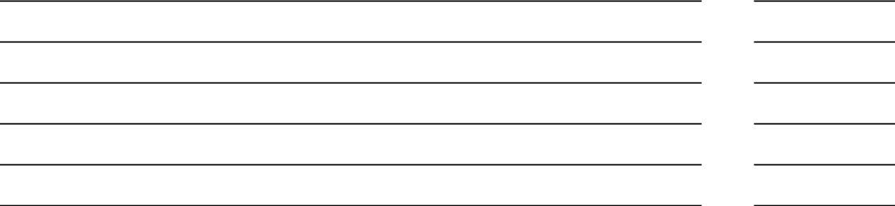

TOTAL CHANGE ORDER AMOUNT:

The Original CONTRACT SUM was:

Net changes by previously approved Change Orders:

CONTRACT SUM prior to this Change Order:

Net Amount of this Change Order is:

The new CONTRACT SUM (including this CHANGE ORDER) is:

The CONTRACT TIME is (increased) (decreased) by:

The Date of Substantial Completion as of this Change Order is:

Days

KORT BUILDERS, INC. |  | SUBNAME
(Signature) |  | (Signature)
(Type or Print Name) |  | (Type or Print Name)
(Title) |  | (Title)
(Date) |  | (Date)

R12/12 X:\2 KBI\Operations\PMOM\Sub Change Order Form.xlsx

