Page 1 of 4

1/2017

NEBRASKA REAL ESTATE COMMISSION SELLER PROPERTY CONDITION DISCLOSURE STATEMENT Residential Real Property

THIS DISCLOSURE STATEMENT IS BEING COMPLETED AND DELIVERED IN ACCORDANCE WITH NEBRASKA LAW. NEBRASKA LAW REQUIRES THE SELLER TO COMPLETE THIS STATEMENT (NEB. REV. STAT. §76-2,120).

How long has the seller owned the property? ______ year(s)

Is seller currently occupying the property? (Circle one) YES | NO If yes, how long has the seller occupied the property? ______ year(s)

If no, has the seller ever occupied the property? (Circle one) YES | NO If yes, when? From ______ (year) to ______ (year)

This disclosure statement concerns the real property located at _________________________________________________________________________
in the city of ________________________________________, County of_____________________________ , State of Nebraska and legally described as:

_____________________________________________________________________________________________________________________________
_____________________________________________________________________________________________________________________________

This statement is a disclosure of the condition of the real property known by the seller on the date on which this statement is signed. This statement is NOT a warranty of any kind by the seller or any agent representing a principal in the transaction, and should NOT be accepted as a substitute for any inspection or warranty that the purchaser may wish to obtain. Even though the information provided in this statement is NOT a warranty, the purchaser may rely on the information contained herein in deciding whether and on what terms to purchase the real property. Any agent representing a principal in the transaction may provide a copy of this statement to any other person in connection with any actual or possible sale of the real property. The information provided in this statement is the representation of the seller and NOT the representation of any agent, and is NOT intended to be part of any contract between the seller and purchaser.

Seller please note: you are required to complete this disclosure statement IN FULL. If any particular item or matter does not apply and there is no

provision or space for indicating, insert “N/A” in the appropriate box. If age of items is unknown, write “UNK” on the blank provided. If the property

has more than one item as listed below please put the numbered in the appropriate box. For example – if the home has three room air conditioners,

one working, one not working, and one not included, put a “1” in each of the “Working”, “Not Working”, and “None/Not Included” boxes for that item, and a “3” on the line provided next to the item description to indicate total number of item. You may also provide additional explanation of any item in the comments section in PART III.

SELLER STATES THAT, TO THE BEST OF THE SELLER’S KNOWLEDGE AS OF THE DATE THIS DISCLOSURE STATEMENT IS COMPLETED AND SIGNED BY THE SELLER, THE CONDITION OF THE REAL PROPERTY IS:

PART I – If there is more than one of any item in this Part, the statement made applies to each and all of such items unless otherwise noted in the Comments section in PART III of this disclosure statement, or number separately as provided in the instructions above. If an item in this Part is not on the property, or will not be included in the sale, check only the “None/Not included” column for that item.

 |  |  |  |  | Do Not | None /
 | Section A -Appliances |  |  | Not | Know If | Not
 |  |  | Working | Working | Working | Included
 | 1. Refrigerator
 | 2. Clothes Dryer
 | 3. Clothes Washer
 | 4. Dishwasher
 | 5. Garbage Disposal
 | 6. Freezer
 | 7. Oven
 | 8. Range
 | 9. Cooktop
 | 10. Microwave oven
 | 11. Built-In vacuum system and equipment
 | 12. Range ventilation systems
 | 13. Gas grill
 | 14. Room air conditioner ( ______ number )
 | 15. TV antenna / Satellite dish
 | 16. Trash compactor

 |  |  |  |  |  |  |  |  | Do Not | None /
 |  | Section B - Electrical Systems |  |  |  |  |  | Not | Know If | Not
 |  |  |  |  |  |  | Working | Working | Working | Included
 |  | 1. Electrical service panel capacity
 |  | ______ AMP Capacity (if known)
 |  | ______ fuse ______ circuit breakers
 |  | 2. Ceiling fan(s) | ( ________ number )
 |  | 3. Garage door opener(s) | ( ________ number )
 |  | 4. Garage door remote(s) | ( ________ number )
 |  | 5. Garage door keypad(s) | ( ________ number )
 |  | 6. Telephone wiring and jacks
 |  | 7. Cable TV wiring and jacks
 |  | 8. Intercom or sound system wiring
 |  | 9. Built-In speakers
 |  | 10. Smoke detectors | ( ________ number )
 |  | 11. Fire alarm
 |  | 12. Carbon Monoxide Alarm | ( _______ number )
 |  | 13. Room ventilation/exhaust fan (_____number )
 |  | 14. 220 volt service
 |  | 15. Security System
 |  | ______ Owned ______ Leased
 |  | ______ Central station monitoring
 |  | 16. Have you experienced any problems with the |  |  |  |  | If YES, explain the condition in the
 |  | electrical system or its components? |  |  |  |  | comments section in PART III of this
 |  | ______ YES ______ NO |  |  |  |  |  | disclosure statement.

Seller’s Initials ____/____ Property Address _____________________________________ Buyer’s Initials____/____

 | Section C - Heating and Cooling Systems |  |  |  |  |  |  |  | Do Not | None /
 |  |  |  |  |  |  |  | Not | Know If | Not
 |  |  |  |  |  |  | Working | Working | Working | Included
 | 1. | Air purifier
 | 2. | Attic fan
 | 3. Whole house fan
 | 4. | Central air conditioning
 |  | ______ year installed (if known)
 | 5. Heating system
 |  | ______ year installed (if known)
 |  | ______ Gas | ______ Electric
 |  | ______ Other (specify _______________ )
 | 6. | Fireplace / Fireplace Insert
 | 7. | Gas log (fireplace)
 | 8. | Gas starter (fireplace)
 | 9. Heat pump
 |  | ______ year installed (if known)
 | 10. Humidifier
 | 11. Propane Tank
 |  | ______ year installed (if known)
 |  | ______ Rent | ______ Own
 | 12. Wood-burning stove
 |  | ______ year installed (if known)
Page 2 of 4

1/2017

 | Section D - Water Systems |  |  |  |  |  | Do Not | None /
 |  |  |  |  |  | Not | Know If | Not
 |  |  |  |  | Working | Working | Working | Included
 | 1. Hot tub / whirlpool
 | 2. Plumbing (water supply)
 | 3. Swimming pool
 | 4. a. Underground sprinkler system
 | b. Back-flow prevention system
 | 5. Water heater | ______ year installed (if known)
 | 6. Water purifier | ______ year installed (if known)
 | 7. Water softener ______ Rent ______ Own
 | 8. Well system
 | Section E - Sewer Systems |  |  |  |  |  | Do Not | None /
 |  |  |  |  |  | Not | Know If | Not
 |  |  |  |  | Working | Working | Working | Included


- Plumbing (water drainage)

- Sump pump (discharges to ______________ )

- Septic System

PART II - In Sections A, B, C, and D if the answer to any item is “YES”, explain the condition in the comments Section in PART III of this disclosure statement.

Section A. Structural Conditions - If there is more than one of any item listed in this Section, the statement made applies to each and all of such items unless otherwise noted in the comment section in PART III of this disclosure statement.

 | Section A - Structural Conditions |  |  |  | Do Not
 |  |  | YES | NO | Know
 | 1. Age of roof (if known) _______ year(s) |  | N / A | N / A
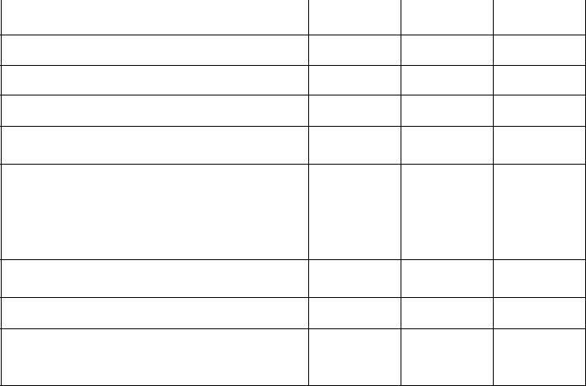

- Does the roof leak?

- Has the roof leaked?

- Is there presently damage to the roof?

- Has there been water intrusion in the basement or crawl space?

- Has there been any damage to the real property or any of the structures thereon due to the following occurrences including, but not limited to, wind, hail, fire, flood, wood-destroying insects, or rodents?

- Are there any structural problems with the structures on the real property?

- Is there presently damage to the chimney?

- Are there any windows which presently leak, or do any insulated windows have any broken seals?

 | Section A - Structural Conditions |  |  |  | Do Not
 |  |  | YES | NO | Know
 | 10. Year property was built _________ (if known) |  | N / A | N / A
 | 11. Has the property experienced any moving or |  | ------ | ------ | ------
 | settling of the following: |  | ------ | ------ | ------
 | - Foundation
 | - Floor
 | - Wall
 | - Sidewalk
 | - Patio
 | - Driveway
 | - Retaining wall
 | 12. Any room additions or structural changes?

Section B. Environmental Conditions - Have any of the following substances, materials, or products been on the real property? If tests have been conducted for any of the following, provide a copy of all test results, if available.

 | Section B - Environmental Conditions |  |  |  | Do Not
 | Section B - Environmental Conditions |  | YES | NO | Know
 | 1. Asbestos
 | 2. Contaminated soil or water
 | (including drinking water)
 | 3. Landfill or buried materials
 | 4. Lead-based paint
 | 5. Radon gas
 | 6. Toxic materials

 | Section B - Environmental Conditions |  |  |  | Do Not
 | Section B - Environmental Conditions |  | YES | NO | Know


- Underground fuel, chemical or other type of storage tank?

- Have you been notified by the Noxious Weed Control Authority in the last 3 years of the presence of noxious weeds, as defined by Nebraska law (N.A.C. Title 25, Ch. 10), on the property?

- Hazardous substances, materials or products identified by the Environmental Protection Agency or its authorized Nebraska Designee (excluding ordinary household cleaners)

Seller’s Initials ____/____ Property Address _____________________________________ Buyer’s Initials____/____

Page 3 of 4

1/2017

Section C. Title Conditions - Do any of the following conditions exist with regard to the real property?
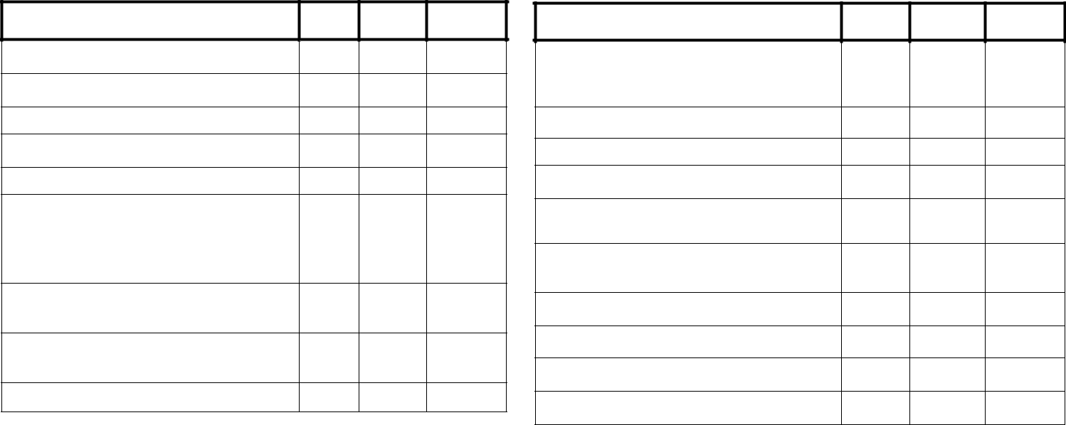

Section C - Title Conditions

YES

NO

Do Not

Know

Section C - Title Conditions

YES

NO

Do Not
Know

- Any features, such as walls, fences and driveways which are shared?

- Any easements, other than normal utility easements?

- Any encroachments?

- Any zoning violations, non-conforming uses, or violations of “setback” requirements?

- Any lot-line disputes?

- Have you been notified, or are you aware of, any work planned or to be performed by a utility or municipality close to the real property including, but not limited to sidewalks, streets, sewers, water, power, or gas lines?

- Any planned road or street expansions, improvements, or widening adjacent to the real property?

- Any condominium, homeowners’, or other type of association which has any authority over the real property?

- Any private transfer fee obligation upon sale?

- Does ownership of the property entitle the owner to use any “common area” facilities such as pools, tennis courts, walkways, or other common use areas?

- Is there a common wall or walls? b. Is there a party wall agreement?

- Any lawsuits regarding this property during the ownership of the seller?

- Any notices from any governmental or quasi-governmental agency affecting the real property?

- Any unpaid bills or claims of others for labor and/or materials furnished to or for the real property?

- Any deed restrictions or other restrictions of record affecting the real property?

- Any unsatisfied judgments against the seller?

- Any dispute regarding a right of access to the real property?

- Any other title conditions which might affect the real property?

Section D. Other Conditions - Do any of the following conditions exist with regard to the real property?

 | Section D - Other Conditions |  |  |  | Do Not
 |  |  | YES | NO | Know
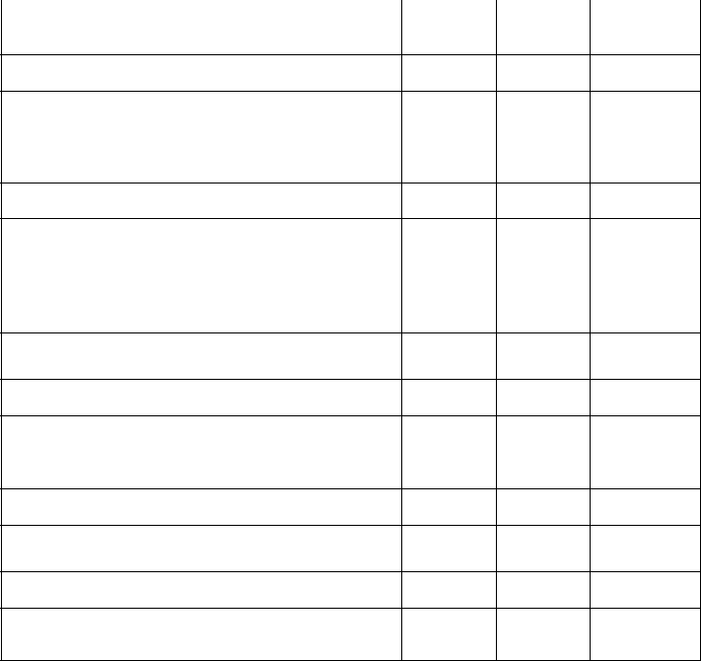

- a. Are the dwelling(s) and the improvements connected to a public water system?

    - Is the system operational?

- a. Are the dwelling(s) and the improvements connected to a private, community (non-public), or Sanitary Improvement District (SID) water system?

b. Is the system operational?

- If the dwelling(s) and the improvements are connected to a private, community (non-public) or SID water system is there adequate water supply for regular household use (i.e. showers, laundry, etc.)?

- a. Are the dwelling(s) and the improvements connected to a public sewer system?

    - Is the system operational?

- a. Are the dwelling(s) and the improvements connected to a community (non-public) or SID sewer system?

    - Is the system operational?

- a. Are the dwelling(s) and the improvements connected to a septic system?

b. Is the system operational?

- Has the main sewer line from the house ever backed up or exhibited slow drainage?

 | Section D - Other Conditions |  |  |  | Do Not
 |  |  | YES | NO | Know
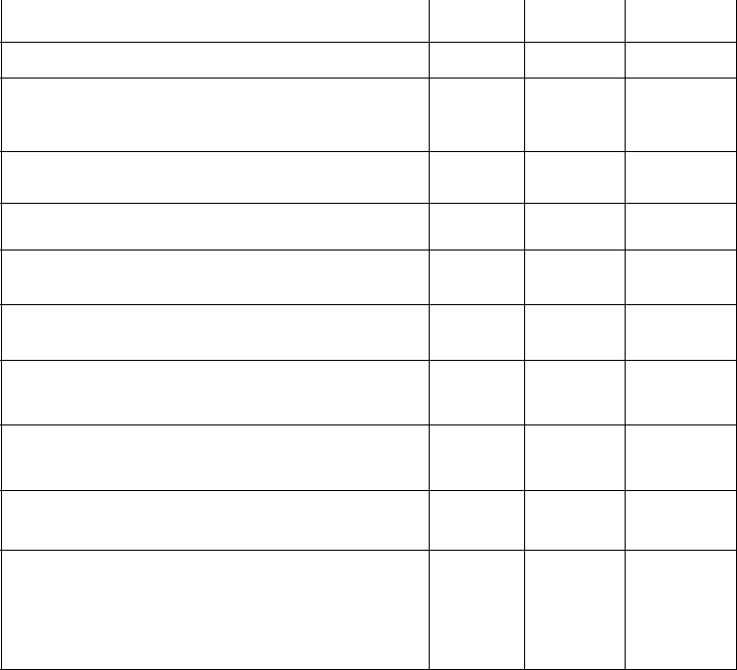

- a. Is the real property in a flood plain? b. Is the real property in a floodway?

- Is trash removal service provided to the real property? If so, are the trash services

______ public ______ private

- Have the structures been mitigated for radon? If yes, when? _____/_____/__________

- Is the property connected to a natural gas system?

- Has a pet lived on the property?
Type(s) ___________________________________

- Are there any diseased or dead trees, or shrubs on the real property?

- Are there any flooding, drainage, or grading problems in connection to the real property?

- a. Have you made any insurance or manufacturer claims with regard to the real property?

  - Were all repairs related to the above claims completed?

- Are you aware of any problem with the exterior wall-covering of the structure including, but not limited to, siding, synthetic stucco, masonry, or other materials?

Section E. Cleaning / Servicing Conditions - Have you ever performed or had performed the following? (State most recent year performed)

 | Section E – Cleaning / Servicing |  |  |  |  |  |  | None /
 | Conditions |  |  |  |  |  | Do Not | Not
 |  |  |  | YEAR | YES | NO | Know | Included


- Servicing of air conditioner

- Cleaning of fireplace, including chimney

- Servicing of furnace

- Professional inspection of furnace A/C (HVAC) System

- Servicing of septic system

 | Section E - Cleaning / Servicing Conditions |  |  |  |  |  | None /
 | Section E - Cleaning / Servicing Conditions |  |  |  |  | Do Not | Not
 |  |  | YEAR | YES | NO | Know | Included
 | 6. Cleaning of wood-burning stove, including
 | chimney
 | 7. Treatment for wood-destroying insects or
 | rodents
 | 8. Tested well water
 | 9. Serviced / treated well water

Seller’s Initials ____/____ Property Address _____________________________________ Buyer’s Initials____/____

PART III – Comments. Please reference comments on items responded to above in PART I or II, with Section letter and item number.

Note: Use additional pages if necessary.

______________________________________________________________________________________
______________________________________________________________________________________
______________________________________________________________________________________
______________________________________________________________________________________

______________________________________________________________________________________
______________________________________________________________________________________
______________________________________________________________________________________
______________________________________________________________________________________

______________________________________________________________________________________
______________________________________________________________________________________
______________________________________________________________________________________
______________________________________________________________________________________

______________________________________________________________________________________
______________________________________________________________________________________
______________________________________________________________________________________
______________________________________________________________________________________

______________________________________________________________________________________
______________________________________________________________________________________
______________________________________________________________________________________
______________________________________________________________________________________

______________________________________________________________________________________
______________________________________________________________________________________

If checked here ______ PART III is continued on a separate page(s)

SELLER’S CERTIFICATION

Seller hereby certifies that this disclosure statement, which consists of _____ pages (including additional comment pages), has been completed by Seller;

that Seller has completed this disclosure statement to the best of Seller’s belief and knowledge as the date hereof, which is the date this disclosure statement is completed and signed by the Seller.

Seller’s Signature __________________________________________________________________________________

Date ____________________

Seller’s Signature __________________________________________________________________________________

Date ____________________

ACKNOWLEDGEMENT OF RECEIPT OF DISCLOSURE STATEMENT, UNDERSTANDING AND CERTIFICATION

I/We acknowledge receipt of a photocopy of the above Seller Property Condition Disclosure Statement; understand that such disclosure statement is NOT a warranty of any kind by the seller or any agent representing any principal in the transaction; understand that such disclosure statement should not be accepted as a substitute for any inspection or warranty that I/we may wish to obtain; understand the information provided in this disclosure statement is the representation of the seller and not the representation of any agent, and is not intended to be part of any contract between the seller and purchaser; and certify that disclosure statement was delivered to me/us or my/our agent on or before the effective date of any contract entered into by me/us relating to the real property described in such disclosure statement.

Purchaser’s Signature _______________________________________________________________________________

Date ____________________

Purchaser’s Signature _______________________________________________________________________________

Date ____________________

