Condition Survey Report

Relating to:

EMD Cinema

186 Hoe Street

Walthamstow

London E17

Issue Date: 9 May 2003
PROPERTY: 186 Hoe Street, Walthamstow, London, E17 Watts and Partners

Project Preface

Client Name: | UCKG Help Centre
Client Address: | 232 Seven Sisters Road
 | Finsbury Park
 | London N4 3NX
Supervising Partner: | Angus Taylor BSc (Hons) MSc FRICS FBEng
 | MAPM
Prepared at: | 11 Haymarket
 | London
 | SW1Y 4BP
Document Prepared by: | Angus Taylor, Robert Burke BSc (Hons) MRICS,
 | Andrew Tee BSc (Hons) CEng MICE MIStructE
Job Reference: | AWT/AT/RB/TR/46517
Reviewed by: | Angus Taylor

JOB REF: | AWT/AT/RB/TR/46517 | i
CLIENT: | UCKG Help Centre

PROPERTY: 186 Hoe Street, Walthamstow, London, E17 Watts and Partners
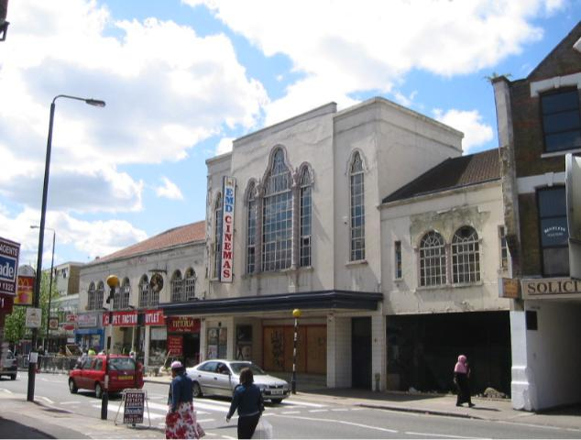

Identification Photograph

View of EMD Cinema from the opposite side of Hoe Street at its junction

with Ciaro Road.

JOB REF: AWT/AT/RB/TR/46517 ^{ii}
PROPERTY: 186 Hoe Street, Walthamstow, London, E17 Watts and Partners

Summary and Conclusions

Summary of Report

This Grade II* listed cinema building contains a large amount of its original and internal fabric, although has been altered from its original single auditorium to now provide three screens.

It is constructed from materials typical for the period, and we have highlighted in our report that extensive repairs are now required to both the internal and external fabric, together with complete replacement of the service installations.

Once the external repairs are completed, there will be an ongoing need for a relatively high degree of maintenance, particularly to all of the external painted joinery and metalwork and the brickwork of the elevations. All of the roof coverings and associated details need to be replaced, and when this is carried out this should reduce some of the maintenance load.

The principal external fabric defects are as follows:

- All of the main roof slopes, subsidiary roofs and all associated details need to be replaced.

- Extensive repairs are required to the parapet brick details, high-level elevations, rainwater outlets and rainwater disposal goods.

- Additional masonry repairs are now required to various cracks, together with monitoring for ongoing movement.

- Extensive repairs are required to the steel frame embedded in the external elevations that will require removal of the present casings, treatment of the steel and reinstatement.

- Extensive repairs are required to the front elevation in terms of its parapet details, render and decoration.

- All external decorations to other elements are now well overdue and many associated repairs will now be required as a result.

- Other external repairs relate to the entrance steps, canopy, external hard standing areas, signage and the front entrance doors.

We have also identified a large quantity of works in relation to various statutory compliance matters, which include:

- Works to access ladders, handrails, hoops, roof access, void access, signage, lighting and additional protection.

- Additional toilet provision is required, together with disabled facilities.

JOB REF: AWT/AT/RB/TR/46517 ^{iii}
PROPERTY: 186 Hoe Street, Walthamstow, London, E17 Watts and Partners

- The fire related items include installation of alarms, detection, fire-fighting equipment, improvements on the means of escape and the associated doorsets, provision of emergency lighting, signage and various structural protection and fire separation issues.

- With regard to DDA matters, improvements are required in the provision of disabled access, provision of disabled WCs, disabled refuge relating to fire, provision of induction loops and other facilities.

In relation to the main internal fabric, this generally requires an extensive refurbishment to include complete redecoration and replacement of all finishes, replacement of all ancillary facilities, including offices, back of house facilities, toilet and catering provisions.

We have carried out an asbestos survey and identified a number of areas where there is extensive asbestos materials that needs to be removed, details of which are given in the section 5 of the report. The costs related to this removal total approximately £100,000.00.

The mechanical and electrical services inspection has concluded that not only are the entire installations of both mechanical and electrical equipment and services beyond their useful life, but also require considerable enhancement in order to comply with modern regulations. The budget costings therefore reflect this. The detailed report is in section 6.

In Section 7 of this report, we identify repair, maintenance and health and safety work required to the structure and fabric of the property at a total approximate cost of £1.1m excluding, amongst other things, VAT, fees and other factors. Similarly the cost of repair, maintenance and health and safety work required to the property’s mechanical and electrical services totals approximately £2.4m, excluding again (amongst other things) VAT, fees and other factors.

Bearing all of the above costs in mind, we have therefore concluded that the works required to bring the cinema back into use in its present three-screen configuration are in the order of £3.5m to which will need to be added professional and statutory fees and VAT.

JOB REF: AWT/AT/RB/TR/46517 ^{iv}
PROPERTY: 186 Hoe Street, Walthamstow, London, E17 Watts and Partners

Table of Contents

Project Preface |  |  | i
Identification Photograph |  |  | ii
Summary and Conclusions |  |  | iii
1 | Introduction |  | 1
2 | Statutory Requirements |  | 2
 | 2.1 | Building Regulations | 2
 | 2.2 | Planning Permission | 2
 | 2.3 | Listed Building Consent | 2
 | 2.4 | Workplace Safety Legislation | 2
 | 2.5 | Fire Precautions and Means of Escape | 5
 | 2.6 | Disability Discrimination Legislation | 6
3 | External Description and Condition of the Fabric |  | 8
 | 3.1 | Roofs | 8
 | 3.2 | Parapets, chimneys and Projections | 9
 | 3.3 | Rainwater Goods | 9
 | 3.4 | External Elevations | 9
 | 3.5 | Front Elevation | 10
 | 3.6 | Windows | 10
 | 3.7 | External Doors | 11
 | 3.8 | External Decorations | 11
 | 3.9 | Boundary and External Areas | 11
4 | Internal Description and Condition of the Fabric |  | 13
 | 4.1 | Description and Layout Internally | 13
 | 4.2 | Structure | 13
 | 4.3 | Roof Voids | 13
 | 4.4 | Ceilings | 14
 | 4.5 | Walls and Partitions | 15
 | 4.6 | Floors | 16
 | 4.7 | Doors and Joinery | 17
 | 4.8 | WCs | 17
 | 4.9 | Stairs | 17
5 | Asbestos |  | 19
6 | Mechanical & Electrical Services |  | 20
7 | Approximate Costings |  | 21

JOB REF: AWT/AT/RB/TR/46517
PROPERTY: 186 Hoe Street, Walthamstow, London, E17 Watts and Partners

Table of Contents

 | 7.1 Repair, Redecoration and Health and Safety Works |  | 22
 | Photographs |  | P/P 1 – P/P 12
Appendices

JOB REF: AWT/AT/RB/TR/46517
PROPERTY: 186 Hoe Street, Walthamstow, London, E17 Watts and Partners

1 Introduction

We were instructed by Mr Paul Hill of UCKG Help Centre to carry out an inspection and prepare a report on the form of construction and condition, including both the fabric and M&E service installations of this Grade II* listed property.

These instructions were confirmed in our letter of 3rd April 2003.

We understand from the listing that the cinema was constructed in 1929 to 1930 as the Granada for Sidney Bernstein. The original cinema has been subsequently sub-divided and is now laid out to provide three cinema screens. At ground floor on the southern side and extending to first floor across the front of the property, two shop units and a public house have been created. These are held under a separate leasehold interest, and we have therefore assumed for the purposes of this report that these interior areas are not included in the remedial plan. However, we have included the main external façade on Hoe Street, as this forms an important part of the listed building.

The building was inspected on the 6th and 7 ^{th} of May by Angus Taylor, Robert Burke and Andrew Tee of our Haymarket office. The mechanical and electrical installations were inspected by Patrick Inns and Graham Crisp of GW Building Services Consulting Engineers.

Angus has extensive experience in both inspecting and reporting upon the condition of listed buildings over the last 14 years, and during that time has also been extensively involved in specifying, designing, procuring and managing a wide variety of restoration and refurbishment works to listed buildings. He is a partner in the firm, and is a fellow of both The Royal Institution of Chartered Surveyors and The Association of Building Engineers.

For this inspection he was assisted by Robert Burke, an associate within the firm, who has been a chartered building surveyor for six and a half years. The third member of the team, Andrew Tee, is the Director in charge of the Building Engineering Technology Department, qualified as both a Civil and Structural Engineer, with over twenty five years of experience. Andrew has provided not only structural engineering input on this inspection, but is also a specialist in the inspection and analysis of asbestos.

The report begins with a commentary on the statutory regulation environment, in which this building will need to operate, covering issues such as fire regulations and means of escape, health and safety, and disabled access. The main body of the report then provides a description and condition of the building fabric, a particular section dealing with the asbestos issues and a report upon the mechanical and electrical services installations.

Section 7 provides a schedule of all the approximate costings, covering not only the building fabric and asbestos, but also drawing out the costs provided by the mechanical and electrical engineers.

Lastly at the rear we have provided some photographs.

JOB REF: AWT/AT/RB/TR/46517

Page 1

CLIENT:

UCKG Help Centre

PROPERTY: 186 Hoe Street, Walthamstow, London, E17 Watts and Partners

2 Statutory Requirements

2.1 Building Regulations

The building will not satisfy a variety of contemporary standards of construction and performance criteria set out in the current building regulations such as, for example, thermal installation. This statement is true for the vast majority of buildings in the UK.

The statute under which the building regulations are made is the Building Act 1984. Neither this act, nor the regulations themselves are applicable retrospectively. This avoids the need for constant improvement of properties to satisfy current standards.

However, any alteration works that would be carried out to bring the building back into use, or to change the present layout, would be required to fully comply with present regulations.

2.2 Planning Permission

We are aware that you are presently undergoing an appeal process with regard to the planning application you have submitted for change of use. We have purposely not considered this as part of this report. We have assumed that the building is to be put back into good repair for use by an occupier as a cinema, presently divided into three screens.

2.3 Listed Building Consent

The property is Grade II* listed, and as such has been recorded as being of special historical and architectural interest. It is essential, therefore, that any alterations works, repairs or improvements are carried out fully in consultation with the local authority, and will be subject to formal listed building consent. Equally it should be borne in mind that all works that are required now to upgrade the building for its present use and compliance with other statutory matters will also need to be carried out in suitably sympathetic design, in order to compliment this important historic building.

2.4 Workplace Safety Legislation

Much of the current legislation dealing with health and safety is aimed at the employer/employee relationship. Legislation is not heavily prescriptive. It relies on risk assessment procedures to establish what protective measures and building work are or are not reasonable in given circumstances.

The preparation of detailed risk assessments is beyond the scope of this report. Our comments with regard to the Workplace Health and Safety Methods are made on the basis of a review of the property as a whole. Our observation deals with those issues, which are, in our experience, of most interests to occupiers of a property of this type, their employees and also the visiting members of the public.

JOB REF: AWT/AT/RB/TR/46517

Page 2

CLIENT:

UCKG Help Centre

PROPERTY: 186 Hoe Street, Walthamstow, London, E17 Watts and Partners

2.4.1 Artificial Lighting

This is dealt with in more detail in the Mechanical and Electrical Services Engineer’s Report. Essentially, the Workplace (Health and Safety and Welfare) Regulations 1992 in Regulation 8 concerns lighting in the workplace. Employers are required to ensure that every workplace has suitable and sufficient lighting, which shall, so far as reasonably practical, be by natural light.

In our experience, all buildings used as workplaces require, to a greater or lesser extent, some artificial lighting. It is important to ensure that the correct type of artificial lighting is installed in order to reduce the risk of ailments rising from glare and eyestrain, such as headaches, nausea and the like.

As you will note from the M&E Engineer’s Report, the present lighting installations are wholly inadequate, and are both beyond their respective lifespan and their operational capability. The lighting installation to the building as a whole will need to be replaced and consideration given within the design to comply with the appropriate legislation.

2.4.2 Protection Against Falling

Regulation 13 of the Workplace (Health and Safety and Welfare) Regulations 1992 requires employers, so far as is reasonably practical, to ensure that suitable and effective measures are to be taken to prevent any person falling a distance that is likely to cause injury, or to prevent any persons from being struck by a falling object likely to cause personal injury.

We consider that in order for an employer to satisfy this regulation, the following permanent measures need to be taken:

- There are a number of access ladders provided to various areas that are both poor in design and inadequate, both from a design point of view, and also from the present state of repair. Various remedial works are required to fixings, protective hoops to ladders, and potentially the replacement of some ladders.

- Where access has been provided, additional measures are required at various high levels both internally and externally where sufficient handrails or other forms of protection for safe access have not been provided. Various pieces of additional equipment will need to be installed. This will also include improved signage, lighting, including emergency lighting and additional protection measures.

2.4.3 Toilet Provision

Since the 1st of January 1996, Regulation 20 of the Workplace (Health and Safety and Welfare) Regulations 1992 has required employers to provide within workplaces readily accessible sanitary conveniences suitable and sufficient in number. In addition, with regard to particular circumstances of this property, there is a requirement also to provide sufficient facilities to serve the number of visiting members of the public.

On analysis by our M&E Engineers, we consider that there is insufficient provision presently within the property, and that in addition to refurbishing the present facilities, there will be a need to provide additional quantities.

JOB REF: AWT/AT/RB/TR/46517

Page 3

CLIENT:

UCKG Help Centre

PROPERTY: 186 Hoe Street, Walthamstow, London, E17 Watts and Partners

2.4.4 Safety Glazing

Regulation 14 of the Workplace (Health and Safety and Welfare) Regulations 1992 requires certain window, door, or other translucent surfaces in a wall or partition to be formed from a safety material, or to be protected against breakage and appropriately marked, where such measures are necessary for health and safety reasons.

Laminated glass, toughened glass or wire glass are considered to be safety materials. Ordinary float or annealed glass is not a safety material, but might satisfy the regulations if of a certain size and thickness. Protection can be provided in the form of a physical barrier, or by applying a thin plastic safety film to the glazing concerned.

Glazing in workplaces must comply with Regulation 14 if an employer is to discharge its statutory obligations. In practical terms, this means that, when measured from roof level, most glazing below 1500 mm, in respect of doors, and below 800 mm in respect of glazed screens/partitions, must satisfy Regulation 14.

It is difficult to identify, from a visual inspection alone, the specific nature of some types of glazing, if it is not already marked appropriately (which is often the case in older properties).

A detailed test of all the glazing in this property is beyond the scope of our inspection, but nevertheless we consider that there are some areas where non-compliance glazing is present.

The glazing to the areas will either need to be replaced, or as descried above, an appropriate protective film will need to be applied. The main occurrence is the front entrance doors, and there are also other areas where various glazed sections of internal doors need to be improved.

2.4.5 Control of Asbestos at Work Regulations 2002 (CAWR)

Although the majority of the CAWR came into operation on 21st November 2002, there is an eighteen month transition period before Regulation 4 comes into force, on 21st May 2004. Regulation 4 imposes a duty to manage asbestos in all non-domestic premises. Management of asbestos includes the assessment to the actual existence of, or likelihood, asbestos-containing materials, the preparation and implementation of a written plan to manage the risks arising, in periodic review of the arrangements and monitoring of remaining asbestos.

You will see from Section 7 of this report that we have carried out a survey and inspection to establish the presence of asbestos, and have identified the material in a large number of locations.

Therefore we have allowed not only for the costs of removal of various elements, but also for the preparation of a detailed item by item survey and management plan that will need to be prepared by the owner and occupier of the cinema.

JOB REF: AWT/AT/RB/TR/46517

Page 4

CLIENT:

UCKG Help Centre

PROPERTY: 186 Hoe Street, Walthamstow, London, E17 Watts and Partners

2.5 Fire Precautions and Means of Escape

We have not undertaken a full fire risk assessment for the property, but have assessed a number of main considerations concerning fire precautions that will need to be considered and undertaken before bringing the building back into use.

2.5.1 Means of alarm

There will be a requirement for an appropriate fire alarm system to be installed, as none is present. Details and costings are given in the M&E Services Report.

2.5.2 Means of Fighting Fire

Some elements of the fire fighting equipment, i.e. the hose reels, are capable of being re-used, but a number of items need to be refurbished and a number of items are not presently in the building. Again details of costings are given in the M&E Report.

2.5.3 Means of Escape

We have not had sight of a fire certificate or licence document that would presumably have been held by the previous owners of the building when it was actually in use as a cinema. It is apparent that certain adaptations have been made, i.e. the restriction of seating capacity on the upper levels, probably in order to reduce the general capacity of the cinema to improve the means of escape situation.

A detailed fire risk assessment on a refurbishment plan to reinstate the cinema in its present configuration will identify some shortcomings in both the number and width of present exit routes. To a certain extent, some of this can be alleviated by appropriate ‘fire engineering techniques’, i.e. the provision of alternative improvements. These will include enhancements to the present smoke and fire protection of the doorsets, for example intumescent strips, cold smoke seals and self-closing devices. Also improvements in the early warning of fire with a suitably comprehensive fire alarm system with smoke and heat detection, smoke ventilation improvements, etc.

There is presently scope to make considerable improvements to the building that would be required not only by the local fire authority, but also the local licensing authority in terms of permitting the re-opening of this public entertainment venue in its present format. We have therefore allowed for these works in our section on approximate costings. In addition, improvements will also need to be made in relation to the provisions of emergency lighting, and suitable both illuminated signage and audible and visual warnings.

2.5.4 Fire Certificate

We are not presently aware that a fire certificate is in existence for the premises, although no doubt one was in existence in conjunction with the licence for the previous user of the property as a cinema. A suitable licence application would need to be made for the local authority prior to bringing the building back into use, which as discussed above, would highlight substantial corrective works to be required. In negotiating this licence, restrictions may also be placed upon the numbers of members of the public that can be admitted to the various auditorium.

JOB REF: AWT/AT/RB/TR/46517

Page 5

CLIENT:

UCKG Help Centre

PROPERTY: 186 Hoe Street, Walthamstow, London, E17 Watts and Partners

2.5.5 Protection of Structure, Fabric and Services

Again we have identified a number of areas where the present fabric is not suitably protected against the spread of fire. Some recent measures have been introduced by way of fire curtains within the main roof void, though there are a number of further improvements now required. These include also the closing of voids and services ducts and apertures, and also the provision of protection to the structural steel frame and upper floor structures.

2.5.6 Summary of Fire Precautions

In summary you will see from the above there are a number of areas of considerable improvement that need to be carried out in order to bring the building safely back into use as a place of public entertainment. The costs of these remedial works are presented in our approximate costings table. In order to establish the full detail of the works required, a comprehensive fire risk assessment will need to be carried out, and also consultation will need to be undertaken with both the local fire brigade and the local licensing authorities.

2.6 Disability Discrimination Legislation

The Disability Discrimination Act 1995 imposes duties on employers, trade organisations, service providers and landlords not to discriminate against disabled persons. We must not treat disabled persons less favourably than persons who are not disabled, and must not breach certain duties contained in the Act. Disability can be physical, sensory or mental and not just those who are wheelchair-bound.

Employers’ duty, relating to the property, is contained in Section 6 (1) of the Act (brought into force on the 2nd December 1996). A similar duty is imposed on trade organisations, property owners and managers and service providers. The duty relating to physical alterations for the employers and service providers comes into full effect in October 2004.

The duty is to take such steps as are reasonable in all the circumstances of the case to change arrangements or physical features of the premises. These put a disabled person at a substantial disadvantage in comparison with persons who are not disabled. The ‘reasonableness’ will include the extent to which it is practical, the cost and disruption, and the funds and resources available to take these steps. We have not carried out a detailed access audit, which is beyond the scope of this report. However, we did note during our inspection certain shortcomings in the physical features of the property, which will need to be attended to as follows:

- There is presently no disabled toilet facilities within the building, and these will need to be provided for the benefit of both staff and visiting members of the public.

- Level access to the building is very difficult to achieve in a number of areas, due to the multiple levels and sections of stairs, and various adaptations will be required in order to provide a suitable wheelchair and ambient disabled access. We do not consider that it would be acceptable to purely rely on some of the side fire escape access routes, as these still require various sets of stairs, etc. to be negotiated once within the building. Suitable areas of ramping or the provision of access lifts will need to be considered, and we have provided budget costings for these in the approximate costs section.

JOB REF: AWT/AT/RB/TR/46517

Page 6

CLIENT:

UCKG Help Centre

PROPERTY: 186 Hoe Street, Walthamstow, London, E17 Watts and Partners

- Consideration will also need to be made for those with both visual and hearing difficulties. That will include facilities such as illumination and colour differentiation on changes in level, the appropriate signage, and provision of induction loops.

- In addition and as part of the fire risk assessment, consideration will need to be given to the means of escape of disabled people, possibly by the introduction of refuge areas as part of the strategy.

JOB REF: AWT/AT/RB/TR/46517

Page 7

CLIENT:

UCKG Help Centre

PROPERTY: 186 Hoe Street, Walthamstow, London, E17 Watts and Partners

3 External Description and Condition of the Fabric

3.1 Roofs

The roofs to the property consist of a number of both pitched and flat surfaces covering the various levels throughout the building.

The uppermost roofs consist of a main duo-pitch over the majority of the main cinema auditorium with a central ridgeline and hips at both ends. These slopes are covered with a profiled cement sheet roofing skin, which is likely to contain asbestos. It is supported internally by metal purlins and trusses. This main set of slopes, together with 2 no. side flat roofs at high level, have been effectively turnerised and overlain with a solar reflective paint coating. This principally consists of a liquid repair compound having been applied to the existing surfaces, which in turn has been treated with a solar reflective coat to help reduce heat gain. This type of repair can only be envisaged as temporary, i.e. with a lifespan of less than 3 – 5 years. Where the cement sheeting is exposed on other slopes and on the underneath surface, it is evident that it is beyond its original design life, and is in need of replacement. There is evidence internally of leakage, and although it was dry at the time of our inspection with a preceding period of dry weather, we would anticipate that there are leaks still active when it rains.

There are also sections of exposed cement sheet roofing on front lower slopes behind the main elevation, and also a large section at the rear. This sheeting is also in poor condition and does not have the benefit of the turnerisation or solar reflective coats. It is at the end of its useful life and should be replaced.

As this material is likely to contain asbestos, it will need to be removed and disposed of by a suitably licensed contractor.

There are two further pitched slopes forming part of the front elevation extending over the first floor areas of the public house. These are covered by a profiled concrete tile that is in fair condition, although in need of some maintenance now. It is likely that these slopes can be made to last for a longer period of time, perhaps in excess of ten years, with appropriate regular maintenance. However, the abutment details at the side of these slopes appear to be in worse condition, and various remedial works are required to both lead flashings and the various cement fillets.

In addition to these pitched slopes, there are a number of areas of flat roofing that have been covered with asphalt. With the exception of the two high level areas described above, these have not been over-coated with solar reflective paint recently, although previous temporary repairs are evident. All of these asphalt surfaces are generally in poor condition and need to be replaced. The various parapet gutters formed at the base of the main slopes are also similarly finished with asphalt and are in poor condition, requiring re-covering, together with all the appropriate abutment details.

At low level to the front elevation, there is a canopy structure, the top surface of which we were not able to gain access. We would assume from the condition of the other roofs we observed that this is likely to be in poor condition and in need of re-covering.

JOB REF: AWT/AT/RB/TR/46517

Page 8

CLIENT:

UCKG Help Centre

PROPERTY: 186 Hoe Street, Walthamstow, London, E17 Watts and Partners

3.2 Parapets, chimneys and Projections

The majority of the roof areas described above are enclosed by projecting brickwork parapets, generally incorporating a brick-on-edge and double creasing tile detail, with an asphalt upstand. The vast majority of these parapets are in poor condition, and extensive repairs will be required. A large number of bricks, particularly those forming the brick-on-edge detail have cracked and spalled, and we would estimate replacement of up to 25 – 30%. On closer inspection of some areas, it is likely that sections will need reconstruction and also the condition of the pointing as such that 100% re-pointing will be required.

A high level, there are other projecting details, including a chimney stack, and also exposed sections of projecting parapet/party walls. Once again a large amount of this brickwork is in very poor condition, requiring not only pointing repairs, but also many brick replacements, together with remedial DPCs and copings.

3.3 Rainwater Goods

The rainwater goods to most areas consist of outlets from the various parapet gutters, discharging by way of asphalt and lead-lined openings into external hoppers and downpipes. These in turn either discharge over other lower roof areas or are connected to the below-ground drains.

A number of remedial repairs are now required around the openings into the hoppers, together with remedial fixings where some have come loose. We would also recommend appropriate debris protection is fixed to prevent blockage. The various downpipes require remedial fixings in a number of incidences, and once these are complete, the whole of this cast iron installation requires redecoration. It should be noted that some sections of the downpipes have been replaced in plastic, and ideally these should be replaced again for new cast iron.

In relation to other external pipework, there is a large number of redundant fitments and fittings, redundant ductwork and pipework, all of which needs to be carefully removed, and appropriate making good carried out to the brickwork.

3.4 External Elevations

The main external elevations, with the exception of the front, are encased with clay facing brickwork, typical in colour and style of pointing for the period of construction. The front façade, which we will describe separately below, has received a decorative render and paint finish.

The majority of brickwork at high level, particularly down the main southern flank, has deteriorated, with large areas of re-pointing required. We have estimated that some 15 – 20% of this brickwork is in need of this level of repair. In addition, there are a number of instances around the building where various cracks have opened up, ranging from 0.5 to 1mm, up to in excess of 15mm. These consist of a number of stepped cracks, typically around various window and door openings that are likely to be the result of localised

JOB REF: AWT/AT/RB/TR/46517

Page 9

CLIENT:

UCKG Help Centre

PROPERTY: 186 Hoe Street, Walthamstow, London, E17 Watts and Partners

differential movement, and or lintel failure above the openings. All of these areas require repair and then monitoring to establish if there is any ongoing movement, when appropriate remedial action can be taken.

We also noted a number of vertical fractures to the brickwork, particularly on the junctions between the various projecting brickwork piers and casings, again notably on the southern flank elevation that are also in other areas as well. These we believe are resultant upon corrosion that is occurring to the main steel frame. In order to repair these areas, it will require extensive removal of the present brickwork casings, removal of the rusting layers, suitable preventative corrosion treatment to the embedded steelwork, provision of additional protective damp proof membranes, and then the reinstatement of the brick casings. This work is liable to prove quite extensive throughout the majority of the main external frame, particularly at high level. In addition to brick casing, there are some areas notably forming the overhanging flanks where concrete casing has been used for steelwork, and this is cracked in a similar vein.

We saw evidence of some potentially more severe corrosion to the steel frame that will require cutting out of sections, and replacement steel to be inserted. This again was noted at low level and also along the northern boundary.

We have provided an estimated cost in our approximate costings, but the nature of this work is such that when the works were carried out with extensive opening up, it is likely that further or additional repairs will be required.

To the main elevation faces, we also noted that some of the brickwork has spalled, due to the effect of the weather, and a number of bricks will now need to cut out and replaced.

As well as the obvious structural implications of these repairs, it should also be remembered that such loose fabric also poses a health and safety risk of falling debris.

3.5 Front Elevation

The front elevation has a far more ornate appearance with what we have presumed to be solid brickwork underneath. This brickwork has then been embellished with painted rendered details. The general decorations are very poor and will need to be completely burned off and renewed. The render itself has extensively cracked and crazed, and although some is able to be repaired, there will no doubt be sections that will need to be removed and reinstated. The head parapet detail is poor and is contributing to degradation, and therefore a suitable remedial detail will need to be installed by way of damp proof course and suitable lead capping detail in order to protect this elevation.

3.6 Windows

All of the main elevations incorporate various metal-framed ‘crittal’ or similar type single-glazed windows, some incorporating opening vents. The front elevation has far more ornate glazing provision, but again consisting of single glazing in a ferous metal framing.

A number of windows to the rear and the flanks have been boarded over. All of the metal frame windows need extensive refurbishment that will include removal of all decorative coatings and rust, suitable priming and treatment and redecoration, together with

JOB REF: AWT/AT/RB/TR/46517

Page 10

CLIENT:

UCKG Help Centre

PROPERTY: 186 Hoe Street, Walthamstow, London, E17 Watts and Partners

extensive glazing repairs, and in some cases replacement sections of metalwork where these have corroded excessively.

The front elevation has some notable storey-height glazing and framing that has deteriorated to the extent that replacement sections of metalwork are likely to be required as part of the general repair and overhaul.

3.7 External Doors

There are various sets of external doors forming both access to ancillary areas, roof access and forming the external doors to all of the fire escapes at ground floor level. These are in the majority of decorated timber, containing also some glazing elements. All of this joinery is generally in poor condition, having worn and not been decorated for some time. Various remedial joinery repairs will be required, including piecing in sections of framing and fascia and then all of this work will require redecoration. The front entrance doors are fully glazed and require remedial work not only to their framing and operating mechanisms, but consideration will need to be given to applying a suitable safety film to the glazing, as this will not comply with modern regulations.

The main entrance steps have been finished in marble. This is generally dirty and damage through use and a number of repairs and replacement sections will now be required.

The entrance elevations have been covered by a modern glazed ‘brick’ tile which now require some repairs. Ideally these should be stripped back and a more appropriate original detail incorporated.

3.8 External Decorations

We have already made reference to various metalwork and timber elements above that require redecoration, and in additional to these there are various external louvre grilles that now require remedial work and redecoration. This element of the external work is particularly worth attention, as considerable ongoing expenditure, notably on the front elevation, will be required to maintain the building in good condition.

3.9 Boundary and External Areas

The building is enclosed on its flanks and rear by masonry walls that appear to pre-date the construction of the main property. Between these boundary walls and the main flank and rear elevations, the area has a mixture of very poor condition hard standing, together with various areas of vegetation notably at the rear. All of these areas need to be thoroughly cleared, and an appropriate hard standing laid, and additional measures for emergency lighting and signage provided, as they form important means of escape. The Fire Brigade would probably also require these to be of a suitable specification to allow access for their equipment/vehicles.

Overhanging these areas on both flanks, sections of the building are supported on steel columns, with exposed cast in-situ concrete soffits above. We have commented on the condition of the steel columns earlier, and noted that where they are encased, the casings are now cracked and need to be attended to. The steelwork requires suitable

JOB REF: AWT/AT/RB/TR/46517

Page 11

CLIENT:

UCKG Help Centre

PROPERTY: 186 Hoe Street, Walthamstow, London, E17 Watts and Partners

corrosive treatment, redecoration and re-encasement. The exposed soffits on both flanks at the rear are showing signs that their buried steelwork has also started to suffer from corrosion, with horizontal cracks being noted. These areas again require various steel treatment, and for the concrete to be repaired and made good.

On the southern flank, a number of these columns have been encased at low level by concrete and have faired better as a result. On the northern boundary, however, steelwork is embedded within a brickwork boundary wall that is now in very poor condition. Here the various embedded steel will need to be exposed, treated and then re-encased, and this leaning section of brickwork will need to be taken down and reconstructed.

JOB REF: AWT/AT/RB/TR/46517

Page 12

CLIENT:

UCKG Help Centre

PROPERTY: 186 Hoe Street, Walthamstow, London, E17 Watts and Partners

4 Internal Description and Condition of the Fabric

4.1 Description and Layout Internally

The main front part of the building opens into a ticket foyer. The bar for the pub next door extends over part of this front section at first floor level. From this entrance foyer, steps lead to screens 2 and 3 on the lower ground floor and up to screen 1 upper ground floor which is the largest auditorium. The rear part of the cinema is taken up with the main auditorium and back of stage area, with ancillary toilets. Some additional offices and preparation rooms are also located at first and second floor to these rear areas.

The remainder of the office accommodation, store rooms and projection rooms are housed on the first and second floors of the main front section. Lighting was poor throughout but particularly to the rear of the stage and the main auditorium.

As the property is listed you should check that permission has been granted for all the alterations currently provided.

No access was gained into the right hand side wing of the upper seats to the main auditorium, and rear room beyond the stage; and above ceiling to auditorium.

4.2 Structure

Where exposed we noted that the property is of a steel framed construction generally encased in concrete and fibrous plaster internally and facing brickwork externally. Some additional concrete columns and beams are also provided. Floors are of suspended concrete construction to upper floors with ground bearing slabs to ground (front) and lower ground (rear) floors. Timber and concrete stairs are provided throughout. The roof is supported via a series of metal trusses.

4.3 Roof Voids

We were able to inspect roof voids to the front, and rear sections of the cinema complex. Access into the roof voids was via cat ladders located in the stairwell from the top projection room and behind the stage to the rear of the property. The ladders, particularly those behind the stage are loose and hinges are missing. These should be re-fixed. Similarly the back support hoop is loose and has been damaged, this should be re-fixed for health and safety purposes.

Where inspected we noted that the roof void was formed of exposed timber joists and some steel beams with mineral fibre insulation and timber walkways affording access through the voids above the foyer and auditorium. These are generally in reasonable condition although we noted that the insulation is old and worn, consideration should be given to upgrading this. Similarly, we noted that some timber boards in isolated locations were loose to the walkways. These should be removed and replaced. A number of handrails to these walkway areas were also loose and missing and access was rather difficult in places. We advise that handrails are reinstated and improvements made to access generally. Areas of low headroom should be provided with protection, signage or yellow/black hazard warning tapes.

Within the roof voids it is possible to inspect the steel trusses for the roof structure and the underside of the asbestos cement boarding of the roof covering. These are generally in good condition although some minor water penetration and defects were noted to the asbestos board roof covering. This should be removed and replaced.

JOB REF: AWT/AT/RB/TR/46517

Page 13

CLIENT:

UCKG Help Centre

PROPERTY: 186 Hoe Street, Walthamstow, London, E17 Watts and Partners

4.4 Ceilings

The ceilings to the upper and lower ground floor areas are formed from fibrous plaster applied to the underside of the structure of the floors of the property. The surface finish is very ornate with a number of areas of raised and feature fibrous plaster particularly through the foyer and lower auditorium area to screens 2 and 3. These are in reasonable condition although some damage has occurred to the cornices of the columns and decorative ceiling panels. We advise that these should be repaired which will require close liaison with English Heritage. Similarly, these areas are in poor decorative condition and require redecoration to suit English Heritage requirements. Again, we advise that this will require close liaison with English Heritage to ensure that this is carried out satisfactorily. Full investigation will also be needed to establish the original colours.

There are several areas of excessive damage noted to ceilings particularly leading to the main auditorium to the left hand side of the upper foyer. In this location in particular, the ceiling has cracked and the cornices collapsed, this requires considerable repair.

The barrel vaults to the upper foyer are in reasonable condition although a hairline crack was noted across the ceiling to one of the vaults. This will require careful repair and full consideration given to the ornate wallpaper in this area, which seems to be an original feature.

To the main auditorium the fibrous plaster ceiling is supplemented with areas of timber suspended ceilings concealing ductwork and service cables. Some of the voids above are part of the air in take plenum and no access was gained to these areas. Ornate grilles and features scrolls have been cut into the timber panel work. These are generally in good condition but require extensive redecoration in accordance with the English Heritage requirements. Difficultly will be experienced over access of this area due to the height of the auditorium and access equipment will be expensive. These costs will have to be factored in the refurbishment costs. The corners of the main auditorium ceiling are composed of built up fibrous plaster with ornate feature details similar to those in the main foyer. These are also in poor decorative condition and should be re-decorated.

The ceilings to the ancillary offices, toilets, projection rooms and back of house areas are generally formed from the plastered underside of the floor above. These are finished in artex and lining papers. These areas are in reasonable condition although are generally in need of redecoration throughout. As the building is listed English Heritage will be interested in the works undertaken in this area although their requirements may not be as strict as their requirements for the remainder of the property.

That said, it is important to note that some original features are provided to the ceiling in the more recently created lower projection rooms. These would have originally been part of the lower seating area, under the main seats for the main auditorium. As part of these adaptations a metal cover plate has been fixed over the ornate ceiling rose. It’s also possible that the current decorations covered some more detailed original features. Although these areas function adequately current reinstatement of these original features may be required by English Heritage.

We draw your attention to the costs section of this report in terms of hand painted wallpapers and coverings.

JOB REF: AWT/AT/RB/TR/46517

Page 14

CLIENT:

UCKG Help Centre

PROPERTY: 186 Hoe Street, Walthamstow, London, E17 Watts and Partners

4.5 Walls and Partitions

The main entrance foyer and upper foyer consists of large mirrored panels with light boxes and timber shelves, and ornate columns complete with fibrous plastered details all highly decorated. These are in reasonable condition throughout although areas of extensive graffiti were noted particularly through the entrance foyer. It is possible that the current decoration would not be acceptable to the English Heritage and therefore an allowance should be made for redecoration which will have to include removing and re-decorating areas of graffiti at the very least.

To the entrance lobby a ticket office and concierge area has been provided which is in poor condition and is damaged throughout and requires repair and redecoration. It is possible that English Heritage would want to retain these features. A number of the columns at low level have been very badly repaired in the past with mastic to corners and marbled skirtings this would be unacceptable to English Heritage and should be replaced. Similarly, the featured corners and cornice details particularly below the mirrors to the upper foyer are also damaged and require rebuilding to meet standards imposed by English Heritage which could include building up layers of fibrous plaster. The columns, particularly to the upper foyer are covered in fibrous plaster casings with a horsehair mix. One column in particular has been badly damaged by impact particularly at low level. This casing will need to be removed in it entirety and rebuilt. A number of these column casings have also moved away from the main wall and structured column through old age. These casings should be rebuilt.

As a health and safety note, there have been instances where horsehair in plaster such as this contains anthrax. This is extremely dangerous and we advise that extreme care is exercised when working on this. A full health and safety method statement should be in place.

The original cinema complex would have consisted of one screen in an extended auditorium area. The recent cinema occupier seems to have created two additional screens (2 and 3) in the area below the main auditorium. This has involved extensive timber stud and plaster partitioning and a fire wall consisting of fibrous insulation held in with chicken wire. New projection rooms have also been provided to this area to accommodate the new layout. These partitions are in poor condition. The chicken wire and various panels and pipes containing asbestos are visible. Impact damage has occurred to the steel partitions and all walls are in a poor decorative condition. The projection equipment seems damaged and will have to be repaired. We also advise that the asbestos is dealt with as recommended in section 7 and the plasterboard re-instated and repaired were damaged. All areas should be re-decorated.

To the main auditorium at first floor level the seating area has been reduced in width by forming timber stud and plasterboard partitions enclosing two areas and removing the seats. Access was gained to one of these sections although we have assumed that the area to the right hand side to which no access was gained is a mirror image. We believe these seats may have been removed to conform to capacity limits for fire certificate purposes. With this is mind it is doubtful that these areas will require to be reinstated by English Heritage. However, we advise that that there may be a need to preserve these unused wings and English Heritage may wish to see the carpet and chairs reinstalled. Some form of ventilation would also be beneficial here. The walls to the ground floor of the main auditorium are provided with ornate timber panelling, concealing feature voids, air plenums and the organ pipework. These are broken, cracked and damaged in a number of places with sections missing. These will have to be replaced. This will require liaison with English Heritage.

JOB REF: AWT/AT/RB/TR/46517

Page 15

CLIENT:

UCKG Help Centre

PROPERTY: 186 Hoe Street, Walthamstow, London, E17 Watts and Partners

To the rear of the stage area behind the curtains the back wall is formed of exposed brickwork. This is in reasonable condition although the lighting was poor in this area of the auditorium. We noted and opening and a rear room at high level which is indicated on the plans and sections produced by MMA Architectural Designs, however, there is no access into this area for the purpose of inspection. It seems that timber stairs or metal cat ladder would have been provided in this location initially although this was not apparent at the time of our inspection.

The walls to the offices, toilets and back of house areas are constructed in masonry and timber steel work with mortar and wall paper coverings. These are in a variety of conditions although all are generally reasonable. However, they will require redecoration throughout.

Flaking paintwork and damp was noted to the walls in the fire escape stairs, these should be redecorated and the cause of damp externally rectified.

4.6 Floors

Floors to the lower atrium and front entrance are solid concrete, which also extends into the fire escapes at low level and upper atrium foyer. These are covered in a variety of finishes including carpet and terrazzo. The carpet is in poor condition and is heavily soiled and stained but is unlikely to have been the original installation. We advise that this should be removed and replaced or if other floor coverings are considered liaison will be required with the English Heritage. Cracks were noted through the terrazzo floor covering which is badly cracked in places and chipped to foot of stairs. Repairs will be required in this area.

Floor finishes to the main seating area and upper corridor service areas are timber construction with concrete infill covered in carpet and vinyl with asbestos content backing. This should be removed and is covered within the section of this report dealing with deleterious materials.

To the lower section of the auditorium towards the stage the vinyl covering has started to peel and has lost adhesion. This is provided on timber joists and boards which have been severely water damaged in this location due to problems with the weight of the water table. We advise that these floorboards are removed and replaced and covering reapplied. We also noted a small sump pump in this area that was discharging water through a drainage channel that runs externally. It seems this have been formed in the concrete perimeter of the flooring for drainage purposes. We advise that the water table seems high in this location although this area is designed for flooding as a number of wells and sumps were noted under the stage.

In a number of locations throughout the auditorium access was available beneath the seats. These area were generally accessed for maintenance and are provided with fire protective material although large amounts of debris were noted in these areas and should be cleared out to prevent a fire spread risk. Asbestos panelling and materials likely to contain asbestos were noted in these areas, which were broken and deteriorated. We advise that these are removed in accordance with all legislation and your attention is drawn to the section of this report dealing with deleterious materials in this connection. Some timber in this location looked in reasonably good condition although the steel work is not boxed in or provided with intumescent paint. We believe, that although this is not an original detail this should be painted with intumescent paint to the areas beneath the seating section of the auditorium.

JOB REF: AWT/AT/RB/TR/46517

Page 16

CLIENT:

UCKG Help Centre

PROPERTY: 186 Hoe Street, Walthamstow, London, E17 Watts and Partners

Limited access was also gained beneath the stage to the rear of the cinema complex. This has been formed with timber struts, joists and bracing and provided over timber floorboards. Beneath this area we noted brick wells and sumps with standing water and what appear to be sections of old or disused pumps. It seems that this is connected with the high water table area in this vicinity and that it may be that these pits were originally designed to fill with water and drain safely away. As a consequence of the standing water in this location a number of timber joists, supports and floorboards are rotten and although the stage currently seems structural sound condition we advise that this area should be exposed, which will involve renewing the stage and all rotten and defective timber removed and replaced. We also advise that increased ventilation should be provided in this area to limit problems of dampness.

Beneath the stage we noted a Music Hall type organ installation that we believe would have to be refurbished and renovated and retained as part of the scheme. We were unable to gain access to this area although it seems in reasonably good condition. We advise that specialists are appointed to review this item in terms of cost for repair. Similar costs should be anticipated for overhauling the pulleys and timber handles and runs for curtains.

In conjunction with the two additional screens that were provided, numbers 2 and 3, beneath the main screen and auditorium a number of steps and raised floors have been provided to the projection room and various storerooms in line with partitions we which have also been provided here. These should be removed to form a clear open span.

4.7 Doors and Joinery

A variety of doors are provided internally constructed of timber within a timber frame and timber fire doors these are generally in poor condition throughout with damaged frames particularly to the foyer and offices leading from this and damage throughout where glazing panels have been removed. We advise that these doors are replaced and frames made good additional fire doors will also have to be installed where required.

Joinery is in a similar condition with damage to joinery at low level, which should be replaced.

4.8 WCs

Male and female toilets are provided throughout the property to the upper foyer and lower auditorium area, either side of the stage and to the offices to the front of the building. We believe these are insufficient for the number of occupiers that the cinema complex could currently hold and additional toilets should be provided. This will be difficult but could be accommodated in the lower ground floor area. The existing toilets are a mix of original sanitary ware and more modern installations. English Heritage will want to return the original features. However, these are in very poor condition and should be already cleaned and refurbished. The more modern installations are also badly damaged and should be removed and replacement to include sanitary ware and cubicles. Wall tiling is in reasonable condition but will require cleaning. Vinyl flooring and opposed concrete is provided by using floor coverings. This vinyl should be removed and replaced and the concrete should be painted. Again liaison will be needed with English Heritage. Similarly, the current toilets should be refurbished entirely to include the WCs, wall tiling, floors and redecoration of doors.

JOB REF: AWT/AT/RB/TR/46517

Page 17

CLIENT:

UCKG Help Centre

PROPERTY: 186 Hoe Street, Walthamstow, London, E17 Watts and Partners

4.9 Stairs

A number of stairs and steps are provided through the property to pick up various levels, to access the upper floors and as fire escapes.

The main stairs to the foyer are covered in terrazzo and carpet, whereas the steps in the auditorium are covered in carpet and vinyl. The terrazzo is cracked in a number of places with evidence of previous repairs. These cracks should be repaired. Similarly the carpet and vinyl throughout is in poor condition and should be removed and replaced.

The, stairs accessing the back of house areas and the upper floors are timber, these are in reasonable condition although some treads are loose and are heavily worn. These should be replaced in isolated locations.

The stairs forming the fire escapes are of concrete construction and are in good condition as fire escape stairs, but would benefit from redecoration.

JOB REF: AWT/AT/RB/TR/46517

Page 18

CLIENT:

UCKG Help Centre

PROPERTY: 186 Hoe Street, Walthamstow, London, E17 Watts and Partners

5 Asbestos

JOB REF: AWT/AT/RB/TR/46517

Page 19

CLIENT:

UCKG Help Centre

Asbestos Survey Report

Relating to:

EMD Cinema,

108 Hoe Street,

Walthamstow,

London E17

Version: One

Issue Date: 9th May 2003
PROPERTY: EMD Cinema, 108 Hoe Street, London E17 | Watts | an d
 | Partners

Project Preface

Client Name: | UCKG Help Centre
Client Address: | 232 Seven Sisters Road
 | Finsbury Park
 | London
 | N4 3NX

Supervising Partner: | Angus Taylor
Prepared at: | Watts and Partners
 | 11 Haymarket, London SW1Y 4BP
Document Prepared by: | Andrew Tee

Job Reference: AWT/ACT/AM/46517

Reviewed by: Angus Taylor

JOB REF: AWT/ACT/AM/46517 ^{i}

PROPERTY: EMD Cinema, 108 Hoe Street, London E17 Watts and Partners

Table of Contents

Project Preface i

1 | Introduction |  | 1
 | 1.1 | Instructions and Brief | 1
 | 1.2 | Site Inspection | 1
 | 1.3 | Terminology | 1
2 | Survey Method |  | 2
3 | Observations |  | 3
 | 3.1 | Foyers and Lobbies | 3
 | 3.2 | Lower Auditorium | 3
 | 3.3 | Main Auditorium | 5
 | 3.4 | Back of Stage Area and Main Ceiling Void | 6
 | 3.5 | Back of House Areas at Front | 7
 | 3.6 | External Areas | 8
4 | Laboratory Analysis |  | 9
5 | Assessment |  | 10
 | 5.1 | General Background to the use of Asbestos | 10
 | 5.2 | Asbestos Within Property | 10
6 | Conclusions and Recommendations |  | 13

Appendices

- Material Assessment Algorithm

- General Arrangement Plans

- Limitations Applying to Our Professional Service

Photographs P/P?–P/P?

Appendices

JOB REF: AWT/ACT/AM/46517 | ii

PROPERTY: EMD Cinema, 108 Hoe Street, London E17 Watts and Partners

1 Introduction

1.1 Instructions and Brief

We received instructions to proceed with a Click here and insert Type 1 or Type 2 Asbestos Survey of Click here and insert name/address of property from Mr/Mrs/Miss Click here and insert name of contact issuing instruction of Click here and insert name of company if relevant on Click here and insert date of instruction.

The purpose of a Type 2 Survey is to undertake a walk-round inspection to visually locate suspect asbestos containing materials. Samples of any suspect materials are taken and subsequently analysed for the presence of asbestos. The presence of asbestos containing materials is therefore positively identified. A risk assessment is provided for all suspect materials which are identified as containing asbestos.

1.2 Site Inspection

The property was inspected on Tuesday 6th May 2003 by Andrew Tee BSc (Hons) CEng MICE MIStructE. We were not accompanied during our inspection.

The front elevation of the elevation of the building is assumed to face due east and other parts of the property take their compass reference from this orientation.

Where the terms “right hand” or “left hand” are used, they assume that the reader is facing the element being described.

1.3 Terminology

Where the expressions immediate, short term, medium term, long term and very long term are used they generally mean the following:

 | Emergency: | within 1 week
 | Immediate: | within 1 year
 | Short term: | within the next 1 | - 3 years
 | Medium term: | within the next 4 | - 10 years
 | Long term: | within 11 - 20 years
 | Very long term: | within 21 - 30 years

JOB REF: AWT/ACT/AM/46517 | 1
CLIENT : UCKG Help Centre

PROPERTY: EMD Cinema, 108 Hoe Street, London E17 Watts and Partners

2 Survey Method

A walk-round inspection was undertaken internally and externally to visually locate the use of suspect asbestos containing materials throughout the property.

As appropriate small representative samples of suspect asbestos containing materials were taken in a safe and controlled manner for subsequent laboratory analysis.

The inspection is non-destructive and includes, where appropriate, a selection of accessible ceiling voids above loose laid tiles, inside openable risers, within service ducts (where the covers can be lifted or unscrewed for removal) and, where safe, inside lift shafts.

The inspection does not include the destructive opening-up of the building structure, fabric or finishes or an inspection within built-in flues, ducts, voids or similar enclosed areas. Where appropriate, attention is drawn to any areas not inspected where asbestos may reasonably be anticipated.

Small pieces of asbestos used indiscriminately may be present obscured from view within concealed or inaccessible areas or behind permanent finishes.

JOB REF: AWT/ACT/AM/46517 | 2
CLIENT : UCKG Help Centre

PROPERTY: EMD Cinema, 108 Hoe Street, London E17 Watts and Partners

3 Observations

A walk-round inspection was undertaken and observations are noted as follows.

3.1 Foyers and Lobbies

The main internal fabric within the foyer and lobby areas comprises ornate painted timber, plaster and hard masonry materials.

3.1.1 Cinema Lobby

In the centre of the cinema lobby there is a small kiosk which is constructed mostly of melamine covered chipboard or other timber based materials. There is a modern sink in the corner with a bitumen based pad on the underside of the bowel. This pad is unlikely to contain asbestos but should be sampled in a more detailed survey.

On either side of the cinema lobby there are decorative column casings which are constructed from timber material. An inspection behind the casings was not available and accordingly there is a possibility that asbestos based materials may be present.

3.1.2 Cinema Foyer

On the right-hand side of the main entrance door there is a small cupboard door leading to a void. The enclosure is constructed from painted timber material and hard plaster covering to masonry. This enclosure extends underneath a staircase. There is an access hatch with a surrounding panel beneath the staircase. This surrounding panel is visually identified as painted asbestos insulation board and is in a poor condition with many signs of damage and loose asbestos fibres on the floor. The area of boarding is approximately 2 square metres and is not part of the original fabric.

On the left-hand side of the cinema foyer there is the original ticket kiosk which is constructed from mainly timber materials. The red coloured thermoplastic sheet floor covering may have an asbestos based backing material. This should be sampled as part of any detailed survey. The approximate area is 2m x 8m.

3.1.3 Main Foyer

Within the Main Foyer the wall finishes appear to be painted wallpaper on plastered masonry walls. The decorative columns are green painted fibrous plaster evident in one location where the column casing is broken to expose the uncased steelwork behind. In this location there is no visible evidence of asbestos containing material. The framework to the column casings is timber.

There are three decorative projecting casings beneath arched mirrors behind which an inspection was not available.

The arched ceiling is decorative fibrous plaster on metal lath and the void above was accessed via a door at first floor level.

3.2 Lower Auditorium

This area includes a foyer, cinemas 2 and 3, the projection booths, toilets under the staircases and fire escapes.

JOB REF: AWT/ACT/AM/46517 | 3
CLIENT : UCKG Help Centre

PROPERTY: EMD Cinema, 108 Hoe Street, London E17 Watts and Partners

In the foyer area the finishes are generally painted blockwork/masonry with painted timber column cases.

In the right-hand side exit lobby adjacent to the double external doors there is a pair of double cupboard doors painted pink which are locked shut with no internal access available.

There is a small room on the left-hand side of the staircase containing a small wash-hand basin. The front enclosure to this room enclosing a door is green painted fibrous board which is presumed not to contain asbestos, however a sample should be taken for confirmation during a more detailed survey.

In the small foyer left-hand side there is a very small empty room next to the double exit doors which may historically have been a toilet or washroom. Presently there is the remains of a water filter equipment on the wall of this room. At high level there is a painted flue pipe which is highly suspect as asbestos-cement. This pipe continues at high level through the adjacent lobby across a corridor where it is built into the wall of the projection room. This pipe appears to be an extract duct or length no more than 10m and diameter 150mm.

There is a corridor to the rear of the projection rooms and the rear of the lower auditorium. On the foyer side this wall is painted masonry and on the projection room side the wall is painted plasterboard. The paint covering to this wall within the projection rooms appears to be a textured paint rather than Artex and is therefore unlikely to contain asbestos.

3.2.1 Projection Booths

The various ornate soffit casings to the beams at high level appear to be painted fibrous plaster hollow casings. An inspection in the void of the casings was not available. We suspect a low risk of asbestos being present.

The red coloured vinyl covering throughout the projection booth areas is probably too recent for containing an asbestos based backing but should nevertheless be sampled for confirmation.

Within the lower projection room the partitions are plaster/plasterboard on studwork.

There is much disused projection equipment within the projector rooms and there is a possibility that the projectors themselves may contain asbestos.

3.2.2 Cinemas 2 and 3

This area is presently split into two cinemas denoted as Cinema 2 and Cinema 3.

Cinema 3 is on the right-hand side.

On the right-hand side wall of Cinema 3 there are a series of three cupboards set within the blue painted partition wall. Access within these cupboards for inspection was not available and there is a possibility that asbestos containing materials may exist.

To the right-hand side of the stage of Cinema 3 there is an exit lobby. In this exit lobby there is a small cupboard door leading into a void adjacent to the stage. This door was locked shut with no access available. Also in this lobby there is a peach coloured duct casing at high level which may be asbestos based. Close quarters access for sampling and testing was not available.

JOB REF: AWT/ACT/AM/46517 | 4
CLIENT : UCKG Help Centre

PROPERTY: EMD Cinema, 108 Hoe Street, London E17 Watts and Partners

There are ladies and gents toilets off the corridor between the auditorium and the foyer. In the gents toilet there is a small room with plant at high level and there was no access within the room owing to a locked door. The partition cubicles within the toilets are non-asbestos based. In the ladies toilet there is a vertical duct which is tiled finished and at high level appears to be plaster rather than asbestos based material.

Over the entrance doors to Cinema 2 and 3 there is a bulkhead comprising a soffit board and vertical cladding which is painted suspect AIB. The boarding is generally in a satisfactory visual condition. The area of boarding is approximately 3m². A sample should be taken during any more detailed survey.

Cinema 3 is largely the same as Cinema 2 including a void to the left-hand side of the stage where the cupboard door in the exit lobby was locked.

The partition walls to the side of the staircases is painted plasterboard studwork.

3.3 Main Auditorium

3.3.1 Cinema Screen 1

The lower level of the main auditorium is stripped of the original seating and there is a very tall and large space directly in front of the old stage.

On the wall of the projection booth and Cinema 3 there is an asbestos -cement fluepipe commencing at the lobby of the door to the projection room and passing along the wall of Cinema 3 where it kicks-up and exits at high level through the external wall. The total length is approximately 20m.

The insulation to the back wall of the lower auditorium is non-asbestos based mineral fibre contained within chicken wire.

The main floor is timber boards laid on a solid concrete substrate. On top of the boarding there are longitudinal strips of a sheet material that was fixed to the floors in rows presumably between the original seating. At the front of the auditorium this sheet material is damaged and a close quarters inspection revealed that it had a grey coloured fibrous backing which may contain asbestos. Sample No. 1 was taken for laboratory analysis. At the rear of the auditorium the floor boarding was in an improved condition with no major sign of damage.

The stage itself appears to be constructed entirely of timber material.

In Cinema 1 there is much ornate decorate panelling which appears to be mainly painted timber and fibrous plaster material.

3.3.2 Upper Seating Area

This area is largely in its original condition with seating in place.

Unlike the lower auditorium the grey coloured vinyl floor covering beneath the seating is a more modern material and localised sampling revealed that it is unlikely to be asbestos based.

JOB REF: AWT/ACT/AM/46517 | 5
CLIENT : UCKG Help Centre

PROPERTY: EMD Cinema, 108 Hoe Street, London E17 Watts and Partners

The ceiling and wall finishes in this area appear to be a variety of painted timber and plaster materials.

There is a walkway at mid-level through the upper dress circle between Rows G and H which has a timber panel upstand balustrade wall either side. In one location to timber panel to this wall is broken exposing asbestos insulation board as a sheet material within the wall. This material is unlikely to form part of the original fabric of the cinema. There is approximately 50m² of this boarding.

At the top of the auditorium there is a walkway. On the right-hand side of this walkway there is a small cupboard door which is locked shut with no access available.

Along this walkway the balustrade wall to the rear of the top row of seats is painted timber material although there may be an inner core of asbestos boarding.

On the left-hand side of the walkway there is a small cupboard door which is open and this leads into a partitioned-off former part of the auditorium where the seats have been removed. The partition to this enclosure is modern plasterboard material, however when looking on the floor it is evident that there is a sheet floor covering with a fibrous backing material similar from which Sample 1 was taken on the main auditorium floor below.

Leading off the top walkway there is the gents toilets. Various partitions are painted timber as is the large bulkhead of the windows at high level.

3.4 Back of Stage Area and Main Ceiling Void

To the right-hand side of the stage there is a small electrical switchgear room where racks of redundant switchgear may contain asbestos based spark arresters. Some of the connecting cables are wrapped in asbestos based cloth and the vertical partitions within this enclosure appear to be asbestos-cement. All of this redundant electrical switchgear should be removed as asbestos waste.

To the right-hand side of the stage there is a fire exit door which is internally lined with AIB.

To the left-hand side of the stage at the rear the black coloured vertical boarding is painted timber.

At the back of the stage there is a room at high level with an open door, however there was no safe access to this door which is some 3 or 4m above stage level.

A series of staircases to the right-hand side of the stage via plantrooms led to the main ceiling void over the stage and main auditorium. In this area there is a small room housing the organ pipework. This room is insulated with a grey coloured blanket material which contains a straw based inner lining.

Over the main stage and the main auditorium roof space there is large cross section ductwork which is formed on three sides with asbestos insulation board. The boarding is in a variable condition with many areas of broken edges and loose fibres of asbestos on the floor decking. There is a substantial quantity of this ductwork estimated in the order of 350m².

JOB REF: AWT/ACT/AM/46517 | 6
CLIENT : UCKG Help Centre

PROPERTY: EMD Cinema, 108 Hoe Street, London E17 Watts and Partners

The main ceiling structure over the auditorium is timber joists supported on the main steel trusses. These timber joists support the main ceiling of fibrous plaster with mineral fibre insulation.

3.5 Back of House Areas at Front

There are a series of rooms on three levels accessed from the main foyer area.

3.5.1 First Floor

To the left-hand side of the main staircase there is a single door leading to a single flight of stairs. Adjacent to this single flight of stairs are two rooms separated by a partition with a doorway. This partition is asbestos insulation board with a painted wood-chip wallpaper finish. The extent of this is approximately 12m². The boarding is in a reasonable condition, although it has been punctured in many places for fixtures and fittings.

It the adjacent ladies toilet the partitions are painted timber material.

3.5.2 Second Floor

There is a floor level above main foyer containing a small corridor and a series of small rooms. At the far end of this corridor there is a plantroom which forms part of the air handling ductwork. The enclosure in this area is formed entirely of brickwork and metal ductwork with no sign of asbestos containing materials. In this area there is a small ladder that leads up to a higher level plantroom containing a large quantity of air handling plant. At the far end of this room there is a small timber access hatch which was bolted shut with no access.

Moving back to the second floor corridor at the far end on the left-hand side there is a hatchway that leads into the void underneath the main stairs. In the void there is a considerable quantity of asbestos insulation board debris lying on the floor, although it is not entirely clear where this originally came from. This material will need to be removed although it is difficult to quantify the extent.

The inner lining to the access door in this location is asbestos insulation board.

To the left of the staircase there is a large room with a red carpet. In this room the melamine cupboard window cills may contain an asbestos backing material. These should be sampled as part of a more detailed investigation. The quantity involved is less than 1m² each. Various partitioning in this room is painted hardboard or other timber materials.

There is a small hatch leading to another void beneath the main auditorium upper seating. The access doorway into this void has an inner lining of asbestos insulation board.

An inspection in the ceiling zone above the main foyer and beneath the seating was undertaken. The insulation to the top of the barrel vault ceiling of the main foyer visually appeared to be non-asbestos based mineral fibre, however safe close quarters access for sampling was not available. At the far end of this ceiling void there is some metal ductwork passing into an enclosure beneath the upper seating which appears to be

JOB REF: AWT/ACT/AM/46517 | 7
CLIENT : UCKG Help Centre

PROPERTY: EMD Cinema, 108 Hoe Street, London E17 Watts and Partners

constructed from asbestos insulation board. The approximate square area of this boarding is 20m².

3.5.3 Third Floor

There is a flight of stairs leading up to an external balcony. On the right-hand side of this balcony there is a black painted door which is lock shut with no access available. On the left-hand side of this balcony there is a concrete staircase leading to a tank and chlorifier room. The chlorifier is insulated with mineral fibre and the tanks are modern GRP material. The pipe insulation is hessian wrapped mineral fibre.

In the main projection room there is no visible evidence of asbestos containing material however old redundant switchgear and projection equipment may contain asbestos within.

In the projector room the thermoplastic floor tiles are of an age which may contain asbestos. Sample B was taken for laboratory analysis.

On the right-hand side of the main foyer there is a pair of double doors at the front leading towards a fire escape. Leading through this fire escape there is a single door leading into a large brick built chamber/void. In this void there is a vertical metal ladder leading up into the right-hand side end of the ceiling void over the main foyer. In this area there is broken asbestos insulation board fragments on the ceiling below. There is also a door which is locked shut with no access available.

3.6 External Areas

Externally the main roof is corrugated sheeting from which Sample No. 3 was taken for laboratory analysis. Refer to the Building Inspection Report for further details of the condition of the roof.

JOB REF: AWT/ACT/AM/46517 | 8
CLIENT : UCKG Help Centre

PROPERTY: EMD Cinema, 108 Hoe Street, London E17 Watts and Partners

4 Laboratory Analysis

Samples of suspect asbestos containing materials were analysed by a UKAS accredited laboratory for the presence of asbestos. The findings of the analysis are presented in the following table.

 | Sample |  |  | Location |  |  | Material |  |  | Material |  |  | Asbestos
 | Number |  |  | Location |  |  | Description |  |  | Type |  |  | Content
1 |  |  |  | Lower Auditorium |  |  | Sheet Covering to |  |  | O/F |  |  | NAD
 |  |  |  |  |  |  | Floor
2 |  |  |  | Main Projection |  |  | Thermoplastic |  |  | O/F |  |  | NAD
 |  |  |  |  |  |  | Floor Tiles
 | Material Type: |  |  |  |  |  | Asbestos Content:
 | AIB = Asbestos Insulation Board. |  |  |  |  |  | NAD=No Asbestos Detected
 | AC = Asbestos-cement.
 | INS = Insulation.
 | SC = Sprayed Coating
 | MSC = Miscellaneous

All samples were found not to contain asbestos.

JOB REF: AWT/ACT/AM/46517 | 9
CLIENT : UCKG Help Centre

PROPERTY: EMD Cinema, 108 Hoe Street, London E17 Watts and Partners

5 Assessment

5.1 General Background to the use of Asbestos

Asbestos is a strong durable flexible and non-combustible fibre. Asbestos fibre was used extensively within a wide range of building components to improve strength, durability and fire resistance. The predominant use was as an insulator of heat and fire.

The three main types of asbestos are chrysotile (white), amosite (brown) and crocidolite (blue). Chrysotile is the least hazardous and crocidolite the most hazardous. The most common asbestos-containing products are:

- Asbestos-cement – typically containing a 10-15% content of white chrysotile asbestos and used for example in roof and wall cladding, shuttering and boiler flues. Asbestos-cement typically has a high density and a low risk of fibre release if disturbed.

- Asbestos Insulation Board - typically containing a 15-25% content of brown amosite asbestos and used extensively as a fire, thermal and acoustic protection and also as a general building board. Asbestos insulation board, otherwise abbreviated to AIB, typically has a medium density and a medium risk of fibre release if disturbed.

- Asbestos Insulation - typically containing a 10-85% content of a combination of white chrysotile, brown amosite or blue crocidolite asbestos and used as pipe insulation, boiler/tank lagging or sprayed to floor soffits or steel frames for fire insulation. Asbestos insulation typically has a low density and a high risk of fibre release if disturbed.

The risk of exposure to respirable asbestos fibres is a function of the product type, the extent of damage or deterioration , the surface treatment and the asbestos type. An assessment of risk is now a regulatory requirement for all premises. Shortly this requirement will extend to the provision of an asbestos register where asbestos has been found.

A material algorithm, based on HSE MDHS 100, is used to classify asbestos containing materials. The algorithm is presented in Appendix A for information. A material assessment score is established thus categorising asbestos containing materials as either a very low, low, medium or high potential for fibre release. Thereafter the management priority is established by further assessing the location, extent and use of the material and the surroundings to include occupancy, activities undertaken and possibility of maintenance access. A scheme for either encapsulation or removal if appropriate may thereafter be prepared.

5.2 Asbestos Within Property

The inspection revealed three large uses and many small uses of asbestos together asbestos board debris in two locations and electrical switch gear which is suspect to containing asbestos. These uses are described as follows.

5.2.1 Large Uses of Asbestos

The main roof to the cinema is presumed asbestos-cement corrugated sheeting confirmed as containing white chrysotile asbestos. A large area of this sheeting has

JOB REF: AWT/ACT/AM/46517 | 10
CLIENT : UCKG Help Centre

PROPERTY: EMD Cinema, 108 Hoe Street, London E17 Watts and Partners

been covered with a waterproof membrane, although there is a small area where the roof sheeting is damaged and should be repaired. Our recommendation is that when the roof covering is replaced, that this is carried out by a suitable specialist contractor and the material taken to a licensed tip.

In the main ceiling void over the auditorium there is a very large quantity of ductwork constructed from panels of asbestos insulation board. This boarding is largely intact although it is locally broken in many locations. If the air handling ductwork were to be re-used then it is highly likely that asbestos fibres may get drawn in within the ductwork. Our recommendation is that this ductwork is removed in its entirety.

Within the upper seating area of the main auditorium the mid-height walkway has balustrade walls which contain an inner panel of asbestos insulation board. This boarding is unlikely to be part of the original fabric of the building and we recommend that it is removed during any refurbishment.

5.2.2 Small Uses of Asbestos

There are small presumed uses of asbestos identified within the building as follows.

Six of these represent asbestos insulation board used as small panels in the following locations.

- Cinema Foyer – enclosure to right-hand side – panel under stairs.

- Rear of stage – right-hand side rear door inner lining.
- Main foyer – old cash room – partition wall.
- Front area first floor corridor – lining to door of ceiling void left-hand side.
- Front area first floor corridor – lining to door of ceiling void right-hand side.
- Entrance to Cinemas 2 and 3 – bulkhead over entrance doors.

In the ceiling void over the main foyer there is AIB duct casings on the extreme right-hand side which should be replaced as it is damaged. If this ductwork is redundant then it should be removed as asbestos waste.

There are two locations where suspect asbestos cement fluepipes have been identified, namely:

- A long length within Cinema 1 fixed to the projection room wall.

- Foyer level – extract pipe from projection room over lobby and into small room.

5.2.3 Other Uses

An inspection within the ceiling void over the main foyer revealed asbestos insulation board debris in two locations, namely on the left-hand side by the entrance hatch and on the far right-hand side adjacent to a cat ladder and by AIB encased ductwork. These are probably localised areas, however removal of the broken AIB and decontamination is required.

There is much redundant electrical switchgear and fuse boxes in many locations throughout the property. All of this switchgear and fuse boxes are suspect as containing asbestos as either flash guards behind the fuses, partitions spark arrester boards within the cabinets themselves or woven cloth insulation to cabling.

Some of the redundant projector equipment may also contain asbestos.

JOB REF: AWT/ACT/AM/46517 | 11
CLIENT : UCKG Help Centre

PROPERTY: EMD Cinema, 108 Hoe Street, London E17 Watts and Partners

There is a large quantity of vinyl floor coverings throughout the property, most of these appear to be relatively modern with a consequently low risk of finding asbestos.

5.2.4 Further Suspect Areas

The following areas are unlikely to contain asbestos but should be sampled during a more detailed second stage survey:

- Cinema lobby – kiosk – bitumen pad under sink.

- Cinema foyer – ticket kiosk – red vinyl floor.
- Melamine covered window cells.

JOB REF: AWT/ACT/AM/46517 | 12
CLIENT : UCKG Help Centre

PROPERTY: EMD Cinema, 108 Hoe Street, London E17 Watts and Partners

6 Conclusions and Recommendations

A Type 2 asbestos survey was undertaken throughout most of the property although access was limited within a small number of rooms as described within this report. In particular the adjacent Public House was not included in the survey.

An inspection throughout the full extent of the property revealed three large uses of presumed asbestos containing materials as noted below:

- Asbestos-cement roof sheeting.

- Asbestos insulation board ducting within main roof void.
- Asbestos insulation board core within the upper seating area balustrade walls.

An inspection throughout the full extent of the property revealed small uses of presumed asbestos containing materials as noted below:

- Cinema foyer – enclosure to right-hand side – AIB panel under stairs.

- Rear of stage – right-hand side rear door AIB inner lining.
- Main foyer – old cash room – AIB partition wall.
- Front area first floor corridor – AIB inner lining to door of ceiling void, left-hand side.

- Front area first floor corridor – AIB inner lining to door of ceiling void, right-hand side.

- Entrance to Cinema 2 & 3 – AIB bulkhead over entrance doors.
- Cinema 1 – Asbestos-cement pipe fixed to the projection room wall.
- Foyer level – Asbestos-cement pipe from projection room passing over foyer.
- Back of stage – redundant switchgear on right hand side.
- Main foyer ceiling void – AIB ductwork on right hand side.

In addition to the above there is asbestos insulation board debris in two locations within the ceiling void over the Main Foyer. Localised decontamination is essential in these areas as a matter of urgency. Until such time as this work is completed the ceiling void should not be accessed.

None of the above uses of asbestos are contained within the original fabric of the building. They are a likely consequence of subsequent historic fit-outs. Given that the property will require an internal refurbishment it is our recommendation that all of the above uses be removed.

A budget cost of £100,000 plus VAT should be allowed to remove the asbestos materials described above. This cost excludes the asbestos-cement roof sheeting.

This survey is not sufficiently detailed to confidently prepare a schedule of works for refurbishment. In particular this report refers to several small scale uses of materials that may contain asbestos. Prior to any refurbishment it is therefore essential that a more detailed second stage survey is undertaken. This further survey could then be used as a basis for compliance with the new Control of Asbestos at Work Regulations 2002.

No other suspect asbestos containing material was identified during the inspection however small pieces of asbestos may be present in areas not inspected where used indiscriminately or where hidden from view within inaccessible or concealed areas.

JOB REF: AWT/ACT/AM/46517 | 13
CLIENT : UCKG Help Centre

PROPERTY: 186 Hoe Street, Walthamstow, London, E17 Watts and Partners

6 Mechanical & Electrical Services

JOB REF: AWT/AT/RB/TR/46517

Page 20

CLIENT:

UCKG Help Centre

May 2003

Our Ref: 19/001/PI/GC/AF
Project No: L4229-01

Consulting Engineer

GW Building Services Consulting Engineers | GW Building Services Consulting Engineers
Edmund House | Treasure House
12/22 Newhall Street | 19/21 Hatton Garden
BIRMINGHAM | LONDON
B3 3EW | EC1N 8NG
Tel No: 0121 233 4525 | Tel No: 020 7831 1717
Fax No: 0121 233 3519 | Fax No: 020 7831 6429

In Connection With

Watts & Partners

For and on behalf of

UCKG Help Centre

SURVEY REPORT

ON
MECHANICAL, ELECTRICAL,
ABOVE GROUND DRAINAGE SERVICES
AT
EMD CINEMA
186 HOE STREET, WALTHAMSTOW,
LONDON E17
SURVEY ON THE MECHANICAL AND ELECTRICAL ENGINEERING SERVICES AT EMD CINEMA, 186 HOE STREET, WALTHAMSTOW, LONDON E17

INDEX

PAGE NO

SECTION 1 | INTRODUCTION
SECTION 2 | MECHANICAL ENGINEERING SERVICES
2.1 | Heating
2.2 | Comfort Cooling
2.3 | Ventilation
2.4 | Etc
SECTION 3 | ELECTRICAL ENGINEERING SERVICES
3.1 | Incoming Supply and Metering
3.2 | LV Distribution
3.3 | Small Power Installation
3.4 | Etc
SECTION 4 | LIFT ENGINEERING SERVICES
4.1 | Passenger Lift
4.2 | Goods Lift
4.3 | Etc
SECTION 5 | LIMITATIONS OF REPORT
SECTION 6 | CONCLUSIONS
6.1 | Mechanical Engineering Services
6.2 | Electrical Engineering Services
6.3 | Lift Engineering Services
SECTION 7 | BUDGET COSTS
7.1 | Mechanical Engineering Services
7.2 | Electrical Engineering Services
7.3 | Lift Engineering Services

MAY 2003 2 L4229-01/19/001/PI/GC/AF

SURVEY ON THE MECHANICAL AND ELECTRICAL ENGINEERING SERVICES AT EMD CINEMA, 186 HOE STREET, WALTHAMSTOW, LONDON E17

SECTION 1

INTRODUCTION

GW Ltd have been appointed by Watts & Partners on behalf of UCKG Help Centre to carry out a survey and prepare a report on the mechanical, electrical and above ground drainage services at EMD Cinema, 186 Hoe Street, Walthamstow, London E17.

The property comprises a conventional cinema with upper “circle” and low level viewing areas. Also at gourd floor level, 2 smaller cinemas have also been incorporated.

Our survey and report has been based on a visual inspection and was carried out on Wednesday 6 May 2003. At the time of our survey the weather conditions were dry and sunny with an approximate temperature of 19ºc. Also at the time of our survey the property was unoccupied with for the most part, services being inoperative.

The information contained within this Report is compiled under the brief to visually inspect and comment on the condition and the quality of the installation relating to normal good standards in the building services industry as dictated by CIBSE and IEE's current recommendations and standards.

We have not inspected parts of the Engineering Services which are built in, covered up, or otherwise made inaccessible in a normal course of construction, alteration, or fitting out. Internal inspection of plant has only been carried out where access is readily available, and not where plant strip down would have been required.

No definitive calculations have been undertaken to determine the capacity of the plant items, nor have performance tests been carried out on any of the systems or plant items. Design analysis of the systems has been undertaken using generally accepted design criteria both past and present, primarily to establish the principles of design.

We have specifically excluded tests relating to the performance of any heating, air conditioning, or ventilation systems, pipe pressure tests, electrical or drainage tests. The omission of such tests might give rise to the fact that certain problems could exist which are not reflected in this report.

We would point out that during the course of our Building Condition Survey we did not carry out a detailed inspection of the underground services.

This report excludes any investigation into structural engineering design, compliance with legislation relating to buildings, or the unsuitable use of high alumina cement or calcium chloride, calcium silicate brickwork, alkali-silicate reaction in concrete, cavity wall tie failure, radon gas seepage, woodwool slab permanent shuttering, asbestos or PCB’s or other materials considered as deleterious in construction, except insofar as such matters may come to knowledge in the normal course of inspecting the materials and state of repair.

This Report does not include an inspection of the telecommunication or data systems found within the building.

We are unable to comment, advise or identify items that are reliant on day/date dependent embedded chips.

MAY 2003 1 L4229-01/19/001/PI/GC/AF

SURVEY ON THE MECHANICAL AND ELECTRICAL ENGINEERING SERVICES AT EMD CINEMA, 186 HOE STREET, WALTHAMSTOW, LONDON E17

Any costs indicated within this Report are based on our best assessment of the situation and the work involved at current prices and should not be taken as firm costs for the items of work detailed. To provide more accurate costs an investigation will be required in greater detail for individual items of the plant and systems, and may involve the employment of specialists where appropriate.

The costs do not include builders work, VAT, or professional fees.

Finally, in accordance with our standard practice, we confirm that this report is for the attention and purposes of the Addressee only and consequently this Practice cannot accept any Third Party Liability for the whole or any part hereof. Neither may the whole nor any part of this report, nor any reference thereto, be published in any way nor included in any published document, circular or statement without our prior written approval of the form and context in which it may appear.

MAY 2003 2 L4229-01/19/001/PI/GC/AF

SURVEY ON THE MECHANICAL AND ELECTRICAL ENGINEERING SERVICES AT EMD CINEMA, 186 HOE STREET, WALTHAMSTOW, LONDON E17

SECTION 2

MECHANICAL SERVICES

2.1 | LOW PRESSURE HOT WATER (LPHW) HEATING
2.1.1 | Description of Installation
 | Heating to the building is provided by a central gas fired heating installation
 | incorporating boilers and circulating pumps. Both the boilers and circulating
 | pumps are located in an external boiler house accessed from the west side
 | ground floor fire escape.
 | The heating system serves primarily a large number of both cast iron column and
 | steel panel radiators located throughout the staff areas, public and circulation
 | areas.
 | Also a number of fan heaters have been incorporated in the public circulation
 | areas.
 | The heating system also serves a number of heating coils installed as part of the
 | auditorium ventilation system.
 | The distribution pipework for the radiator circuit is installed as a “one pipe ladder”
 | system whilst the heating circuits for the heating elements of ventilation are
 | installed as conventional 2 pipe flow and return.
 | The heating distribution pipework is installed using black mild steel pipework and
 | fittings with only limited insulation provided.
 | Cold water make up for the heating system is provided by a single glass
 | reinforced plastic one piece make up tank which is located adjacent to the
 | projector area at the upper level of the “circle” in the main auditorium.
 | The products of combustion are discharged to atmosphere although we could
 | not readily identify the flue location due to limited access.
 | The property is provided with 2 gas supplies, one being metered and one
 | unmetered. The metered gas supply is located adjacent to the external boiler
 | house and serves the heating equipment. The unmetered gas supply is located
 | on the east side of the property, which appears to be installed for future use.
2.1.2 | Design Analysis
 | The heating system appears sufficient to satisfy the needs of the property
 | although this could not be confirmed as access to the boiler house was not
 | available and the systems were inoperable.
2.1.3 | Condition of Installation
 | Other than some recent repairs and recently installed additional radiators, the
remaining elements of the heating system were either in a poor or very poor condition with large amounts of corrosion and a number of pipe leaks identified.

We estimate that the pipework infrastructure is in the order of 40-45 years old with the boilers and circulating pumps being approximately 28-30 years old.

MAY 2003 3 L4229-01/19/001/PI/GC/AF

SURVEY ON THE MECHANICAL AND ELECTRICAL ENGINEERING SERVICES AT EMD CINEMA, 186 HOE STREET, WALTHAMSTOW, LONDON E17

MAY 2003 4 L4229-01/19/001/PI/GC/AF

 | SURVEY ON THE MECHANICAL AND ELECTRICAL ENGINEERING SERVICES AT EMD CINEMA,
 | 186 HOE STREET, WALTHAMSTOW, LONDON E17
2.2 | AIR CONDITIONING
2.2.1 | Description of Installation
 | None installed.
2.2.2 | Design Analysis
 | None installed.
2.2.3 | Condition of Installation
 | None installed.

MAY 2003 5 L4229-01/19/001/PI/GC/AF

SURVEY ON THE MECHANICAL AND ELECTRICAL ENGINEERING SERVICES AT EMD CINEMA, 186 HOE STREET, WALTHAMSTOW, LONDON E17

2.3 VENTILATION

2.3.1 Description of Installation

Ventilation to the property is provided by both mechanical and natural means.

Natural ventilation is provided to the WC’s by use of openable windows with natural ventilation provided to the boiler house by louvred door openings. A number of mechanical ventilation systems have been provided, primarily serving:

- Supply and extract ventilation to the main cinema auditorium and circulating areas.

- Supply and extract ventilation to the supplementary cinemas installed on the ground floor east and west elevations.

The supply ventilation in both the main cinema and supplementary cinemas is provided by one common supply ventilation system. The central equipment incorporates a supply fan and 3 zoned heating coils.

Supply air is delivered by an intake louvre at roof level and by a builderswork shaft where the main supply for is situated. Supply air is discharged into a number of zoned ductwork systems. Two of the zoned systems serve the main cinema whilst the third serves the ground floor supplementary cinemas. Distribution ducting is installed using mild steel galvanised ductwork and by use of this ductwork and ceiling voids as a plenum, discharges fresh air into the occupied areas by use of ornate architectural style grilles.

Extract ventilation again is similar to the supply in that zoned extract ducts are provided serving the main cinema auditorium and supplementary cinema.

The extract fan equipment is located in a dedicated extract fan chamber located on the east side of the cinema at high level at second floor.

2.3.2 Design Analysis

Ventilation systems have been designed to provide a minimum level of fresh air for the public areas although the combined use of plenums and ducts suggests that the system is very efficient and we suspect that the correct levels of fresh air are not being delivered.

2.3.3 Condition of Installation

We estimate that the ventilation that serves the main cinema area is in the order of 40-45 years old whilst the ventilation ductwork serving the ground floor supplementary cinema areas was added in approximately 1975. Overall the condition of the ventilation systems was for the most part found to be very poor although the ductwork systems serving the ground floor cinema area was found to be in reasonable condition.

We also suspect that no filtration has been provided for the inlet ventilation although this could not be confirmed. We also identified a large number of redundant ventilation systems throughout the property.

At the time of our survey mechanical ventilation systems were not operational and this has been the case for some time.

MAY 2003 6 L4229-01/19/001/PI/GC/AF

SURVEY ON THE MECHANICAL AND ELECTRICAL ENGINEERING SERVICES AT EMD CINEMA, 186 HOE STREET, WALTHAMSTOW, LONDON E17

2.4 CONTROLS

2.4.1 Description of Installation

The controls for the mechanical services are provided by simple control equipment provided by individual controls such as starters and temperature sensors.

2.4.2 Design Analysis

The use of simple temperature controls, whilst being easy to maintain provides inefficient control and also provides poor flexibility.

2.4.3 Condition of Installation

Overall the condition of installation was found to be poor although not all items of control equipment were identified, as access to the boiler house was not available.

The majority of the control systems is in the order of 28-30 years old and have exceeded their economic working life.

MAY 2003 7 L4229-01/19/001/PI/GC/AF

 | SURVEY ON THE MECHANICAL AND ELECTRICAL ENGINEERING SERVICES AT EMD CINEMA,
 | 186 HOE STREET, WALTHAMSTOW, LONDON E17
2.5 | FIRE FIGHTING SERVICES
2.5.1 | Description of Installation
 | Fire fighting to the building is provided by a number of hosereels located in the
 | ground floor circulation areas and circulation areas of the main cinema at 2nd
 | floor level.
 | The hosereels are a manual type and are installed in recesses within the building
 | structure.
2.5.2 | Design Analysis
 | The hosereels appear to have been designed in accordance with FOC rules, 28th
 | Edition, which has been superseded on a number of times since original
 | installation. The hosereels generally provide adequate coverage to satisfy
 | current Regulations.
2.5.3 | Condition of Installation
 | The condition of installation was found to be reasonable with minor superficial
defects identified on each hosereel. The hosereels have been regularly maintained although it appears the last maintenance took place in 2000.

MAY 2003 8 L4229-01/19/001/PI/GC/AF

 | SURVEY ON THE MECHANICAL AND ELECTRICAL ENGINEERING SERVICES AT EMD CINEMA,
 | 186 HOE STREET, WALTHAMSTOW, LONDON E17
2.6 | DOMESTIC SERVICES
2.6.1 | Description of Installation
 | We suspect the property is provided with a single unmetered incoming mains
 | cold water supply which serves the main cold water storage tank located
 | adjacent to the projector area at high level, 2nd floor.
 | Cold water service (CWS) is provided by 2 GRP single piece cold water storage
 | tanks, again located adjacent to the projector area at high level 2nd floor. The
 | tanks have a nominal capacity of approximately 850 litres each.
 | The cold water storage tanks provide a supply to each of the WC’s and wash
 | hand basins at both 2nd and ground floor levels.
 | Hot water service (HWS) is provided by both localised electric water heaters and
 | a central horizontal galvanised calorifier. The calorifier is located adjacent to the
 | projector room at high level 2nd floor and has a nominal capacity of approximately
 | 550 litres.
 | The hot water calorifier provides a supply to each of the wash hand basins
 | located in the WC’s.
 | The distribution pipework for the MCW, CWS and HWS is installed using a
 | combination of black mild steel pipework and fittings, galvanised mild steel
 | pipework and fittings and copper pipework and fittings. All 3 elements of the
 | domestic services are uninsulated throughout.
2.6.2 | Design Analysis
 | Global calculations indicate that the cold water and hot water storage facilities
 | are sufficient to satisfy typical storage requirements.
 | The hot water service installation does not incorporate secondary circulation
 | pipework or secondary circulating pumps to comply with the Health and Safety
 | requirements to minimise the risk of legionella.
 | The cold water storage tanks do not comply with current Water Regulations.
2.6.3 | Condition of Installation
 | Overall the condition of installation was found to be very poor with large amounts
 | of corrosion identified on the pipework. We also noted that black mild steel
 | pipework was used for elements of the distribution system which is not in
 | accordance with current Water Regulations.

We suspect that the galvanised lining of the HWS calorifier is breaking down which is typical for a system of this age.

We estimate that the water services installation is in the order of 28-30 years old although the cold water storage tanks, we estimate are in the order of 10-12 years old.

MAY 2003 9 L4229-01/19/001/PI/GC/AF

SURVEY ON THE MECHANICAL AND ELECTRICAL ENGINEERING SERVICES AT EMD CINEMA, 186 HOE STREET, WALTHAMSTOW, LONDON E17

2.7 | PUBLIC HEALTH
2.7.1 | Description of Installation
 | The rainwater system for the property comprises a number of vertical down pipes
 | installed on the external surface to the rear of the property.
 | Rainwater is collected from a number of gutters, hoppers before discharging into
 | the town main. Soil waste system for the building comprises primarily 2 single
 | pipe vented soil waste systems collecting discharge from each of the WC’s.
 | Both the rainwater and soil waste systems are installed mainly using cast iron
 | pipework and fittings with lead caulk cast joint (LEC). In several areas uPVC
 | pipework has been provided on the recently refurbished public WC’s at 2nd floor
 | level.
 | Male and female public WC’s are provided at both ground floor and 2nd floor
 | levels.
 | Also a number of individual staff WC’s are provided throughout the property.
 | The scale of provision of WC’s is as follows.

Location | Male | Female | Other
2nd Floor | 2 WC’s
Upper Circle | 3 urinals
 | 1 child’s urinal
 | 2 wash hand basins
Lower Circle |  | 4 WC’s
 |  | 1 wash hand basin
Ground Floor | 2 WC’s | 4 WC’s
 | 3 urinals | 3 wash hand basins
 | 1 child’s urinal
 | 3 wash hand basins

The WC’s and sanitaryware are provided from vitreous china fittings with the WC’s having high level exposed flushing cisterns. The sanitaryware has been provided by various manufacturers with brassware similar.

2.7.2 Design Analysis

Both soil waste and rainwater systems appear satisfactory to satisfy maximum system discharges.

The scale of provision of public WC’s is sufficient to satisfy 520 male and 200 female in accordance with BS 6465 1994 although we suspect that the original design was based on BS 6465 1984. The scale of provision of WC’s appears inadequate based on a notional occupancy of approximately 1000.

2.7.3 Condition of Installation

Other than the male WC at upper circle level, the remaining WC facilities are in very poor condition with numerous pipe leaks and damage identified.

MAY 2003 10 L4229-01/19/001/PI/GC/AF

SURVEY ON THE MECHANICAL AND ELECTRICAL ENGINEERING SERVICES AT EMD CINEMA, 186 HOE STREET, WALTHAMSTOW, LONDON E17

The external rainwater and soil waste pipework was in very poor condition, again with damage identified to guttering and downpipes.

MAY 2003 11 L4229-01/19/001/PI/GC/AF

SURVEY ON THE MECHANICAL AND ELECTRICAL ENGINEERING SERVICES AT EMD CINEMA, 186 HOE STREET, WALTHAMSTOW, LONDON E17

SECTION 3

ELECTRICAL SERVICES

3.1 | INCOMING MAINS AND METERING
3.1.1 | Description of Installation
 | A main REC service head and digital meter are located within the electrical
 | switch room at 1st floor level. The service head is a standard 400 amps rated
 | unit although on site data suggests that 300 amp fuses are fitted within the head.
 | The meter is a digital type and monitors all power consumed by the premises.
3.1.2 | Design Analysis
 | A 300 amp TP&N incoming service is sufficient for the building’s current use as a
 | 3 screen cinema. The current arrangement within the building contains no heavy
 | electrical demand required for cooling, etc. The incoming service capacity would
 | require to be revised should the building change its use thus dictating a greater
 | electrical supply requirement.
3.1.3 | Condition of Installation
 | The incoming REC service and meter are in a reasonable condition and appear
 | to be approximately 5 years old. A future life span of approximately 15-20 years
 | can be expected from this equipment.

MAY 2003 12 L4229-01/19/001/PI/GC/AF

 | SURVEY ON THE MECHANICAL AND ELECTRICAL ENGINEERING SERVICES AT EMD CINEMA,
 | 186 HOE STREET, WALTHAMSTOW, LONDON E17
3.2 | MAINS DISTRIBUTION
3.2.1 | Description of Installation
 | Main electrical distribution equipment is located within the electrical services
 | switchroom at 1st floor level on the left hand side of the building. This room
 | houses an array of loose mounted switchgear.
 | From the aforementioned REC service head, a TP&N busbar chamber is fed, off
 | which are served a number of single and 3 phase fuse switches. These switches
 | in turn serve load centres of the building.
 | Located throughout the building are a number of fuse distribution boards, which
 | are served from the main LV switch panel. These fuse boards in turn feed final
 | sub circuits to lighting and small power equipment.
 | In addition to the fuse boards there are a number of direct feeds to larger items
 | of mechanical plant and specialist equipment. Sub main distribution is either by
 | means of steel wire armour cable or PVC single cables routed within trunking
 | runs.
3.2.2 | Design Analysis
 | The use of loose mounted switch gear has allowed the extension of electrical
 | systems over the life of the building with additional isolators and switch fuses
 | being provided wall mounted within the electrical switch room to serve new
 | pieces of building services equipment.
 | The current configuration of electrical distribution equipment is adequate for the
 | current use of the building and gives a reasonable provision of lighting and small
 | power supply equipment.
3.2.3 | Condition of Installation
 | The majority of electrical services distribution equipment is approximately 28-30
years old and has reached the end of its economic life span. Some items of equipment, particularly MCB distribution boards within the projector rooms have been more recently installed and are approximately 10 years old. The entire installation would benefit from a complete overhaul and as a very minimum, an amount of Health and Safety work should be carried out to the equipment replacing covers, providing labelling and generally enhancing the Health and Safety provisions within the electrical distribution system.

MAY 2003 13 L4229-01/19/001/PI/GC/AF

 | SURVEY ON THE MECHANICAL AND ELECTRICAL ENGINEERING SERVICES AT EMD CINEMA,
 | 186 HOE STREET, WALTHAMSTOW, LONDON E17
3.3 | SMALL POWER INSTALLATION
3.3.1 | Description of Installation
 | The small power installation within the cinema is limited to the general provision
 | for cleaning and maintenance purposes. This consists of a number of single and
 | twin switch socket outlets throughout the building served from local MCB
 | distribution boards.
3.3.2 | Design Analysis
 | The quantity and arrangement of small power outlets provides a minimum
 | coverage for maintenance and cleaning purposes. Power points have been
 | provided in areas such as kiosks and service areas to feed local equipment but
 | the quantity and level of provision falls short of that expected in a modern
 | environment.
3.3.3 | Condition of Installation
 | The majority of the small power installation dates from a refurbishment of the
 | electrical services some 28-30 years ago and is now at the end of its recognised
 | economic life. The small power installation should be replaced in its entirety.

MAY 2003 14 L4229-01/19/001/PI/GC/AF

 | SURVEY ON THE MECHANICAL AND ELECTRICAL ENGINEERING SERVICES AT EMD CINEMA,
 | 186 HOE STREET, WALTHAMSTOW, LONDON E17
3.4 | LIGHTING INSTALLATION
3.4.1 | Description of Installation
 | The lighting installation within the cinema consists of a variety of luminaire types,
 | these being for the most part tungsten fittings. Fittings include decorative
 | chandeliers and wall lights within the auditorium and main circulation areas,
 | bulkhead luminaires within corridor and service areas. Control of these
 | luminaires is by means of local manual switches, mostly recessed white plastic
 | type.
 | Luminaires are wired utilising PVC singles within conduit/trunking from the local
 | fuse boards throughout the premises.
3.4.2 | Design Analysis
 | The lighting installation has been designed to suit the specific use of the building
 | as a cinema and the normal low lighting levels associated with this type of
 | premises have been provided. The installation is now some years old and the
 | illumination levels provided would not meet current guidelines for such buildings
 | as set out within the CIBSE Code for Interior Lighting.
 | The vast majority of the luminaires within the building are a tungsten lightsource
 | which are inefficient when compared with modern fluorescent light technology.
 | This building would not meet the requirements of the Building Regulations in
 | respect to energy conservation.
3.4.3 | Condition of Installation
 | The majority of the luminaires date from the refurbishment of the electrical
 | system, which took place approximately 28-30 years ago. The lighting
installation has reached the end of its economic life span and we would recommend that the entire installation is replaced.

MAY 2003 15 L4229-01/19/001/PI/GC/AF

 | SURVEY ON THE MECHANICAL AND ELECTRICAL ENGINEERING SERVICES AT EMD CINEMA,
 | 186 HOE STREET, WALTHAMSTOW, LONDON E17
3.5 | EMERGENCY LIGHTING
3.5.1 | Description of Installation
 | Emergency battery back up is provided by means of a central battery system
 | with a number of lead acid batteries linked together via a control unit feeding
 | non-maintained bulkhead luminaires throughout the premises. In addition to the
 | bulkhead luminaires, there are a number of illuminated exit signs, which are
 | maintained type and kept constantly alight within the auditorium area.
3.5.2 | Design Analysis
 | The emergency lighting system falls short of the current recommendations of BS
 | 5266 and should the building be occupied, enhancement of the emergency
 | lighting system would be required.
3.5.3 | Condition of Installation
 | The emergency luminaires themselves are a variety of ages, between 5 and 20
 | years old and for the most part now require replacement. The emergency
 | battery units and control device is between 5 and 10 years old and in a
reasonable condition for its age. If the system is to be re-used, we would recommend that the battery system is fully overhauled and all luminaires are replaced.

MAY 2003 16 L4229-01/19/001/PI/GC/AF

 | SURVEY ON THE MECHANICAL AND ELECTRICAL ENGINEERING SERVICES AT EMD CINEMA,
 | 186 HOE STREET, WALTHAMSTOW, LONDON E17
3.6 | FIRE ALARM INSTALLATION
3.6.1 | Description of Installation
 | There is no main fire alarm coverage for the building. The projector room has
 | been provided with a local fire alarm system consisting of a small fire alarm
 | panel, automatic detector points and a fire alarm bell.
3.6.2 | Design Analysis
 | We would recommend that a fire alarm system be installed to the entire premises
 | in accordance with the latest edition of BS 5839. This system should be linked to
 | a specialist local system replacing the existing fire alarm system within the
 | projector rooms.
3.6.3 | Condition of Installation
 | The fire alarm installation, where installed, has reached the end of its economic
life span and should be replaced with a new system covering the entire premises.

MAY 2003 17 L4229-01/19/001/PI/GC/AF

SURVEY ON THE MECHANICAL AND ELECTRICAL ENGINEERING SERVICES AT EMD CINEMA, 186 HOE STREET, WALTHAMSTOW, LONDON E17

3.7 EARTHING

3.7.1 Description of Installation

A basic earthing provision has been installed within the building following the route of the main electrical distribution from the incoming service head via the main electrical switchboards to sub main distribution points. Final sub circuit wiring has been installed to provide earth continuity between devices and electrical distribution points.

3.7.2 Design Analysis

The earthing system within the building falls short of the requirements of the current edition of the IEE Wiring Regulations (BS 7671) . Additional equipotential earthing should be provided throughout the premises with an adequate earth path between the main incoming service and all parts of electrical distribution equipment. Cross bonding and equipotential bonding should be provided to all metalwork and exposed extraneous parts.

3.7.3 Condition of Installation

The earthing system, where installed, has reached the end of its economic life span and the entire earthing installation should be replaced as part of a new electrical installation.

MAY 2003 18 L4229-01/19/001/PI/GC/AF

 | SURVEY ON THE MECHANICAL AND ELECTRICAL ENGINEERING SERVICES AT EMD CINEMA,
 | 186 HOE STREET, WALTHAMSTOW, LONDON E17
3.8 | LIGHTNING PROTECTION
3.8.1 | Description of Installation
 | No lightning protection is provided to the building and we would recommend that
 | a probability calculation be carried out in accordance with BS 6651 and its
 | results acted upon.
3.8.2 | Design Analysis
 | No lightning protection is provided to the building and we would recommend that
 | a probability calculation be carried out in accordance with BS 6651 and its
 | results acted upon.
3.8.3 | Condition of Installation
 | No lightning protection is provided to the building and we would recommend that
 | a probability calculation be carried out in accordance with BS 6651 and its
 | results acted upon.

MAY 2003 19 L4229-01/19/001/PI/GC/AF

 | SURVEY ON THE MECHANICAL AND ELECTRICAL ENGINEERING SERVICES AT EMD CINEMA,
 | 186 HOE STREET, WALTHAMSTOW, LONDON E17
3.9 | STANDBY GENERATION
3.9.1 | Description of Installation
 | No standby generation is provided within this building.
3.9.2 | Design Analysis
 | No standby generation is provided within this building.
3.9.3 | Condition of Installation
 | No standby generation is provided within this building.

MAY 2003 20 L4229-01/19/001/PI/GC/AF

SURVEY ON THE MECHANICAL AND ELECTRICAL ENGINEERING SERVICES AT EMD CINEMA, 186 HOE STREET, WALTHAMSTOW, LONDON E17

3.10 SECURITY

3.10.1 Description of Installation

No specialist security equipment is provided within this building.

3.10.2 Design Analysis

No specialist security equipment is provided within this building.

3.10.3 Condition of Installation

No specialist security equipment is provided within this building.

MAY 2003 21 L4229-01/19/001/PI/GC/AF

SURVEY ON THE MECHANICAL AND ELECTRICAL ENGINEERING SERVICES AT EMD CINEMA, 186 HOE STREET, WALTHAMSTOW, LONDON E17

SECTION 4

CONCLUSIONS

5.1 MECHANICAL SERVICES

We estimate that a large amount of the mechanical services are in the order of 40-45 years old with a refurbishment/modernisation being carried out in approximately 1975.

We suspect that the modernisation carried out in 1975 resulted in new boiler equipment being installed and ventilation to the supplementary ground floor cinema area.

Overall, the mechanical services are for the most part in very poor condition and they have also exceeded their economic working life. Although, the cast iron radiators and hosereels are in reasonable condition.

The mechanical services systems have no useful life and are in various stages of deterioration.

The systems were not operational and appear to have been so for some months.

5.2 ELECTRICAL SERVICES

The electrical installation within the building has been designed specifically for the building’s current use as a cinema.

The majority of the equipment is now in excess of 25 years old and has reached the end of its recognised economic life span. It requires to be replaced in its entirety and the system should be enhances to ensure that current Regulations are adhered to, particularly in regard to life safety systems.

MAY 2003 22 L4229-01/19/001/PI/GC/AF

SURVEY ON THE MECHANICAL AND ELECTRICAL ENGINEERING SERVICES AT EMD CINEMA, 186 HOE STREET, WALTHAMSTOW, LONDON E17

SECTION 6

BUDGET COSTS

6.1 MECHANICAL SERVICES

The following costs are based upon providing services for a typical modern cinema. The costs exclude those associated with professional fees, builderswork in connection, VAT and local authority charges.

System |  | Age | Condition |  | Years |  | Comments
 |  |  |  | 0-1 | 2-5 | 6-10
Heating
a) | Boilers & Pumps | 28-30 | Poor | £30,000 |  |  | Replace due to equipment exceeding
 |  |  |  |  |  |  | economic working life
b) | Distribution pipework | 40-45 | Poor | £70,000 |  |  | Replace due to economic working life
c) | Cast iron radiators | 40-45 | Fair | £15,000 |  |  | Replace due to economic working life
 |  |  |  |  |  |  | although radiators could be retained and
 |  |  |  |  |  |  | refurbished
Comfort Conditioning |  |  |  |  | --- | --- | Provide comfort cooling to projector
 |  | --- | None installed | £750,000 | --- | --- | rooms and auditorium.
Ventilation
a) | Supply fans main cinema | 40-45 | Very poor | £30,000 |  |  | Replace due to economic working life
b) | Extract fans for ground | 28-30 | Fair | £10,000 |  |  | Replace due to economic working life
 | floor supplementary cinema | 28-30 | Fair | £10,000 |  |  | Replace due to economic working life
Controls |  | 28-30 | Poor | £25,000 |  |  | Replace due to economic working life

MAY 2003 L4229-01/19/001/PI/GC/AF

22

SURVEY ON THE MECHANICAL AND ELECTRICAL ENGINEERING SERVICES AT EMD CINEMA, 186 HOE STREET, WALTHAMSTOW, LONDON E17

System |  | Age | Condition |  | Years |  | Comments
 |  |  |  | 0-1 | 2-5 | 6-10
Fire Fighting
a) | Hosereels | 10-15 | Fair |  | £5,000 |  | Replace due to economic working life
b) | Hosereel distribution | 40-45 | Fair | £20,000 |  |  | Replace due to economic working life
 | pipework | 40-45 | Fair | £20,000 |  |  | Replace due to economic working life
Domestic Services
a) | HWS calorifier and |  |  |  |  |  | Replace due to economic working life
 | pipework | 40-45 | Very poor | £30,000 |  |  | and health and safety
b) | Cold water tanks | 12-15 | Fair | £5,000 |  |  | Upgrade to Water Regulations
c) | Cold water service | 40-45 | Very poor | £25,000 |  |  | Replace due to economic working life
 | distribution pipework
Public Health
a) | Soil waste and rainwater | 40-45 | Very poor | £25,000 |  |  | Replace due to economic working life
 | system
b) | Sanitaryware – ground floor | 28-30 | Very poor | £10,000 |  |  | Replace due to economic working life
c) | Sanitaryware – 2nd floor WC | 12 | Fair | £2,000 |  |  | Superficial repairs
 |  |  |  |  |  |  | Provide additional WC’s to satisfy
d) | Sanitaryware – general | - | - | £25,000 |  |  | maximum potential occupants.

MAY 2003 L4229-01/19/001/PI/GC/AF

23

SURVEY ON THE MECHANICAL AND ELECTRICAL ENGINEERING SERVICES AT EMD CINEMA, 186 HOE STREET, WALTHAMSTOW, LONDON E17

6.2 | ELECTRICAL SERVICES
System |  |  | Age | Condition |  | Years |  | Comments
 |  |  |  |  | 0-1 | 2-5 | 6-10
Main and sub-main electrical switch |  |  | 28-30 | Poor | £150,000 |  |  | Replace due to economic life.
gear
Small power |  |  | 28-30 | Poor | £75,000 |  |  | Replace due to economic life.
Lighting |  |  | 28-30 | Poor | £150,000 |  |  | Replace due to economic life.
Emergency lighting |  |  | 5-20 | Poor | £40,000 |  |  | Required under BS: 5266
Fire alarms |  |  |  | None installed | £90,000 |  |  | Required under BS 5839.
Earthing |  |  | Various | Poor | £10,000 |  |  | Required under BS: 7671/
6.2 | ANCILLARY ELECTRICAL
System |  |  | Age | Condition |  | Years |  | Comments
 |  |  |  |  | 0-1 | 2-5 | 6-10
Security |  |  | - | None installed | £30,000
Projection Equipment/Cinema Sound |  |  |  | Very poor | £750,000 |  |  | Replace
System

MAY 2003 L4229-01/19/001/PI/GC/AF

24

SURVEY ON THE MECHANICAL AND ELECTRICAL ENGINEERING SERVICES AT EMD CINEMA, 186 HOE STREET, WALTHAMSTOW, LONDON E17

SECTION 7

COST SUMMARY

 | ITEM |  | COST
 |  | 0-1 | 2-5 | 6-10
Mechanical |  | £1,072,000 | £5,000 | -
Electrical |  | £545,000 | - | -
Ancillary |  | £780,000 | - | -
TOTAL |  | 2,397,000 | £5,000 | -

MAY 2003 25 L4229-01/19/001/PI/GC/AF

PROPERTY: 186 Hoe Street, Walthamstow, London, E17 Watts and Partners

7 Approximate Costings

This section contains approximate costings for building works. These costings are for budget purposes only.

They indicate building works of a repairing, maintenance and redecoration nature. In this section are also included health and safety works. We would generally expect a tenant to be liable for the costs of these types of building work under the terms of a typical Full Repairing and Insuring property lease. This is relevant in this instance, as some of the costs relating to the front façade repairs may be attributable to the pub/shop lessees depending on the terms of their interest.

When reviewing the costings, please take note of the important assumptions made in the footnotes to the schedules.

In particular we would draw your attention to the fact that we have prepared costings on the assumption of putting the building back into good repair for use as a cinema in its present 3-screen layout. We have not included for removing the more modern projection rooms and removing the sub-division of the original larger auditorium.

JOB REF: AWT/AT/RB/TR/46517

Page 21

CLIENT:

UCKG Help Centre

PROPERTY: 186 Hoe Street, Walthamstow, London, E17 Watts and Partners

7.1 Repair, Redecoration and Health and Safety Works

The schedule of Approximate Costs is not a Planned Maintenance Schedule. For this reason, we do not identify those items of work that are of a cyclical planned nature such as clearance of gutters and lift servicing. Redecoration work, although cyclical in nature, is treated as a special case and, where the existing decorations require re-application now, we have included (once only) costs for this in the schedule below.

 | Item/Defect |  |  |  |  | Repair |  |  | Approximate Costs (£,000’s)
 |  |  |  |  |  | Repair |  |  | Within |  |  | 1 - 3 |  |  | 4-10 |  |  |  | TOTAL
 |  |  |  |  |  |  |  |  | 1 Year |  |  | Years |  |  | Years |  |  |  | TOTAL
 |  | EXTERNALLY
 | 1 | Main roof slopes in |  |  |  | Remove existing and |  |  |  |  | 72 |  |  |  |  |  |  |  | 72
 |  | poor condition. |  |  |  | replace.
 | 2 | Maintenance of front |  |  |  | Replacement of |  | 4.0 |  |  |  |  |  | 2.0 |  |  |  |  | 6.0
 |  | tiled roofs and |  |  |  | flashing/abutment details
 |  | abutments. |  |  |  | and minor repairs.
 | 3 | Poor condition asphalt |  |  |  | Strip out and replace |  | 26.5 |  |  |  |  |  |  |  |  |  |  | 26.5
 |  | flat roofs and parapet |  |  |  | coverings complete with
 |  | gutters. |  |  |  | all new details.
 | 4 | Front entrance canopy |  |  |  | Re-cover roof and |  | 3.0 |  |  |  |  |  |  |  |  |  |  | 3.0
 |  | in poor condition. |  |  |  | replace fascias.
 | 5 | Poor condition parapet |  |  |  | Brickwork |  | 9.5 |  |  |  |  |  |  |  |  |  |  | 9.5
 |  | brickwork. |  |  |  | repairs/replacement, re-
 |  |  |  |  |  | pointing, coping and
 |  |  |  |  |  | cement fillets.
 | 6 | Defects to rainwater |  |  |  | Repair outlet details, |  | 4.8 |  |  |  |  |  |  |  |  |  |  | 4.8
 |  | outlets, hoppers and |  |  |  | replace fixings and
 |  | downpipes. |  |  |  | fitments, provide debris
 |  |  |  |  |  | protection, replace
 |  |  |  |  |  | defective sections of
 |  |  |  |  |  | downpipes and fixings,
 |  |  |  |  |  | and redecorate.
 | 7 | Redundant fixtures |  |  |  | Remove all redundant |  | 6.5 |  |  |  |  |  |  |  |  |  |  | 6.5
 |  | and fittings. |  |  |  | fixtures, fittings, fitments
 |  |  |  |  |  | and equipment to the
 |  |  |  |  |  | various elevations and
 |  |  |  |  |  | make good all
 |  |  |  |  |  | associated brickwork.
 | 8 | Defective high-level |  |  |  | Re-point and replace |  | 18.0 |  |  |  |  |  | 5.0 |  |  |  |  | 23.0
 |  | brickwork and |  |  |  | spalled brickwork.
 |  | pointing.
 | 9 | Various cracked |  |  |  | Carry out remedial |  | 5.0 |  |  |  |  |  | 2.5 |  |  |  |  | 7.5
 |  | brickwork. |  |  |  | repairs, including brick
 |  |  |  |  |  | stitching and fitting
 |  |  |  |  |  | monitoring devices as
 |  |  |  |  |  | appropriate.
 | 10 | Corroding steel |  |  |  | Remove all defective |  | 125.0 |  |  |  |  |  |  |  |  |  |  | 125.0
 |  | framework and |  |  |  | casings, repair and treat
 |  | associated brickwork |  |  |  | steel framework, replace
 |  | damage. |  |  |  | all casings with
 |  |  |  |  |  | appropriate concrete
 |  |  |  |  |  | and brickwork.
 | 11 | Poor conditioned front |  |  |  | Repair all defective |  | 7.5 |  |  |  |  |  | 5.0 |  |  |  |  | 12.5
 |  | elevation render and |  |  |  | render work, redecorate
 |  | decoration. |  |  |  | and provide appropriate
 | JOB REF: |  | AWT/AT/RB/TR/46517 |  |  |  |  |  |  |  |  |  |  |  |  |  | Page 22
 | CLIENT: |  | UCKG Help Centre

PROPERTY: 186 Hoe Street, Walthamstow, London, E17 Watts and Partners

 | Item/Defect |  |  |  |  | Repair |  |  | Approximate Costs (£,000’s)
 |  |  |  |  |  | Repair |  |  | Within |  |  | 1 - 3 |  |  | 4-10 |  |  |  | TOTAL
 |  |  |  |  |  |  |  |  | 1 Year |  |  | Years |  |  | Years |  |  |  | TOTAL
 |  |  |  |  |  | parapet capping.
 | 12 | Damaged painted |  |  |  | Repair various defective |  | 12.5 |  |  |  |  |  |  |  |  |  |  | 12.5
 |  | metal windows. |  |  |  | sections, strip all
 |  |  |  |  |  | decoration and
 |  |  |  |  |  | redecorate. Include also
 |  |  |  |  |  | various re-glazing.
 |  |  |  |  |  | Ease, adjust, etc.
 |  |  |  |  |  | together with
 |  |  |  |  |  | replacement of seal to
 |  |  |  |  |  | surrounding fabric.
 | 13 | Defective external |  |  |  | Repair all defective |  | 2.5 |  |  |  |  |  |  |  |  |  |  | 2.5
 |  | joinery. |  |  |  | external joinery and
 |  |  |  |  |  | remove decoration and
 |  |  |  |  |  | redecorate.
 | 14 | Defective glazing to |  |  |  | Overhaul front doors, |  | 3.5 |  |  |  |  |  |  |  |  |  |  | 3.5
 |  | front entrance doors. |  |  |  | redecorate and provide
 |  |  |  |  |  | safety film to glazing.
 | 15 | Damaged front |  |  |  | Carry out various |  | 35 |  |  |  |  |  |  |  |  |  |  | 3.5
 |  | entrance steps and |  |  |  | remedial and repair
 |  | entrance tiling. |  |  |  | solutions.
 | 16 | Defective main |  |  |  | Replace. |  | 5.0 |  |  |  |  |  |  |  |  |  |  | 5.0
 |  | signage.
 | 17 | Poor and overgrown |  |  |  | Remove all vegetation |  | 16.0 |  |  |  |  |  |  |  |  |  |  | 16.0
 |  | external hard standing |  |  |  | and reinstate suitable
 |  | areas. |  |  |  | hard standing.
 | 18 | Defective exposed |  |  |  | Cut out all defective |  | 6.5 |  |  |  |  |  |  |  |  |  |  | 6.5
 |  | concrete soffits. |  |  |  | areas of concrete, treat
 |  |  |  |  |  | exposed steel and
 |  |  |  |  |  | reinstate.
 | 19 | Defective exposed |  |  |  | Strip, treat and provide |  | 4.5 |  |  |  |  |  |  |  |  |  |  | 4.5
 |  | steel columns below |  |  |  | suitable projective
 |  | overhangs. |  |  |  | coatings.
 | 20 | Cracked and leaning |  |  |  | Take down and |  | 15.0 |  |  |  |  |  |  |  |  |  |  | 15.0
 |  | northern boundary |  |  |  | reconstruct.
 |  | wall.
 |  | STATUTORY COMPLIANCE
 | 21 | Various statutory |  |  |  | Provide appropriate |  | 8.5 |  |  |  |  |  |  |  |  |  |  | 8.5
 |  | compliance issues in |  |  |  | ladders/ladder repairs,
 |  | relation to health and |  |  |  | handrails, hoops, roof
 |  | safety. |  |  |  | access, protection voids,
 |  |  |  |  |  | signage, lighting and
 |  |  |  |  |  | padded protection.
 | 22 | Inadequate toilet |  |  |  | Provide additional new |  | 20.0 |  |  |  |  |  |  |  |  |  |  | 20.0
 |  | provision. |  |  |  | toilets.
 | 23 | Areas of non- safety |  |  |  | Provide suitable |  | 1.5 |  |  |  |  |  |  |  |  |  |  | 1.5
 |  | glazing. |  |  |  | remedial protective film.
 | 24 | Various deficiencies in |  |  |  | Note that alarm |  | 29.2 |  |  |  |  |  |  |  |  |  |  | 29.2
 |  | structural protection |  |  |  | detection, fire fighting,
 |  | and fire separation, |  |  |  | emergency lighting and
 |  | together with |  |  |  | signage allowed for
 |  | upgrading of doorsets. |  |  |  | under M&E costs.
 | 25 | Deficiencies in DDA |  |  |  | Provision of induction |  | 20.0 |  |  |  |  |  |  |  |  |  |  | 20.0
 |  | related issues. |  |  |  | loops.
 | JOB REF: |  | AWT/AT/RB/TR/46517 |  |  |  |  |  |  |  |  |  |  |  |  |  | Page 23
 | CLIENT: |  | UCKG Help Centre

PROPERTY: 186 Hoe Street, Walthamstow, London, E17 Watts and Partners

 | Item/Defect |  |  |  |  | Repair |  |  | Approximate Costs (£,000’s)
 |  |  |  |  |  | Repair |  |  | Within |  |  | 1 - 3 |  |  | 4-10 |  |  |  | TOTAL
 |  |  |  |  |  |  |  |  | 1 Year |  |  | Years |  |  | Years |  |  |  | TOTAL
 | 26 |  |  |  |  | Provision of disabled |  | 2.5 |  |  |  |  |  |  |  |  |  |  | 2.5
 |  |  |  |  |  | WC.
 | 27 |  |  |  |  | Provision of refuge as |  | 3.0 |  |  |  |  |  |  |  |  |  |  | 3.0
 |  |  |  |  |  | part of means of escape.
 | 28 |  |  |  |  | Improvements of |  | 25.0 |  |  |  |  |  |  |  |  |  |  | 25.0
 |  |  |  |  |  | disabled access.
 |  | ASBESTOS REMOVAL
 | 29 | Asbestos removal |  |  |  |  |  | 100.0 |  |  |  |  |  |  |  |  |  |  | 100.0
 |  | works as per report in
 |  | section 5.
 |  | INTERNAL
 | 30 | Insulation to roof void |  |  |  | Renew insulation |  |  |  |  |  |  |  | 18.0 |  |  |  |  | 18.0
 |  | is old
 | 31 | No hazard sign to |  |  |  | Provide hazard signs |  | 1.0 |  |  |  |  |  |  |  |  |  |  | 1.0
 |  | beams and openings
 | 32 | Floor boards rotten to |  |  |  | Replace damaged |  | 2.5 |  |  |  |  |  |  |  |  |  |  | 2.5
 |  | walkway |  |  |  | sections
 | 33 | Highly decorated |  |  |  | Repair and decorate |  | 60.0 |  |  |  |  |  |  |  |  |  |  | 60.0
 |  | specialist ceiling are in
 |  | poor decoration and
 |  | are damaged in places
 | 34 | Specialist wall |  |  |  | Redecorate specialist |  | 70.0 |  |  |  |  |  |  |  |  |  |  | 70.0
 |  | coverings in poor |  |  |  | areas
 |  | decorative condition
 | 35 | All the corridors and |  |  |  | Decorate throughout. |  | 50.0 |  |  |  |  |  |  |  |  |  |  | 50.0
 |  | back of house areas
 |  | are in poor decorative
 |  | condition.
 | 36 | Floor coverings are in |  |  |  | Renew floor coverings |  | 120.0 |  |  |  |  |  |  |  |  |  |  | 120.0
 |  | poor condition |  |  |  | and replace rotten
 |  | throughout with rotten |  |  |  | timber and treat areas.
 |  | timber and damp to
 |  | ground floor
 | 37 | Existing wc in poor |  |  |  | Overhaul and refurbish |  | 25.0 |  |  |  |  |  |  |  |  |  |  | 25.0
 |  | condition
 | 38 | Areas of rotten timber |  |  |  | Remove and replace |  | 25.0 |  |  |  |  |  |  |  |  |  |  | 14.0
 |  | noted to the ground |  |  |  | timbers, and install
 |  | floor and around the |  |  |  | permanent damproof
 |  | stage. |  |  |  | and sump pump
 |  |  |  |  |  | arrangement
 | 39 | Damage noted to |  |  |  | Repair stairs. |  | 5.0 |  |  |  |  |  |  |  |  |  |  | 5.0
 |  | stairs.
 | 40 | Damaged and missing |  |  |  | Replace |  | 100.0 |  |  |  |  |  |  |  |  |  |  | 100.0
 |  | seating
 | 41 | Access and Preliminaries |  |  |  |  |  | 95.0 |  |  |  |  |  |  |  |  |  |  | 95.0
 |  | STRUCTURE AND FABRIC SUB TOTAL |  |  |  |  |  |  | 1022.8 |  |  | 72.0 |  |  | 32.5 |  |  |  | 1127.3
 | JOB REF: |  | AWT/AT/RB/TR/46517 |  |  |  |  |  |  |  |  |  |  |  |  |  | Page 24
 | CLIENT: |  | UCKG Help Centre

PROPERTY: 186 Hoe Street, Walthamstow, London, E17 Watts and Partners

 | Item/Defect |  |  |  |  |  | Repair |  |  | Approximate Costs (£,000’s)
 |  |  |  |  |  |  | Repair |  |  | Within |  |  | 1 - 3 |  |  | 4-10 |  |  |  | TOTAL
 |  |  |  |  |  |  |  |  |  | 1 Year |  |  | Years |  |  | Years |  |  |  | TOTAL
 |  |  |  | SERVICES INSTALLATIONS
 |  |  |  | ELECTRICAL
42 |  |  |  | Main Smith Gear |  |  |  |  | 150.0 |  |  |  |  |  |  |  |  |  |  | 150.0
43 |  |  |  | Small Power |  |  |  |  | 75.0 |  |  |  |  |  |  |  |  |  |  | 75.0
44 |  |  |  | Lighting |  |  |  |  | 150.0 |  |  |  |  |  |  |  |  |  |  | 150.0
45 |  |  |  | Emergency |  |  |  |  | 40.0 |  |  |  |  |  |  |  |  |  |  | 40.0
46 |  |  |  | Fire Alarms |  |  |  |  | 90.0 |  |  |  |  |  |  |  |  |  |  | 90.0
47 |  |  |  | Earthing |  |  |  |  | 10.0 |  |  |  |  |  |  |  |  |  |  | 10.0
48 |  |  |  | Security |  |  |  |  | 30.0 |  |  |  |  |  |  |  |  |  |  | 30.0
49 |  |  |  | Projection |  |  |  |  | 370.0 |  |  |  |  |  |  |  |  |  |  | 370.0
 |  |  |  | MECHANICAL
50 |  |  |  | Heating |  |  |  |  | 115.0 |  |  |  |  |  |  |  |  |  |  | 115.0
51 |  |  |  | Comfort Conditioning |  |  |  |  | 750.0 |  |  |  |  |  |  |  |  |  |  | 750.0
52 |  |  |  | Ventilation and |  |  |  |  | 65.0 |  |  |  |  |  |  |  |  |  |  | 65.0
 |  |  |  | Controls |  |  |  |  |  |  |  |  |  |  |  |  |  |  |  | 65.0
53 |  |  |  | Fire Fighting |  |  |  |  | 20.0 |  |  | 5.0
54 |  |  |  | Domestic |  |  |  |  | 60.0 |  |  |  |  |  |  |  |  |  |  | 60.0
55 |  |  |  | Public Health |  |  |  |  | 62.0 |  |  |  |  |  |  |  |  |  |  | 62.0
 |  |  |  | SERVICES INSTALLATIONS SUB TOTAL |  |  |  |  |  | 2367.0 |  |  | 5.0 |  |  |  |  |  |  | 2372.0
 | GRAND TOTAL |  |  |  |  |  |  |  |  | 3389.8 |  |  | 77 |  |  | 32.5 |  |  |  | 3499.3

FOOTNOTE

With regard to each of the figures contained in the attached schedules please note that the costings:

- include allowances for preliminaries, main contractor’s overhead costs and profit

- are based on approximate quantities estimated from the visual inspection we carried out and are not based on detailed measurements

- have not been corroborated by tenders from the marketplace and it should be noted that market conditions and tender factors are likely to produce figures which might differ from those given hereafter

- have been prepared on the basis of general rates prevailing in the marketplace at present and are exclusive of:

Financing charges, if any Value Added Tax Professional Fees Statutory Fees

- assume that all building work will be undertaken to similar details and using materials similar to those existing

- assume each item of work will be carried out under separate building contracts with appropriate contractors and at different times. It should be noted however that, if some works are carried out together under a single
building contract, certain savings might |  | accrue due to economies of scale
JOB REF: | AWT/AT/RB/TR/46517 | Page 25
CLIENT: | UCKG Help Centre

PROPERTY: 186 Hoe Street, Walthamstow, London, E17 Watts and Partners

Photographs

JOB REF:

CLIENT:

AWT/AT/RB/TR/46517

UCKG Help Centre

PROPERTY: 186 Hoe Street, Walthamstow, London, E17 Watts and Partners
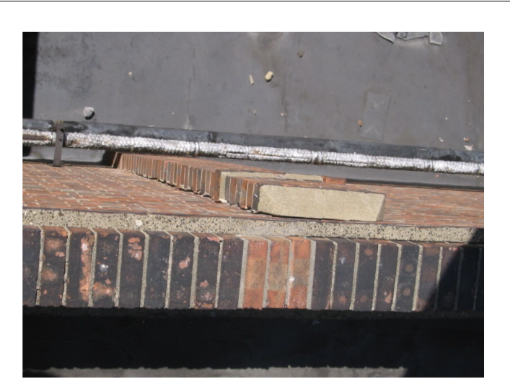

- Cracked brick casing to frame.
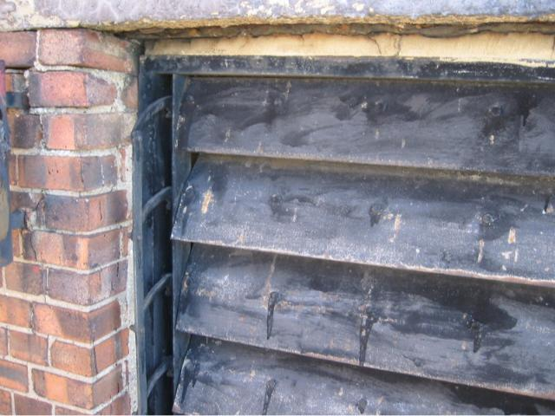

2. Typical poor external decoration and defective opening.

JOB REF: | AWT/AT/RB/TR/46517 | P/P 1
CLIENT: | UCKG Help Centre

PROPERTY: 186 Hoe Street, Walthamstow, London, E17 Watts and Partners
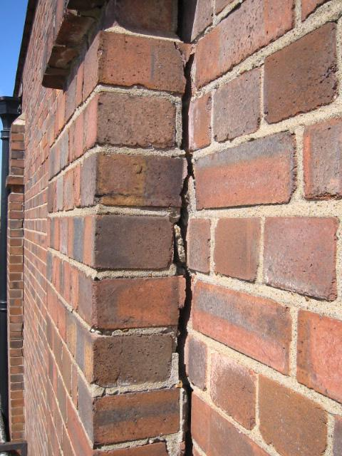

- Close-up of cracked brick casing.

JOB REF: | AWT/AT/RB/TR/46517 | P/P 2
CLIENT: | UCKG Help Centre

PROPERTY: 186 Hoe Street, Walthamstow, London, E17 Watts and Partners
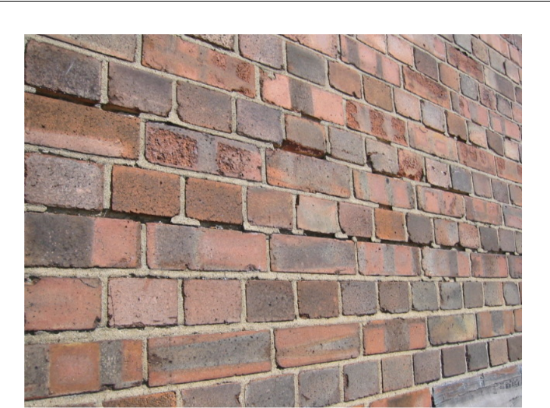

- Typical poor condition of pointing.
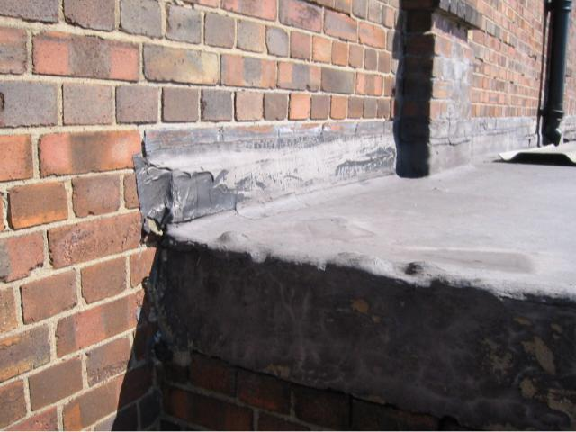

- Poor asphalt with badly detailed temporary repair.

JOB REF: | AWT/AT/RB/TR/46517 | P/P 3
CLIENT: | UCKG Help Centre

PROPERTY: 186 Hoe Street, Walthamstow, London, E17 Watts and Partners
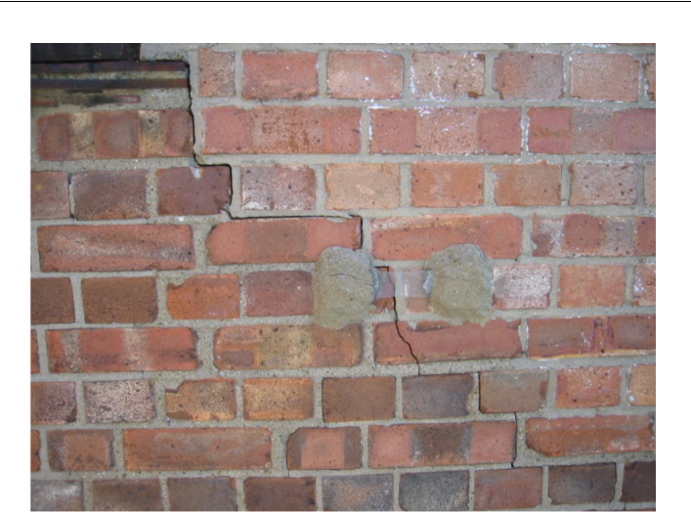

- Stepped crack. Note previous monitoring device has broken.
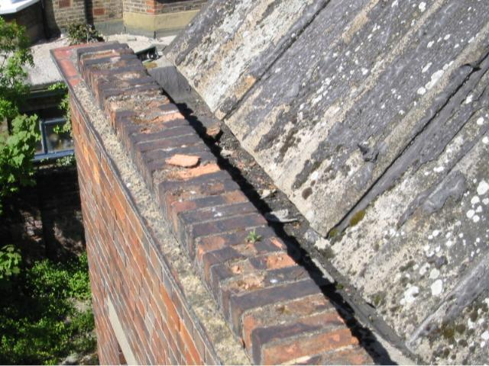

- Typical poor condition parapet and roof slope.

JOB REF: | AWT/AT/RB/TR/46517 | P/P 4
CLIENT: | UCKG Help Centre

PROPERTY: 186 Hoe Street, Walthamstow, London, E17 Watts and Partners
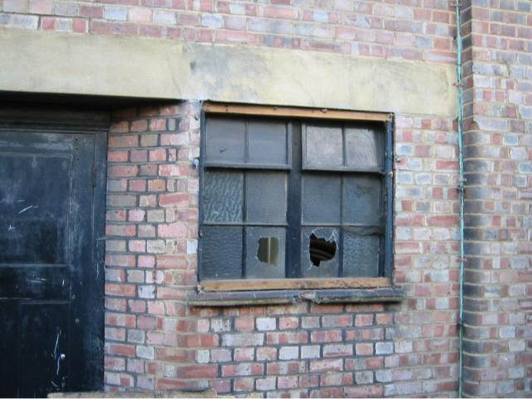

- Poor window and sill condition.

JOB REF: | AWT/AT/RB/TR/46517 | P/P 5
CLIENT: | UCKG Help Centre

PROPERTY: 186 Hoe Street, Walthamstow, London, E17 Watts and Partners
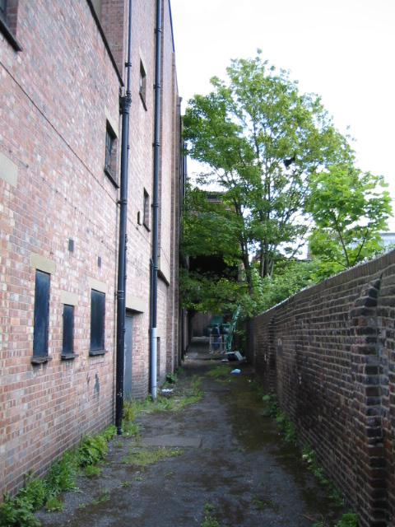

- Poor condition fire escapes.

JOB REF: | AWT/AT/RB/TR/46517 | P/P 6
CLIENT: | UCKG Help Centre

PROPERTY: 186 Hoe Street, Walthamstow, London, E17 Watts and Partners
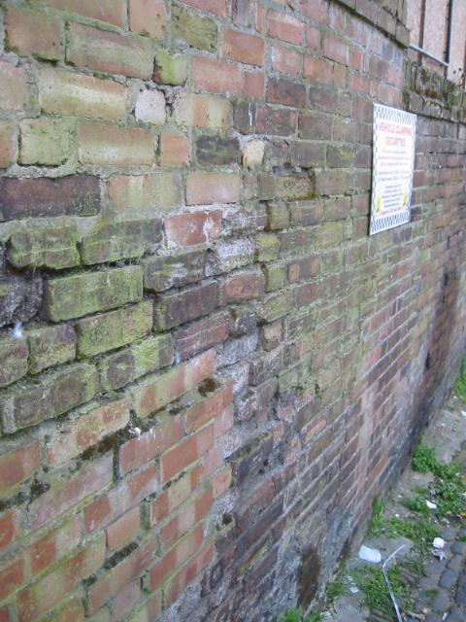

10. Poor condition and leaning flank boundary wall.

JOB REF: | AWT/AT/RB/TR/46517 | P/P 7
CLIENT: | UCKG Help Centre

PROPERTY: 186 Hoe Street, Walthamstow, London, E17 Watts and Partners
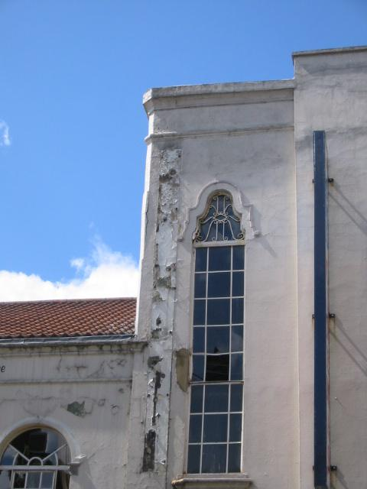

- Poor condition of front façade.

JOB REF: | AWT/AT/RB/TR/46517 | P/P 8
CLIENT: | UCKG Help Centre

PROPERTY: 186 Hoe Street, Walthamstow, London, E17 Watts and Partners
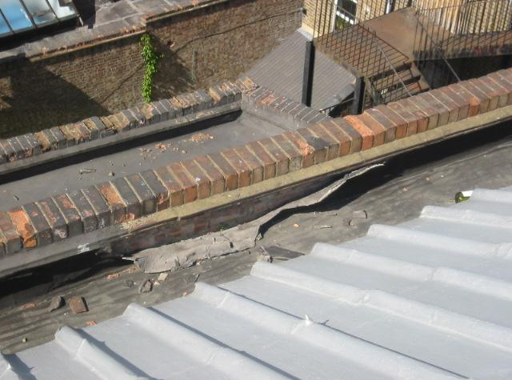

12. Poor condition parapets and flat roof areas.
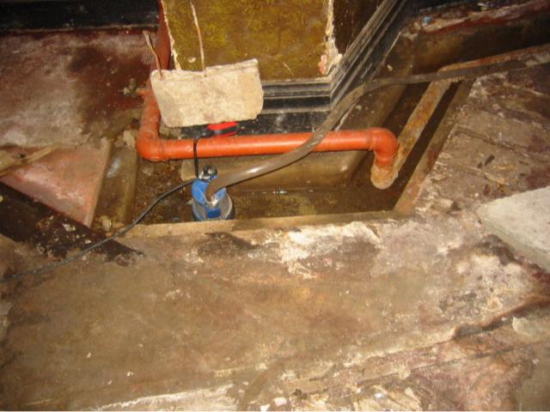

13. Sump and water damage.

JOB REF: | AWT/AT/RB/TR/46517 | P/P 9
CLIENT: | UCKG Help Centre

PROPERTY: 186 Hoe Street, Walthamstow, London, E17 Watts and Partners
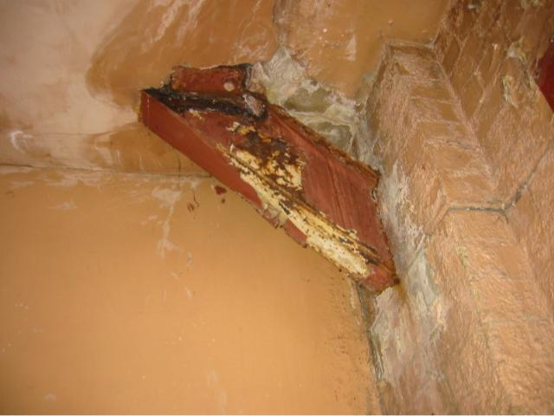

14. Defective/rusty steel.
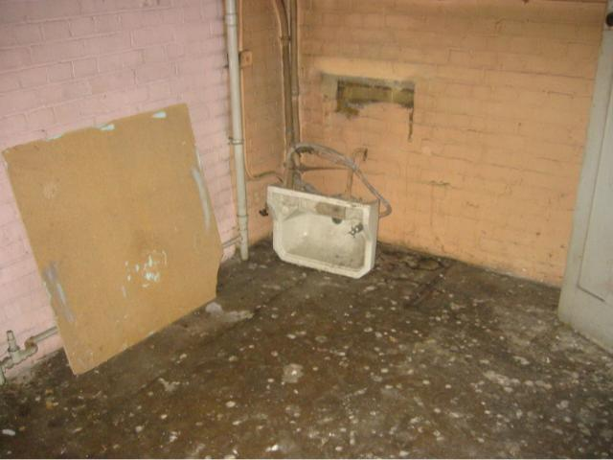

15. First floor preparation room with damaged sink.

JOB REF: | AWT/AT/RB/TR/46517 | P/P 10
CLIENT: | UCKG Help Centre

PROPERTY: 186 Hoe Street, Walthamstow, London, E17 Watts and Partners
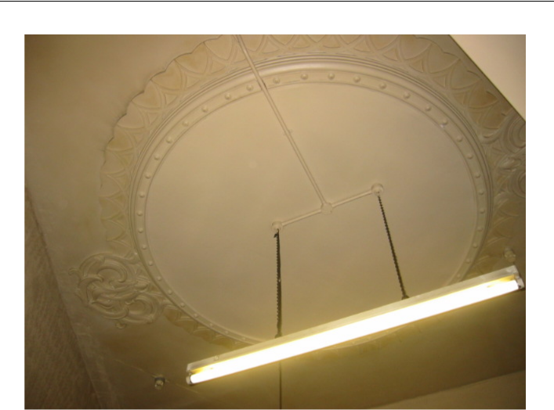

16. Metal plate over ceiling rose.
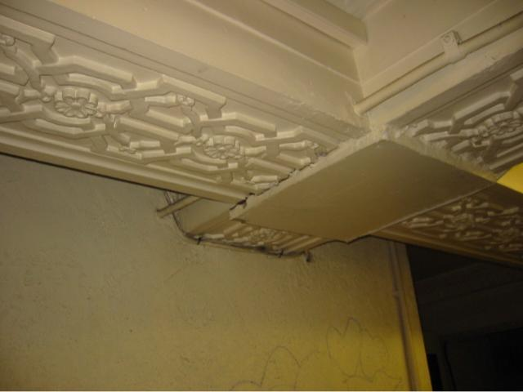

17. Damaged cornice and decorations.

JOB REF: | AWT/AT/RB/TR/46517 | P/P 11
CLIENT: | UCKG Help Centre

PROPERTY: 186 Hoe Street, Walthamstow, London, E17 Watts and Partners
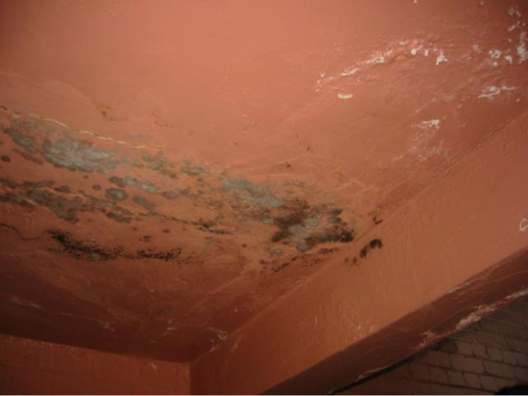

18. Damp staining to stairwell.

JOB REF: | AWT/AT/RB/TR/46517 | P/P 12
CLIENT: | UCKG Help Centre

