CHAPTER 2

SIEVE ANALYSIS AND FINENESS MODULUS

Sampling

Since the reason for sampling aggregates is to determine the gradation (particle size) of the aggregate, it is necessary that they be sampled correctly.

The results of testing will re" ect the condition and characteristics of the aggregate from which the sample is obtained. Therefore, when sampling, it is important to obtain a representative sample that is representative of the source being tested. Unless it is truly representative, the test results apply to the sample only and not to the entire aggregate shipment or stockpile. Without accuracy in sampling, test results are worthless.

In many cases, representative sampling cannot be achieved by a single sample. It may be necessary to take a number of samples to obtain a true picture of the properties of a stockpile or source of material. Also, as the maximum particle size in the aggregate increases, the size of the sample must increase to maintain accuracy in testing.

How To Take a Sample

There are three principal aggregate sampling points that are of concern at a concrete plant. These are:

- source of material, (quarry, gravel pit, etc.)
- the stockpile, and
- the storage bin.

The ! rst two will be discussed in this section and the third in the section on moisture content and batch weight adjustments.

When sampling at the source of materials, it would be well to remember one general rule. It is easier to obtain a representative sample from the production stream, such as from the conveyor belt, than from trucks, storage bins or stockpiles. If the sample is taken from the conveyor belt, take the entire cross-section of the belt. The same is true when sampling from the chutes or bins.

Getting a sample from a stockpile is not easy, and great care must be taken to obtain a truly representative sample. Segregation usually occurs when the material is stockpiled, because the coarse particles will roll to the base of the pile while the ! ne particles stay on top. When sampling coarse aggregates from stockpiles, samples should be taken at or near the top and base, and at some intermediate point. To prevent further segregation while sampling, a board may be shoved into the pile just above the sampling area. A second method of sampling coarse materials would be to expose the face of the stockpile from the top to the bottom, with a front end loader. The samples could then be taken from the exposed face. A third method would be to have the overhead loader take a scoop from bottom to top and dump the material in a convenient location for sampling. The sample bag could then be ! lled from various locations around the scoop of material. Fine aggregate may be sampled with a sampling tube approximately 1 ¼ inches (30 mm) in diameter and 6 feet (1.8 meters) in length. Or if sampling a stockpile of sand, or ! ne aggregate, it is usually necessary to remove the dry layers where the segregation occurs and sample the damp material below.

# " $ % " & # ! "

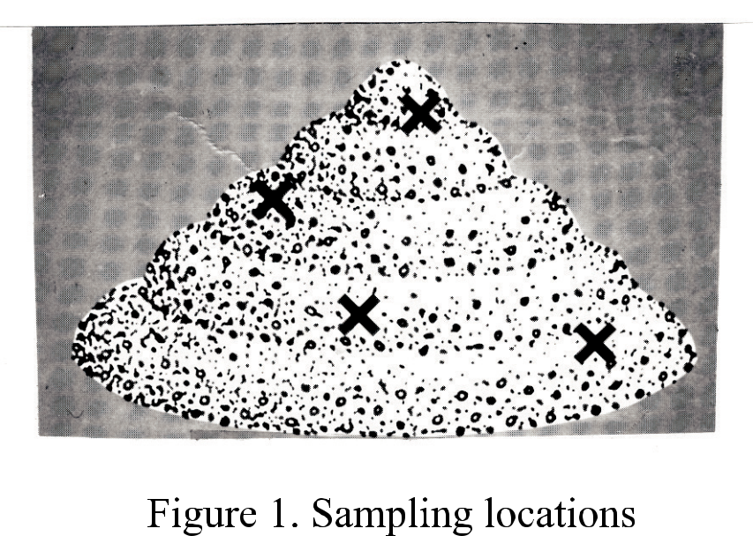

Sieve Analysis

Aggregate gradation (sieve analysis) is the distribution of particle sizes expressed as a percent of the total dry weight. Gradation is determined by passing the material through a series of sieves stacked with progressively smaller openings from top to bottom and weighing the material retained on each sieve. Sieve numbers and sizes most often used in grading aggregates for Hydraulic Concrete paving mixtures are as follows:

! " # $ % # & "

Nominal Dimensions of U.S.
Standard Sieves - AASHTO M 92

Sieve Designation

Nominal sieve
Openings

metric | standard | Metric | inches
50.0 mm | 2 | 50.0 mm | 2.00
37.5 mm | 1 ½ | 37.5 mm | 1.50
25.0 mm | 1 | 25.0 mm | 1.00
19.0 mm | 3/4 | 19.0 mm | 0.750
12.5 mm | 1/2 | 12.5 mm | 0.500
9.5 mm | 3/8 | 9.5 mm | 0.375
4.75 mm | No. 4 | 4.75 mm | 0.187
2.36 mm | No. 8 | 2.36 mm | 0.093
1.18 mm | No. 16 | 1.18 mm | 0.0469
600 µm | No. 30 | 0.600 mm | 0.0234
300 µm | No. 50 | 0.300 mm | 0.0117
150 µm | No. 100 | 0.150 mm | 0.0059
75 µm | No. 200 | 0.075 mm | 0.0029

Sieve sizes to be used for the various mixtures are designated in the Road and Bridge Speci! cations. Gradations are expressed on the basis of total percent dry weight passing, which indicates the total percent of aggregate by weight that will pass a given size sieve.

Some of the descriptive terms used in referring to aggregate gradations are:

Coarse Aggregate: All the materials retained on and above the No. 8 (2.36 mm) sieve

Fine Aggregate: All the material passing the No. 8 (2.36 mm) sieve.

# $ % & $ ' # ! "

Procedure For Sieve Analysis

Dry sieve analysis and washed sieve analysis are two methods of determining proportions of various particle sizes in a mineral aggregate. In Virginia, however, the WASHED SIEVE ANALYSIS is used, and will be discussed in this section. Standard procedures for running the sieve analysis are given in AASHTO T 27 and AASHTO T 11.

Regardless of the size of the aggregate, the procedure for running a sieve analysis is basically the same. The steps for this procedure are outlined as follows:

- Obtain a representative sample of the material from the original sample by either a sample splitter or the quartering method. (See paragraphs a and b below.) Reduce to a size that can be handled on the balance and sieves, also, according to maximum stone size. Reference AASHTO T 27.

  - Sample Splitter - Sample splitters shall have even number of equal width chutes, but not less than a total of eight for coarse aggregates, or twelve for ! ne aggregates, which discharge alternately to each side of the splitter. The splitter shall be equipped with two receptacles to hold the two halves of the sample following splitting. It shall be equipped with a hopper or straightedge pan which has a width of the assembly of chutes, by which the sample may be fed at a controlled rate to the chutes. The splitter and accessory equipment shall be so designed that the sample will " ow smoothly without restriction or loss of material. Place the ! eld sample in the hopper or pan and uniformly distribute it from edge to edge, so that when it is introduced into the chutes, approximately equal amounts will " ow through each chute. The rate at which the sample is introduced shall be such as to allow free " owing through the chutes into the receptacles below. Reintroduce the portion of the sample in one of the receptacles into the splitter as many times as necessary to reduce the sample to the size speci! ed for the intended test. The portion of the material collected in the other receptacle may be reserved for reduction in size for other tests.

  - Quartering Method - The following method for size reduction by quartering is outlined for use when a conventional sample splitter is not available.

    - Distribute a shovel full of the aggregate as uniformly as possible over a wide, " at area on a tight weave canvas or other smooth surface. Continue to distribute shovels full of material in layers until all the sample is used to make a wide, " at pile that is reasonably uniform in thickness and diameter. Do not permit coning of the aggregate.

    - Divide the pile cleanly into equal quarters with a square-ended shovel or straight piece of sheet metal. When a canvas is used, the division may be conveniently made by inserting a thin stick (or rod) under the canvas and raising it to divide the sample equally, ! rst into halves, then into quarters.

! " # $ % & $ ' #

  - Remove two opposite quarters, including all ! ne materials, and set aside.

  - Repeat the foregoing procedure with the remaining portion of the aggregate until a test sample of desired size is obtained.

  - If desired, store the portion that has been set aside for possible check testing.

- Dry aggregate sample thoroughly. The samples are dried to constant weight on a hot plate or in an oven at a temperature of 230°F (110ºC).

- Accurately weigh the dried sample. When weighing and handling the sample, extreme care must be taken to avoid any loss of the material, as this will affect the accuracy of the results. Also, do not adjust the weight of the split sample to an even ! gure, such as 500 grams, 1000 grams, etc. Use the entire reduced and dried sample.

- Record the total dry weight on the worksheet. For example, assume the total dry weight of the sample is 506.4 grams.

- Wash the sample over a nest of two sieves, the upper or top sieve being the No. 16 (1.18 mm) mesh sieve and the lower or the bottom sieve being the No. 200 (75 µm) mesh sieve. Doing this, you would take your sample, add water, to cover the material completely, add a drop of soap and wash it thoroughly being careful not to lose any of the material. Pour the water and material over the nest of sieves, the No. 16 (1.18 mm) and No. 200 (75 µm), being careful not to lose any of the material, then repeat the procedure until the water is clear.

# $ " % $ & # ! "

Sample Splitter
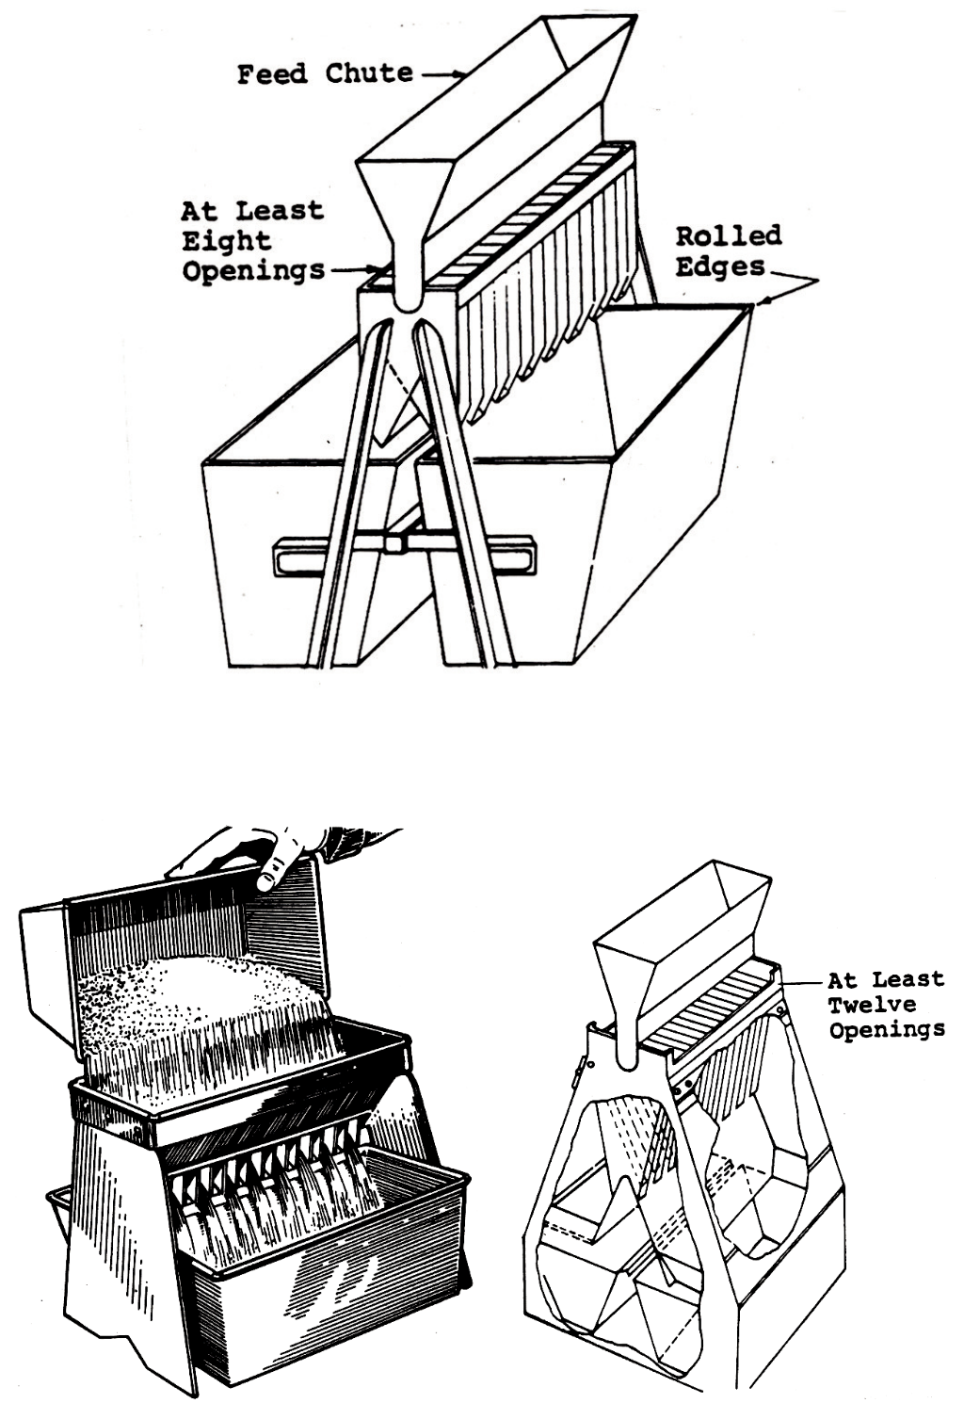

(b) Small Rif" e Sampler for ! ne aggregate

Quartering Method
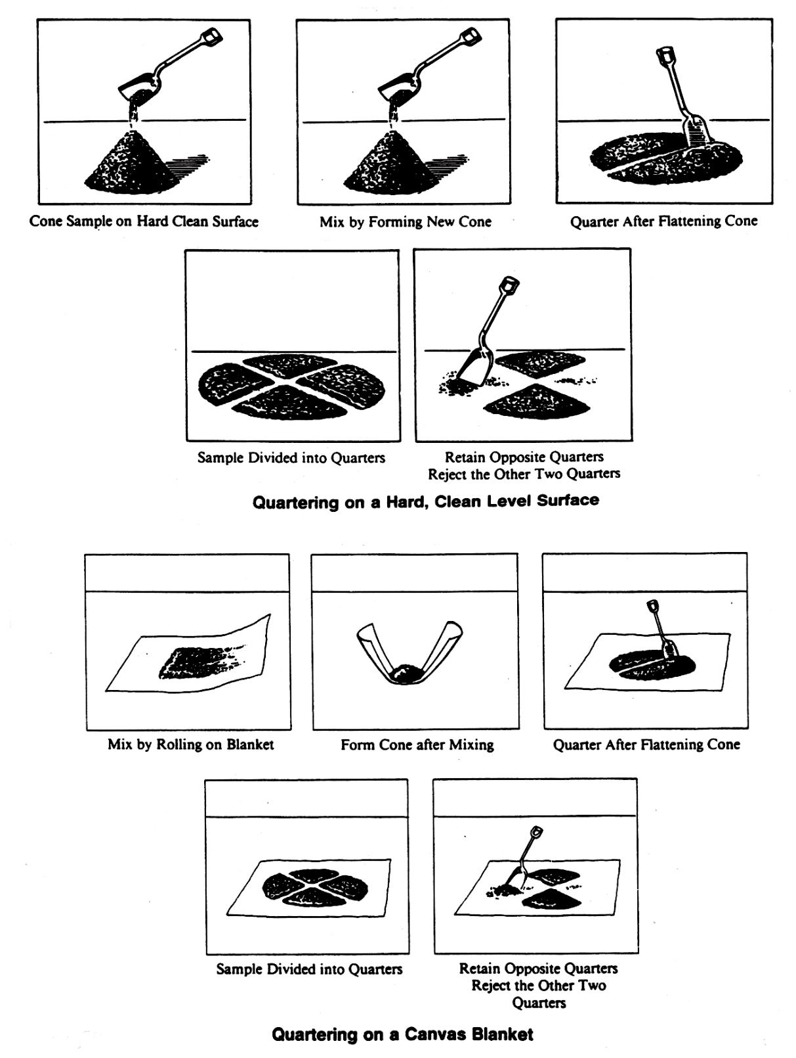

# $ % & $ ' # ! "

- Dry the sample again to a constant weight on a hot plate or in an oven at a temperature of 230°F (110 ºC), then accurately weigh and record.

- Separate the sample into individual sizes using the proper sieves. The sieves normally used are the standard 8 inch (200 mm) sieves. With Fine Aggregate the coarse sieve or the 3/8” (9.5 mm) sieve at the top; each sieve below is ! ner; and the
  - nest sieve, a No. 200 (75 µm) is at the bottom. A pan is placed below to retain any
  - ne material that may pass this sieve.

The dried sample is placed on the top sieve, and the entire nest of sieves is placed in a shaker that produces a circular and tapping motion, or in other approved shaking devices. This motion assists gravity in settling the individual aggregate particles on the sieve which will properly identify the size of that particular particle. It will take approximately 7 to 10 minutes of shaking to separate the material. Always refer to the AASHTO T-27 procedure to assure shaking for the proper amount of time.

- Weigh and record the weights retained on each sieve cumulatively, increasing by successive additions to the nearest 0.1 grams. For example, suppose a particular gradation required a maximum size of 3/8” (9.5 mm). Upon examination of this sieve no material was retained. This would then be recorded in the “Cumulative Grams Retained” column of the worksheet, as “0” for this sieve. The No. 4 (4.75 mm) sieve is then checked, the material carefully removed, placed on the balance and a weight of 14.8 grams is recorded. The No. 8 (2.36 mm) sieve is removed from the nest of sieves, the material is emptied into the pan with the No. 4 (4.75 mm) material and the cumulative weight is recorded on the worksheet beside the No.8 (2.36 mm) sieve, example 47.6 grams. Repeat the procedure until all of the sieves are weighed and recorded cumulatively. (Note: In a ! ne aggregate sieve analysis, the test sample is washed over the No. 200 (75 µm) sieve and the portion retained on the No. 200 (75 µm) sieve is dried and the loss recorded.)

Sieve Analysis - Example

The following sieve analysis is for a sample of natural sand for use in concrete subject to abrasion and meets Virginia Department of Transportation requirements for Grading “A” Sand.

Sieve | Cumulative | Cumulative |  | VDOT Specs.
Size | Grams Retained | %Retained | %Passing | (%Passing)
3/8 inch | 0.0 | 0.0 | 100.0 | 100.0
No. 4 | 14.8 | 2.9 | 97.1 | 95-100
No. 8 | 47.6 | 9.4 | 90.6 | 80-100
No. 16 | 117.3 | 23.2 | 76.8 | 50-85
No. 30 | 274.2 | 54.1 | 45.9 | 25-60
No. 50 | 418.8 | 82.7 | 17.3 | 5-30
No. 100 | 467.4 | 92.3 | 7.7 | 0-10
No. 200 | 494.2 | 97.6 | 2.4 | 0-3
PAN | 506.4 | 100.0 | 0.0

! " # $ % $ ! #

In this example, the cumulative grams retained on each sieve was determined in the sieve analysis.

- Calculate the cumulative percent retained on each sieve. (Answer to the nearest
0.1%) This is determined by the following formula:

Cumulative % Retained: Cumulative Grams Retained X 100
Total Weight of Sample

For Example: Weight on the No. 4 sieve = 14.8 grams
Total Dry Weight of Sample = 506.4 grams

%Retained = 14.8 = .029 x 100 = 2.9%
506.4

This is performed for each sieve size and the end ! gures entered in the “Cumulative
% Retained” column of the worksheet.

- Calculate the percent passing each sieve. (Answer to the nearest 0.1%). To determine this ! gure, subtract the percent retained on each sieve from 100.

Example:
1.) % Retained on 3/8 inch sieve = 0
100 - 0 = 100.0% passing 3/8 inch sieve

2.) % Retained on No. 4 sieve = 2.9
100 - 2.9 = 97.1% passing No. 4 sieve

3.) % Retained on No. 8 sieve = 9.4
100 - 9.4 = 90.6% passing No. 8 sieve

This is performed for each sieve and entered in the % Passing Column of the worksheet. Check to see if the % Passing complies with the Virginia Department of Transportation Speci! cations (Table II-1, page 2-12).

# $ % & $ ' # ! "

! " #

TABLE II-3
Sizes of Open Graded Coarse Aggregates

 |  |  | Amounts Finer !an Each Laboratory Sieve (Square Openings) (% by Mass)
Va.
Size
No. | 4 in | 3 ½ in | 3 in | 2 ½ in | 2 in | 1 ½ in | 1 in | ¾ in
1 | Min. 100 | 90 -100 |  | 25-60 |  | Max. 15 |  | Max .5
2 |  |  | Min. 100 | 90-100 | 35-70 | Max. 15 |  | Max. 5
3 |  |  |  | Min. 100 | 90-100 | 35-70 | 0-15
357 |  |  |  | Min. 100 | 95-100 |  | 35-70
5 |  |  |  |  |  | Min. 100 | 90-100 | 20-55
56 |  |  |  |  |  | Min. 100 | 90-100 | 40-85
57 |  |  |  |  |  | Min. 100 | 95-100
67 |  |  |  |  |  |  | Min. 100 | 90-100
68 |  |  |  |  |  |  | Min. 100 | 90-100
7 |  |  |  |  |  |  |  | Min. 100
78 |  |  |  |  |  |  |  | Min. 100
8
8P
9
10

(Continued)

# " $ % " & #

# " $ % " & #
TABLE II-3
Sizes of Open Graded Coarse Aggregates
(Continued)

Va.
Size
No. | ½ in | 3/8 in. | No. 4 | No. 8 | No. 16 | No. 50 | No. 100

1

2

- Max. 5

357 | 10-30 |  | Max. 5
5 | Max. 10 | Max. 5
56 | 10-40 | Max. 15 | Max. 5
57 | 25-60 |  | Max. 10 | Max. 5
67 |  | 20-55 | Max. 10 | Max. 5
68 |  | 30-65 | 5-25 | Max. 10 | Max. 5
7 | 90-100 | 40-70 | Max. 15 | Max. 5
78 | 90-100 | 40-75 | 5-25 | Max. 10 | Max. 5
8 | Min. 100 | 85-100 | 10-30 | Max. 10 | Max. 5
8P | Min. 100 | 75-100 | 5-30 | Max. 5
9 |  | Min. 100 | 85-100 | 10-40 | Max. 10 | Max. 5
10 |  | Min. 100 | 85-100 |  |  | 10-30

NOTE: No. 30 sieve - 600 µm

No. 200 sieve - 75 µm

! "

! "
TABLE II-1

Fine Aggregate

Grading |  |  | Amounts Finer !an Each Laboratory Sieve (Square Openings) ( % by Mass)
 | 3/8 in | No. 4 |  | No. 8 | No. 16 | No. 30 | No. 50 |  | No. 100 | No. 200
A | Min. 100 | 95-100 |  | 80-100 | 50-85 | 25-60 | 5-30 |  | Max. 10
B | Min. 100 | 94-100 |  |  |  |  |  |  | Max. 10
C | Min. 100 | 94-100 |  |  |  |  | Max. 25

# " $ % "

& #

Section 202.03(e) Deleterious Material: "e amount of deleterious material in sands shall be not more than the following:

 |  | AASHTO
Material | % by Mass | Test Method
Clay lumps | 0.25 | T112
Shale, mica, coated | 1.0 | T113
grains, so# or
$aky particles
Organic material | 0 | T21
Total material passing |  | T11 and
No. 200 (75 µm) sieve by |  | T27
washing¹
For use in concrete | 3
subject to abrasion
For other concrete | 5

¹In the case of stone sand, if the material passing the No. 200 (75 µm) sieve is dust of fracture, essentially free from clay or shale, the percentages shown for use in concrete subject to abrasion

and in other concrete may be increased to 5.0% and 7.0%, respectively.

$ " % & " ' $ ! " #

Fineness Modulus

Fineness Modulus is de! ned as an index to the particle size not to the gradation. Fineness Modulus is calculated from the sieve analysis. It is de! ned mathematically as the sum of the cumulative percentages retained on the standard sieves divided by 100. The standard size sieves are 6” (150 mm), 3” (75 mm), 1 1/2” (37.5 mm), 3/4” (19.0 mm), 3/8” (9.5 mm), No. 4 (4.75 mm), No. 8 (2.36 mm), No. 16 (1.18 mm), No. 30 (600 µm), No. 50 (300µm), and No. 100 (150 µm). Always report the ! neness modulus to the nearest 0.01. In ! neness modulus, the ! ner the material the more the water demand is. It is used for the purpose of estimating the quantity of coarse aggregate to be used in the concrete mix design. The F.M. of ! ne aggregates should not be less than 2.3 or more than 3.1, or vary by more than 0.20 from batch to batch.

The American Concrete Institute (ACI) has developed Table A1.5.3.6. (page 2-
- which for various sizes of coarse aggregate, gives the volume of dry rodded coarse aggregate per unit volume of concrete for different ! neness moduli of sand. If the maximum size of the coarse aggregate and the ! neness modulus of the Fine Aggregate are known, the volume of the dry rodded coarse aggregate can be obtained from this table.

The volume relationship in the ACI Table actually relates to the total surface area of the aggregates, or water demand of the aggregate. For example, if the Fineness Modulus is constant, the volume of coarse aggregate increases with the size of the aggregate, or with the decrease in surface area of the coarse aggregate. Likewise, as the ! ne aggregate decreases for any one size of coarse aggregate, the volume of the coarse aggregate increases. As the particle size of the ! ne aggregate decreases, the surface area increases. Thus, more coarse aggregate and less ! ne aggregate is used in the mix proportions. Therefore, the volume of the coarse aggregate, as determined in the ACI Table, increases or decreases to maintain a constant total surface area, or constant water demand, with the variable ! neness moduli, coarseness or ! neness, of the sand.

! " # $ " % & " ' $

Procedure for Determining the Fineness Modulus

Add the Cumulative % Retained on all of the sieves except the No. 200 (75 µm) and the Pan. Then divide by 100. Remember to report answer to the nearest 0.01.

Example:

Sieve | Cumulative | Cumulative |  | VDOT Specs.
Size | Grams Retained | %Retained | %Passing | (%Passing)
3/8 in | 0.0 | 0.0 | 100.0 | 100.0
No. 4 | 14.8 | 2.9 | 97.1 | 95-100
No. 8 | 47.6 | 9.4 | 90.6 | 80-100
No. 16 | 117.3 | 23.2 | 76.8 | 50-85
No. 30 | 274.2 | 54.1 | 45.9 | 25-60
No. 50 | 418.8 | 82.7 | 17.3 | 5-30
No. 100 | 467.4 | 92.3 | 7.7 | 0-10
No. 200 | 494.2 | 97.6 | 2.4 | 0-3
PAN | 506.4 | 100.0 | 0.0

0.0 + 2.9 + 9.4 + 23.2 + 54.1 + 82.7 + 92.3 = 264.6 = 2.65
100.0 100.0

Once this result is obtained the average size particle in a mix can be determined by looking at the scale and placing a mark where it ! ts in the best. If for example the F.M. is 2.65, then you would place the mark between the No. 50 (300 µm) and the No. 30 (600 µm) sieve.

#100 | #50 | #30 | #16 | #8 | #4 | 3/8” | 3/4” | etc
1 | 2 | X 3 | 4 | 5 | 6 | 7 | 8

$ " # % " & $ ! " #

“Recommended Practice For Selecting
Proportions For Concrete”

(ACI 211) Proportions shall be computed on the absolute volume basis and that the 10 percent adjustment allowed in Table A1.5.3.6 will not be permitted. The actual quantities used, as determined by the methods described herein, shall not deviate more than “ 5 percent from such quantities.

ACI TABLE 5.3.6 - VOLUME OF COARSE AGGREGATE
PER UNIT VOLUME OF CONCRETE (SI)

Maximum size |  |  | Volume of dry-rodded coarse aggregate* per unit
aggregate |  |  | volume of concrete for different ! neness
mm |  |  |  | muduli** of ! ne aggregate
 |  | 2.40 | 2.60 | 2.80 | 3.00
3/8 inch |  | 0.50 | 0.48 | 0.46 | 0.44
½ inch |  | 0.59 | 0.57 | 0.55 | 0.53
¾ inch |  | 0.66 | 0.64 | 0.62 | 0.60
1 inch |  | 0.71 | 0.69 | 0.67 | 0.65
1 ½ inch |  | 0.75 | 0.73 | 0.71 | 0.69
2 inch |  | 0.78 | 0.76 | 0.74 | 0.72
3 inch |  | 0.82 | 0.80 | 0.78 | 0.76
6 inch |  | 0.87 | 0.85 | 0.83 | 0.81

*Volumes are based on aggregates in dry-rodded condition as described in ASTM C29

These volumes are selected from empirical relationships to produce concrete with a degree of workability suitable for usual reinforced construction. For less workable concrete such as required for concrete pavement construction they may be increased up to 10 percent. For more workable concrete, they may be reduced up to 10 percent.

**See ASTM Method 136 for calculation of ! neness modulus

! " # $ " % & " ' $

CHAPTER 2

STUDY PROBLEMS

Sieve Analysis - No. 1

Check the following sieve analysis of a sample of natural sand for use in concrete subject to abrasion and determine if it meets Virginia Department of Transportation requirements for Grading “A” Sand. Circle the sieve not passing, if any.

Sieve | Cumulative |  |  |  | Cumulative |  |  |  |  | VDOT Specs.
Size | Grams Retained |  |  |  | %Retained |  |  |  | %Passing | (%Passing)
3/8 inch | 0.0
No. 4 | 16.6
No. 8 | 64.5
No. 16 | 214.1
No. 30 | 389.2
No. 50 | 483.0
No. 100 | 543.4
No. 200 | 565.0
Total Wt. | 573.0
Does it meet speci! cation? Yes |  |  |  |  |  | No
What is the Fineness Modulus?

$ " % & " ' $ ! " #

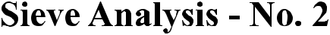

Check the following sieve analysis of a sample of natural sand for use in concrete subject to abrasion and determine if it meets Virginia Department of Transportation requirements for Grading “A” Sand. Circle the sieve not passing, if any.

Sieve | Cumulative |  |  | Cumulative |  | VDOT Specs.
Size | Grams Retained |  |  | %Retained | %Passing | (%Passing)
3/8 inch | 0.0
No. 4 | 6.9
No. 8 | 28.3
No. 16 | 34.9
No. 30 | 219.2
No. 50 | 398.8
No. 100 | 482.9
No. 200 | 498.1
Total Wt. | 503.0

Does it meet speci! cation? Yes No

What is the Fineness Modulus?

! " # $ " % & " ' $
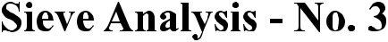

Check the following sieve analysis of a sample of natural sand for use in concrete not subject to abrasion and determine if it meets Virginia Department of Transportation requirements for Grading “A” Sand. Circle the sieve not passing, if any.

Sieve | Cumulative |  |  | Cumulative |  | VDOT Specs.
Size | Grams Retained |  |  | %Retained | %Passing | (%Passing)
3/8 inch | 0.0
No. 4 | 6.7
No. 8 | 54.0
No. 16 | 168.6
No. 30 | 340.5
No. 50 | 407.7
No. 100 | 459.1
No. 200 | 468.1
Total Wt. | 480.0

Does it meet speci! cation? Yes No

What is the Fineness Modulus?

$ " % & " ' $ ! " #

