
Giving Notice to Vacate

If you are approaching the end of a fixed-term tenancy, you are required to provide our office with 30 days’ notice in writing of your intention to vacate. If you are approaching the end of a periodic tenancy, you are required to provide our office with 21 days’ notice in writing of your intention to vacate.

Please complete the Notice of Termination form attached and lodge as per the instructions below. Once the form has been submitted, your Property Manager will acknowledge receipt of the notice and will forward a letter confirming your vacate date, along with a final bond inspection cleaning guide.

Breaking Your Lease

At St Ives Realty, we understand that circumstances may change and our tenants may be forced to break their lease.

Should you wish to break your tenancy agreement, you will be liable to pay rent until the property is re-let or until the expiry of your lease agreement (whichever occurs first). You will also be liable for any expenses incurred by the owner as a result of the broken lease.

A formal break lease document itemising all expenses will be provided and must be signed by the tenant. St Ives Realty will not contact the owner or commence searching for a new tenant until that document has been signed. We will do our best to minimise costs. Please discuss this with your Property Manager.

To start the lease termination process, please complete the Notice of Termination form attached and ensure it is signed by all of the property’s tenants. Once received, we will be in touch to discuss your lease break document and next steps.

Notice of Lease Termination Form

Please complete the attached Notice of Lease Termination form and lodge via one of the following methods:
- as a printed hard copy at the St Ives Realty office (22 Bishop Street, Jolimont WA);

- by email to rentals@stivesrealty.com.au;

- by fax to (08) 9387 5855; or

- by post to PO Box 4014, Wembley WA 6913.

Any Enquiries?

Please contact us to discuss any queries you may have.

ST IVES REALTY
Property Management Team

Address Phone Email

22 Bishop Street
Jolimont WA 6014
1300 20 20 01

rentals@stivesrealty.com.au

stivesrealty.com.au


notice of termination from tenant to lessor
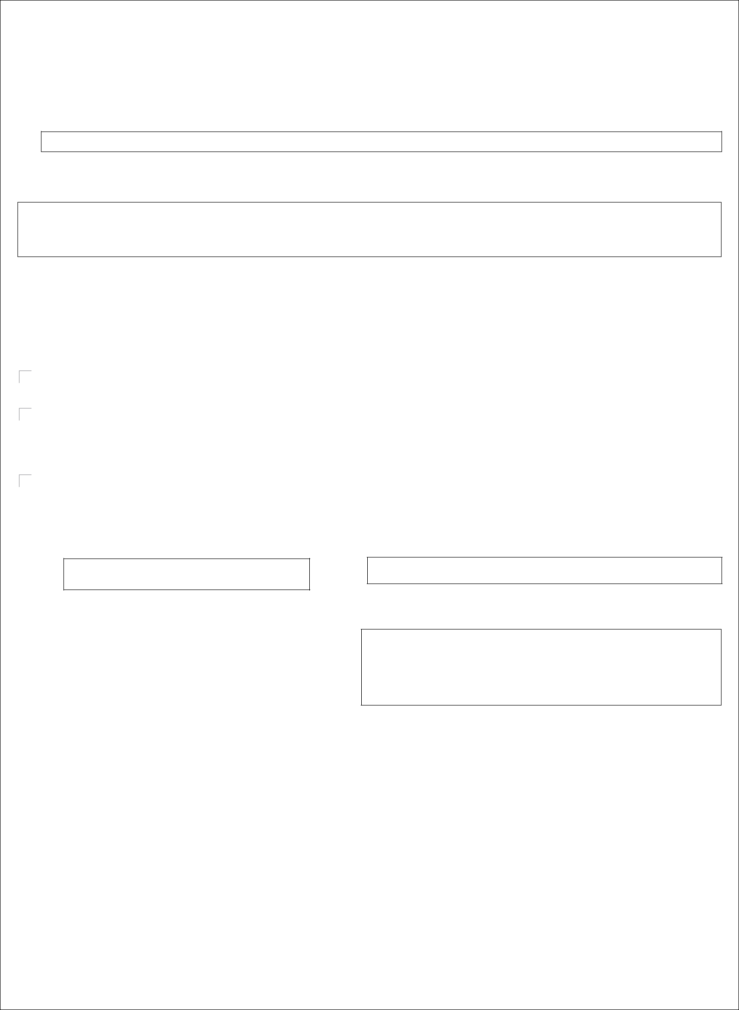

APPROVED BY

THE REAL ESTATE INSTITUTE OF WESTERN AUSTRALIA (INC.) COPYRIGHT © REIWA 2013

FOR USE BY REIWA MEMBERS

SECTION 68, 69(1), 69(3)-(4), 70A

RESIDENTIAL TENANCIES ACT 1987

TO:

(Name of Lessor)

I hereby give you notice of termination in relation to premises at:

 |  | (Address of Rented Premises)
on |  |  | at
(insert date on which the tenant will vacate premises) |  |  |  | (Time)

am/pm

The ground for for termination is

(only tick one box below)

Termination of periodic tenancy without specifying any grounds: Twenty-one (21) days' minimum notice. A periodic tenancy is a tenancy without an end date, or when a fixed term tenancy has continued past its end date. (Section 68)

The premises, or part of the premises, are destroyed/ rendered uninhabitable / cease to be lawfully usable as a residence/ are appropriated or acquired by any authority by compulsory process (cross out whichever is not applicable): Two (2) days' minimum notice. If the damage to the property was not caused by the tenant breaching the tenancy agreement, the tenant may give 2 days minimum notice. (Section 69(1), 69(3)-(4))

Termination to end a fixed term tenancy: Thirty (30) day's minimum notice. A fixed term tenancy does not end on the expiry date of the fixed term tenancy agreement unless the tenant or lessor provides a minimum of 30 days' notice. The date identified above as the date the tenant will vacate the premises can be on or after the date of the expiry of the fixed term agreement. If the lessor and tenant nominate different days, then the earlierst day is the date the tenant must vacate the premises. (Section 70A)

DATED:

SIGNED:

(Tenant)

Forwarding Address:

SEE OVER FOR IMPORTANT INFORMATION

07/13 321 page 1 of 2

notice of termination from tenant to lessor


APPROVED BY
THE REAL ESTATE INSTITUTE OF WESTERN AUSTRALIA (INC.) COPYRIGHT © REIWA 2013

FOR USE BY REIWA MEMBERS

SERVICE INFORMATION FOR TENANTS

If the matter goes to Court you will have to produce evidence of service. Service may be effected by various means, for example:

- by personal delivery (you may seek the assistance of a bailiff from the Magistrates Court or other process server); or

- by post (normal post not registered post).

You can deliver the notice to the lessor (landlord), the lessor's property manager, the person or organisation that receives your rent or any person apparently over the age of 16 years living at the lessor's home. Service may be on any one lessor if there is more than one.

For full details about the service of notices see section 85 of the Residential Tenancies Act 1987.

OTHER IMPORTANT INFORMATION FOR TENANTS

- Residential tenancy laws require a period of written notice and other restrictions on how a lessor (landlord) and tenant can end a tenancy agreement.

- If you want to end the residential tenancy agreement and move out, you will need to let the lessor or their property manager know in writing. You can give written notice using this form or by writing a letter.

- Seek further information if you want to end a fixed term tenancy before the end date in the tenancy agreement because extra costs may apply.

For further information about your tenancy rights, refer to the Residential Tenancies Act 1987 or contact the Department of Commerce on 1300 30 40 54 or www.commerce.wa.gov.au/Consumer Protection

For Translating and Interpreting Services please phone TIS on 13 14 50 and ask to speak to the Department of Commerce (1300 30 40 54) for assistance.

07/13 321 page 2 of 2

