MEMORANDUM OF UNDERSTANDING REGARDING SELLER’S BROKERAGE COMMISSIONS

STATEMENT OF POLICY

The development of publicly owned property within the City of Janesville is often the product of successful public-private partnership. The terms and conditions outlined in this Memorandum of Understanding (hereinafter “MOU”) are intended to govern public owned land transactions between the City of Janesville, as the owner/seller, and the brokers in broker assisted sales. The parcels covered by this MOU are zoned industrial and/or commercial/business, and intended for industrial and/or commercial office uses and are located within various existing and former City of Janesville Tax Increment Financing Districts. Because the City of Janesville may choose to incentivize certain projects through below market sales of publicly owned land, this MOU will protect brokers’ commissions for those brokers bringing transactions to the City of Janesville’s attention which result in successful closings. It is the City of Janesville’s intent to incentivize regional brokers to become actively involved with the opportunities hereunder.

MEMORANDUM OF UNDERSTANDING

WHEREAS, the City of Janesville (hereinafter referred to as “CITY”) and_____________________________________ (hereinafter referred to as “BROKER”), in

consideration of the various benefits inuring to each, as applicable, from the various obligations set forth herein, agree to the following:

- The City hereby offers for sale certain parcels of land shown on Exhibit A attached hereto and described further herein at the “asking” prices set forth in Exhibit B attached hereto. The parcels eligible for this MOU are any publicly owned industrial zoned land within the delineated boundaries of Exhibit A. The parcels offered herein as available for sale are subject to change, from time to time, at the City’s discretion, and the Broker shall confirm the availability of any parcel of interest before entering into any binding or other agreements concerning a parcel.

- Any real estate Broker appropriately licensed to conduct business in the State of

Wisconsin may sell (under the terms and conditions approved by the City) any parcel set forth in the Exhibits hereto and shall receive an appropriate and applicable commission that will be paid by the City to the Broker upon a successful closing of one of the above properties; provided that the Broker otherwise meets the terms and conditions herein. Brokers eligible for commission shall be paid said commission by the City at closing in the amount of six percent (6%) of the gross listing price of the property as set forth in Exhibit B, regardless of the actual “incentivized” sale price.

- This MOU shall be effective from the date of execution hereof until July 31, 2018, unless earlier terminated. Either party may terminate this MOU upon providing thirty (30) days advanced written notice to the other; provided, however, that the City may not terminate
the MOU concerning any “pending transaction.” A “pending transaction” shall be defined as any written offer binding upon a buyer submitted by a Broker to the City for consideration and discretionary action by its Plan Commission, Common Council, and all other applicable government agency(ies) of any kind applicable, and, prior to or within sixty (60) days thereafter, the City’s delivery to the Broker of a notice to terminate this MOU; provided such offer to purchase receives final approval by the Common Council of the City.

- The undersigned Broker agrees to, and shall, communicate and coordinate with the City of Janesville for the purposes of coordinating government licenses or permits needed by the buyer and maximizing business development incentives, as applicable.

- The undersigned Broker understands and agrees that the City will continue to market the subject property by its own efforts, too, as well by the efforts of other Brokers who enter into similar MOUs with the City. This MOU is not exclusive.

- The Common Council of the City reserve unto themselves the absolute right to accept or reject any Broker procured offer and shall have the sole discretion to determine the acceptability, suitability, and sufficiency, and may amend, modify and/or condition any such Broker procured offer and make one or more counteroffers solely at their sole discretion including, but not limited to, any proposed end use of the property and restrictions of any kind thereon. In the event that the Common Council either reject an offer and/or in the event that an accepted offer fail to close, the Broker shall be entitled to a full commission at closing on any subsequent sale by the City to the same buyer where such sale arises from an offer accepted within twelve (12) months of the original offer rejection or the scheduled failed closing date provided that the Broker is otherwise in compliance with the terms and conditions herein Unless another Broker becomes involved with the same buyer and property, in which event all Brokers involved shall pro-rate the one (1) City paid commission calculated as set forth above.

- The undersigned Broker understands and agrees that any sales agreements hereunder are subject to and conditioned upon the formal approval by resolution of the Common Council of the City of Janesville.

- The undersigned Broker agrees to and shall make prior disclosure to the City of any and all conflicts of interest including, without limitation, contracts or agreements, between the Broker and the buyer and other financial arrangements and interests of whatever kind or nature. In such cases, the Broker shall make full prior disclosure to the City and in no event shall the City pay any portion of the buyer’s commission to the Broker. In no event will the City pay any Broker commission in excess of six percent (6%) of the parcel’s gross listing price or more than six percent (6%) of the parcel’s gross listing price for the sale of any individual parcel to any combination of Brokers and/or other persons.

- The undersigned Broker acknowledges and agrees that the City may enter similar or identical MOU’s with other Brokers as to the same properties and further understands and agrees that this MOU gives the Broker no exclusive rights.

- The undersigned Broker understands and agrees that this MOU imposes no affirmative marking obligations upon the Broker, although the City does hereby grant the Broker the right to market the property as the Broker sees fit including, but not limited to, utilization of regional listing services with the exception of placing any type of signage upon the physical property which signage is hereby expressly prohibited.

- This MOU shall be governed by the laws of the State of Wisconsin. Venue for all disputes shall be exclusively a court of competent jurisdiction in the County of Rock, State of Wisconsin. In all instances, all interpretations, ambiguities, conflicts, constructions, meaning, intent, and disputes shall be construed in favor of the City. This MOU does not bestow any third party rights.

Dated this_____ day of _______________________, 20___.

CITY OF JANESVILLE

BROKER, Name

By:______________________________________

Jacob J. Winzenz, Acting City Manager

By:_________________________________

(signature)

_________________________________

(print name)

ATTEST

By:______________________________________ Its:_________________________________ Jean Ann Wulf, City Clerk/Treasurer (print title)

Exhibit A
 |  |  | 25
 |  |  |  |  |  |  |  | 14
 |  |  | 26
 |  | 22 | 16
 |  | 35
Industrial Development Land Values (per Acre) |  |  |  |  |  |  | ± | Wisc nsin's Park Place
 |  |  |  | 0 | 0.5 | 1 | ± | City of Janesville
$34,303 | $32,226 | $22,096 | $22,000 |  |  |  |  | Economic Development
 |  |  |  |  | Miles |  | ± | Date: 7-1-2013 G. Grube, Planning Services
 |  |  |  |  | Miles |  | ± | S:\Projects\Economic_Development\TIF Maps\
 |  |  |  |  |  |  | ± | Industrial Development Land Values 2013.mxd
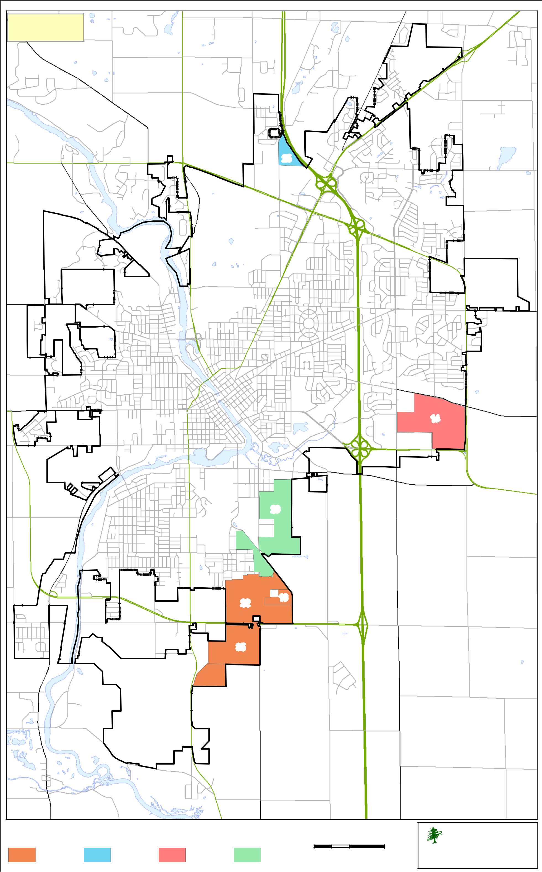
MEMORANDUM OF UNDERSTANDING REGARDING SELLER’S BROKERAGE COMMISSIONS

Exhibit B

The following represents the gross sale price value per acre for each of the respective TIF District’s subject to this MOU. Any real estate Broker appropriately licensed to conduct business in the State of Wisconsin may sell (under the terms and conditions approved by the City) any parcel set forth in the Exhibits hereto and shall receive an appropriate and applicable commission that will be paid by the City to the Broker upon a successful closing of one of the above properties; provided that the Broker otherwise meets the terms and conditions herein. Brokers eligible for commission shall be paid said commission by the City at closing in the amount of six percent (6%) of the gross listing price of the property as set forth in this Exhibit, regardless of the actual “incentivized” sale price.

TIF No. | Price Per Acre
14 | $22,096
16 | $34,303
22 | $34,303
25 | $32,226
26 | $22,000
35 | $34,303

The City hereby offers for sale certain parcels of land shown on Exhibit A attached hereto and described further herein at the “asking” prices set forth in this Exhibit. The parcels eligible for this MOU are any publicly owned industrial zoned land within the delineated boundaries of Exhibit A. The parcels offered herein as available for sale are subject to change, from time to time, at the City’s discretion, and the Broker shall confirm the availability of any parcel of interest before entering into any binding or other agreements concerning a parcel.

