CONFIDENTIAL

 | PERSONAL FINANCIAL STATEMENT
 |  |  | Statement Date:
 | Personal Information
Name: |  | SSN:
Address: |  | Birthdate:
City, State Zip: |  | Dependents:
Home Telephone: |  | Business Telephone:

Section I

 | ASSETS |  | LIABILITIES
1 | Cash on Hand & in Banks | 21 | Notes Due to Banks
2 | Cash Value of Life Insurance | 22 | Notes Due to Relatives & Friends
3 | U.S. Gov. Securities | 23 | Notes Due to Others
4 | Other Marketable Securities | 24 | Accounts & Bills Payable
5 | Notes & Accounts Receivable - Good | 25 | Unpaid Income Taxes Due - Federal State
- Other Assets Readily Convertible to Cash - Itemize 26 Other Unpaid Taxes & Interest

7 |  |  |  | 27 | Loans on Life Insurance Policies
8 |  |  |  | 28 | Contract Accounts Payable
9 |  |  | 29 |  | Cash Rent Owed
10 | TOTAL CURRENT ASSETS | $0.00 |  | 30 Other Liabilities Due within 1 Year - Itemiz
11 | Real Estate Owned |  | 31
12 | Mortgages & Contracts Owned |  | 32
13 | Notes & Accounts Receivable - Doubtful |  | 33 |  | TOTAL CURRENT LIABILITIES
14 | Notes Due from Relatives & Friends |  | 34 |  | Real Estate Mortgage Payable
15 | Other Securities - Not Readily Marketable |  | 35 |  | Liens & Assessments Payable
16 | Personal Property |  | 36 |  | Other Debts - Itemize
17 | Other Assets - Itemize |  | 37
18 |  |  | 38 |  | TOTAL LIABILITIES
19 |  |  | 39 |  | Net Worth (Total Assets - Total Liabilities)
20 | TOTAL ASSETS | $0.00 | 40 |  | TOTAL LIABILITIES & NET WORTH

$0.00

$0.00

$0.00

$0.00

ANNUAL INCOME |  | ESTIMATE OF ANNUAL EXPENSES
Salary, Bonuses & Commissions |  | Income Taxes
Dividends & Interest |  | Other Taxes
Rental & Lease Income (Net) |  | Insurance Premiums
Other Income - Itemize |  | Mortgage Payments
Other Persons Salary, Bonuses & Commissions |  | Rent Payable
Other Income of Other Person - Itemize |  | Other Expenses
Total | $0.00 | Total |  | $0.00

GENERAL INFORMATION |  |  |  |  | CONTINGENT LIABILITIES
Are any Assets Pledged? | No | Yes |  |  | As Endorser, Co-maker or Guarantor- Yes
Are you a Defendant in any Suits or Legal Actions? |  |  | No | Yes | On Leases or Contracts
(Explain) |  |  |  |  | Legal Claims
Have you ever been declared Bankrupt in the last 10 years? |  |  | No | Yes | Federal - State Income Taxes
(Explain) |  |  |  |  | Other -

Section II

A CASH IN BANKS AND NOTES DUE TO BANKS
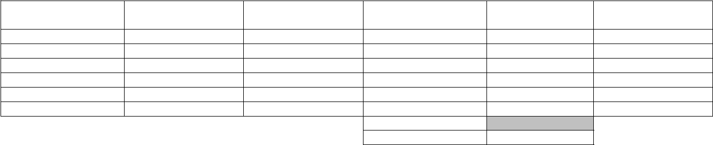

Name of Bank

Type of Account

Type of Ownership

On Deposit

Notes Due Banks

COLLATERAL (If any) & Type of Ownership

Cash on Hand

TOTALS

$0.00

$0.00

PERSONAL FINANCIAL STATEMENT 1

CONFIDENTIAL

SECTION II (Continued)

B LIFE INSURANCE (List only those Policies that you own)

Company

Face of Policy

Cash Surrender

Value

Policy Loan from

Insurance Co.

Other Loans Policy

as Collateral

BENEFICIARY

TOTALS

$0.00

$0.00

C SECURITIES OWNED

Face Value-Bonds | Indicate those Not
No. of Shares Stock | Registered in Your | Type of Ownership

COST
Market Value U.S.

Gov. Sec.

Market Value | MARKET VALUE Not Readily Marketable
Marketable Sec. | SECURITIES

Amount Pledged to Secured Loans

TOTALS

$0.00

$0.00

$0.00

- NOTES AND ACCOUNTS RECEIVABLE (Money Payable or Owed to You Individually-Indicate by a X if Others have an Ownership Interest)
 |  |  |  | Balance Due Good | Balance Due | Bal. Due Notes | Rel. &
MAKER/DEBTOR | X | When Due | Original Amount | Accounts | Doubtful Accounts | Friends | Security (if any)

TOTALS

$0.00

$0.00

$0.00

E REAL ESTATE OWNED (Indicate by a X if Others have an Ownership Interest) |  |  |  |  |  |  |  | MORTGAGE OR CONTRACT PAYABLE
TITLE IN NAME | Description & |  |  |  | Present Value of Real | Amount of Ins.
OF | Location | X | Date Acquired | Original Cost | Estate | Carried | Bal. Due | Payment | Maturity | To Whom Payable

TOTAL | $0.00 | TOTAL

F MORTGAGES AND CONTRACTS OWNED (Indicate by a if Others have an Ownership Interest)

$0.00

Contract

Mortgage

X

Maker Name

Maker Address

Property Covered

Start Date

Payment

Maturity

Balance Due

TOTALS

$0.00

G PERSONAL PROPERTY (Indicate by a X if Others have an Ownership Interest)

DESCRIPTION

X

Date When New | Cost When New

Value Today

Balance Due

To Whom Payable

TOTAL

$0.00

- NOTES (Other than Bank, Mortgage and Insurance Company Loans)
 | Other Obligors (if |  | Notes Due To Rel. & | Notes Due 'Others' | Accounts & Bills
PAYABLE TO | any) | When Due | Friends | (Not Banks) | Payable | Contracts Payable | COLLATERAL (if any)

TOTALS

$0.00

$0.00

$0.00

$0.00

For the purpose of procuring credit from time to time, I/We furnish the foregoing as a true and accurate statement of my/our financial condition. Authorization is hereby given to the Lender to verify in any manner it deems appropriate any and all items indicated on this statement. The undersigned also agrees to notify the Lender immediately in writing of any significant adverse change in such financial condition.

Signature: Signature: Date:

PERSONAL FINANCIAL STATEMENT 1

