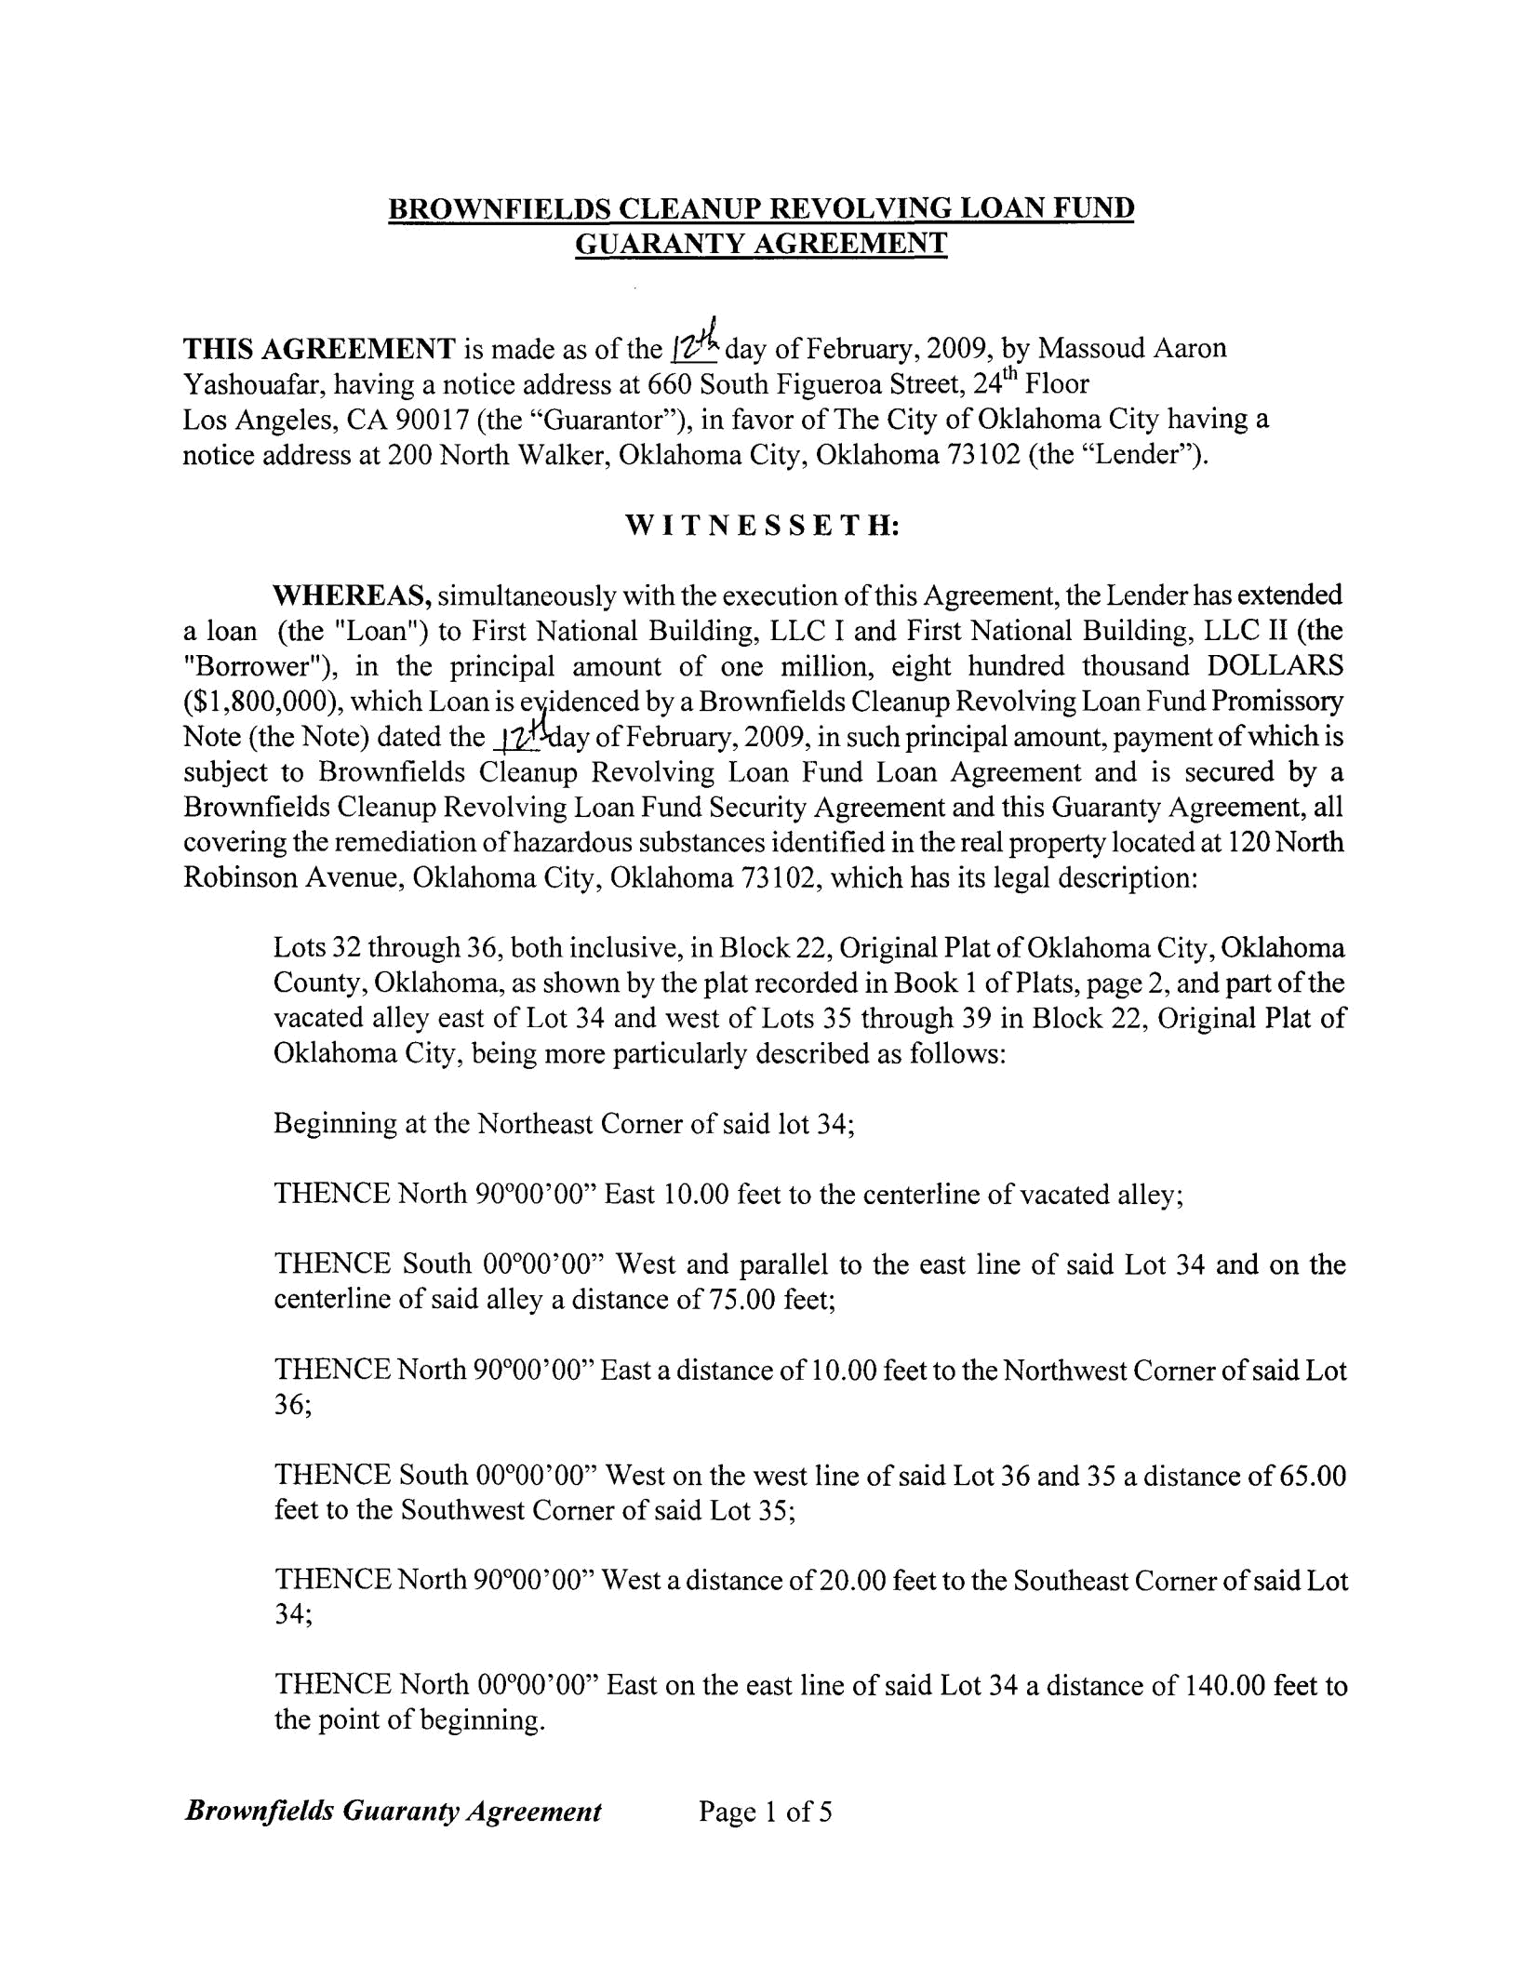
BROWNFIELDS CLEANUP REVOLVING LOAN FUND
GUARANTY AGREEMENT

THIS AGREEMENT is made as of the 1'Z-4day of February, 2009, by Massoud Aaron Yashouafar, having a notice address at 660 South Figueroa Street, 24th Floor

Los Angeles, CA 90017 (the "Guarantor"), in favor of The City of Oklahoma City having a notice address at 200 North Walker, Oklahoma City, Oklahoma 73102 (the "Lender").

WITNESSETH:

WHEREAS, simultaneously with the execution ofthis Agreement, the Lender has extended a loan (the "Loan") to First National Building, LLC I and First National Building, LLC II (the "Borrower"), in the principal amount of one million, eight hundred thousand DOLLARS ($1,800,000), which Loan is e,~idenced by a Brownfields Cleanup Revolving Loan Fund Promissory Note (the Note) dated the ~~ay ofFebruary, 2009, in such principal amount, payment ofwhich is subject to Brownfields Cleanup Revolving Loan Fund Loan Agreement and is secured by a Brownfields Cleanup Revolving Loan Fund Security Agreement and this Guaranty Agreement, all covering the remediation ofhazardous substances identified in the real property located at 120 North Robinson Avenue, Oklahoma City, Oklahoma 73102, which has its legal description:

Lots 32 through 36, both inclusive, in Block 22, Original Plat of Oklahoma City, Oklahoma County, Oklahoma, as shown by the plat recorded in Book 1 of Plats, page 2, and part ofthe vacated alley east of Lot 34 and west of Lots 35 through 39 in Block 22, Original Plat of Oklahoma City, being more particularly described as follows:

Beginning at the Northeast Comer of said lot 34;

THENCE North 90°00'00" East 10.00 feet to the centerline of vacated alley;

THENCE South 00°00'00" West and parallel to the east line of said Lot 34 and on the centerline of said alley a distance of75.00 feet;

THENCE North 90°00'00" East a distance of 10.00 feet to the Northwest Comer of said Lot 36;

THENCE South 00°00'00" West on the west line of said Lot 36 and 35 a distance of 65.00 feet to the Southwest Comer of said Lot 35;

THENCE North 90°00'00" West a distance of20.00 feet to the Southeast Comer of said Lot 34;

THENCE North 00°00'00" East on the east line of said Lot 34 a distance of 140.00 feet to the point of beginning.

Brownfields Guaranty Agreement Page 1 of 5

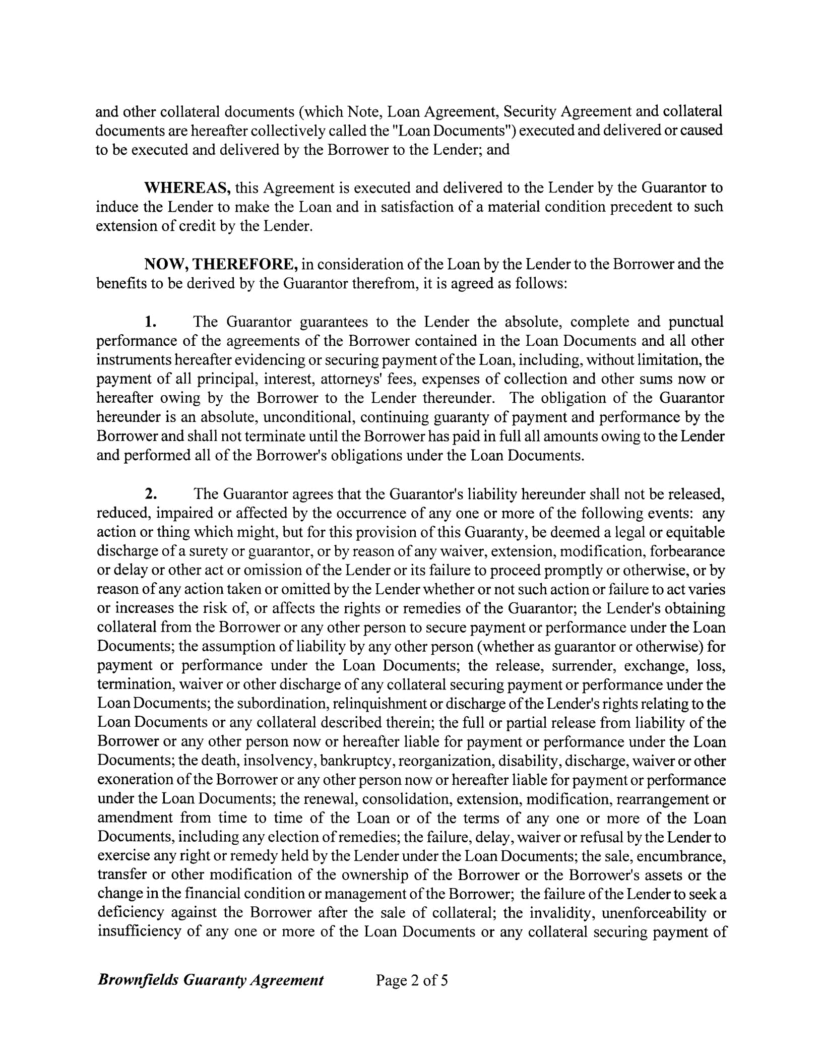
and other collateral documents (which Note, Loan Agreement, Security Agreement and collateral documents are hereafter collectively called the "Loan Documents") executed and delivered or caused to be executed and delivered by the Borrower to the Lender; and

WHEREAS, this Agreement is executed and delivered to the Lender by the Guarantor to induce the Lender to make the Loan and in satisfaction of a material condition precedent to such extension of credit by the Lender.

NOW, THEREFORE, in consideration of the Loan by the Lender to the Borrower and the benefits to be derived by the Guarantor therefrom, it is agreed as follows:

- The Guarantor guarantees to the Lender the absolute, complete and punctual performance of the agreements of the Borrower contained in the Loan Documents and all other instruments hereafter evidencing or securing payment ofthe Loan, including, without limitation, the payment of all principal, interest, attorneys' fees, expenses of collection and other sums now or hereafter owing by the Borrower to the Lender thereunder. The obligation of the Guarantor hereunder is an absolute, unconditional, continuing guaranty of payment and performance by the Borrower and shall not terminate until the Borrower has paid in full all amounts owing to the Lender and performed all of the Borrower's obligations under the Loan Documents.

- The Guarantor agrees that the Guarantor's liability hereunder shall not be released, reduced, impaired or affected by the occurrence of anyone or more of the following events: any action or thing which might, but for this provision of this Guaranty, be deemed a legal or equitable discharge of a surety or guarantor, or by reason of any waiver, extension, modification, forbearance or delay or other act or omission of the Lender or its failure to proceed promptly or otherwise, or by reason of any action taken or omitted by the Lender whether or not such action or failure to act varies or increases the risk of, or affects the rights or remedies of the Guarantor; the Lender's obtaining collateral from the Borrower or any other person to secure payment or performance under the Loan Documents; the assumption of liability by any other person (whether as guarantor or otherwise) for payment or performance under the Loan Documents; the release, surrender, exchange, loss, termination, waiver or other discharge of any collateral securing payment or performance under the Loan Documents; the subordination, relinquishment or discharge ofthe Lender's rights relating to the Loan Documents or any collateral described therein; the full or partial release from liability of the Borrower or any other person now or hereafter liable for payment or performance under the Loan Documents; the death, insolvency, bankruptcy, reorganization, disability, discharge, waiver or other exoneration ofthe Borrower or any other person now or hereafter liable for payment or performance under the Loan Documents; the renewal, consolidation, extension, modification, rearrangement or amendment from time to time of the Loan or of the terms of anyone or more of the Loan Documents, including any election ofremedies; the failure, delay, waiver or refusal by the Lender to exercise any right or remedy held by the Lender under the Loan Documents; the sale, encumbrance, transfer or other modification of the ownership of the Borrower or the Borrower's assets or the change in the financial condition or management ofthe Borrower; the failure ofthe Lender to seek a deficiency against the Borrower after the sale of collateral; the invalidity, unenforceability or insufficiency of anyone or more of the Loan Documents or any collateral securing payment of

Brownfields Guaranty Agreement Page 2 of5

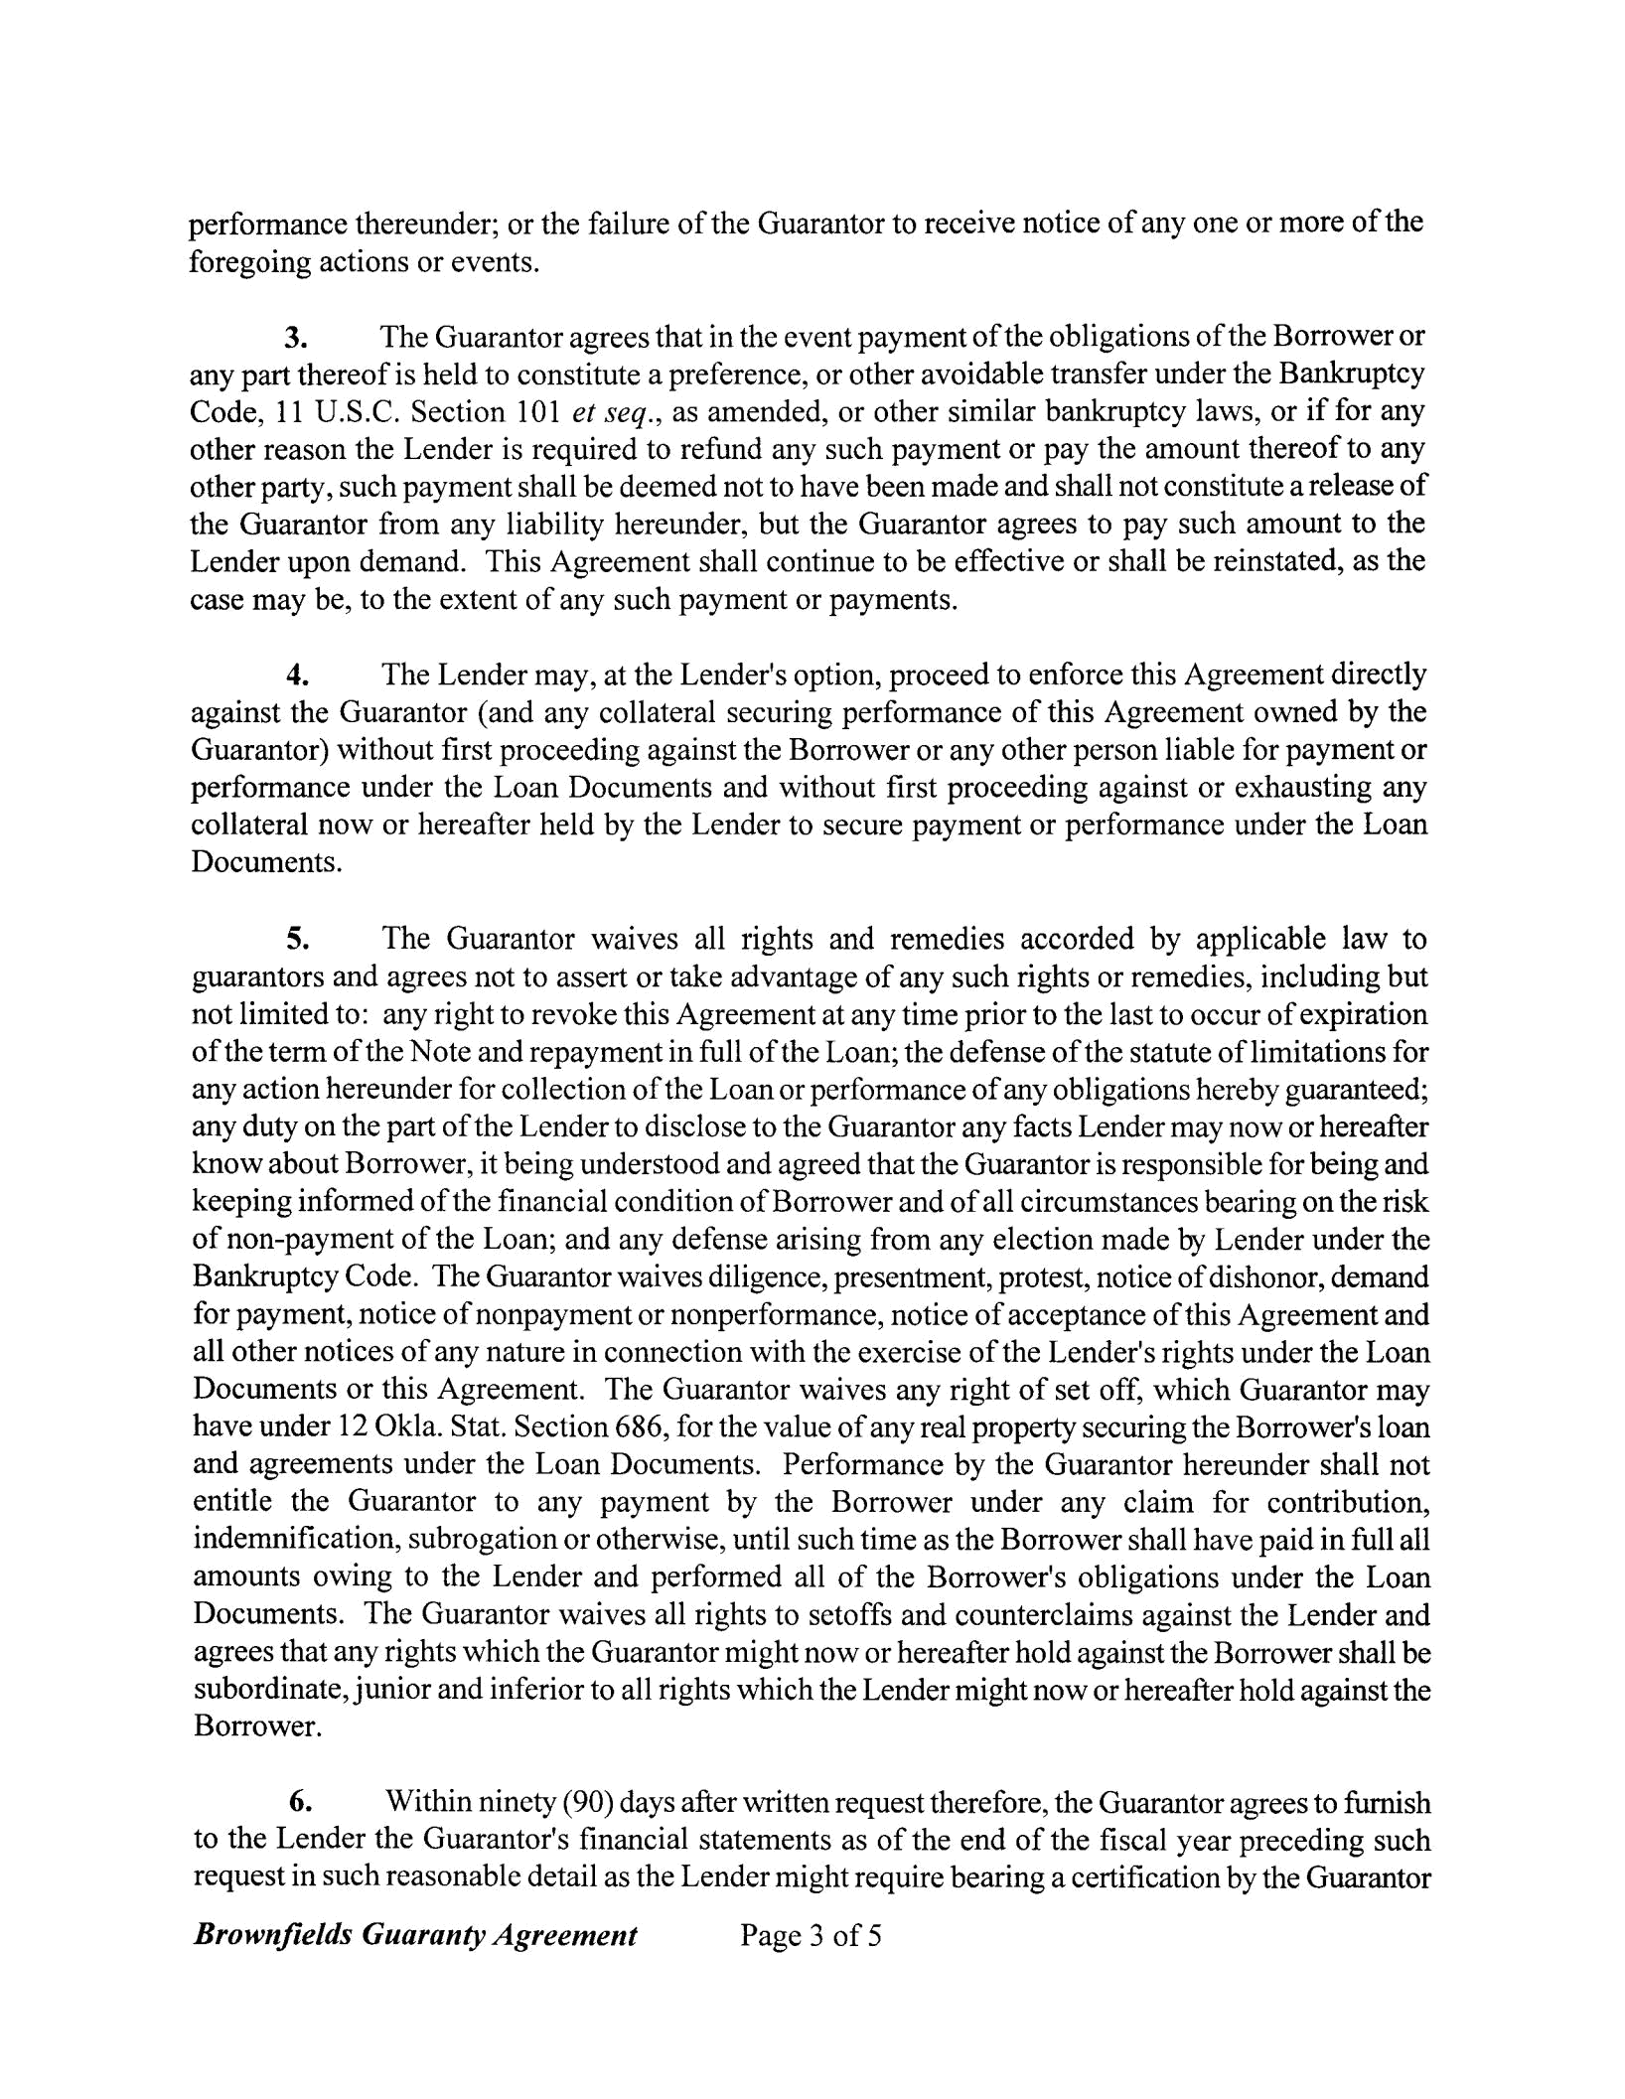
performance thereunder; or the failure of the Guarantor to receive notice of anyone or more of the foregoing actions or events.

- The Guarantor agrees that in the event payment ofthe obligations ofthe Borrower or any part thereof is held to constitute a preference, or other avoidable transfer under the Bankruptcy Code, 11 U.S.C. Section 101 et seq., as amended, or other similar bankruptcy laws, or if for any other reason the Lender is required to refund any such payment or pay the amount thereof to any other party, such payment shall be deemed not to have been made and shall not constitute a release of the Guarantor from any liability hereunder, but the Guarantor agrees to pay such amount to the Lender upon demand. This Agreement shall continue to be effective or shall be reinstated, as the case may be, to the extent of any such payment or payments.

  - The Lender may, at the Lender's option, proceed to enforce this Agreement directly against the Guarantor (and any collateral securing performance of this Agreement owned by the Guarantor) without first proceeding against the Borrower or any other person liable for payment or performance under the Loan Documents and without first proceeding against or exhausting any collateral now or hereafter held by the Lender to secure payment or performance under the Loan Documents.

  - The Guarantor waives all rights and remedies accorded by applicable law to guarantors and agrees not to assert or take advantage of any such rights or remedies, including but not limited to: any right to revoke this Agreement at any time prior to the last to occur of expiration ofthe term ofthe Note and repayment in full ofthe Loan; the defense ofthe statute oflimitations for any action hereunder for collection ofthe Loan or performance ofany obligations hereby guaranteed; any duty on the part ofthe Lender to disclose to the Guarantor any facts Lender may now or hereafter know about Borrower, it being understood and agreed that the Guarantor is responsible for being and keeping informed ofthe financial condition of Borrower and of all circumstances bearing on the risk of non-payment of the Loan; and any defense arising from any election made by Lender under the Bankruptcy Code. The Guarantor waives diligence, presentment, protest, notice ofdishonor, demand for payment, notice of nonpayment or nonperformance, notice of acceptance ofthis Agreement and all other notices of any nature in connection with the exercise of the Lender's rights under the Loan Documents or this Agreement. The Guarantor waives any right of set off, which Guarantor may have under 12 Okla. Stat. Section 686, for the value of any real property securing the Borrower's loan and agreements under the Loan Documents. Performance by the Guarantor hereunder shall not entitle the Guarantor to any payment by the Borrower under any claim for contribution, indemnification, subrogation or otherwise, until such time as the Borrower shall have paid in full all amounts owing to the Lender and performed all of the Borrower's obligations under the Loan Documents. The Guarantor waives all rights to setoffs and counterclaims against the Lender and agrees that any rights which the Guarantor might now or hereafter hold against the Borrower shall be subordinate, junior and inferior to all rights which the Lender might now or hereafter hold against the Borrower.

    - Within ninety (90) days after written request therefore, the Guarantor agrees to furnish to the Lender the Guarantor's financial statements as of the end of the fiscal year preceding such request in such reasonable detail as the Lender might require bearing a certification by the Guarantor

Brownfields Guaranty Agreement Page 3 of5
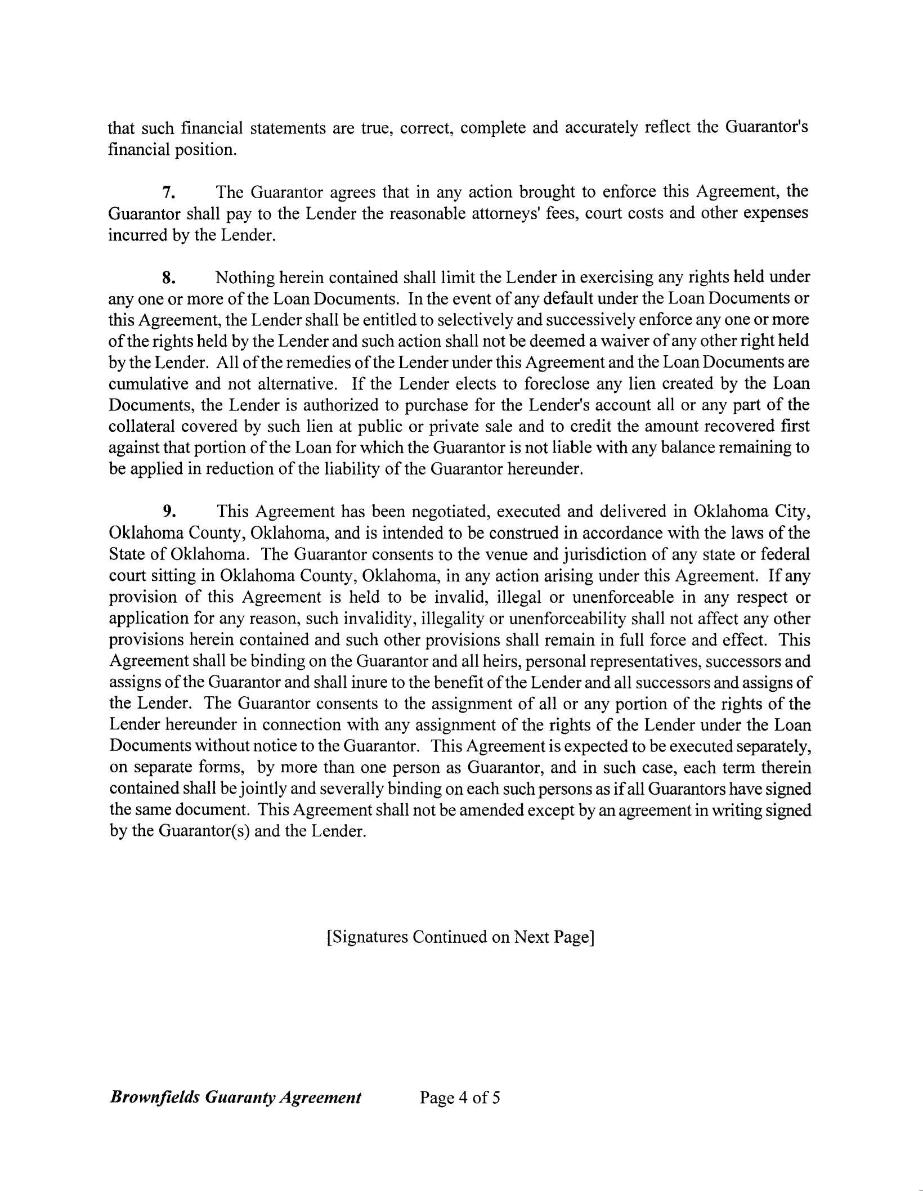
that such financial statements are true, correct, complete and accurately reflect the Guarantor's financial position.

- The Guarantor agrees that in any action brought to enforce this Agreement, the Guarantor shall pay to the Lender the reasonable attorneys' fees, court costs and other expenses incurred by the Lender.

- Nothing herein contained shall limit the Lender in exercising any rights held under anyone or more of the Loan Documents. In the event of any default under the Loan Documents or this Agreement, the Lender shall be entitled to selectively and successively enforce anyone or more ofthe rights held by the Lender and such action shall not be deemed a waiver of any other right held by the Lender. All ofthe remedies ofthe Lender under this Agreement and the Loan Documents are cumulative and not alternative. If the Lender elects to foreclose any lien created by the Loan Documents, the Lender is authorized to purchase for the Lender's account all or any part of the collateral covered by such lien at public or private sale and to credit the amount recovered first against that portion of the Loan for which the Guarantor is not liable with any balance remaining to be applied in reduction of the liability of the Guarantor hereunder.

- This Agreement has been negotiated, executed and delivered in Oklahoma City, Oklahoma County, Oklahoma, and is intended to be construed in accordance with the laws of the State of Oklahoma. The Guarantor consents to the venue and jurisdiction of any state or federal court sitting in Oklahoma County, Oklahoma, in any action arising under this Agreement. If any provision of this Agreement is held to be invalid, illegal or unenforceable in any respect or application for any reason, such invalidity, illegality or unenforceability shall not affect any other provisions herein contained and such other provisions shall remain in full force and effect. This Agreement shall be binding on the Guarantor and all heirs, personal representatives, successors and assigns ofthe Guarantor and shall inure to the benefit ofthe Lender and all successors and assigns of the Lender. The Guarantor consents to the assignment of all or any portion of the rights of the Lender hereunder in connection with any assignment of the rights of the Lender under the Loan Documents without notice to the Guarantor. This Agreement is expected to be executed separately, on separate forms, by more than one person as Guarantor, and in such case, each term therein contained shall be jointly and severally binding on each such persons as ifall Guarantors have signed the same document. This Agreement shall not be amended except by an agreement in writing signed by the Guarantor(s) and the Lender.

[Signatures Continued on Next Page]

Brownjields Guaranty Agreement Page 4 of5

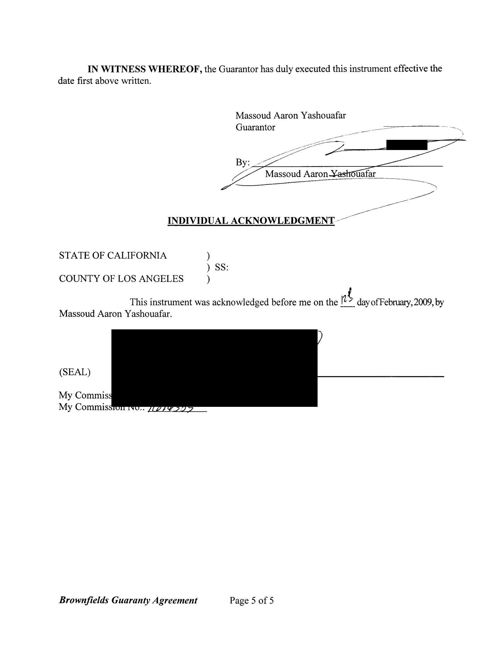
IN WITNESS WHEREOF, the Guarantor has duly executed this instrument effective the date first above written.

Massoud Aaron Yashouafar

Guarantor

^{By:}~~=------------ |  | =--=----
r::/ | ~~~~------ | uafar | ~-
 | Massoud Aaron | uafar
~~,
 | ------------ | ------/'
INDIVIDUAL ACKNOWLEDGMENT//'-------------
STATE OF CALIFORNIA | )
 | ) SS:
COUNTY OF LOS ANGELES | )

This instrument was acknowledged before me on the I~~day ofFebruary, 2009, by Massoud Aaron Yashouafar.

(SEAL)

My Commission Expires: zIt~;;.lJld

My Commission No.: iltllrf.5:j?

Brownfields Guaranty Agreement Page 5 of5

