COMMUTER CONNECTIONS STATE OF THE COMMUTE SURVEY 2010

Technical Survey Report

Draft

Prepared for:

Metropolitan Washington Council of Governments

Prepared by:

LDA Consulting

Washington, DC 20015

(202) 548-0205

In conjunction with:

CIC Research, Inc.

San Diego, CA

June 30, 2010
Commuter Connections 2010 State of the Commute Survey Draft Technical Report June 30, 2010

TABLE OF CONTENTS

SECTION 1 – INTRODUCTION | 1

SECTION 2 – SURVEY AND SAMPLING METHODOLOGY |  | 2
OVERVIEW |  | 2
QUESTIONNAIRE DESIGN |  | 2
SAMPLE SELECTION |  | 2
SURVEY ADMINISTRATION |  | 3
SURVEY DATA EXPANSION |  | 4
SECTION 3 - SURVEY RESULTS |  | 5
3-A CHARACTERISTICS OF THE SAMPLE |  | 7
- | Demographic characteristics | 7
- | Home and work locations | 10
- | Employment characteristics | 12
3-B COMMUTE PATTERNS |  | 14
- Number of days worked per week and work hours |  | 14
- Current commute mode |  | 14
- Primary commute mode by demographic group |  | 20
- Length of commute |  | 25
- Non-standard work schedules |  | 28
- Alternative mode use characteristics |  | 29
- Mode shifts and trial use of modes |  | 30
3-C TELEWORK |  | 34
- Current and potential teleworking |  | 34
- Telework patterns |  | 41
3-D AVAILABILITY OF AND ATTITUDES TOWARD TRANSPORTATION OPTIONS |  | 46
- Public transportation |  | 46
- High occupancy vehicle (HOV) and high occupancy toll lanes |  | 51
- Park & Ride lots |  | 56
- Attitudes toward transportation options |  | 57
- Ease of commute and commute satisfaction |  | 60
Table of Contents (cont.)

i

Commuter Connections 2010 State of the Commute Survey Draft Technical Report | June 30, 2010
3-E AWARENESS OF COMMUTE ADVERTISING AND SERVICES | 69
- Commute advertising recall | 69
- Commute advertising impact | 71
3-F AWARENESS AND USE OF COMMUTER ASSISTANCE RESOURCES | 75
- Awareness of commuter assistance numbers/web sites | 75
- Awareness and use of Commuter Connections Program | 76
- Awareness and use of local commuter assistance programs | 79
- Awareness and use of Regional Guaranteed Ride Home Program | 82
3-G EMPLOYER-PROVIDED COMMUTER ASSISTANCE SERVICES | 85
- Incentives / support services | 85
- Parking facilities and services | 89
- Use and impact of commuter assistance services/benefits | 91
3-H TRANSPORTATION SATISFACTION | 94
- Quality of life | 94
- Transportation satisfaction | 94
- Benefits of ridesharing | 98
SECTION 4 – SUMMARY AND CONCLUSIONS | 101
APPENDIX A – SURVEY DATA EXPANSION | 110
APPENDIX B – FINAL DIALING DISPOSITION

APPENDIX C – SURVEY QUESTIONNAIRE

APPENDIX D – INSTRUCTIONS AND DEFINITION OF TERMS

APPENDIX E – COMPARISON OF KEY SOC RESULTS – 2010, 2007, 2004, 2001

ii

Commuter Connections 2010 State of the Commute Survey Draft Technical Report June 30, 2010

LIST OF TABLES

Tables |  |  |  | Page
1 | Ethnic Background |  |  | 7
2 | Home and Work Locations |  | 10
3 | Home and Work Locations – Inner Core, Middle Ring, and Outer Ring |  | 11
4 | Employer Size |  | 12
5 | Occupation |  | 13
6 | Primary Mode by Ethnic Group |  | 21
7 | Primary Mode by Age |  | 21
8 | Primary Mode by Income |  | 22
9 | Primary Mode by Number of Household Vehicles |  | 22
10 | Primary Mode by Sex |  | 23
11 | Primary Mode by State of Residence and State of Employment |  | 23
12 | Commute Distance by Primary Mode |  | 26
13 | Commute Distance by Home and Work Area |  | 27
14 | Primary Commute Mode by Use of Non-Standard Schedules |  | 28
15 | Means of Getting from Home to Alternative Mode Meeting Place |  | 29
16 | Distance Traveled from Home to Alternative Mode Meeting Place |  | 30
17 | Summary of Current and Potential Telework – Respondents who are not |  | 36
 | Self-Employed/Work at Home
18 | Teleworkers by Demographic and Travel Characteristics |  | 37
19 | Teleworkers by Employment Characteristics |  | 39
20 | Formal or Informal Telework Arrangements, by Employer Type |  | 43
21 | Formal or Informal Telework Arrangements, by Employer Size |  | 44
22 | Frequency of Teleworking |  | 44
23 | Access Mode to Non-Home Telework Locations |  | 45
24 | Transit Service Operating in Home Area and Work Area |  | 46
25 | Public Transportation Companies that Provide Service in Home Area and Work Area |  | 47
26 | Mean Distance from Home to Bus Stop and Train Station By Transit Service Operating |  | 49
27 | Bus and Train Service by Home Area |  | 50
28 | Availability and Use of HOV Lanes by Residence Jurisdiction |  | 53
29 | Reasons for Not Using Carpool/Vanpool to Work |  | 57
30 | Reasons for Not Using Transit to Work |  | 59

iii

 | Commuter Connections 2010 State of the Commute Survey Draft Technical Report |  |  |  | June 30, 2010
 | List of Tables (continued)
 | Tables |  |  |  |  | Page
 | 31 | Commute Compared to Last Year, by Made a Change in Home or Work Location |  |  | 61
32 |  | Importance of Commute Ease Relative to Other Factors Considered in Home or Work |  |  | 64
 |  | Location Changes, Respondents who Made a Change in Work or Residence Location
33 |  | Recall of Advertising Sponsors |  |  | 70
34 |  | Advertising Sources/Media |  |  | 71
35 |  | Recall of Regional Commuter Assistance Telephone Number or Web site |  |  | 76
36 |  | Commuter Connections Program Referral Sources |  |  | 77
37 |  | Information and Services Sought in Contact to Commuter Connections |  |  | 78
38 |  | Information and Services Sought from Local Commute Assistance Programs |  |  | 81
39 |  | Awareness of Regional GRH Program by Current Primary Mode |  |  | 83
40 |  | Awareness of Regional GRH Program by Home and Work Location |  |  | 83
41 |  | Commuter Services/Benefits Offered, by Employer Type |  |  | 87
42 |  | Commuter Services/Benefits Offered, by Employer Size |  |  | 88
43 |  | Commuter Services/Benefits Offered, by Employer Location |  |  | 88
44 |  | Parking Facilities/Services Offered by Employers – 2010, 2007, 2004 |  |  | 89
 | LIST OF FIGURES |  |  |  |  | Page
 | Figures
 | 1 | Geographic Sub-areas – Inner Core, Middle Ring, Outer Ring |  |  | 6
2 |  | Respondent Age Distribution |  |  | 7
3 |  | Annual Household Income |  |  | 8
4 |  | Household Size |  |  | 8
5 |  | Household Vehicles – Owned or Leased |  |  | 9
6 |  | Household Vehicles – All Respondents by Home Area – Inner Core, Middle Ring, Outer Ring |  |  | 9
7 |  | Home and Work Locations – Inner Core, Middle Ring, and Outer Ring |  |  | 11
8 |  | Employer Type |  |  | 12
9 |  | Weekly Trips by Mode – 2010 |  |  | 15
10 |  | Weekly Trips by Mode – 2010, 2007, 2004, 2001 |  |  | 16
11 |  | Primary Modes and Modes Used as Primary or Secondary |  |  | 17
12 |  | Average Days Modes Used |  |  | 18
13 |  | Composition of Alternative Mode Groupings – Modes Used 1+ Days per Week |  |  | 19
14 |  | Duration of Mode Use |  |  | 20
15 |  | Primary Mode by Residence “Ring” |  |  | 24

iv

Commuter Connections 2010 State of the Commute Survey Draft Technical Report |  | June 30, 2010
List of Figures (continued)
Figures |  |  | Page
16 | Primary Mode by Employment “Ring” |  | 25
17 | Commute Distance (miles) |  | 25
18 | Commute Distance (minutes) |  | 26
19 | Non-Standard Schedule Types Used |  | 28
20 | Previous Mode of Current Alternative Mode Users |  | 31
21 | Alternative Modes Used/Tried in Past Two Years |  | 32
22 | Motivations to Start Using Current Mode or Try Another Alternative Mode |  | 33
23 | Percentage of Commuters who Telework – 2001, 2004, 2007, 2010 |  | 35
24 | Telework Status Distribution |  | 35
25 | Sources of Information About Telework |  | 40
26 | Length of Time Teleworking |  | 41
27 | Formal or Informal Telework Arrangements, All respondents and teleworkers vs Non-Teleworkers |  | 42
28 | Telework Arrangements – 2004, 2007, 2010 |  | 43
29 | Distance from Home to Bus Stop and Train Station |  | 48
30 | Distance from Home to Bus Stop by Home Area |  | 50
31 | Commute Mode by Distance from Home to Bus Stop |  | 51
32 | Travel Time Saving of HOV Users |  | 52
33 | Availability and Use of HOV Lanes by Home Area |  | 52
34 | Primary Commute Mode by Availability of HOV Lanes |  | 54
35 | HOV Influence on Choice of Commute Mode and Time Saved by HOV Lane Use |  | 55
36 | Likely to Try Carpool/Vanpool or to Register Existing Carpool/Vanpool to Receive HOT |  | 56
 | Lane Discount
37 | Awareness of Park & Ride Lots Along Route to Work – By Home Location |  | 56
38 | Commute Easier, More Difficult, or Same as Last Year |  | 60
39 | Reasons Commute is More Difficult or Easier |  | 61
40 | Factors Considered in Home or Work Location Changes, Respondents who Made a |  | 62
 | Change in Work or Residence Location
41 | Satisfaction with Commute |  | 65
42 | Satisfaction with Commute – Percent Rating Commute a 4 or 5 by Ease of Commute |  | 65
43 | Satisfaction with Commute – Percent Rating Commute a 4 or 5 by Home and Work Area |  | 66
44 | Satisfaction with Commute – Percent Rating Commute a 4 or 5 by Length of Commute |  | 67
45 | Satisfaction with Commute – Percent Rating Commute a 4 or 5 by Primary Commute Mode |  | 68

v

Commuter Connections 2010 State of the Commute Survey Draft Technical Report |  | June 30, 2010
List of Figures (continued)
Figures |  |  | Page
46 | Commute Information / Advertising Messages Recalled | 69
47 | Likely to Consider Ridesharing After Hearing/Seeing Ads by Respondent Age | 72
48 | Actions Taken to Change Commute After Hearing/Seeing Commute Advertising | 73
49 | Likely to Try Using an Alternative Mode Within the Next Year | 74
50 | Awareness of Regional Commute Information Resources | 75
51 | Awareness of Commuter Connections (Prompted or Unprompted) | 77
52 | Awareness of Commuter Connections Services | 78
53 | Heard of Local Jurisdiction Commute Assistance Program | 80
54 | Used Local Jurisdiction Commute Assistance Program | 80
55 | Awareness of Regional GRH Program – 2010, 2007, 2004 82
56 | Employer Offers any Incentives/Support Services - 2004, 2007, 2010 | 85
57 | Alternative Mode Incentives and Support Services Offered by Employers – 2010 and 2007 | 86
58 | On-site Free Parking Availability by Employer Type, Employer Size, and Work Area | 90
59 | Use of Employer Provided Incentives/Support Services – Of Employees who had | 91
 | Access to Services
60 | Primary Commute Mode by Commuter Services/Benefits Reported Offered | 92
61 | Primary Commute Mode by Free Parking Available at Work | 93
62 | Ratings for Quality of Life | 94
63 | Ratings for Transportation Satisfaction | 95
64 | Ratings for Quality of Life and Transportation Satisfaction by Home Location | 95
65 | Ratings for Transportation Satisfaction by Primary Commute Mode | 96
66 | Ratings for Transportation Satisfaction by Commute Travel Time | 96
67 | Ratings for Transportation Satisfaction by Distance from Home to Bus Stop and Distance | 97
 | From Home to Rail Station
68 | Recommendations to Improve Regional Transportation | 98
69 | Personal Benefits of Alternative Mode Use | 99
70 | Societal Benefits of Alternative Mode Use | 100

vi

Commuter Connections 2010 State of the Commute Survey Draft Technical Report June 30, 2010

SECTION 1 – INTRODUCTION

This report presents the results of the State-of-the-Commute (SOC) Survey conducted for the Commuter Connections program of the Metropolitan Washington Council of Governments (COG).¹ Commuter Connections provides a wide range of transportation information and assistance services in the Washing-ton metropolitan area designed to inform commuters of the availability and benefits of alternatives to driving alone and to assist them to find alternatives that fit their commute needs. COG administers these services, called Transportation Emission Reduction Measures (TERMs), in a regional effort to reduce ve-hicle trips, vehicle miles of travel, and emissions resulting from commute travel.

COG has a strong interest in evaluating the effectiveness of its commuter services programs. In 1997 Commuter Connections established an evaluation framework that outlined a methodology and data collec-tion activities to evaluate several of its commuter programs. This framework was updated and revised four times, in 2001, 2004, 2007, and 2010, to include several enhancements.² A major addition to the 2001 framework was the State of the Commute (SOC) survey, a random sample survey of employed per-sons in the Washington metropolitan region.

The SOC survey serves several purposes. First, it documents trends in commuting behavior, such as commute mode shares and distance traveled, and prevalent attitudes about specific transportation services, such as public transportation, that are available to commuters in the region.

Second, the SOC survey is used to help estimate the impacts of some TERMs, such as Commuter Con-nections’ Telework Assistance and Mass Marketing, two TERMs that might influence the population-at-large as well as commuters who directly participate in Commuter Connections’ programs. Finally, by querying commuters about sources of information on alternative modes and their reasons for choosing alternative modes for commuting, the survey examines how other commute alternative programs and marketing efforts might influence commuting behavior in the region.

This report summarizes the survey methodology, presents key results of the survey, and offers conclu-sions about regional commute travel based on the results. The report is divided into three sections follow-ing this introduction:

Section 2 – Description of the survey and sampling methodology

Section 3 – Presentation of the survey results

Section 4 – Conclusions from the survey results

Following these four main sections are six appendices dealing with survey procedures. They include: Appendix A – Survey data expansion, Appendix B – Final dialing disposition, Appendix C – SOC Survey instruments, Appendix D – Interviewer Instructions and Terms, and Appendix E – Comparison of SOC Results – 2010, 2007, 2004, and 2001.

- Commuter Connections is administered through the National Capital Region Transportation Planning Board at COG and funded through the District Department of Transportation, the Maryland Department of Transportation, and the Virginia Department of Transportation, with state and federal funds.
- For more information on the evaluation framework in effect at the time of this survey, readers may refer to Trans-portation Emissions Reduction Measures (TERMs) Revised Evaluation Framework – 2008 – June 2011, available from COG.

1

Commuter Connections 2010 State of the Commute Survey Draft Technical Report June 30, 2010

SECTION 2 – SURVEY AND SAMPLING METHODOLOGY

Overview

The geographic scope of COG’s responsibility encompasses the 11 independent cities and counties that make up the Washington metropolitan region. All households within this geographic area that had at least one employed person residing in the household were eligible for selection in the 2010 study. A minimum of 600 random telephone surveys were conducted in each of the 11 jurisdictions of the study area, result-ing in 6,629 completed interviews.

The primary purpose of conducting this survey was to meet multiple objectives, including trend analysis and TERM evaluation. Wherever possible, an attempt was made to replicate questions used in previous TDM studies to allow for trend analysis. Additionally, the SOC Survey included survey modules specific to four TERMs: Maryland and Virginia Telework, Guaranteed Ride Home, employer Outreach, and Mass Marketing.

Questionnaire Design

The 2010 SOC questionnaire was based on the questionnaire used in 2007, with modifications and addi-tions as needed. LDA Consulting, CIC Research, and COG modified the survey questionnaire, with in-put from a TDM Evaluation Group comprised of representatives from the District of Columbia, Mary-land, and Virginia. The survey was intended to meet multiple objectives, including trend analysis and evaluation of two TERMs: Telework and Mass Marketing.

Wherever possible, the study team retained the 2007 SOC questions to allow trend analysis, but changes were made when the revisions were expected to add substantially to the accuracy of the data. Minor changes were made to the 2007 questionnaire to enhance respondents’ understanding of the question and several questions were deleted to shorten the survey. Several new questions were added to examine sig-nificant new transportation topics, including quality of life and satisfaction with the regional transporta-tion system.

Before the full survey was conducted, CIC completed a pretest of the questionnaire. The pretest was con-ducted on January 22 and 23, 2010 resulting in 128 completed interviews. Using the responses to these interviews, the questionnaire was finalized with the study team and translated into Spanish. The survey instrument was designed for telephone administration using Computer Assisted Telephone Interviewing (CATI). A copy of the English questionnaire is included in Appendix C. The Spanish version of the questionnaire is available upon request.

Sample Selection

The survey described in this report was conducted using a random sample of residents in the 11-jurisdiction Washington, DC region. Eligible respondents were 18-years of age or older, employed, and residing within the study area. Quotas were set at a minimum of 600 completed surveys in each of the 11 jurisdictions. Sample points were chosen randomly from the database developed by CIC Research. A total of 367,139 sample points were generated internally through CIC’s random digit dialing sampling system, GENESYS. This system was used to randomly draw telephone numbers by county and, where prefixes overlapped counties, by ZIP code, from all working prefixes.

2

Commuter Connections 2010 State of the Commute Survey Draft Technical Report June 30, 2010

Next, CIC used its Voxco CATI system in the sample cleaning process. The Voxco system uses a Pronto dialer which pre-screens the sample points for disconnected, fax, and business telephone numbers. This procedure was completed prior to starting the survey and resulted in 195,865 ineligible sample points be - ing purged from original sample. The remaining 171,454 sample points were eligible to be included for random selection in the survey. A detailed list of dialing results can be found in Appendix B.

Survey Administration

The telephone survey was conducted in CIC’s telephone survey facility. Interviews were conducted using the Voxco CATI system. The Voxco system is an integrated survey system encompassing both CATI and Web applications which simplifies survey management while boosting interviewer performance. Before beginning the full survey effort, CIC conducted an interviewer-training session. Items included in the session were:

Explanation of the purpose of the study

Identification of the group to be sampled

Overview of COG and its function

Review of the definition and instruction sheet to familiarize interviewers with the terminology Verbatim reading of the questionnaire

Paper/CATI review of skip-patterns to familiarize interviewers with questionnaire flow Practice session on CATI systems in full operational mode

Interviews were conducted between January 22 and April 30, 2010. A survey pretest was conducted on January 22 and 23 to test changes to the questionnaire and sample administration. Following the success-ful pretest, interviewing continued on January 28, 2010. All calls were made to the respondents’ home numbers. Weekday calls were made from 5:30 pm to 8:30 pm local time and weekend calls from 10:00 am to 6:30 pm local time. CIC interviewers conducted a minimum of five callback attempts at different times and over different days throughout the data collection period. CIC adopted measures to assure con-fidentiality of responses. Bilingual interviewers surveyed all Spanish-speaking respondents using the Spanish version of the questionnaire. A total of 74 interviews (1.1%) were completed in Spanish.

All interviewing was conducted with survey supervisors present. The survey supervisors were responsi-ble for overseeing the CATI server, checking quotas, editing call-back appointment times, monitoring interviews, answering questions, and reviewing completed surveys. To insure quality control, the survey supervisors monitored a minimum of 10% of each surveyor’s interviews. Other quality assurance logical checks were applied as the survey data was collected. Overall, the interview took an average of 21.1 mi-nutes to complete in 2010 as compared to 16.5 minutes in 2007.

A minimum of 600 interviews were completed in each of the 11 jurisdictions, resulting in a total sample size of 6,629. The refusal rate for the 2010 survey was 14.3 percent³ compared with 14.8 percent in the 2007 study. An average of 73.0 call attempts was made for each completed interview. This was an in-crease from 62.2 call attempts in the 2007 study. This trend toward an increasing number of call attempts is likely due to higher use of personal answering machines, caller-ID services, and other technical servic-es that make it possible for respondents to screen telephone calls and avoid answering calls from un-known persons.

- Refusal rates are calculated as the number of initial refusals plus the number terminated during the interview, di-vided by the total sample. See Appendix B.

3

Commuter Connections 2010 State of the Commute Survey Draft Technical Report June 30, 2010

Survey Data Expansion

Survey responses were expanded numerically to align the sampled survey results with published em-ployment information for the study area. A two-part process was implemented to ensure that the survey results were representative of the region and of each of the 11 study areas. First data from the Bureau of Labor Statistics (BLS), Local Area Unemployment Statistics (LAUS) were utilized to estimate the num-ber of workers for each of the 11 sampled jurisdictions. This employment information was used to com-pute jurisdiction-level expansion factors, which were applied to the survey results to determine their pro-portion for regional analysis.

Second, survey results were adjusted to align the sample for ethnicity: Black, Hispanic, White and Other groups. Weighting factors were calculated from ethnicity distributions published in the U.S. Census Bu-reau’s American Community Survey (ACS). This is an on- going survey which surveys populations throughout the United States and thus includes the 11 study areas. Additional details on the expansion process used for the survey are detailed in Appendix A.

4

Commuter Connections 2010 State of the Commute Survey Draft Technical Report June 30, 2010

SECTION 3 – SURVEY RESULTS

This section of the report presents the key findings of the survey. To align the sampled survey results with published numbers for the study area, the data were weighted to represent the number of employed people in the metropolitan region. The expansion methodology, described in Appendix A, allows the proper representation of employees in each of the 11 jurisdictions included in the survey area. Percentag - es presented in the results tables and figures show percentages weighted to the total working population, but also show the raw number of respondents (e.g., n=__) who answered the question.

The results in this section generally follow the order of sections in the survey questionnaire.

3-A Characteristics of the sample

3-B Commute patterns

3-C Telework

3-D Availability of and attitudes toward transportation options

3-E Awareness of commute advertising and services

3-F Awareness of use of commuter assistance resources

3-G Employer-provided commuter assistance services

3-H Transportation satisfaction

Comparisons to Past SOC Surveys

Where relevant, survey results are compared for sub -groups of respondents. Survey results also are com-pared with corresponding data from the 2007, 2004, and 2001 SOC Surveys, where the comparison is notable. A comparison of key results from the three SOC surveys also is presented in Appendix E.

The 2010 survey surveyed residents of 11 jurisdictions. This also was the sample area for the 2007 sur-vey, but the 2001 and 2004 surveys surveyed residents of 12 jurisdictions. Stafford County, VA, which was included in the 2001 and 2004 survey samples, was removed in 2007 because it was no longer part of the federally-designated COG non-attainment area. Thus, the sampled area in 2010 and 2007 was not identical to the areas covered in the 2004 and 2001 surveys.

In 2007, COG examined the possible implications of the change in the survey area and concluded that eliminating Stafford County from the survey area did not represent a significant issue for comparison of 2007 results to results of the earlier surveys. This was primarily because Stafford County accounted for a very small proportion of the overall weighted sample. In 2004, Stafford County accounted for only 2.0% of the region’s resident workers and an even smaller share, just 0.8%, of all workers destined for the 12-jurisdiction area.

COG compared key variables (e.g., travel mode, commute distance, telework percentage, etc.) for Staf-ford County with values for the 12-jurisdiction region. In most cases, Stafford County results were not statistically different from the regional averages. Thus, removing Stafford County would not have changed the overall regional results in 2004, even if Stafford had constituted a larger share of the total worker population of the region. In a few cases (e.g., travel distance, travel time), the results for Stafford were statistically different from the regional averages, but removing Stafford from the sample did not change the overall regional average significantly, due to the small contribution of Stafford’s results to the regional average.

5

Commuter Connections 2010 State of the Commute Survey Draft Technical Report June 30, 2010

Geographic Analysis

The SOC analysis focused primarily on the region as a whole. However, for some questions, the analysis examined results for individual jurisdictions or other geographic sub-areas of the region. The primary sub-area categorization divided the region into three categories representing concentric rings around the central core (Figure 1).

Figure 1

Geographic Sub-Areas – Inner Core, Middle Ring, Outer Ring
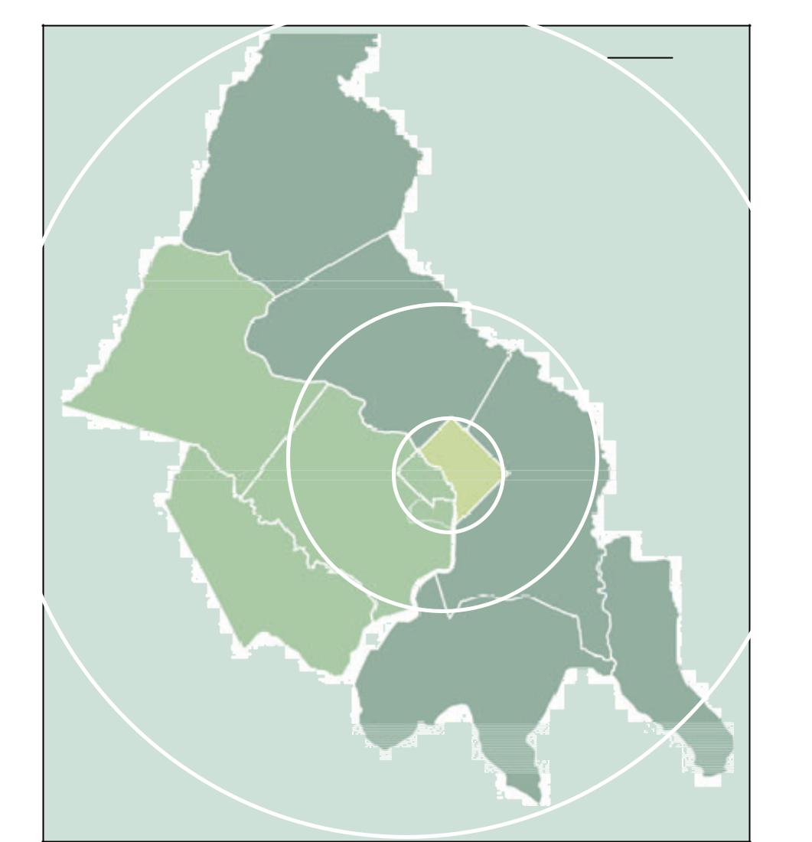

Outer

Ring*

Frederick

County

Loudoun |  | Montgomery |  |  |  |  |  | Middle
 |  |  |  |  |  |  |  | Ring*
County |  | County
 |  | Washington, |  |  |  | Inner Core*
 |  | Arlington _{DC}
Fairfax |  | County
 |  | City of
County |  |  |  | Prince
 |  | Alexandria
 |  |  |  | George’s
 |  |  | County
 | Prince William |  | Calvert
 | County
 |  |  | County
 |  |  | Charles
 |  |  | County

*Lines showing ring areas are an approximation of the geographical areas within each ring.

The Inner Core area included the City of Alexandria, Arlington County, and the District of Columbia.

The Middle Ring, surrounding the core, included Fairfax, Montgomery, and Prince George’s counties.

The Outer Ring included Calvert, Charles, Frederick, Loudoun, and Prince William counties.

6

Commuter Connections 2010 State of the Commute Survey Draft Technical Report June 30, 2010

3-A CHARACTERISTICS OF THE SAMPLE

At the end of the survey interview, respondents were asked a series of questions about themselves, includ-ing: age, ethnic background, sex, income, household size, vehicle ownership, home and work locations, type of employer, size of employer, and occupation. These results are presented first, to define characte-ristics of the sample.

Demographic Characteristics

Age

As shown in Figure 2, more than half (55%) of respondents were between the ages of 35 and 54. About 17% were younger than 35 and 28% were 55 years or older.

 |  | Figure 2
100% |  | Respondent Age Distribution
100% |  | (n = 6,506)
80%
60%
40% | 24% |  | 31%
20%
20% | 13%
0% | 4%
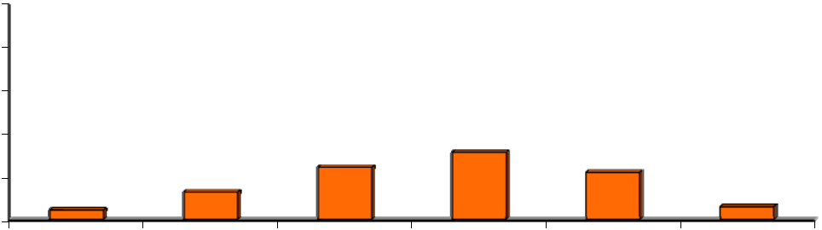

18-24 years 25-34 years 35-44 years 45-54 years

22%

6%

55-64 years 65 or more years

Ethnic Background

As illustrated in Table 1, Caucasians and African-Americans represented the two largest ethnic groups of survey respondents, 53% and 23% respectively. Hispanic and Latino respondents accounted for about 11% and Asians/Pacific Islanders represented 10% of the total.

Table 1

Ethnic Background

(n = 6,308)


 | Ethnic Group |  |  | Percentage
 | White/Caucasian |  | 53%
 | African-American |  | 23%
 | Hispanic/Latino |  | 11%

 | Ethnic Group
 | Ethnic Group |  |  | Percentage
 | Asian |  | 10%
 | Other/Mixed |  | 3%

Sex

Most respondents were female (56%). This was essentially the same percentage as in the 2007, 2004, and 2001 SOC surveys.

7

Commuter Connections 2010 State of the Commute Survey Draft Technical Report June 30, 2010

Income

Figure 3 presents the distribution of respondents’ annual household income. Nearly three-quarters re-ported incomes of $80,000 or more and almost half (49%) had incomes of $120,000 or more.

Figure 3

Annual Household Income

(n = 5,596)
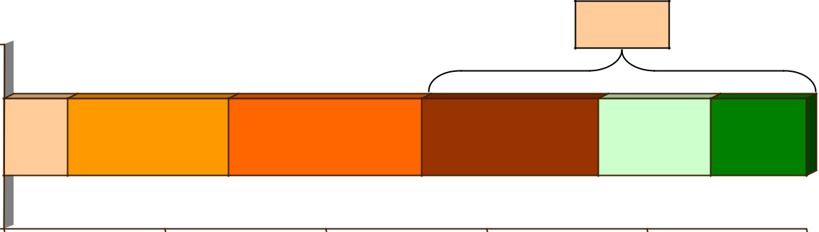

49%

8%

19%

24%

22%

12%

15%

0% | 20% |  |  | 40% | 60% |  | 80% |  | 100%
 |  |  | < $40,000 |  |  | $40,000-$79,999 |  | $80,000-$119,999
 |  |  | $120,000-$159,999 |  |  | $160,000-$199,999 |  | $200,000 +

Household Size and Composition

Fifteen percent of respondents said they were the only member of their household and about three in ten (32%) of respondents lived with one other person (Figure 4). The remaining respondents lived with at least two other household members. The majority of households were comprised of adults and/or child-ren older than 16 years of age. Only 38% of respondents said their households included one or more children under the age of 16.
 |  |  | Figure 4
 |  |  | Household Size
100% |  |  | (n = 6,551)
80%
60%
40% |  | 32% |  |  |  | 33%
20% |  |  |  | 20% |  | 33%
20% | 15%
0% | 15%
 | 1 person | 2 persons |  | 3 persons |  | 4 or more
 |  |  |  |  |  | persons
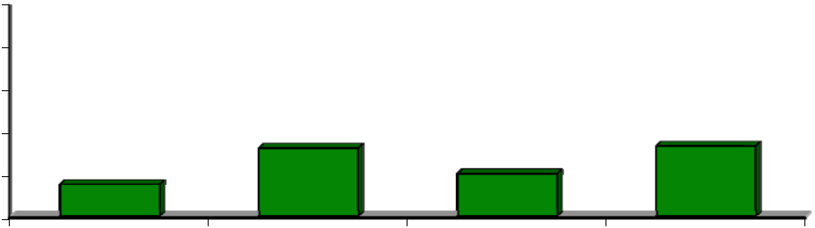

Household Vehicle Ownership

Only four percent of respondents said they had no household vehicle. About a quarter had one vehicle per household and 42% had two or more vehicles. These results are presented in Figure 5.

8

Commuter Connections 2010 State of the Commute Survey Draft Technical Report |  |  |  |  | June 30, 2010
 |  | Figure 5
 |  | Household Vehicles – Owned or Leased
100% |  | (n = 6,522)
80%
60%
40% |  |  | 42%
40% |  | 25% |  | 29%
20% |  | 25%
0% | 4%
 | 0 vehicles | 1 vehicle | 2 vehicles | 3 or more
 |  |  |  | vehicles


Vehicle ownership differed substantially, however, by where respondents lived. As indicated by Figure 6, vehicle ownership was lower among residents who lived in the Inner Core than in either the Middle Ring or Outer Ring.⁴ Twelve percent of Inner Core respondents said they did not have a household vehicle, compared with only two percent of Middle Ring respondents and one percent of Outer Ring respondents.

Figure 6

Household Vehicles – All Respondents

By Home Area – Inner Core, Middle Ring, and Outer Ring

(Inner Core n = 1,768, Middle Ring n = 1,770, Outer Ring n = 2,981)

100%
80%
60% |  | 43% |  |  |  |  |  | 45% _{43%} |  |  | 43%
40% |  |  |  |  |  |  |  | 33% |  |  | 30%
40% |  |  |  |  | 23% |  |  | 33% |  |  | 30%
 |  |  |  |  |  |  |  |  |  |  | 12%
20% | 12% |  |  |  | 13% |  |  |  |  |  | 12%
0% | 2% | 1%
 | 0 vehicles |  |  |  | 1 vehicle |  |  | 2 vehicles |  |  | 3 or more vehicles
 |  |  |  | Inner Core |  |  | Middle Ring |  |  | Outer Ring
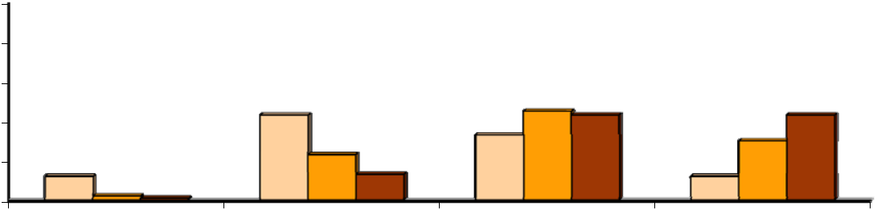

Inner Core area respondents also were much less likely than were respondents in other areas to have two or more vehicles per household. But this was due in part to their smaller household sizes; only 38% of Inner Core respondents lived in a household with three or more members, compared with 55% of Middle Ring respondents and 68% of Outer Ring respondents.

- Section 3 introduced the three geographic “ring” designations that were defined for the survey analysis. The Inner Core area included the City of Alexandria, Arlington County, and the District of Columbia. The Middle Ring, sur-rounding the core, included Fairfax, Montgomery, and Prince George’s counties. The Outer Ring included Calvert, Charles, Frederick, Loudoun, and Prince William counties.

9

Commuter Connections 2010 State of the Commute Survey Draft Technical Report June 30, 2010

Home and Work Locations

Table 2 presents the distribution of respondents by their home and work states and counties. About equal shares of respondents lived in Maryland (44%) and Virginia (45%). The remaining 12% of respondents lived in the District of Columbia. Because the survey only interviewed residents of the 11-jurisdiction area, no respondents lived outside these areas.

Table 2

Home and Work Locations

 | State/County |  |  | Home Location* |  |  | Work Location**
 | State/County |  |  | (n=6,629) |  |  | (n=6,629)
 | District of Columbia |  |  | 12% |  |  | 34%
 | Maryland Counties |  |  | 44% |  |  | 27%
 | Montgomery Co. |  | 19% |  |  | 14%
 | Prince Georges Co. |  | 16% |  |  | 8%
 | Frederick Co. |  | 4% |  |  | 3%
 | Charles Co. |  | 3% |  |  | 1%
 | Calvert Co. |  | 2% |  |  | 1%
 | Virginia Counties |  |  | 45% |  |  | 37%
 | Fairfax Co. |  | 22% |  |  | 18%
 | Prince William Co. |  | 8% |  |  | 3%
 | Arlington Co. |  | 5% |  |  | 8%
 | Loudoun Co. |  | 6% |  |  | 4%
 | Alexandria City |  | 3% |  |  | 4%
 | Other*** |  |  | N/A |  |  | 2%

- Adjusted distribution allows for the proper representation of working households in each geographical area. Note that state totals might add to more than 100% due to rounding.
- Work location percentages for Maryland and Virginia include only counties in the COG 11-jurisdiction re-gion. Maryland and Virginia locations outside this area are counted in the “other” category.
- Each response in the “Other” category was mentioned by less than one percent of respondents.

Work locations were more evenly divided. The largest number of respondents worked in Virginia (37%), but the District of Columbia and Maryland, with 34% and 27% of respondents respectively, were close behind in their share of employment.

Four jurisdictions accounted for residences of seven in ten respondents: Fairfax County (including Fair-fax City and Falls Church) (22%), Montgomery County, MD (19%), Prince George’s County, MD (16%), and the District of Columbia (12%). The same four jurisdictions also represented about three-quarters of

10

Commuter Connections 2010 State of the Commute Survey Draft Technical Report June 30, 2010

the work locations, but in different proportions: District of Columbia (34%), Fairfax County (18%), Montgomery County (14%), and Prince George’s County (8%).

Figure 7 presents the distribution of respondents’ home and work locations by their “ring” location. More than half of respondents lived in the Middle Ring. The remaining respondents were about evenly divided between the Inner Core and Outer Ring. Work locations, by contrast, were concentrated in the Inner Core (46%) and Middle Ring (40%). Only 14% of respondents said they worked in an Outer Ring jurisdiction.

Figure 7

Home and Work Locations – Core, Mid-Ring, and Outer-Ring

(Home area n = 6,629, Work area n = 6,601)

100%
80% | 57%
60% |  |  |  |  |  |  | 46%
60% |  |  |  |  |  |  |  |  | 40%
40% | 20% |  |  | 23%
20% | 20% |  |  | 23% |  |  |  |  | 14%
0%
 | Home Area |  |  |  |  |  |  |  | Work Area
 |  |  | Inner Core |  |  | Middle Ring |  | Outer Ring
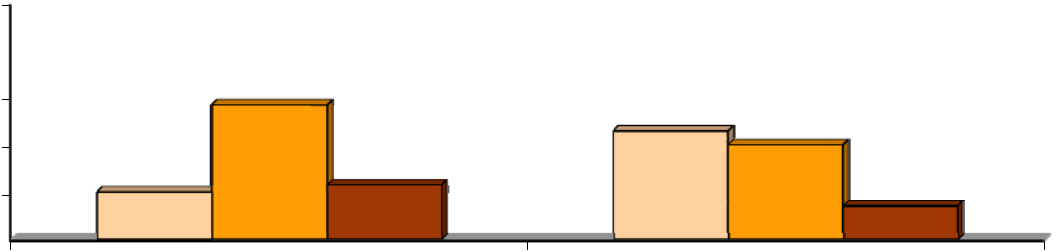

As Figure 7 suggests, most respondents worked either in the geographic region where they lived or in an area closer to the center of the region. Table 3 indicates that 83% of Inner Core respondents also worked in the Inner Core. About half of Middle Ring respondents worked in this sub-area and 42% traveled to the Inner Core. About half (46%) of Outer Ring respondents worked in the Outer Ring, but a third tra-veled inbound to the Middle Ring and 22% traveled to the Inner Core. Few respondents traveled out-bound to a more distant ring.

Table 3

Home and Work Locations – Core, Middle Ring, Outer Ring

 | Home Area |  |  |  |  |  | Work Area
 | Home Area |  |  | Inner Core |  |  | Middle Ring |  |  | Outer Ring
 | Inner Core (n = 2,881) |  | 83% |  |  | 15% |  |  | 2%
 | Middle Ring (n = 2,099 |  | 42% |  |  | 52% |  |  | 6%
 | Outer Ring (n = 1,621) |  | 22% |  |  | 32% |  |  | 46%

11

Commuter Connections 2010 State of the Commute Survey Draft Technical Report June 30, 2010

Employment Characteristics

Type and Size of Employer

Type – Respondents were asked for what type of employer they worked and the number of employees at their worksites. These results are shown in Figure 8 and Table 4, respectively. Four in ten (41%) respon-dents worked for a private sector employer. Government agencies employed about the same share: feder-al agencies, 24%, and state and local agencies, 12%. About one in ten (13%) worked for a non-profit or-ganization and the remaining 10% were self-employed.

Figure 8

Employer Type

(n = 6,512)

Self-employed
10%
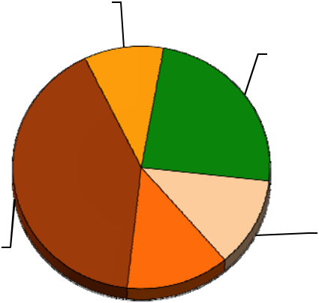

Federal agency
24%

Private sector |  |  | State/local
Private sector |  |  | agency
41% |  |  | agency
41% | 12%
 |  |  | Non-profit
 | 13%

Size – The majority of respondents worked for employers that are either very small or very large (Table 4). More than four in ten (44%) worked for firms with 100 or fewer employees. About a quarter (27%) worked for employers that employ 1,000 or more employees.

Table 4

Employer Size

(n = 5,933)

 | Number of Employees |  |  | Percentage |  |  | Number of Employees |  |  | Percentage
1-25 |  |  | 25% |  |  | 101-250 |  |  | 13%
26-50 |  |  | 8% |  |  | 251-999 |  |  | 16%
51-100 |  |  | 11% |  |  | 1,000+ |  |  | 27%

12

Commuter Connections 2010 State of the Commute Survey Draft Technical Report June 30, 2010

Occupations

Respondents represented many occupations, as shown in Table 5. About six in ten respondents worked in professional (39%) or executive/managerial occupations (21%). Other common occupations included administrative support (12%), and technicians/technical support (11%).

Table 5

Occupation

(n = 6,252)

 | Occupation |  |  | Percentage |  |  | Income |  |  | Percentage
 | Professional |  | 39% |  |  |  | Service |  | 4%
 | Executive/managerial |  | 21% |  |  |  | Precision craft, production |  | 3%
 | Administrative support |  | 12% |  |  |  | Protective services |  | 2%
 | Technicians/support |  | 11% |  |  |  | Military |  | 2%
 | Sales |  | 4% |  |  |  | Other* |  | 2%

* Each response in Other category was mentioned by fewer than one percent of respondents.

13

Commuter Connections 2010 State of the Commute Survey Draft Technical Report June 30, 2010

3-B COMMUTE PATTERNS

An important section of the survey questioned respondents on their weekly commute patterns. Commute questions in the survey included:

Number of days worked per week

Commute mode(s) used and the frequency of use Use of alternative work schedules

Alternative mode characteristics

Length of time using current alternative modes Use of other alternative modes in the past

Reasons for using current commute modes Commute distance

Number of Days Worked Per Week and Work Hours

Full-Time vs Part-Time

Nearly nine in ten (87%) respondents worked full-time, defined as 35 or more hours per week. The re-maining 13% were employed part -time. Respondents were assigned to work an average of 4.9 days per week. Some respondents worked one or more weekend days, so the average number of weekdays worked was slightly less, 4.7 days per week. And respondents traveled an average of 4.2 weekdays per week to a work location outside their homes.

Work at Home

About eight percent of the total survey respondents said they never commuted to a work location outside their homes. The majority of these respondents (6% of total respondents) said they were self-employed and had no other work location. The remaining two percent of respondents said they teleworked from home every day they worked. These two groups of respondents were not asked further questions about commute patterns, but were included in questions about awareness of commute advertising and demo-graphics. Additionally, respondents who teleworked five days per week were asked questions about their telework experience.

Current Commute Mode

Respondents were asked what modes they used to travel to work each weekday (Monday-Friday) during the survey week. If they were sick, on holiday or vacation, or otherwise absent from work one or more days during the week, respondents were asked to report how they likely would have traveled to work on those days. Figures 9 through 11 present several different views of modal distribution.

Weekly Trips by Mode in 2010

Figure 9 presents mode shares as a percentage of weekly commute trips. The figure includes five tradi-tional “on the road” road groups for travel to job locations outside the home: drive alone, train (sub-way/commuter rail), carpool/vanpool, bus, and bike/walk.

14

Commuter Connections 2010 State of the Commute Survey Draft Technical Report June 30, 2010

The figure also includes the mode share for telework and compressed work schedule. These are not ac-tually travel modes, but this figure includes them to show the percentage of weekly work trips that were eliminated through use of these work schedule options.

Figure 9

Weekly Commute Trips by Modes – 2010

(n= 6,050)
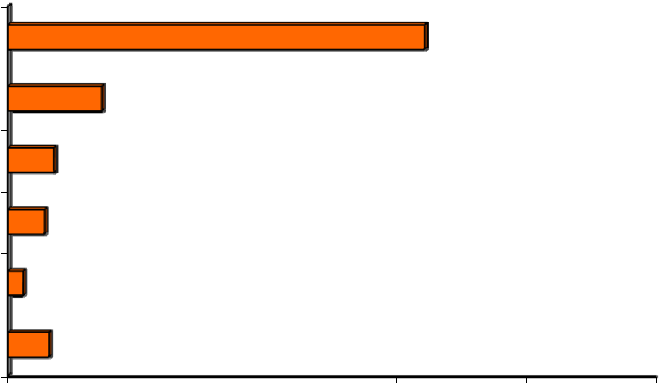

Drive alone | 64.2%

Train _{14.5%}

Carpool/Vanpool _{7.1%}

^{Bus} 5.6%

Bike/Walk _{2.3%}

TW/CWS
6.3%

0% 20% 40% 60% 80% 100%

In 2010, the share commuters made less than two-thirds (64.2%) of weekly commute trips by driving alone. Transit accounted for more than one in five trips. The second most popular mode was train, used for 14.5% of weekly trips and bus was used for about six percent (5.6%) . Respondents used car - pool/vanpool for 7.1% of weekly commute trips and made a small share of trips (2.3%) by bike or walk-ing.

Telework and compressed work schedule days off eliminated slightly more than six percent (6.3%) of weekly work trips. As noted earlier, these “trips” actually were not made, but they were officially as-signed as part of the work week, so were included in this distribution.

If the telework and compressed schedule days off are excluded, to estimate the “on the road” mode share, the percentage use of each of the five travel modes increases. Without telework and CWS, the drive alone share would rise to 68.4% of weekly commute trips. The weekly commute trip distribution would be:

Drive alone | 68.4%
Train | 15.5%
Carpool / vanpool | 7.5%
Bus | 6.0%
Bike/walk | 2.5%

15

Commuter Connections 2010 State of the Commute Survey Draft Technical Report June 30, 2010

Weekly Trips by Mode 2010, 2007, 2004, and 2001

Figure 10 presents mode shares as a percentage of weekly commute trips in 2010, 2007, 2004, and 2001. The comparison shows that the share of drive alone trips appears to have declined since 2001, from

70.3% to 64.2%. Transit and Telework/CWS both gained mode share since 2001. Transit use increased from 16.8% to 20.1% and Telework/CWS nearly doubled, from 3.2% in 2001 to 6.3% in 2010. The car-pool/vanpool and bike/walk mode shares have remained essentially constant.

Figure 10

Weekly Trips by Mode – 2010, 2007, 2004, and 2001

(Including telework and compressed schedules)

100%
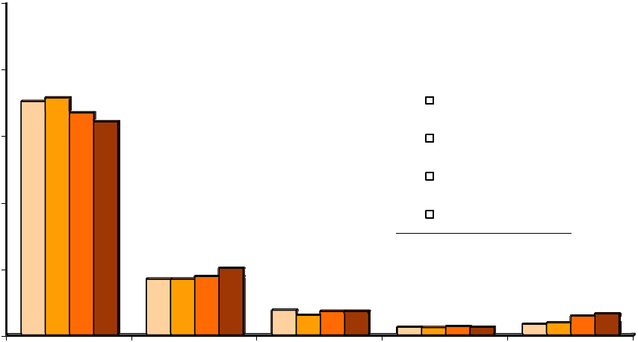

80%

70.3% |  |  |  |  |  | 2001 (n = 6,924)
64.2%
60% |  |  |  |  |  | 2004 (n = 6,851)
40% |  |  |  |  |  | 2007 (n = 6,168)
40% |  |  |  |  |  | 2010 (n = 6,050)
20% |  | 20.1%
20% |  | 16.8%
 |  | 7.4% | 7.1% |  |  | 2.3% | 3.2% |  | 6.3%
0% |  |  | 2.3% |  |  | 2.3% | 3.2%
0% | Drive alone | Carpool/Vanpool |  |  |  |  | TW/CWS

Frequency of Current Mode Use

Figure 11 shows mode split for 2010 as the percentage of respondents who used each mode as their “pri-mary” mode, defined as the mode used most days per week. The figure also shows the percentages of respondents who used each mode one or more days per week, that is, either regularly or occasionally.

Primary Mode – Nearly all (99%) respondents said they used a single mode most days per week. Since most respondents worked five or more days per week, Primary Mode generally equated to use three or more days per week. But for a small percentage of respondents who worked fewer than five days or who used more than two modes, the primary mode could be used just two days per week.

As with mode split by weekly trips, the most common Primary Mode was drive alone, used by 65% of respondents. The second most common Primary Mode, used by 15% of respondents, was train. Seven percent said they primarily carpooled, “casual” carpooled (slug), or vanpooled. Bus was the Primary Mode of six percent of respondents. Two percent of respondents said they primarily biked or walked and four percent said they primarily teleworked.

16

Commuter Connections 2010 State of the Commute Survey Draft Technical Report June 30, 2010

Figure 11

Primary Modes and Modes Used as Primary or Secondary

(n = 6,226)
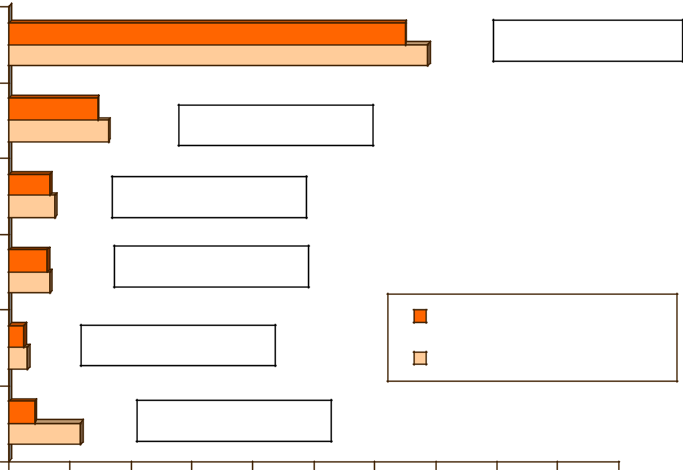

Drive Alone |  |  |  |  |  |  |  | 65% | +4% secondary
Drive Alone |  |  |  |  |  |  |  | 69%
Train |  | 15% |  | +1% secondary
Train |  | 16%
Carpool / Vanpool | 7% |  | +1% secondary
Carpool / Vanpool | 8%
Bus | 6% |  | +1% secondary
 | 7%
 | 2% |  |  |  |  |  |  | Primary Mode
Bike / Walk | 2% | +1% secondary |  |  |  |  |  | Primary or Secondary Mode
Bike / Walk | 3%
TW | 4% |  | +8% secondary
TW | 12%
0% | 10% | 20% |  | 30% | 40% | 50% | 60% | 70% | 80% | 90% | 100%

- Percentages for Primary or Secondary Modes add to more than 100% because some respondents had both a Primary and Secondary mode

Primary or Secondary Use of Modes – Figure 11 also shows the percentage of respondents who used the modes as either their Primary or Secondary mode. This category also includes respondents who said they used these modes occasionally, one or two times during the week.

The relative use of modes did not change from the primary mode order. But the percentages of respon-dents using each mode increased, because respondents who used both a Primary Mode and a different Secondary Mode were counted in both mode categories. Drive alone was still the most popular mode; 69% of respondents used this mode either regularly or occasionally. When compared to the 65% of res-pondents who said they primarily drove alone, this shows that about four percent of respondents drove alone as a Secondary Mode.

One percent of respondents used train as a Secondary Mode, increasing to 16% the share of respondents who used train one or more days per week. Carpooling/vanpooling, bus, and bike/walk similarly had one percent of Secondary Mode use.

The major difference between the Primary Mode and Primary or Secondary Mode distributions was in the percentage of respondents who teleworked. As shown in the figure, a total of 12% of respondents said

17

Commuter Connections 2010 State of the Commute Survey Draft Technical Report June 30, 2010

they teleworked at least one day a week. When the four percent who primarily teleworked is subtracted, this shows that seven percent of respondents reported telework as a Secondary Mode.

Mean Days Used

Figure 12 shows the average number of days each mode/mode group was used. All of modes were used at least three days per week on average and except for bicycle and walk, all modes were used at least four days per week. This is consistent with other results in the survey, which show that most commuters used one mode most of the time for their commute.

Figure 12

Average Days Modes Used

(Drive Alone n = 4,501, Metrorail n = 770, Commuter Rail n = 66, Casual Carpool n = 55, Bus n = 362, Carpool n = 434, Walk n = 154, Bicycle n = 56; Note Vanpool not included due to insufficient sample size)

5.0 | 4.4 | 4.2 | 4.2 | 4.1 | 4.1 | 4.0
4.0 |  |  |  |  |  |  | 3.7
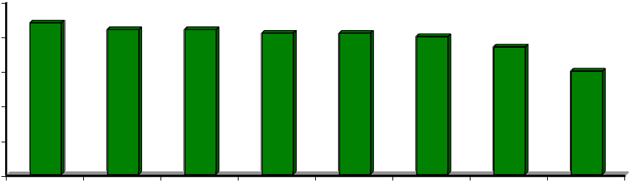

3.0

2.0

1.0

0.0
3.0

Drive Alone Metrorail Carpool Commuter Bus Casual Walk Bicycle
Rail Carpool

Mode Use within Mode Groups

Figure 13 shows relative use of individual modes within the four travel alternative mode groups displayed in Figure 11.

Train – The train mode group was comprised of Metrorail and three commuter rail companies: MARC (Maryland commuter rail), Virginia Railway Express (VRE), and Amtrak. Metrorail dominated this cate-gory, with 93% of train riders using this mode (15.3% of total 16.5% train ridership). The balance of train ridership was in commuter rail.

Carpool/Vanpool – Among respondents who carpooled, regular carpooling dominated. Nearly nine in ten carpool trips were in regular carpools (6.9% of total 8.1% carpool use). The remaining carpool trips were made in casual carpools or “slugs.” A very small share of this mode group (0.1% of 8.1% total) was made by vanpool.

18

Commuter Connections 2010 State of the Commute Survey Draft Technical Report June 30, 2010

Figure 13

Composition of Alternative Mode Groupings

Modes Used 1+ Days per Week

(n=6,226)
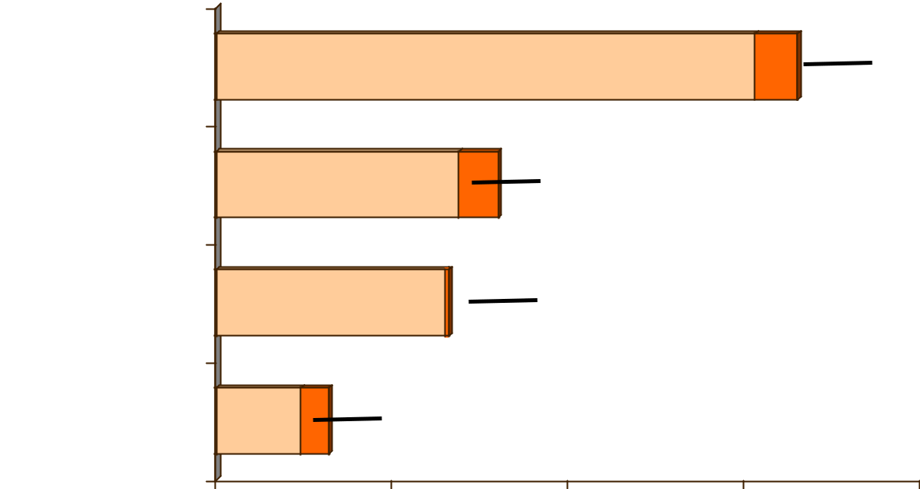

 | Metrorail – 15.3% |  |  |  | Commuter
Train |  |  |  |  | Rail – 1.2%
Carpool Carpool*/Vanpool | Regular CP – 6.9% |  | Casual CP – 1.1%
Carpool Carpool*/Vanpool |  |  | VanpoolCP–0.9%– 0.1%
Bus/Buspool | Bus – 6.5% |  | Buspool – 0.1%
Bike/Walk | Walk – | Bike – 0.8%
 | 2.4%
0% |  | 5% | 10% | 15% | 20%

Bus – Regular, scheduled bus / shuttles accounted for nearly all bus use. Less than 2% of bus ridership was in buspools (0.1% of total 6.6% bus use).

Bike/Walk – Walking accounted for the majority of the bike/walk mode group. Among users of this mode group, walking attracted three-quarters of the respondents (2.4% of 3.2% of bike/walk use).

Length of Time Using Mode

Respondents were asked how long they had been using modes they reported using one or more days per week. Results are shown in Figure 14 for commuters who drove alone, used transit, carpooled, and used bike/walk.

Commuters who drove to work had used this mode an average of 10.7 years, considerably longer on aver-age than had commuters who used alternative modes. Only 23% of drive alone commuters said they started using this mode within the past three years; 45% had used the mode for 10 years or more and al-most two-thirds had driven alone for five or more years.

19

Commuter Connections 2010 State of the Commute Survey Draft Technical Report June 30, 2010

Figure 14

Duration of Mode Use

(Drive alone n = 3,310, Transit n = 1,074, Carpool n = 460, Bike/walk n = 195)
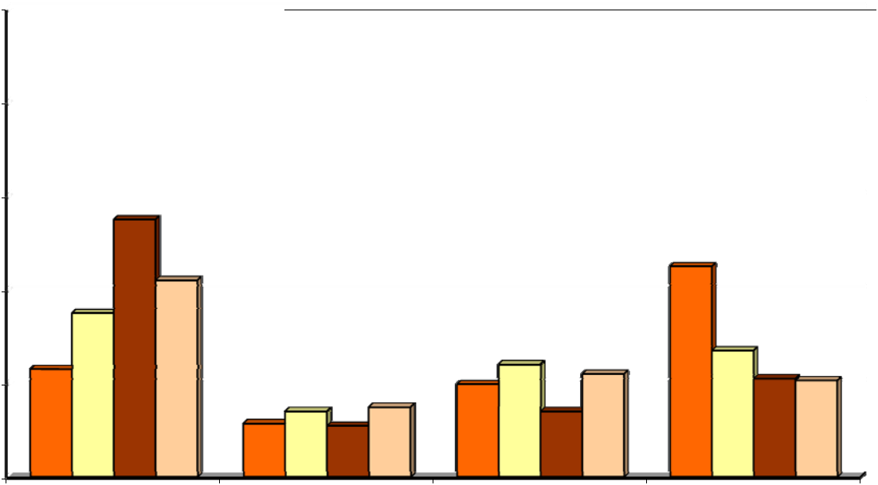

100%

Drive alone Transit Carpool Bike / walk

80%
80% |  |  |  |  | Average Duration
 |  |  | Drive alone: |  |  | 10.7 years
55% |  |  |  | Transit: 7.8 years
60% |  |  |  | Carpool: 5.0 years
 |  |  |  |  |  |  |  |  |  | 45%
42% |  |  |  | Bike/walk: |  | 5.9 years |  |  |  | 45%
35%
40%
23% |  |  |  |  |  |  | 24% |  | 22% | 27%
23% |  |  |  |  |  | 20% |  |  | 22% | 21% | 21%
20% | 11% |  | 14% | 15% |  |  | 14%
20% |  |  | 14% | 11%
0%
Less than 3 years |  |  | 3-4.9 years |  |  |  | 5-9.9 years |  |  | 10 years or more

Alternative mode users had used these modes for shorter times on average, but a substantial portion of alternative mode users still were long-term users. A quarter of transit riders and two in ten carpoolers and bike/walk commuters used these modes for 10 or more years.

Carpoolers were most likely to have started using this mode recently; 55% of commuters who carpool started using this mode within the past three years. About a third of respondents who used transit and four in ten bike/walk commuters started these modes within the past three years.

Primary Commute Mode by Demographic Group

Analysis of survey data showed some differences in choice of primary mode (mode used most days per week) among various demographic groups. Tables 6 through 11 present distributions of primary mode by respondent sex, ethnic group, age, income, vehicle availability, and location of residence and employ-ment.

Ethnic Group

Table 6 shows primary mode for various ethnic groups. White respondents were the most likely to drive alone and were much less likely than other groups to use the bus. Hispanic respondents were the most likely to carpool of all ethnic groups. African-American respondents were statistically more likely to use the train than were either White or Hispanic respondents.

20

Commuter Connections 2010 State of the Commute Survey Draft Technical Report |  |  |  |  |  |  |  |  |  |  |  |  |  |  |  | June 30, 2010
 |  |  |  |  | Table 6
 |  |  | Primary Mode by Ethnic Group
 |  |  |  |  |  |  |  | Primary Commute Mode
 | Ethnic Group | (n= __) |  |  | Drive |  |  | Carpool / |  |  | Bus |  |  |  | Train |  |  | Bike /
 |  |  |  |  | Alone |  |  | Vanpool |  |  | Bus |  |  |  | Train |  |  | Walk
 | Hispanic | 328 |  | 63% |  |  |  | 11% |  |  | 9% |  | 14% |  |  |  | 3%
 | African-American | 1,012 |  | 63% |  |  | 7% |  |  |  | 10% |  |  |  | 19% |  | 1%
 | White | 4,571 |  |  | 73% |  | 7% |  |  |  | 3% |  | 14% |  |  |  | 3%
 | Other | 401 |  | 66% |  |  | 10% |  |  |  | 9% |  | 13% |  |  |  | 2%

Age

Young respondents (younger than 25 years old) were less likely to drive alone and more likely to use the bus and to walk than were older respondents (Table 7). Use of these modes was consistent for respon-dents in the other age groups. Carpool/vanpool was used at equal rates by all age groups.

Table 7

Primary Mode by Age Group

 |  |  |  |  |  | Primary Commute Mode
Age | (n= __) |  | Drive |  |  | Carpool / |  |  | Bus |  |  | Train |  | Bike /
 |  |  | Alone |  |  | Vanpool |  |  | Bus |  |  | Train |  | Walk
<25 years old | 172 |  | 59% |  | 7% |  |  |  | 14% |  | 14% |  |  | 6%
25-34 years old | 796 | 67% |  |  | 7% |  |  | 7% |  |  | 17% |  |  | 3%
35-44 years old | 1,541 | 69% |  |  | 8% |  |  | 7% |  |  | 13% |  |  | 3%
45-54 years old | 2,124 | 69% |  |  | 8% |  |  | 6% |  |  | 15% |  |  | 2%
55 year or older | 1,873 | 70% |  |  | 7% |  |  | 4% |  |  | 17% |  |  | 2%

Income

Table 8 presents primary mode by annual household income. Respondents who had incomes of less than $30,000 showed substantially lower share of driving alone than did other income groups. Solo driving was equally common among both moderate and high-income respondents. Bus ridership declined steadi-ly as income increased. When the lowest-income respondents are excluded, use of other modes was es-sentially the same for most income categories.

21

Commuter Connections 2010 State of the Commute Survey Draft Technical Report June 30, 2010

Table 8

Primary Mode by Annual Household Income


Income

(n=__)

Drive

Alone

Primary Commute Mode

Carpool/ |  |  | Bus |  |  | Train |  |  | Bike /
Vanpool |  |  | Bus |  |  | Train |  |  | Walk

Less than $30,000 |  | 179 | 46%
$30,000 – 59,999 |  | 633 | 69%
$60,000 – 79,999 |  | 581 | 69%
$80,000 – 99,999 |  | 537 | 65%
$100,000 – 119,999 |  | 872 | 70%
$120,000 | – 139,999 | 671 | 70%
$140,000 | – 159,999 | 597 | 76%
$160,000 | – 179,999 | 404 | 70%
$180,000 | + | 1,122 | 70%

9%

4%

8%

6%

6%

8%

5%

8%

11%

25% | 12% | 9%
10% | 16% | 2%
6% | 15% | 2%
7% | 19% | 3%
5% | 17% | 2%
3% | 17% | 2%
4% | 15% | 1%
4% | 15% | 2%
4% | 13% | 3%

Vehicles Available

Finally, Table 9 shows the Primary Mode distribution by the number of vehicles in the respondent’s household. Not unexpectedly, respondents who did not have a car available were considerably less likely to drive alone and considerably more likely to commute by bus or train than were those with one or more vehicles. As the number of vehicles in the household increased from zero to one and from one to two, driving alone increased and the use of bus and train declined significantly. Carpooling was fairly equal, however, regardless of the number of vehicles available.

Table 9

Primary Mode by Number of Vehicles in the Household

 | Number of |  |  |  |  |  |  |  |  | Primary Commute Mode
 | Number of |  |  | (n= __) |  |  | Drive |  |  | Carpool / |  |  |  |  |  |  |  | Bike /
 | Vehicles |  |  | (n= __) |  |  | Drive |  |  | Carpool / |  |  | Bus |  | Train |  |  | Bike /
 | Vehicles |  |  |  |  |  | Alone |  |  | Vanpool |  |  | Bus |  | Train |  |  | Walk
0 |  |  | 198 |  |  | 4%* |  |  | 8% |  |  |  | 40% |  | 36% |  | 13%
1 |  |  | 1,518 |  |  | 57% |  |  | 7% |  |  | 9% |  |  | 23% |  | 5%
2 |  |  | 2,671 |  |  |  | 73% |  | 8% |  |  | 3% |  |  | 14% |  | 2%
 | 3 or more |  | 2,187 |  |  |  | 81% |  | 7% |  |  | 3% |  |  | 8% |  | 1%


* Respondents in this group could be passengers in taxi

Sex

22

Commuter Connections 2010 State of the Commute Survey Draft Technical Report June 30, 2010

There was no significant difference in rates of most modes between men and women; they were equally likely to drive alone, carpool/vanpool, ride a train, and walk or bicycle (Table 10). But women were sta-tistically more likely to ride a bus (8% for women vs 5% for men).

Table 10

Primary Mode by Sex

 |  |  |  |  |  | Primary Commute Mode
Sex | (n= __) |  | Drive |  |  | Carpool/ |  |  | Bus |  |  | Train |  |  | Bike /
 |  |  | Alone |  |  | Vanpool |  |  | Bus |  |  | Train |  |  | Walk
Female | 3,589 | 67% |  |  | 8% |  |  |  | 8% |  | 15% |  |  | 2%
Male | 3,040 | 70% |  |  | 7% |  |  |  | 5% |  | 16% |  |  | 3%

Residence and Employment Location

Residence State – As illustrated in Table 11, respondents’ commute modes differed by where they lived. About seven in ten respondents in Virginia and Maryland primarily drove alone to work, while only four in ten (42%) District of Columbia residents primarily used this mode for commuting. District residents were significantly more likely to use bus, train, bike, or walk to work than were respondents living in oth - er states. The mode shares for Maryland and Virginia residents were statistically the same for all modes.

Table 11

Primary Mode by State of Residence and State of Employment

 |  |  |  |  |  |  |  |  |  | Primary Commute Mode
 | State |  |  | (n= __) |  |  | Drive |  |  | Carpool/ |  |  |  |  |  |  |  |  | Bike /
 | State |  |  | (n= __) |  |  | Drive |  |  | Carpool/ |  |  | Bus |  |  | Train |  |  | Bike /
 |  |  |  |  |  |  | Alone |  |  | Vanpool |  |  | Bus |  |  | Train |  |  | Walk
 | State of Residence
 | District of Columbia |  |  |  |  |  | 42% |  | 7% |  |  |  | 14% |  |  | 27% |  |  | 11%
 | Maryland |  |  |  |  | 72% |  |  | 7% |  |  | 5% |  |  | 15% |  |  | 1%
 | Virginia |  |  |  |  | 72% |  |  | 8% |  |  | 5% |  |  | 13% |  |  | 2%
 | State of Employment
 | District of Columbia |  | 1,948 |  |  |  | 42% |  |  | 11% |  |  | 10% |  |  | 34% |  | 4%
 | Maryland |  | 1,986 |  |  | 84% |  |  | 5% |  |  | 5% |  |  | 4% |  |  | 2%
 | Virginia |  | 2,199 |  |  | 82% |  |  | 6% |  |  | 3% |  |  | 7% |  |  | 2%



Employment State – Table 11 also displays Primary Mode by state of employment. Respondents who worked in the District of Columbia were substantially less likely to drive alone to work than were those who worked in Virginia or Maryland. District workers were twice as likely to carpool or ride a bus as

23

Commuter Connections 2010 State of the Commute Survey Draft Technical Report June 30, 2010

were Maryland or Virginia workers. Train use among respondents working in the District was dramati-cally higher than for other respondents.

Residence Ring – Table 11 showed that mode use differed by respondents’ home state. But it differed even more by how close the respondent lived to the center of the region. Figure 15 displays primary mode as a function of respondents’ residence “ring.”

Figure 15

Primary Mode by Residence “Ring”

(Inner Core n = 1,667, Middle Ring n = 1,691, Outer Ring n = 2,844)

9%
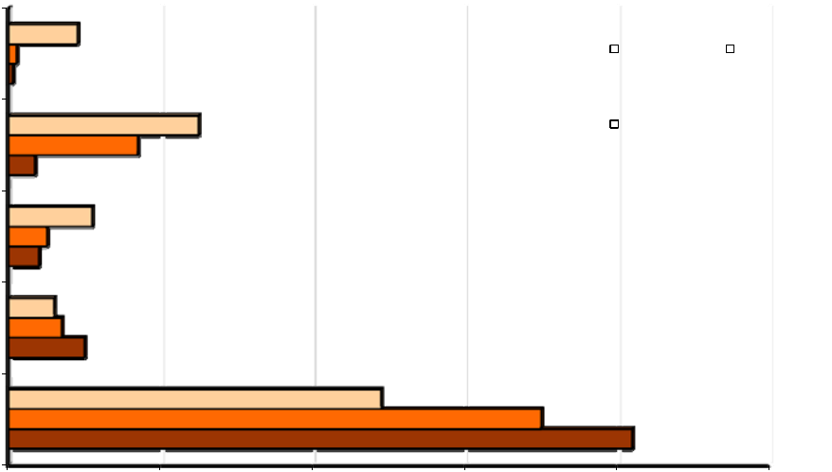

1%

Bike/walk | 1% | 25% |  |  | Inner Core |  | Middle Ring
Train | 3% | 17% |  |  | Outer Ring
 | 11%
Bus | 5%
Bus | 4%
 | 6%
Carpool/vanpool | 7%
 | 10%
Drive Alone |  |  |  | 49%
Drive Alone |  |  |  | 70%
 |  |  |  |  |  | 82%
0% | 20% | 40% | 60% | 80% |  | 100%

Fewer than half (49%) of commuters who lived in the “Inner Core” area, which included the District of Columbia and two Virginia jurisdictions, drove alone. This was much lower than the drive alone rates for the Middle Ring (69%) and the Outer Ring (82%) and just slightly higher than the 42% drive alone share noted for the District of Columbia alone. Transit use was nearly as high for the Inner Core as for the Dis-trict of Columbia alone. This suggests that two Virginia jurisdictions included in the Inner Core are more similar to the District of Columbia in travel mode characteristics than they are to other suburban jurisdic-tions.

Employment Ring – Figure 16 displays primary mode as a function of respondents’ employment location, in the “ring” designations defined earlier.

The mode pattern for employment locations was similar to that for the residence rings, but more pro-nounced. Fewer than half (48%) of commuters who worked in the “Inner Core” area drove alone. This was dramatically lower than the drive alone rates for the Middle Ring and Outer Ring; in both of these areas about nine in ten workers drove alone. Transit use was high in the Inner Core, but nearly non-existent for commute trips to Middle Ring and Outer Ring worksites. This pattern obviously reflects both the availability of transit infrastructure in the Inner Core areas as well as the inbound focus of transit ser-vice during peak commuting hours.

24

Commuter Connections 2010 State of the Commute Survey Draft Technical Report June 30, 2010

Figure 16

Primary Mode by Employment “Ring”

(Inner Core n = 2,744, Middle Ring n = 1,994, Outer Ring n = 1,461)

4%
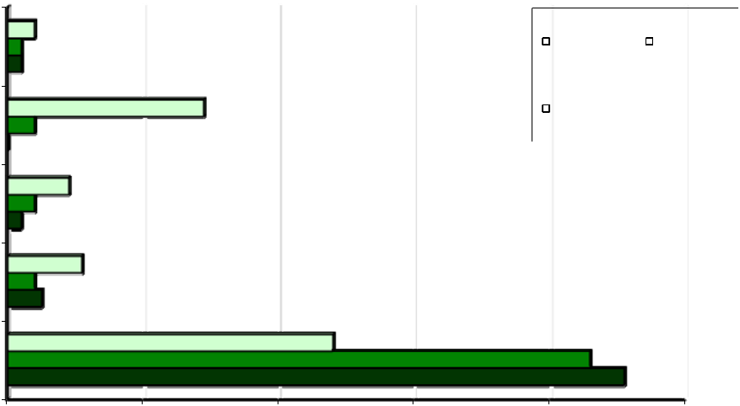

2%

Bike/walk | 2% |  |  |  |  | Inner Core |  | Middle Ring
 |  | 29%
Train | 4% |  |  |  |  | Outer Ring
Train | 0%
 | 9%
Bus | 4%
Bus | 2%
 | 11%
Carpool/vanpool | 4%
 | 5%
Drive Alone |  |  | 48% |  |  |  | 86%
 |  |  |  |  |  |  | 91%
0% | 20% | 40% | 60% | 80% |  |  | 100%

Length of Commute

Number of Miles

Commuters in the sample had a wide range of commute distances, ranging from less than one mile to more than 100 miles, with an overall average of 16.3 miles one- way. Figure 17 presents the distribution of distance. More than a third of respondents (37%) commuted fewer than 10 miles one-way. Three in ten (29%) traveled between 10 and 19 miles. A small percentage (7%) traveled 40 or more miles.

Figure 17

Commute Distance (miles)

(n = 5,538)
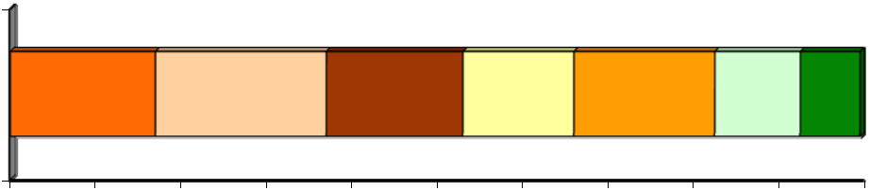

 |  | 17% |  |  | 20% |  |  | 16% |  |  | 13% | 17% |  |  |  | 10% | 7%
0% |  | 10% |  | 20% | 30% |  |  | 40% | 50% |  | 60% | 70% |  | 80% |  | 90% |  | 100%
 | Less than 5 mi |  |  | 5-9.9 mi |  |  | 10-14.9 mi |  |  | 15-19.9 mi |  |  | 20-29.9 mi |  |  | 30-39.9 mi |  |  |  | 40 or more mi

25

Commuter Connections 2010 State of the Commute Survey Draft Technical Report June 30, 2010

Commute Travel Time

Survey respondents commuted, on average, about 36 minutes one way. As shown in Figure 18, a third (33%) of respondents commuted 20 minutes or less and 43% commuted between 21 and 45 minutes. A quarter (25%) traveled more than 45 minutes, with nine percent traveling more than one hour one-way.

Figure 18

Commute Distance (minutes)

(n=5.859)
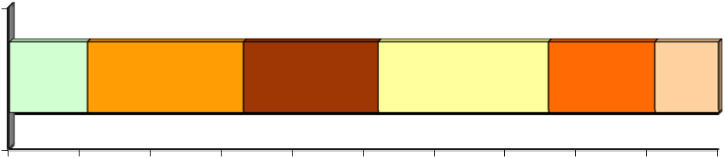

 | 11% | 22% |  |  | 19% |  |  |  | 24% |  |  | 15% |  |  |  | 9%
0% | 10% | 20% |  | 30% | 40% |  | 50% |  | 60% | 70% |  | 80% | 90% |  |  | 100%
10 min or less |  |  | 11-20 min |  |  | 21-30 min |  |  | 31-45 min |  |  | 46-60 min |  |  | More than 60 min

Commute distances and times have remained stable since 2004. In 2010, commuters traveled on average of 16.3 miles and 36 minutes, essentially the same as in 2007 (16.3 miles and 35 minutes) and 2004 (16.5 miles and 35 minutes). Note that the 2004 survey included Stafford County, VA, which was not in the 2007 and 2010 surveys. Because Stafford County had longer than average commute distances, eliminat-ing the county from the sample could have affected the averages in 2007 and 2010.

Commute Distance By Mode

Survey respondents’ travel distance varied by the type of transportation they used to commute (Table 12). Commuter rail riders traveled the farthest, 29.3 miles one-way. Carpoolers / vanpoolers also traveled farther than the 16.3 mile regional average. Commuter rail, bus, and train riders spent the longest time commuting, at least 48 minutes one-way.

Table 12

Commute Distance by Primary Mode

 | Primary Commute |  |  | Average Distance (mi.) |  |  |  |  |  | Average Time (min.)
 | Mode |  |  |  |  |  | Average |  |  |  |  |  | Average
 | Mode |  |  | (n=__) |  |  | Average |  |  | (n=__) |  |  | Average
 | Drive alone |  | 4,026 |  |  |  | 16.3 mi. |  | 4,099 |  |  |  | 33 min.
 | Carpool/Vanpool |  | 405 |  |  |  | 19.0 mi. |  | 421 |  |  |  | 41 min.
 | Bus |  | 258 |  |  |  | 16.5 mi. |  | 320 |  |  |  | 51 min.
 | Metrorail |  | 524 |  |  |  | 15.8 mi. |  | 666 |  |  |  | 48 min.
 | Commuter rail |  | 51 |  |  |  | 29.3 mi. |  | 61 |  |  |  | 68 min.
 | Bike/walk |  | 151 |  |  |  | 3.4 mi. |  | 163 |  |  |  | 20 min.


26

Commuter Connections 2010 State of the Commute Survey Draft Technical Report June 30, 2010

Commute Distance By Home and Work Location

Survey respondents’ travel distance also varied by where they lived and where they worked (Table 13). Respondents who lived in the Inner Core traveled the shortest distance to work, an average of 8.2 miles one-way. Respondents who lived in the Middle Ring commuted nearly twice as far, 15.7 miles. And res-pondents who lived in the Outer Ring traveled 23.7 miles one-way.

Commute distances by work area were less varied. Respondents who worked in the Inner Core traveled an average of 15.6 miles employed. Middle Ring workers traveled slightly farther, 16.1 miles. Respon-dents who worked in the Outer Ring traveled the farthest, 18.9 miles one way.

Inner Core area residents also had the shortest commutes in terms of time; they traveled an average of 30 minutes one-way. Middle Ring residents traveled 37 minutes and Outer Ring residents traveled 42 mi-nutes. But, while the Inner Core respondents traveled fewer minutes to work than did other respondents, they did not have proportionately shorter travel times. This is likely due to the higher transit use among these respondents; transit trips, while short in distance, tend to be longer in time.

By contrast with the home area results, respondents who worked in the Inner Core had the longest com-mute times, an average of 41 minutes one-way. Middle Ring workers and Outer Ring workers commuted 34 minutes and 29 minutes, respectively. This higher travel times for Inner Core workers likely are due to their higher use of transit for commuting and the higher congestion they would encounter in their com-mute.

Table 13

Commute Distance by Home and Work Area

 | Primary Commute |  |  | Average Distance (mi.) |  |  |  |  |  | Average Time (min.)
 | Mode |  |  |  |  |  | Average |  |  |  |  |  | Average
 | Mode |  |  | (n=__) |  |  | Average |  |  | (n=__) |  |  | Average
 | Home Area
 | Inner Core |  | 1,423 |  |  |  | 8.2 mi. |  | 1,575 |  |  |  | 30 min.
 | Middle Ring |  | 1,470 |  |  |  | 15.7 mi. |  | 1,589 |  |  |  | 37 min.
 | Outer Ring |  | 2,634 |  |  |  | 23.7 mi. |  | 2,676 |  |  |  | 42 min.
 | Work Area
 | Inner Core |  | 2,392 |  |  |  | 15.6 mi. |  | 2,603 |  |  |  | 41 min.
 | Middle Ring |  | 1,818 |  |  |  | 16.1 mi. |  | 1,869 |  |  |  | 34 min.
 | Outer Ring |  | 1,297 |  |  |  | 18.9 mi. |  | 1,343 |  |  |  | 29 min.

27

Commuter Connections 2010 State of the Commute Survey Draft Technical Report June 30, 2010

Non-Standard Work Schedules

Non-Standard Work Schedules Used

Figure 19 shows the distribution of work schedules for respondents who said they worked full-time sche-dules and commuted to an outside work location.

Figure 19

Non-Standard Schedule Types Used

(n = 5,393)
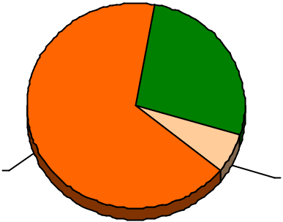

Standard

67%

Flextime

27%

CWS

6%

9/80 CWS – 4.3%

4/40 CWS – 1.1%

3/36 CWS – 0.6%

Two-thirds (67%) of these respondents said they worked a “standard” schedule, defined for full-time workers as five or more days per week. Of those who worked a “non-standard” schedule, the most com-mon schedule was flex-time or flexible work hours, used by 27% of respondents. About six percent of respondents worked a compressed work schedules; 9/80 schedules were most typical.

Primary Mode by Non-Standard Schedule

Use of non-standard work schedules sometimes has been assumed to reduce the use of alternative modes for commuting, by making it more difficult to maintain a carpool or vanpool or by reducing the possibili-ty of using transit for early or late hour commuting. But as seen from Table 14, respondents who worked a compressed schedule actually had higher carpool/vanpool and lower drive alone rates than did respon-dents who worked a standard, non-compressed, schedule. Respondents who worked compressed sche-dules also had higher train ridership.

Table 14

Primary Mode by Use of Non-Standard Schedules

 | Type of Schedule |  |  |  |  |  |  |  |  | Primary Mode
 | Type of Schedule |  |  | (n=__) |  |  | Drive |  |  | Carpool/ |  |  |  | Bus |  |  | Train |  |  | Bike /
 |  |  |  |  |  |  | Alone |  |  | Vanpool |  |  |  | Bus |  |  | Train |  |  | Walk
 | CWS |  | 379 |  |  | 55% |  |  |  | 13% |  |  |  | 9% |  |  | 22% |  | 1%
 | Flextime |  | 1,390 |  |  | 74% |  |  | 7% |  |  | 3% |  |  |  |  | 14% |  | 2%
 | Standard schedule |  | 3,611 |  |  | 67% |  |  | 8% |  |  | 6% |  |  |  |  | 16% |  | 3%

28

Commuter Connections 2010 State of the Commute Survey Draft Technical Report June 30, 2010

Alternative Mode Use Characteristics

Carpool and Vanpool Occupancy

The average number of occupants in respondents’ carpools and vanpools was 2.5 and 7.6 people, respec-tively. Overall average pool occupancy was 2.5. The carpool occupancy was approximately the same as the 2.5 person average from the 2007 survey, but slightly less than the 2.6 person average from the 2004 and 2001 SOC survey. About two-thirds (68%) of carpoolers rode with just one other person.

The vanpool average of 7.6 was lower than the 9.9 observed in 2007 and lower still than the 11.4 ob-served in 2001. This could reflect a continued shift to lower-passenger mini-vans, but the 2010 sample included only 12 vanpoolers, so this result should be viewed cautiously.

Access Mode to Alternative Mode Meeting Points

Table 15 presents how carpoolers, vanpoolers, and transit riders traveled to where they met their rideshare partners or where they started their transit trip. About a third (35%) of respondents walked to the meet-ing place.

Table 15

Means of Getting from Home to Alternative Mode Meeting Place

(n = 1,600)

Access Mode to Alternative Mode | Percentage
Driving access | 28%
Drive to a central location (e.g., Park & Ride) | 18%
Drive alone to driver’s/passenger’s home | 10%
Non-driving access | 72%
Walk | 35%
Picked up at home by carpool/vanpool driver | 10%
Bus/transit | 12%
I am the carpool/vanpool driver | 11%
Dropped off / rode in another carpool / vanpool | 3%
Other* | 1%

*Each response in the “Other” category was mentioned by less than one percent of respondents.

One in ten (10%) said they were picked up at home by the carpool or vanpool driver and 12% of respon-dents said they rode transit to the meeting point. Eleven percent said they drove to the location, but then continued on as the carpool/vanpool driver. Three percent said they were dropped off, for example by a spouse or other household member.

Almost three in ten respondents (28%) said they drove to the meeting point but left their cars there. This is significant, because a large proportion of auto emissions are produced during the first few miles of a

29

Commuter Connections 2010 State of the Commute Survey Draft Technical Report June 30, 2010

vehicle trip, when the engine is cold. Even though these trips generally were short, they must be reflected in an air quality analysis.

Distance to Alternative Mode Meeting Point

As shown in Table 16, access trips to alternative mode meetings points tended to be short. Respondents traveled an average of 2.6 miles. Six in ten (60%) respondents traveled one mile or less to the meeting point. These were primarily bus and Metrorail riders. About three in ten (28%) respondents said they traveled between two and five miles. Only 12% of respondents traveled more than five miles.

Table 16

Distance Traveled from Home to Alternative Mode Meeting Point

(n = 1,189)

Distance

Percentage

1 mile or less | 60%
2 to 3 miles | 17%
4 to 5 miles | 11%
6 to 10 miles | 9%
11 miles or more | 3%

Mode Shifts and Trial Use of Modes

Modes Used Before Starting Current Alternative Modes

Respondents who used an alternative mode and said they had used that mode three years or less were asked what modes they previously used. About two in ten (18%) said they did not have a previous mode to report because they had not been working or commuting in the Washington metropolitan area then or had used only used this mode. The remaining respondents reported their previous modes, as shown in Figure 20.

Of those who had a previous mode, more than half (53%) of current alternative mode users made a shift from driving alone. The remaining 47% shifted from a different alternative mode. Two in ten alternative mode users shifted from train and 14% previously used a bus. Four percent carpooled or vanpooled be-fore switching to their current alternative mode and six percent previously rode a bicycle or walked.

The inset box in the figure shows the share of previous drive alone use for current alternative mode users. Train riders were more likely than were other mode users to have shifted from driving alone; 70% of train riders said they were driving alone before starting to use this mode, compared with only 52% of carpoo-lers, 43% of bus riders, and 31% of walkers/bikers.

30

Commuter Connections 2010 State of the Commute Survey Draft Technical Report June 30, 2010

Figure 20

Previous Mode of Current Alternative Mode Users

(n = 839, multiple responses permitted)
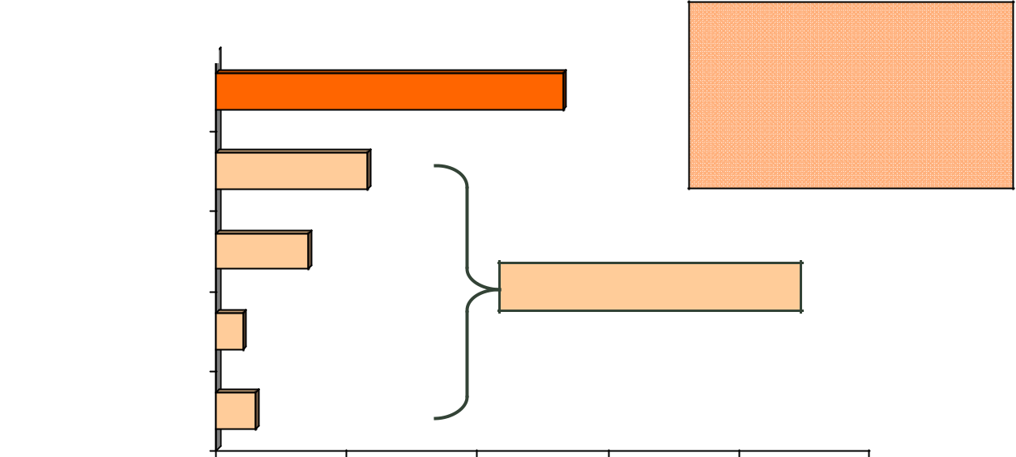

Previous Mode |  |  |  | Shifted from Driving Alone
Drive Alone |  |  | 53% |  | Train riders – 70%
Drive Alone |  |  | 53% |  | Carpoolers – 52%
 |  |  |  |  | Bus riders – 43%
Train |  | 23% |  | Walkers/bikers – 31%
Bus | 14% |  | 47% previous alternative mode
Carpool / Vanpool | 4%
Bike / Walk | 6%
0% | 20% | 40% | 60% | 80% | 100%

Alternative Modes Tried

Respondents who did not work at home full-time were asked about use of alternative modes in the past two years. Respondents who were driving alone at the time of the survey were asked if they had used or tried an alternative mode for their commute. Respondents who were using an alternative mode when the survey was conducted were asked if they had used another alternative mode, other than the mode they were currently using.

In the two years prior to the survey, almost a quarter (23%) of commuters used or tried another type of non- drive alone mode that were not using at the time of the survey (Figure 21). This was a higher percen-tage than was observed in the 2007 survey (14%), but about the same as the percentages who said they tried other alternative modes in the 2004 (22%) and 2001 (25%) surveys. It also is consistent with the higher overall use of alternative modes reported in 2010 than in 2007.

About 13% of commuters tried or used Metrorail in the past two years and seven percent tried or used a bus. Four percent tried or used bike or walk. Three percent tried carpool or vanpool, and one percent noted commuter rail.

31

Commuter Connections 2010 State of the Commute Survey Draft Technical Report June 30, 2010

Figure 21

Alternative Modes Used/Tried in Past Two Years

(n= 6,050, multiple responses permitted)
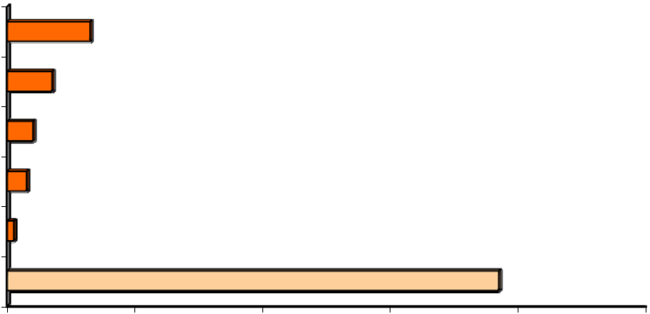

Metrorail 13%

Bus 7%

Bike/Walk _{4%}

Carpool _{3%}

Commuter Rail

No other mode

1%

77%

0% 20% 40% 60% 80% 100%

Reasons for Using Alternative Modes

Respondents who used an alternative mode, either during the survey week or within the past two years were asked why they began using those modes. The reasons are listed in Figure 22, divided into three broad categories of motivations:

Personal benefits – benefits the respondent would expect to receive by using an alternative mode Commute program – commute assistance services the respondent received that encouraged or as-
sisted use of the alternative mode

Personal circumstances – personal circumstances or changes experienced by the respondent

Current Alternative Mode Users – Current alternative mode users noted motivations in each of the three categories. The most common personal benefit reasons were to “save money” (18%) or “save time” (10%). In the commute program category, they cited that they found a “carpool partner” (8%). Seven percent noted either limited parking or a parking charge and three percent said they had received a finan-cial incentive. Personal circumstances reasons included “changed jobs or work hours” (18%), “no vehicle available” (10%), “live close to work or to transportation pick-up location” (8%), and “moved residence” (7%).

Respondents Who Used or Tried Other Alternative Modes – Figure 22 also shows reasons given by “trial users,” for trying or using modes they were no longer using. Several reasons mirrored those that respon - dents gave for why the used their current alternative mode. To “save time” (10%), “save money” (8%), “tired of driving” (5%), or “avoid congestion” (4%) were the most important personal benefit reasons.

But trial users noted motivations that were likely temporary. For example, the most common reason, named by 22% of respondents, was that they had “no vehicle available.” For some, this likely was a tem-porary condition. And 14% cited “weather” as their reason, compared with only three percent of current alternative mode users, suggesting occasional or short -term use. They were less likely to note reasons related to job or home location changes, which would be more permanent in nature.

32

Commuter Connections 2010 State of the Commute Survey Draft Technical Report June 30, 2010

33

Commuter Connections 2010 State of the Commute Survey Draft Technical Report June 30, 2010

Figure 22

Motivations to Start Using Current Mode or Try Another Alternative Mode

(Current Mode n = 768, Trial mode n = 512)

(Note: Scale extends only to 30% to highlight difference in responses)
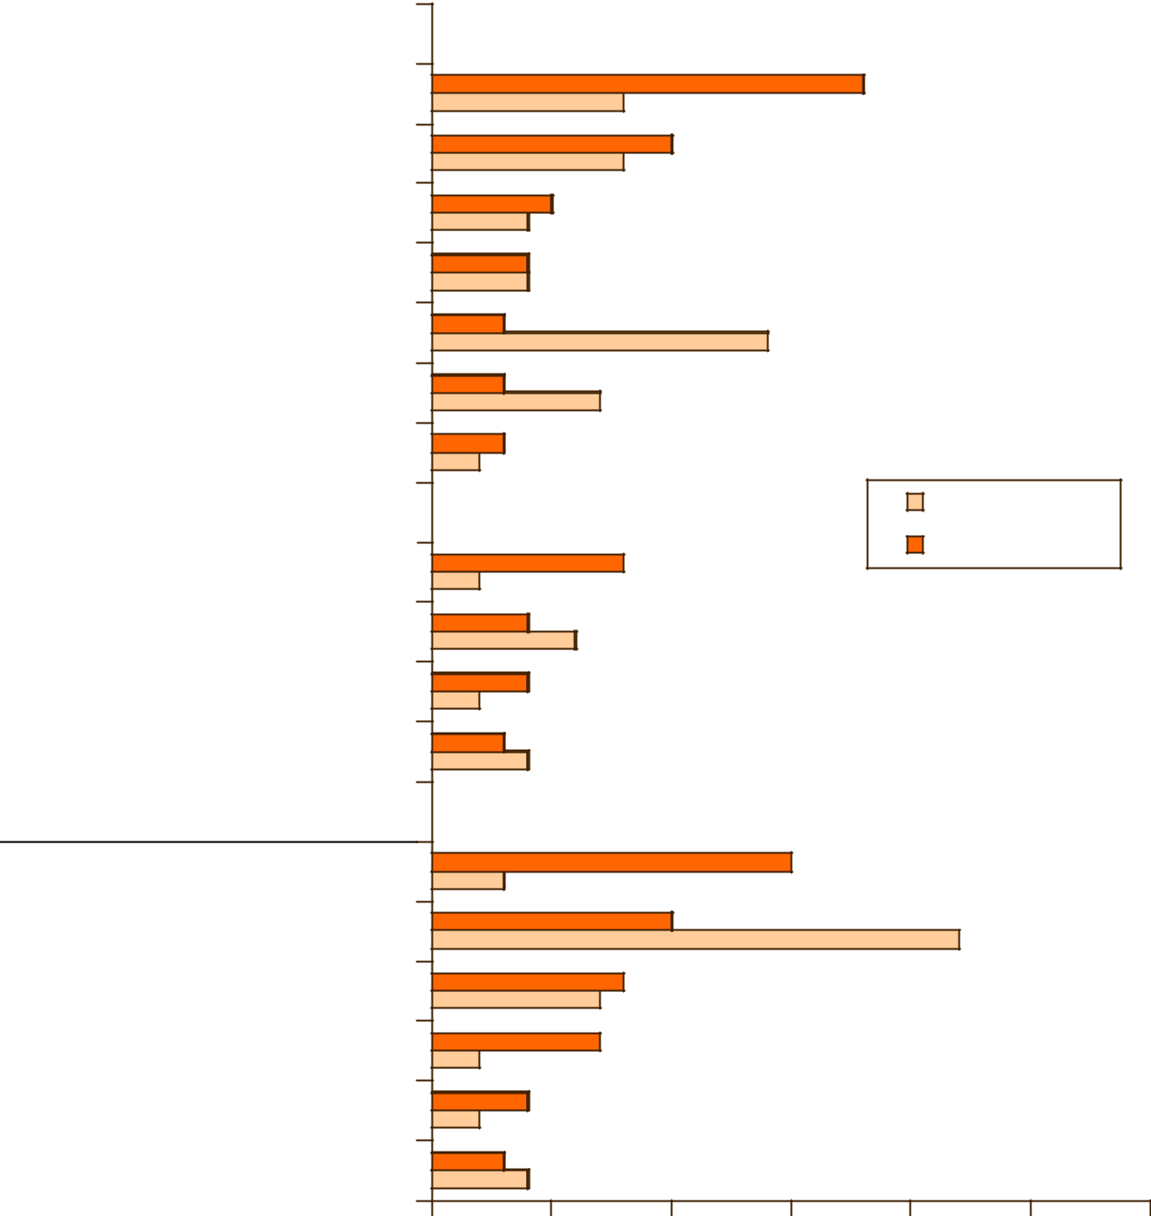

Personal Benefit Motivations
Save money |  |  | 8% |  |  | 18%
Save time |  |  | 8% | 10%
Tired of driving |  | 5%
Tired of driving |  | 4%
Avoid congestion |  | 4%
 |  | 4%
Weather | 3% |  |  |  | 14%
Get exercise | 3% |  | 7%
Concerned about environment | 3%
Concerned about environment | 2%
Commute Program Motivations |  |  |  |  |  | Trial Mode
Commute Program Motivations |  |  |  |  |  | Current Mode
Found carpool partner |  |  | 8%
Found carpool partner | 2% |  | 8%
No parking at work |  | 4% | 6%
Have transit/vanpool incentive | 2% | 4%
Parking too expensive | 3%
Parking too expensive |  | 4%
Personal Circumstances Motivations |  |  |  |  | 15%
Changed jobs/work hours | 3% |  |  |  | 15%
No vehicle available |  |  |  | 10% |  |  | 22%
Close to work/pick-up location |  |  | 8%
Close to work/pick-up location |  |  | 7%
Moved to new residence | 2% |  | 7%
Employer / worksite moved | 2% | 4%
Need travel flexibility | ^{3%}4%
0% |  | 5% | 10% |  | 15% | 20% | 25% | 30%

34

Commuter Connections 2010 State of the Commute Survey Draft Technical Report June 30, 2010

3-C TELEWORK

The SOC survey also explored respondents’ telework experience. For purposes of this survey, telework-ers were defined as “wage and salary employees who at least occasionally work at home or at a telework or satellite center during an entire work day, instead of traveling to their regular work place.”
This section presents these results for 2010 and, in some tables, results for 2007, 2004, and 2001, but a few points on the definition of telework should be noted.

The definition presented above was used in the 2004, 2007, and 2010 SOC surveys. But the definition was changed in 2004 to limit telework to arrangements that reduced vehicle trips; the 2001 definition had interpreted telework more broadly. To enable a valid comparison of later years’ surveys with the 2001 data, the 2001 telework results were revised to exclude respondents who would not have been counted as teleworkers under the current definition. These adjusted data are used in all tables that show 2001 results.

The 2001 SOC definition described teleworkers as, “wage and salary employees who at least occasional-ly work at home or at a location other than their central work place during their normal work hours.” This definition would have included workers who work at client sites outside of the Washington region and workers, such as sales or equipment repair staff, who travel to multiple customer locations during the course of the day. The 2001 definition also could have included respondents who worked a portion of the normal workday at home, for example while waiting for a delivery, but traveled to the regular workplace for another part of the day. These situations are not generally considered teleworking for transportation-related purposes, thus the telework definition was rewritten in 2004 to exclude these cases and they would not have been counted as telework in 2010, 2007, or 2004.

Current and Potential Telework

Respondents who Currently Telework

Respondents were read the above definition of teleworking and asked if they would consider themselves teleworkers based on this definition. A total of 23.5% of all regional workers said they telework, either regularly or occasionally. This represented about 600,000 workers region-wide.

But teleworkers accounted for a higher percentage, 25%, of all regional commuters, that is, workers who travel to a main work location on non-telework days. Using this base of commuters excludes workers who are self-employed and for whom home is their only workplace. These workers do not have an out-side work location, thus never make commute trips. The calculation of teleworkers as a proportion of commuters reflects a more realistic picture of the role of telework in eliminating commute trips, thus is relevant for assessing travel and air quality benefits of telework.

The 25% telework percentage represents a steady growth over the telework percentage from past SOC surveys. As illustrated in Figure 23, 11% of regional commuters teleworked in 2001 and 13% teleworked in 2004. By 2007, the percentage had risen to 19% and grew still further in the past three years.

35

Commuter Connections 2010 State of the Commute Survey Draft Technical Report June 30, 2010

Figure 23

Percentage of Commuters who Telework – 2001, 2004, 2007, 2010

(2001 n = 6,924, 2004 n = 6,851, 2007 n = 6,168, 2010 n = 6,050)

100%
80%
60%
40% |  |  |  | 25%
20% |  | 13% | 19% | 25%
20% | 11% | 13% | 19%
0%
 | 2001 | 2004 | 2007 | 2010
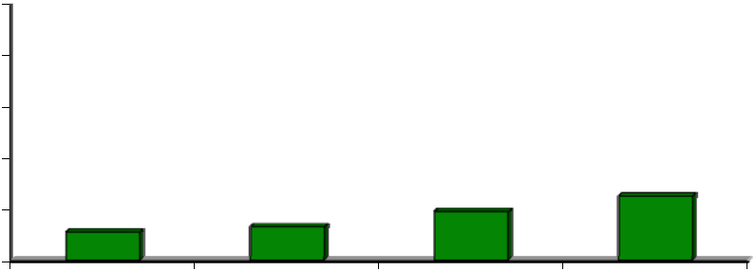

Interest in Teleworking

Respondents who were not teleworking and who were not self -employed/work at home full-time were asked if their job responsibilities would allow them to work at a location other than their main work place, at least occasionally. Approximately 40% said it would be possible. These respondents were then asked if they would want to telework. Seven in ten said they would be interested in teleworking on either an occasional basis (42%) or a regular basis (27%). These interested respondents equal about 28% of non-teleworkers and 21% of all commuters.

These results suggest additional telework growth potential exists in the Washington metropolitan region. Figure 24 summarizes the telework status of all respondents who are “commuters,” that is, not self-employed/work at home full-time.

Figure 24

Telework Status Distribution

(n = 6,050)
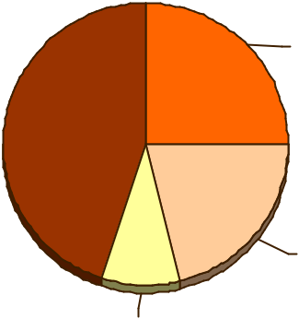

Telework now,

25%

Job not telework

appropriate, 45%

600,000

current te-

leworkers

Could and would

telework, 21%

Could telework,

not interested,

9%

500,000 “could and would” telework

36

Commuter Connections 2010 State of the Commute Survey Draft Technical Report June 30, 2010

A quarter of regional commuters currently telework. An additional 21% of commuters “could and would” telework, that is, they have job responsibilities that could be done while teleworking and they would be interested in teleworking, if given an opportunity. These commuters represent about 500,000 potential teleworkers. The remaining respondents said they would not be interested in teleworking (9%) or that their job responsibilities would not allow teleworking (45%).

Table 17 presents the results shown above, with additional comparisons for current and potential telework percentages measured in 2007 and in 2004. As shown in the table, the percentage of current plus poten - tial telework has grown since 2004, from 29% to 46% and the share of commuters who could telework but are not interested has remained relatively constant.

Table 17

Summary of Current and Potential Telework

All Respondents who are not Self-Employed/Work at Home

 | Teleworking Status |  |  | 2010 SOC |  |  | 2007 SOC |  |  | 2004 SOC
 | Teleworking Status |  |  | Percentage |  |  | Percentage |  |  | Percentage
 |  |  |  | (n = 6,050) |  |  | (n = 6,168) |  |  | (n = 6,896)
 | Currently teleworking |  |  | 25% |  |  | 19% |  |  | 13%
 | Not teleworking |  | 75% |  |  | 81% |  |  | 87%
 | - Job responsibilities allow teleworking and |  | 21% |  |  | 24% |  |  | 16%
 | INTERESTED in teleworking (“could and would”)
 | - Job responsibilities allow teleworking, but |  | 9% |  |  | 6% |  |  | 6%
 | NOT INTERESTED in teleworking
 | - Job responsibilities would NOT allow teleworking |  | 45% |  |  | 52% |  |  | 65%

Interestingly, the percentage of commuters who said their jobs were incompatible with telework dropped, from 65% in 2004 to 45% in 2010. Because it seems unlikely that the composition of jobs changed sub - stantially in the region, these results suggest a shift in commuters’ ability, or perception of their ability, to perform their work at home or another location away from their primary work location. It appears that a larger share of commuters believe they could telework, at least occasionally. This could be related to in-creasing availability of communication and computer technology, such as broadband internet, lower cost telephone options, and computer networking, or perhaps from greater understanding of telework options and a broader definition of what responsibilities are “telework-compatible.”

Teleworking by Personal Characteristics

Teleworking is not distributed equally by demographic group. Table 18 compares teleworking by res-pondents’ sex, ethnic group, age, income, commute distance, and home and work areas. The third column shows the percentage of each demographic group who telework today (e.g., 26% of men and 24% of women telework now). The last column shows the percentage of non-teleworkers in the group who “could and would” telework if given the opportunity (e.g., 29% of non-teleworking women would tele-work). Note that this should be compared against the 28% of all non-teleworkers in the region who “could and would” telework.

37

Commuter Connections 2010 State of the Commute Survey Draft Technical Report |  |  |  |  |  |  |  |  |  |  |  |  |  |  |  |  | June 30, 2010
 |  |  |  |  |  |  |  |  | Table 18
 |  |  | Teleworkers by Demographic and Travel Characteristic
 |  |  |  |  |  | All Respondents |  |  |  |  |  | Non-Teleworkers
 |  | Demographic |  |  |  |  |  |  | Percentage |  |  |  |  |  |  | Percentage who
 |  |  |  |  |  | (n=__)* |  |  | Who Currently |  |  | (n=__)** |  |  |  | “could and would”
 |  | Group |  |  |  | (n=__)* |  |  | Who Currently |  |  | (n=__)**
 |  |  |  |  |  |  |  |  | Telework |  |  |  |  |  |  |  | Telework***
 |  | Sex
 |  | Male |  |  | 2,867 |  |  | 26% |  |  | 2,149 |  |  |  |  |  | 27%
 |  | Female |  |  | 3,325 |  |  | 24% |  |  | 2,509 |  |  |  |  |  | 29%
 |  | Ethnic Group
 |  | White |  |  | 4,242 |  |  | 30% |  |  | 3,093 |  |  |  |  |  | 28%
 |  | Hispanic |  |  | 314 |  |  | 18% |  |  | 250 |  |  |  |  |  | 22%
 |  | African-American |  |  | 969 |  |  | 18% |  |  | 807 |  |  |  |  |  | 31%
 |  | Age
 |  | Under 25 years |  |  | 167 |  |  | 14% |  |  | 151 |  |  |  |  |  | 13%
 |  | 25–34 |  |  | 766 |  |  | 20% |  |  | 592 |  |  |  |  |  | 29%
 |  | 35–44 |  |  | 1,463 |  |  | 27% |  |  | 1,056 |  |  |  |  |  | 30%
 |  | 45–54 |  |  | 1,999 |  |  | 27% |  |  | 1,472 |  |  |  |  |  | 29%
 |  | 55 or older |  |  | 1,678 |  |  | 24% |  |  | 1,301 |  |  |  |  |  | 26%
 |  | Income
 |  | Less than $30,000 |  |  | 161 |  |  | 2% |  |  | 157 |  |  |  |  |  | 8%
 |  | $30,000 – $59,999 |  |  | 579 |  |  | 6% |  |  | 544 |  |  |  |  |  | 15%
 |  | $60,000 – $99,999 |  |  | 1,053 |  |  | 20% |  |  | 867 |  |  |  |  |  | 28%
 |  | $100,000 – $139,999 |  |  | 1,454 |  |  | 26% |  |  | 1,089 |  |  |  |  |  | 34%
 |  | $140,000 – $179,999 |  |  | 948 |  |  | 29% |  |  | 677 |  |  |  |  |  | 35%
 | $180,000+ |  |  |  | 1,064 |  |  | 39% |  |  | 649 |  |  |  |  |  | 35%

Some demographic groups telework more than do others. For example, whites (30%) were considerably more likely to telework than were either African-Americans (18%) or Hispanics (18%). Teleworking ap-peared to increase with age up to the 45-54 years old group, peaking at 27%, then declining as age in-creased further. And teleworking increased as income increased; 26% of workers with household in-comes between $100,000 and $139,999 teleworked, compared with only about five percent of workers with incomes under $60,000. Three in ten (29%) respondents with annual household incomes of $140,000 to $179,999 teleworked.

38

Commuter Connections 2010 State of the Commute Survey Draft Technical Report June 30, 2010

As shown in Table 18 (cont.), below, teleworking also increased with increasing commute distance. Only 12% of respondents who lived less than one mile from work teleworked, while three in ten (30%) respon-dents who commuted 30 miles or more teleworked. There were no significant differences in teleworing by home or work areas: Inner Core, Middle Ring, and Outer Ring.

Table 18 (cont.)

Teleworkers by Demographic and Travel Characteristics

 |  |  |  | All Respondents |  |  |  |  |  | Non Teleworkers
 | Demographic |  |  |  |  |  | Percentage |  |  |  |  |  | Percentage who
 | Demographic |  |  | (n=__)* |  |  | Who Currently |  |  | (n=__)** |  |  | “could and would”
 | Group |  |  | (n=__)* |  |  | Who Currently |  |  | (n=__)**
 | Group |  |  |  |  |  | Telework |  |  |  |  |  | Telework***
 | Commute Distance
 | Less than 1 mile |  | 126 |  |  | 12% |  |  | 112 |  |  | 17%
 | 1 – 14 miles |  | 2,694 |  |  | 21% |  |  | 2,137 |  |  | 26%
 | 15 – 29 miles |  | 1,454 |  |  | 28% |  |  | 1,084 |  |  | 31%
 | 30 miles + |  | 1,270 |  |  | 30% |  |  | 909 |  |  | 39%
 | Home Area
 | Inner Core |  | 1,667 |  |  | 24% |  |  | 1,243 |  |  | 30%
 | Middle Ring |  | 1,687 |  |  | 26% |  |  | 1,226 |  |  | 28%
 | Outer Ring |  | 2,838 |  |  | 24% |  |  | 2,189 |  |  | 25%
 | Work Area
 | Inner Core |  | 2,734 |  |  | 25% |  |  | 2,062 |  |  | 31%
 | Middle Ring |  | 1,982 |  |  | 26% |  |  | 1,437 |  |  | 26%
 | Outer Ring |  | 1,449 |  |  | 22% |  |  | 1,001 |  |  | 21%


- All respondents in the demographic group, both teleworkers and non-teleworkers

- Respondents in the demographic group who do not currently telework

- Respondents whose job responsibilities would allow teleworking and who would be interested in telework-ing, at least occasionally

Table 18 also illustrates which groups have the greatest potential for future telework. That is, in which groups would non-teleworkers be most likely to telework in the future, if given the opportunity? The last column in the table shows percentages of non-teleworkers who believe their job responsibilities would allow teleworking and who would like to telework. This is the group referred to as “could and would.”

In general, the groups with the highest current teleworking show the greatest additional potential and groups with low current teleworking also show low potential. But some groups had noticeably higher potential than the 28% average among all non-teleworkers. These included high-income respondents ($100,000 or more annual income) and respondents with longer than average commute distances (15 miles or more).

39

Commuter Connections 2010 State of the Commute Survey Draft Technical Report June 30, 2010

Teleworking by Employment Characteristics

The survey data also showed some differences in the telework and potential telework distribution by em-ployment characteristics. These results are presented in Table 19.

Table 19

Teleworkers by Employment Characteristics

 |  |  |  | All Respondents |  |  |  |  |  |  | Non-Teleworkers
 |  |  |  |  |  |  | Percentage |  |  |  |  |  |  | Percentage
 | Employment |  |  | (n=__)* |  |  | Who |  |  |  | (n=__)** |  |  | who “could
 | Employment |  |  | (n=__)* |  |  | Currently |  |  |  | (n=__)** |  |  | and would”
 | Characteristics |  |  |  |  |  | Currently |  |  |  |  |  |  | and would”
 | Characteristics |  |  |  |  |  | Telework |  |  |  |  |  |  | Telework***
 | Employer Type
 | Private employer |  | 2,599 |  |  | 28% |  |  |  | 1,854 |  |  | 27%
 | Non-profit org. |  | 771 |  |  | 26% |  |  |  | 571 |  |  | 33%
 | Federal agency |  | 1,602 |  |  | 27% |  |  |  | 1,180 |  |  | 35%
 | State/local agency |  | 858 |  |  | 13% |  |  |  | 772 |  |  | 19%
 | Self-employed |  | 248 |  |  | 21% |  |  |  | 190 |  |  | 22%
 | Employer Size
 | 1–25 |  | 1,386 |  |  | 20% |  |  |  | 1,112 |  |  | 23%
 | 26 – 100 |  | 1,191 |  |  | 17% |  |  |  | 989 |  |  | 26%
 | 101 – 250 |  | 821 |  |  | 20% |  |  |  | 651 |  |  | 26%
 | 251 – 999 |  | 900 |  |  | 28% |  |  |  | 669 |  |  | 35%
1,000+ |  |  | 1,603 |  |  | 31% |  |  |  | 1,112 |  |  | 33%
 | Occupation
 | Technicians/related support |  | 758 |  |  | 37% |  |  |  | 573 |  |  | 32%
 | Executive, manager |  | 1,288 |  |  | 36% |  |  |  | 843 |  |  | 40%
 | Professional |  | 2,322 |  |  | 28% |  |  |  | 1,684 |  |  | 30%
 | Sales |  | 274 |  |  | 21% |  |  |  | 207 |  |  | 21%
 | Administrative support |  | 680 |  |  | 13% |  |  |  | 594 |  |  | 24%
 | Service |  | 199 |  |  | 2% |  |  |  | 196 |  |  | 12%
 | Precision craft, production |  | 154 |  |  | 3% |  |  |  | 148 |  |  | 87

- All respondents in the group, both teleworkers and non-teleworkers

- Respondents in the group who do not currently telework

- Respondents whose job responsibilities would allow teleworking and who would be interested in telework-ing, at least occasionally

40

Commuter Connections 2010 State of the Commute Survey Draft Technical Report June 30, 2010

Private employers (28%), federal agencies (27%), and non -profit agencies (26%) had higher telework rates than did respondents who were self-employed (21%) or employed by a state/local agency (13%).

Generally, use of telework increased with increasing employer size. Three in ten respondents who worked for employers with 1,000 or more employees teleworked and 28% of employers with between 251-999 employees teleworked, compared with only 17% of respondents who worked for employers with 26-100 employees. The exception to this rule was for respondents who worked for very small employers, those with 1-25 employees. About 20% of these respondents said they telework. This is likely informal teleworking, in which the employee teleworks under an informal agreement between the employee and the supervisor, rather than a formal telework program.

Some occupations had higher telework rates than average, including technicians (37%), execu-tive/managerial (36%), and professional (28%). Three common occupations with below average telework rates included administrative support (13%), service (2%), and precision craft/production (3%).

Table 19 also illustrates the potential for telework among these employment groups. As with the demo - graphic groups, the relative percentages of non-teleworkers who could and would telework if given the opportunity generally mirrored the relative percentages of respondents who teleworked in each group. A few groups did have higher potential than the 28% average for all non-teleworkers, however.

Two groups with sizeable telework potential were employees of federal government agencies and non-profit organizations. More than a third of non-teleworkers in these categories said their jobs would allow them to telework and that they would like to telework. Similarly, potential appears to exist among em-ployers with 250 or more employees. About a third of non-teleworkers in this group said they could and would telework if given the opportunity.

Sources of Telework Information

Respondents who teleworked were asked how they had learned about telework and if they had received telework information from Commuter Connections or MWCOG, either from Commuter Connections or from an MWCOG web site. The most frequently mentioned sources are shown in Figure 25.

 |  |  | Figure 25
 |  | Sources of Information About Telework
 |  |  | (n = 1,538)
Program at work/employer |  |  |  | 55% | 71%
Initiated on my own |  | 15% | 23%
Commuter Connections |  | 7%
Commuter Connections |  | 6% |  |  | 2007
Word of mouth |  | 13% |  |  | 2010
Word of mouth |  | 5%
Advertising |  | 2%
Advertising | 0%
Other |  | 3%
Other |  | 3%
0% |  | 20% | 40% | 60% | 80% | 100%
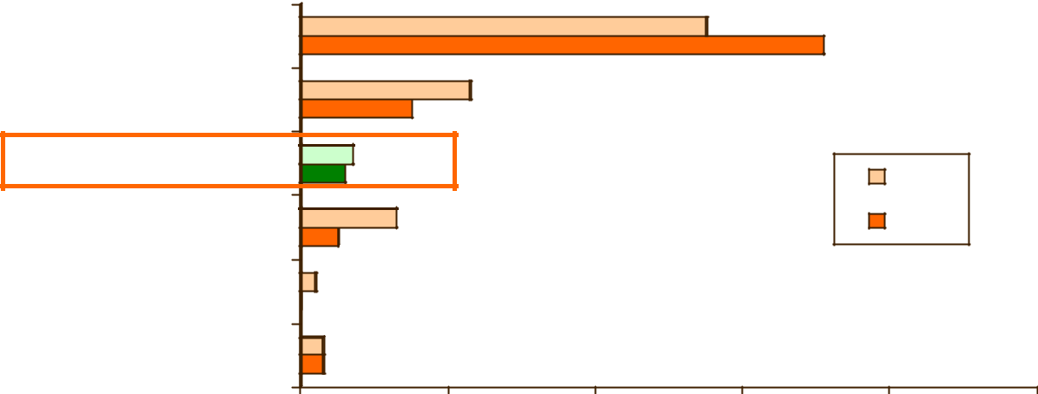

41

Commuter Connections 2010 State of the Commute Survey Draft Technical Report June 30, 2010

The largest source of information, by far, was “special program at work/employer,” named by seven in ten (71%) of respondents. This percentage was considerably higher than in the 2007 survey, in which only 55% of teleworkers cited their employer as the source of information and higher still compared with the 34% who gave this answer in 2004.

Fifteen percent said they “initiated the request on their own” and five percent said they learned of tele-work through “word of mouth.” But had both declined as telework information sources since 2007, when they were named by 23% and 13% respectively

Seven percent of teleworkers said they received telework information directly from Commuter Connec-tions or MWCOG. This was about the same percentage as mentioned Commuter Connections/MWCOG in each of the previous three SOC surveys: 2007 (6%), 2004 (5%), and 2001 (4%).

Telework Patterns

Respondents who said they teleworked, at least occasionally were asked a series of questions about their telework characteristics including: length of time teleworking, use of informal or formal telework ar-rangement, telework location, frequency of teleworking, and access mode to telework locations outside the home.

Length of Time Teleworking

As illustrated in Figure 26, approximately four in ten (38%) respondents who teleworked started tele-working within the past two years and 16% started within the past year. Three in ten (29%) said they had been teleworking more than five years. On average, respondents had been teleworking about 56 months. This was slightly longer duration than had been estimated in 2007 (53 months) and considerably longer than the 42 months average measured in the 2004 SOC survey. In the 2004 SOC survey, nearly half (49%) of teleworkers started teleworking within the past two years and only 19% said they had been teleworking more than five years.

Figure 26

Length of Time Teleworking

(n=1,132)

25-60 months
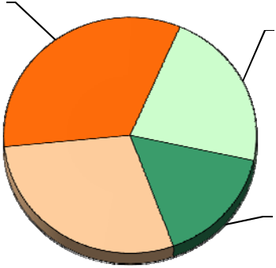
33% 12-24 months

22%

Less than one
year
More than 5 16%

years
29%

42

Commuter Connections 2010 State of the Commute Survey Draft Technical Report June 30, 2010

Formal or Informal Telework Arrangement

Teleworkers were asked if they teleworked under a formal program or through an informal arrangement with a supervisor. Respondents who did not telework were asked if their employer had a telework pro-gram, even though the respondent did not use it.

As shown in Figure 27, 54% of all respondents said their employers allowed some telework, either under a formal program (29%) or under an informal arrangement (25%). Slightly less than half (46%) of res-pondents said their employers did not have any telework program or that they didn’t know about any pro-gram.

Figure 27

Formal or Informal Telework Arrangements

All respondents and Teleworkers vs Non-Teleworkers

(All workers n = 5,854, Teleworkers n = 1,488, Non-teleworkers n = 4, 366)

0% | 20% |  |  | 40% | 60% |  | 80% |  |  | 100%
All workers |  |  |  | 50% |  |  | 46%
All workers |  |  |  | 25%
Teleworkers | 22% |  |  |  |  |  | 50% |  |  | 0%
Non-teleworkers |  |  |  | 17% |  |  | 61%
 |  |  |  | Formal |  | Informal |  |  | No program
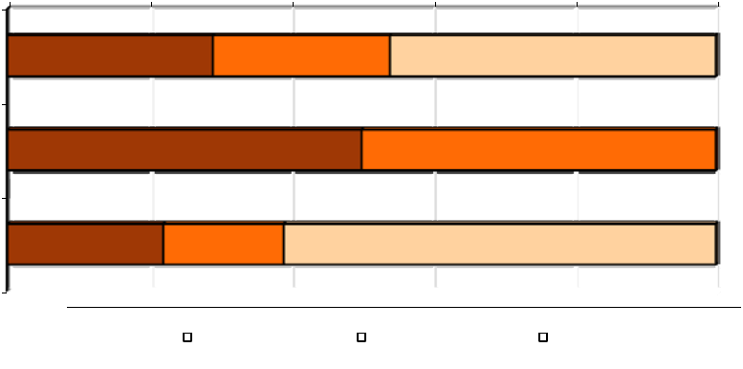

Figure 27 also presents the distribution of telework availability among respondents who currently tele-worked and those who did not. Teleworkers were much more likely than were other respondents to work for an employer with a formal telework program. Half of teleworkers said they teleworked under a for-mal arrangement and the other half teleworked under an informal arrangement with their supervisor.

By contrast, only 22% of non-teleworkers said their employers had a formal telework program and 17% said teleworking was permitted under informal arrangements. More than six in ten (61%) said the em-ployer had no program or they didn’t know if a program existed.

Telework Arrangements 2004 through 2010 – Figure 28 shows the incidence of telework arrangement in 2004, 2007, and 2010. As is clear from the figure, the share of employers that offer or permit telework has increased since 2004. In the 2004 SOC survey, only 35% of respondents noted that their employer allowed telework. In 2007, the share had risen to 41%. By 2010, more than half of respondents said their employer offered some telework option.

43

Commuter Connections 2010 State of the Commute Survey Draft Technical Report June 30, 2010

Figure 28

Telework Arrangements – 2004, 2007, 2010

(2004 n = 6,896, 2007 n = 6,168, 2010 n = 5,854)
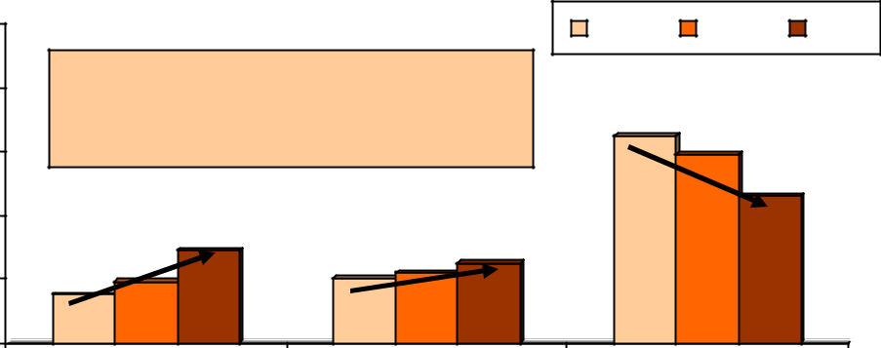

100% |  |  |  |  | 2004 | 2007 | 2010
80% | Telework Available |  |  |  | 65%
60% | 2004 – 35%; 2007 – 41%; 2010 – 54% |  |  |  | 65% | 59%
60% |  |  |  |  |  | 46%
40% |  | 29% | 22% | 25%
20% | 15% ^{19%} | 20% | 22% | 25%
0% | Formal | Informal |  |  | No program

As the figure also shows, while both formal and informal telework arrangements have grown, formal pro-grams have grown more

Arrangement by Employer Type – The availability of telework arrangements varied widely by respondents’ employer types, as illustrated in Table 20.

Table 20

Formal or Informal Telework Arrangements

By Employer Type

 |  |  |  | Federal |  |  | State/local |  |  | Non-profit |  |  | Private
 | Program Type |  |  | Agencies |  |  | Agencies |  |  | Organizations |  |  | Employers
 | Program Type |  |  | (n = 1,520) |  |  | (n = 813) |  |  | (n = 741) |  |  | (n = 2,458)
 | Formal program |  | 57% |  |  | 18% |  |  | 21% |  |  | 20%
 | Informal arrangement |  | 15% |  |  | 15% |  |  | 36% |  |  | 32%
 | No program |  | 28% |  |  | 67% |  |  | 43% |  |  | 48%

Formal programs were most common among respondents who worked for a federal government agency. Nearly six in ten (57%) respondents who worked for federal agencies said their employer had a formal program, compared to only about 21% of respondents who worked for non -profit organizations, 20% who worked for private employers, and 18% who were employed by state/local agencies. Respondents who worked for non- profit organizations or private employers were most likely to have informal telework. More than three in ten respondents in these two groups said their employers permitted informal telework. State/local government agencies were least likely to permit telework under any arrangement. Two-thirds (67%) of these respondents said their employer did not permit telework.

44

Commuter Connections 2010 State of the Commute Survey Draft Technical Report June 30, 2010

Arrangement by Employer Size – Telework arrangements also varied by the number of employees at res-pondents’ worksites. These results are presented in Table 21.

Table 21

Formal or Informal Telework Arrangements

By Employer Size


 |  |  |  | 1-100 |  |  | 101-250 |  |  |  | 251-999
 | Program Type |  |  | Employees |  |  | Employees |  |  |  | Employees
 | Program Type |  |  | (n = 2,454) |  |  | (n = 774) |  |  |  | (n = 847)
 | Formal program |  | 14% |  |  | 23% |  |  | 36%
 | Informal arrangement |  | 25% |  |  | 29% |  |  | 30%
 | No program |  | 61% |  |  | 48% |  |  | 34%

1,000+

Employees

(n = 1,507)

49%

22%

29%

Respondents who worked for large employers were more likely to have access to a teleworking program and to have access to a formal program. Seven in ten of these respondents said their employer had a for-mal program (49%) or permitted informal telework (22%). By contrast, only four in ten respondents who worked for employers with 100 or fewer employees had access to either formal (14%) or informal (25%) telework.

Telework Frequency

The frequency with which respondents teleworked is detailed in Table 22. About two in ten respondents who teleworked did so infrequently, either for special projects (10%) or less than once per month/only in emergencies (12%). Three in ten (30%) said they teleworked a few times each month. Slightly under half (48%) said they teleworked at least one day per week.

Table 22

Frequency of Telework

(n = 1,529)

Frequency | Percentage
Occasionally for special projects | 10%
Less than once per month/emergency | 12%
1 – 3 times per month | 30%
1 day per week | 19%
2 days per week | 12%
3 or more times per week | 17%
Average (mean) days per week | 1.3

45

Commuter Connections 2010 State of the Commute Survey Draft Technical Report June 30, 2010

On average, teleworkers used this arrangement about 1.3 days per week. This overall average 1.5 days per week frequency represents a decline from the 1.5 days per week average observed in the 2007 SOC survey, but is on a par with the 1.3 days per week average estimated in the 2004 survey.

Telework Locations

The overwhelming percentage (97%) of teleworkers said they teleworked exclusively from home. About two percent named another telework location, such as a satellite office, library or community center, or Telework Center. And one percent mentioned that they teleworked some days from home, but some days also from another location.

Travel to Telework Location Outside the Home

About three percent of the teleworkers surveyed said they teleworked from locations outside their homes. They traveled an average distance of 8.1 miles to these locations. As shown in Table 23, 81% of these respondents drove alone to the telework location. About two in ten used an alternative mode: bus (11%), bicycle (4%), walk (3%), or Metrorail (1%).

Table 23

Access Mode to Non-Home Telework Locations

(n = 35)

Access Mode

Percentage

Drive alone

Bus

Bicycle

Walk

Metrorail

81%

11%

4%

3%

1%

46

Commuter Connections 2010 State of the Commute Survey Draft Technical Report June 30, 2010

3-D AVAILABILITY OF AND ATTITUDES TOWARD TRANSPORTATION OPTIONS

The third major section of the State of the Commute Survey examined the availability of transportation options, such as transit, and respondents’ attitudes toward these options.

Public Transportation

Respondents who worked outside their homes were asked to name any public transportation companies that provided service in the area where they lived and the area where they worked. Respondents also were asked how far their homes were from the nearest bus stop and the nearest train station.

Transit Companies Operating

Table 24 presents the results for the first question. As shown, a large majority (90%) of respondents said that they knew of some public transportation that provided service in their home area. Seven in ten (70%) said they knew of both bus and train service, two in ten (19%) said they knew of bus service but not train, and three percent said they knew of train service but not bus service. The remaining respondents said ei-ther that no bus or train companies provided service or that they didn’t know of any service (8%).

Table 24

Transit Service Operating in Home Area and Work Area

(Home area n = 6,189, Work area n = 6,050)


Transit Service Operating

Home Area

Percentage


Work Area

Percentage

Bus and train | 70%
Bus only - no train service | 19%
Train only – No bus service | 3%
No transit in area / don’t know transit | 8%

70%

18%

2%

10%

The percentage who said they knew of transit companies that provided service in their work area was ap-proximately the same as for the home area. Seven in ten (70%) said they knew of both bus and train ser-vice, about two in ten (18%) said they knew of bus service only, and two percent said they knew only that train service was provided. One in ten (10%) said that no transit companies operated either bus or rail service in their work area.

The specific companies that respondents could name are presented in Table 25. Not surprisingly, the two companies mentioned most frequently for both home and work area were those that operate throughout the region. About half (54%) noted Metrobus provided service in their home area and six in ten (59%) said Metrobus provided service in the area where they worked. Similar percentages said that Metro-rail/subway operated in their home area (55%) and at work (60%).

47

Commuter Connections 2010 State of the Commute Survey Draft Technical Report June 30, 2010

Table 25

Public Transportation Companies that Provide Service in

Home Area and Work Area

(Home Area n= 6,189; Work Area n = 6,050)

 | Transit Available |  |  | Home Area |  |  | Work Area
 | Transit Available |  |  | Percentage |  |  | Percentage
 | Bus Available – Bus Companies
 | Metrobus |  | 54% |  |  | 59%
 | Ride On |  | 13% |  |  | 9%
 | Fairfax Connector |  | 8% |  |  | 7%
 | THE BUS |  | 3% |  |  | 2%
 | Loudoun Commuter Bus |  | 4% |  |  | 3%
 | Arlington Transit (ART) |  | 3% |  |  | 3%
 | OmniRide |  | 3% |  |  | 2%
 | Alexandria DASH |  | 3% |  |  | 2%
 | PRTC |  | 2% |  |  | 1%
 | MTA Bus |  | 2% |  |  | 2%
 | DC Circulator |  | 1% |  |  | 2%
 | Other |  | 8% |  |  | 5%
 | Don’t know name of company |  | 15% |  |  | 18%
 | Train Available – Train Companies
 | Metrorail/subway |  | 55% |  |  | 60%
 | MARC |  | 12% |  |  | 10%
 | Virginia Railway Express |  | 11% |  |  | 9%
 | AMTRAK/ACELA |  | 8% |  |  | 9%
 | Don’t know name of company |  | 6% |  |  | 8%

*Might add to more than 100% because multiple responses were permitted.

**Each response in the “Other” category mentioned by less than one percent of respondents.

Two bus companies that provide service in part of the region were noted by at least five percent of res-pondents. Thirteen percent of respondents said RideOn, operated in their home area (Montgomery Coun-ty, MD) and eight percent mentioned Fairfax Connector, serving Fairfax County, VA. These bus compa-nies also topped the list of services available in respondents’ work areas, but they were mentioned by slightly lower percentages of respondents.

48

Commuter Connections 2010 State of the Commute Survey Draft Technical Report June 30, 2010

In addition to Metrorail, respondents noted names of three commuter rail companies. MARC, operating several lines in Maryland, and Virginia Railway Express (VRE), serving Northern Virginia areas, were cited by 12% and 11% of respondents, respectively. Eight percent of respondents said AMTRAK pro-vided service from their home area. These services also were noted as serving work areas, in percentages similar to those for the home areas.

Distance to Bus Stop and Train Station

The results presented above reflect respondents’ perception of transit availability; they are not an objec-tive measure of transit availability or level of transit access. A respondent who is willing to drive to a bus stop or rail station might consider service that operates within five miles of his home to be “in my home area,” while another respondent who lives within one mile could feel that “no transit operates.” The sur-vey also did not address other factors that might enter into a respondent’s assessment of the practical fea-sibility of using transit, such as the directness of the trip or the time needed to make the trip. Thus, some respondents might have considered these factors in assessing whether “service was provided” and others might have excluded them from their assessment.

To assess a measure of the closeness of transit, all respondents, including those who said no transit oper-ated, were asked the distance from their homes to the nearest bus stop and nearest train station. Figure 29 displays the distribution of access distance. More than half of respondents said they lived less than one-half mile from a bus stop and 67% said they lived less than one mile. Among respondents who could provide a distance to a bus stop, the average distance was 1.4 miles.

Figure 29

Distance from Home to Bus Stop and Train Station

(Bus stop n = 6,189, Train station n = 6,189)
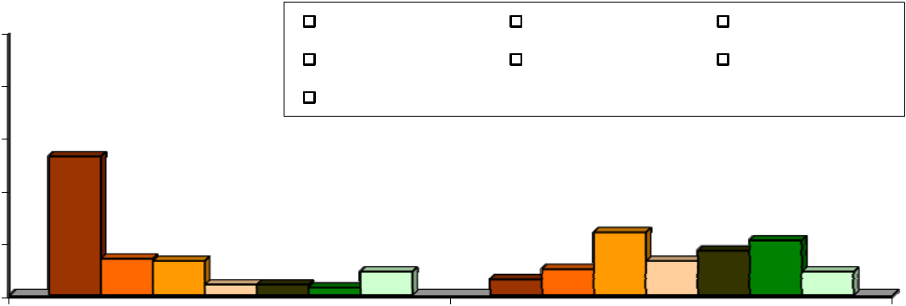

100% |  |  |  |  | Less than 0.5 mi |  |  |  | 0.5-0.9 mi |  |  |  |  | 1.0-2.9 mi
100% |  |  |  |  | 3.0-4.9 mi |  |  |  | 5.0-9.9 mi |  |  |  |  | 10.0 mi or more
80% |  |  |  |  |  |  |  |  |  |  |  |  |  | 10.0 mi or more
80% | 53% |  |  |  | DK
60% | 53% |  |  |  | DK
40% |  |  |  |  |  |  |  |  |  | 24% |  | 17% ^{21%}
20% | 14%13% |  |  |  |  |  |  |  |  | 24% | 13%
20% | 14%13% | 4% |  |  |  | 9% | 6% |  |  | 10% | 13% | 9%
 | 4% |  |  | 3% |  | 9% |  |  |  | 10%
0% | 4%
 | Bus Stop |  |  |  |  |  |  |  |  | Train Station

Train stations were quite a bit farther away for most respondents. Only six percent said they lived less than one-half mile of a Metrorail or commuter rail station and only 16% lived less than one mile. About half (51%) said they lived three or more miles away from the nearest train station. On average, respon-dents who provided a distance lived 6.4 miles away.

49

Commuter Connections 2010 State of the Commute Survey Draft Technical Report June 30, 2010

Table 26 presents a comparison of the transit access distance for the four bus available – train available categories in Table 24. Again, it is important to emphasize that “service provided” was defined by res-pondents’ perception.

Table 26

Mean Distance from Home to Bus Stop and Train Station

By Type of Transit Service Operating in Home Area


Service Provided

Bus Stop

Train

Station

Bus and train provided | 0.9 miles | 3.8 miles
(bus n = 3,370, train n = 3,457) | 0.9 miles | 3.8 miles
Bus only - no train service provided | 1.8 miles | 14.5 miles
(bus n = 1,504, train n = 1,451) | 1.8 miles | 14.5 miles
Train only – No bus service provided | 4.9 miles | 7.4 miles
(bus n = 134, train n = 171) | 4.9 miles | 7.4 miles
No bus or train service / don’t know transit | 5.4 miles | 13.8 miles
(bus n = 434, train n = 523) | 5.4 miles | 13.8 miles

Respondents who said both bus and train service operated reported the shortest distance to transit access points, 0.9 miles to the nearest bus stop and 3.8 miles to the nearest train station. Respondents who said only bus operated in their home area lived on average 1.8 miles from a bus stop and 14.5 miles from a train station. Among respondents who reported only access to train, the average bus stop distance was 4.9 miles, greater than in the “bus only” category. But the train station distance (7.4 miles) was much shorter.

Respondents were asked to estimate the distance to bus and rail, even if they said neither bus nor rail op-erated in the area where they lived. As seen in Table 26, these respondents reported an average bus access distance (5.4 miles) approximately the same as that for respondents who reported access to “train only“ (4.9 miles) and train access distance (13.8 miles) approximately the same as reported by respon-dents who said they had “bus only” access (14.5 miles) . Because these respondents reported no service operating, these distances were clearly beyond the area these respondents classified as their “home area.”

Transit Service Provided by Home Area

The analysis examined availability of transit services by respondents’ home location within the “ring” designations defined earlier: Inner Core (City of Alexandria, Arlington County, and the District of Co - lumbia), Middle Ring (Fairfax, Montgomery, and Prince George’s counties), and Outer Ring (Calvert, Charles, Frederick, Loudoun, and Prince William counties). Table 27 presents the percentage of respon-dents in each area who said bus and/or rail operated in their home area.

As expected, both bus and train services were more available in the central part of the region than in the outer jurisdictions. In the Inner Core, 99% of respondents said some transit service operated in their home area and 88% said they both bus and train operated. Within the Middle Ring, three-quarters of res-pondents said both bus and train operated and 19% said either bus or rail companies provided service. Transit availability dropped off markedly in the outer ring; only 82% of respondents said both some train operated and only 41% said they had access to both bus and train.

50

Commuter Connections 2010 State of the Commute Survey Draft Technical Report |  |  |  |  |  |  |  |  |  |  |  | June 30, 2010
 |  |  | Table 27
 |  |  | Bus and Train Service by Home Area
 |  | Transit Operating |  |  |  | Core Area |  |  | Inner Ring |  |  | Outer Ring
 |  |  |  |  |  | (n = 1,667) |  |  | (n = 1,685) |  |  | (n = 2,837)
 |  | Bus and train |  |  |  | 88% |  | 75% |  |  | 41%
 |  | Bus only - no train service |  |  |  | 10% |  | 17% |  |  | 36%
 |  | Train only – No bus service |  |  |  | 1% |  | 2% |  |  | 6%
 |  | No bus or train service / don’t know service |  |  |  | 1% |  | 6% |  |  | 18%


Distance to Transit by Home Area

Figure 30 presents the distribution of distance for the three area rings. Eighty-five percent of respondents in the Inner Core reported living less than one-half mile from a bus stop, compared to 56% of respondents in the Middle Ring, and 16% of respondents in the Outer Ring. Only three percent of Inner Core respon-dents lived one or more miles from a bus, compared with more than half (55%) of Outer Ring respon-dents. It is also notable that two in ten Outer Ring respondents said they didn’t know how far they lived from a bus stop.

Figure 30

Distance from Home to Bus Stop by Home Location

(Inner Core n = 1,667, Middle Ring n = 1,685, Outer Ring n = 2,837)

100%
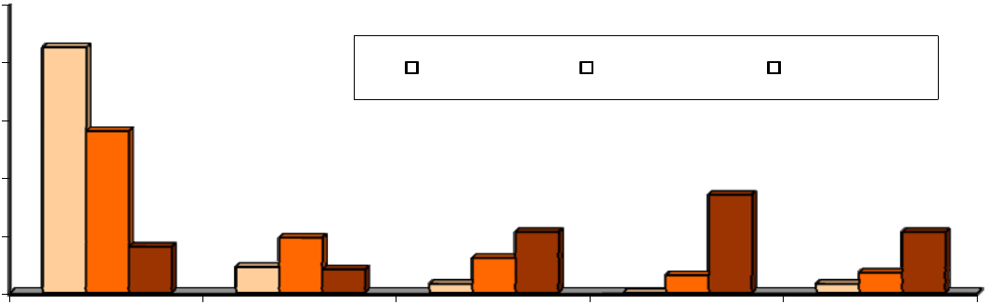
85%

80% | 56% |  |  |  | Inner Core |  | Middle Ring |  |  | Outer Ring
60% | 56%
40% |  |  |  |  |  |  |  | 34%
20% | 16% |  | 19% | 21% |  |  |  |  |  |  | 21%
 |  | 9% | 8% | 12% |  |  |  | 6% |  |  | 7%
0% |  | 9% | 8% | 3% |  | 0% |  | 6% |  | 3% | 7%
 | Less than 0.5 | 0.5-0.9 mi |  |  | 1.0-2.9 mi |  | 3.0 mi or more |  |  | Don't know
 | mi

The average transit access distance was the shortest for respondents who lived in the core area; just 0.3 miles to the nearest bus stop and 1.5 miles to the nearest train station. Respondents in the inner ring said they would have to travel 0.9 miles to the nearest bus stop and 4.8 miles to the nearest train station. Res-pondents who lived in the outer ring reported that the nearest bus stop was an average of 4.2 miles away and train was 15.5 miles away.

51

Commuter Connections 2010 State of the Commute Survey Draft Technical Report June 30, 2010

Commute Mode by Distance to Bus Stop – As might be expected, the commute mode share of transit de-clines with increasing distance from a bus stop. Figure 31 presents the mode shares of driving alone, bus/train, and carpool/vanpool for respondents who live various distances from a bus stop. More than a quarter (27%) of commuters who live less than one-half mile from a bus stop commute primarily by bus or train. As the distance from home to a bus stop increases, the transit share falls steadily. When the nearest bus stop is 10 miles from home, only six percent of respondents commute by transit, a drop of 21 percentage points.

Figure 31

Commute Mode by Distance from Home to Bus Stop

 | (Less than 0.5 mi n = 2,696, 0.5-0.9 mi n = 681, 1.0-2.9 mi n = 843, 3.0-4.9 mi n = 338,
 |  | 5.0-9.9 mi n = 455, 10.0 mi or more n = 429)
100% |  | Drive alone | Bus/Train | Carpool/vanpool
100% |  |  |  |  |  | 81%
 |  | 74% |  |  |  | 81%
80% |  | 74% | 69% | 72% | 75% | +23%
60% | 58%
40% | 27% |  |  |  |  | -21%
20% | 7% | 13%_{7%} | 17% | 14% | 11%_{8%} | 6% ^{9%}
20% | 7% | 13%_{7%} | 8% | 10% | 11%_{8%} | 6% ^{9%}
0% | Less than 0.5 | 0.5-0.9 mi | 1.0-2.9 mi | 3.0-4.9 mi | 5.0-9.9 mi | 10.0 mi or
 | mi |  |  |  |  | more
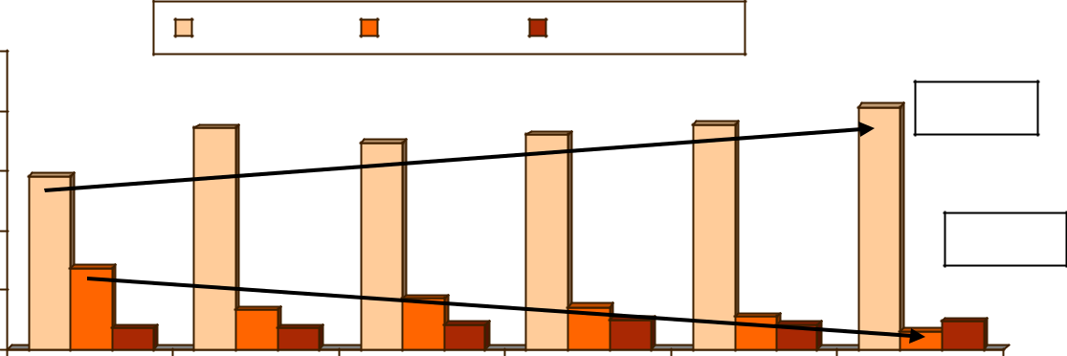

These commuters shift almost entirely to driving alone. As the figure shows, the drive alone rate for commuters who live more than 10 miles from a bus stop is 81%, compared to 58% for commuters who live within one -half mile of a bus stop. This represents a 23 percentage point increase for driving alone. Use of carpool / vanpool remains fairly constant at all bus access distances.

High Occupancy Vehicle (HOV) and High Occupancy Toll (HOT) Lanes

Availability and Use of HOV Lanes

The survey also examined the availability and use of High Occupancy Vehicle (HOV) lanes. Three in ten (30%) of the respondents who commuted one or more days per week said there was a special HOV lane along their route to work. Of these commuters, 27% said they used these lanes. This equated to about nine percent of commuters region- wide. This was essentially the same percentage as reported HOV availability and HOV use in 2007.

Respondents who regularly used the HOV lane for commuting estimated that using the lane saved them an average of 23 minutes for each one-way trip. As displayed in Figure 32, a third (33%) said they saved 10 minutes or less and three in ten (30%) saved between 11 and 20 minutes. The remaining HOV users were evenly split between savings of 21 to 30 minutes (20%) and saving more than 30 minutes one-way (17%).

52

Commuter Connections 2010 State of the Commute Survey Draft Technical Report |  |  |  |  |  | June 30, 2010
 |  | Figure 32
 | Travel Time Saving of HOV Users
 |  | (n = 486)
 |  |  |  |  | 100%
 |  |  |  |  | 80%
 |  |  |  |  | 60%
33% |  | 30% | 20% |  | 40%
 |  |  | 20% |  | ^{17%}20%
 |  |  |  |  | 0%
10 min or less 11 - 20 min |  | 21 - 30 min | 31 min or
 |  |  | more
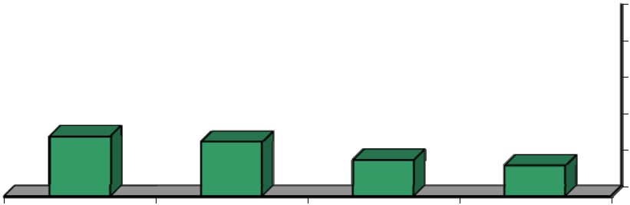

HOV Lanes by Home Area – Figure 33 shows availability and use of HOV lanes by respondents’ home lo-cation within the three “ring” categories. Commuters who lived in Middle Ring and Outer Ring jurisdic-tions were more likely to say they have HOV lanes available on their route to work than were commuters who lived in the Inner Core.

Figure 33

Availability and Use of HOV Lanes by Home Area

(HOV Available – Region-wide n = 6,050, Inner Core n = 1,637, Middle Ring n = 1,651, Outer Ring n = 2,760)

(HOV Used – Region-wide n = 1,757, Inner Core n = 483, Middle Ring n = 487, Outer Ring n = 787)
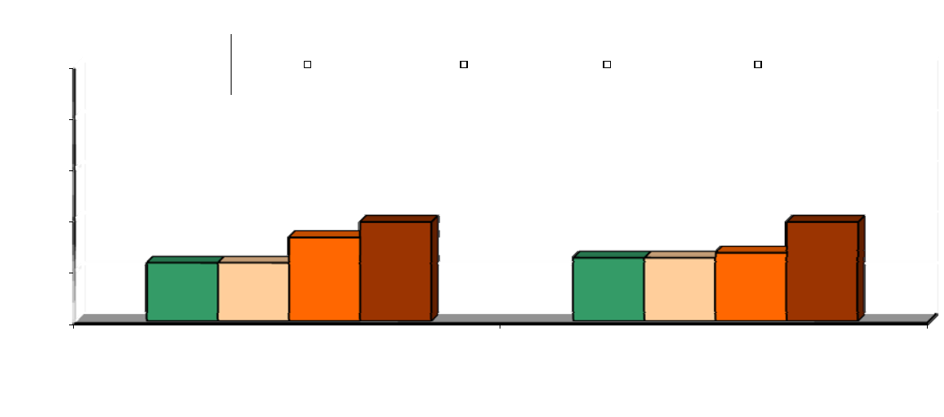

100% |  |  |  | Region Wide |  |  | Inner Core |  |  | Middle Ring |  |  |  | Outer Ring
80%
60%
 |  | 33% |  |  | 39% |  |  |  |  |  |  | 39%
 |  |  |  |  |  |  |  |  |  |  |  | 27%
40% | 23% | 23% |  |  |  |  |  | 25% |  |  | 25%
20%
0%

HOV Available Used HOV

Commuters HOV lanes them, when they were available. Nearly four in ten Outer Ring respondents who had access to HOV lanes said they used them, compared to about a quarter of Inner Core and Middle Ring respondents.

53

Commuter Connections 2010 State of the Commute Survey Draft Technical Report June 30, 2010

Table 28 shows availability and use of HOV lanes by respondents’ home county or city. Virginia resi-dents had higher HOV availability than did residents of Maryland or the District of Columbia. At least one-third of respondents in each of the five Virginia jurisdictions said an HOV lane was available to them and in Prince William County, six in ten (60%) respondents reported HOV lanes available.

Table 28

Availability and Use of HOV Lanes

by Residence Jurisdiction

 |  |  |  | All Respondents |  |  |  |  |  | Respondents With HOV
 |  |  |  |  |  |  |  |  |  | Available
 | Home |  |  |  |  |  | Percentage |  |  |  |  |  | Percentage
 | Home |  |  | (n=___) |  |  | with HOV lane |  |  | (n=___)* |  |  | using HOV
 | Jurisdiction (County/City) |  |  | (n=___) |  |  | with HOV lane |  |  | (n=___)* |  |  | using HOV
 | Jurisdiction (County/City) |  |  |  |  |  | available |  |  |  |  |  | lane
 | Virginia jurisdictions
 | Prince William County |  | 548 |  |  | 60% |  |  | 322 |  |  | 45%
 | City of Alexandria |  | 533 |  |  | 52% |  |  | 250 |  |  | 28%
 | Fairfax County |  | 547 |  |  | 49% |  |  | 260 |  |  | 30%
 | Loudoun County |  | 537 |  |  | 42% |  |  | 220 |  |  | 35%
 | Arlington County |  | 527 |  |  | 35% |  |  | 182 |  |  | 24%
 | Maryland jurisdictions
 | Frederick County |  | 542 |  |  | 34% |  |  | 177 |  |  | 28%
 | Montgomery County |  | 522 |  |  | 31% |  |  | 154 |  |  | 23%
 | Prince George’s County |  | 558 |  |  | 13% |  |  | 73 |  |  | 23%
 | Charles County |  | 550 |  |  | 7% |  |  | 36 |  |  | 23%
 | Calvert County |  | 559 |  |  | 6% |  |  | 32 |  |  | 19%
 | District of Columbia |  | 511 |  |  | 9% |  |  | 40 |  |  | 21%

* Respondents in the jurisdiction who have an HOV lane available along their route to work.

By comparison, HOV was available to three or more respondents in only two Maryland jurisdictions, Montgomery County (34%) and Frederick County (31%). And only one in ten respondents from the Dis-trict of Columbia reported having access to HOV lanes along their route to work.

The last column of Table 28 illustrates the use of HOV lanes by residence jurisdiction for respondents who said they had HOV lanes available. With the exception of Prince William County, in which 45% of respondents who had access to HOV used the lanes, HOV use was fairly consistent across the region with about 25% to 30% of respondents using the lanes.

54

Commuter Connections 2010 State of the Commute Survey Draft Technical Report June 30, 2010

HOV Lane Influence on Commute Choice – HOV lanes appear to have an impact on choice of commute modes. More than half (54%) of the respondents who used the lanes for commuting said availability of the HOV lane influenced their decision to carpool, vanpool, or ride transit for their commute. The influ-ence on carpooling is best illustrated by the drive alone and carpool/vanpool mode shares when HOV lanes are available and when they are not.

As shown in Figure 34, about 11% of respondents who said an HOV lane was available to them were car-pooling or vanpooling to work, compared with six percent of respondents who did not have access to HOV. Transit use also was higher for respondents who said an HOV lane was available. Conversely, the drive alone rate for respondents who had access to HOV was 63%, compared to 71% for respondents who could not use HOV.

Figure 34

Primary Commute Mode by

Availability of HOV Lanes

(HOV Available n = 1,763, HOV Not Available n = 4,151)
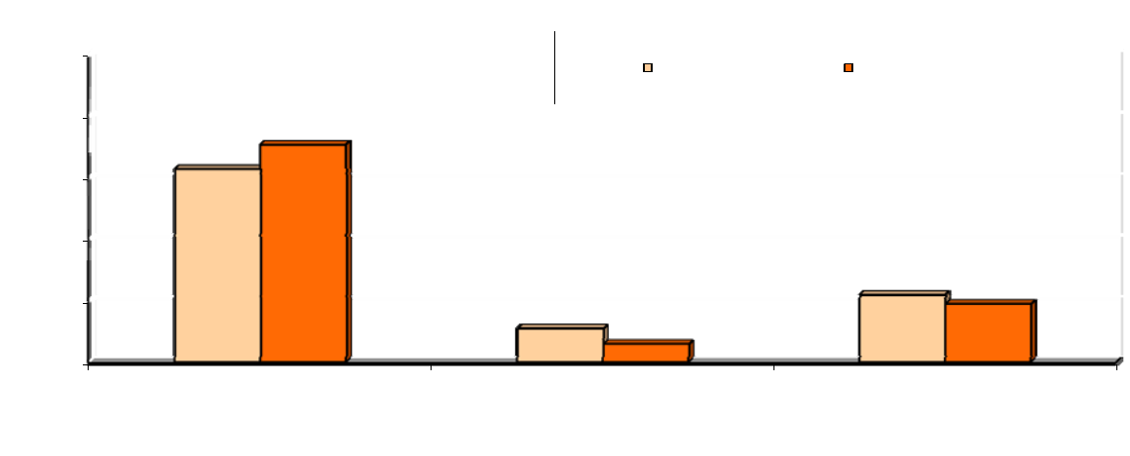

100% | HOV Available | HOV Not Available

80% | 71%
80% | 63%
60%
40%
 |  |  |  | 22%
 |  |  | 11% | 19%
20% |  |  | 11%
 |  |  | 6%
0%
Drive alone |  |  | Carpool/vanpool | Transit

Various HOV studies have suggested that the influence of HOV lanes is due to both the amount of time saved by HOV lanes and the reliability of travel time that HOV lanes afford. Overall, 54% of HOV users said that availability of the lane influenced their decision to choose an alternative mode for commuting. On average, these users saved 23 minutes one-way in their commute time. Figure 35 shows these results.

Figure 35 also presents comparisons results for the each of the three ring designations. About a quarter of HOV users who lived in the Inner Core reported that HOV availability influenced their mode choice and they saved an average of 13 minutes one-way. HOV lanes’ influence on HOV users who lived in the Middle Ring and Outer Ring was much higher; 53% of Middle Ring respondents and 63% of Outer Ring respondents said the HOV lanes influenced their commute mode choice. They also reported much greater time saving in their commute; 22 minutes and 28 minutes one-way, respectively.

55

Commuter Connections 2010 State of the Commute Survey Draft Technical Report June 30, 2010

Figure 35

HOV Influence on Choice of Commute Mode and Time Saved by HOV Lane Use

By Home Location

(HOV lane influenced - All Region n = 539, Inner Core n = 123, Middle Ring n = 133, Outer Ring n = 283)

(HOV time saving - All Region n = 486, Inner Core n = 103, Middle Ring n = 121, Outer Ring n = 262)
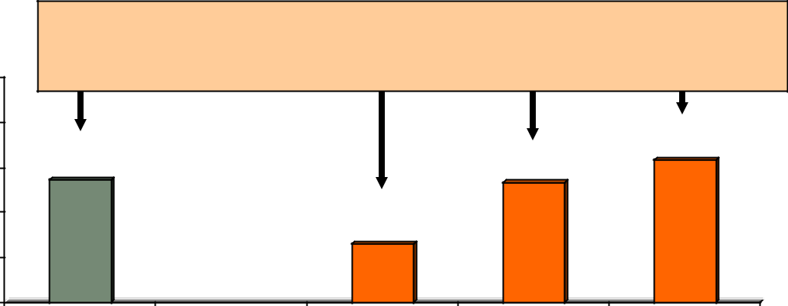

Average one-way time saving

100% | 23 minutes | 13 minutes | 22 minutes | 28 minutes
80% |  |  |  | 63%
 | 54% |  | 53% | 63%
60% | 54% |  | 53%
40% |  | 26%
20%
0% | All Region | Inner Core | Middle Ring | Outer Ring

Interest in HOT Lanes

The 2010 survey included two new questions related to commuters’ interest in High Occupancy Toll (HOT) lanes, which are under construction or being proposed for several jurisdictions. Respondents were asked about their interest in carpooling or vanpooling on a toll road that was free or reduced cost for car-pools and vanpools. Respondents who were not ridesharing were asked: “Several jurisdictions in the Washington region are building or considering building toll roads. If you could use one of these roads for your trip to work and carpools and vanpools traveled for free or for a reduced toll, how likely would you be to start carpooling or vanpooling to use these roads?”

Respondents who were carpooling or vanpooling were asked how likely they would be to register their carpool or vanpool with a regional commute organization to be able to receive the discount: “… If you could use one of these roads for your trip to work and carpools and vanpools that registered with a re-gional commute organization could use these roads for free or for a reduced toll, how likely would you be to register your carpool or vanpool?” Results for both of these questions are presented in Figure 36.

About a quarter (26%) of non-ridesharers said they were either very likely (12%) or somewhat likely (14%) to start ridesharing to use the lanes. Current ridesharers were more willing to register their car-pools/vanpools to receive the discount; two-thirds said they were either very likely (39%) or somewhat likely (27%) to register their carpool / vanpool to use the lanes at a discount.

Interest in HOT lanes did not vary substantially across the three “ring” sub-areas of the region. About 22% of Inner Core residents said they would be likely to try ridesharing. Middle Ring and Outer Ring residents were only slightly more interested; about 26% of Middle Ring and 30% of Outer Ring residents said they were likely to try ridesharing to use the lanes at a reduced price.

56

Commuter Connections 2010 State of the Commute Survey Draft Technical Report June 30, 2010

Figure 36

Likely to try Carpool/Vanpool or to Register Existing Carpool / Vanpool to Receive HOT Lane Discount

(Try carpool / vanpool n = 5,368; Register carpool / vanpool n = 472)
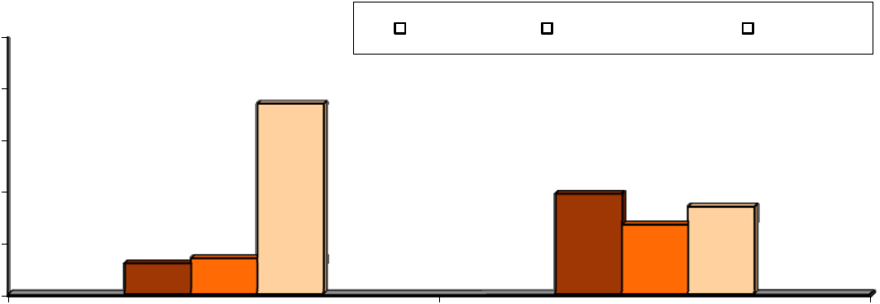

100% |  |  |  |  | Very likely |  |  | Somewhat likely |  |  | Not likely
80% |  | 74%
60% |  |  |  |  |  | 39%
40% |  |  |  |  |  |  |  |  | 34%
40% |  |  |  |  |  |  |  |  | 27%
20% | 12% | 14%
0%
 | Try carpool / vanpool |  |  |  |  | Register carpool / vanpool

Park & Ride Lots

Figure 37 depicts respondents’ awareness of the locations of Park & Ride lots along their route to work. Forty-five percent of respondents across the region said they knew the locations of Park & Ride lots along their commuting route. About a third (32%) said they did not know the locations. A quarter (23%) said there were no Park & Ride lots along their route to work.

The figure also shows that awareness / availability of P&R lots varied substantially by home location in the region. Respondents who lived in the Inner Core were least likely to say they knew of a P&R lot on their route; only 23% of these respondents knew of a lot, while 47% of respondents who lived in the Mid-dle Ring and 60% of respondents in the Outer Ring knew of a lot along their route to work.

Figure 37

Awareness of Park & Ride Lots Along Route to Work – By Home Location

(All region n = 6,045, Inner Core n = 2,269, Middle Ring n = 1,989, Outer Ring n = 1,412)

60% |  | 60%
60% |  | 47%
50% | 45% |  |  |  |  |  | 44%
40% |  |  |  |  | 32% |  | 32% |  |  | 33%
30% |  | 23% |  |  |  |  | 22% |  |  | 23% |  | ^{21%}18%
20% |  |  |  |  |  |  |  |  |  |  |  | ^{21%}18%
10%
0%
 | Know P&R location |  |  |  |  | Don't know location |  |  |  |  | No P&R lots
 |  |  |  | All region |  | Core area |  |  | Inner ring |  | Outer ring
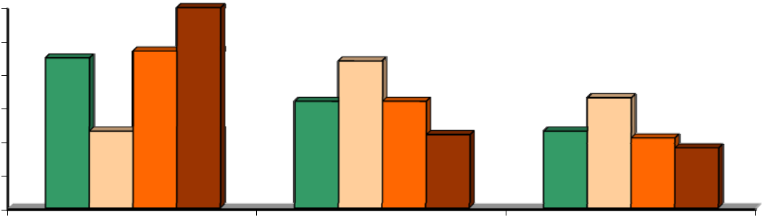

57

Commuter Connections 2010 State of the Commute Survey Draft Technical Report June 30, 2010

Two in ten (21%) of those who knew the P&R locations had used these lots when commuting during the past year. These respondents represented nine percent of total respondents in the survey, slightly higher than the seven percent of respondents who reported use of Park & Ride lots in the 2007 SOC survey. Use of P&R lots was more common among Middle Ring (24%) and Outer Ring (19%) residents than for Inner Core (15%) residents. But respondents who worked in the Inner Core used the lanes at a much higher rate than did other respondents. A third of Inner Core workers who knew of the lanes had used them in the past year, compared with just one in ten respondents who worked in the Middle Ring (11%) or Outer Ring (9%).

Attitudes Toward Transportation Options

Carpool / Vanpool Barriers

Respondents who did not carpool or vanpool to work were asked why they did not use these modes. Ta-ble 29 shows respondents’ barriers to rideshare use, grouped into three reason categories: service availa-bility, service characteristics, and personal preferences/needs.

Table 29

Reasons for Not Using Carpool / Vanpool to Work

(n = 4,086, multiple responses permitted)

 | Reasons |  |  | Percentage
 | Service Availability ***
 | Don’t know anyone to carpool/vanpool with |  | 45%
 | Service Characteristics
 | Takes too much time |  | 5%
 | Bus/train/carpool partner could be unreliable/late |  | 2%
 | Doesn’t save time |  | 2%
 | Personal Preferences/Needs
 | Work schedule irregular |  | 28%
 | Need my car for work |  | 10%
 | Need car before/after work |  | 11%
 | Live close to work, can walk, use other mode |  | 6%
 | Don’t like to ride with strangers, prefer to be alone |  | 6%
 | Need car for emergencies/overtime |  | 3%
 | Just not interested |  | 2%
 | Prefer to drive, want freedom / flexibility |  | 1%
 | Trip is too long/distance too far |  | 1%
 | Other |  | 5%

58

Commuter Connections 2010 State of the Commute Survey Draft Technical Report June 30, 2010

The most common reason, cited by nearly half (45%) of respondents was one of service availability; that they didn’t know anyone to carpool or vanpool with. Only a small share of respondents noted concerns or barriers related to service characteristics. The most common concern here was that carpooling and van-pooling take too much time.

Respondents noted greater barriers related to personal preferences/needs. The most common reason was an irregular schedule, cited by 28% of respondents. About one in ten said they needed a personal vehicle for trips before or after work or that their work responsibilities required use of a vehicle. Six percent of respondents said they lived too close to work to make carpooling or vanpooling attractive and six percent said they did not want to ride with strangers or preferred to be alone during commuting.

Transit Barriers

Respondents who did not use a bus or train for commuting were asked why they did not use transit. Table 30 shows respondents’ barriers to transit use, grouped in the three reason categories: service availability, service characteristics, and personal preferences/needs.

Respondents cited reasons in each category. About half of the respondents said they did not use transit because they did not have train service available and three in ten said bus service was not available in ei - ther the home or work area. Respondents who did not use bus or train also noted several characteristics of the services as barriers to their use. The top reason in this group was that transit “takes too much time,” mentioned by a third of respondents. Small percentages of respondents noted issues with cost, conveni-ence, comfort, and safety.

Common reasons in the personal preferences/needs category included needing a vehicle for work or be-fore or after work, having an irregular work schedule, and that the trip was too long. Smaller shares of respondents said the commute was too short, they needed or wanted travel freedom and flexibility, and that they did not want to ride with strangers.

59

Commuter Connections 2010 State of the Commute Survey Draft Technical Report June 30, 2010

Table 30

Reasons for Not Using Transit to Work

(n = 4,135, multiple responses permitted)

 | Reasons | Percentage
 | Service Availability *
 | No train service available in home/work area | 52%
 | No bus service available in home/work area | 29%
 | Don’t know if service is available/location of service | 2%
 | Service Characteristics
 | Takes too much time | 32%
 | Too expensive | 5%
 | Have to transfer/too many transfers | 4%
 | Bus/train could be unreliable/late | 3%
 | Have to wait too long for service | 2%
 | Too uncomfortable/crowded | 2%
 | Might not be safe | 2%
 | Personal Preferences/Needs
 | Need my car for work | 11%
 | Work schedule irregular | 10%
 | Need car before/after work | 9%
 | Trip is too long/distance too far | 8%
 | Commute is too short | 5%
 | Prefer to drive, want freedom / flexibility | 4%
 | Don’t like to ride with strangers, prefer to be alone | 4%
 | Need car for emergencies/overtime | 1%
 | Other | 5%


- Respondents who said no train or bus service was available also were permitted to answer other reasons why they could not use bus or train

60

Commuter Connections 2010 State of the Commute Survey Draft Technical Report June 30, 2010

Ease of Commute and Commute Satisfaction

Ease of Commute Compared to Last Year

Respondents who did not telework or work at home all the time were asked if their commute time was easier, more difficult, or about the same as it was a year prior. As seen in Figure 38, the majority of res-pondents (62%) said their commute was about the same as a year ago. About a quarter (25%) said their commute was more difficult and 12% said their commute was easier. One percent of respondents said they were not commuting in the Washington region a year ago, so a comparison was not provided.

Figure 38

Commute Easier, More Difficult, or About the Same as Last Year

(n = 6,049)

 | N/A 1%
About the | Easier
same | Easier
same | 12%
62% | 12%
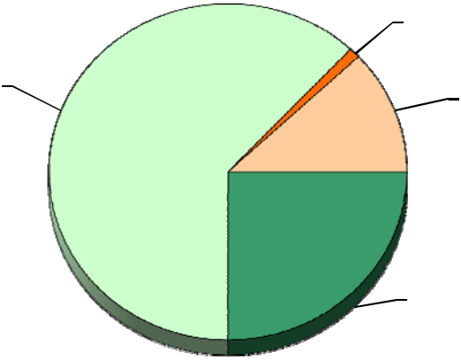

More difficult
25%

Respondents who said their commute had changed were asked in what way it was easier or more difficult. The top section of Figure 39 presents reasons that respondents’ commutes had worsened. The bottom section of the Figure shows the reasons that respondents’ commutes had improved.

More Difficult Commute – Six in ten respondents who said their commute was more difficult said their route had become more congested. About two in ten respondents the trip took more time and 14% said new construction along the route made the trip more difficult. About one in ten said the distance was longer (11%) or that the trains / buses were more crowded (8%).

Easier Commute – The most common reason for an easier commute was that it was shorter, cited by 34% of these respondents. This is likely due to a change in either a work location or home location. About three in ten respondents said the trip was faster (29%) and 26% said the route they used was less con-gested or that the road had been improved. One in ten respondents (11%) said the commute was easier because construction along the route had ended. A similar share of respondents attributed their easier commute to a change they had made in their travel mode: started using bus/train (5%), started driving to work (4%), or started carpooling/vanpooling to work (3%).

61

Commuter Connections 2010 State of the Commute Survey Draft Technical Report June 30, 2010

Figure 39

Reasons Commute is More Difficult or Easier

(More Difficult Commute n = 1,501; Easier Commute n = 681, multiple responses permitted)
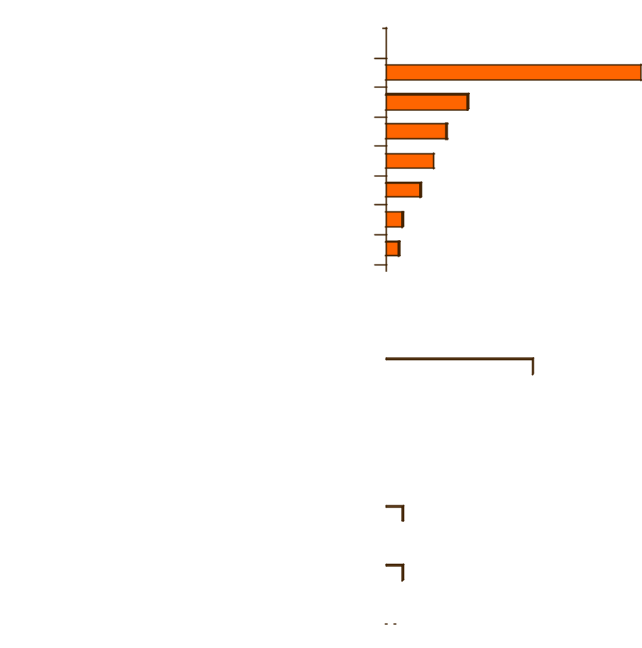

Reasons Commute is More Difficult
Route is more congested | 59%
Trip is slower, takes more time | 19%
Construction on route to work | 14%
Longer distance | 11%
Trains/buses more crowded | 8%
Gas prices are higher | 4%
More stressful | 3%

Reasons Commute is Easier

Shorter distance |  |  |  |  |  |  |  |  |  |  |  | 34%
 |  |  |  |  |  |  |  |  |  |  | 29%
Trip is faster, takes less time
 |  |  |  |  |  |  |  |  |  | 26%
Route is less congested, road improvements
Construction on route has ended |  |  |  |  |  |  |  | 11%
Started using bus/train |  |  |  |  |  |  | 5%
 |  |  |  |  | 4%
Started driving to work
Less stressful |  |  |  |  |  | 4%
New transit vehicles/improved service |  |  |  |  | 4%
Started carpool/vanpool to work |  |  |  | 3%
 |  |  |  | 2%
Gas prices are lower
0% |  |  |  | 20% |  |  |  |  |  | 40% |  |  |  | 60% |  | 80% |  | 100%

Influence of Changes in Residence or Work Location

Because it was expected that a commute might have become easier or more difficult because the origin and/or destination of the commute changed, all respondents were asked if they had made a change in their work location and/or home location in the past year. Table 31 displays results of commute ease for res-pondents who did and did not make a move.

62

Commuter Connections 2010 State of the Commute Survey Draft Technical Report |  |  |  |  |  |  |  |  |  |  |  |  |  | June 30, 2010
 |  |  |  |  | Table 31
 |  |  | Commute Compared to Last Year
 |  | by Made a Change in Home or Work Location
 |  | Changed Home or |  |  | (n =__) |  |  |  |  |  | More |  |  | About the
 |  | Work Location |  |  | (n =__) |  |  | Easier |  |  | Difficult |  |  | Same
 |  | No change |  | 5,070 |  |  |  | 29% |  | 33% |  |  | 38%
 |  | Yes |  | 993 |  |  |  | 9% |  | 24% |  |  | 67%
 |  | Type of change made
 |  | Changed home |  | 320 |  |  |  | 25% |  | 34% |  |  | 41%
 |  | Changed work |  | 464 |  |  |  | 32% |  | 34% |  |  | 34%
 |  | Changed home and work |  | 209 |  |  |  | 32% |  | 34% |  |  | 34%

About 17% made a change and 83% made no change. Three-quarters (76%) said they moved within the Washington metropolitan region. The other 24% moved from a location outside the Washington area. Because those who moved from outside the region could not provide a before-the-move comparison, they were excluded form the base for Table 31.

The percentages shown in the table suggest the ease or difficulty of the commute appears to have been related to moves for at least some of the respondents. The majority (67%) of respondents who did not move said their commutes were about the same. Nine percent said their commute had improved and about a quarter (24%) said it had gotten more difficult.

About a third (33%) of respondents who moved said they had a more difficult commute. But the percen-tage of these respondents who said their commute had improved was much higher, 29%, than the percen-tage of respondents who had an easier commute without a move. This suggests that the move might have played a role in either improving or worsening a commute, but that the move more often improved the commute.

The table also shows a breakdown of change in commute conditions by the type of move made: home only, work only, or both home and work. The differences between responses for these groups are small all are within the statistical margin of error.

Commuting as a Factor in Location Change Decisions – Anecdotal reports have suggested that some com-muters might move their residences and/or seek new jobs at least in part because they wanted to make their commute easier or less costly. Several questions were included in the SOC survey in 2007 to ex-amine if commute factors were influencing residents of the area to make home or work location changes. Respondents who said they had made a change were asked what factors they considered in making the change and how important to their decision the ease of the trip to work was compared to other factors they considered. Figure 40 displays the decision factors respondents mentioned.

63

Commuter Connections 2010 State of the Commute Survey Draft Technical Report June 30, 2010

Figure 40

Factors Considered in Home or Work Location Changes

Respondents who Made a Change in Work or Residence Location)

(n = 993, multiple responses permitted)


Commute Factors

Length or ease of commute |  |  |  |  | 15%
Commuting options available |  |  |  | 3%
Cost of commute |  |  | 2%

Residential Factors

Cost of living |  |  |  |  |  |  |  | 7%
 |  |  |  |  |  |  | 6%
Size of house
Cost of house |  |  |  |  |  |  | 6%
 |  |  |  |  |  | 5%
Quality of neighborhood
 |  |  |  |  | 4%
Closeness to family/friends
 |  |  |  | 4%
Quality of schools/stay in school system
 |  |  | 2%
Bought new house

Job / Career Factors

Career advancement |  |  |  |  |  |  |  | 17%
 |  |  |  |  |  |  | 11%
Job transfer |  |  |  |  |  |  | 11%
 |  |  |  |  |  | 10%
Job satisfaction
Income, salary |  |  |  |  |  | 10%
Job opportunities for spouse/self |  |  |  |  | 7%
Laid off, no job, job ended |  |  |  | 5%
 |  |  | 2%
Job requirement, no choice |  |  | 2%
0% |  |  | 10% |  |  |  |  | 20% |  | 30% |  | 40%

About two in ten respondents cited a commute-related factor as one factor that they considered in the moving decision. Length or ease of commute was cited by 15%; smaller percentages said the cost of commuting or the range of commuting options available at the new location had been a factor.

The job factor of career advancement was noted by 17% of respondents as a factor in the decision; job transfers (11%), job satisfaction (10%) and income/salary (10%) each were named by at about one in ten respondents. About a third named a residential factor, such as the cost of living (7%), size of the house (6%), cost of the house (6%), and quality of the neighborhood (5%) as factors they considered.

64

Commuter Connections 2010 State of the Commute Survey Draft Technical Report June 30, 2010

Three groups of respondents were more likely than were others to cite commute factors as important to their decision:

Respondents who lived in the Inner Core – 24% of Inner Core residents noted commute factors compared with 16% of Middle Ring respondents and 17% of Outer Ring respondents

Respondents who worked in the Middle Ring – 22% named commute factors compared with 15% of Inner Core and 15% of Outer Ring workers.

Respondents who moved from another location in the Washington region – 20% of respondents who moved within the region named commute factors compared with 12% for respondents who moved from outside the region

Respondents who had made a move were asked how important commuting factors had been in their deci-sion, relative to the other factors they considered. Table 32 shows that three in ten (29%) said the com-mute factors were more important the others, four in ten (38%) said they were about equally important, and a third said commuting factors were less important.

Table 32

Importance of Commute Ease Relative to Other Factors Considered

in Home or Work Location Changes

Respondents who Made a Change in Work or Residence Location

(n = 887)


Importance of Commute Ease

Percentage

More important than other factors | 29%
About the same importance as other factors | 38%
Less important than other factors | 33%

Finally, employees who made a residential location change were asked if their employers had offered any information about financial incentives that might be available if the respondent moved to a home that was closer to the work location or moved closer to a bus stop or transit station. These questions were de-signed to measure the impact of the “Live Near Your Work” program that Commuter Connections im-plemented in 2008. This program encourages employers to inform employees of several state and/or fed-eral financial incentives offered to employees who choose a home location that reduces the distance they travel to work or who choose a home location near a transit stop.

In 2010, six percent of respondents who had moved their homes had received information from their em-ployers. This was about the same percentage as reported receiving information in 2007 (7%). Four per-cent said they received information on financial incentives to move closer to transit, again about the same as the five percent who noted this information in the 2007 SOC survey.

65

Commuter Connections 2010 State of the Commute Survey Draft Technical Report June 30, 2010

Commute Satisfaction

The 2010 survey included a new question that asked commuters to rate how satisfied they were with their trip to work. As shown in Figure 41, 62% rated their commute satisfaction as a “4” or “5” on a 5-point scale, where “5” meant “very satisfied. Two in ten gave a rating of 3. Sixteen percent rated their satisfac-tion as either a “1 – not at all satisfied (7%) or 2 (9%).

Figure 41

Satisfaction with Commute

(n = 6,033)
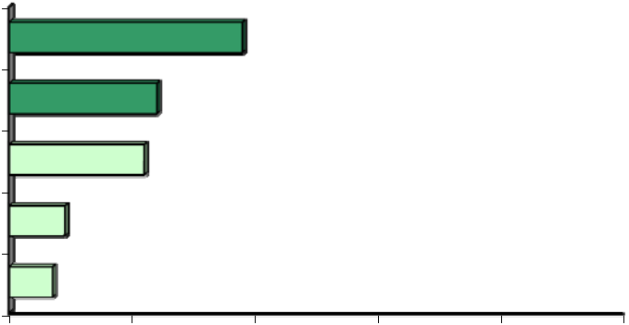

5 - Very satisfied |  | 38%
4 | 24%
3 | 22%
2 | 9%
1 - Not at all satisfied | 7%
0% | 20% | 40% | 60% | 80% | 100%

Satisfaction by Commute Ease – Respondents’ level of satisfaction with their commute was influenced by the ease of the commute. As illustrated in Figure 42, 76% of respondents who said they had an easier commute than last year and 71% who said their commute had not changed were satisfied with their com-mute, compared to only 36% who said their commute had become more difficult.

Figure 42

Satisfaction with Commute – Percent Rating Commute a 4 or 5

by Ease of Commute

(n = 6,033)
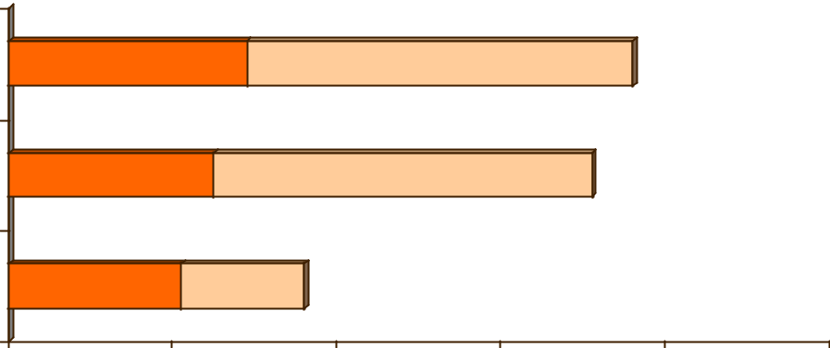

E asie r co m m u te | 2 9 % |  |  | 4 7 % | 76%
C o mm u te ab o u t th e | 2 5 % |  | 4 6 % |  | 71%
same | 2 5 % |  | 4 6 % |  | 71%
M o re d ifficu lt co m m u te | 2 1 % | 1 5 % | 36%
0 % | 2 0 % |  | 4 0 % | 6 0 % | 8 0 % | 100%
 | 4 | 5 - Ve ry s atis fied

66

Commuter Connections 2010 State of the Commute Survey Draft Technical Report June 30, 2010

Satisfaction by Home and Work Location – Commute satisfaction also differed by where in the region the respondent lived and worked. Figure 43 presents the percentages of commuters in each of the three areas of the region who gave a rating of 4 or 5 for commute satisfaction.

Figure 43

Satisfaction with Commute – Percent Rating Commute a 4 or 5 by Home and Work Area

(Home Area – Inner Core n = 1,634, Middle Ring n = 1,644, Outer Ring n = 2,755)

(Work Area – Inner Core n = 2,699, Middle Ring n = 1,934, Outer Ring n = 1,374)
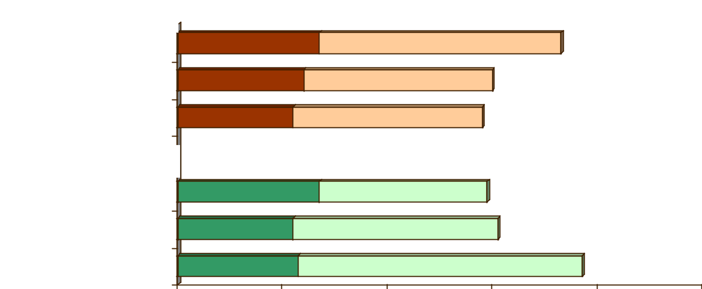

Home Location

Inner Core

Middle Ring

Outer Ring

27% | 46% | 73%
24% | 36% | 60%
22% | 36% | 58%

Work Location

Inner Core | 27% | 32% | 59%
Middle Ring | 22% | 39% | 61%
Outer Ring | 23% | 54% |  | 77%
0% | 20% | 40% | 60% | 80% | 100%
 | 4 | 5 - Very satisfied

Respondents who lived in the Inner Core were notably more satisfied with their commute than were res-pondents who lived in the Middle Ring or Outer Ring areas. But respondents who worked in the Outer Ring were more satisfied than were respondents who worked in the Inner Core and Middle Ring.

Satisfaction by Commute Travel Time – Commute satisfaction declined dramatically as commute length increased. As shown in Figure 44, 96% of commuters who had very short commutes – 10 minutes or less

– gave a 4 or 5 rating for satisfaction. When the commute was between 11 and 20 minutes, 84% were satisfied. At 21 to 30 minutes, satisfaction dropped still further; only 71% gave a 4 or 5 rating. Less than half of commuters who traveled 31 to 46 minutes were satisfied and satisfaction dropped to 44% for tra-vel times of 46 to 60 minutes. When travel time exceeded 60 minutes, only three in ten said they could rate their commute a 4 or 5.

67

Commuter Connections 2010 State of the Commute Survey Draft Technical Report June 30, 2010

Figure 44

Satisfaction with Commute – Percent Rating Commute a 4 or 5

By Length of Commute in Minutes

(1-10 min n = 735, 11-20 min n = 1,247, 21-30 min n = 1,010, 31-45 min n = 1,282,

46-60 min n = 871, More than 60 min n = 702)
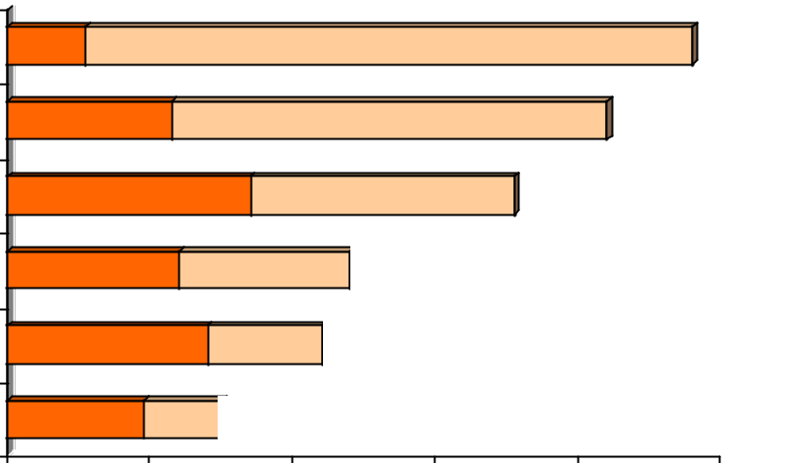

10 minutes or less | 11% |  |  |  | 85% |  | 96%
11-20 minutes |  | 23% |  |  | 61% |  | 84%
21-30 minutes |  | 34% |  |  | 37% | 71%
31-45 minutes |  | 24% |  | 24% | 48%
45-60 minutes |  | 28% |  | 16% | 44%
More than 60 minutes |  | 19% | 11% | 30%
0% |  | 20% |  | 40% | 60% | 80% | 100%
 |  |  | 4 | 5 - Very satisfied

Satisfaction by Mode – As evident in Figure 45, more than nine in ten bikers/walkers reported high com-mute satisfaction. But other respondents were about equally satisfied with their commute, regardless of the mode they primarily used to get to work.

68

Commuter Connections 2010 State of the Commute Survey Draft Technical Report June 30, 2010

Figure 45

Satisfaction with Commute – Percent Rating Commute a 4 or 5

By Primary Commute Mode

(Bike/walk n = 166, Bus n = 327, Carpool/Vanpool n = 435, Drive alone n = 4,243, Metrorail n = 685)
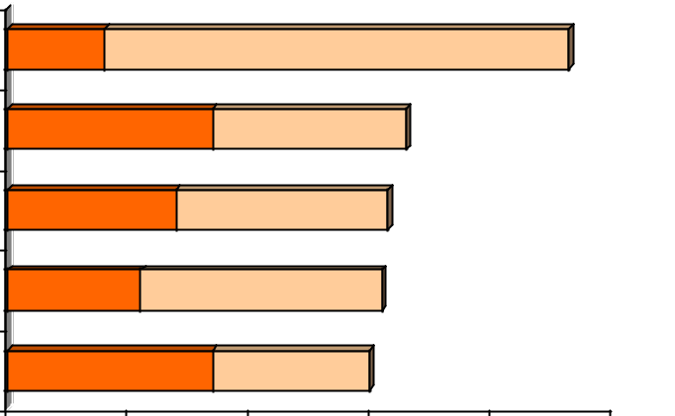

Bike/walk | 16% | 77% |  |  | 962
Bus | 34% | 32% |  | 66%
Carpool / vanpool | 28% | 35% |  | 63%
Drive alone | 22% | 40% |  | 62%
Metrorail | 34% | 26% |  | 60%
0% | 20% | 40% | 60% | 80% | 100%
 | 4 | 5 - Very satisfied

69

Commuter Connections 2010 State of the Commute Survey Draft Technical Report June 30, 2010

3-E AWARENESS OF COMMUTE ADVERTISING AND SERVICES

Commute Advertising Recall

The next set of questions in the survey inquired about respondents’ awareness of commute information advertising. Nearly six in ten (58%) respondents said they had seen, heard, or read advertising about commuting in the six months prior to the survey. This was slightly higher than the 52% recall noted in the 2007 SOC survey.

Message Recall

These respondents were then asked what messages they recalled from this advertising. Seven in ten (70%) could cite a specific message, slightly higher than the 65% who could recall a message in 2007.

Figure 46 lists messages respondents in the 2010 survey remembered and the percentage of respondents who cited each message. The messages are divided into two categories: general rideshare messages and commute services messages.

 |  |  |  |  |  |  |  |  |  |  | Figure 46
 |  |  |  | Commute Information / Advertising Messages Recalled
 |  |  |  |  |  |  |  |  |  | (n = 3,951)
 |  |  | General Rideshare Messages
 |  |  | Use bus/train
 |  |  |  |  |  |  |  |  |  |  |  |  | 6%
 |  |  | Help environment |  |  |  |  |  |  |  |  |  | 6%
 |  |  | Save money |  |  |  |  |  |  |  |  | 5%
 |  |  | Carpool/vanpool |  |  |  |  |  |  |  |  | 5%
 |  |  |  |  |  |  |  |  |  |  | 4%
 |  |  | Reduces traffic |  |  |  |  |  |  |  | 4%
 |  |  |  |  |  |  |  |  | 2% |  | 4%
 |  |  | Saves time |  |  |  |  |  | 2%
 |  |  | Less stressful |  |  |  |  |  | 2%
 |  | Commute Services Messages |  |  |  |  |  |  |  |  |  |  |  |  | 11%
 |  |  | Call for CP/VP info |  |  |  |  |  |  |  |  |  |  |  | 11%
 |  |  | Guaranteed Ride Home |  |  |  |  |  |  |  |  |  |  | 9%
 |  |  | New trains/buses coming |  |  |  |  |  |  |  |  |  | 6%
 | Contact Commuter Connections |  |  |  |  |  |  |  |  |  | 4%
 |  |  | HOV lanes |  |  |  |  |  |  | 3%
Regional commute services available |  |  |  |  |  |  |  |  |  | 3%
 |  |  |  |  |  |  |  |  | 2%
 |  |  | Telework Center / telework |  |  |  |  |  | 2%
 |  |  | HOT lanes |  |  |  |  |  | 2%
Employer will give financial incentive |  |  |  |  |  |  |  |  | 2%
 |  |  |  |  |  |  |  |  | 2%
 |  |  | Transit cost increasing |  |  |  |  |  | 2%

14%

0% 5% 10% 15% 20%

70

Commuter Connections 2010 State of the Commute Survey Draft Technical Report June 30, 2010

General Rideshare Messages – The top reason noted was a general rideshare message, “use the bus, train, Metrorail,” which was recalled by 14% of respondents. This was slightly less than the 18% who noted this message in 2007. About five percent said they recalled a general message of “carpool or vanpool” (5%). Small numbers of respondents mentioned rideshare benefit messages: helps the environment (6%), saves money (5%), reduces traffic (4%), saves time (2%), and less stressful (2%). Recall of all of these messages was essentially the same as in 2007.

Commute Program/Service Messages – Commuters cited several commute program or service messages. About 11% mentioned “you can call for carpool/vanpool information” and seven percent said they had heard that “new trains or buses are coming.” These were similar percentages to those found for these messages in 2007.

Nine percent of respondents mentioned Guaranteed Ride Home, higher than the six percent who volun-teered this response in 2007. Four percent mentioned “contact Commuter Connections,” about the same percentage as gave this response in 2007. An additional three percent said the ad mentioned that regional services were available to help with commuting. Two percent mentioned Telework Centers or telework.

Recall of Advertising Sponsors

Forty-five percent of respondents who had heard or seen ads said they remembered who sponsored the ad. These respondents mentioned the organizations listed in Table 33. The Washington Metropolitan Area Transit Authority (WMATA, Metro) was named by 20% of respondents, the same percentage as noted this sponsor in 2007. Commuter Connections or COG were named by 13% of respondents, slightly high-er than the nine percent who gave this response in 2007. The Virginia Department of Transportation and Arlington County Commuter Services each was named by about two percent of respondents. Numerous other organizations were named in 2010, but each was named by less than one percent of respondents.

Table 33

Recall of Advertising Sponsors

(n = 1,478)


Advertising Sponsor

Percentage

Metro, WMATA | 20%
Commuter Connections, MWCOG | 13%
Virginia Dept. of Transportation (VDOT) | 2%
Arlington County Commuter Services | 2%
Virginia Railway Express, VRE | <1%
Maryland Mass Transit Administration (MTA) | <1%
Don’t remember, don’t know | 55%
Other * | 11%

* Each response in the “Other category” mentioned by less than one percent of respondents.

71

Commuter Connections 2010 State of the Commute Survey Draft Technical Report June 30, 2010

Advertising Sources/Media

Table 34 presents the primary sources or media through which respondents heard, saw, or read commute advertising in 2010, 2007, and 2004. The 2010 sources were very similar to those noted in 2007. Four in ten respondents who recalled an ad said they heard it on the radio, slightly higher than the 35% share who mentioned this source in 2007, but still significantly lower than the 55% who mentioned radio as their source in 2004. Other common sources named in 2010 included television (24%), sign on a transit ve-hicle or at a bus stop or Metro station (22%), and in a newspaper (18%). Smaller shares of respondents cited other sources.

Table 34

Advertising Source/Media

 | Advertising Source/Media* |  |  | 2010 SOC |  |  | 2007 SOC |  |  | 2004 SOC
 | Advertising Source/Media* |  |  | (n = __) |  |  | (n = 2,275) |  |  | (n = 4,133)
 | Radio |  | 40% |  |  | 35% |  |  | 55%
 | Television |  | 24% |  |  | 25% |  |  | 25%
 | Sign on transit vehicle, at bus stop, or Metro station |  | 22% |  |  | 20% |  |  | 9%
 | Newspaper |  | 18% |  |  | 22% |  |  | 12%
 | At work |  | 6% |  |  | 5% |  |  | <1%
 | Website/internet |  | 2% |  |  | 2% |  |  | 2%
 | Roadside billboard/ad |  | 5% |  |  | 2% |  |  | 2%
 | Postcard in the mail |  | 3% |  |  | 3% |  |  | 1%
 | Other ** |  | 4% |  |  | 3% |  |  | 4%

- Might add to more than 100% because multiple responses were permitted.

- Each response in the “Other category” mentioned by less than one percent of respondents.

Commute Advertising Impact

Persuasiveness of Advertising Messages

The advertising appeared to have an effect for some respondents. Almost a quarter (24%) of respondents who had seen, heard, or read advertising said that they were more likely to consider ridesharing or using public transportation after seeing or hearing the advertising, the same percentage as in 2004.

The respondents who were most persuaded by the advertising were those who were already using transit modes during the survey week. About 48% of bus riders, 25% of Metrorail riders, and 30% of carpoolers and vanpoolers said they were likely to consider using an alternative after hearing the ads, compared with only 21% of respondents who were driving alone. It is possible that some respondents who said they were likely to consider alternative modes after hearing or seeing the ads and who were using alternatives at the time of the survey shifted to alternatives after hearing or seeing the ads. But this conclusion was not tested with the survey data.

72

Commuter Connections 2010 State of the Commute Survey Draft Technical Report June 30, 2010

The advertising appeared to have more impact on younger respondents. As shown in Figure 47, willing-ness to consider ridesharing declined steadily with increasing age. Nearly half of respondents who were under 25 said they would consider ridesharing, compared with only 17% of those who were 55 to 64 years old and only eight percent of respondents who were 65 or older.

Figure 47

Likely to Consider Ridesharing After Hearing / Seeing Ads

By Respondent Age

(Under 25 n = 55, 25-34 n = 319, 35-44 n = 605, 45-54 n = 812, 55-64 n = 544, 65 or older n = 104)
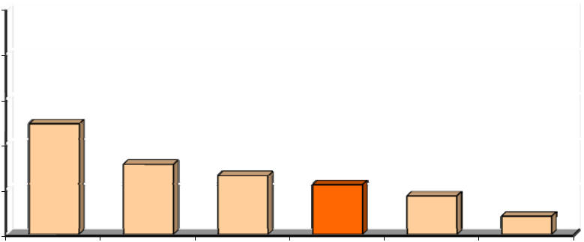

100%
80%
60% | 49%
40% |  | 31% | 26%
40% |  |  | 26% | 22%
 |  |  |  | 22% | 17%
20% |  |  |  |  | 8%
0%
 | Under 25 | 25-34 years 35-44 years 45-54 years 55-64 years65 or older

Commute Actions Taken After Hearing or Seeing Commute Advertising

Respondents who said they were more likely to consider alternative modes after hearing the ads were asked if they had taken any actions to try to change how they commuted. About 19% of these respon-dents said they did take some action. Specific actions noted are presented in Figure 48.

The majority of respondents who took an action said they sought information or services for commuting. Five percent said they looked for a carpool or vanpool partner. Three percent said they looked for more information on the internet, two percent contacted a local or regional commute organization, and one per-cent contacted a transit operator.

Four percent (23 respondents) said they tried or started using an alternative mode for commuting. Two percent tried or started using a bus to get to work, two percent tried or started bicycling or walking to work, and one percent tried or started using a train. Prior to starting these new modes, half of the respon-dents had been driving alone to work. The other half had been using a different alternative mode.

73

Commuter Connections 2010 State of the Commute Survey Draft Technical Report June 30, 2010

Figure 48

Actions Taken to Change Commute After Hearing / Seeing Commute Advertising

(n = 546, multiple responses permitted)
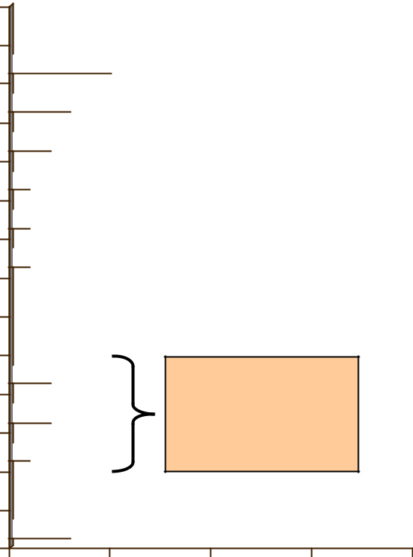

Sought more information

Looked for carpool/vanpool partner 

Looked for commute information on internet  3%

Contacted local/regional commute organization  ^{2%}
Contacted transit operator 1%

Looked for information on GRH  1%

Other information response 1%

Changed Commute Mode

Tried / started using bus  2%

Tried / started bicycling / walking  2%

Tried / started using train  1%

Other change  3%

5%

4% tried or

started using an
alternative mode

for commuting

0% 5% 10% 15% 20%

Influence of Ads on Commute Change Actions

A large majority (83%) of respondents who took an action to change their commute said the advertising they saw or heard encouraged the action. And more than 70% of respondents who took an action were driving alone at that time. This suggests that the advertising, although having a small impact on mode shifts, is acquainting drive alone commuters with other commuting opportunities and encouraging them to seek more information on these options.

This conclusion is supported by results of one additional question asked in this section about commute advertising. Respondents who sought information but had not made a commute mode change were asked how likely they were to try a form of transportation other than driving alone for their commute within the next year. As shown in Figure 49, 23% said they were very likely and 40% said they were somewhat likely to try an alternative mode. This is likely an overstatement of actual future changes, but it suggests that an initial effort to seek information might lead to commute changes at a later time.

74

Commuter Connections 2010 State of the Commute Survey Draft Technical Report June 30, 2010

Figure 49

Likely to Try Using an Alternative Mode Within the Next Year

(n = 43)

Very likely
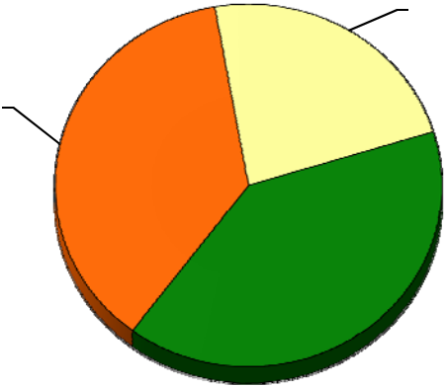
23%

Not at all likely
37%

Somewhat
likely

40%

75

Commuter Connections 2010 State of the Commute Survey Draft Technical Report June 30, 2010

3-F AWARENESS AND USE OF COMMUTER ASSISTANCE RESOURCES

Awareness of Commuter Assistance Numbers/Websites

The next set of questions in the survey investigated commuters’ knowledge and use of regional commute assistance services. First, respondents were asked if they were aware of a telephone number or web site they could use to obtain information on ridesharing, public transportation, HOV lanes, and telework in the Washington region. Two-thirds (66%) of respondents said they knew such a number existed.
The remaining respondents either said there was not such a phone number or website (15%) or that they did not know if a phone number or web site existed (19%).

As illustrated in Figure 50, awareness of regional commute information resources has grown steadily over the past nine years. The current level of 66% awareness is 15 percentage points higher than in 2007 and twice as high as in 2001.

100%

80%

60%

40%

20%

0%

Figure 50

Awareness of Regional Commute Information Resource

(2001 n = 7,200, 2004 n = 7,200, 2007 n = 6,600, 2010 n = 6,629)
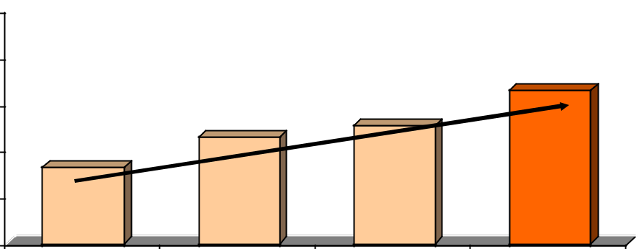

 |  |  | 66%
 | 46% | 51%
33%
2001 | 2004 | 2007 | 2010

Recall of Web Sites and Phone Numbers

When respondents who had said there was a regional phone number or web site were questioned on their recall of the actual number or website, about four in ten, or 25% of all regional workers, could name a specific number or web site. Table 35 summarizes the awareness of all numbers/web sites, as percentages of the regional population. About 10% named a specific WMATA phone number or web site and three percent mentioned WMATA or Metro, but did not specify the number or site. Commuter Connections was second only to WMATA as a regional information source, named by about two percent of all respon-dents.

Respondents named more than 20 additional organizations that they knew or believed offered commuter assistance and information. Each of these was named by less than one percent of respondents, but collec - tively they accounted for 12% additional responses. This was much higher than the number of resources mentioned in 2007, suggesting that commuters are more aware of resources and/or that more resources are available now than in 2007.

76

 | Commuter Connections 2010 State of the Commute Survey Draft Technical Report |  |  |  |  |  |  |  |  | June 30, 2010
 |  |  | Table 35
 |  | Recall of Regional Commuter Assistance Telephone Number or Web site
 |  |  | (2010 n = 6,629, 2007 n = 6,600, 2004 n = 7,200)
 | Number or Web site |  |  |  | 2010 SOC |  |  | 2007 SOC |  |  |  | 2004 SOC
 |  |  |  |  | Percentage* |  |  | Percentage* |  |  |  | Percentage*
 | Not aware of phone number/web site |  |  | 15% |  |  |  | 31% |  |  | 38%
 | Don’t know if a phone number exists |  |  | 19% |  |  |  | 18% |  |  | 16%
 | Aware of phone number/web site, but cannot name it |  |  | 40% |  |  |  | 30% |  |  | 31%
 | Aware of phone number/web site and can name it |  |  |  | 26% |  |  | 21% |  |  |  | 15%
 | Telephone numbers recalled: |  |  | 0.7% |  |  |  | 0.8% |  |  | 1.5%
 | 1-800-745-RIDE (7433) Commuter Connections |  |  |  |  |  |  | 0.8%
202-637-7000 |  |  | METRO, WMATA | 2.4% |  |  |  | 3.5% |  |  | 1.4%
 | Web sites recalled:
 | www.mwcog.org |  |  | 0.4% |  |  |  | 0.2% |  |  | 0.2%
 | www.commuterconnections.org |  |  | 0.8% |  |  |  | 0.3% |  |  | 0.3%
 | www.commuterconnections.com |  |  | 1.1% |  |  |  | 1.0% |  |  | 1.0%
 | wwww.wmata.com |  |  | 6.9% |  |  |  | 6.8% |  |  | 6.8%
 | www.MetroOpensDoors.com |  |  | 2.9% |  |  |  | 0.5% |  |  |  | N/A
 | WMATA website (unspecified) |  |  | 3.9% |  |  |  | N/A |  |  |  | N/A
 | www.vre.org |  |  | 0.5% |  |  |  | 0.3% |  |  | 0.3%
 | Other** |  |  | 12.4% |  |  |  | 4.7% |  |  | 3.0%

- Might add to more than 100% because multiple responses were permitted.

- Each response in the “Other” category mentioned by less than one percent of respondents

Awareness and Use of Commuter Connections Program

The “awareness” section of the questionnaire also explored respondents’ awareness of the Commuter Connections Network and the services it offers commuters. Some indications of respondents’ awareness of the program appeared in unprompted questions about regional commute advertising messages, adver-tising sponsors, and regional commuter information resources.

As noted earlier, two percent of the regional population named Commuter Connections as a regional in-formation source without being prompted with the organization’s name. But when directly asked if they had heard of an organization in the Washington region called Commuter Connections, an additional 62% of respondents said they had heard of the program for a total of 64%. This was higher than the percentage who knew of Commuter Connections in 2007 (53%) and about the same level of name recognition than was observed in 2004 (66%) (Figure 51).

77

Commuter Connections 2010 State of the Commute Survey Draft Technical Report June 30, 2010

Figure 51

Awareness of Commuter Connections (Prompted or Unprompted)

(2004 n = 7,200, 2007 n = 6,600, 2010 n = 6,629)
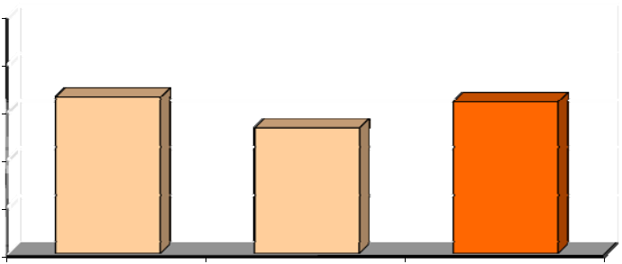

100%

80% | 66% | 64%

53%

60%

40%

20%

0%

2004 2007 2010

Referral Sources to Commuter Connections Program

Table 36 displays the methods by which respondents reported learning about Commuter Connections in 2010, with comparisons to sources named in 2007 and in 2004. In 2010, almost half (48%) of respon - dents cited the radio as their source of information and about 15% named television. Word of mouth / referrals (9%), sign/billboard (7%), and newspaper ads or articles (6%), were other common sources. Smaller percentages cited other sources, including internet (4%), employer (4%), sign on a transit vehicle (3%), or brochure (1%) . About 11% said they didn’t remember how they heard about Commuter Connec-tions. The 2010 results were very similar to those observed in 2007.

Table 36

Commuter Connections Program Referral Sources

 |  | 2010 SOC | 2007 SOC | 2004 SOC
Information Source |  | Percentage | Percentage | Percentage
 |  | (n = 4,398) | (n = 3,614) | (n = 4,133)
Radio | 48% |  | 43% | 56%
Television | 15% |  | 16% | 19%
Word of mouth, friend, co-worker | 9% |  | 8% | 5%
Sign/billboard | 7% |  | 7% | 5%
Newspaper ads/article | 6% |  | 7% | 4%
Internet | 4% |  | 3% | 2%
Employer | 4% |  | 4% | 2%
Sign on transit vehicle, bus stop | 4% |  | 2% | N/A
Brochure | 1% |  | 1% | 1%
Don’t know | 11% |  | 14% | 10%
Other * | 3% |  | 3% | 4%


* Each response in “Other category” mentioned by less than one percent of respondents.

78

Commuter Connections 2010 State of the Commute Survey Draft Technical Report June 30, 2010

Awareness and Use of Commuter Connections’ Services

Respondents who knew of Commuter Connections were asked what services the organization provided. Their responses are shown in Figure 52. About three in ten said they didn’t know specific services of-fered by the program, but respondents who did mention a service largely cited services that Commuter Connections actually does provide. Six in ten knew the program offered either general rideshare informa-tion (30%) or help finding a carpool or vanpool partner (30%) . About a quarter (26%) knew that Com-muter Connections offered a regional Guaranteed Ride Home program. Nine percent said Commuter Connections offered transit route and schedule information, which can be accessed through links on Commuter Connections’ web site.

Figure 52 also shows service awareness in 2007. Awareness of each individual service was higher in 2010 than in 2007. Awareness of rideshare assistance grew from 46% to 60% and awareness of the GRH program also grew slightly, from 23% in 2007 to 26% in 2010. Almost half knew the organization of-fered either general rideshare information (24%) or help finding a carpool or vanpool partner (22%). A quarter (23%) knew that Commuter Connections sponsored a GRH program, much less than said they knew about this program in 2004.

Figure 52

Awareness of Commuter Connections Services

(2007 n = 3,614, 2010 n = 4,398)

24%

30%
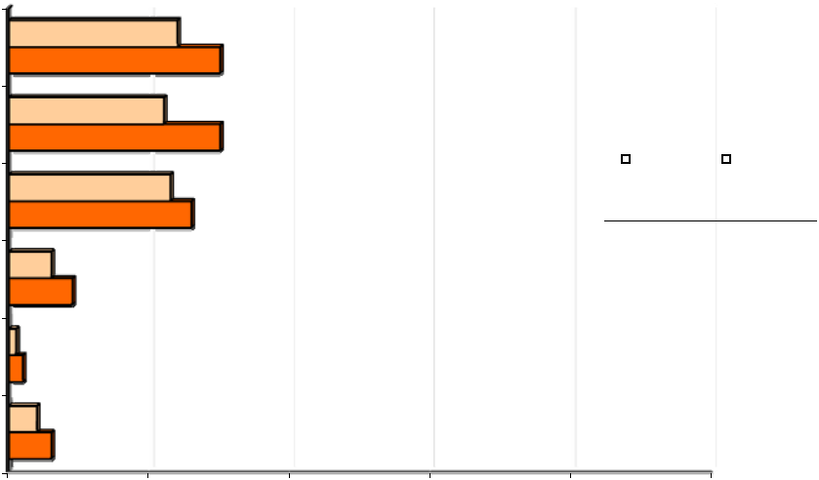

Rideshare/CP/VP info |  | 22%
Help finding CP/VP partners |  | 30%
 |  | 23% |  |  |  | 2007 SOC |  | 2010 SOC
Guaranteed Ride Home |  | 26% |  |  |  | 2007 SOC |  | 2010 SOC
 | 6%
Transit information | 9%
 | 1%
Park & Ride information | 2%
Other | 4%
 | 6%
0% | 20% | 40% | 60% | 80% | 100%

Respondents who knew of Commuter Connections also were asked if they had contacted the program or visited a Commuter Connections or COG website in the past year and if so, what information or services they were seeking. Seven percent of respondents who knew of Commuter Connections had contacted the program, representing about five percent of all employed residents of the region. Table 37 lists the in-formation respondents said they were seeking in this contact.

79

Commuter Connections 2010 State of the Commute Survey Draft Technical Report June 30, 2010

Table 37

Information and Services Sought in Contact to Commuter Connections

(2010 n = 313, 2007 n = 200)


Commuter Connections Services


2010 SOC

Percentage

2007 SOC

Percentage

Transit route/schedule information

Rideshare (carpool/vanpool) information

Help finding carpool/vanpool partners

Guaranteed Ride Home (GRH)

MetroChek / SmarTrip

Bicycle / walking information

Telework information

General information / traffic and weather

Other *

24%

20%

20%

12%

4%

2%

1%

8%

6%

33%

21%

14%

19%

3%

N/A

1%

N/A

9%

* Each response in the “Other category” mentioned by less than one percent of respondents.

The largest share of respondents who contacted Commuter Connections said they were seeking transit route or schedule information (24%). About two in ten were looking for general rideshare (car-pool/vanpool) information and 20% said they were looking for help finding a carpool or vanpool partner. One in ten (12%) said they were looking for information about Guaranteed Ride Home.

Awareness and Use of Local Commuter Assistance Programs

Finally, respondents were asked about their awareness and use of local jurisdiction commuter programs that delivered commute assistance services in the areas where they lived and/or worked. If they lived and worked in different jurisdictions, they were asked about both the organization in their home area and the organization in their work area.

Figure 53 presents the percentage of respondents who said they had heard of each of the nine organiza - tions, when prompted with the organizations’ names. Awareness of these programs ranged from 10% to 51% of respondents who were asked the questions. Four of nine programs examined were known to at least a third of the target area respondents.

80

Commuter Connections 2010 State of the Commute Survey Draft Technical Report June 30, 2010

Figure 53

Heard of Local Jurisdiction Commute Assistance Program

(Frederick n = 732, Arlington n = 958, Loudoun n = 660, Southern Maryland n = 1,224,

Prince William n = 1,244, Prince George’s n = 894, Montgomery n = 928, Alexandria n = 732, Fairfax n = 1,253)
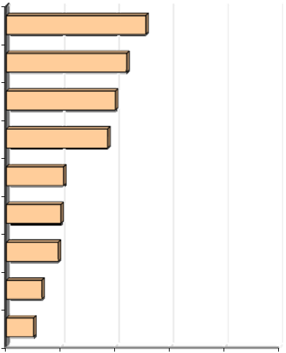

TransIT Services of Frederick Co |  |  | 51%
Arlington Co Commuter Services |  |  | 44%
Loudoun Co Office of Transportation |  |  | 40%
Tri-County Council (Southern MD) |  | 37%
Prince William (PRTC/Omni Match) | 21%
RideSmart (Prince Georges) | 20%
Montgomery Co Commuter Services | 19%
Alexandria Rideshare | 13%
Fairfax RideSources | 10%
0% | 20% | 40% | 60% | 80% | 100%

Use of Local Jurisdiction Services – Respondents who knew of a local organization were asked if they had contacted it. Figure 54 presents these results for the nine organizations, listed in the same order they ap-peared in Figure 53.

Figure 54

Used Local Jurisdiction Commute Assistance Program

Of Respondents who had Heard of Program

(Frederick n = 326, Arlington n = 421, Loudoun n = 259, Southern Maryland n = 435,

Prince William n = 341, Prince George’s n = 177, Montgomery n = 168, Alexandria n = 127, Fairfax n = 121)
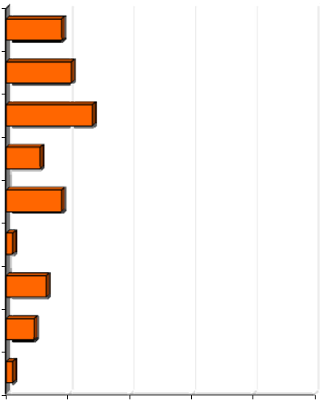

TransIT Services of Frederick Co |  | 18%
Arlington Co Commuter Services |  | 21%
Loudoun Co Office of Transportation |  | 28%
Tri-County Council (Southern MD) | 11%
Prince William (PRTC/Omni Match) |  | 18%
RideSmart (Prince Georges) | 2%
Montgomery Co Commuter Services | 13%
Alexandria Rideshare | 9%
Fairfax RideSources | 2%
0% | 20% | 40% | 60% | 80% | 100%

81

Commuter Connections 2010 State of the Commute Survey Draft Technical Report June 30, 2010

Use ranged from two percent to 28% of respondents who had heard of the services. Twenty-eight percent of respondents in the Loudoun County service area said they had contacted this organization, 21% of res-pondents who lived or worked in Arlington County said they contacted Arlington County Commuter Ser-vices, and 18% of respondents in Frederick and Prince William Counties contacted the commuter service organizations in their areas. All other local organizations had lower contact levels.

With the exception of Arlington County Commuter Services, use was generally higher for programs in outer jurisdictions (Frederick, Loudoun, Prince William). The relationship to the location in region is likely because outer jurisdiction commuters encounter more congestion in their travel and have longer commute distances, which would encourage them to seek options for travel to work.

Use also was higher for programs associated with transit agencies (Frederick, Loudoun, Prince William). This connection might be due to higher visibility of the services, but 65% of respondents who contacted a local program said they were seeking transit information. In the inner jurisdictions, transit assistance is provided by transit organizations that are separate from the local commute assistance program.

Information and Services Sought form Local Organizations – Respondents who had contacted a local juris-diction program were asked what information or services they were seeking. The services desired are shown in Table 38. By far, the most prominent service sought by respondents was transit information, sought by 65% of respondents who contacted a local program. Much smaller percentages said they were looking for Metrochek / SmarTrip fare information (9%), help finding a carpool or vanpool partner (5%), or general rideshare information (4%). The predominance of transit information is reasonable, given that several of the local programs are administered by transit organizations

Table 38

Information and Services Sought from Local Commute Assistance Programs

(n = 364)

 | Commute Assistance Services |  |  | Percentage
 | Transit route/schedule information |  | 65%
 | Travel directions, traffic, weather information |  | 9%
 | MetroChek / SmarTrip |  | 9%
 | Help finding carpool/vanpool partners |  | 5%
 | Rideshare (carpool/vanpool) information |  | 4%
 | Metro passes, transit tickets/fare media |  | 4%
 | Park & Ride lot information, parking information |  | 4%
 | Bicycle / walking information |  | 4%
 | Road construction information |  | 2%
 | Other * |  | 9%

* Each response in the “Other category” mentioned by less than one percent of respondents.

82

Commuter Connections 2010 State of the Commute Survey Draft Technical Report June 30, 2010

Awareness and Use of Regional Guaranteed Ride Home Program

Since 1997, Commuter Connections has offered Guaranteed Ride Home to eliminate alternative mode users’ fear of being without transportation in the case of an emergency. The program provides free rides in a taxi or rental car in the event of an unexpected personal emergency or unscheduled overtime. Some employers also offer GRH programs, as was shown in the previous section of this report.

Awareness of GRH

Survey respondents who did not work at home all the time were questioned on their awareness and use of GRH programs. First, they were asked if they knew of a regional GRH program available for commuters who rideshare or use public transportation. As shown in Figure 55, about a quarter (27%) replied there was such a program, 39% mentioned there was no such program, and the remaining 34% were unsure.

Figure 55

Awareness of Regional GRH Program – 2010, 2007, and 2004

(2004 n = 6,867, 2007 n = 6,071, 2010 n = 6,084)
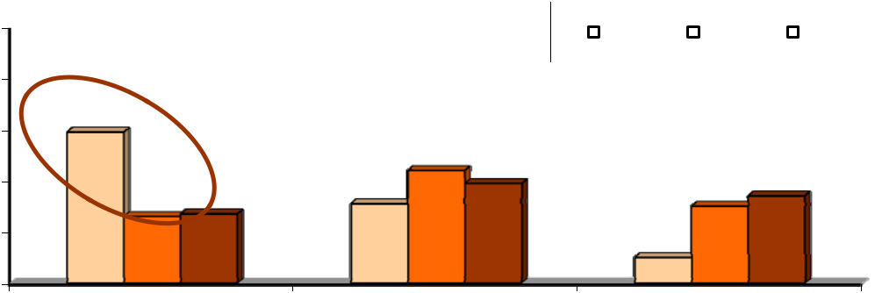

100% |  |  |  |  |  |  | 2004 |  |  | 2007 |  |  |  | 2010
80% | 59%
60% | 59%
60% |  |  | 44% | 39%
 |  |  | 44% | 39% |  |  |  | _{30%}34%
40% | 26% | 27% | 31%
20% |  |  |  |  | 10%
0%
 | Yes GRH exists |  | No GRH program |  |  |  |  | Don't know

The figure also shows GRH awareness for 2004 and 2007. Awareness in 2010 was about the same as in 2007, but considerably lower than the awareness in 2004, when 55% of respondents said a regional GRH program existed.

Awareness of GRH by Commute Mode – As shown in Table 39, awareness of GRH services varied by the commute modes respondents were using at the time of the survey. Respondents who primarily car-pooled/vanpooled or rode a commuter train were slightly more likely than were other respondents to be aware of the regional GRH program. Awareness was similar for users of other modes.

83

Commuter Connections 2010 State of the Commute Survey Draft Technical Report |  |  |  |  |  |  |  |  |  |  |  |  |  | June 30, 2010
 |  |  |  |  | Table 39
 |  |  |  | Awareness of Regional GRH Program
 |  |  |  | by Current Primary Mode
 |  | Current Primary Mode |  |  |  |  | Percentage Aware of GH Program
 |  |  |  |  |  |  | 2010 SOC |  |  | 2007 SOC |  |  |  | 2004 SOC
 |  | Drive alone | (2010 n = 4,243) |  |  | 27% |  |  | 26% |  |  |  | 61%
 |  | Carpool/vanpool | (2010 n = 435) |  |  | 39% |  |  | 29% |  |  |  | 66%
 |  | Bus | (2010 n = 327) |  |  | 32% |  |  | 22% |  |  |  | 52%
 |  | Metrorail | (2010 n = 685) |  |  | 30% |  |  | 26% |  |  |  | 55%
 |  | Commuter train | (2010 n = 61) |  |  | 37% |  |  | 56% |  |  |  | 55%
 |  | Bike/walk | (2010 n = 166) |  |  | 26% |  |  | 15% |  |  |  | 43%

Awareness of GRH by Home and Work Location – Table 40 displays awareness of GRH services by the home and work locations of respondents. There were no significant differences in awareness by respon-dents’ home locations, but respondents who worked in the Inner Core area were more likely to know about GRH than were respondents who worked in the Outer Ring areas.

Table 40

Awareness of Regional GRH Program

by Home and Work Location

 | Location – Ring Designation |  | 2010 SOC
 | Location – Ring Designation |  | Percentage

Home Location
Inner Core | (2010 n = 1,646) | 27%
Middle Ring | (2010 n = 1,661) | 28%
Outer Ring | (2010 n = 2,777) | 33%
Work Location
Inner Core | (2010 n = 2,714) | 32%
Middle Ring | (2010 n = 1,956) | 27%
Outer Ring | (2010 n = 1,388) | 22%

84

Commuter Connections 2010 State of the Commute Survey Draft Technical Report June 30, 2010

Use of GRH

Five percent of regional commuters said they had registered for or used a GRH service in the past two years. These respondents included respondents who had previously mentioned that they registered for or used a GRH service offered by their employer.

Sponsor of GRH Program

The 328 respondents who had registered for or used any GRH service were asked who sponsored this ser-vice. More than eight in ten (82%) of these respondents said their employers sponsored the programs they had used. Note that the base for this distribution includes respondents who mentioned in a previous question that they had used an employer-provided GRH service. They were not asked who sponsored the GRH program they had used, but they were included in the results to this question.

About 13% of respondents noted Commuter Connections or MWCOG/COG as the sponsor of the pro-gram. This was much lower than the 37% who mentioned Commuter Connections as the sponsor in 2007.

85

Commuter Connections 2010 State of the Commute Survey Draft Technical Report June 30, 2010

3-G EMPLOYER-PROVIDED COMMUTER ASSISTANCE SERVICES

The SOC survey also included questions on commute assistance services and benefits that employer might provide to employees. Respondents were asked about two types of services:

Alternative mode incentives and support services

Parking facilities and services

This section presents results regarding respondents’ availability and use of these services in 2010. Re-sults also are presented for some questions from the 2007 and 2004 SOC surveys.

Incentives/Support Services

More than six in ten (61%) respondents said their employer offered one or more incentives or support services (Figure 56). This is higher than the percentages of respondents who reported having access to these services in 2007 (54%) and 2004 (53%).

Figure 56

Employer Offers any Incentive/Support Services – 2004, 2007, 2010

(2004 n = , 2007 n = 6,071, 2010 n = 5,899)
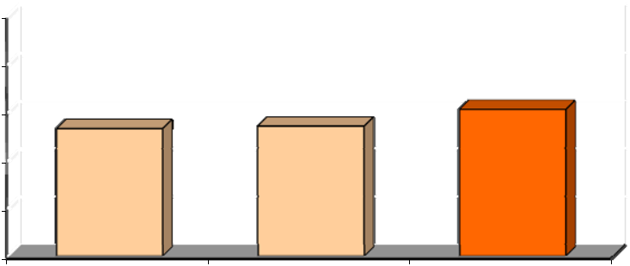

100%

80% 61%

53% 54%

60%

40%

20%

0%

2004 2007 2010

Individual Incentives / Support Services Offered

The percentages for individual services offered are shown in Figure 57. Four in ten (39%) of respondents said their employers offered one or two of these services. An additional 23% said their employers offered three or more services.

The most commonly offered services were SmarTrip/other subsidies for transit/vanpool, provided by 45% of employers, and information on commuter transportation options, offered by 26% of employers. Nearly a quarter (24%) of respondents said their employers offered services for bikers and walkers and 21% said their employers offered preferential parking (21%). Fifteen percent said their employers offered GRH (14%). Only seven percent said their employers offered carpool subsidies.

As shown in the figure, availability of transit/vanpool subsidies has grown substantially, from 33% to 45% since 2007. Availability of other services also appears to have risen since 2007, as reported in the 2007 SOC survey.

86

Commuter Connections 2010 State of the Commute Survey Draft Technical Report |  |  |  |  |  | June 30, 2010
 |  | Figure 57
 | Alternative Mode Incentives and Support Services Offered by Employers – 2010 and 2007
 | (2007 n = 6,076, 2010 n = 5,899)
 |  | 33%
0% |  | 20% | 40%45% | 60% | 80% |  | 100%
 | Transit/vanpool subsidy | 20%
 | Transit/vanpool subsidy | 26%
 | Info on travel options | 17%
 | Info on travel options | 24% |  |  |  | 2007
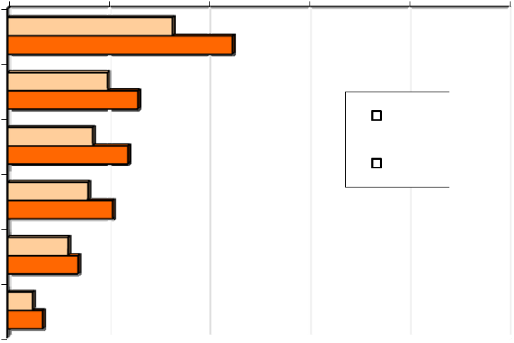

Bicycling / walking services | 16% |  | 2010
Preferential parking for CP/VP | 21% |  | 2010
Preferential parking for CP/VP | 12%
Guaranteed Ride Home | 14%
5%
Carpool subsidy7%

Incentives / Support Services Offered by Employer Type

Respondents who worked for federal agencies were most likely to have incentives/ support services avail-able at their worksites; 89% of federal employees said they had at least one of these services, compared with 64% of respondents who worked for non- profit organizations. Respondents who worked for private employers and state / local agencies were least likely to have incentives/support services; only about half of employees who worked for these types of employees had access to commuter benefit services.

Table 41 present a comparison of the percentages of employers that offered various incentives/support services and parking services by employer type. Not surprisingly, Federal agency employees also had greater access than other respondents to individual incentive/support service. This was especially true for transit/vanpool subsidies 80% of Federal employees said these subsidies were offered, while only 46% of non-profit employees and three in ten employees of private firms and state/local agencies had this benefit. Commute information and preferential parking also were disproportionately available to Federal agency employees.

87

Commuter Connections 2010 State of the Commute Survey Draft Technical Report June 30, 2010

Table 41

Commuter Services/Benefits Offered

by Employer Type

Incentives/Support Services

Percentage of Employers Offering Services

 | Federal | State/local | Non-profit | Private
 | (n = 1,290) | (n = 774) | (n = 696) | (n = 2,281)

 | Any services offered |  | 89% | 46% | 64% | 50%
 | Metrochek/transit/VP subsidy |  | 80% | 30% | 46% | 30%
 | Commute information |  | 50% | 25% | 26% | 19%
 | Preferential parking |  | 51% | 15% | 10% | 12%
 | GRH |  | 16% | 10% | 12% | 17%
 | Carpool subsidy / cash payment |  | 17% | 9% | 4% | 5%
 | Bike/walk services |  | 37% | 20% | 27% | 16%

Commuter Services Offered by Employer Size

Large employers were more likely to offer commuter services than were small employers. As indicated by Table 42, only 44% of respondents who worked for employers with 100 or fewer employees and 58% of respondents who worked for employers with 101-250 employees said they had any services. By con-trast, seven in ten (71%) respondents employed by large (251-999 employees) employers and more than eight in ten (82%) respondents who worked for very large firms (1,000+ employees) had one or more employer-provided commuter service.

Table 42 compares availability of specific commuter assistance services by employer size. Respondents who worked for employers with 251 or more employees had substantially greatest access to most incen-tive/support services, compared with employees of smaller firms. This trend of increasing services with increasing size was most striking with transit/vanpool subsidies, commute information, preferential park-ing, and bicycle / walking services.

88

Commuter Connections 2010 State of the Commute Survey Draft Technical Report June 30, 2010

Table 42

Commuter Services/Benefits Offered

by Employer Size (number of employees)

 |  |  | Percentage of Employers Offering Services
Incentives/Support Services |  |  | 1-100 | 101-250 | 251-999 | 1,000+
 |  |  | (n=2,284) | (n=736) | (n=788) | (n=1,300)
 | Any services offered |  | 44% | 58% | 71% | 82%
 | Metrochek/transit/VP subsidy |  | 28% | 39% | 56% | 67%
 | Commute information |  | 14% | 29% | 34% | 48%
 | Preferential parking |  | 9% | 13% | 22% | 48%
 | GRH |  | 15% | 13% | 16% | 16%
 | Carpool subsidy / cash payment |  | 5% | 6% | 10% | 15%
 | Bike/walk services |  | 14% | 19% | 29% | 38%

Services Offered by Employer Location

Finally, the analysis examined availability of services by respondents’ work locations, divided into the three “ring” designations described earlier: Inner Core (Alexandria, Arlington, and the District of Co-lumbia), Middle Ring (Fairfax, Montgomery, and Prince George’s), and Outer Ring (Calvert, Charles, Frederick, Loudoun, and Prince William). As shown in Table 43, Inner Core respondents had greater access to incentive / support services than did other respondents. Three-quarters of Inner Core employees said they had commute services, while only half of Middle Ring workers and 40% of Outer Ring em-ployees had access to these services.

Table 43

Commuter Services Offered

by Employer Location

 |  |  |  | Percentage of Employers Offering Service *
Incentives/Support Services |  |  |  | Inner Core |  |  | Middle Ring |  | Outer Ring
 |  |  |  | (n = 2,283) |  |  | (n = 1,690) |  | (n = 1,238)
 | Any services offered |  |  | 74% |  |  | 53% |  | 40%
 | Metrochek/transit subsidy |  |  | 65% |  | 31% |  |  | 14%
 | Commute information |  |  | 33% |  | 27% |  |  | 17%
 | Preferential parking |  |  | 27% |  | 22% |  |  | 13%
 | GRH |  |  | 16% |  | 15% |  |  | 15%
 | Carpool subsidy / cash payment |  |  | 10% |  | 8% |  |  | 4%
 | Bike/walk services |  |  | 28% |  | 21% |  |  | 14%


89

Commuter Connections 2010 State of the Commute Survey Draft Technical Report June 30, 2010

Inner Core workers also had greater access to each individual service; two-thirds of these respondents were offered transit subsidies, compared to a third of respondents who worked in the Middle Ring, and only 14% of respondents who worked in the Outer Ring. Inner Core workers had somewhat higher access to other commute services also. These differences were less dramatic, but there was a clear pattern of highest availability in the Inner Core, moderate availability in the Middle Ring, and significantly lower availability of most services in the Outer Ring.

Parking Facilities and Services

Respondents also were asked about the parking services available at their worksites. These results are displayed in Table 44 for 2010, 2007, and 2004.

Table 44

Parking Facilities / Services Offered by Employers – 2010, 2007, 2004

 |  |  |  | Employer Offered Service
 | Parking Facilities and Services
 | Parking Facilities and Services |  |  | 2010 SOC | 2007 SOC | 2004 SOC
 |  |  |  | (n = 5,819) | (n =5,426) | (n = 6,866)
 | Free on-site parking |  | 63% |  | 65% | 66%
 | Free off-site parking |  | 2% |  | 4% | 3%
 | Employee pays all parking charges |  | 22% |  | 21% | 21%
 | Employee and employer share parking charge |  | 7% |  | 7% | 6%
 | Parking discounts for CP/VP* |  | 16% |  | 15% | 14%

- Note that percentages of parking discounts for CP/VP are calculated on a base of respondents who do not have free parking available. These sample sizes were (2010 n = 1,610; 2007 n = 1,674; 2004 n = 1,752)

The majority of respondents (63%) across the region said their employers provided “free parking” at the worksite. An additional two percent said they had access to “free parking off-site.” About three in ten said they paid at least part of the cost of parking; 22% paid the total cost and seven percent paid a portion of the cost with the balance paid by their employers. The availability of free parking appears to be the same as in 2007 and 2004.

Figure 58 portrays free parking availability by employer type, employer size, and the location of the res-pondents’ worksite.

Parking by Employer Type – Federal agency employees and employees of non-profit organizations were least likely to have free parking at work. About 49% of respondents who worked for Federal agencies and 50% of respondents who worked for a non-profit said their employer provided free parking. Other workers in these two groups either had no parking at all or had to pay all or part of the cost of parking. By contrast, 77% of respondents who worked for state and local agencies and 71% of respondents who worked for private employers said they had free parking.

90

Commuter Connections 2010 State of the Commute Survey Draft Technical Report June 30, 2010

Figure 58

On-site Free Parking Availability

by Employer Type, Employer Size, and Work Area

Employer Type – Federal n = 1,563, State/local n = 859, Non-profit n = 754, Private n = 2,453)

Employer Size – 1-100 n = 2,398, 101-250 n = 812, 251-999 n = 989, 1,000+ n = 1,582)

Inner Core n = 2,597, Middle Ring n = 1,880, Outer Ring n = 1,319)
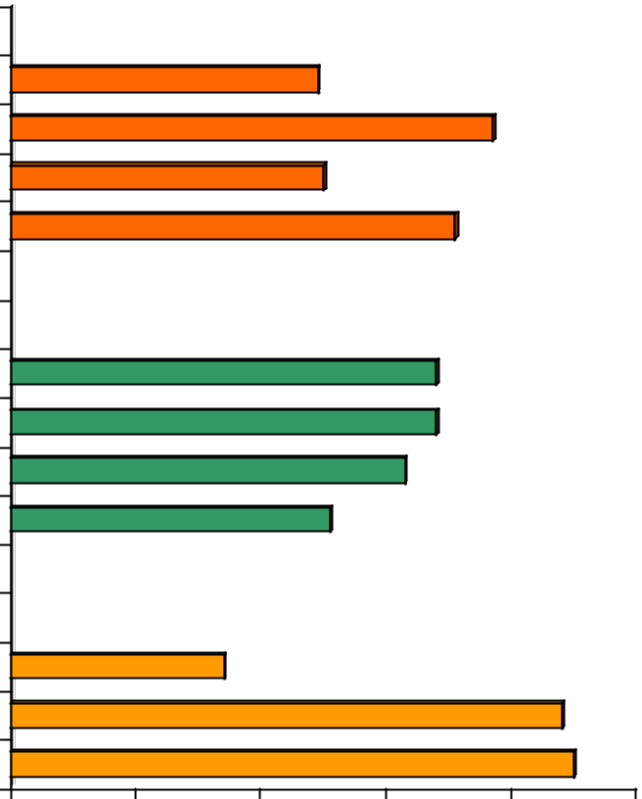

Employer Type |  |  | 49%
Federal agency |  |  | 49%
State / local agency |  |  |  | 77%
Non-profit organization |  |  | 50%
Private employer |  |  |  | 71%
Employer Size
1 - 100 employees |  |  |  | 68%
101 - 250 employees |  |  |  | 68%
251 - 999 employees |  |  |  | 63%
1,000 or more employees |  |  | 51%
Work Location |  | 34%
Inner Core |  | 34%
Middle Ring |  |  |  |  | 88%
Outer Ring |  |  |  |  | 90%
0% | 20% | 40% | 60% | 80% | 100%

Parking by Employer Size – Figure 58 also shows parking availability by employer size. Respondents who worked for large employers were less likely to have free parking. Fewer than six in ten (57%) respon-dents who were employed by employers with 1,000 or more employees had free parking, compared with more than seven in ten respondents who worked for employers with 250 or fewer employees.

Parking Services by Work Location – Dramatic differences between respondents who worked in different parts of the region also are evident for parking availability. As can be seen in Figure 58, only a third (36%) of respondents employed in the Inner Core area said they had free parking on- site or off-site, com-pared to nearly nine in ten (88%) respondents who worked in the inner ring and nine in ten (92%) of res-pondents who worked in the outer ring.

91

Commuter Connections 2010 State of the Commute Survey Draft Technical Report June 30, 2010

Use and Impact of Commuter Assistance Services/Benefits

Respondents whose employers offered incentives/support services were asked if they had ever used these services. There results are provided in Figure 59.

Figure 59

Use of Employer-Provided Incentives/Support Services

Of Employees Who had Access to Services

(Transit/vanpool subsidy n = 2,431, Information on travel options n = 1,525, GRH n = 813,

Bicycling / walking services n = 1,311, Preferential parking n = 1,218, Carpool subsidy n = 387)
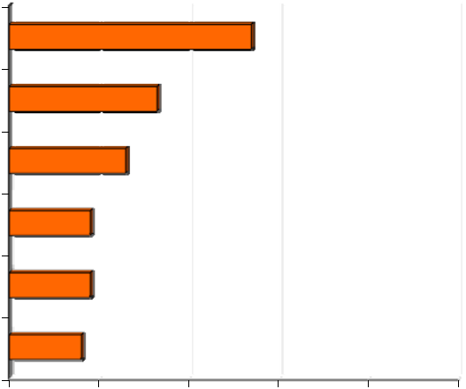

Transit/vanpool subsidy |  |  | 54%
Info on travel options |  | 33%
Guaranteed Ride Home |  | 26%
Bicycling / walking services |  | 18%
Preferential parking for CP/VP |  | 18%
Carpool subsidy | 16%
0% | 20% | 40% | 60% | 80% | 100%

The most commonly used incentives/support services were transit / vanpool subsidies, used by 54% of respondents whose employers offered this service, commute information, used by 33% of respondents who had access to this service, and Guaranteed Ride Home, used by about a quarter of respondents. About one in five had used preferential parking, bike/walk services, and carpool subsidies.

Commute Mode by Commuter Assistance Services/Benefits Offered

Figure 60 presents the percentages of respondents who used various commute modes by whether or not their employer provides commuter assistance services or benefits.

As the table clearly illustrates, respondents whose employers provided alternative mode incentives and support services were less likely to drive alone (57%) than were respondents whose employers did not provide these services (80%). Respondents who had these services at their worksites used all alternative modes at higher rates than did respondents who did not have these services. Train use was particularly higher; 21% of respondents whose employers offered incentives/support services rode the train to work, compared with six percent of respondents whose employer did not offer these services.

92

Commuter Connections 2010 State of the Commute Survey Draft Technical Report June 30, 2010

Figure 60

Primary Commute Mode

by Commuter Services/Benefits Reported Offered

(Services offered n = 3,441, Services not offered, n = 2,427)
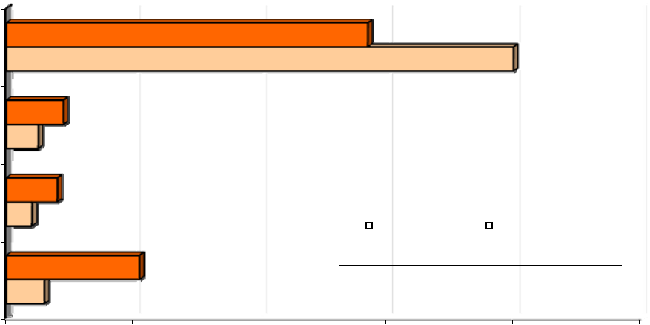

 |  |  |  |  |  | 80%
Drive alone |  |  | 57%
Carpool/Vanpool | 5%
Carpool/Vanpool | 9%
Bus | 4%
Bus | 8%
 | 8% |  |  |  | Services offered |  | Services not offered
Train | 6% | 21% |  |  | Services offered |  | Services not offered
0% | 20% | 40% | 60% |  |  | 80% |  | 100%

These differences were significant at the 95% confidence level, but it is not possible to say that the avail-ability of these services was the only reason, or even the primary reason, for the differences in mode use. As noted before, employers in the Inner Core area were much more likely than were employers in the Middle Ring and Outer Ring to offer commuter assistance services and drive alone rates were much lower for respondents who work in the Core (46%) than for residents who work in either the Middle Ring (65%) or Outer Ring (76%).

But respondents who work in the Core area also could be faced with greater impediments to driving alone. For example, respondents who work in the Core area travel an average of 41 minutes to work, compared with 34 minutes for respondents working in the Middle Ring and 29 minutes for respondents who work in the Outer Ring. And respondents in the core also might experience greater congestion levels and have greater availability of commute options, such as transit, than would be experienced by workers outside this area. Any of these factors might have been at least as important in influencing respondents’ commute mode choices.

Commute Mode by Parking Services Offered

Figure 61 presents a comparison of mode use rates for respondents who had free on-site parking at work and those who either had to pay for parking or who had no parking at all. The difference in drive alone rates for these two groups was dramatic; 82% of respondents who had free parking drove alone, compared with only four in ten (41%) respondents who did not have this benefit. Respondents who had to pay for parking used all alternative modes at higher rates than did respondents who had free parking. The differ-ence was especially striking for use of the train; train mode share was more than six times as high for res-pondents who did not have free parking as for respondents who did.

Many other surveys and research studies have documented the important role parking availability and cost play in commute decisions. But as was noted above, many factors influence commuters’ mode choice.

93

Commuter Connections 2010 State of the Commute Survey Draft Technical Report June 30, 2010

Figure 61

Primary Commute Mode

by Free Parking Available at Work

(Free parking offered n = 3,866, Free parking not offered, n = 1,953)
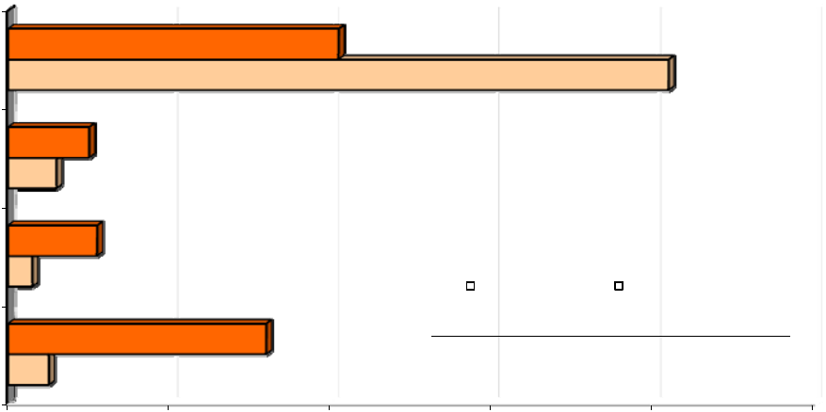

 |  |  |  |  |  |  | 82%
Drive alone |  |  | 41%
Carpool/Vanpool | 6%
Carpool/Vanpool | 10%
Bus | 3%
Bus | 11%
 | 11% |  |  |  |  | No free parking |  | Free parking offered
Train | 5% | 32% |  |  |  | No free parking |  | Free parking offered
0% | 20% | 40% | 60% |  |  |  | 80% |  | 100%

94

Commuter Connections 2010 State of the Commute Survey Draft Technical Report June 30, 2010

3-H TRANSPORTATION SATISFACTION

COG / Commuter Connections added a series of questions to the 2010 SOC survey to explore commu-ters’ impressions of the role transportation plays in creating a livable region. These questions focused on:

Quality of life

Satisfaction with transportation and desired improvements Benefits of ridesharing

Quality of Life

The survey asked respondents to rate Quality of Life in the Washington region, using a five-point scale in which 1 meant “poor” and 5 meant “excellent. Two -thirds (66%) of respondents gave high rating for quality of life in the Washington region (rating of 4 or 5 on a 5-point scale). Only eight percent gave a low rating (1 or 2).

Figure 62

Ratings for Quality of Life

(n = 6,525)
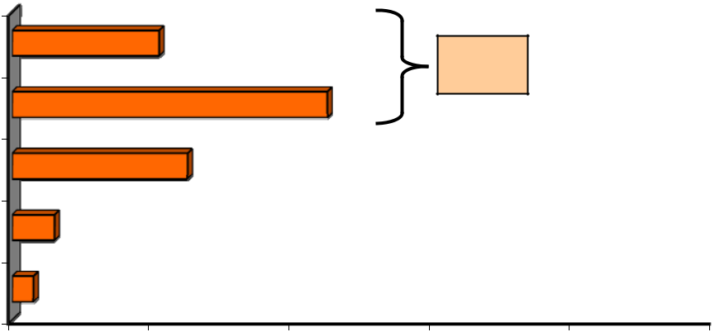

21%
5 - Excellent

4 | 45%
₃ 25%

- 6%

1 - Poor3%

66%

0% 20% 40% 60% 80% 100%

Transportation Satisfaction

Commuters gave lower ratings for their satisfaction with transportation in the region (Figure 63). Only 40% said they were satisfied (rating of 4 or 5 on a 5-point scale) and more than a quarter (26%) said they were not satisfied (rating of 1 or 2).

95

Commuter Connections 2010 State of the Commute Survey Draft Technical Report June 30, 2010

Figure 63

Ratings for Transportation Satisfaction – Rating of 4 or 5

(n = 6,525)
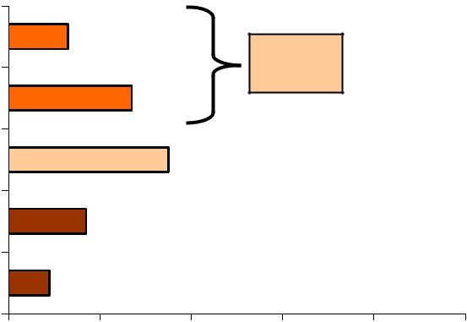

5 - Very satisfied

4

3

2

1 - Not at all satisfied

13%

27%

35%

17%

9%

40%

0% 20% 40% 60% 80% 100%

Satisfaction by Home Location – Residents of the Inner Core gave somewhat higher ratings for both quali-ty of life and transportation, as shown in Figure 64 than did residents of either the Middle Ring or Outer Ring. Three quarters of residents of the Inner Core rated quality of life a 4 or 5, compared with 65% of Middle Ring residents and 61% of Outer Ring residents. About half of Inner Core residents gave high marks to transportation satisfaction, while only 38% of Middle Ring residents and 29% of Outer Ring residents rated transportation satisfaction as high.

Figure 64

Ratings for Quality of Life and Transportation – Rating of 4 or 5

By Home Location

(Quality of Life – Inner Core n = 1,787, Middle Ring n = 1,776, Outer Ring n = 2,962)

Transportation satisfaction – Inner Core n = 1,784, Middle Ring n = 1,770, Outer Ring n = 2,866)

100% | 74%
80% | 65% | 61%
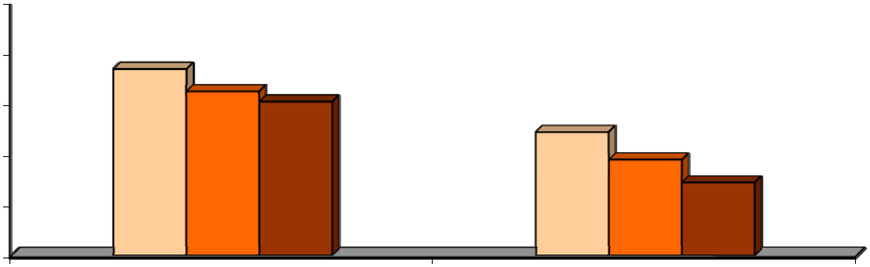

60% | 49% | 38%
40% |  | 29%
20%
0%

Quality of life - rating of 4 or 5 |  |  |  |  | Transportation satisfaction - rating of
 |  |  |  |  |  |  |  | 4 or 5
 |  | Inner Core |  |  |  | Middle Ring |  | Outer Ring

96

Commuter Connections 2010 State of the Commute Survey Draft Technical Report June 30, 2010

Satisfaction by Commute Mode – Respondents who drove alone and those who carpooled / vanpooled gave the lowest ratings for transportation satisfaction; only a third were satisfied (Figure 65). Respon-dents who used transit or bike/walk for commuting gave higher satisfaction ratings. One common trait of these other modes is that the commuters do not need to drive, so can avoid congestion.

Figure 65

Ratings for Transportation Satisfaction – Rating of 4 or 5

By Primary Commute Mode

(Drive alone n = 4,088, Carpool/vanpool n = 425, Bus n =322, Metrorail n = 683,

Commuter rail n =61, Bike/walk n = 165)

100%
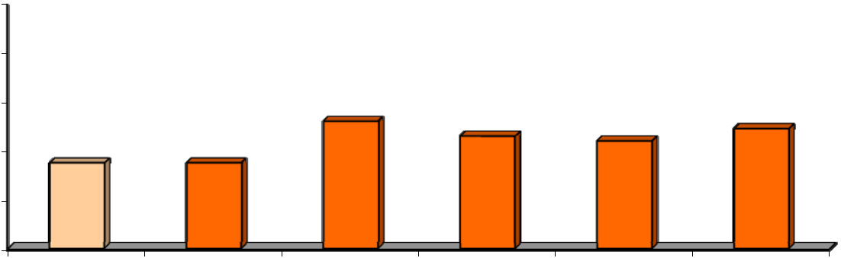

80%
60% |  | 52% | 46% | 44% | 49%
60% | 35% |  | 46% | 44% | 49%
 | 35% | 35% | 46% | 44%
40% | 35% | 35%
20%
0%
 | Drive aloneCarpool/vanpool Bus |  | Metrorail | Commuter rail Bike/walk

Satisfaction by Travel Time – There was a clear pattern between commute travel time and transportation satisfaction. Satisfaction declined as the length of the commute increased, from a high of 47% satisfac-tion for respondents who had very short commutes of 10 minutes or less, to 29% for respondents who traveled more than an hour to work.

100%

80%

60%

40%

20%

0%

Figure 66

Ratings for Transportation Satisfaction – Rating of 4 or 5

By Commute Travel Time

(1-10 min n = 698, 11-20 min n = 1,209, 21-30 min n =983, 31-45 minl n = 1,255,

46-60 min n = 853, More than 60 min n = 691)
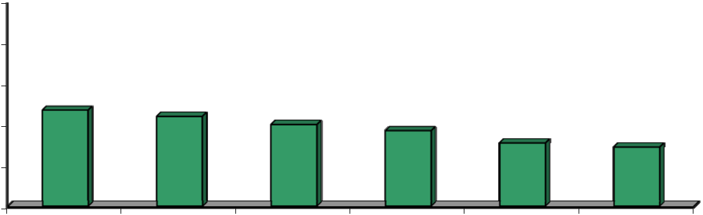

47%
44% | 40% | 37% | 31%
 |  | 37% | 31% | 29%

1-10 min | 11-20 min | 21-30 min | 31-45 min | 46-60 min | More than
 |  |  |  |  | 60 min

97

Commuter Connections 2010 State of the Commute Survey Draft Technical Report June 30, 2010

Satisfaction by Proximity to Transit – A pattern emerged also between satisfaction with transportation and the respondent’s proximity to bus and train stops. Respondents who lived close to transit gave higher marks for transportation satisfaction than did respondents who lived farther away. The pattern was par-ticularly striking for distance to train. Almost six in ten respondents who lived within easy walking dis-tance of a train station were satisfied with transportation, compared with only four in ten or less respon-dents who lived one mile or more from a train station.

Figure 67

Ratings for Transportation Satisfaction – Rating of 4 or 5

By Distance from Home to Bus Stop and Distance from Home to Rail Station

(Bus stop Distance – Less than 0.5 mi n = 2,645, 0.5-0.9 mi n = 667, 1.0-2.9 mi n = 817, 3.0-4.9 mi n = 331, 5.0-9.9 mi n = 436, 10.0 mi or more n = 403)

(Train station Distance – Less than 0.5 mi n = 353, 0.5-0.9 mi n = 528, 1.0-2.9 mi n = 1.302, 3.0-4.9 mi n = 574, 5.0-9.9 mi n = 773, 10.0 mi or more n = 1,939)

100%
80% |  |  |  |  |  |  |  |  |  | 58%
60% |  |  | 44% |  |  |  |  |  |  |  |  | 47%
 |  |  | 44% | 34% |  | 34% |  |  |  |  |  | ^{40%} 33% |  |  | 36%
40% |  |  |  |  |  | 34% | ^{29%} 27% 27%
 |  |  |  |  |  |  |  |  |  |  |  |  |  |  | 28%
20%
0%
 |  |  |  | Home to bus distance |  |  |  |  |  |  |  | Home to train distance
 |  | Less than 0.5 mi |  |  |  | 0.5-0.9 mi |  |  | 1.0-2.9 mi |  | 3.0-4.9 mi |  |  | 5.0-9.9 mi |  | 10.0 mi or more
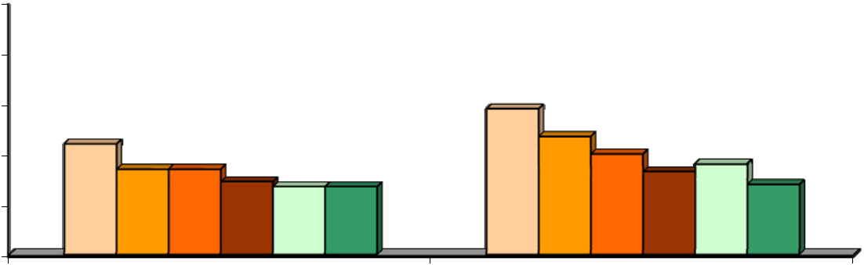

Suggestions to Improve Transportation – The survey interview gave respondents an opportunity to provide suggestions for how they thought the transportation system could be improved. The question was open-ended, so respondents were free to make any recommendation and to offer multiple ideas. About two in ten respondents said they did not think any improvements were needed and another 10% said they didn’t have any suggestions. Figure 68 presents the ideas proposed by the remaining respondents.

A large share of the recommendations focused on ways to improve transit service in the region, with par-ticular emphasis on increasing transit availability and safety. Two in ten respondents proposed Metrorail expansions to more destinations and 17% wanted more bus and train service. Eight percent suggested that Metrorail safety be enhanced.

Some respondents noted other types of improvements, such as better regional management / planning of transportation facilities, more funding, and reducing traffic congestion. About four percent volunteered that the region should build more roads or repair existing roads.

98

Commuter Connections 2010 State of the Commute Survey Draft Technical Report June 30, 2010

Figure 68

Recommendations to Improve Regional Transportation

(n = 6,629)

 | Transit Recommendations
Expand Metrorail to more locations
 |  | More bus / train service
 |  | Improve Metrorail safety |  |  |  |  |  |  |  |  |  | 8%
 | Upgrade/ maintain equipment |  |  |  |  |  |  |  |  | 4%
 |  | Reduce transit fares |  |  |  |  |  |  |  | 4%
 |  | Improve bus safety |  |  |  |  |  |  | 3%
 |  | Improve employee training |  |  |  |  |  |  | 3%
 | Improve on-time performance |  |  |  |  |  |  |  | 3%
 |  | Other Recommendations |  |  |  |  |  |  |  |  | 6%
 | Better management/planning
 |  | More funding |  |  |  |  |  |  |  | 4%
 |  | Reduce traffic/congestion |  |  |  |  |  |  |  | 4%
 |  | More roads |  |  |  |  |  |  |  | 4%
 |  | Roads need repair |  |  |  |  |  |  |  | 4%
Widen lanes, overpasses, bridges |  |  |  |  |  |  |  |  | 3%
 |  | More bicycle lanes / paths |  |  |  |  |  | 2%

19%
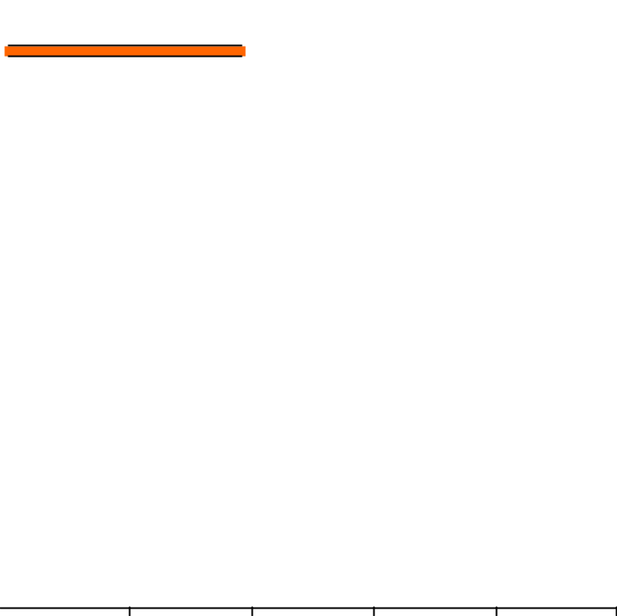

17%

0% 10% 20% 30% 40% 50%

Benefits of Ridesharing

Finally, questions were added to the 2010 SOC survey to assess commuters’ opinions about the benefits generated by use of alternative modes and the importance of future investment in alternative transporta-tion. Respondents were asked about the following:

What personal benefits do people who use alternative modes receive from using these types of transportation?
What impacts or benefits does a community or region receive when people use alternative modes?

Personal Benefits of Alternative Mode Use

When asked what personal benefits users of alternative modes receive from using alternative modes, 90% named at least one benefit and 53% reported two or more personal benefits. Figure 69 details the res-ponses to this question.

99

Commuter Connections 2010 State of the Commute Survey Draft Technical Report |  |  |  |  |  | June 30, 2010
 |  | Figure 69
 | Personal Benefits of Alternative Mode \Use
 |  | (n = 6,050)
Save money / save gas |  |  |  |  |  |  | 55%
Avoid stress |  |  | 17%
Use time productively |  |  | 17%
Help environment |  |  | 15%
Reduce wear & teear on car |  | 11%
Have companionship |  | 10%
No need for a car |  | 6%
Arrive on time |  | 5%
Use HOV lane |  | 5%
Reduce greenhouse gas |  | 4%
Less traffic, avoid traffic |  | 4%
Save gas, energy |  | 4%
0% |  | 10% | 20% | 30% |  | 40% | 50%
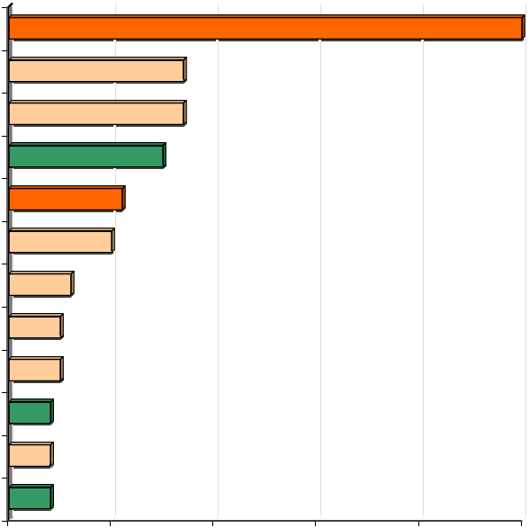

Saving money or gas topped the list of personal benefit, cited by an overwhelming 55% of respondents. No other benefit came close in the percentage of responses. Eleven percent noted a related cost- saving benefit of reducing wear and tear on one’s personal vehicle. Almost two in ten respondents said alterna-tive mode users received a benefit of reducing stress (17%) and using travel time productively (17%). One in ten noted that alternative modes offer companionship on the commute.

Respondents noted three benefits related to environmental concerns. Fifteen percent said commuters who use alternative modes help the environment, indicating a recognition that use of alternative modes has an impact of environmental quality and suggesting that alternative mode users can take pleasure in contribut-ing to cleaner air. Four percent noted reducing greenhouse gases and four percent said saving gas or energy, a benefit related to sustainability.

Societal Benefits of Alternative Mode Use

When asked what benefits society receives from use of alternative modes, 85% of respondents named at least one benefit. Figure 70 displays these responses.

100

Commuter Connections 2010 State of the Commute Survey Draft Technical Report June 30, 2010

Figure 70

Societal Benefits of Alternative Mode \Use

(n = 6,050)
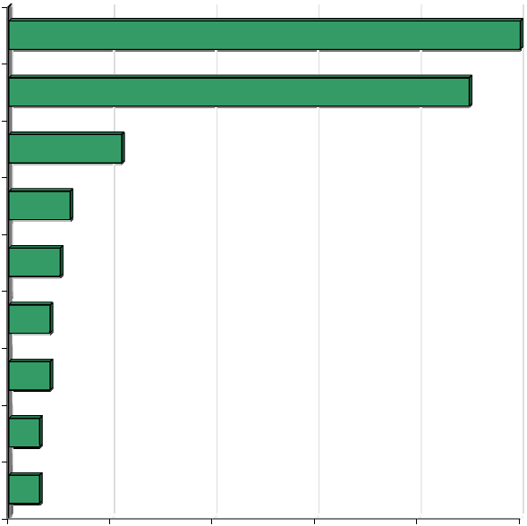

Less traffic, less congestion |  |  |  |  | 64%
Reduce pollution |  |  |  |  | 45%
Reduce greenhouse gases |  | 11%
Less wear & teear on roads | 6%
Save energy | 5%
Safety / less road rage | 4%
Reduce government costs | 4%
Reduce accidents | 3%
Save money | 3%
0% | 10% | 20% | 30% | 40% | 50%

Nearly two-thirds (64%) of respondents said that use of alternative modes could reduce traffic congestion and 45% said it could reduce pollution or help the environment. One in ten (11%) cited reduced green-house gases and six percent noted that society could benefit because roads did not deteriorate as quickly, presumably reducing the cost to maintain or repair roads. Smaller percentages of respondents noted ener-gy savings, reduced government costs, reducing road rage, and reducing accidents.

101

Commuter Connections 2010 State of the Commute Survey Draft Technical Report June 30, 2010

SECTION 4 – SUMMARY AND CONCLUSIONS

This section of the report summarizes the highlights of the results presented in Section 3 and presents major conclusions from the analysis of the survey.

A primary function of the SOC survey was to examine regional trends in commute behavior, awareness, and attitudes. The results of this 2010 survey would be compared against past results as measured in the 2007, 2004, and 2001 SOC surveys, the most recently performed regional commute surveys to identify any commute trends.

A second objective of the SOC survey was to collect data to support the upcoming TERM evaluation, scheduled to be performed in the spring of 2011. Additional analysis of SOC data is underway for this purpose and results of these analyses will be included in a TERM evaluation report to be produced in June 2011.

Following is a summary of the key results from the SOC survey for the following topics:

Commute patterns

Telework

Awareness and attitudes toward transportation options

Awareness of commute advertising

Awareness of commute assistance resources

Commuter assistance services provided by employers

Transportation satisfaction and alternative mode benefits

Commute Patterns

The share of commute trips made by driving alone has fallen since 2004 and train use has risen.

Drive alone continued to be the most popular commute mode in the Washington metropolitan re-gion but the share of weekly commute trips made to worksites outside the home (excluding tele-work) declined from 71.0% in 2007 to 68.4% in 2010. When compared to the 2004 mode split, the 2010 drive alone rate represents a drop of 5.7 percentage points from 2004 (74.1% in 2004 to 63.8% in 2010 .

Weekly trips made by all alternative modes increased from 2004 to 2010. Train use increased from 12.8% in 2004 to 15.5% and bus use grew from 4.7% to 6.0%. Carpool and vanpool trips increased from 6.1% to 7.5% of weekly trips.

Three in ten (30%) regional commuters used an alternative mode (carpool, vanpool, bus, Metrorail, commuter rail, bicycle, or walk) as their primary mode, that is, the mode they used most days in a typical week. An additional 3.7% of commuters used an alternative mode one or two days per week, resulting in more than a third of all regional commuters using a non-drive alone mode at least once per week.

The most popular alternative mode was train, which was used by about 15% of respondents as their primary mode. An additional 1% of commuters said they used the train one or two days per week.

102

Commuter Connections 2010 State of the Commute Survey Draft Technical Report June 30, 2010

Bus was the primary commute mode for about six percent of respondents. An addition one percent occasionally rode the bus to work.

Carpooling/vanpooling was used by about seven percent of commuters most days during the week and one percent used these modes one or two days per week. The majority of carpoolers used a “traditional” form of carpooling, with the same partner(s) all the time. About one in ten carpoo-lers/vanpool trips was made by “casual” carpooled (slug).

Regional commuters continue to try new alternative modes.

Almost a quarter (23%) of respondents had used or tried any alternative mode, other than one they were currently using, within the two years prior to the survey. This represented an increase over the 14% of respondents who said in the 200y survey that they tried another mode.

Transit was the mode mentioned most often; 13% of all regional commuters had used or tried the train in the past two years and seven percent tried or used a bus. Four percent tried or used bicycle or walk for commuting.

More than half (53%) of the commuters who made a switch to an alternative mode in the past three years switched from driving alone. The other 47% switched from another, different alternative mode previously drove alone to work. These “retention” switches are important to maintain the traffic congestion and environmental benefits of existing alternative mode use.

A sizeable portion of commuters who use alternative mode drive alone part of the trip.

Nearly three in ten (28%) of commuters who used an alternative mode said they drove alone to the alternative mode meeting spot (park & ride lot, train station, etc.) and left their cars at those places. Respondents traveled an average of 2.6 miles to these meeting points. A third (35%) of respon-dents walked to the meeting point and the remaining respondents who used an alternative mode ei-ther took transit, or were dropped off by a carpool partner or picked up at home.

Commute lengths remained the same as in 2004.

Respondents traveled on average of 16.3 miles and 36 minutes in 2010, essentially the same as in 2007 (16.3 miles, 35 minutes) and 2004 (16.2 miles and 34 minutes).

Telework

Teleworking continued to grow between 2007 and 2010, reaching a milestone of one-quarter of the regional commuting population. Even with this growth, potential exists for additional teleworking.

A quarter (25%) of regional commuters said they teleworked at least occasionally. This percentage is based on workers who were not self-employed and would otherwise travel to a worksite outside their homes if not teleworking.

The percentage of regional telework has more than doubled since 2001 and telework incidence grew in nearly every demographic and employer segment in which telework is feasible.

The 2010 survey showed that an additional 21% of commuters who do not telecommute today “could and would” telecommute if given the opportunity. These respondents said their job respon-sibilities would allow them to telecommute and they would like to telecommute. About two-thirds

103

Commuter Connections 2010 State of the Commute Survey Draft Technical Report June 30, 2010

of these interested respondents said they would like to telecommute “regularly,” while one-third would like to telecommute “occasionally.”

Teleworking continues to be concentrated in certain demographic and employment groups, but the percentage of all regional commuters who said their jobs were incompatible with telework dropped, from 65% in 2004 to 45% in 2010. Because it seems unlikely that the composition of jobs changed substantially in the region, these results suggest a shift in commuters’ perception of their ability to perform work away from their primary work location. This could be related to increasing availability of communication and computer technology or perhaps from a broader definition of what responsibilities are “telework-compatible.”

The percentage of teleworkers who work under “formal” telework arrangements is now equal to the percentage who telework under informal arrangements with supervisors.

About 29% of all respondents (both teleworkers and non-teleworkers) said their employer had a formal telework program and 25% said telework is permitted under informal arrangements between a supervisor and employee. Formal programs were most common at Federal agencies and among large employers.

Among current teleworkers, 50% of telework under a formal arrangement. This represents a shift from 2007, when only four in ten teleworkers had a formal agreement and an even greater shift from 2004, when formal programs comprised only 32% of all telework. This appears to signal a greater acceptance of formal telework.

Teleworkers get information on telework from a variety of sources.

The largest source of telework information, by far, was “special program at work/employer,” named by 71% of respondents. This percentage was considerably higher than in the 2007 survey, in which only 55% of teleworkers cited their employer as the source of information and higher still compared with the 34% who gave this answer in 2004.

Seven percent of teleworkers said they received telework information directly from Commuter Connections or MWCOG. This was about the same percentage as mentioned Commuter Connections/MWCOG in each of the previous three SOC surveys: 2007 (6%), 2004 (5%), and 2001 (4%).

Awareness and Attitudes Toward Transportation Options

A large percentage of respondents reported that either bus or train service operated in their home area.

Respondents were asked to name bus and train companies that provided service in the areas where they lived and worked. Nearly nine in ten said either bus or train operated in their home area.

About half of respondents said Metrobus operated near their home (54%) and a slightly higher share (59%) said it operated in the area where they worked. Nearly as many respondents said that Metrorail operated: 55% said it operated in their home area and 60% said Metrorail operated where they worked.

About half of respondents (53%) said they lived less than ½ mile from a bus stop and 67% said they lived within a mile. Train station access was less convenient; only 16% lived within one mile of a train station. The average distances were 1.4 miles to the nearest bus stop and 6.4 miles to the near-est train station. But respondents who lived in the core jurisdictions of the District of Columbia, Alexandria, and Arlington said bus access was an average of 0.3 miles away and a train station was

104

Commuter Connections 2010 State of the Commute Survey Draft Technical Report June 30, 2010

1.5 miles away on average. Eighty-five percent of commuters in this core area lived less than ½ mile from a bus stop.

Over a quarter of respondents have access to HOV lanes for their commutes and HOV availability influences mode choice.

Three in ten respondents said there was an HOV lane along their route to work. A quarter (27%) of these commuters said they use the lanes. This equated to about nine percent of commuters region-wide, essentially the same percentage as reported HOV availability and HOV use in 2007.

More than half (54%) of the respondents who used the lanes for commuting said availability of the HOV lane influenced their decision to carpool, vanpool, or ride transit for their commute. This is borne out by a comparison of rideshare mode use with and without HOV. The carpool/vanpool mode share was 11% for commuters who had access to an HOV lane for commuting, compared to six percent carpool/vanpool use for commuters who did not have access to HOV.

Respondents who regularly used the HOV lane for commuting estimated that using the lane saved them an average of 23 minutes for each one-way trip. But HOV users who lived in the outer juris-dictions of the region saved an average of 28 minutes one-way. They also were more likely to say the HOV lane had influenced their mode choice. 53% of “Middle Ring” respondents (Fairfax, Montgomery, Prince George’s) and 63% of “Outer Ring” respondents (Calvert, Charles, Frederick, Loudoun, and Prince William) said the HOV lanes influenced their commute mode choice.

Commuters appear interested in HOT lanes and willing to consider ridesharing to use the lanes for a discount.

A quarter (26%) of commuters who don’t currently carpool or vanpool said they would be very likely or somewhat likely to start ridesharing to use a HOT lane if they would be able to use the lanes for free or a discounted price.

A large share of current ridesharers said they were willing to register their carpools/vanpools to re-ceive a discount on HOT lanes; two- thirds said they were either very likely (39%) or somewhat likely (27%) to register their carpool / vanpool to use the lanes at a discount.

Commutes appear to be getting somewhat more difficult, but commuters are making changes to improve their commutes.

A quarter (25%) of respondents said their commute was more difficult than it was a year ago. The primary reason for it being worse was that the route was more congested now (59%), but 14% said it was more difficult due to construction along the route to work.

About 12% of respondents said their commute was easier than last year. The primary reasons were that the trip was a shorter distance (34%), took less time (29%), or was less congested (26%) . Eight percent said the commute was easier because they started using an alternative mode. Eleven per-cent said it was easier because construction along the route had ended.

Respondents considered ease of commuting when making job or home changes.

About 17% of respondents said they made a job or home change in the past year. Two in ten of these respondents said they considered a commuting factor, such as the ease or cost of commuting

105

Commuter Connections 2010 State of the Commute Survey Draft Technical Report June 30, 2010

to the new location, when making their location decision and 29% said commute ease was more important than other facrors in the decision.

Three groups of respondents were more likely than were others to cite commute factors as impor-tant to their decision: 1) respondents who lived in the Inner Core jurisdictions, 2) respondents who worked in the Middle Ring jurisdictions, and 3) respondents who moved from another location in the Washington region. Presumably, these three groups expected to encounter a more difficult commute with their move.

More than half of commuters say they are satisfied with their current commute, but not all commuters are equally satisfied.

Six in ten commuters rated their commute satisfaction as a “4” or “5” on a 5- point scale, where “5” meant “very satisfied. But 16% rated their satisfaction as either a “1 – not at all satisfied” or “2.”

Respondents’ commute satisfaction was influenced by the ease of the commute. Three quarters (76%) of respondents who said they had an easier commute than last year and 71% who said their commute had not changed were satisfied with their commute, compared to only 36% who said their commute had become more difficult.

Commute satisfaction also differed by where in the region the respondent lived and worked. Res-pondents who lived in the Inner Core were notably more satisfied with their commute than were respondents who lived in the Middle Ring or Outer Ring areas. But respondents who worked in the Outer Ring were more satisfied than were respondents who worked in the Inner Core and Middle Ring.

Commute satisfaction declined dramatically as commute length increased. More than nine in ten commuters who had very short commutes – 10 minutes or less – gave a 4 or 5 rating for satisfac-tion. When the commute was between 21 to 30 minutes, satisfaction dropped to 71%. Less than half of commuters who traveled 31 to 46 minutes were satisfied and when travel time exceeded 60 minutes, only 30% rated their commute a 4 or 5.

Awareness of Commute Advertising

Awareness of commute information advertising remained high.

Six in ten respondents said they had seen, heard, or read advertising for commuting in the six months prior to the survey and 70% of these respondents could cite a specific advertising message. Both the general recall and specific message recall were higher than was observed in the 2007 survey.

More than four in ten respondents who had heard ads could name the sponsor. WMATA was named by 20% as the advertising sponsor and Commuter Connections was named by 13%.

Commute advertising also appears to be having an effect on commuters’ consideration of travel options.

Almost a quarter (24%) of respondents who had seen advertising said they were more likely to consider ridesharing or public transportation after seeing or hearing the advertising. This was higher than the 18% who noted this willingness in 2007.

Respondents who were using alternative modes were more likely to be influenced by the advertising. Almost half of bus riders, 25% of Metrorail riders, and 30% of carpooolers/vanpoolers

106

Commuter Connections 2010 State of the Commute Survey Draft Technical Report June 30, 2010

said they were likely to consider alternative modes after hearing the ads, compared with 21% of commuters who drove alone.

The advertising appeared to have more impact on younger respondents. A third of respondents who were younger than 35 years said they were likely to consider ridesharing compared with only about two in ten respondents who were 45 or older.

About 19% of respondents who said they were likely to consider ridesharing or public transportation for commuting had taken some action to try to change their commute. These respondents cormprised slighly more than one percent of all regional commuters. A large majority (83%) of respondents who took an action to change their commute said the advertising they saw or heard encouraged the action.

The majority of these respondents sought more information about commuting options but four percent tried or started using a bus, train, or bicycling or walking to work. Prior to starting these new modes, half of the respondents had been driving alone to work. The other half had been using a different alternative mode.

Awareness of Commute Assistance Resources

Awareness of commuter information and assistance resources has grown dramatically since 2001.

Two-thirds (66%) of respondents said they knew of a telephone number or web site they could use to obtain commute information. This was highher than the 51% who knew of these resources in 2004 and considerably higher than the 33% of respondents who knew of these resouces in 2001

About 25% of respondents could name a specific number or web site; 14% named a Metro/WMATA phone number or website and three percent named a phone number or website administered by Commuter Connections.

Awareness of Commuter Connections has grown since 2007.

In 2010, 64% of all regional commuters said they had heard of an organization in the Washington region called Commuter Connections. This was higher than the 53% who knew of Commuters Connections in 2007.

Respondents largely cited services that Commuter Connections actually does provide. About three in ten didn’t know specific services offered by the program, but respondents who six in ten knew the program offered either general rideshare information (30%) or help finding a carpool or vanpool partner (30%). About a quarter (26%) knew that Commuter Connections offered a regional Guar-anteed Ride Home program. Nine percent said Commuter Connections offered transit route and schedule information, which can be accessed through links on Commuter Connections’ web site. Awareness of each individual service was higher in 2010 than in 2007.

Most local jurisdiction services are known to at least a quarter of their target commuters.

Respondents were asked about local commute assistance services provided in the counties where they lived and worked. Awareness of these programs ranged from 10% to 51% of respondents who were asked the questions. Four of the nine programs examined were known to at least a third of their target area respondents.

Use of the services ranged from two percent to 28% of respondents who had heard of the services. Use was generally higher for programs in outer jurisdictions and for programs associated with tran-

107

Commuter Connections 2010 State of the Commute Survey Draft Technical Report June 30, 2010

sit agencies or with a strong transit component. The relationship to the location in region is likely because outer jurisdiction commuters encounter more congestion in their travel and have longer commute distances, which would encourage them to seek options for travel to work. The transit connection might be due to higher visibility of the services, but 65% of respondents who contacted a local program said they were seeking transit information. In the inner jurisdictions, transit assis-tance is provided by transit organizations that are separate from the local commute assistance pro-gram.

Commuter Assistance Services Provided by Employers

Availability of worksite commute assistance services is about the same as in 2004.

Six in ten (61%) respondents said their employers offered one or more alternative mode incentives or support services to employees at their worksites. This is slightly higher than the 54% noted in the 2007.

The most commonly offered services were Metrochek/transit/vanpool subsidies (45% of employ-ers), commute information (26% of employers), preferential parking (21%), and services for bikers and walkers (247%). In all cases, these services were more available in 2010 than they had been in 2007.

Respondents who worked for federal agencies were most likely to have incentive/support services available (89%), compared with 40 -60% of respondents who worked for other types of employers. Respondents also were most likely to have access to all types of incentive/support services if they worked for large firms than for small firms. And incentives and support services were far more common among respondents who worked in the core area jurisictions (Alexandria, Arlington, and District of Columbia); eight in ten of these respondents had access to services compared to about half of those in the inner ring (Fairfax, Montgomery, and Prince George’s Counties) and four in ten of those in jurisdictions outside these areas.

Most commuters continue to have free worksite parking.

The majority of respondents (63%) said their employers offered free, on -site of off-site parking, about the same percentage as that resported in 2007 (65%), 2004 (66%) and 2001 (65%).

Federal agency employees and non-profit organizations were least likely to have free parking; only half of these employees said they had free parking, compared with 71% of employees working for private firms and 77% of respondents who worked for state/local governments. Free parking also was much less common in the core area of the region. Only a third of respondents who worked in these areas had free parking, compared with nearly nine in ten other respondents.

Worksite commuter assistance services appear to encourage use of alternative modes.

Commute information and Metrochek/transit/vanpool subsidies were the most widely used commuter assistance services, used, respectively, by 54% and 33% of employees who had access to these incentives.

Driving alone was less common for commuters who had access to incentive/support services. Only 57% of commuters with these services drove alone to work, compared with 80% of commuters whose employers did not provide these services.

108

Commuter Connections 2010 State of the Commute Survey Draft Technical Report June 30, 2010

Respondents whose employers did not offer free parking also used alternative modes at much higher rates. Only four in ten (41%) respondents who did not have free parking drove alone, compared with 82% of respondents who did have free parking.

Transportation Satisfaction and Alternative Mode Benefits

Commuters recognize both personal and societal benefits of ridesharing.

When asked what personal benefits users of alternative modes receive from using alternative mod-es, 90% or respondents named at least one benefit and 53% reported two or more personal benefits. Saving money or gas topped the list of personal benefit, cited by an overwhelming 55% of respon-dents. Eleven percent noted a related cost-saving benefit of reducing wear and tear on one’s per-sonal vehicle. Almost two in ten respondents said alternative mode users received a benefit of re-ducing stress (17%) and using travel time productively (17%).

Respondents noted three benefits related to environmental concerns. Fifteen percent said commu-ters who use alternative modes help the environment, indicating a recognition that use of alternative modes has an impact of environmental quality and suggesting that alternative mode users can take pleasure in contributing to cleaner air. Four percent noted reducing greenhouse gases and four per-cent said saving gas or energy, a benefit related to sustainability.

Nearly two-thirds (64%) of respondents said that use of alternative modes could benefit society by reducing traffic congestion and 45% said it could reduce pollution or help the environment. One in ten (11%) cited reduced greenhouse gases and six percent noted that society could benefit because roads did not deteriorate as quickly, presumably reducing the cost to maintain or repair roads.
Smaller percentages of respondents noted energy savings, reduced government costs, reducing road rage, and reducing accidents.

Commuters believe the regional transportation system could be improved.

Only four in ten regional commuters give high ratings for satisfaction with transportation in the re-gion. More than a quarter (26%) said they were not satisfied (rating of 1 or 2).

Respondents who drove alone and those who carpooled / vanpooled gave the lowest ratings for transportation satisfaction; only a third were satisfied. Respondents who used transit or bike/walk for commuting gave higher satisfaction ratings.

And respondents who lived close to transit gave higher marks for transportation satisfaction than did respondents who lived farther away. Almost six in ten respondents who lived within easy walk-ing distance of a train station were satisfied with transportation, compared with only four in ten or less respondents who lived one mile or more from a train station.

There was a clear pattern between commute travel time and transportation satisfaction. Satisfaction declined as the length of the commute increased, from a high of 47% satisfaction for respondents who had very short commutes of 10 minutes or less, to 29% for respondents who traveled more than an hour to work.

When asked how to improve transportation in the region, a respondents focused primarily on ways to improve transit service in the region, with particular emphasis on increasing transit availability and safety. Two in ten respondents proposed Metrorail expansions to more destinations and 17% wanted more bus and train service. Eight percent suggested that Metrorail safety be enhanced.

109

Commuter Connections 2010 State of the Commute Survey Draft Technical Report June 30, 2010

110

Commuter Connections 2010 State of the Commute Survey Draft Technical Report June 30, 2010

APPENDICES

Appendix A – Survey Data Expansion

Appendix B – Final Dialing Disposition

Appendix C – Survey Questionnaire

Appendix D – Instructions and Definitions of Terms

Appendix E – Comparison of Key 2007 SOC Results with 2004 and 2001 SOC Results

111

Commuter Connections 2010 State of the Commute Survey Draft Technical Report June 30, 2010

APPENDIX A

SURVEY DATA EXPANSION

Survey responses from the State of the Commute 2010 were expanded numerically by expansion and weighting factors. These factors were applied to each survey result to align them with published, em-ployment and ethnic information for the study area. The process developed for the 11-area, Washington, DC metropolitan region is described below in detail.

The Bureau of Labor Statistics’ Local Area Unemployment Statistics (LAUS) for January-March, 2010, was used to calculate the expansion factor needed. This timeframe was chosen to approximate the survey period. Dividing the BLS estimate by the number of interviews yields the expansion factor by jurisdic-tion. These factors were then applied to each survey response, allowing the survey results to be expanded to the employment total for each of the 11 areas. This expansion methodology is the same as the method used for the 2007 State of the Commute. Table A-1 shows the number of employed households living in each of the 11 areas and the number of employed persons surveyed. These figures were used in compu-ting the expansion factors applied to each survey response.

Table A-1 – Estimate of Workers by Survey Area and Expansion Factors


Survey Area

Estimated Employed Workers Totals from Bureau of Labor Statis-tics Local Area Unem-ployment Statistics (LAUS) Program (1st Qtr 2010)


Number of Working Persons Interviewed

Expansion

Factors

Alexandria City, VA | 89,401 | 602
Arlington Co., VA | 131,511 | 602
Calvert Co., MD | 44,897 | 608
Charles Co., MD | 71,299 | 603
District of Columbia | 298,148 | 602
Fairfax Co., VA | 568,119 | 602
Frederick Co., MD | 113,284 | 602
Loudoun Co., VA | 165,979 | 602
Montgomery Co., MD | 480,100 | 602
Prince George’s Co., MD | 410,487 | 602
Prince William Co., VA | 196,553 | 602
Total | 2,569,778 | 6,629

149

218

74

118

495

944

188

276

798

682

327

Ethnic weighting factors were applied to survey results from each area in the District of Columbia region (two cities and nine counties). Weighing factors were calculated using ethnic breakdowns published in U.S. Census Bureau’s American Community Survey (ACS) 2006-2008 series. This series was used be-cause the ethnic breakdowns were based on employment status of the households living in the study area.

112

Commuter Connections 2010 State of the Commute Survey Draft Technical Report June 30, 2010

The ACS is an on-going survey which surveys populations throughout the United States and thus includes the 11 study areas. The weighting factor is calculated by the ratio of the ACS ethnic distribution and the survey ethnic distribution. This is shown in Table A-2 below.

Table A-2 – Ethnic Weighting Factors by Survey Area


Survey Area

Ethnic Weighting Factors*

Hispanic | Black | White |  | Other

Alexandria City, VA Arlington Co., VA Calvert Co., MD Charles Co., MD District of Columbia Fairfax Co., VA Frederick Co., MD Loudoun Co., VA Montgomery Co., MD Prince George’s Co., MD Prince William Co., VA

2.21 | 1.45 |  | 0.79
1.88 | 1.64 | 0.84
0.14 | 2.41 | 0.97
0.21 | 1.50 | 0.90
1.36 | 1.19 | 0.78
2.05 | 1.51 | 0.76
1.64 | 1.94 | 0.90
2.11 | 1.24 | 0.89
2.44 | 1.33 | 0.75
1.85 | 1.06 | 0.61
2.07 | 1.22 |  | 0.70

2.28

1.74

0.26

0.21

1.54

2.03

1.92

1.17

1.60

1.70

2.87

*Rounded to the nearest two decimals.

The product of the expansion factor and the weighting factor generates the final expansion/weighting fac-tor. Table A-3 shows the value for each of these factors by area.

113

Commuter Connections 2010 State of the Commute Survey Draft Technical Report June 30, 2010

Table A-3 – Final Expansion/Weighting Factors by Ethnicity and Survey Area


Survey Area

Final Expansion/Weighting Factors*

Hispanic | Black | White |  | Other

 | Alexandria City, VA | 329 | 215 |  | 117 | 339
 | Arlington Co., VA | 411 | 365 | 183 |  | 380
 | Calvert Co., MD | 10 | 178 | 72 |  | 19
 | Charles Co., MD | 25 | 177 | 107 |  | 24
 | District of Columbia | 673 | 588 | 389 |  | 764
 | Fairfax Co., VA | 1934 | 1427 | 720 |  | 1917
 | Frederick Co., MD | 309 | 364 | 169 |  | 361
 | Loudoun Co., VA | 582 | 343 | 246 |  | 324
 | Montgomery Co., MD | 1942 | 1062 | 599 |  | 1278
 | Prince George’s Co., MD | 1263 | 724 | 419 |  | 1162
 | Prince William Co., VA | 676 | 400 |  | 230 | 937

*Weighting factors used in these calculations are not rounded and therefore, when multiplying the rounded expansion factors (Table A-1) by the ethnic weighting factors (Table A-2), numbers will be slightly different to those using the rounded weighting factors.

The expansion/weighting factors allow for the proper representation of workers in each geographical area when analyzing the survey results. For example, without the expansion/weighting factor, the final esti-mated 44,897 workers in Calvert County would have the same representation as the estimated 568,119 workers in Fairfax County. By using the expansion/weighting factor shown in the table above for each sub-area, the number of workers and ethnicity has been adjusted so that each worker is equally represented within the region.

Level Of Confidence For Analysis

The level of confidence for analysis of the region and the county/city sub-areas will differ because the sample sizes in each category differ. Table A-4 shows the level of confidence for each of these geograph-ic divisions for the State of the Commute 2010 survey sample. In addition, the level of confidence has been calculated for several other non-geographic key sub-populations of interest in the study. Note that some questions were answered by smaller numbers of respondents, and therefore the confidence level for these questions will be lower.

114

 | Commuter Connections 2010 State of the Commute Survey Draft Technical Report |  |  |  |  |  |  |  |  | June 30, 2010
 |  | Table A-4 – Level of Confidence for Analysis
 | Sub-Area or Sub-Population |  | Sample Size |  |  |  |  |  | Level of Confidence
 | Geographic Sub-Areas
 | Study Region – Eleven Areas |  | 6,629 |  |  |  |  |  | 95% | + 1.2%
 | Study Portion of Virginia |  | 3,010 |  |  |  |  |  | 95% | + 1.8%
 | Study Portion of Maryland |  | 3,017 |  |  |  |  |  | 95% | + 1.8%
 | District of Columbia |  | 602 |  |  |  |  |  | 95% | + 4.0%
 | Individual County or City Level |  | 600 |  |  |  |  |  | 95% | + 4.0%
 | Sub-Area or Sub-Population |  | Sample Size |  |  |  | Level of Confidence
 | Sub-Populations
 | Telecommuters |  | 1,538 |  |  |  |  |  | 95% | + |  |  |  | 2.5%
 | Carpoolers (including casual)/Vanpoolers |  | 499 |  |  |  |  |  | 95% | + |  |  |  | 4.4%
 | Transit Users |  | 1,145 |  |  |  |  |  | 95% | + |  |  |  | 2.9%
 | Bike Users or Walkers |  | 207 |  |  |  |  |  | 95% | + |  |  |  | 6.8%
 | Commuters Aware of GRH |  | 1,862 |  |  |  |  |  | 95% | + |  |  |  | 2.3%

Summary

Survey responses from each of the 11 study areas within the Washington, DC, metropolitan region comprising the State of the Commute 2010 were expanded numerically by an expan-sion and weighting factor. These factors were applied to survey results to ensure they aligned with published employment and ethnicity information for the study area.

115

Commuter Connections 2010 State of the Commute Survey Draft Technical Report June 30, 2010

Figure A-1. Figure of Weighting and Expansion for Working Households

Example: Montgomery County, MD

Objective: Apply the survey results (602 respondents) to the Bureau of Labor Statistics (480,100) with adjustments for ethnicity from the U.S. Census Bureau’s American Community Survey to represent employed individuals by ethnicity living in Montgomery County (479,871).
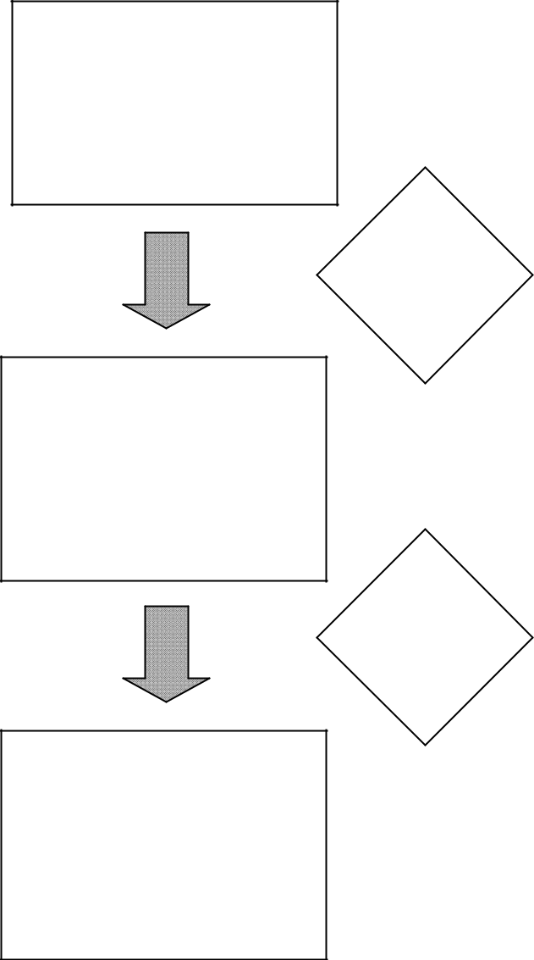

Survey Results

602 Respondents

Develop

Expansion

Factor

1

Expanded
Survey Results

480,396 Individuals

Apply

Weight

Factor

3

Expanded/ Weighted

Survey Results

479,871 Individuals

480,100 / 602 = 798

 | 2
Black | 1.33 x 798 = 1062
Hispanic | 2.44 x 798 = 1942
White | 0.75 x 798 = 599
Other | 1.60 x 798 = 1278

________

Note: 1. 798 x 602 = 480,396 individuals.

- Final expansion/weight factors estimates workers by ethnicity for Montgomery County.

- Note: the difference from 480,100 individuals is due to rounding.

116

Commuter Connections 2010 State of the Commute Survey Draft Technical Report June 30, 2010

APPENDIX B

FINAL DIALING DISPOSITION

Figure B-1. Total Dialing Dispositions

 |  | Total | Total
 | Dialing Disposition | Count | Percent
 | Answering Machine | 54,750 | 31.9%
 | No Answer | 31,699 | 18.5%
 | Call Backs | 4,649 | 2.7%
 | Busy | 10,686 | 6.2%
 | Over quota | 81 | <0.1%
 | Total Lives | 101,865 | 59.4%
 | Not in service | 13,661 | 8.0%
 | Business | 11,074 | 6.5%
 | Fax | 3,832 | 2.2%
 | Refusals | 23,695 | 13.8%
 | Other language | 702 | 0.4%
 | Terminates during interview | 757 | 0.4%
 | Terminates – screened out | 8,849 | 5.2%
 | Never available | 314 | 0.2%
 | Blocked Number | 76 | <0.1%
 | Total Deads | 62,960 | 36.7%
 | Total Completes | 6,629 | 3.9%
 | Total Sample Used | 171,454 | 100.0%

Total Dialings: 483,760

Average Number of Dialings per Complete: 73.0

Prescreened Invalid Sample Points: 195,685

Total Sample Generated: 367,139
Commuter Connections 2010 State of the Commute Survey Draft Technical Report June 30, 2010

Figure B-2. Dialing Dispositions by Sample Area

 |  |  |  |  |  |  |  |  |  | Sample Area
 | Alexandria City, |  | Arlington Co., |  | Calvert Co., |  | Charles Co., |  | District of |  | Frederick Co., |  | Loudoun Co., |  | Montgomery |  | Prince George’s |  | Prince William
 | VA |  | VA |  | MD |  | MD |  | Columbia (DC) | Fairfax Co., VA | MD |  | VA |  | Co., MD |  | Co., MD |  | Co., VA | Total
Answering Machine | 4,980 |  | 4,073 |  | 4,340 |  | 6,336 |  | 6,221 | 1,897 | 4,943 |  | 4,223 |  | 4,612 |  | 8,536 |  | 4,589 | 54,750
No Answer | 2,822 |  | 3,559 |  | 1,916 |  | 2,671 |  | 5,978 | 1,359 | 2,386 |  | 2,066 |  | 2,435 |  | 4,320 |  | 2,187 | 31,699
Call Backs | 362 |  | 345 |  | 338 |  | 575 |  | 516 | 167 | 304 |  | 303 |  | 385 |  | 853 |  | 501 | 4,649
Busy | 1,140 |  | 764 |  | 850 |  | 1,489 |  | 1,054 | 349 | 553 |  | 719 |  | 659 |  | 1,903 |  | 1,206 | 10,686
Over Quota | 0 |  | 0 |  | 0 |  | 0 |  | 0 | 64 | 5 |  | 1 |  | 7 |  | 1 |  | 3 | 81
TOTAL LIVES | 9,304 |  | 8,741 |  | 7,444 |  | 11,071 |  | 13,769 | 3,836 | 8,191 |  | 7,312 |  | 8,098 |  | 15,613 |  | 8,486 | 101,865
Not in Service | 1,772 |  | 2,303 |  | 1,363 |  | 1,064 |  | 1,269 | 691 | 750 |  | 591 |  | 1,193 |  | 1,628 |  | 1,037 | 13,661
Business | 1,297 |  | 1,188 |  | 681 |  | 1,122 |  | 1,784 | 595 | 864 |  | 737 |  | 816 |  | 1,099 |  | 891 | 11,074
Fax | 350 |  | 330 |  | 284 |  | 427 |  | 458 | 157 | 292 |  | 344 |  | 317 |  | 522 |  | 351 | 3,832
Refusals | 1,909 |  | 1,907 |  | 2,525 |  | 3,241 |  | 2,070 | 1,182 | 2,229 |  | 1,951 |  | 2,125 |  | 2,596 |  | 1,960 | 23,695
Other Language | 117 |  | 119 |  | 15 |  | 36 |  | 61 | 53 | 33 |  | 43 |  | 91 |  | 85 |  | 49 | 702
Terminates during interview | 61 |  | 67 |  | 71 |  | 72 |  | 72 | 67 | 52 |  | 76 |  | 78 |  | 77 |  | 64 | 757
Terminates - Screened out | 646 |  | 598 |  | 974 |  | 1,524 |  | 1,128 | 340 | 871 |  | 448 |  | 751 |  | 1,073 |  | 496 | 8,849
Never Available | 25 |  | 30 |  | 35 |  | 31 |  | 38 | 25 | 32 |  | 20 |  | 26 |  | 28 |  | 24 | 314
Blocked Number | 7 |  | 12 |  | 2 |  | 5 |  | 14 | 2 | 5 |  | 3 |  | 10 |  | 14 |  | 2 | 76
Prescreened - Invalid Phone | 18,249 |  | 20,054 |  | 11,172 |  | 17,626 |  | 28,080 | 6,986 | 12,907 |  | 7,258 |  | 13,985 |  | 25,797 |  | 13,691 | 175,805
TOTAL DEADS | 6,184 |  | 6,554 |  | 5,950 |  | 7,522 |  | 6,894 | 3,112 | 5,128 |  | 4,213 |  | 5,407 |  | 7,122 |  | 4,874 | 62,960
TOTAL COMPLETES | 602 |  | 602 |  | 608 |  | 603 |  | 602 | 602 | 602 |  | 602 |  | 602 |  | 602 |  | 602 | 6,629
TOTAL | 16,090 |  | 15,897 |  | 14,002 |  | 19,196 |  | 21,265 | 7,550 | 13,921 |  | 12,127 |  | 14,107 |  | 23,337 |  | 13,962 | 171,454
Commuter Connections 2010 State of the Commute Survey Draft Technical Report June 30, 2010

APPENDIX C

SURVEY QUESTIONNAIRE

INTRODUCTION |  |  | . I’m calling (from CIC Research) on behalf of the Metropolitan Washington
Hello. My name is
Council of Governments |  | . We’re | talking to residents of Maryland, Virginia, and the District of Columbia about their

travel to work. (IF NECESSARY: This is a genuine survey. No attempt will be made to sell you anything. Your an-swers will be kept completely confidential and will be used only together with those of other respondents.). Is now a good time? (ARRANGE CALL BACK)

SCREENING QUESTIONS

S1 Is anyone in your household employed? By employed, I mean a wage or salaried employee, military or self-employed…

INTERVIEWERS: SCREEN OUT KEEPING OWN HOUSE (HOUSEWIFE), DISABLED, RETIRED, STU-DENT, VOLUNTEER OR UNEMPLOYED-LOOKING FOR WORK

- yes (SKIP TO QS4)
- no ( THANK AND TERMINATE)

S4 Are you an employed person who is at least 16?

- yes (SKIP TO Q1)
- no (ASK QS5)

S5 Is anyone else in your household employed either full-time or part-time?

- yes (ASK FOR THAT PERSON AND REPEAT INTRO, THEN GO BACK TO QS4 OR ARRANGE CB)
- no (THANK AND TERMINATE)

EMPLOYMENT STATUS AND HOME/WORK LOCATION

- What is your employment status right now -- are you employed 35 hours or more per week, or less than 35 hours?

1 Employed full-time (35 hours or more) (CONTINUE)
2 Employed part-time (less than 35 hours) (CONTINUE)
3 Not employed, keeping house, retired, disabled, full-time student, looking for work (GO BACK TO QS5) 8 Don’t know (THANK & TERMINATE)
9 Refuse (THANK & TERMINATE)

1a What is your home zip code?

________________

AUTOCODE COUNTY FOR CHANTILLY
IF Q1a = 20151, AUTOCODE Q2 = 6 (Fairfax), THEN SKIP TO Q3
IF Q1a = 20152, AUTOCODE Q2 = 8 (Loudoun), THEN SKIP TO Q3

AUTOCODE ALEXANDRIA (EXCEPT 22311)
IF Q1a = 22301, 22302, 22304, 22305, OR 22314, AUTOCODE Q2 = 1 (Alexandria), THEN SKIP TO Q3
IF Q1a = 22303, 22306, 22307, 22308, 22309, 22310, OR 22315, AUTOCODE Q2 = 6 (Fairfax), THEN SKIP TO Q3
Commuter Connections 2010 State of the Commute Survey Draft Technical Report June 30, 2010

AUTOCODE TAKOMA PARK, MD, TAKOMA DC
IF Q1a = 20903, 20910, 20912, 20913, AUTOCODE Q2 = 9 (Montgomery), THEN SKIP TO Q3 IF Q1a = 20011 OR 20012, AUTOCODE Q2 = 5 (DC), THEN SKIP TO Q3

AUTOCODE LAUREL
IF Q1a = 20707 OR 20708, AUTOCODE Q2 = 10 (Prince Georges), THEN SKIP TO Q3

IF Q1a = 20723 OR 20724, AUTOCODE Q2 = 12 (Other –out of area), THEN THANK AND TERMINATE

AUTOCODE SILVER SPRING (EXCEPT 20903)
IF Q1a = 20901, 20902, 20904, 20905, 20906, OR 20910, AUTOCODE Q2 = 9, THEN SKIP TO Q3

AUTOCODE STERLING

IF Q1a = 20164, 20165, OR 20166, AUTOCODE Q2 = 8 (Loudoun), THEN SKIP TO Q3

AUTOCODE FAIRFAX AND FALLS CHURCH CITIES
IF Q1a = 22030, 22041, 22042, 22043, 22044, OR 22046, AUTOCODE Q2 = 6 (Fairfax), THEN SKIP TO Q3

AUTOCODE WALDORF (EXCEPT Q20601)

IF Q1a = 20602 OR 20603, AUTOCODE Q2 = 12 (Other - out of area), THEN THANK AND TERMINATE

AUTOCODE MANASSAS, MANASSAS PARK
IF Q1a = 20110 OR 20113, AUTOCODE Q2 = 11, THEN SKIP TO Q3

IF Q1a = ANY OTHER ZIP CODE, ASK Q2

QUOTA SCREENER – NEED 600 IN EACH OF 11 AREAS 1 - 11

- In what county (or Independent City) do you live now? (DO NOT READ)

1 Alexandria City, VA
2 Arlington Co., VA
3 Calvert Co., MD
4 Charles Co., MD
5 Washington, DC (District of Columbia)
6 Fairfax Co., VA (City of Falls Church, City of Fairfax)
7 Frederick Co., MD (City of Frederick)
8 Loudoun Co., VA (South Riding)
9 Montgomery Co., MD (City of Rockville, City of Gaithersburg, City of Takoma Park, Silver Spring) 10 Prince George’s Co., MD(City of Greenbelt, City of College Park, City of Bowie)
11 | Prince William Co., VA (City of Manassas, City of Manassas Park)
12 | Other (SPECIFY) | (THANK AND TERMINATE)

- Don’t know (THANK AND TERMINATE)
- Refused (THANK AND TERMINATE)
Commuter Connections 2010 State of the Commute Survey Draft Technical Report June 30, 2010

- In what county (or independent city) do you work? (IF “ALL OVER”, ASK: Where do you work the most?)

1 Alexandria City (VA)
2 Anne Arundel Co. (MD)
3 Arlington Co. (VA)
4 Calvert Co. (MD)
5 Charles Co. (MD)
6 Washington, DC (District of Columbia)
7 Fairfax Co. (VA)
8 Fairfax City (VA)
9 Falls Church City (VA)
10 Frederick Co. (MD)
11 Howard Co. (MD)
12 Loudoun Co. (VA)
13 Manassas City (VA)
14 Manassas Park City (VA)
15 Montgomery Co. (MD)
16 Prince George’s Co. (MD)
17 Prince William Co. (VA)
18 Stafford Co. (VA)
19 Baltimore County (MD)
20 Carroll County (MD)
21 Other
88 Don’t know
99 Refuse

COMMUTE PATTERNS

Now, I’d like to ask you some questions about your commute to and from work. If you have more than one job, just tell me about your primary job.

4 First, in a TYPICAL week, how many days are you assigned to work?

days

____ “0”, not currently working (GO BACK TO QS5)

5 How many of those days are weekdays (Monday-Friday)?

days

____ “0”, (CODE AS WKALL, THEN SKIP TO Q57)

- And how many weekdays do you commute to a work location outside your home? (IF RESPONDENT SAYS, “VARIES BY WEEK” OR “DON’T KNOW”, PROMPT “What would you say would be most typi-cal?” IF RESPONDENT STILL SAYS “DON’T KNOW,” CODE AS 8)

10 None (CONTINUE TO Q8)

1 One
2 Two
3 Three
4 Four
5 Five
8 Don’t know (SKIP TO Q61)

9 Refuse (SKIP TO Q61)

IF Q1 = 2, SKIP TO Q13

IF Q1 = 1 AND Q6 = 1, 2, 3, 4, OR 5, SKIP TO Q11
Commuter Connections 2010 State of the Commute Survey Draft Technical Report June 30, 2010

- So to be sure I understand, you work at home every weekday you work. Is that right?

1 Yes (CONTINUE)
2 No (INTERVIEWER PROMPT, “SO YOU COMMUTE TO A WORK LOCATION OUTSIDE YOUR HOME ONE OR MORE WEEKDAYS, IS THAT CORRECT?) GO BACK TO Q5)

- Are you self-employed with your primary work location at home?

1 Yes (PROGRAMMER, CODE AS HOMEALL) (SKIP TO INSTRUCTIONS BEFORE Q15)
2 No (CONTINUE)

- Do you telecommute every weekday you work?

1 Yes (PROGRAMMER, CODE AS TELEALL, SKIP TO INSTRUCTIONS BEFORE Q13)
2 No (SPECIFY SITUATION, THEN THANK AND TERMINATE)

- Do you work a compressed or flexible work schedule, for example, a full-time work week in fewer than five days or a schedule with flexible start and end times?

1 yes (CONTINUE)
2 no (SKIP TO Q13)

- What type of schedule do you use? (DO NOT READ, UNLESS NEEDED TO CLARIFY)

1 4/40 (4 10-hour days per week, 40 hours)
2 9/80 (9 days every 2 weeks, 80 hours)
3 3/36 (3 12-hour days per week, 36 hours - police, fire, hospitals)
4 flex-time or flexible work hours (core hours with flexible start & stop)
5 Work 5 or more days per week, 35 or more hours per week (RECODE Q11 = 2) 6 other (SPECIFY)

INSTRUCTIONS BEFORE Q13

IF TELEALL (FROM Q10), AUTOCODE Q13 = 1, THEN SKIP TO Q13a

- Now I want to ask you about telecommuting, also called teleworking. For purposes of this survey, “telecom-muters” are defined as “wage and salary employees who at least occasionally work at home or at a telework or satellite center during an entire work day, instead of traveling to their regular work place.” Based on this definition, are you a telecommuter?

- yes
- no (SKIP TO Q14d)

- DK/Ref (SKIP TO Q14d)

13a Does your employer have a formal telecommuting program at your workplace or do you telecommute under an informal arrangement between you and your supervisor?

- formal program
- informal arrangement
- N/A

9 DK/Ref

IF TELEALL AND Q5 = 1, AUTOCODE Q14 = 4, THEN SKIP TO INSTRUCTIONS BEFORE Q15 IF TELEALL AND Q5 = 2, AUTOCODE Q14 = 5, THEN SKIP TO INSTRUCTIONS BEFORE Q15
IF TELEALL AND Q5 = 3, 4, 5, 6, OR 7, AUTOCODE Q14 = 6, THEN SKIP TO INSTRUCTIONS BEFORE Q15
Commuter Connections 2010 State of the Commute Survey Draft Technical Report June 30, 2010

- How often do you usually telecommute? (DO NOT READ)

1 occasionally for special project
2 Less than one time per month/only in emergencies (e.g., sick child, snowstorm) 3 1-3 times a month
4 one day a week
5 two days a week
6 3 or more times a week
7 other (SPECIFY)
9 DK/Ref.

SKIP TO Q15

14d Does your employer have a formal telecommuting program at your workplace or permit employees to tele-commute under an informal arrangement with the supervisor?

- yes, formal program
- yes, informal arrangement
- no
9 DK/Ref

14e Would your job responsibilities allow you to work at a location other than your main work place at least oc-casionally?

- yes
- no (SKIP TO Q15)

- DK/Ref (SKIP TO Q15)

14f Would you be interested in telecommuting on an occasional or regular basis?

- yes, occasional basis
- yes, regular basis
- no
9 DK/Ref

CURRENT COMMUTE PATTERNS

INSTRUCTIONS BEFORE Q15

IF HOMEALL FROM Q9, DON’T ASK Q15. AUTO FILL Q15, RESPONSE 18 = Q5, THEN SKIP TO Q61

IF TELEALL FROM Q10, DON’T ASK Q15. AUTO FILL Q15, RESPONSE 2 = Q5, THEN SKIP TO INSTRUCTIONS BEFORE Q34

- Now thinking about LAST week, how did you get to work each day. Let’s start with Monday? … How about Tuesday? … Wednesday? …. Thursday? …. Friday?

IF RESPONDENT MENTIONS MORE THAN ONE MODE ON ANY DAY, PROMPT FOR THE MODE USED FOR THE LONGEST DISTANCE PORTION OF THE TRIP.

IF Q12 = 1, 2, OR 3 AND RESPONDENT DOES NOT MENTION "CWS day off" (RESPONSE 1), ASK:
“You said you typically work a compressed work schedule. Did you have a compressed work sche-dule day off last week?”

IF Q14 = 4, 5, OR 6 AND RESPONDENT DOES NOT MENTION "Telecommute" (RESPONSE 2), ASK:
“You said you typically telecommute one or more days per week. Did you telecommute last week?”

IF RESPONDENT SAYS TRAVEL TO WORK IN A CAR, TRUCK, OR VAN, SAY, Were you alone in the vehicle? IF YES, REPORT RESPONSE 3. IF NO, SAY, “Including yourself, how many people were in the vehicle?” IF 2-4, RECORD RESPONSE 5, IF 5, PROBE TO ASK ABOUT VANPOOL, THEN CODE RESPONSE 5 OR 7 AS APPROPRIATE, IF 6 OR MORE, RECORD AS RESPONSE 7
Commuter Connections 2010 State of the Commute Survey Draft Technical Report June 30, 2010

IF ALL WEEKDAYS IN Q5 ARE ACCOUNTED FOR BY MODES 1-15 IN Q15 BEFORE ALL WEEKDAYS ARE COUNTED, ASK: You said you typically work only (number of weekdays reported in Q5) per week. Were the weekdays I haven’t asked you about regular days off for you last week? IF RE-

SPONSE IS YES, CATI WILL AUTOFILL REMAINING DAYS WITH CODE 16; OTHERWISE CONTINUE AND RECORD MODES USED FOR THOSE DAYS

IF RESPONDENT MENTIONS “SICK, VACATION, HOLIDAY” (RESPONSE 17) FOR ANY DAY, CODE RESPONSE 17, THEN ASK “If you had worked that day, how would you likely have traveled to work?” AND CODE ADDITIONAL MODE RESPONSE FOR THAT DAY.

Mode/Day of Week |  |  |  |  | Go to Work
 |  |  | Mon | Tues | Wed | Thur | Fri
1. compressed work schedule day off |  |  | 1 | 1 | 1 | 1 | 1
2. telecommute/telework |  |  | 2 | 2 | 2 | 2 | 2
3. drive alone in your car, truck, or van |  |  | 3 | 3 | 3 | 3 | 3
4. motorcycle |  |  | 4 | 4 | 4 | 4 | 4
5. carpool, including carpool w/family member, dropped off |  |  | 5 | 5 | 5 | 5 | 5
6. casual carpool (slugging) |  |  | 6 | 6 | 6 | 6 | 6
7. vanpool |  |  | 7 | 7 | 7 | 7 | 7
8. buspool |  |  | 8 | 8 | 8 | 8 | 8
9 rode a bus (public Bus, shuttle) |  |  | 9 | 9 | 9 | 9 | 9
10. | Metrorail |  | 10 | 10 | 10 | 10 | 10
11. MARC (MD Commuter Rail) |  |  | 11 | 11 | 11 | 11 | 11
12. VRE |  |  | 12 | 12 | 12 | 12 | 12
13. | AMTRAK/other train |  | 13 | 13 | 13 | 13 | 13
14. bicycle |  |  | 14 | 14 | 14 | 14 | 14
15. walk |  |  | 15 | 15 | 15 | 15 | 15
16. regular day off (non-CWS) |  |  | 16 | 16 | 16 | 16 | 16
17. sick, vacation, holiday, work out of area, etc. (prompt |  |  | 17 | 17 | 17 | 17 | 17
 | for travel on non sick, vacation day)
18. | work at home – self-employed |  | 18 | 18 | 18 | 18 | 18
19. | taxi |  | 19 | 19 | 19 | 19 | 19
20. | N/A
21. | N/A
88. | N/A

- How long is your typical daily commute one way? Please tell me both how many minutes and how many miles. First, how many minutes?

Number of minutes
Time varies _________________________
888 Don’t know
999 Refuse

- And how many miles? (IF LESS THAN 1 MILE, RECORD AS 0.5)

Number of miles 888 Don’t know 999 Refuse

USE OF ALTERNATIVE MODES

IN Q18, <MODE Q15> = ALL MODES 3, 4, 5, 6, 7, 8, 9, 10, 11, 12, 13, 14, 15, 19 NAMED IN Q15
Commuter Connections 2010 State of the Commute Survey Draft Technical Report June 30, 2010

- How long have you been using <MODE Q15> to get to work? (DO NOT READ)

IF MORE THAN ONE <MODE Q15>, REPEAT FOR OTHER <MODE Q15>
ADD TO BRIEFING DOCUMENT INSTUCTIONS IF RESPONDENT SAYS, “DO YOU MEAN HOW LONG HAVE I BEEN USING <MODE Q15, THIS TYPE OF TRANSPORTATION> OR HOW LONG I’VE BEEN IN THIS PARTICULAR <MODE Q15, bus route, carpool, vanpool, etc.>,” INTERVIEWER SHOULD SAY, “USING <MODE Q15, this type of transportation>.

CODE MONTHS FOR EACH MODE CURRENTLY USED IF LESS THAN ONE MONTH, CODE 1 MONTH
IF RESPONDENT SAYS “always used,” “only used,” or “no other choice / no other option” FOR ANY <MODE Q15>, CODE MONTHS AS 888.
IF RESPONDENT SAYS, “don’t know” FOR ANY <MODE Q15>, CODE MONTHS AS 999

1 | N/A | Number of months
2 | N/A | _____
3 | drive alone | _____
4 | motorcycle | _____
5 | carpool | _____
6 | casual carpool (slugging) | _____
7 | vanpool | _____
8 | buspool | _____
9 | bus | _____
10 | Metrorail | _____
11 | MARC | _____
12 | VRE | _____
13 | AMTRAK, other train | _____
14 | Bicycle | _____
15 | Walk | _____
- N/A
- N/A
- N/A
19 Taxi _____

DEFINE RECENT MODE = Q18 MODE WITH FEWEST MONTHS
IF TIE FOR RECENT MODE, DESIGNATE BOTH MODES AS RECENT MODE

Skip Q19a – Q20b (reasons for change) if respondent has never used another mode IF Q18 = 888 FOR RECENT MODE, AUTOCODE Q19a = 20, THEN SKIP TO Q22

Skip Q19a – Q20b (reasons for change) if RECENT MODE duration is more than 3 years IF RECENT MODE Q18 DURATION IS GREATER THAN 36 MONTHS, SKIP TO Q22
Commuter Connections 2010 State of the Commute Survey Draft Technical Report June 30, 2010

19a Before starting to <RECENT MODE Q15> to work, what type or types of transportation did you use to get to

work? (ALLOW MULTIPLE MODES 1 – 15. DO NOT ACCEPT MULTIPLES FOR 16-21 OR 99)

IF Q12 = 1, 2, OR 3 AND RESPONDENT DOES NOT MENTION "CWS day off" (RESPONSE 1), ASK: “You said you typically work a compressed work schedule now. Did you work a compressed schedule at that time?”

IF Q14 = 4, 5, OR 6 AND RESPONDENT DOES NOT MENTION "Telecommute" (RESPONSE 2), ASK:

“You said you typically telecommute one or more days per week now. Did you telecommute at that time?” (DO NOT READ OTHER RESPONSES)

- compressed work schedule
- telecommute
- drive alone in your car, truck, van
- motorcycle
- carpool, including carpool with family member, dropped off
- casual carpool (slugging)
- vanpool
- buspool
- bus
- Metrorail
- MARC
- VRE
- AMTRAK, other train
- Bicycle
- walk
- N/A
- N/A
- N/A
- Taxi
- always used, only used <RECENT MODE Q15>
- not working then, not in DC area then

99 Don’t know, refused

- What were the reasons you began using <RECENT MODE Q15>? (DO NOT READ; CHECK ALL THAT
APPLY) (Probe for the 3 most important and only record 3) (OKAY NOT TO SHOW INFREQUENT IN-
CIDENCE RESPONSES ON SCREEN – CODE AS OTHER THEN CODE TO PROPER CATEGORIES IN POST-PROCESSING)

Personal circumstances/preferences
- changed jobs/work hours
- moved to a different residence
- employer or worksite moved
- spouse started new job
- save money
- save time
- gas prices too high
- tired of driving
- prefer to drive, wanted to drive
- safety
- no vehicle available
- car became available, additional car in household
- to stay with family/children
- HOV lanes too congested
- Congestion (other)
- always used
- close to work or transportation pick up/drop off location
- afraid of or didn’t like previous form of transportation
- stress
- weather
- bought hybrid vehicle
- convenient (NOT AN ANSWER, PROBE FOR WHY IT’S CONVENIENT)
- to get exercise
- concerned about the environment, global warming
Commuter Connections 2010 State of the Commute Survey Draft Technical Report June 30, 2010

Commute Services/Programs
- new option that became available
- special program at work
- pressure or encouragement from employer
- GRH
- Ozone action/Code Red days
- no parking
- parking expense, parking cost too high
- found carpool partner
- NuRide (VA carpool incentive)
- SmartTrip/SmartBenefit, Metrochek, transit subsidy, vanpool subsidy
- Commuter Choice Maryland

Information/Promotion
- advertising
- initiated request/looked for information on my own
- info. from Commuter Connections/Council of Governments/COG/800 number
- Commuter Connections Website
- other Website
- word of mouth/recommendation
- information from transit agency
- saw highway sign
- yellow pages
- Other

- Don’t know
- Refuse

- In the past two years, have you used or tried any other type of transportation between home and work that you’ve not already mentioned?

1 yes
2 no (SKIP TO INSTRUCTIONS BEFORE Q28)

- What was that type of transportation? (DO NOT READ; CHECK ALL THAT APPLY. IF Q23 = Q15 ANY
DAY OR Q19a, INTERVIEWER PROMPT, “YOU ALREADY MENTIONED <MODE Q15, Q19a>, DID YOU TRY ANY OTHER TYPE OF TRANSPORTATION?”

1 compressed work schedule day off
2 telecommute
3 drive alone
4 motorcycle
5 carpool, including carpool with family member, dropped off
6 casual carpool (slugging)
7 vanpool
8 buspool
9 bus
10 Metrorail
11 MARC
12 VRE
13 AMTRAK, other train
14 bicycle
15 walk
16 N/A
17 N/A
18 N/A
19 taxi
20 N/A
21 N/A
99 don’t know, refused
Commuter Connections 2010 State of the Commute Survey Draft Technical Report June 30, 2010

- How long did you use <Q23 mode(s)>? (DO NOT READ)

_______ months (CONVERT YEARS TO MONTHS)
0less than one month
888 | occasionally (tried one, emergency use)
999 | still using
-997 | Don’t know

SET Q23LONG = Q24, LONGEST DURATION
IF Q24 = 999 (STILL USING) FOR ANY MODE, THAT MODE = Q23LONG

IF Q24 = 888 (occasionally) FOR ANY MODE, THAT MODE = Q23LONG, UNLESS RESPONDENT MENTIONED BOTH OCCASIONAL MODE AND OTHER MODE, THEN USE OTHER MODE

- What prompted you to use or try this type of transportation? (DO NOT READ; IF MORE THAN THREE
REASONS GIVEN, PROBE FOR 3 MOST IMPORTANT AND CODE ONLY THOSE 3) (OKAY NOT TO SHOW INFREQUENT INCIDENCE RESPONSES ON SCREEN – CODE AS OTHER THEN CODE TO PROPER CATEGORIES IN POST-PROCESSING)

Personal circumstances/preferences
- changed jobs/work hours
- moved to a different residence
- employer or worksite moved
- spouse started new job
- save money
- save time
- gas prices too high
- tired of driving
- prefer to drive, wanted to drive
- safety
- no vehicle available
- car became available, additional car in household
- to stay with family/children
- HOV lanes too congested
- congestion (other)
- always used
- close to work or transportation pick up/ drop off location
- afraid of or didn’t like previous form of transportation
- stress
- weather
- bought hybrid vehicle
- convenient (NOT AN ANSWER, PROBE FOR WHY IT’S CONVENIENT)
- to get exercise
- concerned about the environment, global warming

Commute Services/Programs
- new option that became available
- special program at work
- pressure or encouragement from employer
- GRH
- Ozone action/Code Red days
- no parking
- parking expense, parking cost too high
- found carpool partner
- NuRide (VA carpool incentive)
- SmartTrip/SmartBenefit, Metrochek, transit subsidy, vanpool subsidy
- Commuter Choice Maryland
Commuter Connections 2010 State of the Commute Survey Draft Technical Report June 30, 2010

Information/Promotion
- advertising
- initiated request/looked for information on my own
- info. from Commuter Connections/Council of Governments/COG/800 number
- Commuter Connections Website
- other Website
- word of mouth/recommendation
- information from transit agency
- saw highway sign
- yellow pages
- Other

- Don’t know
- Refuse

ALTERNATIVE MODE PATTERNS

IF Q15 = 5, 6, 7, CONTINUE, OTHERWISE, SKIP TO Q29

- Now I’d like to ask you about your current car/van pool (FROM Q15). Including yourself, how many people usually ride in your carpool or vanpool? (If more than 1 answer in Q15, select 1 using this priority: vanpool, carpool, casual carpooling/slug.)

total people in pool (must be more than 1)

IF Q15 = 5, 6, 7, 8, 9, 10, 11, 12, OR 13, CONTINUE USING THE MOST COMMON ALTERNATIVE MODE, OTH-

ERWISE, SKIP TO INTRO BEFORE Q34

- How do you get from home to where you meet your <Q15 ALT MODE: carpool, vanpool, buspool, bus, or train>?

1 picked up at home by car/van pool (SKIP TO INSTRUCTIONS BEFORE Q34)

2 drive alone to driver’s home or drive alone to passenger’s home
3 drive to a central location, like park & ride, or train or subway station 4 dropped off or another car/van pool
5 bicycle
6 motorcycle
7 walk
8 I am the driver of car pool/van pool (SKIP TO INSTRUCTIONS BEFORE Q34)

9 bus/transit
10 other (SPECIFY)

- How many miles is it one way from your home to where you meet your <Q15 ALT MODE: carpool, vanpool, buspool, bus, or train>? (IF LESS THAN 1 MILE, ENTER 0.5)

miles

TELECOMMUTE

INSTRUCTIONS BEFORE Q34

IF Q13 = 1 OR Q15 = 2 ANY DAY, CONTINUE, OTHERWISE, SKIP TO INTRO BEFORE Q44 IF TELEALL, DO NOT READ INTRO TO Q34, SKIP DIRECTLY TO Q34

INTRO TO Q34: Now I have a few more questions about telecommuting.

34 How long have you been telecommuting?

_______ months (CONVERT YEARS TO MONTHS)

999 Don’t know/refused

IF TELEALL, AUTOCODE Q36 = 1, THEN SKIP TO Q42
Commuter Connections 2010 State of the Commute Survey Draft Technical Report June 30, 2010

- Where do you work when you telecommute? Do you work at home, in a telework center, a satellite office provided by your employer, or someplace else? (IF NECESSARY: Telework Centers are federally funded facilities located around the Washington area that allow government and non-government employees to work closer to home some or all of the time.)

1 Home (SKIP TO Q42)

2 Telework Center
3 Both home and Telework Center
4 Satellite office provided by employer
5 Both home and satellite office
6 Business service center (Kinkos) or other “retail” location
7 Both home and business service center (Kinkos) or other “retail” location 8 Library or community center
9 Both home and library or community center
10 Executive office suites
11 Both home and executive office suites
12 other location (SPECIFY) ____________

IF Q36 = 3, 5, 7, 9, OR 11, CONTINUE, OTHERWISE, SKIP TO Q38

- How many days per week, on average, do you telecommute from the location outside your home?

__________ days per week

- How many miles is it one way from your home to this location? (IF LESS THAN ONE MILE, RECORD “1”)

_________ miles (no decimals)

- And how do you get from home to this location?

1 N/A
2 N/A
3 drive alone
4 motorcycle
5 carpool, including carpool with family member, dropped off
6 casual carpool (slugging)
7 vanpool
8 buspool
9 bus
10 Metrorail
11 MARC
12 VRE
13 AMTRAK, other train
14 bicycle
15 walk
16 N/A
17 N/A
18 N/A
19 taxi
99 DK/Ref
Commuter Connections 2010 State of the Commute Survey Draft Technical Report June 30, 2010

- How did you find out about telecommuting?” (DO NOT READ)

1 advertising (radio, newspaper or TV)
2 special program at work/employer provided information
3 initiated request on my own
4 information from Commuter Connections / COG (Council of Governments) 5 word of mouth
6 newspaper or magazine article
7 Commuter Connections Website
8 Other Website
9 County or jurisdiction program
10 other (SPECIFY)
99 DK/Ref

IF Q42 = 4 OR 7, AUTOCODE Q43 = 1, THEN SKIP TO INTRO BEFORE Q44

- Did you receive any information about telecommuting from Commuter Connections or from the Telework Resource Center at the Council of Governments?

- yes
- no
9 DK/Ref

AVAILABILITY OF TRANSPORTATION OPTIONS

INTRO BEFORE Q44: Next, I want to ask you about transportation services that might be available in your area.

- Regardless of whether or not you use them, what train or bus companies provide service in the area where you live? (DO NOT READ; PROBE WELL FOR BOTH BUS AND TRAIN; ACCEPT MULTIPLE RES-PONSES FOR 2-13 AND FOR 15-20)

Buses
1 No buses provide service (DO NOT ALLOW MULTIPLES WITH 2-13) 2 Alexandria DASH
3 Fairfax Connector
4 Fairfax Cue
5 Loudoun Commuter Bus
6 Metrobus
7 MTA bus
8 Omni Ride
9 Ride On
10 “The Bus”
11 TransIT Bus
12 ART, Arlington Transit
13 Bus (PROBE FOR NAME)

Train
14 No trains provide service (DO NOT ALLOW MULTIPLES WITH 15-19) 15 AMTRAK/ACELA

16 MARC (Maryland commuter rail)
17 MetroRail/subway
18 Virginia Railway Express (VRE)
19 Train (PROBE FOR NAME)

20 Other (SPECIFY)
99 Don’t know/Refused

Commuter Connections 2010 State of the Commute Survey Draft Technical Report |  |  |  |  |  |  | June 30, 2010
44a | About how far from your home is the nearest bus stop? (NOTE IF MILES OR BLOCKS)
 | Number of miles
 | Number of blocks |  | _____________________
 | 999 | Don’t know
44b | How far from your home is the nearest train station? (NOTE IF MILES OR BLOCKS)
 | Number of miles
 | Number of blocks |  | _____________________
 | 999 | Don’t know
44c | What train or bus companies provide service in the area where you work? (DO NOT READ; PROBE FOR
 | BOTH BUS AND TRAIN, ALLOW MULTIPLE RESPONSES FOR 2-13 AND FOR 15-20)

Buses
- No buses provide service (DO NOT ALLOW MULTIPLES WITH 2-13)
- Alexandria DASH
- Fairfax Connector
- Fairfax Cue
- Loudoun Commuter Bus
- Metrobus
- MTA bus
- Omni Ride
- Ride On
- “The Bus”
- TransIT Bus
- ART, Arlington Transit
- Other Bus (PROBE FOR NAME)

Trains
- No trains provide service (DO NOT ALLOW MULTIPLES WITH 15-19)

- AMTRAK/ACELA
- MARC (Maryland commuter rail)
- MetroRail/subway
- Virginia Railway Express (VRE)
- Other Train (PROBE FOR NAME)

- Other (SPECIFY)

99 Don’t know/Refused

Q46. Is there a special HOV (High Occupancy Vehicle) lane that can be used only by carpools, vanpools and buses along your route to work?

- Yes
- No (SKIP TO INSTRUCTIONS BEFORE Q51a)
- Refuse/Don't know (SKIP TO INSTRUCTIONS BEFORE Q51a)

IF Q15 = 15 ANY DAY, AUTOCODE Q47 = 3, THEN SKIP TO Q51a

- Do you ever use the HOV lane to get to or from work?

1 Yes
2 No (SKIP TO INSTRUCTIONS BEFORE Q51a)
3 No, not asked – walk to work
9 Refused/Don't know (SKIP TO INSTRUCTIONS BEFORE Q51a)

- How much time does the HOV lane save you in your one-way trip to or from work?

___________ minutes 999 DK/Ref.
Commuter Connections 2010 State of the Commute Survey Draft Technical Report June 30, 2010

51 Did the HOV lane influence your decision to use your current way of commuting?

- Yes
- No

9 Refused/Don't know

IF Q15 = 5, 6, OR 7, ANY DAY, SKIP TO Q51b

Q51a Several jurisdictions in the Washington region are building or considering building toll roads. If you could use one of these roads for your trip to work and carpools and vanpools traveled for free or for a reduced toll, how likely would you be to start carpooling or vanpooling to use these roads? Would you be… very likely, somewhat likely, or not likely?

- Very likely
- Somewhat likely
- Not likely

9 DK/Ref.

SKIP TO Q52

Q51b Several jurisdictions in the Washington region are building or considering building toll roads. If you could use one of these roads for your trip to work and carpools and vanpools that registered with a regional com-mute organization could use these roads for free or for a reduced toll, how likely would you be to register your carpool or vanpool?

- Very likely
- Somewhat likely
- Not likely

9 DK/Ref.

- Do you know the locations of Park ‘n Ride lots along the route that you take to work?

1 Yes
2 No (SKIP TO INSTRUCTIONS BEFORE Q54)
3 There aren’t any (SKIP TO INSTRUCTIONS BEFORE Q54)
8 Don’t know (SKIP TO INSTRUCTIONS BEFORE Q54)
9 Refuse (SKIP TO INSTRUCTIONS BEFORE Q54)

- In the past year have you used Park ‘n Ride lots when commuting to work?

1 Yes
2 No
9 DK/Ref.

ATTITUDES TOWARD TRANSPORTATION MODES

INSTRUCTIONS BEFORE Q54
If Q15 = 5, 6, 7, 8, 9, 10, 11, 12, 13, 14, 15 OR Q29 = 1, 4, 8, OR 9, SKIP TO Q56f
If Q23 = 5, 6, 7, 8, 9, 10, 11, 12, 13, 14, 15 AND Q24 = 999 (still using), SKIP TO Q56f If Q44 = 1 OR Q44c = 1, AUTOCODE Q54 = 1 If Q44 = 14 OR Q44c = 14, AUTOCODE Q54 = 2

IF BOTH RESPONSES 1 AND 2 ARE AUTOCODED IN Q54 (no bus and no train service), DO NOT READ Q54, SKIP TO Q56
Commuter Connections 2010 State of the Commute Survey Draft Technical Report June 30, 2010

- You said earlier that you don’t ride public transit (public transportation) regularly for your commute to work. Why not? (DO NOT READ, ACCEPT MULTIPLE RESPONSES)

- No bus service available (in home area or in work area/bus too far away
- No train service available (in how area or in work area/train too far away)
- Don’t know if service is available/don’t know location of bus stops / train stations
- Need my car for work
- Need car before or after work
- Need car for emergencies/overtime
- It might not be safe/I don’t feel safe on bus or at bus stops
- It might not be safe/I don’t feel safe on trains or train stations
- Bus / train is unreliable/late
- Trip is too long/distance too far
- Takes too much time
- Don’t like to ride with strangers
- Prefer to be alone during commute
- Work schedule irregular
- Too expensive
- Buses are too uncomfortable/crowded
- Trains are too uncomfortable/crowded
- Buses or trains too dirty
- Have to transfer/too many transfers
- Had a bad experience with the bus or train in the past
- Have to wait too long for the bus or between buses
- Have to wait too long for the train or between train
- Other (specify) ___________________________

99 DK/Ref

- You said that you do not use a carpool or vanpool for your trip to work. Why don’t you carpool or vanpool?
(DO NOT READ, ACCEPT MULTIPLE RESPONSES)

1 Don’t know anyone to carpool/vanpool with
2 Need my car for work
3 Need car before or after work
4 Need car for emergencies/overtime
5 It might not be safe/I don’t feel safe
6 Carpool/vanpool partners are/could be unreliable/late
7 Trip is too long/distance too far
8 Takes too much time
9 Doesn’t save time
10 Don’t like to ride with strangers
11 Prefer to be alone during commute
12 Work schedule irregular
13 Too expensive
14 Had a bad experience with carpooling/vanpooling in the past 15 Other (specify) ___________________________
99 DK/Ref
Commuter Connections 2010 State of the Commute Survey Draft Technical Report June 30, 2010

56f Now I have a few questions about benefits of traveling by carpool, vanpool, bus, or train. What personal benefits do you think people receive from using these types of transportation? (DO NOT READ)

- Save money
- Avoid stress
- Not need to have a car
- Less wear and tear on car
- Use travel time productively (e.g., read, work, sleep)
- Have companionship when they travel
- Arrive at work on time, less likely to be late
- Get exercise, health benefits
- Help the environment
- Reduce greenhouse gases, reduce carbon footprint
- Can use HOV lane
- Other (specify) _____________________________________________
- No benefits
- Don’t know

56g What impact or benefit does a community or region receive when people use these types of transportation?
(DO NOT READ)

- Less traffic, less congestion
- Reduce air pollution, help the environment
- Reduce greenhouse gases, reduce carbon footprint
- Save energy
- Less wear and tear on roads
- Reduce accidents, improve travel safety
- Reduce government costs
- Less stress, less road rage
- Other (specify) _____________________________________________
- No benefits
- Don’t know

CURRENT COMMUTE COMPARED TO LAST YEAR

56m Overall, how satisfied are you with your trip to work? Use a scale of 1 to 5, where “1” means not satisfied at all and “5” means very satisfied.

Not at all |  |  |  |  | Very | (Don’t
 | satisfied |  |  |  | satisfied | Know)
Scale: | 1 | 2 | 3 | 4 | 5 | 9

- Would you say your commute is easier, more difficult, or about the same now as it was one year ago?

1 easier (ASK Q58)
2 more difficult (ASK Q59)
3 about the same (SKIP TO Q60)
4 not applicable (SKIP TO Q60)
9 DK/Ref (SKIP TO Q60)
Commuter Connections 2010 State of the Commute Survey Draft Technical Report June 30, 2010

- In what way is it easier?

1 shorter distance
2 trip is faster, takes less time
3 route is less congested
4 started carpooling/vanpooling to work
5 started using bus, train to work
6 started driving alone to work
7 less stressful
8 bought a hybrid or compressed natural gas (CNG) vehicle 9 started using HOV lanes
10 gas prices are lower, gas costs less
11 other _______
19 Refused/Don't know

- In what way is it more difficult?

1 longer distance
2 trip is slower, takes more time
3 more congested
4 started carpooling/vanpooling to work
5 started using bus, train to work
6 started driving alone to work
7 more stressful
8 construction on route to work
9 trains, buses, metro more crowded
10 gas prices are higher, costs more
11 other ________________________________
19 DK/Ref.

- Have you changed your work or home location in the last year? IF YES, AND RESPONDENT DOES NOT VOLUTEER INFORMATION, ASK, “Did you change your home or work location?”

1 Yes, changed home location
2 Yes, changed work location
3 Yes, changed both home and work locations
4 No (SKIP TO Q61)
9 DK/Ref. (SKIP TO Q61)

60a Was your previous location also in the Washington metropolitan region?

- Yes
- No

9 DK/Refused
Commuter Connections 2010 State of the Commute Survey Draft Technical Report June 30, 2010

60b What factors did you consider in your decision to make this change? (DO NOT READ, ACCEPT MUL-
TIPLE RESPONSES)

Commute Factors
- Length, ease of commute
- Cost of commuting
- Commuting options that would be available (e.g., transit)

Residential Factors
- Quality of schools, stay in same school system
- Cost of house
- Cost of living
- Size of house
- Quality of neighborhood
- Closeness to family or friends
- Entertainment, shopping, services nearby

Job Factors
- Income, salary
- Job satisfaction
- Career advancement
- Job opportunities for spouse

- Other (SPECIFY) ____________________________
- DK/Refused

60c How important to your decision was the ease of your trip to work compared to the other factors you just mentioned? Was it less important than other factors, more important, or about the same importance?

- Less important
- More important
- About the same importance
- DK/Refused

IF Q60 = 1 OR 3, ASK Q60d and Q60e, OTHERWISE, SKIP TO Q61

60d Did your employer offer you any information about financial incentives that might be available to you if you moved your home to a location close to work?

- Yes
- No

9 DK/Refused

60e Did your employer offer you any information about financial incentives that might be available if you moved your home to a location close to a bus stop or train station?

- Yes
- No
9 DK/Refused

AWARENESS OF ADVERTISING

- Have you heard, seen, or read any advertising about commuting in the past year?

1 yes
2 no (SKIP TO Q81)
9 DK/Ref (SKIP TO Q81)
Commuter Connections 2010 State of the Commute Survey Draft Technical Report June 30, 2010

- What messages do you recall from this advertising? (DON’T READ, ACCEPT MULTIPLE RESPONSES) (OKAY NOT TO SHOW INFREQUENT INCIDENCE RESPONSES ON SCREEN – CODE AS OTHER THEN CODE TO PROPER CATEGORIES IN POST-PROCESSING)

1 none (SKIP TO Q81)
2 that you should rideshare, carpool, vanpool) (NOT ACCEPTABLE ANSWER; PROBE FOR WHY AND RECORD ELSEWHERE)

3 that new trains and/or buses are coming
4 that you can call for carpool or vanpool info
5 call 1-800-745-RIDE / call Commuter Connections 6 Commuter Choice Maryland
7 contact the Commuter Connections website (www.commuterconnections.org, www.commuterconnections.com)
8 it saves money
9 it saves time
10 it is less stressful
11 guaranteed ride home (GRH)
12 employer would give me SmartTrip/SmartBenefit, Metrochek benefits
13 it would help the environment
14 it reduces traffic
15 it saves wear and tear on the car
16 Ozone Action Days / Code Red Days
17 Telework Center / telecommuting
18 HOV lanes
19 regional services/programs are available to help with commute
20 use the bus or train, use Metrobus
21 Way to Go, Way to Go Arlington
22 Virginia MegaProjects, Dulles rail extension
23 HOT lanes
24 Inter-County Connector (ICC)
25 other (SPECIFY)
99 DK/Ref. (SKIP TO Q81)

- What organization or group sponsored the ad you recall? (DO NOT READ, ACCEPT MULTIPLE RES-
PONSES)

1 Commuter Connections
2 Metropolitan Washington Council of Governments, MWCOG, COG
3 Metro, WMATA
4 MARC, Maryland Commuter Rail
5 VRE, Virginia Railway Express
6 VDOT (Virginia Department of Transportation)
7 DDOT (District of Columbia Department of Transportation)
8 MDOT (Maryland Department of Transportation)
9 VDRPT, Virginia Department of Rail and Public Transportation
10 Maryland State Highway Administration
11 MTA, Maryland Mass Transit Administration
12 Maryland Department of the Environment
13 WABA, Washington Area Bicycling Association
14 Arlington County Commuter Services
15 other (specify) __________________
99 DK/Ref.

Commuter Connections 2010 State of the Commute Survey Draft Technical Report June 30, 2010

- And where did you see, hear, or read this advertisement? (DO NOT READ, ACCEPT MULTIPLE RES-
PONSES)

1 Commuter Connections website
2 other website, internet (specify _______________________)
3 radio
4 TV
5 postcard in mail
6 newspaper
7 in train station
8 on train or bus
9 at work
10 other (___________)
19 DK/Ref.

IF HOMEALL, SKIP TO Q81
IF TELEALL, SKIP TO Q81

IF WKALL, SKIP TO Q81

Attitude changes/actions taken after hearing ads

- After seeing or hearing this advertising, were you more likely to consider ridesharing or public transporta-tion?

1 yes
2 no (SKIP TO Q81)
9 DK/Ref (SKIP TO Q81)
Commuter Connections 2010 State of the Commute Survey Draft Technical Report June 30, 2010

- After seeing or hearing this advertising, did you take any actions to try to change how you commute? IF YES, ASK “What actions did you take? (DO NOT READ)

No action
1 didn’t take any action (SKIP TO Q81)

Sought information
- looked for commute information on the internet
- asked friend, family member, or co-worker for commute information (referral)
- contacted a local or regional organization for commute information
- looked for a carpool or vanpool partner
- called a transit operator to ask about schedules or routes
- asked employer about telecommuting opportunities
- asked employer about SmartTrip SmartBenefit, Metrochek
- looked for information about guaranteed ride home (GRH) program
- looked for information about HOV lanes

Started participating in commute service/program
- registered for guaranteed ride home (GRH) program
- purchased alternative fuel vehicle (e.g., electric car, hybrid car, CNG-fueled vehicle)
- started using HOV lane to get to work

Changed personal situation, work schedule, or commute route
- moved my home or job location, changed jobs
- started going to work earlier or later
- changed or reduced number of days I work
- changed route to work

Tried another way of getting to work, started using another form of transportation
- tried or started driving alone to work
- tried or started carpooling to work
- tried or started vanpooling to work
- tried or started using bus to get to work
- tried or started using train to get to work
- tried or started bicycling or walking to work
- tried or started telecommuting/teleworking

Other
- other action (specify____________) (SKIP TO Q81)

- DK/Ref (SKIP TO Q81)

- Did the advertising you saw or heard encourage you to take this action?

1 yes
2 no
9 DK/Ref
Commuter Connections 2010 State of the Commute Survey Draft Technical Report June 30, 2010

IF Q66 = 2, 3, 4, 5, 6, 7, 8, 9, OR 10, AND Q66 NE 19, 20, 21, 22, 23, OR 24 ASK Q70, OTHERWISE, SKIP TO Q71

- How likely is it that you will try another type of transportation for your commute to work, other than driving alone, taxi, or motorcycle, within the next year? Would you say it is … (READ RESPONSES 1-3. DO NOT READ RESPONSE 9)

1 very likely
2 somewhat likely
3 not likely
9 DK/Ref

Collect info on mode/modes used before trying/starting new alt mode – skip out respondents who did not try alt mode and respondents who answered this question in Q19

IF Q66 NE 19, 20, 21, 22, 23, OR 24, SKIP TO Q81

Autofill mode duration for respondents currently using alternative mode (Q15) named in Q66
IF Q66 EQ 19 AND Q15 = 5 OR 6, AUTOFILL Q71 = “still using,” THEN SKIP TO Q72a IF Q66 EQ 20 AND Q15 = 7, AUTOFILL Q71 = “still using,” THEN SKIP TO Q72a
IF Q66 EQ 21 AND Q15 = 8 OR 9, AUTOFILL Q71 = “still using,” THEN SKIP TO Q72a
IF Q66 EQ 22 AND Q15 = 10, 11, 12, 13, AUTOFILL Q71 = “still using,” THEN SKIP TO Q72a IF Q66 EQ 23 AND Q15 = 14,15, AUTOFILL Q71 = “still using,” THEN SKIP TO Q72a
IF Q66 EQ 24 AND Q15 = 2, AUTOFILL Q71 = “still using,” THEN SKIP TO Q72a Autofill duration for respondents who tried alt mode named in Q66 in past two years (Q23)

IF Q66 = 19 AND Q23 = 5 OR 6, ANY DAY, AUTOFILL Q71 = Q24, THEN ASK Q72a IF Q66 = 20 AND Q23 = 7, ANY DAY, AUTOFILL Q71 = Q24, THEN ASK Q72a
IF Q66 = 21 AND Q23 = 8 OR 9, ANY DAY, AUTOFILL Q71 = Q24, THEN ASK Q72a
IF Q66 = 22 AND Q23 = 10, 11, 12, OR 13, ANY DAY, AUTOFILL Q71 = Q24, THEN ASK Q72a IF Q66 = 23 AND Q23 = 14 OR 15, ANY DAY, AUTOFILL Q71 = Q24, THEN ASK Q72a IF Q66 = 24 AND Q23 = 2, ANY DAY, AUTOFILL Q71 = Q24, THEN ASK Q72a

- How long did you <ALT MODE FROM Q66> to work? (IF MORE THAN ONE ALT MODE NOTED IN Q66, ASK DURATION FOR ALL)

_______ months (CONVERT YEARS TO MONTHS)
_______ less than one month

_______ 991 occasionally (tried one, emergency use) (SKIP TO Q81)

_______ 999 still using

999 DK/Ref.

IF Q66 = 19, 20, 21, 22, 23, 24 (MORE THAN ONE OF THESE), THEN CHOOSE ALT MODE USED LONGEST TIME FOR Q72a. IF MORE THAN ONE ALT MODE USED SAME AMOUNT OF TIME, CHOOSE BOTH MODES.

72a Before trying <ALT MODE FROM Q66> to work, what type or types of transportation did you use to get to work? (ACCEPT MULTIPLE RESPONSES, PROGRAMMER, LIST MODES FOR USE IN Q72b)

FOR EACH MODE MENTIONED IN Q72a, ASK…
Commuter Connections 2010 State of the Commute Survey Draft Technical Report June 30, 2010

72b About how many days per week did you use <MODE FROM Q72a>?

IF SUM OF DAYS FROM Q72b NE Q5, ASK “And how did you commute on other days you were assigned to work?” ACCEPT OPTION OF “didn’t work, regular day off.”

IF Q12 = 1, 2, OR 3 AND RESPONDENT DOES NOT MENTION "CWS day off" (RESPONSE 1), ASK:

“You said you typically work a compressed work schedule now. Did you work a compressed schedule at that time?”

IF Q14 = 4, 5, OR 6 AND RESPONDENT DOES NOT MENTION "Telecommute" (RESPONSE 2), ASK:

“You said you typically telecommute one or more days per week now. Did you telecommute at that time?”

Mode/Day typically used per week |  |  | Number of days using mode |  |  |  |  | 5
1 | compressed work schedule day off |  | 1 | 2 | 3 | 4 |  | 5
2 | telecommute |  | 1 | 2 | 3 | 4 |  | 5
3 | drive alone in your car, taxi |  | 1 | 2 | 3 | 4 |  | 5
4 | motorcycle |  | 1 | 2 | 3 | 4 |  | 5
5 | carpool, including carpool with family
 | member, dropped off |  | 1 | 2 | 3 | 4 |  | 5
6 | casual carpool (slugging) |  | 1 | 2 | 3 | 4 |  | 5
7 | vanpool |  | 1 | 2 | 3 | 4 |  | 5
8 | buspool |  | 1 | 2 | 3 | 4 |  | 5
9 | bus |  | 1 | 2 | 3 | 4 |  | 5
10 | Metrorail |  | 1 | 2 | 3 | 4 |  | 5
11 | MARC |  | 1 | 2 | 3 | 4 |  | 5
12 | VRE |  | 1 | 2 | 3 | 4 |  | 5
13 | AMTRAK, other train |  | 1 | 2 | 3 | 4 |  | 5
14 | bicycle |  | 1 | 2 | 3 | 4 |  | 5
15 | walk |  | 1 | 2 | 3 | 4 |  | 5
16 | didn’t work, regular days off |  | 1 | 2 | 3 | 4 |  | 5
- N/A
- N/A
19 | Taxi | 1 | 2 | 3 | 4 | 5
20 | N/A
21 | not working then, not in DC area then |  |  |  |  | 5
99 | don’t know, refused |  |  |  |  | 5

AWARENESS OF COMMUTE PROGRAMS/SERVICES

Now I have a few questions about services that might be available to commuters in your home or work areas.

- Is there a phone number or website you can use to obtain information on ridesharing, public transportation, HOV lanes, and telecommuting in the Washington region?

1 Yes
2 No (SKIP TO Q86)
9 DK/Ref (SKIP TO Q86)
Commuter Connections 2010 State of the Commute Survey Draft Technical Report June 30, 2010

- What is it? (DON’T READ, ACCEPT MULTIPLES)

1. | 800-745-RIDE (7433) |  |  |  |  |  |  |  |  |  |  | Commuter Connections (COG)
2. | 888-730-6664 |  |  |  |  |  |  |  |  |  |  | PRTC, Potomac Rappahannock Transportation
3. | 703-324-1111 |  |  |  |  |  |  |  |  |  |  | Fairfax County RideSources
4. | 301-770-POOL |  |  |  |  |  |  |  |  |  |  | Montgomery County Commuter Services
5. | 240-777-RIDE |  |  |  |  |  |  |  |  |  |  | Montgomery County Commuter Services
6. | 202-637-7000 |  |  |  |  |  |  |  |  |  |  | WMATA, METRO (Washington Metro. Area Transit
7. |  | www.mwcog.org |  |  |  |  |  |  |  |  |  | Authority)
7. |  |  |  |  |  |  |  |  |  |  |  | Commuter Connections (COG)
8. |  |  |  |  |  |  |  |  |  |  |  | Commuter Connections (COG)
8. |  | www.commuterconnections.org |  |  |  |  |  |  |  |  |  | Commuter Connections (COG)
9. |  | www.commuterconnections.com |  |  |  |  |  |  |  |  |  | Commuter Connections (COG)
10. |  | www.vre.org |  |  |  |  |  |  |  |  |  | Virginia Railway Express (VRE)
11. |  | www.commuterdirect.com |  |  |  |  |  |  |  |  |  | Arlington County Commuter Services
12. |  | www.commuterpage.com |  |  |  |  |  |  |  |  |  | Arlington County Commuter Services
13. |  | 703-228-RIDE |  |  |  |  |  |  |  |  |  | Arlington County Commuter Services
14. |  | www.springfieldinterchange.com |  |  |  |  |  |  |  |  |  | Springfield Interchange (VDOT)
15. |  | www.maryland.com |  |  |  |  |  |  |  |  |  | Maryland Mass Transit Admin. (MTA)
16. |  | www.wmata.com |  |  |  |  |  |  |  |  |  | MARC Commuter Rail
16. |  |  |  |  |  |  |  |  |  |  |  | WMATA, Metro
17. |  |  |  |  |  |  |  |  |  |  |  | VDOT
17. |  | www.HOVcalculator.com |  |  |  |  |  |  |  |  |  | VDOT
18. |  |  |  |  |  |  |  |  |  |  |  | Maryland Mass Transit Admin (MTA)
18. |  | www.commuterchoicemaryland.com |  |  |  |  |  |  |  |  |  | Maryland Mass Transit Admin (MTA)
19. |  | 866-RIDE-MTA (1-800-743-3682) |  |  |  |  |  |  |  |  |  | Maryland Mass Transit Admin (MTA)
20. |  | www.metroopensdoors.org |  |  |  |  |  |  |  |  |  | WMATA, Metro
21. |  | Other (SPECIFY) _____________________________________________________

IF Q83 = ONLY 2, 3, 4, 5, 10, 11, 12, 13, 14, 15, 17, 18, 19, ASK Q84, INSERTING “this” IF Q83 = 1, 7, 8 OR 9, Ask Q84, INSERTING “this Commuter Connections” IF Q83 = 6, 16, 20, ASK Q84, INSERTING “this Metro”

IF Q83 = 1, 6, 7, 8, 9, 16, 20 AND ANY OTHER RESPONSE, ASK Q84, INSERTING “this other”

- Have you used [this, this Commuter Connections, this Metro, this other] number or website in the past year?
(CHECK FOR ALL RESPONSES IN Q83)

- Yes
- No
- Don’t know
- Refuse

DELETED Q85 – combined with Q87

- IF Q83 = 1, 7, 8, OR 9, CODE Q86 = 1, THEN SKIP TO Q87 IF Q20 = 38 OR 39, CODE Q86 = 1, THEN SKIP TO Q87 IF Q26 = 38 OR 39, CODE Q86 = 1, THEN SKIP TO Q87 IF Q42 = 4 OR 7, CODE Q86 = 1, THEN SKIP TO Q87
IF Q43 = 1, CODE Q86 = 1, THEN SKIP TO Q87
IF Q62 = 5 OR 7, CODE Q86 = 1, THEN SKIP TO Q87 IF Q63 = 1, CODE Q86 = 1, THEN SKIP TO Q87
IF Q64 = 1, CODE Q86 = 1, THEN SKIP TO Q87

Have you heard of an organization in the Washington region called Commuter Connections?

1 yes
2 no (SKIP TO Q88c)
8 Don’t know (SKIP TO Q88c)
9 Refuse (SKIP TO Q88c)
Commuter Connections 2010 State of the Commute Survey Draft Technical Report June 30, 2010

- IF Q86 WAS AUTOCODED = 1, START Q87 WITH: You mentioned knowing about Commuter Connec-tions.
How did you learn about Commuter Connections? (DO NOT READ; ACCEPT MULTIPLE RESPONSES)

1 TV
2 magazine
3 newspaper ad
4 newspaper article
5 sign/billboard
6 mail/postcard
7 brochure
8 transportation fair/special event
9 radio
10 employer
11 Library
12 phonebook, yellow pages
13 word of mouth (family, friend, co-worker)
14 internet/Web
15 InfoExpress kiosks
16 Ozone Action/Code Red days
17 Other __________________
88 Don’t know
99 Refuse

- What services does Commuter Connections provide? (DO NOT READ, ACCEPT MULTIPLE RES-
PONSES)

1 guaranteed ride home
2 rideshare (carpool/vanpool) information
3 help finding carpool/vanpool partners, matchlists
4 transit schedule/route information
5 HOV lane information
6 park & ride lot information, parking information
7 telecommute information
8 bicycle/walking information
9 road construction information
10 kiosks, InfoExpress
11 SmartTrip/ SmartBenefit, Metrochek
12 other (specify) ______________________
88 don’t know
99 Refuse

IF Q83 = 1, 7, 8, OR 9, AND Q84 = 1 FOR ANY OF THOSE PROGRAMS, AUTOCODE Q88a = 1, THEN SKIP TO Q88b.
IF Q20 = 38 OR 39, AUTOCODE Q88a = 1, THEN SKIP TO Q88b

IF Q26 = 38 OR 39, AUTOCODE Q88a = 1, THEN SKIP TO Q88b IF Q42 = 4 OR 7, AUTOCODE Q88a = 1, THEN SKIP TO Q88b IF Q43 = 1, AUTOCODE Q88a = 1, THEN SKIP TO Q88b IF Q64 = 1, AUTOCODE Q88a = 1, THEN SKIP TO Q88b

88a Have you contacted Commuter Connections in the past year or visited a website sponsored by this organi-zation?

- Yes
- No (SKIP TO Q88c)
- Don’t know (SKIP TO Q88c)
- Refuse (SKIP TO Q88c)
Commuter Connections 2010 State of the Commute Survey Draft Technical Report June 30, 2010

88b IF Q88a WAS AUTOCODED = 1, START Q88b WITH: “When you contacted Commuter Connections or visited its website,”
What information or services were you seeking? (DO NOT READ, ACCEPT MULTIPLE RESPONSES)

- transit schedule/route information
- carpool, vanpool (rideshare) information
- help finding carpool/vanpool partners, matchlists
- guaranteed ride home
- Ozone alerts
- park & ride lot information, parking information
- telecommute, telework information
- bicycle, walking information
- road construction information
- SmarTrip/ SmartBenefit, Metrochek
- travel directions, driving directions
- other (specify) ______________________
- don’t know
- Refuse

Define Local Program for Q88c - Q88f

88c SET ORGANIZATIONS TO ASK ABOUT IN Q88c-Q88f (DO NOT READ)

IF Q2 = 1 OR Q3 = 1 (Alexandria), INSERT Alexandria LocalMotion as <PROGRAM> in Q88c - Q88f

IF Q2 = 2 OR Q3 = 3 (Arlington), INSERT Arlington County Commuter Services or The Commuter Store as <PROGRAM> in Q88c - Q88f
IF Q2 = 3 OR Q3 = 4 (Calvert), INSERT Tri-County Council for Southern Maryland as <PROGRAM> in Q88c - Q88f
IF Q2 = 4 OR Q3 = 5 (Charles), INSERT Tri-County Council for Southern Maryland as <PROGRAM> in Q88c - Q88f
IF Q2 = 6 OR Q3 = 7, 8, OR 9 (Fairfax Co, Ffx City, Falls Church), INSERT Fairfax County RideSources as <PROGRAM> in Q88c - Q88f
IF Q2 = 7 OR Q3 = 10 (Frederick), INSERT TransIT Services of Frederick County as <PROGRAM> in Q88c - Q88f
IF Q2 = 8 OR Q3 = 12 (Loudoun), INSERT Loudoun County Office of Transportation Services as <PROGRAM> in Q88c - Q88f

IF Q2 = 9 OR Q3 = 15 (Montgomery), INSERT Montgomery County Commuter Services, Bethesda Transporta-tion Solutions, or North Bethesda Transportation Center as <PROGRAM> in Q88c - Q88f
IF Q2 = 10 OR Q3 = 16 (Prince Georges), INSERT Ride Smart as <PROGRAM> in Q88c - Q88f

IF Q2 = 11 OR Q3 = 13, 14, OR 17 (Prince William, Manassas, Manassas Park), INSERT PRTC OmniMatch as <PROGRAM> in Q88c-Q88f

- Alexandria LocalMotion
- Arlington County Commuter Services, The Commuter Store
- Tri-County Council of Southern Maryland (Calvert, Charles)
- Fairfax County RideSources
- TransIT Services of Frederick County
- Loudoun County Office of Transportation Services
- Montgomery County Commuter Services, Bethesda Transportation Solutions, North Bethesda Trans-portation Center
- Ride Smart (Prince Georges Commuter Solutions)
- PRTC OmniMatch (Prince William)
Commuter Connections 2010 State of the Commute Survey Draft Technical Report June 30, 2010

88d Have you heard of an organization or service called <PROGRAM>?
IF YES AND Q88c = 2 OR 7, CLARIFY WHICH PROGRAM OR PROGRAMS ARE KNOWN. THEN CODE THAT/THOSE PROGRAMS IN 88d

- Alexandria LocalMotion
- Arlington County Commuter Services, The Commuter Store
- Tri-County Council of Southern Maryland (Calvert, Charles)
- Fairfax County RideSources
- TransIT Services of Frederick County
- Loudoun County Office of Transportation Services
- Montgomery County Commuter Services, Bethesda Transportation Solutions, North Bethesda Trans-portation Center
- Ride Smart (Prince Georges Commuter Solutions)
- PRTC OmniMatch (Prince William)

- Don’t know (SKIP TO INSTRUCTIONS BEFORE Q89)
- Refuse (SKIP TO INSTRUCTIONS BEFORE Q89)

ASK Q88e FOR ANY RESPONSE CODED YES IN Q88d

88e Have you contacted <Q88d PROGRAM OR SERVICE> in the past year or visited a website sponsored by this organization?

- Alexandria LocalMotion
- Arlington County Commuter Services, The Commuter Store
- Tri-County Council of Southern Maryland (Calvert, Charles)
- Fairfax County RideSources
- TransIT Services of Frederick County
- Loudoun County Office of Transportation Services
- Montgomery County Commuter Services, Bethesda Transportation Solutions, North Bethesda Trans-portation Center
- Ride Smart (Prince Georges Commuter Solutions)
- PRTC OmniMatch (Prince William)

- Don’t know (SKIP TO INSTRUCTIONS BEFORE Q89)
- Refuse (SKIP TO INSTRUCTIONS BEFORE Q89)

IF ONE OR MORE <Q88e PROGRAM OR SERVICE> CODED YES IN Q88e, ASK Q88f, DO NOT ASK ABOUT EACH PROGRAM INDIVIDUALLY

88f What information or services were you seeking? (DO NOT READ, ACCEPT MULTIPLE RESPONSES)

- transit schedule/route information
- carpool, vanpool (rideshare) information
- help finding carpool/vanpool partners, matchlists
- guaranteed ride home
- Ozone alerts
- park & ride lot information, parking information
- telecommute, telework information
- bicycle, walking information
- road construction information
- SmarTrip/ SmartBenefit, Metrochek
- travel directions, driving directions
- other (specify) ______________________
- don’t know
- Refuse
Commuter Connections 2010 State of the Commute Survey Draft Technical Report June 30, 2010

EMPLOYER SERVICES

IF HOMEALL SKIP TO Q105
IF TELEALL SKIP TO Q105

- Next please tell me if your employer makes any of the following commute services or benefits available to you and, if they are available, have you used them. How about…. ,? ASK ABOUT EACH SERVICE. IF NECESSARY, ASK “Does your employer make it available? IF AVAILABLE AND RESPONDENT DOES NOT INDICATE USE, ASK “Have you used this service?”

IF RESPONDENT SAYS HE/SHE IS THE OWNER OF THE COMPANY OR IS SELF-EMPLOYED, CODE ALL RESPONSES = 8, THEN SKIP TO Q102

Service |  | 1 - Available | 2 - Available, | 3 - Not | 8 – Owner/ | 9 - Don’t
 |  | and Used | not used | available | Self-employed | know
1 | Information on commuter transportation options
2 | Special parking spaces for carpools or vanpools
3 | SmarTrip/ SmartBenefit, Metrochek, or other
subsidies for public transportation or vanpooling
4 | Cash payments or other subsidies for carpooling
5 | Facilities or programs for employees who bike or
walk to work
6 | Guaranteed rides (GRH) home in case of emer-
gencies or unscheduled overtime

- Does your employer make free on-site parking available to all employees at your worksite?

1 yes
2 no (SKIP TO Q91)
9Don’t know/Ref (SKIP TO Q102)

90a Have you used this free parking?

- yes
- no

9 DK/Ref

SKIP TO Q102

- Does your employer pay part of your parking cost or do you have to pay the entire cost if you drive to work?

1 employer pays part/employee pays part
2 employee pays all
3 free offsite parking
9 DK/Ref

- Does your employer offer parking discounts for carpools or vanpools?

1 yes
2 No (SKIP TO Q102)
9Don’t know/Ref (SKIP TO Q102)

92a Have you used this parking discount?

- yes
- no

9 DK/Ref
Commuter Connections 2010 State of the Commute Survey Draft Technical Report June 30, 2010

GUARANTEED RIDE HOME

- Do you know if there is a regional GRH or Guaranteed Ride Home program available in the event of unex-pected emergencies and unscheduled overtime for commuters who rideshare or use public transportation?

1 yes, there is
2 no , there isn’t (SKIP TO Q105) 9 DK/Ref (SKIP TO Q105)

IF Q89, RESPONSE 6 (GRH) = 1 (AVAILABLE AND USED), CODE Q103 = 1, CODE Q104 = 2, THEN SKIP TO Q105

- In the past two years, have you registered for or used any guaranteed Ride Home service?

1 Yes
2 No (SKIP TO Q105)
9 DK/Ref (SKIP TO Q105)

- Who sponsored or offered the service? (DO NOT READ)

1 Commuter Connections/Council of Governments/COG
2 Employer
3 VRE
4 TMA (TyTran)
5 Other ____________________
9 Don’t know/Refuse

DELETED Q104f

QUALITY OF LIFE AND SATISFACTION WITH TRANSPORTATION

- Next, I have a few questions regarding quality of life and transportation in the Washington region. Overall, how would you rate the quality of life in the Washington region? Please use a scale of 1 to 5 where “1” means poor and “5” means excellent.

IF RESPONDENT ASKS WHAT QUALITY OF LIFE MEANS, ADD: “Quality of life” means “the general well-being of residents taking into consideration such things as employment opportunities, the economy, personal safety, housing, educational and entertainment opportunities, and so forth.”

 |  |  |  |  |  | (Don’t
 | Poor |  |  |  | Excellent | Know)
Scale: | 1 | 2 | 3 | 4 | 5 | 9

- How satisfied you are with the transportation system in the Washington metropolitan region? “Transporta-tion system” means all the services and options available to travel around the region and the quality of those services, including roads, buses and trains, and services for bicycling, walking, carpooling, and so forth.” Please use a scale of 1 to 5 where “1” means not satisfied at all and “5” means very satisfied.

Not at all |  |  |  |  | Very | (Don’t
 | satisfied |  |  |  | satisfied | Know)
Scale: | 1 | 2 | 3 | 4 | 5 | 9

Commuter Connections 2010 State of the Commute Survey Draft Technical Report June 30, 2010

- How satisfied are you with the level of attention being paid to transportation needs by federal elected offi-cials? Please use a scale of 1 to 5 where “1” means not satisfied at all and “5” means very satisfied. How about State level elected officials? And County or City level?

Not at all |  |  |  |  | Very | (Don’t
 | satisfied |  |  |  | satisfied | Know)
Scale: | 1 | 2 | 3 | 4 | 5 | 9

- Federal level
- State level
- County / city level

107a How well do you think the operation of the regional transportation system is managed? Please use a scale of 1 to 5 where “1” means very poorly managed and “5” means very well managed?

Very poorly |  |  |  |  | Very well | (Don’t
managed |  |  |  |  | managed | Know)
Scale: | 1 | 2 | 3 | 4 | 5 | 9

- Do you have any recommendations for how the transportation system in the region needs to be improved?
DO NOT READ (ALLOW UP TO THREE RESPONSES)

1 No improvements needed
2 Reduce traffic, congestion
3 More roads
4 More bus/train service, more transit
5 Expand Metrorail to more locations
6 Transit / Metrorail / buses too crowded
7 More bicycle lanes/paths
8 More parking at Metro stations
9 More parking – other locations
10 More HOV lanes
11 Eliminate HOV lanes – open HOV lanes to everyone 12 Expand the hours for HOV lanes
13 Build more toll facilities, convert existing roads to toll roads 14 Reduce transit fares, Bus or Metrorail fares too high
15 Reduce parking fees, parking fees too high
16 Reduce fees on current or planned toll roads
17 Improve Metrorail safety
18 Improve bus safety
19 Clearer / bigger road signs
20 Roads need repair
21 Other _______________________
99 Don’t know

- I’m going to read you several possible ways the Washington region could spend its current transportation dollars. For each, tell me if you think the region should allocate more, less, or about the same amount of money on this item as it does now?

ROTATE AND READ


- Road maintenance

- Maintenance for public transit, including Metro

- Road expansion

- Expansion of public transit

- Expansion of pedestrian and bicycle facilities

- Programs to support use of carpools, vanpools, and public transit

Allocate

More

1

Allocate

Less

2

About

Right

3

Don’t

know

4

Commuter Connections 2010 State of the Commute Survey Draft Technical Report June 30, 2010

- Finally, I’ll read several possible ways to increase transportation funding for the region. Please rate your support for each using a scale of 1 to 5, where 1 means you “strongly oppose” it and 5 means you “strongly support” it as a way to increase transportation funding. How much do you support …

Strongly |  |  |  |  | Strongly | (Don’t
 | oppose |  |  |  | support | Know)
Scale: | 1 | 2 | 3 | 4 | 5 | 9

- Increasing gas taxes
- Automatically adjusting gas taxes based on inflation
- Increasing transit fares
- Instituting tolls to build new roads
- Instituting tolls on existing roads
- Increasing vehicle registration fees
- Increasing vehicle sales taxes
- Replacing the gas tax with a per mile charge on vehicle miles driven
- Increasing income taxes
- Increasing property taxes
- Increasing sales taxes

DEMOGRAPHICS

My last few questions are for classification purposes only.

- In total, how many motor vehicles, in working condition, including automobiles, trucks, vans, and highway motorcycles are owned or leased by members of your household? _________

- How many persons live in your home? Please count yourself, family and friends, and anyone who may be unrelated to you such as live-in housekeepers or boarders.

persons

- Don’t know (SKIP TO INSTRUCTIONS BEFORE Q118)
- Refuse (SKIP TO INSTRUCTIONS BEFORE Q118)

IF Q114 = 1, AUTOCODE Q114a = 0, THEN SKIP TO INSTRUCTIONS BEFORE Q118

114a And how many of these household members are under the age of 16?
household members

- Don’t know
- Refuse

DELETED Q115 - Q116

Instructions before Q118
IF TELEALL OR HOMEALL SKIP TO Q119

- About how many employees work at your worksite? Is it . . . (READ CHOICES)

1 1–25
2 26-50
3 51-100
4 101-250
5 251-999
6 1,000 or more
9 DK/Ref.

- What is your occupation?

Commuter Connections 2010 State of the Commute Survey Draft Technical Report June 30, 2010

IF HOMEALL, AUTOCODE Q120 = 5, AUTOCODE Q120a = Q1a, THEN SKIP TO Q121

- What type of employer do you work for? Is your employer a federal agency, a state or local government agency, a non-profit organization or association, a private employer, or are you self-employed?

1 federal agency
2 state, or local government agency
3 non-profit organization/association
4 private sector employer
5 self-employed
6 other (SPECIFY) ____________________________________
9 DK/Ref.

120a What is your zip code at work?

- Which of the following groups includes your age? (READ CHOICES)

1 under 18
2 18-24
3 25-34
4 35-44
5 45-54
6 55-64
7 65 or older
9 Refused (DON’T READ)

- Do you consider yourself to be any of the following: Latino, Hispanic, or Spanish?

1 Yes
2 No
9 DK/Ref.

- Now I want to ask you about your race. Which one of the following best describes your racial background. Is it . . . (READ CHOICES 1-5; SELECT ONE RESPONE ONLY)

1 White
2 Black or African-American
3 American Indian or Alaska Native
4 Asian
5 Native Hawaiian or Other Pacific Islander
6 Other (SPECIFY) ____________
9 Refused

124Last, is your household’s total annual income $100,000 or more?.

1 No, less than $100,000 (ASK Q124a)
2 Yes, $100,000 or more (SKIP TO Q124b)
9 Refused (DON’T READ) (SKIP TO Q125)

124a Please stop me when I reach the category that best represents your household’s total annual income. Is it .
. . (READ CHOICES)

- less than $20,000
- $20,000 - $29,999
- $30,000 - $39,999
- $40,000 - $59,999
- $60,000 - $79,999
- $80,000 - $99,999
- Refused (DON’T READ)

SKIP TO Q125
Commuter Connections 2010 State of the Commute Survey Draft Technical Report June 30, 2010

124b Please stop me when I reach the category that best represents your household’s total annual income. Is it .
. . (READ CHOICES)

- $100,000 -$119,999
- $120,000 - $139,999
- $140,000 - $159,999
- $160,000 - $179,999
- $180,000 - $199,999
- $200,000 or more

9 Refused (DON’T READ)

Thank you very much for your time and cooperation!

Q125

(RECORD SEX:)

1 male

2 female

(RECORD LANGUAGE OF INTERVIEW:)

1 English

2 Spanish

Commuter Connections 2010 State of the Commute Survey Draft Technical Report June 30, 2010

APPENDIX D

INSTRUCTIONS AND DEFINITIONS OF TERMS

Q10, Q13, Q14, Q34: Teleworking. Also known as telecommuting, means using information technology and telecommunications to replace work-related travel. Simply put, it means working at home or closer to home. With teleworking, employees work at home or perhaps at a local telework center one or more days per week.

Q11: Flexible work schedule/“Flex-time”. Employees select their own starting and finishing times within a set daily period of time, e.g., between 7am and 7pm, to make up the hours they need to work dai-ly. Flex-time is generally not available to staff who are required to work shifts.

Q13, Q36 Q62: Telework Centers. Federally funded facilities located around the Washington area that allow government and non-government employees to work closer to home some or all of the time.

Q15, Q18, Q19a, Q23, Q72, Q110, Q112:

Drive Alone. Does not include Taxi. You drive alone if you travel from your home to work by driving your car, truck, motorcycle, or moped, without a passenger.

Carpool. You carpool if you arrive at your worksite by automobile with 2 to 6 occupants and your carpool has a regular arrangement between the occupants. May also include occupants that are being dropped off at other worksites or companies.

Vanpool. 7 - 15 occupants commuting to and from work by automobile. May also include occupants that are being dropped off at other worksites or companies.

Buspool. A buspool is a large vanpool - generally 16+ people regularly riding together. It differs from a bus in that the riders “subscribe” or sign up to ride and have a reserved seat.

Casual carpooling/slugging. Casual carpools are carpools that are formed on a day-to-day basis to take advantage of HOV lanes. They are most popular for commuters coming from Virginia to down-town Washington. People who want rides park at a few well-established but unofficial parking areas in VA and line up to wait for drivers. People who want riders cruise by that location and pick up as many as the car will hold. There are pick-up locations in Washington for the evening trip as well, but drivers and riders do not generally carpool home together.

Transit. You are a transit commuter if you ride a local or commuter bus (Metrobus, ART-Arlington Transit, The Bus, Ride-On, Fairfax Connector, Fairfax CUE, Loudon County Commuter Bus Service, PRTC OmniRide, OmniLink, DASH or any other public or private bus), commuter rail (MARC, VRE), Amtrak, or Metrorail to get to work.

Telecommuting. You telework or telecommute if you work at your home, telework center, or satellite of-fice other than your normal worksite, during your regular work time. Either formal or informal.

Day off/compressed work schedule. This is a non-standard or flexible (flex) schedule:

4/40 (4 10-hour days per week for a total of 40 hours)

9/80 (9 days every 2 weeks for a total of 80 hours)

3/36 (3 12-hour days per week for a total of 36 hours per week, usually worked by police, firemen,

hospital employees, etc.

flex-hours (core hours with flexible start & stop times)

MARC. Maryland Area Rail Commuter. Light rail which comes from Baltimore and West Virginia, similar to our Coaster.

MTA. Maryland Transit Authority. Light rail

VRE. Virginia Railway Express. Light rail.

Amtrak. Just like the Amtrak train here.
Commuter Connections 2010 State of the Commute Survey Draft Technical Report June 30, 2010

Metrorail. This is a subway within Washington, D.C., & northern Virginia and Maryland. It’s mostly un-derground, but does also run above ground in some areas.

Taxi. Should include dropped off by taxi or other “livery” service, if the passenger is the only passenger.

Q17: Miles traveled. Distance from home to work not including side trips, unless they are regular stops (e.g., dropping off a child at day care).

Q20, Q26, Q62, Q66, Q67, Q88, Q97, Q97a, Q102–Q104, etc.: GRH Guaranteed Ride Home (other-wise known as GRH) provides commuters who regularly carpool, vanpool, bike, walk or take tran-sit to work with a reliable ride home when one of life’s unexpected emergencies arises. Commu-ters will be able to use GRH to get home for unexpected personal emergencies and unscheduled overtime up to FOUR times per year.

Q20, Q26, Q46-Q51, Q58, Q62, Q66, Q67, Q81, Q88, Q108: HOV lane. “high occupancy vehicle” lane/carpool lane/diamond lane

Q20, Q62, Q66 Q67, Q88, Q88b, Q88f, Q94: SmarTrip and SmartBenefits are a tax-free commute ben-efit that companies can offer to employees in the Washington metropolitan area. SmarTrip is a permanent, rechargeable fare card and is embedded with a special computer chip that keeps track of the value of the card. Instead of receiving transit benefits as paper Metrochek cards, the benefit is loaded to the SmarTrip account. SmartBenefits replace the old Metrochek program and are claimed electronically each month.

Q85, Q87, Q88: Prior to January 2008, InfoExpress Kiosks offered a regional network of information and services for area commuters. InfoExpress kiosks were equipped with touch screen monitors & easy to use interface. Even though the kiosks were removed from the Washington, DC area in January 2008, a respondent may remember using one.

Purpose of survey:

The State of the Commute Survey is being conducted in the Washington Metropolitan area on behalf of the Washington Metropolitan Council of Governments. The purpose of the study is to provide an up-dated view of commuting in the Washington D.C. area for transportation policymakers from Washington D.C., Maryland and Virginia.

The study responses will be expanded to represent the commute patterns for employed households within the eleven jurisdictions of the study area. The results will be used to measure current commute patterns and program effectiveness, as well as commuter awareness and attitudes.

Contact person:

Mr. Nicholas W. Ramfos, Chief of Alternative Commute Programs Metropolitan Washington Council of Governments (COG) Commuter Connections
777 North Capitol Street NE, Suite 300

Washington DC 20002

202/962-3200

How we got your number:

When trying to reach households in the Metropolitan Washington, D.C. area, we start with your area code and the 3-digit prefix that begins your phone number. Then, a computer randomly selects the last 4 digits to make up a 7- digit phone number. We have no name or address, nor will we ask for one. We are just trying to gather information from households in your area.

You work for:

CIC Research, Inc.

San Diego, CA

(800) 892-2250 or (858) 637-4000

Supervisors: Lena Aguirre, Scott Evans, Dave Harper, and Susan Landfield
Commuter Connections 2010 State of the Commute Survey Draft Technical Report June 30, 2010

APPENDIX E – COMPARISON OF KEY SOC RESULTS – 2010, 2007, 2004, AND 2001

Current Travel Information

- Current mode split – Percentage of weekly commute trips (including CWS and TW days)

2010 2007 2004 2001

•

•

•

DA/Motorcycle | 64.1% | 66.9% | 71.4% | 70.3%
CP | 7.0% | 6.9% | 5.6% | 6.9%
VP | 0.1% | 0.2% | 0.3% | 0.5%
Bus | 5.6% | 4.9% | 4.4% | 4.5%
Metrorail | 13.5% | 12.0% | 11.5% | 11.5%
Commuter Rail | 1.0% | 0.8% | 0.9% | 0.8%
Bike/walk | 2.4% | 2.6% | 2.2% | 2.3%
CWS | 0.6% | 0.6% | 0.7% | 0.9%
Telework | 5.7% | 5.1% | 2.3% | 2.3%

Regular mode use – Percentages of weekly “on the road” commuter trips (without TC/CWS)

 |  | 2010 |  | 2007 |  |  | 2004 |  |  | 2001
DA/Motorcycle | 68.4% |  |  | 71.0% |  |  | 74.1% |  |  | 72.6%
CP/VP | 7.5% |  |  | 7.6% |  |  | 6.1% |  |  | 7.6%
Bus | 6.0% |  |  | 5.2% |  |  | 4.7% |  |  | 4.6%
Train | 15.5% |  |  | 13.55 |  |  | 12.8% |  |  | 12.7%
Bike/walk | 2.5% |  |  | 2.7% |  |  | 2.3% |  |  | 2.4%
Average length of commute
 |  | 2010 |  | 2007 |  |  | 2004 |  |  | 2001
Distance | 16.3 mi |  |  |  | 16.3 mi |  | 16.5 mi |  |  | 15.5 mi
Time | 36 min |  |  |  | 35 min |  | 34 min |  |  |  | 32 min
Work Non-standard/flexible schedules
 |  | 2010 |  | 2007 |  |  | 2004 |  |  | 2001
No |  | 67% |  |  | 67% |  |  | 69% |  | 72%
Yes | 33% |  |  | 33% |  |  | 31% |  |  | 28%
4/40 | 2% |  |  | 1% |  |  | 2% |  |  | 3%
9/80 | 4% |  |  | 3% |  |  | 3% |  |  | 2%
Flextime | 27% |  |  | 29% |  |  | 26% |  |  | 22%

Commuter Connections 2010 State of the Commute Survey Draft Technical Report June 30, 2010

•

•

•

•

Length of time using current alternative modes – regional commuters who currently use alterna-tive modes

 |  | 2010 |  | 2007 |  |  | 2004 |  |  | 2001
1 – 11 months |  | 18% |  |  | 17% |  |  | 23% |  | 28%
12 – 24 months | 11% |  |  | 21% |  |  | 23% |  |  | 23%
25 – 36 months | 11% |  |  | 10% |  |  | 9%
37 – 60 months | 13% |  |  | 13% |  |  | 12% |  |  | 49%
More than 60 months | 47% |  |  | 39% |  |  | 33%
Average duration (months) | 83 |  |  | 80 |  |  | 70 |  |  |  | N/A
Carpool/Vanpool occupancy
 |  | 2010 |  | 2007 |  |  | 2004 |  |  | 2001
Carpool/slug |  | 2.5 |  |  | 2.5 |  |  | 2.6 |  | 2.6
Vanpool | 7.6 |  |  | 9.9 |  |  | 10.0 |  |  | 11.4
Access mode to rideshare/transit modes
 |  | 2010 |  | 2007 |  |  | 2004 |  |  | 2001
Picked-up at home |  | 10% |  |  | 12% |  |  | 15% |  | 16%
Drive to driver’s home | 10% |  |  | 10% |  |  | 11% |  |  | 11%
Drive to central location | 18% |  |  | 18% |  |  | 18% |  |  | 14%
Another pool/dropped off | 3% |  |  | 1% |  |  | 1% |  |  | 1%
Walk | 35% |  |  | 35% |  |  | 39% |  |  | 39%
Drive CP/VP | 11% |  |  | 10% |  |  | 6% |  |  | 9%
Bus/transit | 12% |  |  | 12% |  |  | 9% |  |  | 10%
Average access distance (mi) | 2.6 mi |  |  | 3.1 mi |  |  | 3.1 mi |  |  | 2.6 mi

Reasons for using alt modes – regional commuters who currently use alternative modes.

 | 2010 |  | 2007 |  | 2004 |  | 2001
Changed jobs | 15% |  | 18% |  | 16% |  | 5%
Save money | 18% |  | 18% |  | 14% |  | 21%
Save time | 10% |  | 13% |  | 18% |  | 20%
No parking / parking expense | 4% |  | 9% |  | 3% |  | 4%
No vehicle available | 10% |  | 8% |  | 11% |  | 19%
Moved residence | 7% |  | 8% |  | 9% |  | 3%
Avoid congestion | 4% |  | 5% |  | 7% |  | 8%
Convenient / close to work | 8% |  | 4% |  | 1% |  | 4%
Gas prices too high | 0% |  | 4% |  | 0% |  | 0%
Tired of driving | 5% |  | 4% |  | 6% |  | 8%

Commuter Connections 2010 State of the Commute Survey Draft Technical Report June 30, 2010

- Switching among modes – Modes used previously by commuters who use alternative modes now. Not all shifts to alt modes are from drive alone. Some shifting occurs from one alt mode to another

 | 2010 |  | 2007 |  | 2004
Not in Washington area then | 13% |  | 15% |  | 17%
Always used this mode | 7% |  | 23% |  | 12%
Made a change from another mode | 80% |  | 62% |  | 71%
Previous modes used (respondents who shifted from another mode)
Drive alone | 55% |  | 55% |  | 56%
Train | 23% |  | 20% |  | 12%
Bus | 14% |  | 15% |  | 15%
Carpool/Vanpool | 4% |  | 10% |  | 10%
Bike/walk | 6% |  | 6% |  | 8%

- Used or tried other alternative modes – Respondents used or tried an alt mode they are not using now within the past two years (all regional commuters)

 |  | 2010 |  | 2007 |  | 2004 |  | 2001
Yes |  | 22% |  | 14% |  | 22% |  | 24%
Other Alternatives Tried |  | 3% |  | 11% |  | 14% |  | 14%
Carpool/casual carpool |  | 3% |  |  |  |  |  | 14%
Vanpool |  | 0% |  | 0% |  | 1% |  | <1%
Bus |  | 7% |  | 32% |  | 32% |  | 33%
Metrorail |  | 13% |  | 45% |  | 11% |  | 13%
Commuter Rail |  | 1% |  | 7% |  | 1%
Bike/walk |  | 4% |  | 15% |  | 13% |  | 9%

Telework

- Telework incidence in region – all commuters (workers who are not self-employed and working only at home)

 |  | 2010 |  | 2007 |  |  | 2004 |  |  | 2001
% regional workers who telework | 25.0% |  |  | 18.7% |  |  | 12.8% |  |  | 11.3%
Home-based teleworkers | 97% |  |  | 95% |  |  | 95% |  |  | 98%

- Employer telework programs – all regional commuters + FT teleworkers

 | 2010 |  | 2007 |  | 2004 |  | 2001
Employers with formal program | 29% |  | 19% |  | 15% |  | N/A
Employers with informal TW | 25% |  | 22% |  | 20% |  | N/A

Commuter Connections 2010 State of the Commute Survey Draft Technical Report June 30, 2010

- Potential for additional regional telework – regional commuters who do not telework

 | 2010 |  | 2007 |  | 2004 |  | 2001
Non-TW (percent of commuters) | 75% |  | 81% |  | 87% |  | 89%
Job tasks allow TW (“could TWC”) | 30% |  | 30% |  | 25% |  | 31%
Interested in TW (“could and would TW”) | 21% |  | 24% |  | 19% |  | 21%

- Telework frequency – current teleworkers

 | 2010 |  | 2007 |  | 2004 |  | 2001
Occasionally/special projects | 10% |  | 10% |  | 10% |  | 17%
< once per month/emergency | 12% |  | 8% |  | 12% |  | 12%
1 – 3 times per month | 30% |  | 26% |  | 32% |  | 28%
1 day per week | 19% |  | 18% |  | 15% |  | 16%
2 days per week | 12% |  | 16% |  | 12% |  | 9%
3 or more times per week | 17% |  | 22% |  | 19% |  | 16%
Mean (days per week) | 1.3 |  | 1.5 |  | 1.3 |  | 1.1

•

•

Length of time teleworking – current teleworkers
 | 2010 |  | 2007 |  | 2004 |  | 2001
Less than one year | 16% |  | 14% |  | 22% |  | 23%
One to two years | 22% |  | 29% |  | 27% |  | 29%
More than two years | 62% |  | 58% |  | 51% |  | 48%
How learned about telework – current teleworkers
 | 2010 |  | 2007 |  | 2004 |  | 2001
Program at work/employer | 71% |  | 55% |  | 56% |  | 34%
Word of mouth | 5% |  | 13% |  | 18% |  | 18%
Initiated request on my own | 15% |  | 23% |  | 16% |  | 26%
Commuter Connections/COG | 6% |  | 7% |  | 5% |  | 6%
Advertising | 0% |  | 2% |  | 3% |  | 6%

Awareness/Attitudes Toward Transportation Options

- HOV lane availability and use – all regional commuters

 | 2010 |  |  | 2007 |  |  | 2004 |  |  | 2001
Commuters with lane on route to work |  | 30% |  |  | 29% |  | 29% |  |  | 27%
Use lanes | 27% |  |  | 27% |  |  | 8% |  |  | 7%
Ave time saving – one way trip (min) | 23 min |  |  | 21 min. |  |  | 25 min. |  |  | 22 min.

Commuter Connections 2010 State of the Commute Survey Draft Technical Report June 30, 2010

- Park & Ride availability and use – all regional commuters

 | 2010 |  | 2007 |  | 2004 |  | 2001
Know locations of P&R lots | 45% |  | 38% |  | 40% |  | 42%
Used P&R in past year | 9% |  | 7% |  | 7% |  | 7%

•

•

Reasons for not riding bus – regional commuters who don’t currently use bus (note that in 2010, one question was asked about reasons for not using transit)

 | 2010* |  |  | 2007 |  | 2004 |  | 2001
Trips takes too much time | 32% |  |  | 31% |  | 32% |  | 27%
Need car for work | 11% |  |  | 16% |  | 15% |  | 19%
No bus service, don’t know service | 31% |  |  | 19% |  | 16% |  | 21%
Work schedule irregular | 10% |  |  | 8% |  | 8% |  | 7%
Trip too long – distance too far | 8% |  |  | 10% |  | 7% |  | 7%
Bus unreliable/late | 3% |  |  | 5% |  | 5% |  | 5%
Need car before or after work | 9% |  |  | 9% |  | 5% |  | 6%
Don’t like riding with strangers, | 4% |  |  | 6% |  | 4% |  | 3%
Prefer to be alone
Too expensive | 5% |  |  | 0% |  | 0% |  | 0%
Reasons for not riding train – regional commuters who don’t currently use train
 |  | 2010 |  | 2007 |  | 2004 |  | 2001
No train service, don’t know service |  | N/A |  | 30% |  | 38% |  | 43%
Trips takes too much time |  | N/A |  | 22% |  | 21% |  | 16%
Need car for work |  | N/A |  | 16% |  | 14% |  | 18%
Trip too long – distance too far |  | N/A |  | 6% |  | 6% |  | 5%
Work schedule irregular |  | N/a |  | 7% |  | 5% |  | 5%
Need car before or after work |  | N/A |  | 8% |  | 4% |  | 4%
Don’t like riding with strangers, |  | N/A |  | 5% |  | 2% |  | 2%
Prefer to be alone |  | N/A
Too expensive |  | N/A |  | 4% |  | 4% |  | 5%

- Reasons for not carpooling/vanpooling – regional commuters who don’t currently CP or VP

 | 2010 |  | 2007 |  | 2004 |  | 2001
Don’t know anyone to CP/VP with | 45% |  | 48% |  | 47% |  | 48%
Work schedule irregular | 28% |  | 18% |  | 20% |  | 18%
Need car for work | 10% |  | 9% |  | 12% |  | 12%
Need car before or after work | 11% |  | 11% |  | 7% |  | 7%
Doesn’t save time | 2% |  | 5% |  | 5% |  | 4%
Takes too much time | 5% |  | 5% |  | 4% |  | 4%
Don’t like riding with strangers, | 6% |  | 4% |  | 4% |  | 4%
Prefer to be alone

Commuter Connections 2010 State of the Commute Survey Draft Technical Report June 30, 2010

- Commute easier, more difficult, or same as one year ago – all regional commuters

 |  |  | 2010 |  | 2007 |  | 2004 |  | 2001
Easier |  |  | 12% |  | 14% |  | 14% |  | N/A
More difficult |  |  | 25% |  | 27% |  | 29% |  | N/A
About the same |  |  | 62% |  | 57% |  | 54% |  | N/A
Reasons commute is easier |  |  | 34% |  | 36% |  | 44% |  | N/A
Shorter distance |  |  | 34% |  |  |  |  |  | N/A
Route less congested |  |  | 26% |  | 27% |  | 19% |  | N/A
Faster trip, less time |  |  | 29% |  | 28% |  | 21% |  | N/A
Less stressful |  |  | 4% |  | 9% |  | 9% |  | N/A
Changed home/work location, hours |  |  | 0% |  | 5% |  | 5% |  | N/A
Started using bus, train |  |  | 5% |  | 4% |  | 4% |  | N/A
Started driving alone |  |  | 4% |  | 4% |  | 4% |  | N/A
Reasons commute is more difficult |  |  | 59% |  | 75% |  | 81% |  | N/A
Route more congested |  |  | 59% |  |  |  |  |  | N/A
Longer distance |  |  | 11% |  | 12% |  | 11% |  | N/A
Slower trip, more time |  |  | 19% |  | 12% |  | 11% |  | N/A
More stressful |  |  | 3% |  | 7% |  | 5% |  | N/A
Construction on route to work |  |  | 14% |  | 7% |  | <1% |  | N/A

Advertising/Messages

- Heard, seen, or read commute advertising in past 6 months – all respondents (includes both commuters and respondents who work at home/telework from home full-time)

 |  | 2010 |  | 2007 |  | 2004 |  | 2001
Yes |  | 58% |  | 51% |  | 55% |  | 55%
Ad messages recalled |  | 14% |  | 18% |  | 7% |  | 7%
Use bus/train, Metro |  | 14% |  |  |  |  |  | 7%
You can call for CP/VP info |  | 11% |  | 14% |  | 17% |  | 9%
New buses/trains coming |  | 6% |  | 7% |  | 7% |  | 4%
GRH |  | 9% |  | 6% |  | 12% |  | 3%
It would help the environment |  | 6% |  | 5% |  | 2% |  | 4%
It reduces traffic |  | 4% |  | 5% |  | 3% |  | 5%
Call CC, CC web site |  | 4% |  | 4% |  | 6% |  | 5%
Telecommuting |  | 2% |  | 3% |  | 3% |  | 2%
It saves money |  | 5% |  | 3% |  | <1% |  | <1%
It saves time |  | 2% |  | 3% |  | 2% |  | 10%
HOV lanes |  | 3% |  | 3% |  | 2% |  | 12%

Commuter Connections 2010 State of the Commute Survey Draft Technical Report June 30, 2010

- Attitudes/actions after hearing/seeing commute ads (respondents who remembered ads)

 |  | 2010 |  | 2007 |  |  | 2004 |  |  | 2001
More likely to consider RS/transit |  | 24% |  |  | 18% |  |  | 18% |  | 28%
Took actions to change commute |  | 4% |  | <1% |  |  | 2% |  |  | N/A
Advertising encouraged action taken |  | 83% |  | 67% |  |  | 68% |  |  | N/A
(of respondents who took action)
Actions taken |  | 2% |  | 0.7% |  |  | 1.6% |  |  | N/A
Sought commute info (internet, family,
commute organization, other source)
Tried alt mode |  | <1% |  | < 0.1% |  |  | 0.2% |  |  | N/A

•

•

Awareness and use of regional commute info phone/web site – all respondents

2010 2007 2004 2001

 | Know regional number/web site | 66% |  |  | 51% |  | 46% |  | 33%
Named CC as source (unprompted) |  | 2% |  |  | 2% |  | 6% |  | 5%
Used CC number/web site in past year |  |  |  |  | 3% |  | 1% |  | N/A
Know of CC (prompted or unprompted) – all respondents
 |  | 2010 |  |  | 2007 |  | 2004 |  | 2001
 | Yes – unprompted | 2% |  |  | 2% |  | 6% |  | 5%
 | Yes – prompted | 62% |  |  | 53% |  | 66% |  | N/A
 | CC services recalled (respondents aware of CC) |  |  |  | 19% |  | 40% |  | N/A
 | GRH | 26% |  |  |  |  |  |  | N/A
 | CP/VP, ridematch info | 30% |  |  | 24% |  | 28% |  | N/A
 | Help finding CP/VP partners | 30% |  |  | 22% |  | 16% |  | N/A
 | Transit information | 9% |  |  | 6% |  | 5% |  | N/A
 | Telecommute info | 0% |  |  | 1% |  | 2% |  | N/A

Employer Services

- Employer offers parking services – all non-self employed commuters

 | 2010 |  | 2007 |  | 2004 |  | 2001
Free on-site parking | 63% |  | 65% |  | 66% |  | 65%
Free off-site parking | 2% |  | 4% |  | 3% |  | 3%
Employee pays full parking charge | 22% |  | 21% |  | 21% |  | 23%
Employer pays part of parking charge | 7% |  | 7% |  | 6% |  | 6%
CP/VP parking discount | 16% |  | 15% |  | 14% |  | 14%
when parking is not free

Commuter Connections 2010 State of the Commute Survey Draft Technical Report June 30, 2010

- Employer offers TDM services – all non-self employed commuters

 | 2010 |  | 2007 |  | 2004 |  | 2001
Discount/free transit pass | 45% |  | 33% |  | 31% |  | 29%
Information on commute options | 26% |  | 20% |  | 22% |  | 25%
Preferential parking for CPVP | 21% |  | 16% |  | 16% |  | 19%
Bike/ped facilities or services | 24% |  | 17% |  | 14% |  | 9%
GRH | 14% |  | 12% |  | 12% |  | 19%
CP financial incentive | 7% |  | 5% |  | 4% |  | 7%
None – employer doesn’t offer any | 39% |  | 46% |  | 47% |  | 49%

- Respondent used TDM services (respondents who have access to services)*

 | 2010 |  | 2007 |  | 2004 |  | 2001
Discount/free transit pass | 54% |  | 41% |  | 41% |  | 31%
Information on commute options | 33% |  | 46% |  | 45% |  | 3%
Preferential parking for CPVP | 18% |  | 20% |  | 20% |  | 2%
Bike/ped facilities or services | 18% |  | 12% |  | 16% |  | 3%
GRH | 26% |  | 25% |  | 25% |  | 18%
CP financial incentive | 16% |  | 15% |  | 18% |  | 3%

- Note that in 2004 and 2007, this series of questions was asked differently than n 2001. In 2001, res-pondents were asked if the employer offered each of the services listed above, then were asked a general question to name any services they had used. In 2004 and 2007, respondents were asked a two-question series about each service: did the employer offer it and, if it was offered, did the respondent use that ser-vice. It is likely that the 2001 approach could have resulted in lower recall of use for some services in 2004 than was noted in 2001, with the single, non-service specific, question about service use.

Demographics

- States of Residence and Employment – all respondents

Residence |  | 2010 |  | 2007 |  | 2004 |  | 2001
District of Columbia |  | 12% |  | 12% |  | 11% |  | 12%
Maryland | 44% |  |  | 45% |  | 45% |  | 48%
Virginia | 45% |  |  | 43% |  | 44% |  | 41%
Other/Ref | 0% |  |  | 0% |  | 0% |  | 0%

Employment | 2010 |  | 2007 |  | 2004 |  | 2001
District of Columbia | 34% |  | 30% |  | 29% |  | 30%
Maryland | 27% |  | 32% |  | 32% |  | 32%
Virginia | 37% |  | 36% |  | 37% |  | 34%
Other/Ref | 2% |  | 2% |  | 2% |  | 4%

Commuter Connections 2010 State of the Commute Survey Draft Technical Report June 30, 2010

- Employer type – all respondents

 | 2010 |  | 2007 |  | 2004 |  | 2001
Federal agency | 24% |  | 20% |  | 22% |  | 20%
State/local government | 12% |  | 12% |  | 13% |  | 14%
Non-profit organization | 13% |  | 11% |  | 10% |  | 10%
Private sector | 41% |  | 47% |  | 49% |  | 50%
Self-employed | 10% |  | 10% |  | 7% |  | 7%

•

•

•

Employer size – all respondents
 |  | 2010 |  | 2007 |  | 2004 |  | 2001
1 – 25 employees |  | 25% |  | 26% |  | 25% |  | 30%
26 | – 50 employees | 8% |  | 10% |  | 12% |  | 12%
51 | – 100 employees | 11% |  | 12% |  | 12% |  | 11%
101 – 250 employees |  | 13% |  | 13% |  | 13% |  | 12%
251 – 999 employees |  | 16% |  | 15% |  | 15% |  | 14%
1,000 employees |  | 27% |  | 24% |  | 25% |  | 22%
Age – all respondents
 |  | 2010 |  | 2007 |  | 2004 |  | 2001
Under 24 |  | 4% |  | 4% |  | 7% |  | 10%
25 | – 34 | 13% |  | 16% |  | 21% |  | 23%
35 | – 44 | 24% |  | 28% |  | 28% |  | 29%
45 | – 54 | 31% |  | 30% |  | 27% |  | 25%
55 | – 64 | 22% |  | 18% |  | 14% |  | 10%
65 or older |  | 6% |  | 4% |  | 3% |  | 3%
Gender – all respondents
 |  | 2010 |  | 2007 |  | 2004 |  | 2001
Female |  | 56% |  | 54% |  | 55% |  | 54%
Male |  | 44% |  | 46% |  | 45% |  | 46%

Commuter Connections 2010 State of the Commute Survey Draft Technical Report June 30, 2010

- Income – all respondents

 | 2010 |  | 2007 |  | 2004 |  | 2001
Under $20,000 | 2% |  | 2% |  | 2% |  | 3%
$20,000 – $29,999 | 2% |  | 4% |  | 4% |  | 6%
$30,000 – $39,999 | 4% |  | 5% |  | 8% |  | 9%
$40,000 – $59,999 | 9% |  | 12% |  | 14% |  | 18%
$60,000 – $79,999 | 10% |  | 14% |  | 17% |  | 19%
$80,000 – $99,999 | 9% |  | 15% |  | 16% |  | 15%
$100,000 – $119,999 | 15% |  | 14% |  | 14%
$120,000 – $139,999 | 12% |  | 9% |  | 7% |  | 30%
$140,000 – $159,999 | 10% |  | 7% |  | 5%
$160,000 – $179,999 | 7% |  | 18% |  | 13%
$180,000 – $199,999 | 5%
$200,000 or more | 15%

- Ethnic/Racial background – all respondents

 | 2010 |  | 2007 |  | 2004 |  | 2001
Hispanic/Latino | 11% |  | 9% |  | 6% |  | 6%
White | 53% |  | 62% |  | 64% |  | 61%
Black/African-American | 23% |  | 22% |  | 23% |  | 23%
Asian | 10% |  | 4% |  | 5% |  | 5%
Other/Mixed | 3% |  | 3% |  | 2% |  | 5%

