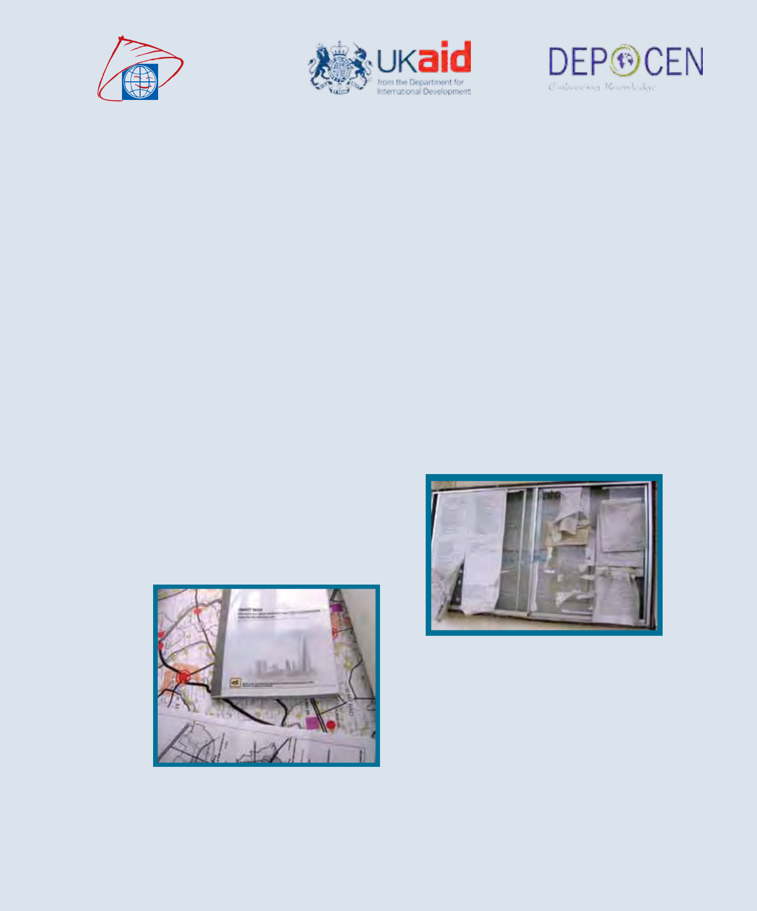

SURVEY REPORT

ON INFORMATION DISCLOSURE

OF LAND MANAGEMENT REGULATIONS

SURVEY REPORT

ON INFORMATION DISCLOSURE OF LAND
MANAGEMENT REGULATIONS

Prepared by

Nguyen Ngoc Anh

Nguyen Duc Nhat

Tran Thanh Thuy

Kirby Prickett

Phan Thi Van

Development and Policies Research Center (DEPOCEN)

Hanoi, 23 November 2010

Acknowledgement

This study was commissioned and financed by the World Bank and the Department for International Development (DFID) of the United Kingdom through the GAPAP trust fund. The views expressed are those of the authors alone and do not necessarily represent those of either institution. The authors would like to thank Mr. James Anderson, Ms. Tran Thi Lan Huong, Dr. Dang Ngoc Dinh, Prof. Dang Hung Vo, Ms. Asmeen Khan, Mr. Le Anh Tuan and Ms. Pham Thi Mong Hoa for helpful suggestions and stimulating discussion, and the DANIDA research team for sharing information. We also would like to thank Mr. Le Van Lan (the Office of Central Steering Committee on Anti-Corruption) and Mr. Dao Trung Chinh (the General Department of Land Administration) for their constructive comments on our report. An earlier version of this report was also presented at the roundtable on “Improving Transparency in Land Administration in Vietnam”, organized by the Swedish Embassy, with support from Transparency International and Towards Transparency, Denmark, UNDP and the World Bank on 18 November 2010 in Hanoi, Vietnam. The research team was also supported by the DEPOCEN survey team consisting of the following members: Le Quang Nhat, Dinh Khuong Duy, Tran Nguyen Chat, Nguyen Hong Tra My, Nguyen Thi Minh Thanh, Bui Van Tuan, Bui Thu Ha, Nguyen Thi Ha Trang and Ngo Thi Thu Ha. Their efforts to complete the fieldwork within a stringent time frame facilitated the completion of this study. As always, the authors of this report bear all responsibility for any remaining errors and omissions.

2

Page

Contents

Executive Summary........................................................................................................................ |  |  | 5
I/ Introduction............................................................................................................................... |  |  | 13
II/ Research Methodology............................................................................................................ |  |  | 15
2.1 | Collection of data on web-based publication of land-related information............................... |  | 15
2.2 | Spot-check collection of data on non-web-based publication of land-related information...... |  | 15
 | 2.2.1 | Sampling.......................................................................................................................... | 18
2.3 | Land information regulations................................................................................................... |  | 18
III/ Findings.................................................................................................................................. |  |  | 21
3.1 | Disclosure on the web............................................................................................................... |  | 21
 | 3.1.1 | Land-Related Administrative Procedures........................................................................ | 21
 | 3.1.2 | Information on Land use Planning and Drafts for Land use Planning............................. | 25
 | 3.1.3 | Information on Urban Planning....................................................................................... | 26
 | 3.1.4 | Information concerning compensation and resettlement................................................. | 27
 | 3.1.5 | Information on Land Allocation....................................................................................... | 28
3.2 | Non-web based disclosure........................................................................................................ |  | 29
 | 3.2.1. Disclosure at the provincial level.................................................................................... |  | 29
 | 3.2.2 | Disclosure at the district level.......................................................................................... | 31
 | 3.2.3 | Disclosure at the commune level..................................................................................... | 35
3.3 | Performance Analysis............................................................................................................... |  | 43
 | 3.3.1 | Provincial Performance Score on commune level accessibility...................................... | 44
 | 3.3.2 | Provincial performance score on District level accessibility........................................... | 45
 | 3.3.3 | Provincial Performance Score on Province level accessibility........................................ | 45
 | 3.3.4 | Overall Performance........................................................................................................ | 46 | 3

PageIV/ Conclusions 49

References 51

Appendix 53

A1 Web-check protocol 53

A2 Fieldwork Observation protocol 57

A2.1 Provincial observation protocol 57

A2.2 District observation protocol 62

A2.3 Commune observation protocol. 67

A3 Selected Sample of Fieldwork sites 72

A4 Law and regulation on disclosure of land related information 74

A5 Some Illustrative qualitative evidence on the disclosure of land related information 81

A5.1 Good examples of land related information web-based disclosure 81

A5.2 Bad examples of land related information web-based disclosure 83

A5.3 Good examples of land related information non-web-based disclosure. 84

A5.4 Bad examples of land related information non-web-based disclosure 85

4

Page

Executive Summary

Introduction

Land, and its proper management, is a central issue in developing countries. Efficient use and management of land are key contributors to maximizing the potential benefits of sustainable socioeconomic development. Accurate and accessible land information is a necessary requirement for sustainable rural and urban development, which will contribute to the elimination of poverty. A well-functioning land market is crucial for achieving these goals and a prerequisite for a land market to function properly includes easy, rapid and cost-effective access to land information.

Although the Vietnam Land Law (2003) aims at facilitating the development of a land market, there are still impediments to the growth of the land market due to a lack of access to land information. Consequently, land information users depend on personal contacts or approach land sellers through informal means. Therefore, enhancing access to land information is of high priority as land information is fundamental to decision-making on land investment and management.

From a broader perspective, the accessibility of land information is indicative of the level of transparency in land administration. The government has issued a number of regulations on disclosure policies and on the simplification of administrative procedures with a view to enhancing public access to information, reducing red-tape and preventing corruption in public administration. Among others, these policies and procedures are the Anti-Corruption Law 2005, the IT Law 2006, the Ordinance on Grassroots Democracy 2007, and Project 30. Land management regulations intersect well with these aforementioned policies. The Land Law, later elaborated by Decree 84 (2007) and Decree 69 (2009), requires a certain level of transparency in land management.

Although the promulgation of these land management laws and regulations is considered significant and substantial progress in improving access to land information, there is a lack of systematic empirical evidence as to how well the transparency provisions of the legal framework on land management in Vietnam have been implemented in practice. Against this background, this report is prepared to document the actual disclosure of land information as required by the laws and regulations.

Methodology

The research methodology adopted in this study was designed with two supplementary tasks. The first task was the collection of data on web-based publication of land-related information. A list of provincial websites and ministry-level websites was constructed. Land-related information on these websites was checked and recorded into a database for later analysis. The second task involved a spot-check collection of data on the publication of land related information which is not publicly available on the internet but is published in other forms. A “systematic observation” technique was central to the data collection conducted in this task. Observations were carried out at all three levels (province, district and sub-district). A representative sample of provinces was firstly selected

Page 5

Page 6
with Ha Noi, Da Nang, and Ho Chi Minh City being selected with certainty. From each selected province, two districts were selected using an urban indicator as the stratification criteria. For each district, five sub districts/communes were randomly selected. The resulting sample included 12 provinces, 24 districts and 120 communes/sub-districts.

Findings

Disclosure on the Web

Five types of information were investigated: Land-Related Administrative Procedures; Information on Land-Use Planning; Information on Urban Planning; Information Concerning Compensation and Resettlement and Information on Land Allocation. The items were a mixture of mandatory online publication; non-mandatory online publication; and mandatory, but not online, publication. Some of the findings regarding the frequency of publication and the sufficiency of the information provided are summarized below.

Table 1: Land-Related Administrative Procedures

 | Publication | Percent
 | type
1/ Lists of procedures and forms related to certificates of land use rights | Mandatory | 89.39
 | on-line
2/ Contact information (including the addresses, phone numbers, and | Mandatory | 33.33
email address) that organizations and individuals can use to submit | on-line
feedback and recommendations regarding regulations on administrative
procedures for granting certificates of land use rights
3/ Information on feedback and recommendations of individuals and | Mandatory | 34.85
organizations regarding regulations on administrative procedures for | on-line
granting certificates of land use rights
4/ Solutions that have been adopted in response to feedback and | Mandatory | 27.27
recommendations on land–related administrative procedures | on-line
5/ Documents regulating the rate/charge for granting certificates of land | Not | 50.00
use rights | mandatory
6/ Online services for granting certificates of land use rights | Not | 13.64
 | mandatory

Results regarding the frequency of publication for Land-Related Administrative Procedures are mixed (see Table 1 above). For example, for Item 1 (List of procedures and forms related to certificates of land use rights), 89.4% of the websites surveyed published this mandatory information. However for Item 4 (Solutions that have been adopted in response to feedback and recommendations on land–related administrative procedures), which is also mandatory, only 27.3% of websites surveyed published this information online. Findings regarding the sufficiency of information provided were also mixed.
Findings on the frequency of publication for Information on Land Use Planning were also diverse (see Table 2 below). 51.5% of websites published information on Item 1 (Reports on detailed land use planning, and detailed land use plans) where as only 9.1% of websites published Item 2 (Map of current land-use situation). Both of these items are mandatory. For Item 1, only slightly more than 50% of the websites provided sufficient or very sufficient information. Just over 20% of the websites provided insufficient data/information.

Table 2: Information on Land Use Planning

 | Publication | Percent
Reports on detailed land use planning, and detailed land use plans | Mandatory on-line | 51.51
Maps of current land-use situations | Mandatory on-line | 9.09
Maps of detailed land-use planning in the case of approved | Mandatory on- line | 22.73
detailed land use plans

The frequency of publication for Information on Urban Planning was 12.1% for Item 1 (Drafts of urban planning) and 31.8% for Item 2 (Approved urban planning) (see Table 3 below). For urban plans that have been approved officially, the accessibility increases significantly. This finding suggests that it is quite possible for provincial and local authority to increase the transparency of land-related information.

Table 3: Information on Urban Planning

 | Publication | Percent
Drafts of urban planning | Mandatory, but not on-line | 12.12
Approved urban planning | Mandatory, but not on-line | 31.82

Similar to the accessibility of information on urban planning, information on the draft versions of Compensation and Resettlement Plans were available on a number of websites despite the fact that they were not mandatory to make available on the internet (see Table 4).

Table 4: Information Concerning Compensation and Resettlement

 | Publication type | Frequency | Percent
Decisions on compensation, support and resettlement | Mandatory, but | 26 | 39.39
 | not on-line
Drafts of compensation and resettlement plans | Mandatory, but | 3 | 4.55
 | not on-line

Information on Land Allocation consists of two items (i) the Criteria for land allocation and (ii)
Decisions regarding land allocation (see Table 5). According to current regulations, this kind of | 7
information does not require publishing. Surprisingly, our observers were still able to obtain this | 7
category of information on a significant number of websites. | Page

Table 5: Information on Land Allocation

 | Publication type | Frequency | Percent
Criteria for land allocation | Not mandatory | 14 | 21.21
Decisions regarding land allocation including: investor | Not mandatory | 7 | 10.61
profiles, name and content of the project, final rate and the
rate proposed by the Ministry of Finance

Non-Web Based Disclosure

Non-web based disclosure was investigated for the provincial, district and commune levels of government. For all three levels, data was collected on both mandatory and non mandatory information publication. As with the web based disclosure, the results were mixed. In many cases the frequency of the provision of information was quite high, as was the sufficiency of information provided. However there were also instances where both frequency and sufficiency of information could be improved, and a few cases where it was unfavorably low. For more specific information on Disclosure at the Provincial Level, see Table 6 below.

Table 6: Provincial Level Disclosure

 | Percentage of locations where | Comments on difficulty of
 | information is available | accessing information
Mandatory information
Detailed land use planning and | 50% (6 of 12) | 3 difficult to access
plans |  | 3 easy to access
Urban planning | 66.7% (8/12) | 3 difficult to access
Draft urban planning | 16.7% (2/12) | Fee requested, and information
 |  | only available on request
Non-mandatory information
Land allocation | 66.7% (8/12) | Mostly not difficult (7/8
 |  | normal access)
Investment site maps | 16.7% (2/12) | Difficult
Agreed minutes on urban planning | Not able to access | Very difficult (impossible)

For more specific information on Disclosure at the District Level, see Table 7 below.

8

Page

Table 7: District Level Disclosure

 | Percentage of locations | Comments on difficulty of
 | where information is | accessing information
 | available
Mandatory information
Procedure for issuing certificates for | 87.5% (21/24) | Easily accessible at over 70%
land-use rights |  | of locations
Land use planning and detailed land use | 41.7% (10/24) | Provided free of charge at
plans |  | 9/10 locations, 20% reported
 |  | difficulty in accessing
 |  | information
Urban planning | 45.8% (11/24) | Charge, easy access
Draft urban planning | 4.2% (1/24) | Difficult
Non-mandatory information
Plans on compensation, support and | 8.3% (2/24) | Limited access
resettlement and agreed consultation
minutes for draft plans of compensation,
support and resettlement
Agreed consultation minutes on draft | 0% (0/24) | No access
urban plans

Table 8 below provides information on Disclosure at the Commune Level.

Table 8: Disclosure at the Commune Level

 | Percentage of |  | Comments
 | locations where |  | on difficulty
 | information is |  | of accessing
 | available |  | information
Administrative Procedures for issuing Land Use | 79.5% | (93/117) | 81.7% rated access
Certificates |  |  | as easy or very easy
List of qualified and unqualified households and | 29.9% | (35/117) | 82.9% rated access
organizations for submitting application for Land Use |  |  | as easy or very easy
Certificates
Decision approving compensation, support and re- | 20.5% | (24/117) | 75.0% rated access
settlement plans |  |  | as easy or very easy
Draft compensation, support and re-settlement plans | 4.27% | (5/117) | Difficult
Detailed land use plans and planning | 51.3% | (60/117) | 63.3% rated access
 |  |  | as easy or very easy
Urban planning (drawings and models) | 23.1% | (27/117) | 55.5% rated access
 |  |  | as easy or very easy
Draft urban planning | 3.4% (4/117) |  | Difficult
Agreed consultation minutes on draft compensation, | 3.4% (4/117) |  | Difficult
support and re-settlement plans
Agreed consultation minutes on draft urban planning | 0.0% (0/117) |  | Impossible

Page 9

Page 10
Performance Analysis

Data was aggregated so that performance scores could be constructed for the 12 provinces. These scores allow for the identification of “best practice” performers. Ho Chi Minh City was the best performer at the commune level, followed by Khanh Hoa, Ha Noi and Hung Yen. The average performers were Da Nang, Quang Nam, Thai Binh and Can Tho.

The results also suggest that high income provinces/cities are more likely to be top performers for accessibility of information. But the results also indicate that lower income provinces/cities can also be good performers (e.g. Quang Nam and Hung Yen). At the district level, the results of the data collection showed that Khanh Hoa, Ha Noi and Da Nang were the top performers, followed by Can Tho and Ho Chi Minh City. At the provincial level, the top performer was again Da Nang, followed by Ho Chi Minh City, Hung Yen, Thai Binh, Can Tho, Tien Giang and Ben Tre.

Table 9: Summary of Scores at Commune, District and Province Levels

Province | Commune Score | District Score | Province Score
Ha Tinh | 1.22 | 1.67 | 1.67
Ben Tre | 1.48 | 1.67 | 5.00
Bac Ninh | 1.67 | 2.50 | 0.00
Tien Giang | 1.89 | 2.50 | 5.00
Can Tho | 2.00 | 5.00 | 5.00
Thai Binh | 2.22 | 1.67 | 5.00
Da Nang | 2.56 | 5.00 | 6.67
Quang Nam | 2.56 | 3.33 | 3.33
Ha Noi | 3.11 | 5.00 | 1.67
Hung Yen | 3.11 | 2.50 | 5.00
Khanh Hoa | 4.08 | 5.00 | 3.33
HCMC | 4.22 | 4.17 | 5.00

Conclusions

The results of the Land Survey are somewhat mixed. Even in the areas where the results are quite positive, there is room for improvement. Hence, while transparency and accountability seem to have increased, it appears that it would still be greatly difficult for laypeople to navigate the Vietnamese land administration system. This implies that significant inefficiencies and overly burdensome transaction costs remain in the land administration system, which would be impeding Vietnamese economic growth and efficiency to some extent. More information could be made more easily and widely available (available on the web). This would improve the ability of local people to access the information, plus it would increase transparency and accountability as outsiders and evaluators could also access the information. Surprisingly, in some instances where information isn’t even mandatory to provide, it is provided anyway. It may be the case that in these instances, it
is convenient and in the interest of information providers to provide the information. In other areas, the level of information provided is insufficient. The qualitative evidence further suggests that in order to improve further the accessibility to land information a more comprehensive approach is needed as problems hindering the accessibility of land information include: implementation capacity (i.e. lack of physical and human resources); poor records management practices (i.e. the non-existence of archival system in a number of locations); organizational culture (such as an “I have to check with my boss” mentality and a non-service oriented culture toward citizens); and lack of awareness, since many public officials don’t seem to even know which land-related information is required by the law to be made public. At the same time, many citizens may not be aware that they have the right to such information. The overall conclusion from this study is that although Vietnam has relatively good laws and regulations on the disclosure of information to the public, there is room for improvement at the enforcement and implementation levels.

11

Page
I/ Introduction

In 1986, the Government of Vietnam undertook an economic reform named “Doi Moi” to transform the country from a centrally-planned economy toward a market-based economy. The last 20 years have witnessed comprehensive reforms, especially in land administration and policy. These reforms, together with an open-door policy to attract foreign direct investment and trade liberalization which culminated in World Trade Organization (WTO) accession in 2007, have created a growing dynamic private sector in the country. Thanks to these comprehensive reforms, Vietnam has recorded remarkable achievements in terms of GDP growth, macroeconomic stabilization, export expansion, poverty reduction and market institution development. It is now generally recognized that Vietnam is among the most successful developing countries in terms of achieving relatively high economic growth and reducing poverty. Over the period 1990-2008, Vietnam’s GDP growth rate averaged over 7% per year. Vietnam’s growth rates continue to remain among the highest in the region (second only to China).

The development of the country has now reached a critical juncture, where governance becomes vitally important for national development. The absence of good governance is the reason why many countries – especially developing countries – continue to fail in their efforts at poverty reduction and in their quest for economic and human development (ADB, 2005, p. 2). Such a situation breeds inefficiency, corruption and further undermines government development efforts. Unfortunately, Vietnam is not an exception and the country is now facing this challenge. Governance is recognized as a key area for improvement in order to facilitate continued high and sustainable economic growth for the country.1

A wealth of literature and empirical findings has pointed out that a good land administration system aids the social, economic and ecological development of a society. Indeed, it is a precondition for economic progress, social stability and sustainable development. The challenge is to make it efficient and effective, so as to unleash its potential contribution to the country’s development. Vietnam’s continuous economic development over the past decades has given rise to the proliferation of legal documents that govern different areas of development. One of the areas with significant regulatory development is land management. This began with the first Land Law in 1987 which recognized the rights of households and individuals to use land, and continued with the third Land Law in 2003 which regulated broader spheres of land management including market pricing for land, conditions for land conversion (compulsorily and voluntarily), as well as compensation and resettlement policies.2 Decree 84 (2007) and Decree 69 (2009) further elaborated the extent of transparency in the 2003 Land Law, with supplementary regulations on granting land use certificates, land acquisition and procedures for compulsory land conversion, compensation and resettlement, and settlement of complaints.3

- In particular, corruption has been singled out as a severe threat for national development. However, this report will not attempt to address the substantial task of solving governance and corruption issues in Vietnam, but rather will try to contribute to the discussion on the land administration sector.

- According to Vietnam’s Constitution, land is the property of the entire people, which is allocated or leased by the State to organizations, households or individuals for long-term use. Depending on their status, land users are fully or partly granted the rights of land exchange, transfer, inheritance, mortgage, lease and investment into

joint-venture

3 World Bank Policy Note on Land Acquisition and Voluntary Conversion in Vietnam, June 2009.

Page 13

Land, and its proper management, is a central issue in developing countries. Efficient use and management of land are key contributors to maximizing the potential benefits of sustainable socioeconomic development. The importance of land information in decision making in almost every aspect of the economy is increasingly being recognized. Like many other developing countries Vietnam is increasingly relying on market forces to determine access to land, natural resources, inputs and services. In order for the market to work, information is critical.

Accurate and accessible land information is a necessary requirement for sustainable rural and urban development that will contribute to the elimination of poverty. Unequal access to information prevents the poor from accessing land, while encouraging speculative buying of land by elites for massive profits. A well-functioning land market is crucial for achieving these goals and a prerequisite for a land market to function properly includes easy, rapid and cost-effective access to land information. Although the Vietnam Land Law 2003 aims at facilitating the development of a land market, there are still impediments to the growth of the land market due to a lack of access to land information. Consequently, land information users depend on personal contacts or approach land sellers through informal means. Therefore, enhancing access to land information is of high priority.

Public disclosure of information and reporting are fundamental for ensuring transparency and accountability. Increasingly the Government of Vietnam adopts disclosure policies to enhance public access to government information through a number of laws and regulations (i.e. the Ordinance on Democracy at the Grass Roots Level, the Decree 69 (2009), the Draft Law on Access to Information).4 Land information is fundamental to decision making on land investment and management. Accessibility of land information is indicative of the level of transparency in land administration and access to information acts as a check on corruption. From a broader perspective, the government has issued a number of regulations on disclosure policies and on the simplification of administrative procedures with a view to enhancing public access to information, reducing red-tape and preventing corruption in public administration. Among others, these policies and procedures are the Anti-Corruption Law 2005, the IT Law 2006, the Ordinance on Grassroots Democracy 2007, and Project 30. Land management regulations intersect well with these aforementioned policies. The Land Law, later elaborated by Decree 84 (2007) and Decree 69 (2009), requires a certain level of transparency in land management. Although land management regulations intersect well with the aforementioned policies, there is a lack of systematic empirical evidence as to how well the transparency provisions of the legal framework on land management have been exercised in practice.

In that context, this project set out to collect systematic data on the extent and nature of publication of information related to land issues. It is expected that the findings from the assignment will ultimately help clarify the key weaknesses that are hindering more thorough transparency and provide a baseline against which to measure future progress in land information accessibility. For that purpose, the assignment is implemented as a systematic observation study which involves two important and related components (i) collection of data on the web-based publication of land-related information; and (ii) spot check collection of data on the publication of land-related information not publicly available on the internet. Section II discusses our methodology in conducting the assignment. The fieldwork and web check observations and findings are presented in Section III. Section IV concludes our report with some recommendations and implications.

Page 14

- Many countries around the world are now giving legal effect to the right of access to information in their constitutions and by adopting laws which give practical effect to the right.

II/ Research Methodology

According to land regulations, land information is to be made available in various forms, depending on the responsible information providers. The forms of disclosure vary: from posting the information and procedures on the internet portals the provinces, of the ministries or their line departments, as the highest level of information dissemination; to posting on bulletin boards at the People’s Committee offices at different levels; to information provided only upon request, as the lowest level of dissemination. In order to collect data on access to land information, two interrelated tasks are required to be undertaken:

Task 1: Collection of data on web-based publication of land-related information.

Task 2: Spot-check collection of data on publication of land-related information not publicly available on the internet.

The two data collection modes entail different data collection methods. We therefore discuss the two methods in turn.

2.1 Collection of Data on Web-Based Publication of Land-Related Information

The purpose of this task was to collect online data on the publication of land management information. It is required that this information be made publicly available on the internet through web-based portals by relevant ministries and local authorities. To collect the information on the on-line accessibility of land information, the following steps were undertaken:

- Step 1: Review legal documents and policies related to land-management with a view to identifying the types of land-management information which require web based publication.
- Step 2: Develop the list of websites (both at central and local governments) to be checked/visited. The list consists of all websites of provincial authorities and a number of central agencies.
- Step 3: Develop a protocol for data collection (see Appendix).

- Step 4: Conduct the website visit and data collection. Printouts and logs to be kept for the purpose of later verification.
- Step 5: Data entry and analysis.

2.2 Spot-Check Collection of Data on Non-Web-Based Publication of Land-Related Information

This purpose of this task was to collect data information, which is not publicly available on the internet but may be published in other forms. In this study we use a three-step approach in which the systematic observation technique played the key role in the data collection fieldwork. Systematic observation is a primary method of collecting data (by human, mechanical, electrical or electronic means), which is a tool in both qualitative and quantitative research. Systematic observation uses

Page 15

clearly defined categories (often with operational definitions) and collects quantitative (numerical) data. One distinct advantage of the systematic observation technique proposed for this assignment is that it records actual behaviour, rather than recording what people report (i.e. what they said/ did or believe they will say/do). This is appropriate when the topics of research are sensitive, and the technique can provide greater insights than the usual survey technique.5 The systematic observation method systematizes field work/observation methods for a team of researchers who observe the object of study (in this case, access to land information) in its natural setting. Researchers record events as they see (and hear) them. They follow well-specified protocol that can be duplicated. This makes it possible for many researchers to conduct observations, rather than relying on the observations of just one individual. Our approach is outlined in the following diagram, which broadly divides the assignment into three main blocks: (i) research design; (ii) systematic observation field work; and (iii) report writing.

Main Implementation Steps for Conducting Spot-Check of Publication of Information: Systematic Observation Approach

RESEARCH DESIGN

-- | Review reports, studies
-- | Develop a work plan and |  |  | SYSTEMATIC OBSERVATION
 | report outline |  |  | FIELDWORK
-- | Develop observation
 | fieldwork protocol
-- | Sample design and selection -- |  |  | Pretest the research protocol
 | -- |  |  | Fieldwork training
 | -- |  |  | Conduct survey on selected
 |  |  |  | provinces
 | -- |  |  | Quality control and supervision
 | -- |  |  | Data entry and analysis

PREPARE FINAL REPORT


-- Report writing

-- Participating in workshop with WB to present draft report, facilitate the discussion and collect feedback

-- Revise the report

-- Submit the final independent review report

Page 16

- Observation is a technique that involves directly observing behaviour with the purpose of describing it. To observe means to examine an object, individual, group of people, or an event with all of the senses. Recording of observations may take many forms, from the simple and casual to the exact and sophisticated. For example, an observer may observe an event and then complete a checklist on whether or not key behaviours occurred. Or the observer may write notes on everything that happens in his or her presence. More sophisticated recording may involve audio-visual devices. Albert J. Reiss, Jr., who developed the methods notes a number of important considerations in conducting systematic observation include: (1) selection of problems for investigation, (2) preliminary investigation by direct observation, (3) definition of the universe to be observed, (4) sampling for observation, (5) development of instruments to collect and record observations systematically, (6) provision for measuring error, (7) pretesting instruments, (8) organization for direct field observations, (9) processing observations, and (10) quantitative analysis. The disadvantage of the observation method is that it is time consuming.

- Research Design

Like any other research, the research design stage was of utmost importance, as it defined all later stages and provided key ingredients for later stages. At the research design stage, the research team consulted with senior and experienced land experts and public governance experts to seek their inputs and advice in designing the research. The team then conducted an extensive and thorough review of the land laws and regulations that are required to be published, but not necessarily via the internet. A number of issues in conducting observation studies were also addressed: (a) reliability; (b) generalization; (c) methods of observation and (d) researcher bias.

- Reliability: The observational research method is considered strong in validity because the researcher is able to collect a depth of information about a particular activity and/or behavior. However, the problem of reliability arises, that is the extent that observations can be replicated, which is a necessary condition in observational research.6 A common approach to ensure reliability is to have two independent observers recording the information that will be adopted in our assignment. An important check for reliability is to develop/use operational definitions - making abstract and complex concepts that are subject to individual interpretation more understandable. Within the context of this assignment, we worked together with the World Bank team to develop, define and finalize the: (i) universe of information mandated for non-web publication; (ii) instrument fieldwork note;7 and (iii) procedures for conducting the observation, that is, the instructions for the observers.

- Generalizability:8 In observational research, findings may only reflect a unique population/ location (i.e. province, district or commune) and therefore cannot be generalized. Generalization could be ensured by constructing a sampling procedure in such a way so as to ensure that a representative sample is obtained. In selecting our sample we used the two stratification criteria:

- regional – north, central and south; and (ii) urbanization.9 For each province selected in our sample, we selected two districts from which we randomly selected five communes.

- Methods of observation: Six different ways of classifying the observation methods listed below:

- participant and nonparticipant observation;

- obtrusive and unobtrusive observation;

- observation in natural or contrived settings;

- disguised and non-disguised observation;

- structured and unstructured observation; and

- direct and indirect observation.

- In other words, the results are consistent. If we replicate the study again, we would come to the same findings.

7 E.g. defining clearly such things as ‘difficult to obtain’.

8 Generalizability is sometimes referred to as external validity - the extent that the study’s findings would also be true for other people, in other places, and at other times.
9 As informed by the World Bank team, we understand that in parallel with the assignment, there is another study conducted by DANIDA on five provinces in Vietnam. In order to avoid repetition but also to benefit from this DANIDA study, we proposed that in selecting our sample, we select some provinces where DANIDA has conducted their study.

Page 17

In our assignment, we used a combination of these methods, i.e. participant, unobtrusive, natural, disguised, structured and direct observations. This combination of methods allowed our researchers to interact with the information providers in their natural work setting using a structured, direct yet unobtrusive and disguised manner. During the observation process, the observers/researchers kept contact details of relevant persons so that a report could later be sent to them.

- Researcher bias: Sometimes it is assumed that the researcher may “see what they want to see”. Bias, however, can often be overcome with training or electronically recording observations. In our assignment, extensive training was conducted for all researchers and they were also equipped with electronic recording devises.

- Systematic Observation Fieldwork

The fieldwork research protocol was developed by the whole team and included participation by the observers. Several rounds of pilot tests were conducted before finalizing the protocol. Before the actual fieldwork commenced, all observers/researchers were trained by the Lead Researcher. Each fieldwork group was organized to have 2-3 members, consisting of a team leader/supervisor and team member(s). Once all researchers/observers had been trained, they were sent out to conduct fieldwork for the purpose of data collection. A program in CSPro was designed for data entry. To ensure the highest quality of data, 100 percent double entry and double check was performed to avoid human errors in entering the data.

2.2.1 Sampling

Having a representative sample for the assignment is of utmost importance for the validity of the study. As the assignment was carried out at all three levels (province, district and sub district) we therefore first selected a representative sample of provinces. These were randomly selected and stratified according to geographical criteria as well as the PCI Land Access Sub-Index.10 From each selected province, we selected two districts using an urban indicator as our stratification criteria. For each district, we randomly selected five sub districts. We also would like to note that the three cities, Hanoi, Danang and Ho Chi Minh were selected with certainty. The resulting sample is presented in the Appendix A3 - Selected Sample of Fieldwork Sites below. Altogether, we selected 12 provinces, 24 districts and 120 communes/sub-districts.

2.3 Land Information Regulations

Land-related information (both mandatory and non-mandatory) that is required to be published is provided for in detail in the relevant laws and regulations. However, in order to systemize land-related information for the purpose of our study and to provide the readers with a concise picture of what land-related information is required to be disclosed at different levels and whether that information is mandatory to be made online, we rely on the Value Chains developed by Vo (2010). Details of the laws and regulations on the disclosure of land related information are also summarized in Appendix 4.

18

Page

10 PCI is the annual provincial competitiveness index published by the Vietnam Chamber of Commerce and Industry, which provides information on governance at the provincial level.

Value Chain 1: Transparency in the Land Title Certificate Issuance Procedure


DISSEMINATION | SUBMISSION OF | EVALUATION OF | HANDING | COMPLAINTS &
OF INFORMATION | APPLICATION FORM | APPLICATION | CERTIFICATE TO | DENOUNCEMENTS
ON PROCEDURES | AND ALL RELATED | AND APPROVAL | LAND USER | SETTLEMENT
 | DOCUMENTS
Land | District land | District people’s | Land | District &
administration at | administration for | committees for | administration or | provincial
provincial & | households | households | communal | people’s
district level and | Provincial land | Provincial people’s | people’s | committees
communal | administration for | committees for | committees
people’s | organizations | organizations
committees
Disclosure in |  | Disclosure of list of |  | Disclosure of
provincial websites, |  | households/organiz |  | settlement
and in offices of all |  | ations that will |  | decisions at
local levels |  | receive Land Title |  | provincial and
 |  | Certificate |  | district levels

Value Chain 1: Process Flow of Land Tenure Certificate Issuance (adopted from Vo 2010)

Value Chain 2: Transparency in Land Transaction Procedures


DISSEMINATION OF | SUBMISSION OF | IMPLEMENTATION OF
INFORMATION ON | REGISTRATION FORM | LAND REGISTRATION
PROCEDURES | AND ALL RELATED
 | DOCUMENTS
Land registration offices at | District land registration | District land registration
provincial & district level and | offices for households | offices for households
communal people’s | Provincial land registration | Provincial land registration
committees | offices for organizations | offices for organizations

Disclosure in land registration

office at all levels and

communal people’s committees

Value Chain 2: Process Flow of Land Transaction (adopted from Vo 2010)

Value Chain 3: Transparency in Land Compulsory Acquisition of Land for Investment Projects


LAND USE | URBAN | INTRODUCTION | LAND | LAND | PLAN FOR | COMPLAINTS &
PLANNING | PLANNING | OF LOCATION | RECOVERY | ALLOCATIO | COMPENSATION & | DENOUCEMENTS
 |  | FOR | PLAN | N/ LEASE | RESETTLEMENT | SETTLEMENT
 |  | INVESTMENT |  | DECISION
 |  | PROJECTS
Office of | Office of | Land | People’s | People’s | People’s | People’s
people’s | people’s | administration | committees at | committees at | committees at | committees at
committees at | committees at | at provincial | provincial & | provincial | provincial & | provincial &
all level | all level | level | district levels | levels | district levels | district levels
Disclosure | Disclosure | Disclosure of | Disclosure of | Disclosure of | Disclosure of | Disclosure of
Disclosure | Disclosure | investment | approved | the content of | draft and | settlement
of approved | of approved
of approved | of approved | location map | plan at | the decision is | approved plan | decisions at
planning at | planning at
planning at | planning at | is not | commune | not mandatory | at commune | provincial and
all local | all local
all local | all local | mandatory | level |  | level | district levels
levels | levels | mandatory | level |  | level | district levels

Page 19

Value Chain 3: Process Flow of Land Compulsory Acquisition (adopted from Vo 2010)

III/ Findings

3.1 Disclosure on the Web

Disclosing land related regulations and information on the internet is provided for in a number of laws and regulations. In total, there are 66 websites, including 63 provincial websites and three ministry websites (Ministry of Natural Resources and Environment, Ministry of Planning and Investment, and Ministry of Construction), that have been checked during our observation exercise. The information which are expected be made publicly available on the web-based platform can be classified into five groups: (i) Land-Related Administrative Procedures; (ii) Information on Land Use Planning (national level, provincial level, district level) and Drafts for Land Use Planning;

- Information on Urban Planning; (iv) Information Concerning Compensation and Resettlement and (v) Information on Land Allocation. Within each group, some information is mandatory and some is not mandatory to be published online. In the tables presented below, we indicate which information is mandatory or not.

In addition to checking if land-related information was available, the observers were also required to attempt to evaluate the data they obtained on a scale from one to five with one being very insufficient and five being very sufficient. The scale was constructed for each item of information during the pilot test by the research team to ensure consistency among observers. Depending on the details required for each item of information, a scale was constructed for each item separately. In some cases where quantitative indicators were available, the scale was constructed on the basis of these indicators. In other cases, its assessment was left for the observers, with later verification.

3.1.1 Land-Related Administrative Procedures

Under the category of land related administrative procedures there are a number of items that have been made mandatory to make available online, including items one to four in Table 1 below. These items have been made mandatory by the Government through Article 28 of the Law on Information Technology, Article 21 of the Law on Anti-Corruption and Transparency in Land Use and Management, and Articles 13 and 19 in Decree 20/2008, Decision 30/QD-TTg on 10 January 2007 (which provides for information regarding office addresses, mail addresses specialized telephone numbers, website addresses and e-mail addresses for receiving individuals’ and organizations’ feedback and proposals on administrative regulations). Items five and six are not mandatory to make available online.

21

Page

22
Table 1: Land-Related Administrative Procedures

 | Publication type | Frequency | Percent
1/ List of procedures and forms related to certificates | Mandatory on-line | 59/66 | 89.39
for land use rights
2/ Contact information (the addresses, phone | Mandatory on-line | 22/66 | 33.33
numbers, and the email addresses) that organizations
and individuals can use to send feedback and
recommendations regarding regulations of
administrative procedures for granting certificates of
land use rights
3/ Information on feedback and recommendations of | Mandatory on-line | 23/66 | 34.85
individuals and organizations regarding regulations of
administrative procedures for granting certificates of
land use rights
4/ Solutions that have been adopted in response to | Mandatory on-line | 18/66 | 27.27
feedback and recommendations on land–related
administrative procedures
5/ Documents regulating the rate/charge for granting | Not mandatory | 33/66 | 50.00
certificates of land use rights
6/ Online service for granting certificates of land use | Not mandatory | 9/66 | 13.64
rights
Total observations |  | 66/66 | 100%

Table 1 above provides summary statistics on the provision of information regarding land related administrative procedures. In some aspects the results are very encouraging. 89.4% of the visited websites contain information regarding Item 1 - “List of procedures and forms related to certificates for land use rights”.

Figure 1. List of Procedures and Forms Related to Certificates for Land Use Rights
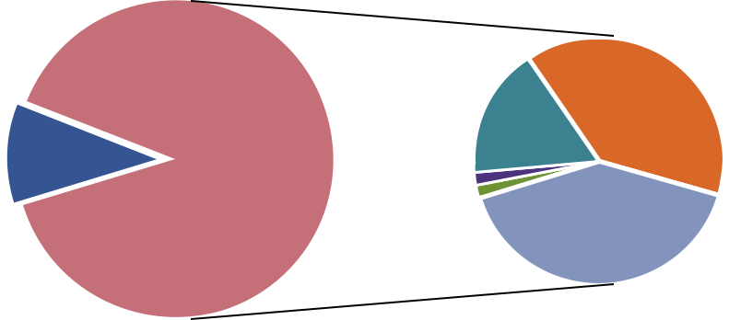

 |  |  |  |  | 39% |  | Very insu cient
 |  |  | 16.9% |  | 39% |  | Insu cient
 | 59, YES
7, No |  | 1.7% |  |  |  |  | So So
 |  | 1.7% |  | 40.7% |  |  | Su cient
 |  |  |  |  |  |  | Very su cient

Page

Figure 1 shows that among the 59 websites where we could obtain the information, the information retrieved was at least sufficient in the judgment of the information seekers, with 79.7% of the cases considering the information provided to be sufficient or very sufficient. In assessing the completeness of this item of information, we checked if the websites provided the following information: (i) the procedure to process land use certificate transfer; (ii) relevant forms; (iii) regulations on time; and (iv) related fees and charges. If a website contained all of this information it would be rated as very sufficient.

However, for Item 2, we could only obtain contact information for providing feedback on 22 websites, accounting for 33.3% of the total websites visited. Among those 22 websites that provide contact information, only 13.6% were considered to provide a very sufficient amount of contact information, although a significant number considered as sufficient (36.4%), as illustrated in Figure 2.

Figure 2. Contact Information that Organizations/Individuals can to

Provide use Feedback
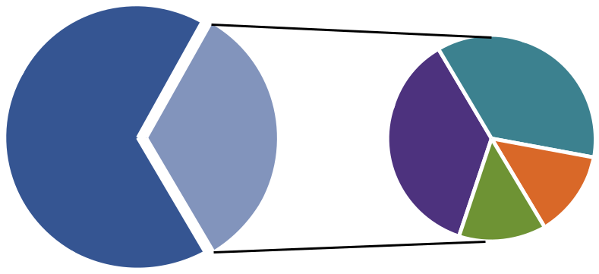

 | 36.4%
 | 36.4% |  | Insu cient
 | 36.4% |  | So So
44, No | 22, YES
 |  |  | Su cient

Very su cient

13.6%

13.6%

A similar result was obtained for Item 3 - “Information on feedback and recommendations of individuals and organizations regarding regulations of administrative procedures for granting certificates of land use rights”. Only 23 websites (accounting for 34.9%) provided the information. Among those 23 websites that provide the information required, the data was considered to be sufficient or very sufficient in just under 50% of cases (see Figure 3).

Related to this is Item 4 – “Solutions that have been adopted in response to feedback and recommendations on land–related administrative procedures”. This information can be found on 18 websites (accounting for 27.3% of total websites included in the study).

23

Page

Page 24
Figure 3. Information on Feedback and Recommendations
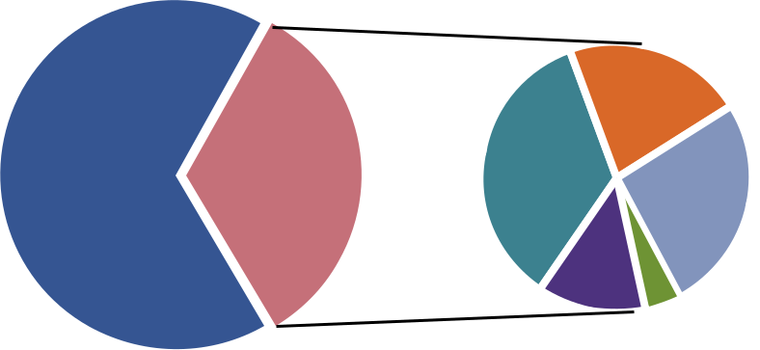

 |  |  | 21.7% |  | Very insu cient
 |  | 34.8% | 21.7% |  | Insu cient
43, No | 23, YES | 34.8% | 26.1% |  | So So

Su cient

Very su cient

_{13%} 4.4%

Within the category of land related administrative procedures, there are two information items that are required to be made available but not necessarily online, Items 5 and 6 in Table 1 above. According to Table 1, 50% of the websites provides information relating to rates and charges for granting Certificates of Land Use Rights and, among those that provide information, their information is mostly considered as sufficient or very sufficient (Figure 4). This is very interesting finding because although this information is not required to be made available online, it often is in practice.

Figure 4. Information Relating to Rates and Charge for Granting

Certificates of Land Use Right
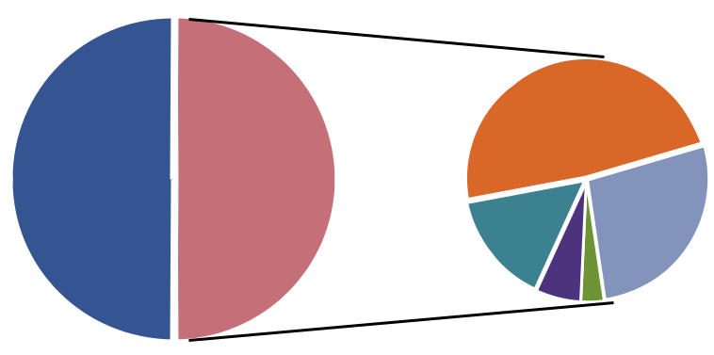

 | 48.5% |  |  |  | Very insu cient
 |  |  |  |  | Insu cient
33, No | 33, YES |  |  |  | So So
 | 15.1% |  |  |  | Su cient
 | 15.1% |  | 27.3% |  | Very su cient
 | 6.1% | 3%

With respect to Item 6, another non-mandatory information item, the information is not as encouraging as for Item 5. We could only find a few websites (9 out of 66) that provide an online service for granting certificates of land use rights. They include Binh Phuoc, Thai Binh, Gia Lai, Tien Giang, Ha Nam, Tay Ninh, Hau Giang, Lang Son and Phu Yen.
3.1.2 Information on Land Use Planning and Drafts for Land Use Planning

Under the category Information on Land Use Planning, all information items reported here are mandatory to make available online. According to Article 27 on publishing Land Use Planning of the Decree 181 on the implementation of the Land Law, the Ministry of Natural Resources and Environment is obligated to make publicly available documents relating to State land use plans and plans that have been approved by the National Assembly. Publishing this information online is also provided for in Article 27. Also according to this Article, the Departments and Divisions of Natural Resources and Environment (correspondingly at the provincial and district level) are required to publish online all documents relating to the respective local land use plans and planning that have been approved.

Table 2: Information on Land Use Planning

 | Publication | Frequency | Percent
Reports on detailed land use planning, and detailed | Mandatory on-line | 34 | 51.51
land use plans
Maps of current land-use situations | Mandatory on-line | 6 | 9.09
Maps of detailed land-use planning in the case of | Mandatory on- line | 15 | 22.73
approved detailed land-use plans

Table 2 provides information on the accessibility of information regarding land use planning and drafts for land use planning. As can be seen, the availability of information on the web-based portal is very limited. Half of the websites (34 websites) provides report on detailed land use planning and detailed land use plans, accounting for 52% of total 66 websites visited. Among those 34 websites, only slightly more than half of the 34 website provide sufficient or very sufficient information as indicated in Figure 5. Just over 20% of the 34 websites provides insufficient data/information.

Figure 5. Report on Detailed Planning, and Detailed Land Use Plans
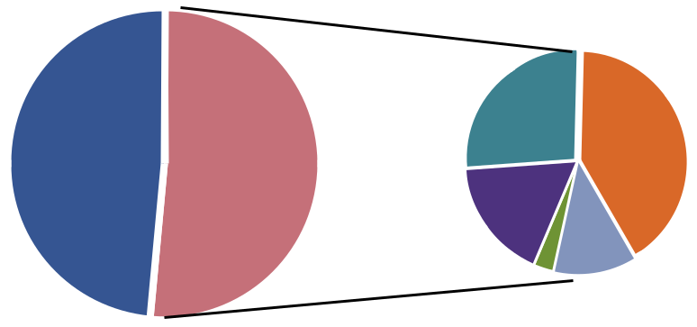

 |  |  |  |  | Very insu cient
 |  | 26.5% | 41.2% |  | Insu cient
32, No | 34, YES | 26.5% | 41.2% |  | So So

Su cient

17.6%
Very su cient

^{2.9%} 11.8%

25

PageThe number of websites that provide information regarding the maps of land use situations and maps of detailed land use plans is quite small. There are only 15 websites where a “Map of detailed land-Use planning in the case of approved detailed land-use plans” can be found. Figure 6 illustrates the completeness of the information provided by these 15 websites. Over one third of those websites provide sufficient or very sufficient information as assessed by the web-check observers. However, the number of the websites that provides insufficient data/information is as high as 26.7%.

Figure 6. Map of Detailed Land-Use Planning in the Case of

Approved Detailed Land-Use Planning
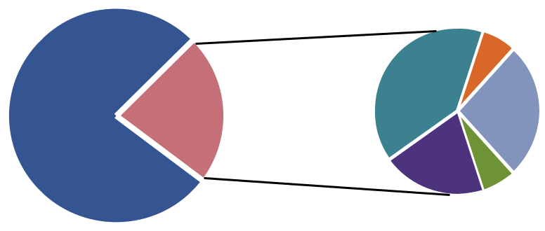

 |  | 6.7% |  | Very insu cient
 |  | 40% |  | Insu cient
 |  | 40% |  | So So
51, No | 15, YES | 26.6% |  | So So

20% |  |  | Su cient
 | 6.7% |  | Very su cient

With respect to the information regarding the maps of current land use, the situation is even worst. There are only six websites that provide maps of current land-use situation. They include An Giang, Ba Ria - Vung Tau, Bac Ninh, Ben Tre, Long An, and Thai Nguyen.

3.1.3 Information on Urban Planning

This group of information on urban planning contains two pieces of important information: (i) drafts for urban planning; and (ii) approved urban planning. The publication of information on urban planning is provided for in Articles 20, 21, 54 and 55 of the Law on Urban Planning. Although the publication is mandatory there is no regulation requiring this kind of information to be published online on the websites of provincial people’s committees or relevant Ministries’ websites. In addition to on-site checking of the availability of this information reported in the non-web disclosure, we also checked its online availability. The results are presented in Table 3. As indicated, there were a significant number of cases where we could obtain this information online (although the authorities are not obligated to publish this particular information online). The web-check results indicate that 12% of the websites make the drafts of urban planning available through the web. We could retrieve the drafts of urban planning at eight websites, namely Lam Dong, Long An, Da Nang, Can Tho, An Giang, Hau Giang, Dak Nong and Dien Bien. Details on approved urban planning were available on 21 websites.

26

Page

Table 3: Information on Urban Planning

 | Publication | Frequency | Percent
Drafts of urban planning | Mandatory, but not on-line | 8 | 12.12
Approved urban planning | Mandatory, but not on-line | 21 | 31.82

For urban plans that have been approved officially, the accessibility increases significantly. The information on approved urban planning has been made available on 21 out of 66 websites (31.9%). This finding suggests that it is quite possible for provincial and local authority to increase the transparency of land-related information. For the information on approved urban planning that can be accessed on those 21 websites, less than half of them provide sufficient or very sufficient data/ information - suggesting significant room for improvement (See Figure 7 below).

Figure 7. Completeness of Information Regarding Approved Urban Planning
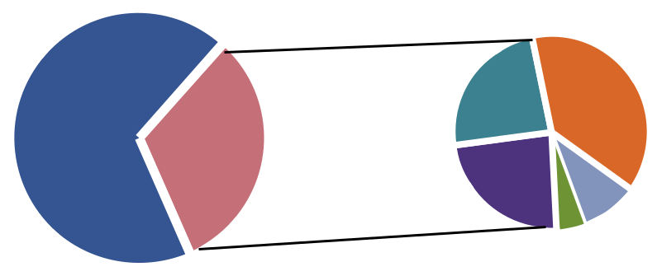

 |  |  |  | Very insu cient
 | 23.8% | 38.1% |  | Insu cient
 | 23.8% | 38.1% |  | So So
45, No | 21, YES |  |  | So So
 | 23.8% | 9.5% |  | Su cient

Very su cient

4.8%

3.1.4 Information Concerning Compensation and Resettlement

Information on compensation and resettlement consists of two main items: (i) decisions on compensation, support and resettlement and (ii) drafts on compensation and resettlement plans. Similar to the above group of information on urban planning, according to Article 57 of Decree 84/2007-CP (and later in Decree 69/CP issued on August 2009), the publication of these items are mandatory, but there is no regulation requiring these information items be made available on the websites of provinces/cities or ministries.

Table 4: Information Concerning Compensation and Resettlement

 | Publication type | Frequency | Percent
Decisions on compensation, support and | Mandatory, but not on-line | 26 | 39.39
resettlement
Drafts of compensation and resettlement | Mandatory, but not on-line | 3 | 4.55
plans

Page 27

Page 28
The observation results are presented in Table 4. Similar to the accessibility of information on urban planning, information on the draft versions of compensation and resettlement plans are available on a number of websites despite the fact that they are not mandatory to make available on the internet. Only three websites (provinces of Ba Ria - Vung Tau, Hau Giang, and Lai Chau) contain information regarding the drafts of compensation and resettlement plans. However, there is significant improvement in the availability of decisions on compensation, support and resettlement. Almost half of the websites contained information regarding official decisions. Figure 8 shows the level of information that can be accessed. Among those websites that provide further information regarding the sufficiency of the information, 44% of the 26 websites provide sufficient and/or very sufficient information regarding decisions on compensation, support and resettlement.

Figure 8. Decisions on Compensation, Support and Resettlement
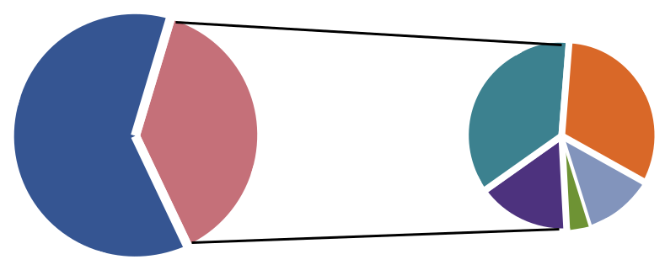

 |  |  |  |  | Very insu cient
 |  | 36% | 32% |  | Insu cient
 | 26, YES | 36% | 32% |  | So So
40, No | 26, YES |  |  |  | So So
40, No |  | 16% | 12% |  | Su cient

Very su cient

4%

3.1.5 Information on Land Allocation

This group of information consists of two items: (i) criteria for land allocation; and (ii) decisions regarding land allocation. According to the current regulations, these kinds of information do not require publishing. As they are not required, we expected that it would be difficult to obtain these kinds of information during web-check observations. Surprisingly, our observers were still able to obtain these kinds of information on a significant number of websites. Table 5 indicates that 14 websites out of 66 websites contained information on the criteria for land allocation, and only seven websites provided information on decisions regarding land allocation. The seven provinces where we could find land allocation information on the web were Binh Dinh, Kon Tum, Lai Chau, Quang Ninh, Quang Tri, Quang Nam and Thua Thien Hue.

Table 5: Information on Land Allocation

 | Publication type | Frequency | Percent
Criteria on land allocation | Not mandatory | 14 | 21.21
Decisions regarding land allocation including: | Not mandatory | 7 | 10.61
investor profiles, name and content of the project,
final rate and the rate proposed by the Ministry of
Finance

After finishing web-check observations, in cases where some information was missing or researchers were unable to locate the materials on the specific website, the researchers/web-checkers were to contact the Website Administration (often provided at the top of or at the foot of the site). Researchers asked about the missing information in those five groups above. The aim of this activity was to find out whether the website administrators respond to information requests. According to the information collected, only a very limited number of responses were recorded by the researchers. Out of 61 requests sent to local web administrators, we only received replies from five provinces including Binh Phuoc, Khanh Hoa, Kon Tum, Quang Nam and Quang Tri. Generally, these replies pointed us to another webpage to seek further information or apologized that the information we were seeking was not published on their website.

3.2 Non-Web Based Disclosure

In this section, we report on the disclosure of non web-based information (that is, information that is not mandatory to provide online). As indicated earlier, the information will be made available at all three levels of local administration/governments, namely provincial level, district level and commune level. It is worth reminding readers that the obligations to disclose information and the type of information to be disclosed differ at different levels of government administration.

3.2.1. Disclosure at the Provincial Level

At the provincial level, there are two types of land related information to be observed in our fieldwork: (1) mandatory information: information related to detailed land use planning and plans; urban planning (including drawings and models); and draft urban planning; and (2) non-mandatory information including: land allocation criteria; investment site maps; and agreed minutes on urban planning consultations. In addition to checking if these data are available, we also ask the observers to assess the accessibility of information, whether the information is provided for free and the form of information disclosure.11

(1) Mandatory information:

- Information related to detailed land use planning and plans: One of the key disclosure obligations at the city and provincial level is availability of information on detailed land use plans and planning. Article 27 of Decree 181/2004 on implementation of the Land Law provides that Provincial Departments (and District Level Divisions) of the Ministry of Natural Resources and

Environment are obligated to publish all documents on approved local land use plans and planning at their offices (see also the above section on the publication of this information online). The research teams visited the land planning divisions in the Departments of Natural Resources and Environment to obtain this information. According to our observations in 12 provinces, such information was only accessible at six out of 12 locations (50%). This is surprisingly low at the provincial level. Among those locations that provided information about detailed land use plans and planning, three were rated as difficult to access and the other three as easy to access. The information could be accessed at no charge and was mostly on public display (five out of six locations). In terms of the

11 In practice, individual citizens rarely make it to the provincial level offices to seek for information. Therefore, when our observers visited the provincial people’s committee offices to look for information, we surprised the officers there. In almost all cases, we were requested to show our ‘introduction letter’.

Page 29

30
geographical distribution, there was a difference between regions. In the north, we could not obtain any information. This was in contrast with provinces in the central part of the country where we could obtain information for all of the provinces. The information in these provinces was on public display. In the South, we could only obtain information at two out of four provinces.

Box 1: Best Performer in Providing Information Related to Detailed Land Use Planning and Plans

Our fieldwork experience shows that a number of provinces including Ho Chi Minh city, Da Nang and Tien Giang do a really good job in providing this information. Ho Chi Minh city is perhaps the best performer. Right in front of the Department of Natural Resources and Environment and the Institute for Architecture Planning, people could view the1/10000 land use planning maps for the whole city. We continued to look for detailed land use plans and planning by visiting the Institute for Architecture Planning. We were correctly instructed to obtain detailed information in a showroom where all of the detailed maps, planning and models were on display for the public to view. We did not even show the “introduction working document” to the staff. Danang and Tien Giang also performed well in providing information to the public. This was in total contrast with Hanoi. Although in Hanoi we did a pilot observation to develop the observation protocol, when we conducted the real observation by sending another team to collect this information at the Department of Natural Resources and Environment, we could not access the information. There was no map on display. When seeking this information from staff we were asked to visit some other places and Departments to no avail.

- Urban planning (including drawings and models): Article 55 of the Law on Urban Planning mandates that information on approved urban planning be published by the people’s committee at all levels (in this case the provincial level). In order to obtain this information, our observer visited either the provincial department of construction or the institute of architecture planning. Information regarding urban planning could be accessed in eight out of twelve provinces (accounting for 66.7% of provinces). All of this information could be accessed without charge but in some provinces (three) the accessibility of information was rated as difficult. In the provinces where accessibility was rated as difficult, the information was not on public display, rather it was provided upon request by our observers.

- Draft urban planning: Information regarding draft urban planning is required to be published by Article 21 of the Law on Urban Planning. As expected, the accessibility of draft urban planning information was even worse than official urban planning. According to our data, we could access draft urban planning in two out of 12 provinces (accounting for 16.7%). Our observers reported that in order to obtain the information some fee needed to be paid and that the information would only be provided on request. For the ten refused cases, the main reason as stated by the staff was that the drafts had become the official documents so the period for publishing was no longer valid.

(2) Non-mandatory information:

Page

- Land allocation criteria: Although classified under the non-mandatory information category, information regarding land allocation criteria is considered critically important, especially from

the perspective of enterprises and potential institutional investors. Interestingly, although this information is not mandatory, eight out of twelve provinces provide this information (accounting for 66.7%) and in most cases it was not difficult to obtain this information (observers reported that it could be accessed normally at seven of out eight locations). The information was either on display or supplied by people/officers in charge. To collect this information, we visited the provincial Department for Natural Resources and Environment or the One-Stop Shops for administrative procedures.

- Investment site maps: The accessibility to investment site maps was substantially limited. Out of 12 provinces, we could only access the site maps in two. This is consistent with what we envisioned before the fieldwork commenced as this is the non-mandatory type of information and furthermore, the information can either be sensitive or outdated, which makes the publication of information difficult.

- Agreed minutes on urban planning consultation: In all 12 provinces, our observers could not obtain any information regarding agreed minutes on urban planning consultations. This may be explained by the “window problem” whereby our observation takes place without consultation, or the time window for consultation has passed. In order to obtain further information about this, we believe some further in-depth investigation may be needed. Our observers were asked to report reasons that the information was not accessible. Strangely, in five out of twelve provinces the agreed minutes do exist but the officers in charge refused to allow our observers access to this information.

3.2.2 Disclosure at the District Level

Different from the commune level, where the researcher only visited the office to ask for all relevant information, at the district level, there are specialized divisions. As a result, the observers had to visit different divisions to collect different information; i.e. the One-Stop Shop for administrative procedures, the Division for Natural Resources and Environment for land use planning and the Urban Planning Division for urban planning. Similar to the provincial level, at the district level there were also two types of land related information to be observed in our fieldwork: (1) mandatory information – including procedures for issuing certificates for land use right transfers; land use planning and detailed land use plans; urban planning (including draws and models) and draft urban planning; and (2) non-mandatory information – including plans on compensation, support and resettlement and agreed consultation minutes on draft plans of compensation, support and resettlement and agreed consultation minutes on draft urban planning.

(1) Mandatory information

- Procedure for issuing certificate for land use rights transfers: The commune authority is responsible for issuing first-time land use rights certificates while the district authority is responsible for issuing, re-issuing and modifying land use right transfer certificates. The Law on Anti-Corruption clearly provides for the publication of administrative procedures, processes, orders and authorities when issuing such certificates. At the district level it is required that this information to be made available with all details such as the steps involved, expected time for each step, fees and charges. The result is very encouraging. According to our observation, this information was substantially available at the district level.

Page 31

Figure 9. Accessibility of Land Transfer Procedure Information
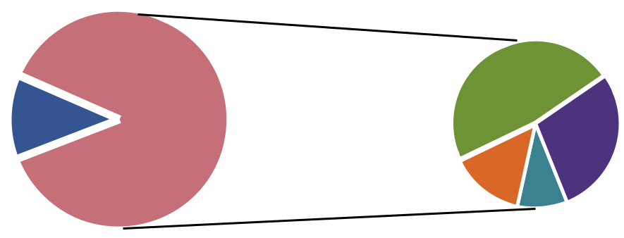

 |  | 47.6% |  |  | Very easy
 |  | 47.6% |  |  | Easy
3, No | 21, YES |  | 28.6% |  | Easy
3, No | 21, YES |  | 28.6% |  | So So
 |  | 14.3% |  |  | So So
Di cult

9.5%

Out of the 24 districts we visited, we could access this information in 21 districts (87.5% which is quite high). Not only was the information available, but it was also very accessible. Figure 9 above illustrates that the information was easily accessible at over 76% of the locations investigated. The level of accessibility is also reflected in the form information being disclosed. In terms of published information among those 21 provinces, 61.9% were on public display, 28.6% were guided by the officers in charge and 9.5% by other forms (i.e. the procedures are readily printed on their card) as illustrated in Figure 10.

Figure 10. Forms of Disclosing Information Regarding Procedure

for Issuing Certificate of Land Transfer
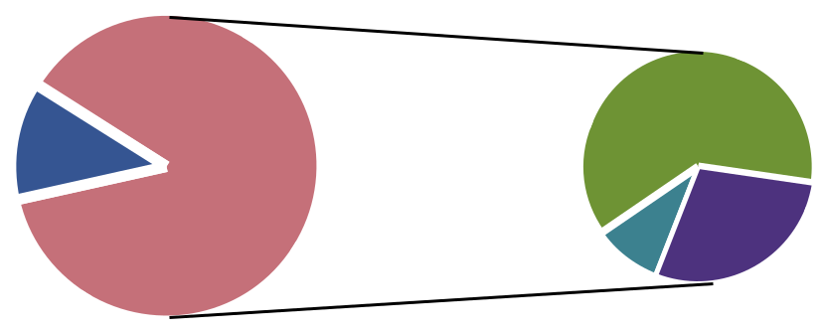

3, No | 21, YES | 61.9% |  | Public display
3, No | 21, YES | 61.9% |  | Assisted by o cers

28.6% |  | Other
9.5%

The completeness of information is presented in Figure 11 below. As can be seen, in over 80% of the cases where the information was provided it contained almost all details regarding procedures for issuing certificates for land use transfers.

32

Page

Figure 11. The Completeness of Information Regarding Procedures for Issuing Certificate of Land Use Transfer
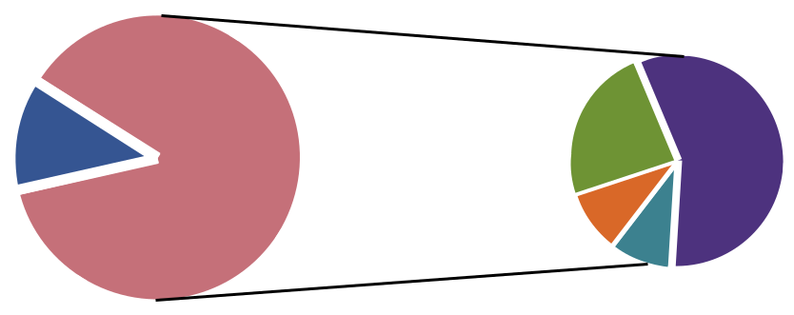

 |  |  |  |  | All details
3, No | 21, YES | 23.8% | 57.2% |  | Almost all

9.5% |  |  | Some details
9.5% |  |  | Only a few
 | 9.5% |  | Only a few

- Land use planning and detailed land use plans: Similar to the responsibility of the provincial authority, the responsibility to publish documents relating to land use plans and planning at the district level is provided for in Article 27 of Decree 181/2004 on implementation of the Land Law.12 At the district level, the disclosure of information on land use planning and detailed land use plan is somewhat limited. Our observers could only access this information at 10 districts out of the 24 districts we visited (41.7%). However, the information was provided at no charge in nine out of these 10 districts. The level of accessibility to this information is provided in Figure 12 below. As can be seen, this information was not easily available in all instances, with 20% reporting difficulty in accessing the information. This was also consistent with the form of disclosing information. Out of 10 districts that provided this information, six of them provided it by public display while four only provided it at the request of our observers. Unsurprisingly, the level of completeness of the information accessed was also very much limited. We could only obtain all the details at one location/ district and almost all details at one more location.13

Figure 12. Accessibility Level to Land Use Planning and Detailed

Land Use Plan
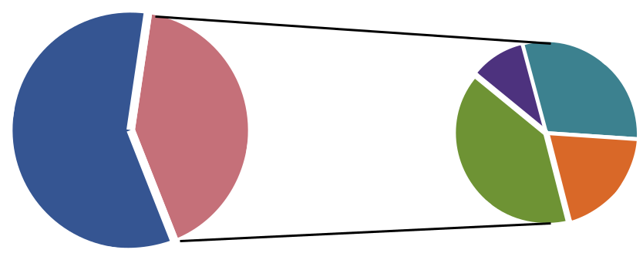

 | 10% |  |  | Very easy
 |  | 30% |  | Easy
14, No | 10, YES |  |  | Easy
 | 40% | 20% |  | So so

Di cult

12 This Article provides that District Level Divisions of Natural Resources and Environment are obligated to publish all documents on approved local land use plans and planning at their office (c.f. the above section on the publication of this information online).

13 With only small number of observations, readers should be cautious in using and extrapolating these percentages.

Page 33

- Urban planning (including drawings and models): The responsibility of district level authority to publish information on urban planning and draft urban planning is provided for in Article 55 of the Law on Urban Planning. At the district level, individual citizens could access to this information by visiting the One-Stop Shop, the Division for Natural Resources and Environment, and the Urban Planning Division to seek information on urban planning, land use plan and planning. Our observed could only find information on urban planning at the district level for 11 out of 24 districts (45.8%) and this information could be obtained without any fee (100% - i.e. for 11 cases where we could obtain the information). According to our observers the information could be accessed quite easily in those districts where we were able to access the information at all (see Figure 13 below). Similar to previous examples, the form of information disclosure was by public display (72%).

Figure 13. Accessibility to Urban Planning
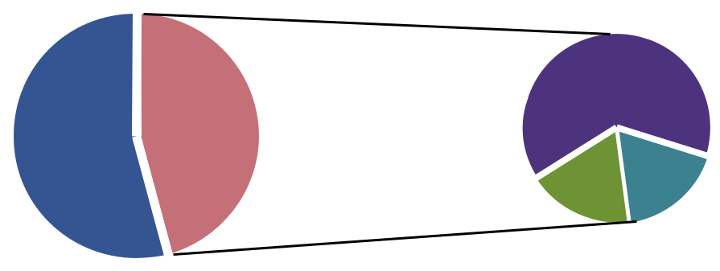

 | 63.6% |  | Very easy
13, No | 11, YES |  | Easy
 | _{18.2%} 18.2% |  | So so

34

- Draft urban planning: Drafts of urban planning are supposed to be made publicly available for the purpose of public consultation. However, in reality our observers could only observe one instance of this out of 24 districts. In all of the other 23 districts, we could not obtain this information.

(2) Non-mandatory information

Although not mandatory, lists of households that are qualified, and lists of households that are not yet qualified for being issued such certificates can be made available.

- Plans on compensation, support and resettlement and agreed consultation minutes for draft plans of compensation, support and resettlement: As this information is not mandatory for publication, the information that could be accessed is very limited. There were only two districts where we could obtain the information.

- Agreed consultation minutes on draft urban planning: We could not obtain this information for any district.

Page

3.2.3 Disclosure at the Commune Level

We were supposed to conduct observations at 120 communes in 12 provinces. However, due to physical and weather conditions (no roads and heavy storm) in some locations (i.e. Ha Tinh province), we were unable to visit three communes. As a result, the total number of communes that are available for analysis is 117.

Similar to the provincial and district levels, at the commune level there are also two types of land related information to be observed in our fieldwork: (1) mandatory information; and (2) non-mandatory information. However, at the commune level, there are more types of information that must be made available.

Table 6: Disclosure at the Commune Level

 | Frequency | Percentage
Administrative procedures for issuing land use certificates | 93 | 79.49
List of qualified and unqualified households and organizations for | 35 | 29.91
submitting application for land use certificates
Decisions approving compensation, support and re-settlement plans | 24 | 20.69
Draft compensation, support and re-settlement plans | 5 | 4.27
Detailed land use plans and planning | 60 | 51.28
Urban planning (drawings and models) | 27 | 23.08
Draft urban planning | 4 | 3.42
Agreed consultation minutes on draft compensation, support and | 4 | 3.42
re-settlement plans
Agreed consultation minutes on draft urban planning | 0 | 0.00

(1) Mandatory Information

- Administrative procedures for issuing land use certificates: In Vietnam, issuing land use right certificates plays a critical role, as this information has implications for both individual citizens as well as businesses. According to Vietnamese laws and regulations, information regarding administrative procedures for issuing land use certificates, house ownership, and property associated with land is required to be published in a number of ways and forms. According to Section 4, Article 21 of the Anti-Corruption Law and Article 5 of the Grass Roots Democracy Law, the people’s committees of communes, wards and towns are required to make publicly available all information regarding administrative procedures. The information could be made available in the following ways: (i) public display at the offices of the commune people’s committee or commune people’s council; (ii) announcements in local communication channels; (iii) making available through the head of the commune who meets and informs the individual people; and (iv) any combination of these forms. However, when retrieving the information, our observers could only visit two of these locations. They were the places where the information is supposed to be on public display and the office of the commune people’s committees. At these locations, we could directly ask for information.

Page 35

Therefore, the results reported here should be interpreted in that context, as there may be many cases where such information is disclosed to the local residents through other channels/form such as the head of the commune. According to our observations, this information was available at a large number of communes. Among 117 districts, 93 districts provided information (79.5%). Figure 14 below indicates that for this information was quite accessible.

Figure 14. Accessibility to Information Regarding Administrative

Procedures for Issuing Land Use Certificates
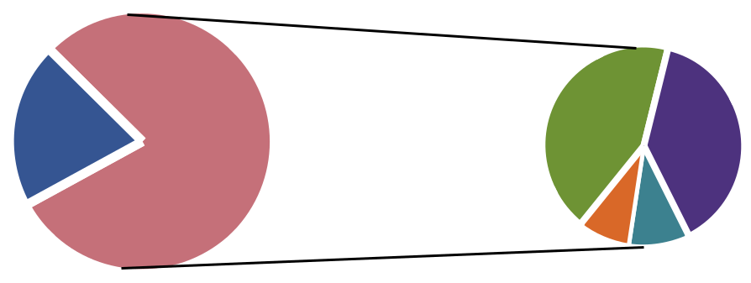

 | 43% |  |  |  |  | Very easy
 |  |  |  |  |  | Easy
24, No | 93, YES |  |  | 38.7%
 |  |  |  |  |  | So so
 |  | 8.6% | 9.7% |  |  | Di cult

Figure 15 below shows that the form of information disclosure is mostly via public display and assisted by officers. In the assessment of our observers, the completeness of the information is very high (79.5%). In the experience of our observers, this is perhaps the most easily accessible land related information for individuals when they visit the authority offices.

Figure 15. Form of Disclosing Information
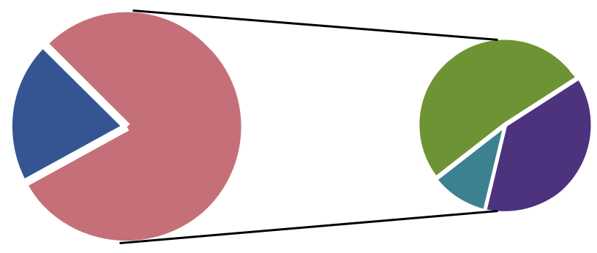

 | 51.6% |  |  | Public display
24, No | 93, YES | 37.6% |  | Assisted by o cers

Other

10.8%

Page 36

- List of qualified and unqualified households and organizations for submitting application for land certificates

The list of qualified and unqualified households and organizations for submitting applications for land use certificates is required by Article 135 of the Decree 181/2004 to be made publicly available. The people’s committee of the commune or township is responsible for displaying publicly a list of land users satisfying all conditions for issuance of a certificate of land use right at its office for fifteen (15) days; and shall consider recommendations on the applications for issuance of a certificate of land use right and shall send files to the land use right registration office under the Division of Natural Resources and Environment. To access this kind of information, the research team visited the offices of the commune authority to see if this information was on public display. If not, the research team would then request the information from local staff. As indicated in Table 6 above, our observers could only access information regarding the list of qualified and not yet qualified households and organizations for submitting application for land certificates in 35 communes out of 117 communes (accounting for 29.9% the total 117 communes). For those 35 communes where we could access the list, obtaining the list was not that difficult, and they were mostly available on public display (See Figures 16 and 17 below).

Figure 16. Accessibility of the List of Qualified and Unqualified Households and Organizations for Submitting Application for Land Certificate
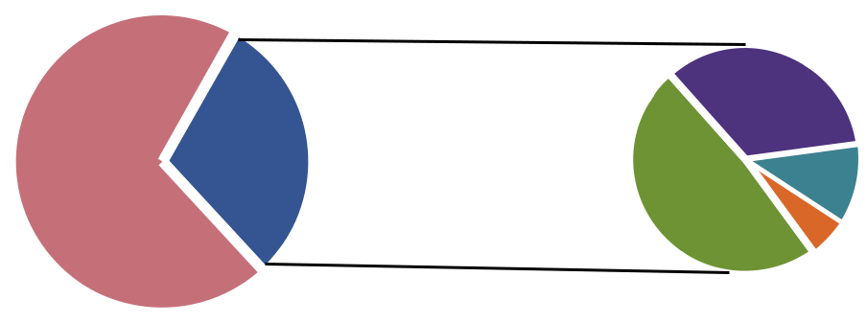

 |  | 34.3% |  |  |  | Very easy
82, No | 35, YES |  |  |  |  | Easy
82, No | 35, YES | 11.4%
 |  |  | 48.6% |  |  | So so
 |  |  |  | 5.7% |  | Di cult

Figure 17. Form of Disclosure of the List of Qualified and Unqualified Households and Organizations for Submitting Application for Land Certificate
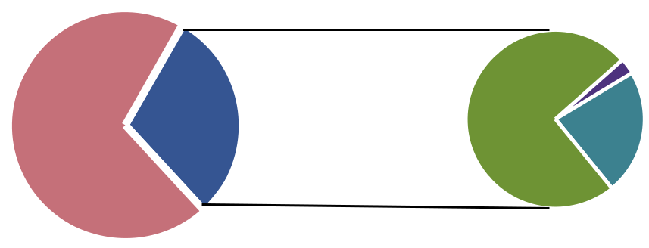

 |  |  |  | 2.9%
82, No | 35, YES |  |  |  |  | Public display
82, No | 35, YES | 74.3% | 22.8% |  |  | Assisted by o cers

Other | 37

PageThe circumstance where we could not obtain the information for these 82 cases differed greatly. First, in 15 cases we could not obtain the information when the data (i.e. the list) was not displayed and the officials were not available in the normal working time to provide the information. Second, in 25 cases we were denied to access to the information by the officials. They often asked for approval by the head of the commune or stated that if we needed specific information about particular cases they would look for us. Thirdly, in nine cases, we were denied access with such as reasons as the time required to publishing such a list has passed, or the information has been provided in other forms (i.e. through local speakers or the head of commune). Finally, in as many as 30 cases we were not able to obtain the information because such a list simply “does not exist”. When probing, we obtained a number of reasons why such list does not exist: (i) when local residents apply for certificate in small number (not in a batch), the relevant information was sent directly to the households; (ii) only a few families do not have land certificates so the local authority will process on a case-by-case basis and the list literally do is not exist; (iii) the issuance of certificates is done over long time periods. As can be seen, improvements could be made in these locations with appropriate intervention.

- Decisions approving compensation, support and re-settlement plans: The publication of this information is provided for in Article 57 of Decree 84/2007/ND-CP and later in Decree 69/ CP issued in August 2009. This information is of critical importance as it affects the livelihoods and decisions of many individuals and households. However, according to the Table 6 above, our observers could only obtain such information at 24 locations, accounting for only 20.7% of the communes. The information regarding decisions approving compensation, support and re-settlement plans was disclosed through two main channels: mostly through public display (77.3% - among those 24 communes, we could access the information directly on the public display for 19 communes) and by public officers (22.7%, by requesting for the remaining five cases).

Figure 18. Accessibility to Decisions Approving Compensation,

Support and Re-settlement Plans
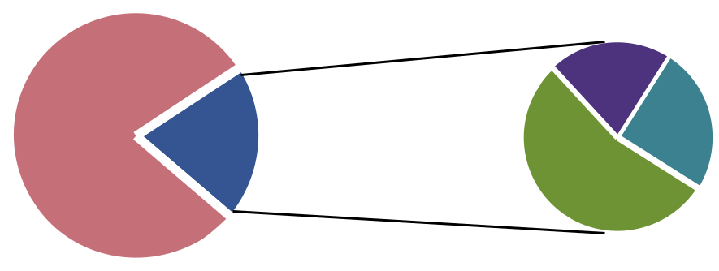

 | 20.8% | 25% |  | Very easy
93, No | 24, YES | 25% |  | Easy
 | 54.2% |  |  | So so

Page 38

Figure 18 above provides information regarding the accessibility of this information. As can be seen, it was not that difficult to obtain the information among those 24 cases where we could obtain the information at all. 54.2% of the cases were reported as being “very easy” to access by our

observers, and another 20.8% as easy to access. Another dimension of the quality of information is the completeness of information. For the information we could access, it was considered to contain some level detail (see Figure 19 below).

Figure 19. Completeness of Information Regarding Decisions

Approving Compensation, Support and Re-settlement Plans
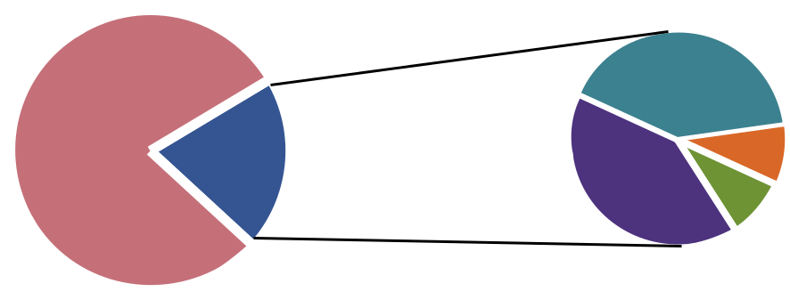

 |  | 40.9% |  |  | All details
93, No | 24, YES | 40.9% | 19.1% |  | Almost all
93, No | 24, YES |  |  |  | Some details
 |  | 40.9% |  |  | Some details

Only a few

9.1%

The circumstances in which we could not obtain information for those 93 locations differed and the situation is not as bad as it may appear. In 19 cases we could not meet the relevant officials when the information was not on public display. In 20 cases the relevant officials intentionally asked our observers to acquire permission from leaders of communes, or an introduction letter from District Environment Department or informed us that this information is only provided to state agencies or organizations, not to individuals. In 18 cases, the relevant officials replied that the compensation was over, and refused to disclose the information. In 35 cases, the officials stated that they were not currently processing any land reclamation or compensation activities so such information was not available.

+ Draft compensation, support and re-settlement plans: As provided for in Article 19 of the Ordinance on Democracy at the Grass Roots Level and Decree 69 (2009), the people will be given opportunities to comment on a number of issues including drafts of compensation plans, support for land clearance, construction of infrastructure and resident planning. According to this Article, the draft compensation, support and re-settlement plans should be made available at the commune level for consultation with the households. It is clear from the discussion above, when the information regarding official decisions approving compensation, support and re-settlement plans are difficult to obtain, the information regarding draft compensation, support and re-settlement plan becomes even more difficult to access. According to the Table 6 above, our observers could only obtain this land-related information in four communes (3.42%).14

+ Detailed land use plan and planning: this information has been made mandatory by the | 39
Government through Article 28 of the Law on Land 2003:(i) People’s committees of communes, | 39

14 As the number is so small, we do not perform further analysis regarding this information.

Page

40
wards and townships shall be responsible to announce publicly detailed land use zoning and detailed land use planning for the locality at the head office of the committee; (ii) Administrative bodies for land at all levels shall be responsible to announce publicly their land use zoning and land use planning for the locality at their offices and in the mass media; and (iii) Land use zoning and planning must be publicly announced at the offices of people’s committees and administrative bodies for land throughout the entire period of its validity.

According to Table 6 above, information regarding detailed land use plans and planning was accessible at 60 communes, accounting for 52.3% of 117 communes where we conducted our observation study. According to our observation, people could obtain the data without a charge (59/60 cases). As illustrated in Figure 20 below, it was relatively easy to access this information.

Figure 20. Accessibility of Detailed Land Use Plans and Planning
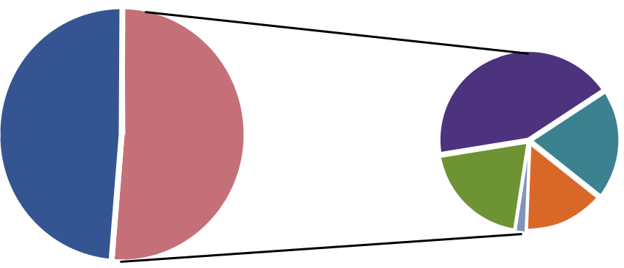

 |  |  |  |  | Very easy
57, No | 60, YES | 43.3% |  |  | Easy
57, No | 60, YES | 43.3% | 20% |  | So So

20% | 15% |  | Di cult
 | 15% |  | Very di cult
 | 1.7% |  | Very di cult

The form of disclosing this information is presented in Figure 21. Our observers could obtain information directly from the public display platform for 36.7% of the communes. In another 55% of the communes, our observers could access by simply asking the officers in charge.15

Figure 21. Form of Disclosure for Detailed Land Use Plans and Planning
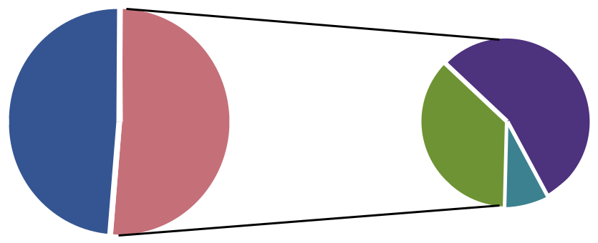

 |  |  | 55% |  | Public display
57, No | 60, YES | 36.7% |  |  | Assisted by o cers

Other

8.3%

Page

15 These documents are often kept locked in their tables draws. In some cases, the officers did not even remember where they kept the information.

Figure 22 illustrates the completeness of information regarding those communes where we could access the information on detailed land use plans and planning. As indicated in Figure 22, the quality of information was not yet high. Around 20% of cases contained almost all details and only about 3% contained all details.

Figure 22. The Completness of Information Regarding Detailed

Land Use Plans and Planning
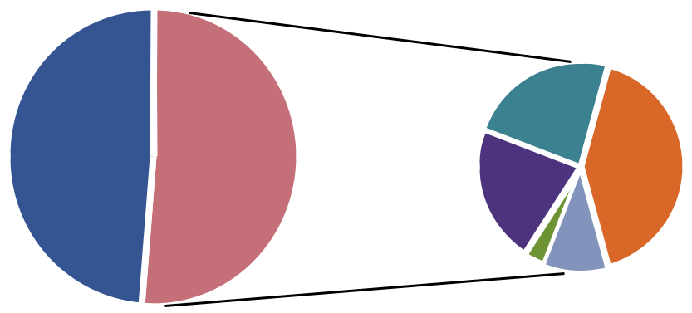

 |  |  |  |  | All details
57, No | 60, YES | 23.3% |  |  | Almost all
57, No | 60, YES | 23.3% | 41.7% |  | Some details
57, No | 60, YES | 21.7% | 41.7% |  | Some details
 |  | 21.7% | 41.7% |  | Few

3.3% |  |  | Only a few
 | 10%

Among those 57 cases where we were unable to access to information, the circumstance differed greatly. In 20 cases, the officials seemed to be very cautious with this kind of information, explaining to us that this information is not available to individuals. In some cases (i.e. in Da Nang) we were requested to obtain an introduction letter from the district environment department in order to gain access to the information. In other cases we were requested to explain the purpose of accessing the information and provide our personal details for commune leaders to consider. Ironically, in some locations the reply was that the information was classified as internal and should not be disclosed, and that the information is so complicated that citizens would not understand the justification for their non disclosure. In some (five) locations access was denied due to an improper archival system (e.g. broken maps, unable to locate the document). In other locations, commune officials directed our researchers to the district level offices.

+Urban planning (drawings and models): Information regarding urban planning could only be
accessed at 27 communes out of 117 communes (accounting for 23.1%). This kind of information
was also not easy to obtain as can be seen in Figure 23. However, the data presented here contained
both urban and rural communes and only the former is required to publish information regarding
urban planning. This implies that a significant number of rural communes do publish the information
on urban planning, although they are not required to. To explore further, we focused only on
the urban communes and found that we could obtain urban planning from 14 out of 59 urban
communes and this information was slightly easier retrieve as illustrated in Figure 23b. Figures 24 | 41
and 24b show the form of information disclosure for urban planning. | 41

PageFigure 23. The Accessibility of Information Regarding Urban

Planning
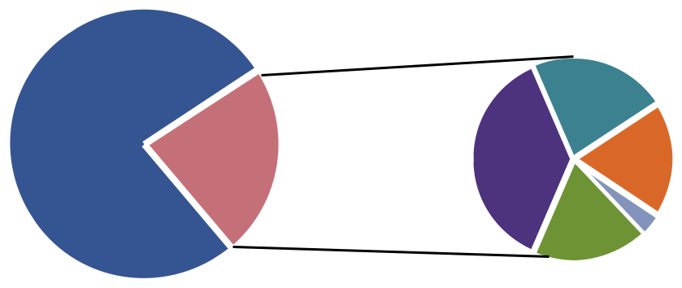

 |  |  | 22.2%
90, No | 27, YES | 37% | 18.5%
 |  |  | 18.5% | 3.7%

Very easy

Easy

So so

Di cult

Very di cult

Figure 23b. The Accessibility of Information Regarding urban

Planning (Urban Only)
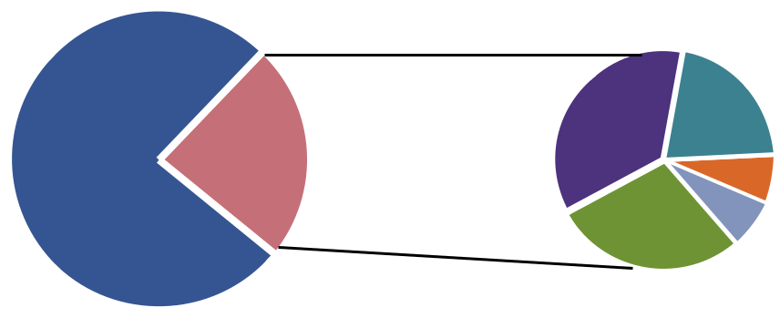

 | 35.7% | 21.4%
45, No | 14, YES | 7.14%

28.57% | 7.14%

Very easy

Easy

So so

Di cult

Very di cult

Among the 90 cases where we could not obtain information, in 34 cases relevant officials replied that there was no urban planning information (37.8%) available. In 21 cases they requested further information from our observers (i.e. introduction letters) arguing that land information is confidential and can not be disclosed. In another 21 cases, the information was not on display and officials were not available for questioning. In some other cases, we were refused because the maps were ruined or outdated, or we were directed to go to the district level.

42

Page

Figure 24. Form of Information Regarding Disclosure Urban

Planning
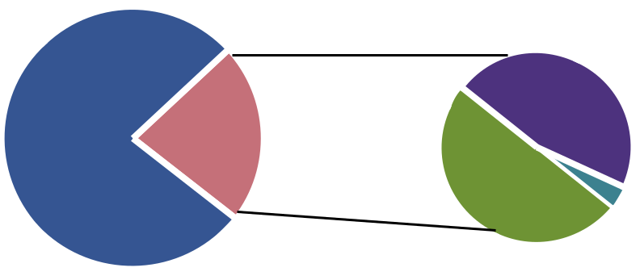

90, No | 27, YES

 | 46.1% |  |  | Public display
50% | 46.1% |  |  | Assisted by o cers
50% |  | 3.9% |  | Other

Figure 24b. Form of Information Regarding Disclosure Urban

Planning (Urban Only)
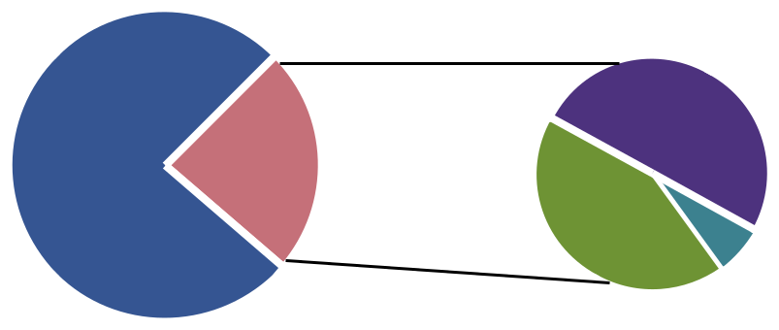

45, No | 14, YES

 | 50% |  |  | Public display
42.9% | 50% |  |  | Assisted by o cers
42.9% |  | 7.1% |  | Other

- Draft urban planning: Information regarding draft urban planning could only be accessed at a few (four locations) communes (accounting for 3.4% of total locations).

- Non-mandatory information: Unlike the situation at the provincial level regarding non mandatory information, at the commune level, the availability of non-mandatory information is extremely limited. Our observation indicates that the agreed consultation minutes on draft compensation, support and re-settlement plans were available at only four communes, and we could not obtain any information regarding the agreed consultation minutes on draft urban planning.

3.3 Performance Analysis

The data obtained from the on-site fieldwork observations provide an overall picture of the accessibility to land related information at three levels, namely the province, district and commune levels in 12 selected provinces. In this section, we aggregate and construct performance scores for the 12 provinces. With these scores, we are able to identify the “best practice” performers.

Page 43

44
3.3.1 Provincial Performance Scores on Commune Level Accessibility

In order to construct the provincial performance scores using the commune level data we used a simple method to calculate the aggregate score for each province. For each province, we conducted our observations at 10 communes for nine aspects of land-related information.16 For a particular aspect of land related information, we assigned a score of one for each commune where we could obtain the information and zero otherwise. For example, in Bac Ninh we obtained the necessary information at seven out of 10 communes for “Administrative procedures for issuing land use certificates”. Bac Ninh province will be given a score of 7 on this aspect (e.g. “Info 1” column, Table 7). We did similarly for other information. The final Provincial Performance Score on Commune Level Accessibility will be the simple average of the sub-scores. As can be seen in Table 7, Ho Chi Minh city is the best performer at the commune level, followed by Khanh Hoa, Hanoi and Hung Yen. The average performers are Da Nang, Quang Nam, Thai Binh and Can Tho. The results suggest that higher income provinces/cities are more likely to be top performers for accessibility of information. But the results also indicate that lower income provinces/cities can also be good performers (e.g. Quang Nam and Hung Yen).17

Table 7: Provincial Performance Score on Commune Level Accessibility

Province | Info 1 | Info 2 | Info 3 | Info 4 | Info 5 | Info 6 | Info 7 | Info 8 | Info 9 | Score
Ha Tinh | 4.4 | 0 | 1.1 | 0 | 3.3 | 1.1 | 0 | 1.1 | 0 | 1.22
Ben Tre | 8.9 | 3.3 | 0 | 0 | 1.1 | 0 | 0 | 0 | 0 | 1.48
Bac Ninh | 7 | 0 | 1 | 0 | 2 | 4 | 1 | 0 | 0 | 1.67
Tien Giang | 6 | 2 | 1 | 0 | 6 | 2 | 0 | 0 | 0 | 1.89
Can Tho | 10 | 0 | 0 | 0 | 5 | 3 | 0 | 0 | 0 | 2.00
Thai Binh | 9 | 3 | 1 | 0 | 6 | 0 | 1 | 0 | 0 | 2.22
Da Nang | 9 | 5 | 3 | 0 | 4 | 2 | 0 | 0 | 0 | 2.56
Quang Nam | 9 | 4 | 1 | 0 | 8 | 1 | 0 | 0 | 0 | 2.56
Ha Noi | 8 | 2 | 6 | 1 | 6 | 3 | 2 | 0 | 0 | 3.11
Hung Yen | 8 | 2 | 6 | 1 | 6 | 3 | 2 | 0 | 0 | 3.11
Khanh Hoa | 8.9 | 7.8 | 4.4 | 1.1 | 8.9 | 5.6 | 0 | 0 | 0 | 4.08
HCM | 8 | 7 | 6 | 2 | 8 | 6 | 0 | 1 | 0 | 4.22

16 In some provinces we conducted our observation at only nine communes due to unexpected weather conditions. 17 The best communes are Vĩnh Phương. Phước Long, Vĩnh Phước, Xương Huân of Nhat Trang city (Khanh Hoa Province) Ninh Phước, Ninh Phước of Ninh Hòa district (Khanh Hoa province); Phú Xuân, Vũ Chính communes from Thái Binh city, Đông Phong, Hồng Giang communes from Dong Hung district, Thai Binh province; Cát Lái, Thạnh Mỹ Lợi (District number 2; HCM), Nhà Bè town, Hiệp Phước, Phước Kiểng, Phước Lộc (Nhà Bè

district, HCM city).

Page

3.3.2 Provincial Performance Scores on District Level Accessibility

We use a similar method to calculate the score for provinces using district level data. We have two observations at the district level for each province and for each district we have six aspects of information to check the availability of. We assign a score of 10 for a province for particular information if we were able to observe the information at both districts. The results presented in Table 8 show that Khanh Hoa, Hanoi and Da Nang were the top performers at the district level, followed by Can Tho and Ho Chi Minh city.

Table 8: Provincial Performance Score on District Level Accessibility

Provinces | Info 1 | Info 2 | Info 3 | Info 4 | Info 5 | Info 6 | Total | Score
Ha Tinh | 5 | 0 | 5 | 0 | 0 | 0 | 10 | 1.67
Ben Tre | 10 | 0 | 0 | 0 | 0 | 0 | 10 | 1.67
Bac Ninh | 10 | 5 | 0 | 0 | 0 | 0 | 15 | 2.50
Tien Giang | 5 | 0 | 5 | 0 | 5 | 0 | 15 | 2.50
Can Tho | 10 | 10 | 10 | 0 | 0 | 0 | 30 | 5.00
Thai Binh | 5 | 5 | 0 | 0 | 0 | 0 | 10 | 1.67
Da Nang | 10 | 10 | 10 | 0 | 0 | 0 | 30 | 5.00
Quang Nam | 10 | 5 | 5 | 0 | 0 | 0 | 20 | 3.33
Ha Noi | 10 | 5 | 5 | 5 | 5 | 0 | 30 | 5.00
Hung Yen | 10 | 5 | 0 | 0 | 0 | 0 | 15 | 2.50
Khanh Hoa | 10 | 10 | 10 | 0 | 0 | 0 | 30 | 5.00
HCM | 10 | 10 | 5 | 0 | 0 | 0 | 25 | 4.17

3.3.3 Provincial Performance Score on Province Level Accessibility

Similarly, we obtain the scores for provinces/cities using the province level data. The highest score for particular information is ten and zero otherwise. The results are presented in Table 9. Again, the top performer was Da Nang, followed by Ho Chi Minh city, Hung Yen, Thai Binh, Can Tho, Tien Giang and Ben Tre.

45

Page

Page 46
Table 9: Provincial Performance Score on Province Level Accessibility

Provinces | Info 1 | Info 2 | Info 3 | Info 4 | Info 5 | Info 6 | Total | Score
Ha Tinh | 10 | 0 | 0 | 0 | 0 | 0 | 10 | 1.67
Ben Tre | 0 | 10 | 0 | 10 | 10 | 0 | 30 | 5.00
Bac Ninh | 0 | 0 | 0 | 0 | 0 | 0 | 0 | 0.00
Tien Giang | 10 | 10 | 0 | 10 | 0 | 0 | 30 | 5.00
Can Tho | 10 | 10 | 0 | 10 | 0 | 0 | 30 | 5.00
Thai Binh | 0 | 10 | 10 | 10 | 0 | 0 | 30 | 5.00
Da Nang | 10 | 10 | 10 | 10 | 0 | 0 | 40 | 6.67
Quang Nam | 10 | 10 | 0 | 0 | 0 | 0 | 20 | 3.33
Ha Noi | 0 | 0 | 0 | 10 | 0 | 0 | 10 | 1.67
Hung Yen | 0 | 10 | 0 | 10 | 10 | 0 | 30 | 5.00
Khanh Hoa | 10 | 10 | 0 | 0 | 0 | 0 | 20 | 3.33
HCM | 10 | 10 | 0 | 10 | 0 | 0 | 30 | 5.00

3.3.4 Overall Performance

Table 10 puts together all three scores to calculate the overall score. As can be seen, in the aggregate the best performer is Danang, followed by Ho Chi Minh, Khanh Hoa, Can Tho and Hanoi. An interesting finding is that although Danang is the overall winner, it is not the best at the commune level, but scores very well at the district and province levels. Ho Chi Minh city on the other hand scores very well at all three levels. Khanh Hoa performs better than Danang at both commune and district level but worse than Danang at the provincial level.

Table 10: Overall Transparency of Provinces

Province | Commune Score | District Score | Province Score | Overall score
Ha Tinh | 1.22 | 1.67 | 1.67 | 1.52
Ben Tre | 1.48 | 1.67 | 5.00 | 2.72
Bac Ninh | 1.67 | 2.50 | 0.00 | 1.39
Tien Giang | 1.89 | 2.50 | 5.00 | 3.13
Can Tho | 2.00 | 5.00 | 5.00 | 4.00
Thai Binh | 2.22 | 1.67 | 5.00 | 2.96
Da Nang | 2.56 | 5.00 | 6.67 | 4.74
Quang Nam | 2.56 | 3.33 | 3.33 | 3.07
Ha Noi | 3.11 | 5.00 | 1.67 | 3.26
Hung Yen | 3.11 | 2.50 | 5.00 | 3.54
Khanh Hoa | 4.08 | 5.00 | 3.33 | 4.14
HCM | 4.22 | 4.17 | 5.00 | 4.46

In general the results reported in Table 10 are consistent with the impression of our observers. They agree that the top three are Da Nang, Ho Chi Minh and Khanh Hoa. However, our observers suggest that they would rate Khanh Hoa the best performer instead of Danang as the accessibility of information at Khanh Hoa at all three levels was very good. Our approach gives the same weight to commune, district and province data as we do not have a strong a priori judgment on the weight. We suspect that if the commune level data is given more weight the results may differ.

We speculate that in some higher income provinces like Ho Chi Minh, Khanh Hoa and Danang the demand for land information is high due to vibrant investment and economic activities. In these provinces there are many investment and construction projects which involve land reclamation, resettlement and compensation. These in turn would lead to higher demand for information by citizens and enterprises. As the demand for information increases so will the response to demand by local authorities. For example, by responding to the many requests by local residents for land information, the local land authorities and their officials are more likely to have more experience and knowledge of land related information and procedures than their colleagues in locations where the demand for information is low (other things being equal). In addition, it is also in these locations where land related information such as land certificate issuance procedures, land use maps, and land compensation and resettlement plans are more likely to be available. This may explain in part why we would be able to observe more land related information in these higher income locations. On the other hand, our observation also indicates that in some lower income provinces the disclosure of land related information is quite good. There are two situations: (i) mountainous locations where there are few projects that involve land re settlement or compensation. As a result, land related information and administrative procedures and current land use maps can be retrieved by officials quite easily; and (ii) locations where local officials are seeking to attract investors to their locations, so they are very active in providing land related information.

47

Page
IV/ Conclusions

Overall, the results are mixed. Even in the areas where the results are quite positive, there is room for improvement. Hence, while transparency and accountability appear to have increased, it appears that it would still be greatly difficult for laypeople to navigate the Vietnamese land administration system. This implies that significant inefficiencies and overly burdensome transaction costs remain in the land administration system, which would be impeding Vietnamese economic growth to some extent. A number of suggestions flow directly from our analysis:

- Improve the knowledge and capacity for local commune officials, especially land officials. Holding training courses on legal provisions on the obligations of commune officials regarding information disclosure on land related information should be considered, as it is a common practice among local commune officials to say that “land is managed by the State and land related information can only be disclosed to state agencies and individuals and non-state organizations are not expected to access this information”.18 In a number of locations, district and commune public officials do not seem to be accustomed to the fact that individual citizens can ask them for information. They often request some sorts of “introduction letter” or explanation regarding the purpose of information seeking, despite the fact that the information is supposed to be disclosed.

- Comprehensive and systemic implementation of land related information disclosure at district and commune level: The implementation of land related information disclosure should be implemented in a systemic and comprehensive way. An often-encountered practice is that commune officials direct information seekers to the district level and at the same time district officials direct information seekers to commune level. A more systemic and comprehensive approach would mean the information seekers would be able to access land information at all levels (district and commune). Information should be made readily available and be easily retrievable from the archive system. In many cases local officials cannot locate the information themselves and/or the retrieved information is not in good condition (badly damaged maps/ documents).

- Awareness raising and legal education enhancement campaign: Individual citizens do not seem to be aware of their right to access to information in general and land related information in particular.

- Accessibility is important but quality also matters: it is difficult for individual citizens to know which information is accessible and whether the information provided as such is complete and comprehensive.

18 Publicly disclosed information can be accessed and recorded. However, when our observers were taking pictures often local officials were not comfortable. They argued that these kinds of information were for eye inspection only, not for photographing, and taking pictures in the premises of state agencies is not allowed without permission.

Page 49

In addition, more information could be made more easily and widely available (available on the web). This would improve the ability of local people to access the information, plus it would increase transparency and accountability as outsiders and evaluators could also access the information. Although, online disclosure is not without problems (as indicated by our research) it is far quicker to implement, quicker to check and requires many less resources (both human and physical). At the moment, the accountability system for online disclosure seems to be lacking.

Surprisingly, in some instances where information isn’t even mandatory to provide, it is provided anyway. In other areas, the level of information provided is insufficient. It may be the case that in these instances, it is convenient and in the interest of information providers to provide the information. The qualitative evidence further suggests that in order to improve further the accessibility to land information a more comprehensive approach is needed as the problems hindering access to land information include; implementation capacity (i.e. lack of physical and human resources); poor records management practices (i.e. the non-existence of archival system in a number of locations); organizational culture (such as an “I have to check with my boss” mentality and a non-service oriented culture toward citizens); and awareness, since many public officials don’t seem to even know which land-related information is required by the law to be made public. At the same time, many citizens may not be aware that they have the right to such information. The overall conclusion from this study is that although Vietnam has relatively good laws and regulations on the disclosure of information to the public, there is room for improvement at the enforcement and implementation levels.

50

Page

References

Asian Development Bank (ADB). 2005. Country governance assessment, Philippines. Manila.

Dang Hung Vo (2010) Transparency In Land Administration In South East Asia And In Vietnam, mimeo.

ENEMARK Stig (2004) Building Land Information Policies, Inter-regional Special Forum on The Building of Land Information Policies in the Americas Aguascalientes, Mexico 26-27 October 2004 http://www.fig.net/pub/mexico/papers_eng/ts2_enemark_eng.pdf

Linh Dang Thuy (2009) Investigation Into the Causes of Impediment of Access to Land Information in Land Market (Case study in Hanoi, Vietnam) 7th FIG Regional ConferenceSpatial Data Serving People: Land Governance and the Environment – Building the CapacityHanoi, Vietnam, 19-22 October 2009.

World Bank (2009) Policy note - improving land acquisition and voluntary land conversion in Vietnam, the World Bank, Hanoi.

Klaus Deininger and Hans Binswanger (1999) The Evolution of the World Bank’s Land Policy: Principles, Experience,and Future Challenges, The World Bank Research Observer, vol. 14, no. 2, pp. 247–76.

Reiss, Albert J., Jr., “Systematic Observation of Natural Social Phenomena,” in Sociological Methodology, ed. Herbert L. Costner, San Francisco: Jossey-Bass, 1971: 3–33.

Truong Thien Thu and Ranjith Perera (2011) Intermediate levels of property rights and the emerging housing market in Ho Chi Minh City, Vietnam, Land Use Policy 28 (2011) 124–138. http://viet-studies.info/kinhte/Housing_HCM_LandUsePolicy.pdf

Truong Thien Thu and Ranjith Perera (2011) Consequences of the two-price system for land in the land and housingmarket in Ho Chi Minh City, Vietnam, Habitat International 35 (2011) 30 – 39, http://viet-studies.info/kinhte/Land_TwoPriceSystem_HCMCity.pdf

51

Page
Appendix

A1. Web-check protocol

PROTOCOL

STUDY ACCESS TO INFORMATION ON THE WEBSITE OF THE CITY/PROVINCE

1. Objectives:

To collect evidence on the publication of land–related information on the current websites of appropriate authorities in Vietnam. The collectors are responsible for gathering the publication status of information only, rather than specific land–related information.

2. Websites to access:

- Website of the Ministry of Natural Resources and Environment

- Websites of the Ministry of Natural Resources and Environment’s Departments

- Official Websites/Portals of 63 provinces/cities in Vietnam

- Websites of Provinces’ Departments of Natural Resources and Environment

- Websites of Districts (if any) linked with the Portal of Provinces

- Google.com

3. Information to check:

Includes information on:

- Land related administrative procedures

- Issues on land allocation

- Planning, land-use plans, urban planning

- Compensation and resettlement planning

Forms of information will be displayed in details as below.

Implementation:

- Search for the required websites as above, list the websites addresses in an Excel table which includes: No., website name, website address, province, district

No

Name

Address

Province

District

Page 53

Page 54
- Access the websites above, checking the official websites first to check the existence of information and then go to www.google.com.

- Group One includes information on land-related administrative procedures (TTHC), which normally can be found on the websites of the Provincial Departments of Natural Resources and Environment. This information can be found under the following headings: administrative procedures/guidance on procedures/set of administrative procedures. Information on the rate, which is compulsory to provide online and easily accessible, is excluded.

- Group Two includes information on planning, land use planning (national level, provincial level and district level) and drafts for land use planning (QHKH) which can normally found on the websites of Provincial Departments of Natural Resources and Environment, in the following items: planning/planning publication/planning information. Information of this group is compulsory to be provided online, so it is easily accessible.

- Group Three includes information on Urban Planning (QHDT), which normally can be found on the websites of the Provincial Departments of Natural Resources and Environment, in the following items: planning/planning publication/planning information.

- Information of Groups Three, Four and Five is not compulsory to provide online, so collectors are recommended to use www.google.com.

- Save files into folders in a directory path as below: Level 1: North, Central, South Vietnam,

And Level 2: names of provinces in those areas; Level 3: names of districts in those provinces.

- Name the files by Vietnamese code without tones, for instance: “TTHC01 tinh A”/ “QHKH huyen B”.

- Take screen shots and then print them to keep as a record of whether the relevant information can be found or not. Save the screen shots in relevant folders with names, for instance: “AnhTTHC01 huyen A”.

- Evaluate the sufficiency of the information found, record the time and steps of access in a summary sheet. This recording into the summary sheet must be done immediately after checking the website of each province/district to guarantee accuracy.

4. Information output:

- Group 1: Information on Land-related Administrative Procedures

Includes:

¾¾ List of procedures and forms related to certificates for land use rights (TTHC1).

¾¾ Contact information on the address, phone number, and the email address that organizations and individuals can use to send their feedback and recommendations regarding regulations of administrative procedures for granting certificate of land use right (TTHC2).

¾¾ Information on feedback and recommendations of individuals and organizations regarding regulations of administrative procedures for granting certificates of land use rights (TTHC3).
¾¾ Solutions that have been adopted to response to feedback and recommendations on land– related administrative procedures. (TTHC4).

¾¾ Documents regulating the rate charge for granting certificate of land use rights. (TTHC5).

¾¾ Online service for granting certificates of land use right. (TTHC6).

- Group 2: Information on Land use Planning (national level, provincial level, district level) and Drafts for Land use Planning (QHKH)

Includes:

¾¾ Report on detailed planning, and detailed land use plans; (QHKH1).

¾¾ Map of current land-use situation; (QHKH2).

¾¾ Map of detailed land-use planning in case of approving detailed land-use planning (QHKH3).

- Group3 :Information on Urban Planning (QHDT)

Includes:

¾¾ Drafts of urban planning (QHDT1).

¾¾ Approved urban planning (QHDT2).

d. Group 4:Information concerning compensation and resettlement (TDC)

Includes:

¾¾ Decisions on compensation, support and resettlement (TDC1).

¾¾ Drafts on compensation and resettlement plan (TDC2).

- Group 5: Information on Land Allocation (GDCD)

Includes:

¾¾ Criteria on land allocation (GDCD1).

¾¾ Decisions regarding land allocation including: investor profiles, name and content of the project, final rate and rate proposed by Ministry of Finance (GDCD2).

After finishing, researchers will contact the Website Administrator by the address that is at the top of, or at the foot of the site. Researchers will ask about the missing information in those five groups above. The aim of this activity is to find out whether the Website Administrator gives guidance for researchers or not.

5. Summary Sheet

After searching for 16 items of information by national level, provincial level, researchers shall fill in a summary sheet as below, save the files with relevant names as regulated, for instance “SS huyen A”, and save them into relevant directory path. In addition, printed documents are also necessary.

Page 55

Page 56

SUMMARY SHEET

Province:

Survey scale level (nation, province):

Record code:

Researcher’s full name:

Date of access:

- General information:

Notice: From item 2 onwards, it is not necessary to answer for the missing information.

No. | Info type | 1. Found | 2. Sufficient or | 3. Link | 4. Name of | 5. Searched | 6. Time for | 7. Legal | 8. Publisher
 |  | or missing | not? (1: very | Path | the site (not | itemed (eg: | searching | document | (found on the
 |  | (Yes, No) | insufficient; 5: | (address) | the address) | Administrative | (start – finish) |  | left top of the
 |  |  | very sufficient) |  |  | Procedure) |  |  | document)
1 | TTHC1
2 | TTHC2
3 | TTHC3
4 | TTHC4
5 | TTHC5
6 | TTHC6
7 | QHKH1
8 | QHKH2
9 | QHKH3
10 | QHDT1
11 | QHDT2
12 | TDC1
13 | TDC2
14 | GDCD1
15 | GDCD2
16 | LHQTM

- Steps used to find information obtained

- Steps used for the missing information:

Notice Record the start time and finish time for searching each item of information.

Screen shots are necessary for all steps, including for obtained information and missing information.

Researchers can stop after 30 minutes searching on the Websites of provinces/districts as well as on Google.

A2. Fieldwork Observation protocol

A2.1 Provincial observation protocol

PROTOCOL

LAND INFORMATION DISCLOSURE IN PROVINCES

******

NOTE BEFORE CONDUCTING ON THE SPOT SURVEY

Objective: To collect information about the publication of land information in provinces.

Method of observation: It is noted that secret obversationis the method applied in this reserch. By impersonating an ordinary citizen who needs land information or wants to buy land, the observer can access information.

If being asked for a reason, the observer can explanin he/she is an representative of a company which needs land information. The observer will try to collect information about the publication of information, but not detailed information about land issues.

Observers should try their best to make sure that individuals/organizations providing information will not be affected/influenced during the survey.

Preparation:

Gathering information about the survey area will help observers carry out the field work quickly, accurately and effectively. Atleast, observers should search for general information about land in the survey area.

In order to observe the make observations on Requirement Three, observers must find out which urban areas have been approved and which ones are still awaiting approval.

Bring the Introductory Letter issued by DEPOCEN, in which the observer is introduced as a staff member of DEPOCEN who authorized to collect land information for the company.

Bring the Introductory Letter issued by the World Bank certifying that the observer is participating in this land information publication survey. Note: the letter should not be used to access information. Only use it when being asked by local officers for the reason for your collecting information at that area.

Roles to impersonate:

- Ordinary citizen who needs to buy land or needs land information.

- Authorized DEPOCEN staff member collects land information for his/her director (only applied when acquiring information about land allocation at province-level.)

Requirement:

- Record the time duration to access information, the attitude of officers, and the times needed to contact of ficers. This isused to assess the difficulty level in the summary sheet.

- Briefly note all steps followed in the summary sheet.

Page 57

- If the information is not accessible, observers must specify the reason.

- After each observation, besides immediately filling in the summarysheet, observers need to create a diary sheet to write down the observation process used, the information obtained and the experience gained.

Requirement:

- Collecting information by observing is prioritized (looking for information in the notice board, listening to local radio, observing local people who are dealing with procedures). After observing, directly ask for information without having to give any reason. Roles to impersonate are to be resorted to only when asking directly is not effective.

- In cases that require contacting officers; ask for their names and numbers to note down in the diary sheet. If they are absent, try to call them. If you cannot call the officers or if they answer that there’s no information available, you should ask local people before skipping to the next Requirement.

ON THE SPOT SURVEY STEPS

Requirement 1: Acquire information about detailed land use plan and planning.

Land use plan/planning includes:

- Summary report on land use plan/planning

- Land use current situation map

- Or land use planning map (if the land use planning is awaiting approval).

Detailed land use plan/planning includes:

- Summary report on detailed land use plan/planning

- Land use current situation map

- Or detailed land use planning map (if the land use planning is awaiting approval).

Note:

Detailed land use planning includes the content of land use planning shown in the cadastral map.

Detailed land use plan include the content of land use plan and is attached to land lots.

The agency responsible for providing the above information is Department of Natural Resource and Environment.

58

Page

Scenario: Visit the DONRE office (or another agency appointed to provide land information).

In reality, such a plan is often presented in the form of a land use planning map ora cadastral map shown at the DONRE office (observers should not use the word “planning” as it may mislead to Department of Urban Planning).

Moreover, currently it’s 2010 while the current detailed land use plan was approved in 1990 and the plan for 2011-2020 will be approved by the end of this year. Hence, planning documents and detailed land use plan are quite difficult to access.

Land use plan documents define which land lots are spared for agriculture, industry, forestry and transport, etc.

At first, the observer can impersonate a citizen who needs land information (for buying/selling) to ask directly. If this approach is not effective, the observer can impersonate a real estate broker/ customer representative/DEPOCEN staff member needing to collect land information.

The observer also needs to see if paying official fees for accessing information is necessary.

- See if there is a land use planning map at the DONRE Office. ☺ If any: Take photos as evidence

- Request to have a look at the land use plan documents.

Case 2.1: Allowed to have a look take photos or try requesting a copy.

Case 2.2: Not allowed or if the responsible officers say that there are no such documents Continue asking some other officers to verify.

Case 2.3: If they do not understand use the information in the box above to explain or ask them if the have documents that go with the planning maps outside (if available).

Note: According to law, the publication of the above information is mandatory. Therefore, a request to collect information from government agencies is not out of the ordinary.

The estimation of difficulty level of accessing information must be based on the approval of plans. Understandably, only if the information is available can observers estimate the difficulty of accessing information.

Requirement 2: Acquire information

- Set of criteria for land allocation

- Investment location map

59

PageScenario: Visit the Provincial PC Committee or the DONRE Office.

Enterprises and organizations (especially manufacturing ones) often need to lease state land to operate.

At first, the observer can directly request responsible officers (perhaps Head of the Department) to provide information. If being asked for a reason, the observer can impersonate a DEPOCEN staff member who needs to know land lease procedures in the province, land allocation criteria, documents required and theinvestment location map.

An investment location map is a document listing all investible spots, which contains the address, and border of land lots. This is to be handed out to investors and issued at the beginning of the financial year. This map is often filled right after publication.

Case 1: Allowed to have a look at the complete documents of a practical plan: Take photos as evidence if possible.

Case 2: Not allowed: Ask if the access of this information requires some official or unofficial fee and follow local officers’ instructions.

Note: According to law, the publication of the above information is not mandatory. Therefore, it may be more difficult for observers to access information than for Requirement 1. Observers should flexibly change roles.

Information about land allocation criteria and investment location map is difficult to access because the publication responsibilities of agencies are not clearly defined.

Requirement 3: Acquire information on:

- Approved and draft urban planning (under-construction, not approved urban planning), including

- Planning graphs;

- Planning maps;

- Modes;

- Planning documents or draft planning documents; and

- Planning decisions;

2. Minutes of consultations on draft urban planning.

60

Page

Scenario: Visit Provincial PC Office (perhaps Department of Urban Planning).

The observer can access information directly as an ordinary citizen who needs land information (buying/selling). If being asked for a reason, the observer can impersonate a DEPOCEN staff member who needs to collect land information.

With prepared information, the observer name one or some specific urban areas which have been approved and ask for urban planning documents for these areas. Similarly, in not-yet approved urban areas, the observer will ask for draft planning documents and the minutes of consultations on draft urban plans.

- See if there is a planning map shown at the Office.

Take photos as evidence.

- Ask the officers in the “Department of Urban Planning” for planning documents and draft urban plans.

Case 2.1. Redirected to commune

Case 2.2. Allowed to have a look ☺Request to copy or try to take photos

Case 2.3. Not allowed to have a look, suggest buying information.

- Using the reason that the company needs to lease land, ask the officers to have a look at the minutes of consultations on draft urban planning to know which draft may be applied.

If not allowed to have a look, the observer asks if the access of this information requires some official fee.

Note: According to law, the publication of information about approved/draft urban planning is mandatory. Therefore, a request to collect information from government agencies is not out of the ordinary.

In contrast, the publication of information about the minutes of consultations on draft urban plans is not mandatory and it will be more difficult to access.

61

Page

Page 62
A2.2 District Observation Protocol

PROTOCOL

LAND INFORMATION DISCLOSURE IN DISTRICTS

******

NOTE BEFORE CONDUCTING ON THE SPOT SURVEY

Objective: To collect information about the publication of land-related information in districts.

Method of observation: It is noted that secret obversation is the method applied in this research. By impersonating an ordinary citizen who needs land information or wants to buy land, the observer can access information.

If being asked for a reason, the observer can explanin he/she is an representative of a company which needs land information. The observer will try to collect information about the publication of information, but not detailed information about land issues.

Observers should try their best to make sure that individuals/organizations providing information will not be affected/influenced during the survey.

Preparation:

Gathering information about the survey area will help observers carry out the field work quickly, accurately and effectively. At least, observers should search for general information about land in the survey area.

The observer also needs to find out if there is any (approved or draft) urban plan in the survey district to ask for information about urban planning.

Find out if there is any land lot in the district has been or is about to be recovered to ask about Minutes of consultations on compensation, support, and resettlement draft plan. Information should be as detailed as possible. At least, observers must know which commune the lot is located at, and the stage of clearing/ compensation process.

Bring the Introductory Letter issued by DEPOCEN, in which the observer is introduced as a staff member of DEPOCEN who authorized to collect land information for the company.

Bring the Introductory Letter issued by the World Bank certifying that the observer is participating in this land information publication survey. Note: the letter should not be used to access information. Only use it when being asked by local officers for the reason for your collecting information at that area.

The observer can flexibly impersonate the following roles:

- Ordinary citizen who needs to buy land or needs land information.

- Authorized DEPOCEN staff member collects land information for his/her director.

Requirement:

- Record the time duration to access information, the attitude of officers, and the times needed to contact officers. This is used to assess the difficulty level in the summary sheet.

- Briefly note all steps followed in the summary sheet.

- If the information is not accessible, observers must specify the reason.

- After each observation, besides immediately filling in the summary sheet, observers need to create a diary sheet to write down the observation process used, the information obtained and the experience gained.

Note:

- Collecting information by observing is prioritized (looking for information in the notice board, listening to local radio, observing local people who are dealing with procedures). After observing, directly ask for information without having to give any reason. Roles to impersonate are to be resorted to only when asking directly is not effective.

- In cases that require contacting officers; ask for their names and numbers to note down in the diary sheet. If they are absent, try to call them. If you cannot call the officers or if they answer that there’s no information available, you should ask local people before skipping to the next Requirement.

ON THE SPOT SURVEY STEPS

Requirement 1: Acquire information about the land use right transfer issuance procedures and the list of households meeting requirements to get LURC, including:

- Steps of procedures

- Timing of each step

- Fee

- List of households meeting requirements to get LURC.

The agency responsible to provide the above information is The District People’s Committee.

Scenario: Visit the District PC Office, ask the guards to show the one-door room (to hand in LURC transfer documents), or land use register room (perhaps in the same room with the DONRE).

Impersonate a local citizen who needs information about LURC issuance procedures. List of households may be posted at the one-door room or the DONRE office.

The district level only issues LURCs for land transfer cases, first-time LURC will be issued at the commune level. Information about LURC issuance procedures are often posted in notice boards.

1. | Look at the notice boards to see if the procedures with full information mentioned above.
 | ☺If there is take photos as evidence.
2. | Ask one/some officer(s) about the LURC issuance procedures, note: observers should ask for | 63
 | detailed information about timing and fee. | 63

Page

Page 64
Case 2.1: The officer refuses to explain

Case 2.2: The officer agrees to explain

Case 2.3: The officer shows you the notice board

- Ask some local people who are dealing with LURC transfer procedures about steps, timing and fees required to get LURCs.

Note: According to law, the publication of the above information is mandatory. Hence, it is often quite easy to access this information (except for the list of households awaiting LURC).

Requirement 2: Acquire information about (detailed) land use plan and planning.

Land use plan/planning includes:

- Summary report on land use plan/planning

- Land use current situation map

- Or land use planning map (if the land use planning is awaiting approval).

Detailed land use plan/planning includes:

- Summary report on detailed land use plan/planning

- Land use current situation map

- Or detailed land use planning map (if the land use planning is awaiting approval).

Note:

Detailed land use planning includes the content of land use planning shown in the cadastral map.

Detailed land use plan include the content of land use plan and is attached to land lots.

Scenario: “One-door” Room, which deals with land information providing procedures or DONRE.

In reality, such a plan is often presented in the form of a land use planning map or a cadastral mapshown at the DONRE office (observers should not use the word “planning” as it may mislead to Department of Urban Planning).

Moreover, currently it’s 2010 while the current detailed land use plan was approved in 1990 and the plan for 2011-2020 will be approved by the end of this year. Hence, planning documents and detailed land use plan are quite difficult to access. Land use plan documents define which land lots are spared for agriculture, industry, forestry and transport, etc.

The observer should firstly ask directly ask for information as an ordinary citizen. If necessary, the observer can impersonate a land buyer to ask for information about detailed land use plan and planning.

- See if there is a land use planning map of that district. ☺ If there is: Take photos as evidence

- Impersonating an ordinary citizen who needs to buy land, request to have a look at the district’s land use plan documents.

Case 2.1: Allowed to have a look: ☺ Take photos as evidence

Case 2.2: Not allowed to have a look or the officer answers there are no such documents: ask other officers to verify.

Case 2.3: If they do not understand, use the information in the box above to explain or ask them if the have documents that go with the planning maps outside (if available). If they still do not understand, skip to Step 3.

Case 2.4: If not allowed to have a look, the observer asks if the access of this information requires some official fee.

Note: According to law, the publication of the above information is mandatory. Therefore, a request to collect information from government agencies is not out of the ordinary.

Requirement 3: Acquire information about approved and draft urban planning, including:

- Planning graphs;

- Planning maps;

- Modes;

- Planning documents;

- Planning decisions; or

- Draft planning documents.

Scenario: Visit the “One-door” Room or the Urban Management Department.

At first, the observer can impersonate a citizen who needs land information (buying/selling) to ask directly. If this approach is not effective, you can impersonate a real estate broker/customer representative/ company staff (DEPOCEN) who needs to collect land information.

With prepared information, the observer name one or some specific urban areas which have been approved and ask for urban planning documents for these areas. Similarly, in awaiting approval urban areas, the observer will ask for draft planning documents.

- Request to have a look at the general urban planning of the district. Case 2.1: There are such maps, graphs ☺ Take photos as evidence.

Case 2.2: Redirect to the commune, you should explain that this is the general planning of the district. If it sounds too difficult, suggest buying information.

65

- PageRequest to have a look at the particular planning of an urban area, all steps repeat as Part 1.

- Request to have a look at local urban planning.

Case 3.1: Allowed to have a look: ☺ Ask to make copies or take photos

Case 3.2: Not allowed, request to buy

4. If observers are not allowed to have a look, gracefully request to buy information.

Note: According to law, the publication of information about approved/draft urban planning is mandatory. Therefore, a request to collect information from government agencies is not out of the ordinary.

Requirement 4: Acquire information about the minutes of consultations on compensation, support, and resettlement draft plan.

Scenario: Visit the DONRE.

After the notification about compensation, support, and resettlement plan is publicized in communes whose land is recovered, local people will send their opinion about this plan to the Commune PC Office or District PC Office or the Commune PC Office will organize a citizen meeting to collect opinions. The Commune PC Office or District PC Office will note down citizens’ opinion in the minutes of consultations.

The observer can impersonate a land buyer, who buys a land lot in the recovered/cleared area to ask officers for this information.

The observer requests to have a look at the minutes of the consultations on the draft compensation, support, and resettlement plan.

Case 1: Allowed to have a look.

Case 2: Not allowed to have a look.

If not allowed to have a look, the observer asks if the access of this information requires some official fee.

Note: According to law, the publication of information about compensation, support, and resettlement plan and the minutes of consultations on compensation, support, and resettlement draft plan is not mandatory and it will be very difficult to access.

66

Page

A2.3 Commune Observation Protocol

PROTOCOL

LAND INFORMATION DISCLOSURE IN COMMUNES

******

NOTE BEFORE CONDUCTING ON THE SPOT SURVEY

Objective: To collect information about the publication of land information in communes.

Method of observation: It is noted that secret obversation is the method applied in this research. By impersonating an ordinary citizen who needs land information or wants to buy land, the observer can access information.

If being asked for a reason, the observer can explain he/she is a representative of a company which needs land information. The observer will try to collect information about the publication of information, but not detailed information about land issues.

Observers should try their best to make sure that individuals/organizations providing information will not be affected/influenced during the survey.

Preparation:

Gathering information about the survey area will help observers carry out the field work quickly, accurately and effectively. At least, observers should search for general information about land in the survey area.

The observer also needs to find out if there is any (approved or draft) urban plan in the survey commune/town to ask for information about urban planning. Find a land lot available for sale in the commune/town, information about which should be as detailed as possible, to impersonate a land buyer (which may be necessary if being asked by local officers for a reason).

Find out if there is any area in the survey commune/town recovered to build roads, industry zones, etc., to ask for information about decisions on compensation, support, and resettlement.

This information can be acquired by searching the internet or asking local people.

Bring the Introductory Letter issued by DEPOCEN, in which the observer is introduced as a staff member of DEPOCEN who authorized to collect land information for the company.

Bring the Introductory Letter issued by World Bank certifying that the observer is participating in this land information publication survey. Note: the letter should not be used to access information. Only use it when being asked by local officers for the reason for your collecting information at that area.

The observer can flexibly impersonate the following roles: Ordinary citizen

- Ordinary citizen who needs to buy land or needs land information.

- A citizen living in the nearby commune/town, whose land is going to be recovered.

- Authorized DEPOCEN staff member collects land information for his/her director.

Page 67

Requirement:

- Record the time duration to access information, the attitude of officers, and the times needed to contact officers. This isused to assess the difficulty level in the summary sheet.

- Briefly note all steps followed in the summary sheet.

- If the information is not accessible, observers must specify the reason.

- After each observation, besides immediately filling in the summary sheet, observers need to create a diary sheet to write down the observation process used, the information obtained and the experience gained.

Note:

- Collecting information by observing is prioritized (looking for information on the notice board, listening to local radio, observing local people who are dealing with procedures). After observing, directly ask for information without having to give any reason. Roles to impersonate are to be resorted to only when asking directly is not effective.

- In cases that require contacting officers; ask for their names and numbers to note down in the diary sheet. If they are absent, try to call them. If you cannot call the officers or if they answer that there’s no information available, you should ask local people before skipping to the next Requirement.

- Information about the publication of urban planning only needs collecting in areas which have urban planning.

ON THE SPOT SURVEY STEPS

Requirement 1: Acquire information about the LURC issuance procedures (first-time or transfer if the land lot is located in a rural commune) and the list of households meeting requirements to receive LURCs. Information includes:

- Steps of procedures

- Timing of each step

- Fee

- List of households.

The Section for Land Issues is responsible for providing this information.

68

Page

Scenario: Visit Commune/Town PC Office to apply for first-time LURC (Note: Don’t ask about LURC transfer procedures because you may be redirected to District PC Office.)

The observer can access information as an ordinary citizen who needs land-related administrative procedures information. If being asked for a reason, the observer can explain that he/she is going to buy a land lot in this area and needs to know LURC issuance procedures and the list of households to see if the land lot he/she intends to buy meets requirements to be granted LURC.

Such information is publicly posted in walls/notice boards. The list may be posted or announced on the commune/town loudspeakers.

If the list is not posted or if the officers refuse to answer, the observer can ask some local people or some citizens visiting the Commune PC Office to deal with LURC issuance procedures about the list’s form of publication.

- Look at the notice boards to see if the procedures with full information mentioned above and if the list of households is publicly posted.
☺ If there is: Take photos as evidence.

- Ask one/some officer(s) about the LURC issuance procedures, note: observers should ask for detailed information about timing and fee.

Case 2.1: The officer refuses to explain.

Case 2.2: The officer agrees to explain.

Case 2.3: The officer shows you the notice board.

- Ask one (some) officers how the LURC issuance results will be announced.

Case 3.1: The officer refuses to explain or there is no available to officer to explain: ask some local people.

Case 3.2: The officer agrees to explain.

Note: According to law, the publication of the above information is mandatory. In reality, it is often quite easy to access this information. The observer needs to note down carefully and take photos to compare the detail and clarity level of information in different areas.

Requirement 2: Acquire information about the publication of decisions on compensation, support and resettlement, draft plans about compensation, support and resettlement, including and minutes of consultation on the draft plan for compensation support and resettlement:

• | Amount of support;
• Location of houses or land for resettlement (if available);
• Time and place to grant support; and |  | 69
• | Deadline for transferring recovered land. | 69
• | Deadline for transferring recovered land. | Page

Page 70
Scenario: Commune/Town PC Office, Section of Land Issues.

No longer than 3 days after receiving the decisions approving compensation suggestions, this information will be posted on the notice boards of communities where the land is recovered or at the Commune/Town PC Office and announced through public means of communication.

The observer can access this information as an ordinary citizen who needs land information. If being asked for a reason, the observer can impersonate a citizen living in the nearby commune whose land lot is going to be recovered to ask about compensation amount and other information (listed above) in the survey commune (for comparing).

Ask local people for more information if possible.

- Observe the notice board to see whether draft or approved plans about compensation and resettlement are posted. If there are no information posted, impersonate one suitable role and directly ask the officer in charge of the Section of Land Issues to have a look at such documents. If not allowed, the observer asks if the access of this information requires some official fee.

- Observe local people who visit the Commune PC Office to deal with compensation and resettlement procedures (if any) and directly ask them for information mentioned above.

- Ask some local people outside the Commune PC Office if the compensation amount is transparent and reasonable; where and when they receive the compensation amount.

Note:

The observer only needs to check this information in communes/towns whose land is recovered and cleared. According to law, the publication of this information is mandatory.

The publication of this information is only carried out for certain duration. If the observer does not come at the right time, besides asking local officers in charge, he/she needs to ask local people how the information has been publicized.

Requirement 3: Acquire information about approved detailed land use planning, approved urban planning (map and model), draft urban planning, and the minutes of consultations on draft urban planning.

Land use plan/planning includes:

- Summary report on land use plan/planning

- Land use current situation map

- Or land use planning map (if the land use planning is awaiting approval).

Detailed land use plan/planning includes:

- Summary report on detailed land use plan/planning

- Land use current situation map
- Or detailed land use planning map (if the land use planning is awaiting approval).

Note:

Detailed land use planning includes the content of land use planning shown in the cadastral map. Detailed land use plan include the content of land use plan and is attached to land lots.

Scenario: Commune/Town PC Office, Section of Land Issues.

The observer can access this information as an ordinary citizen who needs land information. If being asked for a reason, the observer can impersonate a land buyer, requesting to have a look at the detailed land use planning to make sure if the lot he/she intends to buy is under any planning.

Forms of information about land use planning include: planning graphs, planning maps, models, planning documents, planning decisions; or draft planning documents.

You may need to explain to officers that land use planning contains drawings or maps which specify which land lots are spared for transport, agriculture, and industry.

- Request to have a look as the commune’s land use planning. If the officers don’t understand, use the information in the box above to explain. If there are such drawings and maps: ☺Take photos as evidence

- Continue requesting to have a look at approved/draft urban planning. If there are such drawings and maps: ☺ Take photos as evidence

- Ask the officer about the minutes of consultations on draft urban planning

If not allowed to have a look, the observer asks if the access of this information requires some official fee.

Note: The observer only needs to ask for this information in communes/towns which have approved/draft planning.

As for the information about the minutes of consultations on draft urban planning, observers only ask officers in communes/towns whose urban plans have not been approved. The publication of this information is not mandatory; therefore, it is very difficult to access.

71

Page

Page 72
A3. Selected Sample of Fieldwork sites

 |  |  |  | Province- level
 | North |  |  |  | Central |  |  |  | South
Ha Noi |  |  |  | Da Nang |  |  |  | TP HCM
BacNinh |  |  |  | KhanhHoa |  |  |  | Can Tho
Hung Yen |  |  |  | Ha Tinh |  |  |  | Ben Tre
Thai Binh |  |  |  | Quang Nam |  |  |  | TienGiang
 |  |  |  | District-level
 | North |  |  |  | Central |  |  |  | South
Ha Noi |  | Tay Ho |  | Da Nang |  | Lien Chieu |  | HCM |  | District 2
 |  | TuLiem |  |  |  | HoaVang |  |  |  | Nha Be
BacNinh |  | Tu Son town |  | KhanhHoa |  | NhaTrang city |  | Can Tho |  | NinhKieu
 |  | Tien Du |  |  |  | NinhHoa |  |  |  | PhongDien
Hung Yen |  | Hung Yen city |  | Ha Tinh |  | Hong Linh town |  | Ben Tre |  | Ben tre city
 |  | My Hao |  |  |  | HuongKhe |  |  |  | ChauThanh
Thai Binh |  | Thai Binh city |  | Quang Nam |  | Tam Ky city |  | TienGiang |  | My Tho city
 |  | Dong Hung |  |  |  | Dai Loc |  |  |  | Cho Gao
 |  |  |  | Commune |  | – level
 | North |  |  |  | Central |  |  |  | South
Ha Noi | Tay Ho |  | NhậtTân | Da Nang | Lien Chieu |  | Hòa Hiệp | HCM | District 2 |  | An Đông
 |  |  |  |  |  |  | Nam |  |  |  | Lợi
 |  |  | Quảng An |  |  |  | Hòa Hiệp |  |  |  | Thủ Thiêm
 |  |  |  |  |  |  | Bắc
 |  |  | TứLiên |  |  |  | Hòa |  |  |  | Thạnh Mỹ
 |  |  |  |  |  |  | Khánh |  |  |  | Lợi
 |  |  |  |  |  |  | Nam
 |  |  | YênPhụ |  |  |  | Hòa |  |  |  | An Phú
 |  |  |  |  |  |  | KhánhBắc
 |  |  | ThụyKhê |  |  |  | Hòa Minh |  |  |  | Cát Lái
 | TuLiem |  |  |  | HoaVang |  |  |  | Nha Be
 |  |  | ĐôngNgạc |  |  |  | Hòa Châu |  |  |  | TT NhàBè
 |  |  | MễTrì |  |  |  | Hòa |  |  |  | Long Thới
 |  |  |  |  |  |  | Khương
 |  |  | PhúDiễn |  |  |  | Hòa Liên |  |  |  | Phước
 |  |  |  |  |  |  |  |  |  |  | Kiềng
 |  |  | Trungvăn |  |  |  | Hòa Nhơn |  |  |  | Hiệp
 |  |  |  |  |  |  |  |  |  |  | Phước
 |  |  | TâyTựu |  |  |  | Hòa |  |  |  | Phước Lộc
 |  |  |  |  |  |  | Phước
BacNinh | Tu Son |  |  | Khanh | NhaTrang |  |  | Can Tho | NinhKieu
 | town |  |  | Hoa | city
 |  |  | ĐìnhBảng |  |  |  | Vĩnh Long |  |  |  | An Cư
 |  |  | Đồng Kỵ |  |  |  | Vĩnh |  |  |  | An Bình
 |  |  |  |  |  |  | Phước
 |  |  | PhùKhê |  |  |  | Vĩnh |  |  |  | An Hòa
 |  |  |  |  |  |  | Phương
 |  |  | Tương |  |  |  | Vĩnh |  |  |  | An Khế
 |  |  | Giang |  |  |  | Thạnh
 |  |  | ChâuKhê |  |  |  | Xương |  |  |  | Xuân
 |  |  |  |  |  |  | Huân |  |  |  | Khánh
 | Tien Du |  |  |  | NinhHoa |  |  |  | PhongDien

 |  | ĐạiĐồng |  |  | NinhBình |  |  | TT Phong
 |  |  |  |  |  |  |  | Điền
 |  | HiênVân |  |  | Ninh |  |  | Giai Xuân
 |  |  |  |  | Phước
 |  | HoànSơn |  |  | Ninh |  |  | MỹKhánh
 |  |  |  |  | Thượng
 |  | LiênBão |  |  | Ninh Van |  |  | Trường
 |  |  |  |  |  |  |  | Long
 |  | PhậtTích |  |  | Ninh Hoa |  |  | TânThới
 |  |  |  |  | Town
Hung Yen | Hung Yen |  | Ha Tinh | Hong Linh |  | Ben Tre | Ben Tre
 | City |  |  | Town |  |  | city
 |  | An Tảo |  |  | Đức |  |  | Phường 1
 |  |  |  |  | Thuận
 |  | Hiến Nam |  |  | Đậu Liêu |  |  | Phường 4
 |  | LêLợi |  |  | Nam Hồng |  |  | Phường 7
 |  | QuảngChâu |  |  | Thuận Lộc |  |  | Phú
 |  |  |  |  |  |  |  | Khương
 |  | TrungNghĩa |  |  | Trung |  |  | Phú Hưng
 |  |  |  |  | Lương
 | My Hao |  |  | HươngKhê |  |  | ChauThanh
 |  | Bạch Sam |  |  | TT Hương |  |  | Tam Phước
 |  |  |  |  | Khê
 |  | Cẩmxá |  |  | Hòa Hải |  |  | Giao Long
 |  | Dương |  |  | Phương |  |  | Tiên Long
 |  | Quang |  |  | Mỹ
 |  | Nhân Hòa |  |  | Phúc |  |  | Thanh
 |  |  |  |  | Trạch |  |  | Triều
 |  | Phùng Chí |  |  | Phương |  |  | Tường Đa
 |  | Kiên |  |  | Điền
TháiBinh | Thai Binh |  | Quang | Tam Ky |  | TienGiang | My Tho
 | city |  | Nam | City |  |  | city
 |  | ĐồngThọ |  |  | An Sơn |  |  | Phường 1
 |  | PhúXuân |  |  | An Phú |  |  | Phường 4
 |  | TânBình |  |  | HòaThuận |  |  | Phường 7
 |  | Vũ Chính |  |  | Phước |  |  | Mỹ Phong
 |  |  |  |  | Hòa
 |  | Vũ Lạc |  |  | Trường |  |  | Thới Sơn
 |  |  |  |  | Sơn
 | Dong Hung |  |  |  |  |  | Cho Gao
 |  | ĐồngPhú |  | Dai Loc | Đại Đồng |  |  | Phú Kiết
 |  | ĐôngKinh |  |  | Đại Hiệp |  |  | Tân Bình
 |  |  |  |  |  |  |  | Thạnh
 |  | Đông |  |  | Đại Phong |  |  | Bình Phan
 |  | Phương
 |  | ĐôngPhong |  |  | Đại Sơn |  |  | An Thạnh
 |  |  |  |  |  |  |  | Thủy
 |  |  |  |  |  |  |  |  | 73Page
 |  | HồngGiang |  |  | Đại Thạnh |  |  | Hòa Định | 73Page
Page 74

A4. Law and Regulations on the Disclosure of Land Related Information

Information to be disclosed | Forms of disclosure | Responsible | Legal basis
 |  | agencies

LAND Administrative procedures carried

ADMINISTRATION out by dependent units; name of

person responsible for each step of the

administrative procedures; the time limit

for handling the administrative procedure;

the official list of e-mail addresses of each

dependent unit and of competent cadres

and civil servants. (Note: This applies to

LURC procedures)

Database of administrative procedures and forms for both ministerial and provincial levels (Note: This applies to LURC procedures)

The competence, order and procedures to grant LURCs

Wesites of responsible state | Ministries, | Art. 28 Law on
agencies | ministerial- | IT (2006); Art.
 | level agencies, | 20 Decree 64
 | government-attached | (2007)
 | agencies, provincial-
 | level People´s
 | Committees
Website of the Prime Minister | Prime Minister | Annex 1 and
Special Task Force for Project | Special Task Force | Attachment to
30 | for Project 30 | Prime Minister
 |  | Decision 7
 |  | (2008)
Announcement at meetings of | All state agencies, | Art. 21 Law
agencies, organizations, units; | organizations and | on Anti-
posting up at working offices | units | Corruption
of agencies, organizations, |  | (2005)
units; written notification
to concerned agencies,
organizations or individuals;
distribution of publications;
notification to the mass
media; upload in websites;
upon request

Information to be disclosed | Forms of disclosure | Responsible | Legal basis
 |  | agencies

Office address, mail address, specialized telephone number, website address and e-mail address for receiving individuals´ and organizations´ feedback and poposals on administrative regulations (Note: This applies to LURC procedures. Administrative regulations are defined as regulations on mechanisms, policies and administrative procedures related to business activity and people´s life)

Electronic portal or website | Office of | Art. 13 Decree
of the responsible agency; | Government, | 20 (2008)
public posting in the head | ministries,
offices of the attached | ministerial-level
administrative agencies of the | agencies, and
responsible agency. | provincial-level
 | People´s Committees

Results of the handling of individuals´and organizations´ feedback and proposals on administrative regulations (Note: This applies to LURC procedures)

Electronic portal or website | Office of | Art. 19 Decree
of the responsible agency; | Government, | 20 (2008)
mass media; sending an | ministries,
official notice to individuals | ministerial-level
or organization giving | agencies, and
feedback or proposals. | provincial-level
 | People´s Committees

Legal regulations on administrative procedures and settlement of people´s affairs implemented by the commune government. (Note: This applies to LURC procedures)

Offices of Commune People´s | Commune People´s | Art. 5-6
Committees and People´s | Committees | Ordinance
Councils; notification through |  | Grassroots
village chiefs and population |  | Democracy
group leaders; broadcasting |  | (2007)
systems at the commune-level

Objects and level of fees and charges collected by the commune government. (Note: This applies to LURC procedures)

Offices of Commune People´s | Commune People´s | Art. 5-6
Committees and People´s | Committees | Ordinance
Councils; notification through |  | Grassroots
village chiefs and population |  | Democracy
group leaders; broadcasting |  | (2007)
systems at the commune-level

Page 75

Page 76

 | Information to be disclosed | Forms of disclosure | Responsible | Legal basis
 |  |  | agencies
 | Appraised documents for LURC issuance | Offices of Commune People´s | Commune People´s | Art. 29 of
 | (Note: this includes the list of households | Committees | Committees | Decree 88
 | and organizations with appraised |  |  | (2009)
 | documents for LURC issuance)
 | Provision of on-line services: Granting of | Portals or websites of | Ministries, | Art.1.B.II
 | LURCs | responsible agencies | ministerial- | Prime Minister
 |  |  | level agencies, | Decision 48
 |  |  | government- | (2009)
 |  |  | attached agencies
 |  |  | and provincial-level
 |  |  | People´s Committees
 |  |  | (Important Note: Not
 |  |  | all of these agencies
 |  |  | are obliged. The
 |  |  | legal requirement
 |  |  | is to "prioritize"
 |  |  | during 2009-2010
 |  |  | the provision of
 |  |  | this on-line service,
 |  |  | "depending on the
 |  |  | practical situation")
LAND | Approved "national" detailed land-use | Government´s information | MONRE | Art. 27 Decree
ALLOCATION | plannings and plans | network; Official Gazette; |  | 181 (2004),
 |  | excerpts on a central daily |  | Art. 21 Law
 |  | newspaper |  | on Anti-
 |  |  |  | Corruption
 |  |  |  | (2005)

Information to be disclosed | Forms of disclosure | Responsible | Legal basis
 |  | agencies
Approved "provincial and district-level" | Information networks of | Provincial and | Art. 27 Decree
detailed land-use plannings and plans | provincial governments; | district-level | 181 (2004),
 | offices of provincial and | DONREs | Art. 21 Law
 | district-level DONREs; local |  | on Anti-
 | newspapers |  | Corruption
 |  |  | (2005)
Approved "commune-level" detailed | Offices of Commune People´s | Commune People´s | Art. 27 Decree
land-use plannings and plans | Committees and People´s | Committees | 181 (2004),
 | Councils; notification through |  | Art. 21 Law
 | village chiefs and population |  | on Anti-
 | group leaders; broadcasting |  | Corruption
 | systems at the commune-level |  | (2005), Art.
 |  |  | 5-6 Ordinance
 |  |  | Grassroots
 |  |  | Democracy
 |  |  | (2007)
Draft land-use plans for public comments | Unspecified. The only legal | All agencies or | Art. 21 Law
 | requirements to "ensure | organizations | on Anti-
 | democracy and publicity" in |  | Corruption
 | the elaboration of land use |  | (2005)
 | planning and plans, and to
 | "publicly announce such to
 | the people of the localities
 | where the plannings are
 | made"

Draft land-use plans of the commune for public comments

Meeting with voters of | Commune People´s | Art. 19 & 26
households representatives; | Committees | Ordinance on
providing feedback cards |  | Grassroots
to voters of household |  | Democracy
representatives; box for |  | (2007)
suggestion letters

Page 77

Page 78

Information to be disclosed | Forms of disclosure | Responsible | Legal basis
 |  | agencies

Approved urban plans, which must include basic details of the plan and the promulgated regulations on management.

Display in offices of urban | People´s Committees | Art. 53-54
planning related state | of cities, towns and | Law on Urban
management agencies of | townships; People´s | Planning
all levels; mass media; | Committees of urban | (2009)
publications in hard copy. | and rural districts of
 | centrally run cities;
 | People´s Committees
 | of provincial cities,
 | towns and townships.

Draft urban plans for public comments | Sending dossiers and | Agencies organizing | Art. 20-21
 | documents or holding | urban planning | Law on Urban
 | conferences/workshops with | and investors | Planning
 | the concerned agencies, | of construction | (2009)
 | organizations and individuals; | investment, in
 | distribution of survey | coordination with
 | card questionnaires to the | concerned People´s
 | population community; | Committees;
 | opinion polls with population | Ministry of
 | community through public | Construction, for
 | display; introduction of | urban planning tasks
 | planning options on the mass | and urban plans
 | media | under approving
 |  | competence of Prime
 |  | Minister.

Decision on the approval of the compensation, support and resettlement plan, which should state: compensation and support amount, allocation of the house or land for the resettlement (if any), time and place of payment of compensation and support money, and the time of hand-over of the recovered land.

Posting in the office of the Organization

commune-level People´s in charge of

Committee and public meeting compensation and places in the residential area ground clearance, where the land to be recovered in coordination with exists; Sending the decision to the commune-level the person with the land to be People´s Committee recovered.

Art. 57 Decree 84 (2007)

Art. 30 Decree 69 (2009)

Information to be disclosed | Forms of disclosure | Responsible | Legal basis
 |  | agencies
Draft compensation, support and | Posting in the office of the | Organization | Art. 56.2
resettlement plan for public comments | commune-level People´s | in charge of | Decree 84
 | Committee and public | compensation and | (2007)
 | meeting places in the | ground clearance. | Art. 30 Decree
 | residential area where the |  | 69 (2009)
 | land to be recovered exists,
 | for at least 20 days.

Approved compensation schemes, subsidies for resettlement and reallocation related to project and building areas managed by the commune level.

Offices of Commune People´s | Commune People´s | Art. 5-6
Committees and People´s | Committees | Ordinance
Councils; notification through |  | Grassroots
village chiefs and population |  | Democracy
group leaders; broadcasting |  | (2007)
systems at the commune-level

Draft compensation schemes, resettlement schemes, reallocation schemes in the commune.

Citizen reception places for filing written or verbal complaints and denunciations, with reception time-tables and rules.

The time-tables must show the time, the positions of the citizen receivers, and the rights and obligations of the persons who make complaints or denunciations.

Meeting with voters of | Commune People´s | Art. 19 & 26
households representatives; | Committees | Ordinance on
providing feedback cards |  | Grassroots
to voters of household |  | Democracy
representatives; box for |  | (2007)
suggestion letters
Posting (unspecified location) | All state agencies | Art. 50-51
and public notification to |  | Decree 53
citizens (unspecified forms) |  | (2005)

LAND-RELATED Decisions of the settlement of land-

COMPLAINTS related complaints issued by provincial

and district- level People´s Committees' presidents.

Unspecified. The only legal | Provincial and | Art. 163
requirement is to "publicly | district-level People´s | Decree 181
announce" the decisions and | Committees. | (2004), Art.
send them to "complainants |  | 63-64 Decree
and other persons with related |  | 84 (2007)
interests and obligations"

Page 79

Page 80

Information to be disclosed | Forms of disclosure | Responsible | Legal basis
 |  | agencies
Provision of on-line services: Settlement | Websites | Ministries, | Art.1.B.II
of Complaints and Denunciations |  | ministerial- | Prime Minister
 |  | level agencies, | Decision 48
 |  | government- | (2009)
 |  | attached agencies
 |  | and provincial-
 |  | level People´s
 |  | Committees.
 |  | (Important Note: Not
 |  | all of these agencies
 |  | are obliged. The
 |  | legal requirement
 |  | is to "prioritize"
 |  | during 2009-2010
 |  | the provision of
 |  | this on-line service,
 |  | "depending on the
 |  | practical situation")

A5. Some Illustrative Qualitative Evidence on the Disclosure of Land Related Information

A5.1 Good Examples of Land Related Information Web-Based Disclosure

List of Procedures and Forms Related to Certificates of Land Use Rights on Ha Tinh’ s Website
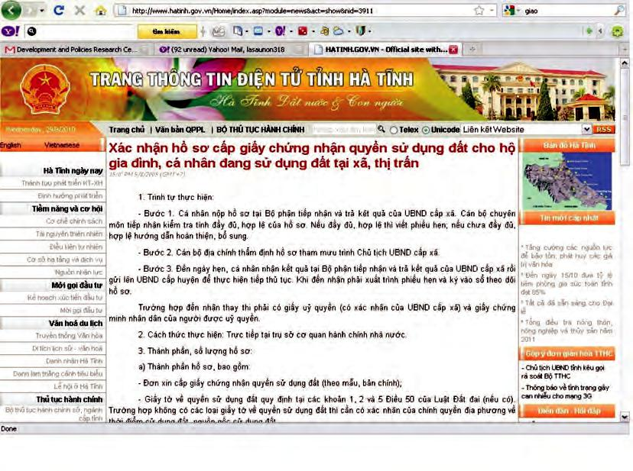

81

PageReport on Detailed Land Use Planning, and Detailed Land Use Plans on Bac Ninh’ s Website
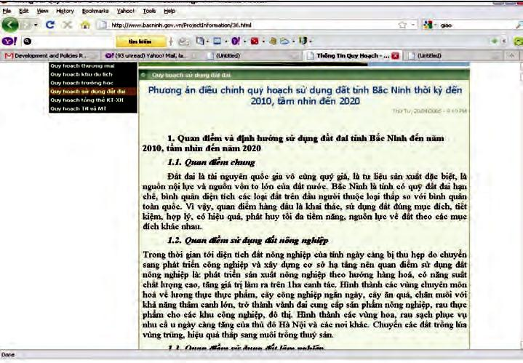

Decision Regarding Land Allocation on Quang Nam’ s Website
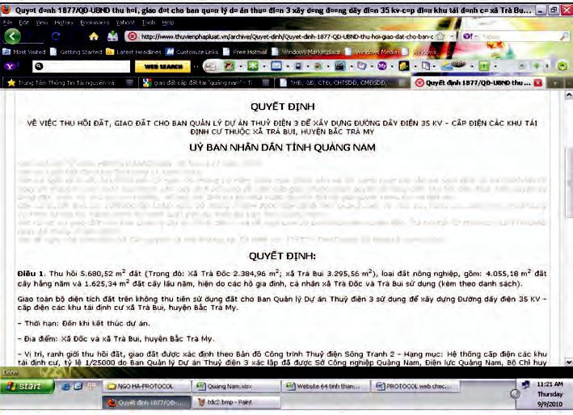

82

Page

A5.2 Bad Examples of Land Related Information Web-Based Disclosure

No Information on Land-related Administrative Procedures in Administrative Procedures on Ninh Binh’ s website
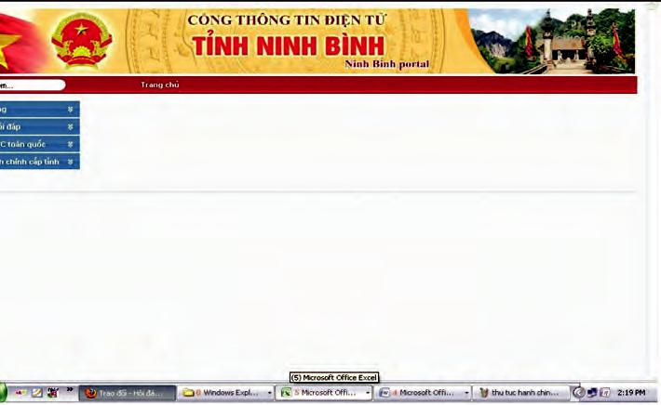

No Information on Online Service for Granting Certificates of Land Use Right on Ha Giang’ s Website
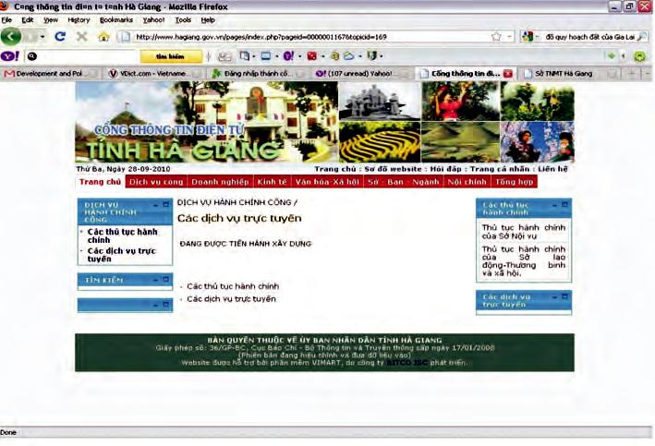

83

PageA5.3 Good Examples of Land Related Information Non-Web-Based Disclosure

All Detailed Maps, Planning and Models are on Display for Public to View in the Institute for Architecture Planning HCM City
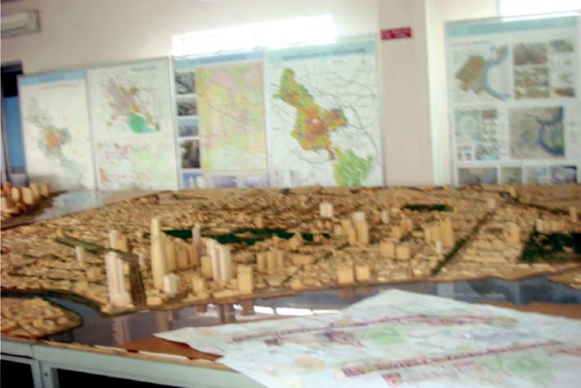

Land Use Planning and Detailed Land Use Plans in Commune Level in Front of the One-Stop Shop for Administrative Procedures
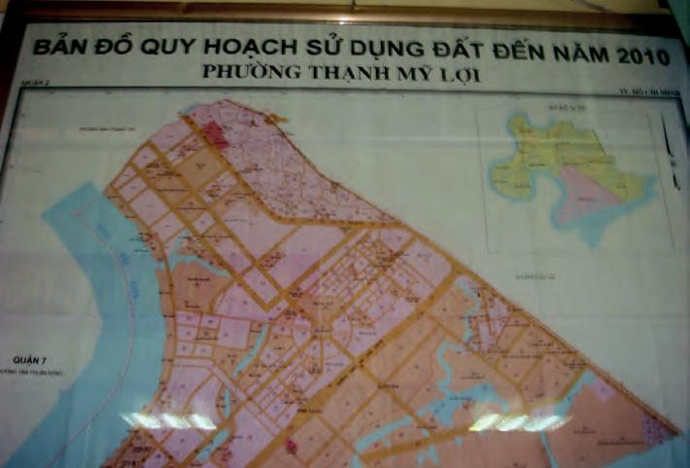

84

Page

A5.4 Bad Examples of Land Related Information Non-Web-Based Disclosure

Notice Board Where Posting on Administrative Procedures at a Commune Level
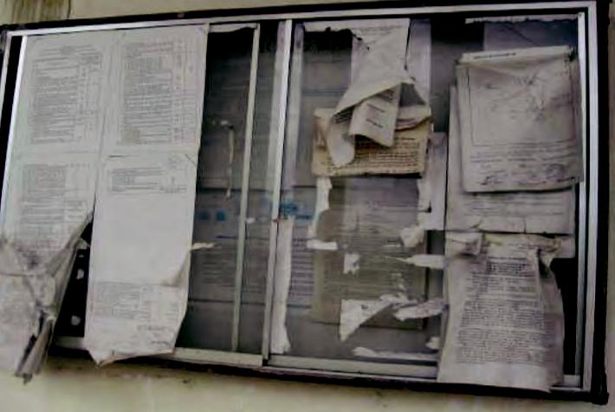

Notice Board Where Posting on Administrative Procedures at a Commune Level
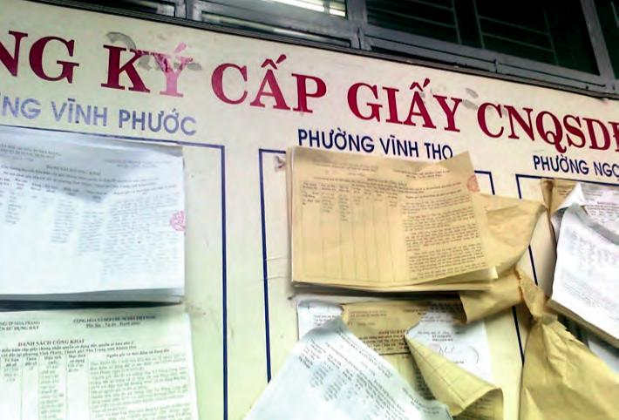

85

Page

Nhà xuất bản Văn hóa - Thông tin

In 200 cuốn khổ 19x24cm

Số giấy phép xuất bản: 171-2010/CXB/31/03-01-VHTT cấp ngày 29/12/2010


Available from:

VIETNAM DEVELOPMENT INFORMATION CENTER 63 Ly Thai To Street, Hanoi

Tel: (84 4) 3934 6845, Fax: (84 4) 3934 6847 www.vdic.org.vn

Cover photo: DEPOCEN

