Land-Use
and

Building

Condition
Survey
Report –

Poplar
Bluff, MO

2012-

2013

The Land-Use and Building Condition Survey study is intended to assist as an overall guide for the physical, economic and social development of the CX-3, Commercial/Residential Mixed Use District of Poplar Bluff. The study was designed to help guide the development of the downtown commercial district in a method that encourages safety, preservation of historic resources, revitalization, and general welfare of the overall community of Poplar Bluff.

Prepared by Terri L. Foley, Historic Preservation Consultant

Acknowledgements: This project is partially funded by a grant from the Missouri Department of Natural Resources, State Historic Preservation Office and the U.S. Department of the Interior, National Park Service. Grant awards do not imply an endorsement of contents by the grantor. Federal laws prohibit discrimination on the basis of race, religion, sex, age, handicap or ethnicity. For more information, write to the Office of Equal Opportunity, U.S. Department of the Interior, Washington D.C. 20240.
Table of Contents

Executive Summary 1

Introduction 2

Methodology 4

Property Database 5

Land-Use Survey Field Work 5

Condition Definitions and Standards 7

Land Use Analysis 9

Land Use Categories 10

Land Use Survey Findings 17

Land Use Parcel Area 17

Parcel Ownership Analysis 20

Building Area Analysis 21

Property Assessment 23

Assessed Values by Land Use Type 23

Building Structural Characteristics and Conditions 26

Building Height Analysis 29

Building Types 30

Exterior Wall Cladding 31

Analysis of Existing Building Conditions 33

Interior Conditions 36

Deterioration by Occupancy Status 36

Vacant Buildings 37

Control of Litter and Vegetation 38

Vacant Lots 39

Public Spaces 39

Parking Area Analysis 40

Historic Assets 41

Historic Buildings Analysis 41

National Register Parcels 42

Downtown Revitalization and Poplar Bluff 46

Business and Economic Development 48

i
The Main Street Approach and Principles 48

Main Street 48

Main Street Four Point Approach 49

The Eight Principles of Main Street 50

Summary of Land-use Existing Conditions 51

Recommendations and Development Strategy 54

Resources 58

Chart 1. Study Area and CX-3, Central Commercial, Mixed-Use District Boundary Map 5

Chart 2: Rating Score of Building Elements 8

Chart 3: Interior Rating Score of Buildings 9

Chart 4: Land Use of properties in the study area. 13

Chart 5: Broadway Street Building Use 14

Chart 6: Main Street Building Use 15

Chart 7: Vine Street Building Use 15

Chart 8: Second Street Building Use 16

Chart 9: Poplar, Pine, Moran and Maple Streets Building Use 16

Chart 10: The Overall District Building Use 17

Chart 11: Total Parcel Acreage by Use 18

Chart 12: Pine and Vine Street Parcel Acreage by Use 18

Chart 13: Poplar and Cedar Street Parcel Acreage by Use 19

Chart 14: Second and Main Street Parcel Acreage by Use 19

Chart 15: Broadway, Moran and Maple Streets Parcel Acreage 19

Chart 16: Total Parcel Acreage by Use 20

Chart 17: Ownership of Parcels 20

Chart 18: Parcels owned by local or absentee owners 21

Chart 19: Total Building Square footage 21

Chart 20: Total Building Square footage for Pine and Vine Streets 22

Chart 21: Total Building Square footage for Poplar and Second Streets 22

Chart 22: Total Building Square footage for Main and Broadway Streets 22

Chart 23: Total Building Square footage for Moran and Maple Streets and for the Overall Study Area 23

Chart 24: Assessed Values of the Study Area 24

Chart 25: Total Assessed Values of the Study Area 24

Chart 26: Total Assessed Building Values of the Study Area 25

Chart 27: Total Assessed Land Values of the Study Area 25

Chart 28: Total Appraised Values of the Study Area 26

Chart 29: Parcels assigned a value of $0 by Butler County Assessor’s Office 26

ii
Chart 30: Age of Buildings for Pine and Vine Streets 27

Chart 31: Age of Buildings for Poplar, Second, Moran and Maple Streets 28

Chart 32: Age of Buildings for Main and Broadway Streets 28

Chart 33: Age of Buildings for Overall District 29

Chart 34: Building Heights for Pine, Vine and Poplar Streets. 29

Chart 35: Building Heights for Second, Main and Broadway Streets 30

Chart 36: Building Heights for Moran and Maple Streets and Study Area Total 30

Chart 37: Percentage of Building Types 31

Chart 38: Exterior Wall Cladding for Study Area 32

Chart 39: Exterior Wall Cladding for Pine, Vine and Poplar Streets 32

Chart 40: Exterior Wall Cladding for Second, Broadway and Main Streets 32

Chart 41: Building Condition Map 34

Chart 42: Overall Building Condition for Study Area 35

Chart 43: Building Condition for Pine, Vine and Poplar Streets 35

Chart 44: Building Condition for Second and Main Streets 35

Chart 45: Building Condition for Broadway, Moran and Maple Streets 35

Chart 46: Overall Interior Condition Rating of Study Area (19 of 68 Buildings) 36

Chart 47: Deterioration by Occupancy Status for Overall Study Area 36

Chart 48: Vacant and Occupied Buildings for the Study District 37

Chart 49: Vacant Buildings Data by Level, and Space 37

Chart 50: Vacant Buildings by Ownership 38

Chart 51: Parking Acreage by Parking Lot Type and Ownership 40

Chart 52: Parking Lots by Ownership 40

Chart 53: Parking Lot Use Map 41

Chart 54: Historic Designation of Buildings in the Study Area by Listing and Streets 44

Chart 55: National Register of Historic Places Map 45

iii

Land-Use and Building Condition Survey Report – Poplar Bluff, MO

2012-
2013

Executive Summary

The Land-use and Building Condition Study was conducted in response to a new zoning classification of CX-3, Commercial/Residential Mixed Use District located in downtown Poplar Bluff. The study area consists of 27 blocks and the Poplar Bluff Commercial Historic District, located within the boundaries of the new zoning classification. For the purposes of this study, the “Land-use and Building Condition survey” was defined as being the boundaries of the CX-3, Central Commercial, Mixed-Use District, as outlined in the CX-3, Central Commercial, Mixed-Use District, Ordinance No. 7301. The purpose and intent of the CX-3, Central Commercial, Mixed-Use District per Ordinance No. 7301 is:

- Accommodate mixed-use buildings with neighborhood-serving retail, service and other uses on the ground floor and residential units above the nonresidential space;

- Encourage development that exhibits the physical design characteristics of pedestrian-oriented, storefront-style shopping streets;

- Promote the health and well-being of residents by encouraging physical activity, alternative transportation, and greater social interaction; and

- Promote an environment of confidence in property owners that a return of their investment is possible.

In order for a community to take the steps for the revitalization and economic development of a neighborhood in the future, it is essential to comprehend the targeted area in its current state. To take steps of planning for a neighborhood or area of a community, it depends upon knowing and understanding that section of town from many perspectives. Information collected from a land-use survey provides a fundamental knowledge of an area from a physical perspective. It provides specific data about individual parcels. Furthermore, the information may be merged and compared to generate data about general trends and to assess areas of future opportunities. An inventory of properties and their current uses may be used to identify where growth potential exist and what type of development and planning changes may be most beneficial to the Poplar Bluff community.

In this report, an analysis of land use, building structural characteristics, property conditions, and a parking assessment in the CX-3, Central Commercial, Mixed-Use District is presented. The analysis involved 68 buildings. Data was then further refined to allow analysis for each of the nine streets (Vine, Pine, Poplar, Cedar, Maple, Second, Main, Broadway, Moran) located within the district boundaries. The data supporting the analysis originated from the Butler County Assessor’s Office records, City of Poplar Bluff CX-3, Central Commercial, Mixed-Use District map, National Register of Historic Places nominations, architectural survey records, oral

1

Land-Use and Building Condition Survey Report – Poplar Bluff, MO

2012-
2013

interviews with property owners/business owners, and field survey conducted in July 2012, of every commercial parcel.

The survey area is predominantly commercial with little mixed-use. While it is possible more mixed-use properties exist, the consultant was limited in resources to determine the exact number of commercial buildings with residential apartments located on the upper levels. The data supporting the analysis of mixed-use was gathered from tax assessment records, interviews with property or business owners, and the number of electrical meters present. Bulks of properties are owned by individuals who own multiple properties in the study area and by absentee landowners (out-of-town landowners), including parcels with buildings and vacant lots. There are few vacant lots within the study area.

The average construction period of the buildings in the study area is 1920 - 1929. Most properties are constructed of brick. Several of the brick buildings have exterior wall coverings consisting of wood, vinyl, metal or stucco. The average building tends to exhibit some level of deterioration, which the consultant objectively assessed. Furthermore, approximately 53 percent of the buildings are vacant, i.e. partially vacant, boarded up or appear abandoned – a substantial concern, but then again a significant opportunity. Vegetation and litter management appears to be satisfactory to decent, with the majority of issues in this area found around vacant properties. Even though the study area is not the commercial hub it was in the past, this is a commercial district with a built environment that retains substantial stabilization and economic development potential.

The Land-use and Building Condition Study provides parcel and building information research for the entire 27 blocks of the CX-3, Central Commercial, Mixed-Use District. The study presents the opportunity to get an outline of overall current district land use conditions, as well as allowing for a greater examination of these blocks in the survey area. The data compiled in this report can offer a reference for both public and private sector land use policy decisions in the future. It is anticipated this report will provide the Poplar Bluff Planning Department, City policy leaders, Downtown Poplar Bluff organization, and property owners with a tool to use toward revitalization of the CX-3, Central Commercial, and Mixed-Use District.

Introduction

The following report provides the results of the Land-use and Building Condition survey project. The survey was funded in part by the State Historic Preservation Office of Missouri’s Department of Natural Resources. The purpose of this study was to complete an analysis of property conditions and land use for 27 blocks located within the CX-3, Central Commercial,

2

Land-Use and Building Condition Survey Report – Poplar Bluff, MO

2012-
2013

and Mixed-Use District in downtown Poplar Bluff, Missouri. This documentation is necessary to fulfill the city’s planning needs and to provide data for future revitalization and economic development within the district.

The project area is located in downtown Poplar Bluff (Butler County), Missouri and is comprised of 27 commercial blocks. The survey area is bounded by Fifth Street to the west, Pine Street to the north, the Black River to the east, and Cherry Street to the south. The project was completed by Terri L. Foley, historic preservation consultant. Dennis Avery, city planner for Poplar Bluff, was local coordinator for the project and Michelle Diedriech, Survey Coordinator and JoAnn Radetic, Certified Local Government Coordinator for the Missouri Historic Preservation Office (MO-SHPO), served as monitors for the project.

The consultant conducted survey activities on July 2 – 11, 2012. A total of 68 properties were documented during the course of the survey. Included in the survey were commercial/public buildings, vacant lots, public green space/parks, parking lots (public/private), lighting conditions, and sidewalks. The study area is situated in downtown Poplar Bluff. A detailed analysis of property tax assessment records, survey of buildings conditions and land-use was conducted. In this report, the consultant will present a descriptive analysis of land-use and building conditions located within the district boundaries.

The consultant used tax parcel data to gather data on ownership, parcel information, approximate square footage of buildings, approximate construction dates, and parcel acreage. The field survey data collected information on building condition, building use, vacant buildings, litter and vegetation, lighting conditions, parking conditions, and vacant lots. Photographs were taken of each building located in the study area.

The project is designed to assemble the base information about the activities of the CX-3, Central Commercial, Mixed-Use District. In addition, information on the sustainable character of the district was also assessed. It is the goal of this study to provide the City of Poplar Bluff with a comprehensive understanding of its district. With this information the City of Poplar Bluff’s Planning Department, City officials, and Downtown Poplar Bluff can make informed decisions about the future directions of the district.

The basic principle of this survey project is to provide information and recommendations to assist the City of Poplar Bluff and Downtown Poplar Bluff in their revitalization efforts. An understanding of the CX-3, Central Commercial, Mixed-Use District land uses is of vital significance in verifying the scope and complexity of activities in the district. Also the survey

3

Land-Use and Building Condition Survey Report – Poplar Bluff, MO

2012-
2013

helps to identify what is omitted or what could be developed or extended (types of commercial businesses, infrastructure, etc.). For the most part, it is presumed the use of a building, on all floors, is whatever located on the first floor. For instance, if a building houses offices on the first floor, most people assume the uppers floors house office space as well. The data compiled in this study furnishes the building use of all floors, if known. In addition, the report will also supply information on the various types of business, and services found within the district boundaries.

Methodology

For the purposes of this analysis, the study area was defined as being all land parcels located within the boundaries of the CX-3, Central Commercial, Mixed-Use District, as defined in the Ordinance No. 7301. Please refer to the map below for an overview of the survey area’s boundaries. For the purpose of this study, the charts and results by streets combine Maple and Moran Streets data together. Each street holds one building; the building located on Maple Street (420) is located near the corner of Maple and Moran Streets.

4

Land-Use and Building Condition Survey Report – Poplar Bluff, MO

2012-
2013

Chart 1. Study Area and CX-3, Central Commercial, Mixed-Use District Boundary Map – Boundary of area is designed by dotted lines -----------
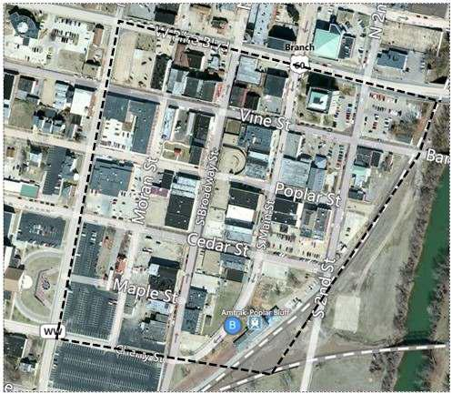

Property Database

Parcel data was collected from the Butler County Tax assessments, Butler County Internet Mapping System website (http://butler.villagis.net/) and Butler County parcel map of the study area. Information on historical status was collected from the National Register of Historic Places database (http://www.dnr.mo.gov/shpo/Butler.htm) with the MO-SHPO.

Land-Use Survey Field Work

Between, July 2 – July 11, 2012, the consultant conducted an intensive land-use survey of all properties in the study area by street address. Digital photos of each property were taken and afterwards evaluated based on the survey form utilized in the study. When possible, the consultant entered buildings, conducted an interior survey and sketched floor plans. The survey was created to evaluate land use, building condition, building type and construction, occupancy status, parking use and litter and vegetation control.

5

Land-Use and Building Condition Survey Report – Poplar Bluff, MO

2012-
2013

The function of in-field survey for existing land use and building conditions is to document the conditions and use of any buildings on a parcel. Documentation is conducted from the vantage position of facing street, sidewalk or alley. The consultant recorded the list of necessary information in data fields in the survey form. The data fields for the form were structured from input by the City of Poplar Bluff Planning Department, MO-SHPO, and the consultant’s previous data collection experience.

The following data categories were analyzed for each parcel:

Land use: the type of use on a parcel (see more detailed definitions further in this report).

Owner: legal owner of property.

Owner status: each property owner was recorded as one of the following in this report: Private: a non-publicly owned property which may be under the control of a single individual or a group of individuals.

Public: a non-privately owned property that is under the control of local government. Most of these properties are open and accessible to the general public.

Non-Profit: a non-private or publicly owned property that is owned by a non-profit organization or group.

Local Owner: an owner who lives locally, but may not live on-site.

Absentee Owner: an owner who does not live locally. Parcel area: the approximate size of the property lot.

Building use: what is housed in each of the building such as, commercial, mixed-use, public, service, etc.

Building condition: Documented any issues or concerns with the buildings.

Attached or stand-alone building: a single building or a building with shared party walls.

Building fabric: exterior wall surface of a building (brick, wood, stucco, etc.).

Vacant or occupied: the current status of a building.

Building height: the number of stories for each building.

Building area: approximate square footage.

Assessment data: property assessment amount.

Parking availability on-site: indicating whether parking is, or is not, available for a specific property.

Parking ownership: property owner of parking lots.

Parking type and area: indicating whether parking is an uncovered lot or a parking structured (parking garage).

6

Land-Use and Building Condition Survey Report – Poplar Bluff, MO

2012-
2013

National Register of Historic Places designation status: indicating if buildings located on parcels, are listed in the National Historic Register of Historic Places.

Condition Definitions and Standards

The buildings were scored based upon certain factors; the survey form was designed to include definitions, examples to rate building conditions. The overall building condition was originated based on the total score of the exterior building element conditions and interior building conditions (when allowed) completed by a visual assessment.

The primary building elements were categorized as follows:

Trim

Exterior walls Roof

Entrance/Porch Steps

Windows Doors

Gutters/Downspouts

Vegetation/overgrown or on building (including landscape features)

Each of the above elements was documented for the following issues:

Loose materials (trim, shingles, etc.)

Missing materials (shingles, bricks, mortar, windows, steps, doors, etc.) Worn/weathered (paint, trim, roofing materials, gutters, doors, etc.)

Cracks (windows, bricks, mortar, etc.)

Holes (roof, windows, wall surface, etc.)

Bowing (roofing caving inward, wall leaning outward, etc.)

Other (infill of windows, boarded up windows, bent trim, damaged siding, etc.)

Location (area where elements were documented: façade, west, east, south, north, etc.)

Each of the building elements (location documented) was given a rating from 0 – 4 based on the following categories and definitions as follows:

7

Land-Use and Building Condition Survey Report – Poplar Bluff, MO

2012-
2013

Chart 2: Rating Score of Building Elements

 | LOCATION OF DEFECT: |  |  |  |  |  | TOTAL SCORE OF OVERALL BUILDING CONDITION:
 | FAÇADE |  | CENTER |  |  |  | 36 – EXCELLENT | 18-26 – FAIR
 | BACK |  | THROUGHOUT |  |  |  | 27-35 – GOOD | 9-17 - POOR
 | WEST |  | SOUTH |  |  |  | 0-8 - DILAPIDATED
 | NORTH |  | EAST
 | RATING SCORE |  |  |  |  | RATING CATEGORY |  | DEFINITIONS/EXAMPLES
0 |  |  |  |  |  | DILAPIDATED |  | ABSENCE OF ROOF, ABSENCE
 |  |  |  |  |  |  |  | OF A WALL/S, ABSENCE OF
 |  |  |  |  |  |  |  | STAIRS/PORCH, ABSENCE OF
 |  |  |  |  |  |  |  | WINDOWS
1 |  |  |  |  |  | POOR |  | SAGGING ROOF, HOLE IN ROOF,
 |  |  |  |  |  |  |  | HOLE OR OPEN CRACK IN
 |  |  |  |  |  |  |  | FOUNDATION, BULGING
 |  |  |  |  |  |  |  | EXTERIOR WALLS, CRUMBLING
 |  |  |  |  |  |  |  | CHIMNEY, HOLES IN WALL,
 |  |  |  |  |  |  |  | SHATTERED WINDOWS, MAJOR
 |  |  |  |  |  |  |  | RE-POINTING OF BRICK
2 |  |  |  |  |  | FAIR |  | CRACKED WINDOWS, BROKEN
 |  |  |  |  |  |  |  | DOOR, BROKEN STEPS, MINOR
 |  |  |  |  |  |  |  | RE-POINTING OF BRICK, MISSING
 |  |  |  |  |  |  |  | SHINGLES, LOOSE SHINGLES,
 |  |  |  |  |  |  |  | LOOSE SIDING, MISSING TRIM
 |  |  |  |  |  |  |  | (WINDOWS/DOORS), ENCLOSED
 |  |  |  |  |  |  |  | WINDOWS OR ENTRANCES;
 |  |  |  |  |  |  |  | MISSING
 |  |  |  |  |  |  |  | GUTTERS/DOWNSPOUTS,
 |  |  |  |  |  |  |  | BOARDED UP WINDOWS/DOORS
3 |  |  |  |  |  | GOOD |  | PEELING PAINT, MINOR
 |  |  |  |  |  |  |  | MAINTENANCE ISSUES
4 |  |  |  |  |  | EXCELLENT |  | BUILDING ELEMENTS ARE
 |  |  |  |  |  |  |  | SOUND/INTACT

The primary interior building elements were categorized as follows:

Floors Ceilings Walls

Each of the above elements was documented for the following issues:

Loose material Missing material Holes

Cracks Other Location

8

Land-Use and Building Condition Survey Report – Poplar Bluff, MO

2012-
2013

The overall score of the interior condition and location guide is as follows:

Chart 3: Interior Rating Score of Buildings

12 – EXCELLENT |  | 1st FLOOR-L1
9–11 – GOOD |  | 2nd FLOOR-L2
6-8 | – FAIR | 3rd FLOOR- L3
1-5 | – POOR
0 - DILAPIDATED

In addition to the overall building condition, the building mechanical system, utilities and safety devices were documented when possible. Those items are as follows:

Central Heat and Air (Gas or Electric) Other forms of heating and cooling Water (hot and cold running)

Fire sprinkler system Fire alarms

Smoke detectors

Carbon monoxide detectors

Land Use Analysis

In this section of the report, data was analyzed to examine information pertaining to land use for the entire study area. This section will be beneficial for comprehending overall baseline data for the district.

While the study area is considered a commercial district, there are different classifications of building usage: commercial, mixed-use, non-profit and public. Parcels without a building have various classifications such as, underdeveloped lot, parking lot, and green space/ park. The table on the following pages illustrates each land use category within the study area. Commercial buildings that do not have mixed-use are exceedingly common. Mixed-used (commercial with residential) are minor, the exact amount of residential in upper levels of some buildings is unknown, as the consultant was not able to gain access to all buildings. In addition, when the consultant inquired about the use of an upper level, for the most part the tenant located on the lower level did not know the use of the upper level. The consultant had to determine if mixed-use was present by local tax assessment records, oral interviews and in-field survey.

9

Land-Use and Building Condition Survey Report – Poplar Bluff, MO

2012-
2013

A few of the vacant lots within the study area are the result of a couple of razed buildings that has not undergone redevelopment. This property presents a key redevelopment opportunity.

The following information defines the various categories of land use and examples of each category.

Land Use Categories
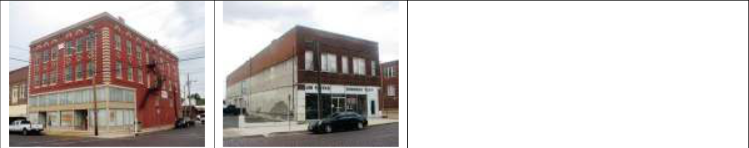

Commercial Retail: A retail establishment offering goods: clothes, supplies, musical instruments, durable goods, second-hand goods, etc.

A Commercial Retail use – 401 and 416 Vine Streets
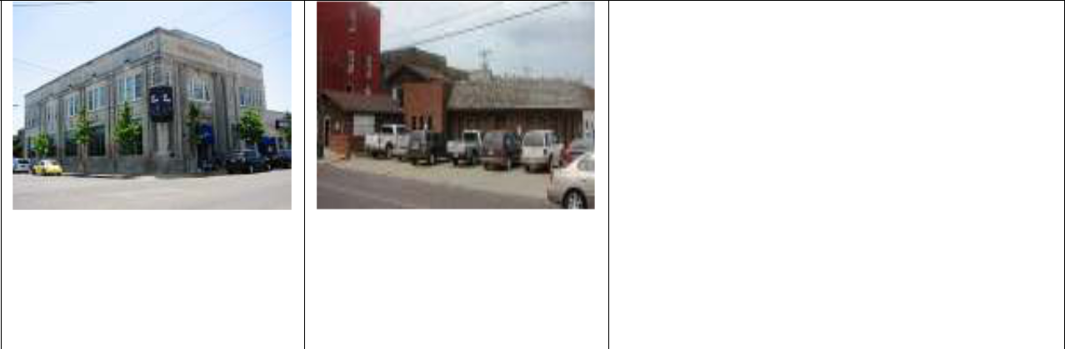

Commercial Services: An establishment that offers a service, examples include: restaurants, food establishments, bars, taverns, banks, law offices, professional offices, doctor offices, medical offices, repair businesses, hair care, tattoo parlors, engineering services, taxi services, etc.

*A breakdown of these services is provides in
the charts below

A Commercial Service use – 200 Main and 109 N. Broadway Streets
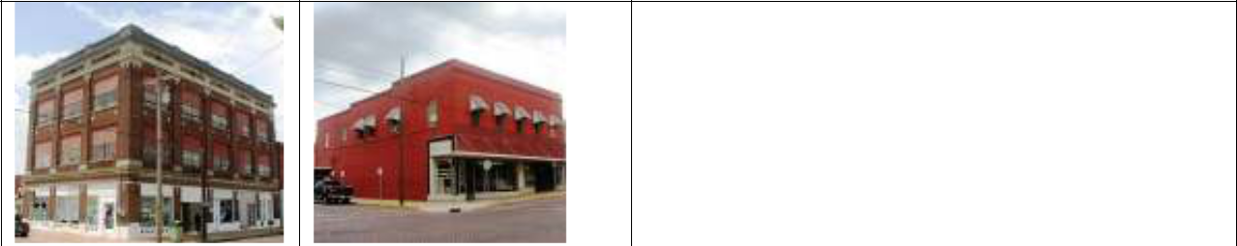

Mixed Use: A combination of commercial and residential use at a single location. Typically includes a commercial space on the first floor and residential space on the floors above.

Mixed Use development – 117-125 S. Broadway and 325 Vine Streets

10

Land-Use and Building Condition Survey Report – Poplar Bluff, MO
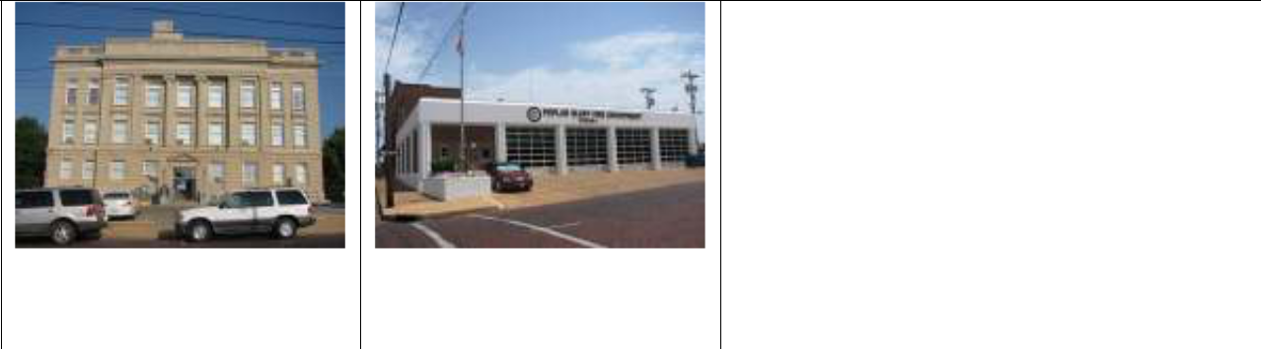
2012-
2013

Public Use: Federal, state, or local government civic uses. This includes parcels containing a fire station, courthouse, government office or facility, post office, government owned museum, or park. This category also includes all parcels owned by the county government that houses vacant buildings.

Example Public Use – 100 N. Main and 300 S. Main Streets
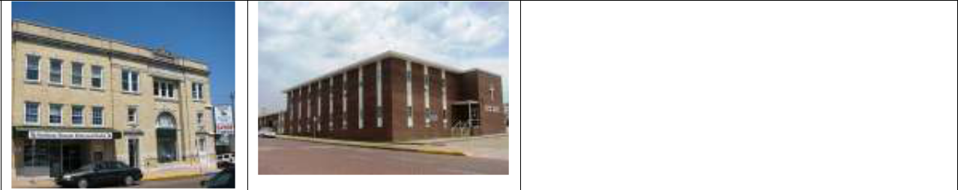

Non-Profit Service/Office: All non-government, tax exempt organizations. This includes homeless shelters, non-profit service agencies and providers (e.g. Habitat for Humanity, Rescue Mission), community foundations, etc.

Examples of Non-Profit Service/Offices – 101 S. Main and 400 S. Broadway


Private Parking: Privately owned parking lots that restrict public use, or is available to business patrons only on a short-term basis. Also includes publicly owned parking lots that generally restrict availability to designated vehicles most of the time (e.g. such as county employee vehicle parking area)

An example of private parking – 414 Poplar Street
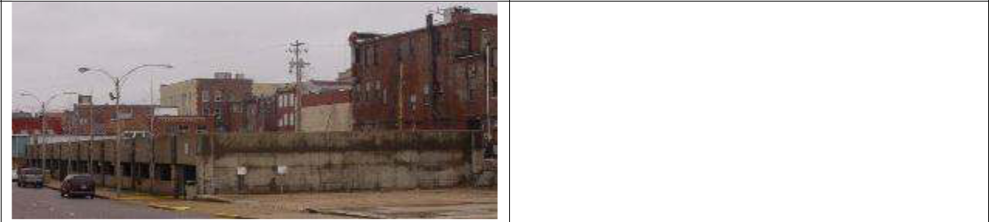

Public Parking: Parking that is owned by public entity and generally available for public use at all times, examples includes: the city owned parking garage on Broadway and parking lot on Vine Street.

An example of public parking – S. Broadway Street

11

Land-Use and Building Condition Survey Report – Poplar Bluff, MO
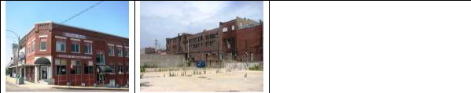
2012-
2013

Vacant Developed: Parcels that were previously developed, but are now available for reutilization. This may include vacant buildings, and vacant lots.

An example of a vacant developed building and lot – 301 S. Main Street and S. Broadway

None within district boundaries

Vacant Unimproved: Parcels that usually have no prior development. This includes undisturbed green space, open land and other undeveloped areas.
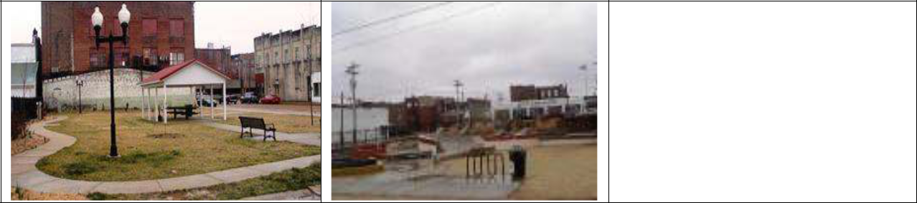

Public Space: Parcels owned by the local government for the use of public gathering.

This includes green space and various types of parks.

Example of public spaces – Poplar and Cedar Streets
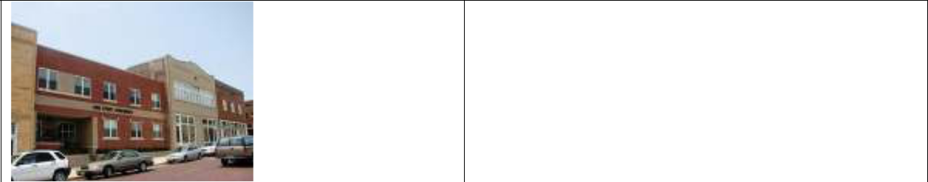

Multi-Family Residential: Any building, group of buildings, or portions thereof containing two or more individual dwelling units.

Vine Street Apartments, a Multi-Family Residential building – 430 Vine Street

12

Land-Use and Building Condition Survey Report – Poplar Bluff, MO

2012-
2013

The following map represents the study area’s buildings and parcels use by the above mentioned categories.

Chart 4: Land Use of properties in the study area.
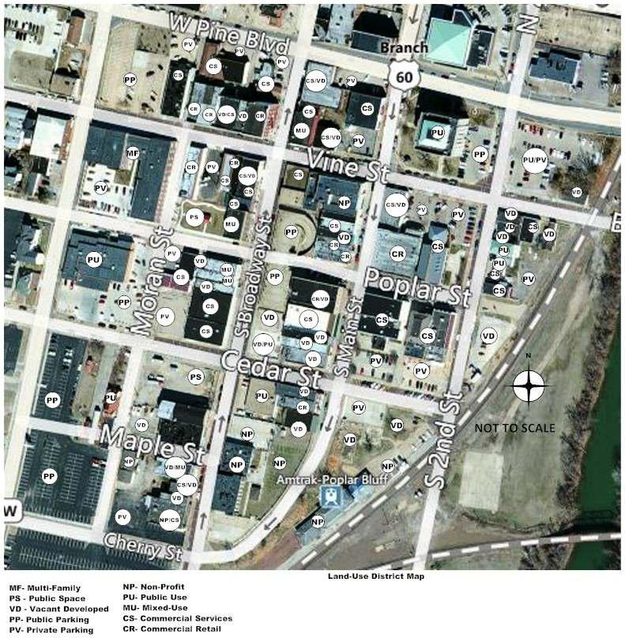

13

Land-Use and Building Condition Survey Report – Poplar Bluff, MO

2012-
2013

The following charts represent the study area’s building use by the above mentioned categories. The category “commercial services” has been broken down into various services to provide more detailed data at what types of services are located within the study area. In addition, “transportation” was included in the detailed count to reflect a taxi cab service and Amtrak service located within the district. The category of “social services” includes the Gospel Rescue Mission, and Southeast Missouri Behavioral Health. Under residential, any known apartments in the upper level of buildings were included (vacant or occupied), as well as, the Gospel Rescue Mission since it is a shelter that provides living quarters on a permanent basis. Public service includes the county offices, the Butler County prosecuting attorney’s office and the post office. Buildings that housed more than one use, was accounted for coordinately by each use located in the building. For instance, a building that housed a professional service, professional office and residential on the upper levels would have a listing under each category. Individual streets provide detailed information on what types of businesses or services are located on them, then the overall total for the study area is summarized on another chart. The percentages below do not reflect the vacant spaces within the buildings.

Chart 5: Broadway Street Building Use
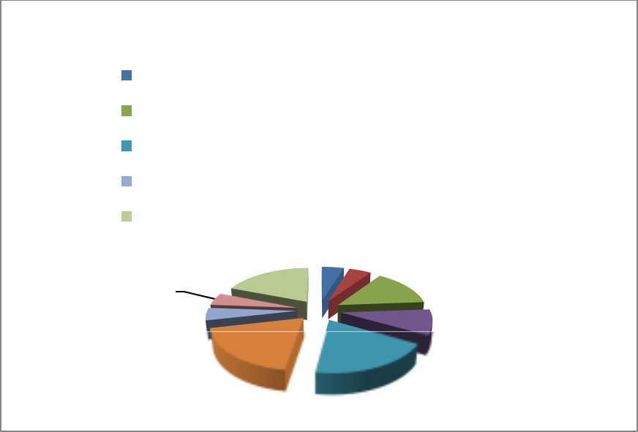

Broadway Street Building Use

Retail |  | Food Establishment
Drinking Establishment |  | Social Services
Professional Service |  | Professional Service
Public Service |  | Transportation
Residential
19% | 5% |  | 5%
19% |  |  | 14%
5% |  |  | 14%
5%
19% | 19% |  | 9%

14

Land-Use and Building Condition Survey Report – Poplar Bluff, MO

2012-
2013

Chart 6: Main Street Building Use
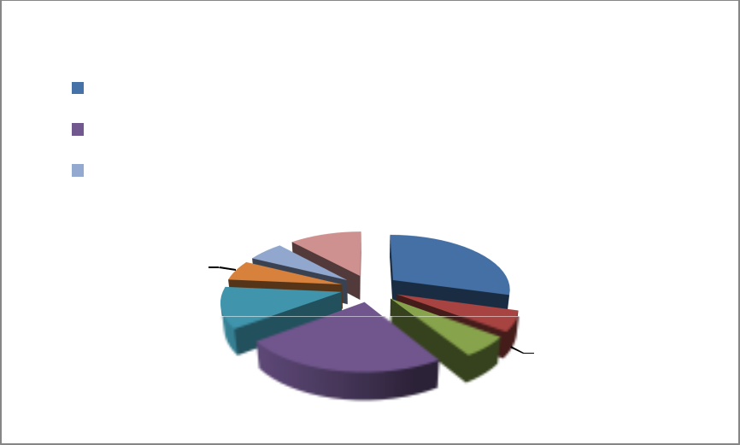

Main Street Building Use

Retail |  | Medical |  | Social Service
Professional Office |  | ProfessionalService |  | Public Service
Transportation |  | Residential
 | 12%
6%
6% | 29%
12% | 23% |  | 6%
 |  |  | 6%

Chart 7: Vine Street Building Use
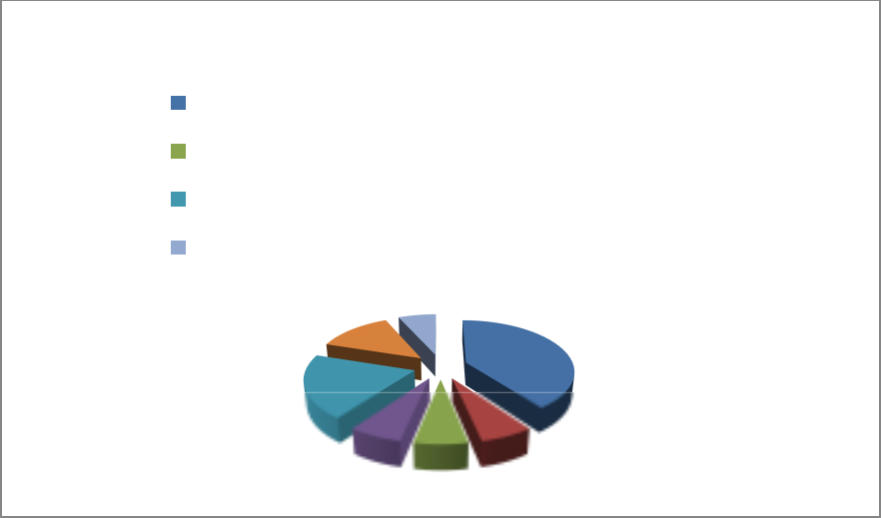

Vine Street Building Use

Retail |  |  |  | Food Establishment
Drinking Establishment |  |  |  | Professional Office 1
Professional Service |  |  |  | Residential
Multi-Family
13% | 7%
 |  | 40%
20%
7% |  | 7% |  |  | 6%

Multi-Family Residential:

15

Land-Use and Building Condition Survey Report – Poplar Bluff, MO

2012-
2013

Chart 8: Second Street Building Use
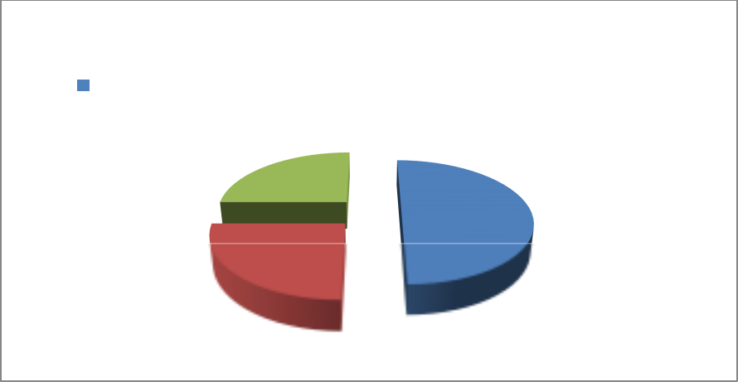

Second Street Building Use

Professional Office |  | Professional Service |  | Public Service

25%
50%

25%

Chart 9: Poplar, Pine, Moran and Maple Streets Building Use
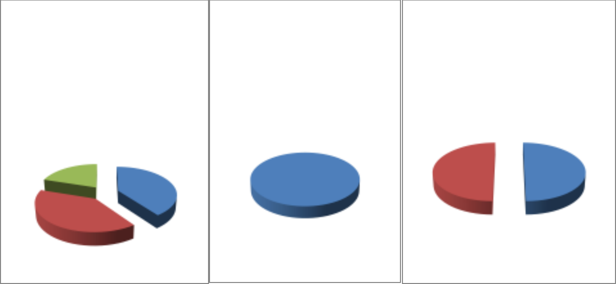

Poplar Street Building |  |  | Pine Street Building |  |  |  | Moran/Maple Streets
 |  | Use |  |  | Use |  | Building Use
 |  | Professional Office |  |  | Professional Service |  | Museum |  | Professional Office
 |  | Professional Service
 |  | Public Service
20% |  |  |  |  |  | 50% |  | 50%
40% |  |  | 100%
40%

16

Land-Use and Building Condition Survey Report – Poplar Bluff, MO

2012-
2013

Chart 10: The Overall District Building Use
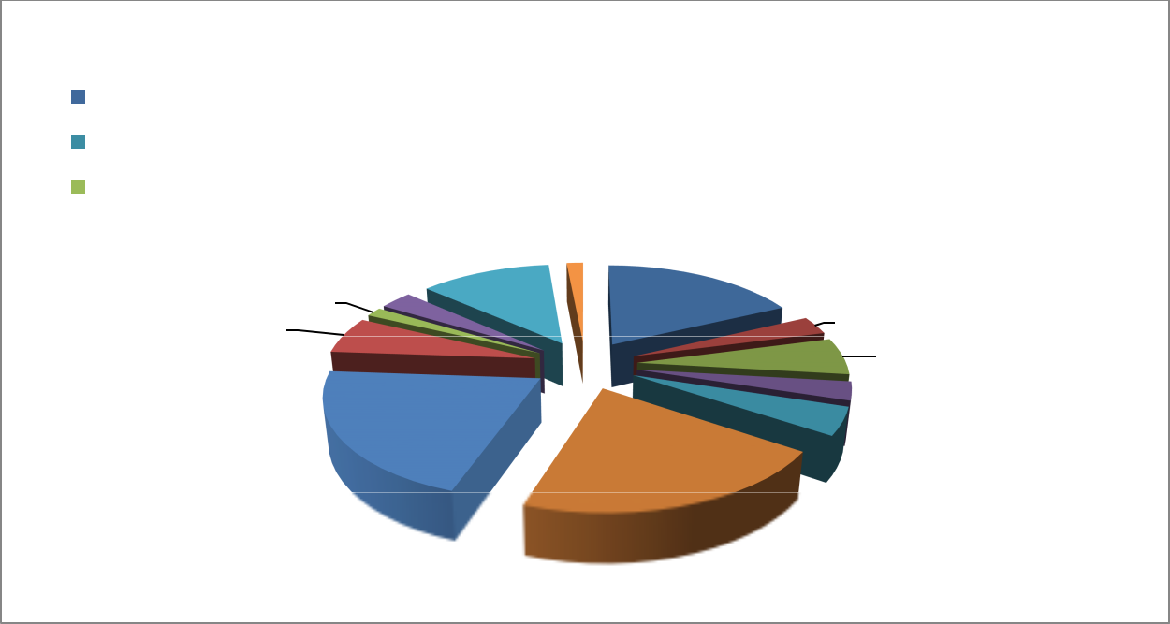

Building Use Overall for Study Area

Retail |  |  |  | Food Establishment |  |  |  | Drinking Establishment |  |  | Medical
Social Services |  |  |  | Professional Office |  |  |  | Professional Service |  |  | Public Service
Musem |  |  |  | Transportation |  | 1% |  | Residential |  |  | Multi-Family
2% |  |  | 3% |  | 12% | 18%
 | 6% |  |  |  |  |  |  |  | 3%
 |  |  |  |  |  |  |  |  | 6%
 |  | 21% |  |  |  |  |  |  | 3%
 |  | 21% |  |  |  |  |  |  | 4%

Land Use Survey Findings

The study area holds two eating establishments with one of the establishments being a restaurant/bar (three percent) and a total of four drinking establishments (six percent). There are no café, sandwich or coffee shops located in the district. Retail businesses make up only 18 percent of the study area. The consultant located only one store within the survey boundaries to sell bottled drinks (water, soft drinks, etc.) Located in the district are two barber shops, one hair salon, and a shoe repair store. Retail stores were comprised mainly of resale type shops for furniture and various goods. There is one music store which seemed to draw a lot business. As mentioned previously, it is unknown how many upper levels hold apartments but overall only 12 percent (total includes the housing at Gospel Rescue Mission) of the buildings in the survey area appear to contain apartments. Professional office and services each account for 21 percent of building space. A vacant rating of buildings within the study area is discussed in the section “Vacant or Boarded-Up Buildings.”

Land Use Parcel Area

Summarized in the table below is the total parcel area in acreage, for each land use based on the Butler County’s assessor’s data. Commercial services have considerable total parcel acreage in the study area, as well as commercial retail (shown under “Commercial”). Public uses have substantial parcel acreage in the study area also. The public uses embody county government offices, the city’s fire department station, U.S. Post Office, local government

17

Land-Use and Building Condition Survey Report – Poplar Bluff, MO

2012-
2013

parking areas and vacant developed lots. Several vacant buildings were noted during the in-field survey. These “Vacant Developed” acres signify an opportunity for new economic development to occur within the study area. Any future development of the Vacant Developed properties may well enhance additional economic enticement to the CX-3, Central Commercial, Mixed-Use District

Chart 11: Total Parcel Acreage by Use

Total Parcel | Commercial | Mixed-Use | Multi-family | Public | Non-Profit
Acreage |  | Residential
Pine Street | 0.741 | 0 | 0 | 0 | 0
Vine Street | 1.95 | 0.337 | 0.997 | 0.466 | 0
Poplar Street | 0.904 | 0 | 0 | 0.997 | 0
Cedar Street | 0.105 | 0 | 0 | 0 | 0
Second Street | 0.826 | 0 | 0 | 0.306 | 0
Main Street | 2.77 | 0.253 | 0 | 1.06 | 0.312
Broadway | 1.91 | .313 | 0 | 1.23 | 1.45
Street
Moran/Maple | 0 | 0 | 0 | 2.21 | 0.154
Streets
Total | 9.206 | 0.903 | 0.997 | 6.269 | 1.916

Total Parcel Acreage for the district without figuring the acreage for streets and sidewalks is 19.291 acres. Approximate acreage including the streets and sidewalks is 30.807 acres.

Chart 12: Pine and Vine Street Parcel Acreage by Use


Pine Street Parcel Acreage |  |  | Vine Street Parcel Acreage
 |  | Commercial |  |  | Commercial |  | Mixed - Use
 |  |  |  |  | Multi-Family |  | Public
 |  |  | 12%
100% |  |  | 27% |  |  | 52%
 |  |  | 9%

18

Land-Use and Building Condition Survey Report – Poplar Bluff, MO

2012-
2013

Chart 13: Poplar and Cedar Street Parcel Acreage by Use


Poplar Street Parcel Acreage |  |  |  |  | Cedar Street Parcel Acreage
 |  | Commercial |  | Public |  |  | Commercial

48%

52%
100%

Chart 14: Second and Main Street Parcel Acreage by Use
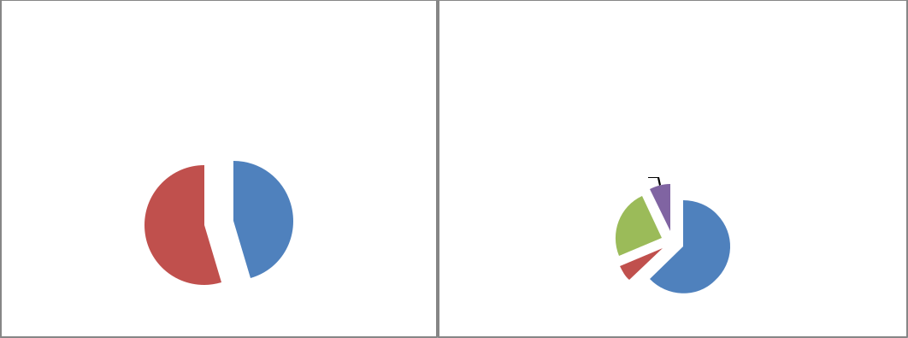

Second Street Parcel Acreage |  |  |  |  | Main Street Parcel Acreage
 |  | Commercial |  | Public |  |  | Commercial |  | Mixed-Use
 |  |  |  |  |  |  | Public |  | Non-Profit

 | 7%
45% | 24%
55% | 24%
 | 63%
 | 6%

Chart 15: Broadway, Moran and Maple Streets Parcel Acreage
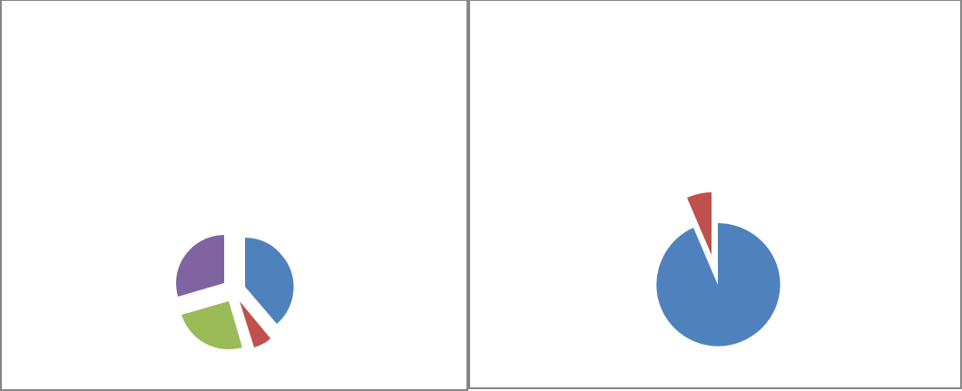

Broadway Street Parcel |  |  |  |  | Moran/Maple Streets Parcel
 |  | Acreage |  |  |  |  | Acreage
 |  | Commercial |  | Mixed-Use |  |  | Public |  | Non-Profit
 |  | Public |  | Non-Profit | 7%
30%
 |  |  | 39%
 |  |  |  |  | 93%
25% |  |  | 6%

19

Land-Use and Building Condition Survey Report – Poplar Bluff, MO

2012-
2013

Chart 16: Total Parcel Acreage by Use


Total Parcel Acreage by Land Use

Commercial Mixed-Use Multi-Family Public Non-Profit

10%

47%
33%
5% | 5%

Parcel Ownership Analysis

The majority of parcels located within the study area boundaries are privately owned. Parcels owned by public entities is 16% of the total 88 parcels located in the study area. Publicly owned parcels are located throughout the district.

Located within the study area boundaries are a few parcels owned by non-profit organizations. It is common for various non-profit organizations to locate to downtown commercial areas, as it usually allows for the organization to better serve a community and to reach a larger number of people in a concentrated area. A few of the non-profit organizations located in the study area are Southeast Missouri Treatment Center, Gospel Rescue Mission and The Habitat for Humanity store. The following charts provide information of a breakdown of ownership of parcels.

Chart 17: Ownership of Parcels
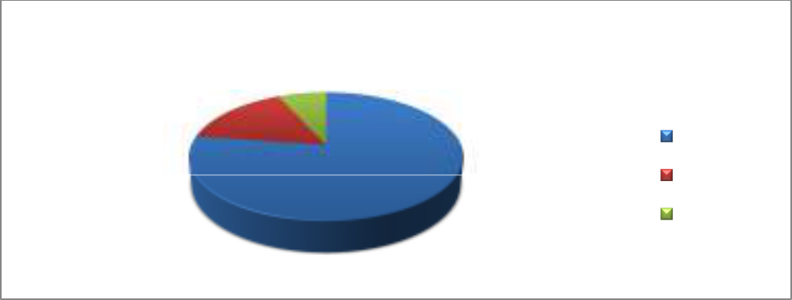

Ownership of Parcels

7%

16% |  | Private
 | 77% | Public
 |  | Non-Profit

20

Land-Use and Building Condition Survey Report – Poplar Bluff, MO

2012-
2013

Chart 18: Parcels owned by local or absentee owners


Local or Absentee Owners

35% | Local
65% | Absentee

Building Area Analysis

An important piece of the character of the CX-3, Central Commercial, Mixed-Use District is the building height and building area. These dimensions aid in the identification of the bulk, density and scale of development in the district. Presented in the following charts is information pertaining to building area, building height, commercial area, and residential area.

The following data in the charts below were ascertained from the Butler County Assessor’s Office parcel data. The Assessor’s Office had square footage summaries listed for commercial, mixed-use residential (when known), multi-family, public and non-profit.

Chart 19: Total Building Square footage

Total Building | Commercial | Mixed-Use | Multi-family | Public | Non-Profit
Square Footage |  | Residential
Pine Street | 14,076 | 0 | 0 | 0 | 0
Vine Street | 55,485 | 17,600 | 125,634 | 0 | 0
Poplar Street | 19,685 | 0 | 0 | 15,780
Cedar Street | 0 | 0 | 0 | 0 | 0
Second Street | 10,431 | 0 | 0 | 5,956 | 0
Main Street | 76,809 | 7,320 | 0 | 37,638 | 28,826
Broadway | 51,859 | 25,572 | 0 | 2,368 | 18,512
Street
Moran/Maple | 0 | 0 | 0 | 3,592 | 2,560
Streets
Total | 228,345 | 50,492 | 125,634 | 65,334 | 49,898

21

Land-Use and Building Condition Survey Report – Poplar Bluff, MO

2012-
2013

Chart 20: Total Building Square footage for Pine and Vine Streets


Pine Street Building Square |  |  | Vine Street Building Square
 |  | Footage |  |  | Footage
 |  | Commercial |  |  | Commercial
 |  |  |  |  | Mixed-Use Residential
 |  |  |  |  | Multi-Family
 |  |  | 28%
 |  |  | 63%
100% |  |  | 9%

Chart 21: Total Building Square footage for Poplar and Second Streets
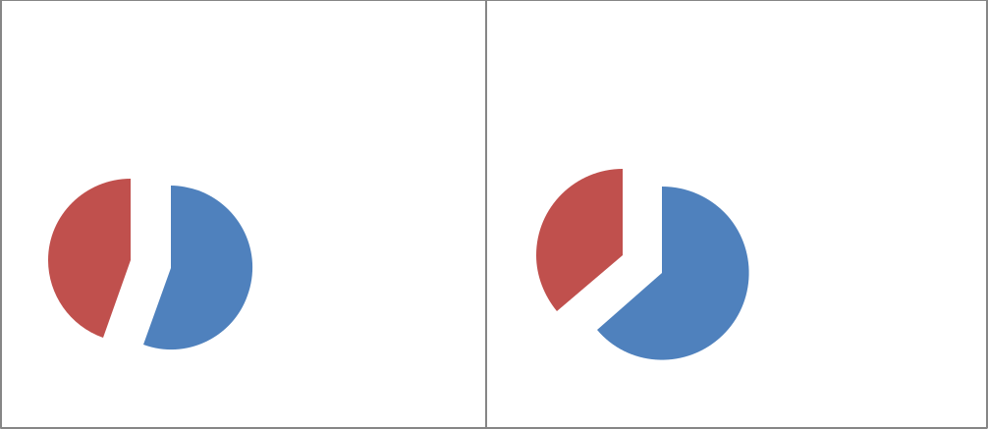

Poplar Street Building | Second Street Building
Square Footage | Square Footage

44% |  | Commercial | 36% |  |  | Commercial
56% |  | Public |  | 64% |  | Public

Chart 22: Total Building Square footage for Main and Broadway Streets
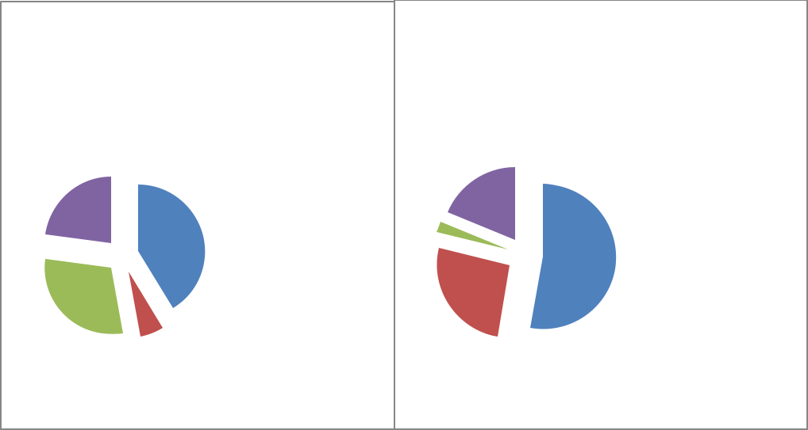

Main Street Building Square |  |  |  | Broadway Street Building
Footage |  |  |  | Square Footage
 |  | Commercial |  |  |  |  | Commercial
 | 76809
23% |  | Mixed-Use | 2% | 19% |  |  | Mixed-Use
41% |  | Residential |  |  |  |  | Residential
 |  | Public |  | 53% |  |  | Public
30% |  |  |  | 26%
6% |  | Non-Proft |  |  |  |  | Non-Proft

22

Land-Use and Building Condition Survey Report – Poplar Bluff, MO

2012-
2013

Chart 23: Total Building Square footage for Moran and Maple Streets and for the Overall Study Area
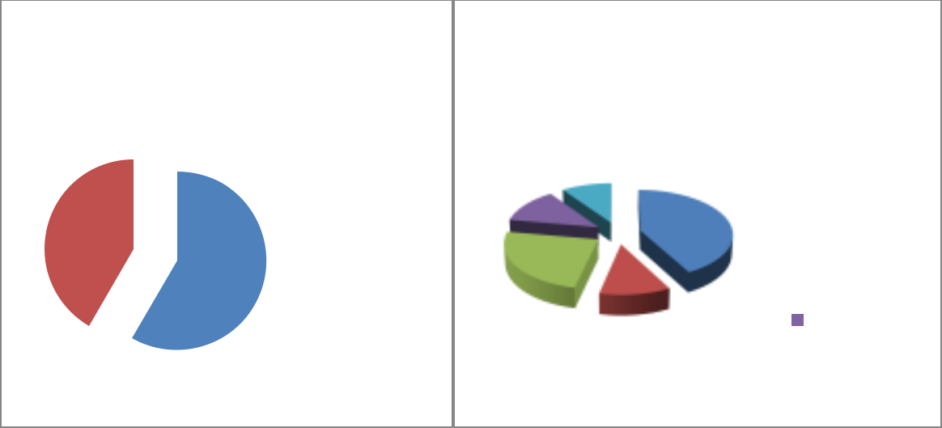

Moran/Maple Streets Building |  |  |  | Total Building Square Footage of
 | Square Footage |  |  | Study Area
 |  |  |  | 10% |  | Commercial
 |  | 13% |  |  |  | Mixed-Use
42% |  |  | Public | 42% |  | Residential
42% |  |  | Public | 24% |  | Multi-Family
 | 58% |  | Non-Profit | 24% |  | Multi-Family

Public
11%

Non-Proft

Property Assessment

Assessed Values by Land Use Type

While there is little known mixed-use in the study area, in general the district is a perfect location for Mixed-Use development.

The assessed and appraised values of properties in the study area were obtained by the property records on file with the Butler County Assessor’s Office. The following data was used to determine the property values in the district:

Assessed Value – assessed value of commercial property is 32 percent of the appraised value of a property.

Appraised Value – appraised value is the real market value of a property. Building Value – appraised value of the building.

Land Value – appraised value of the land.

Summarized in the charts below, is the assessment information acquired from the Butler County Assessor’s Office. Assessment records utilized were obtained on July 11, 2012. Totals include all properties (private, public, and non-profit). Values (appraised, assessed, building and land) were gathered from each parcel in the district from the property assessment records. These totals were then compiled to provide the values by each street and total study area.

23

Land-Use and Building Condition Survey Report – Poplar Bluff, MO

2012-
2013

Chart 24: Assessed Values of the Study Area

Value | Assessed | Building | Land | Appraised
Pine | $67,750.00 | $174,160.00 | $37,540.00 | $211,700.00
Vine | $813,900.00 | $3,394,030.00 | $409,860.00 | $3,771,920.00
Poplar | $133,680.00 | $409,840.00 | $95,390.00 | $505,230.00
Cedar | $3,160.00 | $0.00 | $9,880.00 | $9,880.00
Second | $112,170.00 | $297,440.00 | $53,120.00 | $350,560.00
Main | $447,280.00 | $1,207,570.00 | $166,360.00 | $1,367,050.00
Broadway | $207,360.00 | $591,230.00 | $87,580.00 | $678,810.00
Moran | $880.00 | $0.00 | $3,780.00 | $3,780.00
Total | $1,895,270.00 | $6,407,140.00 | $924,970.00 | $7,293,260.00

*This total includes one multi-family residential; all other values for buildings are commercial. Totals for the multi-family are as follows:

Multi-Family |  | Assessed |  |  | Building |  |  | Land |  |  |  |  | Appraised
Residential Value |  | Assessed |  |  | Building |  |  |  |  |  |  |  | Appraised
Vine | 589,510.00 |  |  | 2,826,150.00 |  |  |  | 276,510.00 |  |  |  |  | 3,102,660.00
Chart 25: Total Assessed Values of the Study Area
 |  | Total Assessed Values
 | 0% |  |  | 4% |  |  |  |  |  | Pine Street
 | 12%
 |  |  |  |  |  |  |  |  |  | Vine Street
 | 25%
 |  |  |  |  |  |  |  |  |  | Poplar Street

46%
 |  |  |  | Cedar Street
 |  | 7% |  | Second Street
6% |  |  |  | Main Street
6% | 0% |  |  | Broadway Street

*The assessed values of properties on Moran/Maple Streets are a smaller enough percentage of the overall figures that is shown as zero percent on the chart. There are no buildings on Cedar Street to be appraised.

24

Land-Use and Building Condition Survey Report – Poplar Bluff, MO

2012-
2013

Chart 26: Total Assessed Building Values of the Study Area
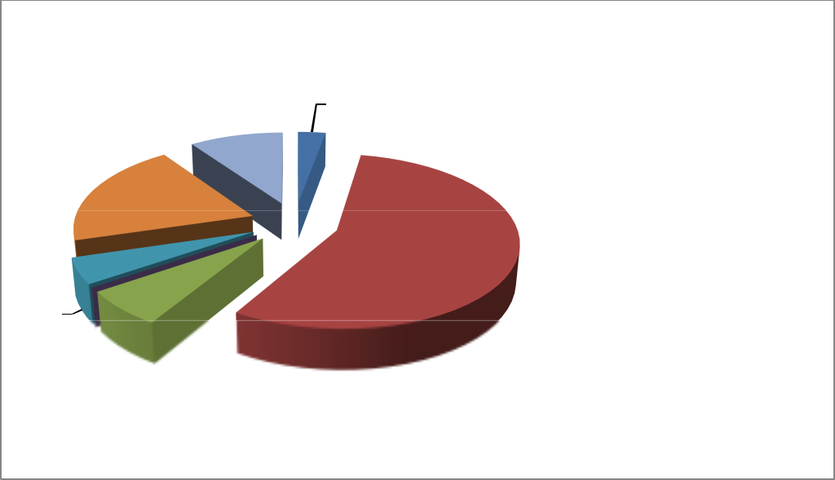

 |  |  |  | Total Building Values
 |  |  | 0% | 3%
 |  |  | 0% |  |  | Pine Street
 |  | 9% |  |  |  | Pine Street
 |  | 9% |  |  |  | Vine Street
 | 20% |  |  |  |  | Vine Street
 | 20% |  |  |  |  | Poplar Street
 |  |  |  | 56% |  | Cedar Street
 |  |  |  | 56% |  | Second Street
5% | 7% |  |  |  |  | Second Street
5% |  |  |  |  |  | Main Street
0% |  |  |  |  |  | Main Street
0% |  |  |  |  |  | Broadway Street
 |  |  |  |  |  | Moran/Maple Streets

*The assessed building values of properties on Moran/Maple Streets is a smaller enough percentage of the overall figures that is shows on the chart as zero percent. There are no buildings on Cedar Street to be appraised.

Chart 27: Total Assessed Land Values of the Study Area
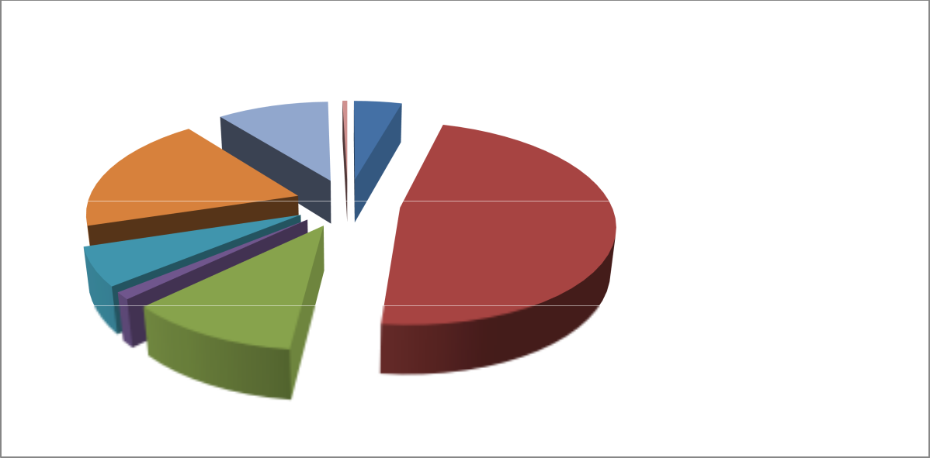

 | Total Land Values
 | 1%
10% | 4% |  | Pine Street
19% |  |  | Vine Street
 |  |  | Poplar Street
6% | 48% |  | Cedar Street
6% |  |  | Second Street
11% |  |  | Main Street
1% |  |  | Broadway Street
Moran/Maple Streets

25

Land-Use and Building Condition Survey Report – Poplar Bluff, MO

2012-
2013

Chart 28: Total Appraised Values of the Study Area


Total Appraised Values
 |  | 0% _{3%} |  |  | Pine Street
 |  | 10% |  |  | Pine Street
 | 20% | 10% |  |  | Vine Street
 | 20% |  |  |  | Poplar Street
 |  |  | 55% |  | Cedar Street
5% | 7% |  |  |  | Second Street
5% | 0% |  |  |  | Main Street
 | 0% |  |  |  | Broadway Street
 |  |  |  |  | Moran/Maple Streets

*The appraised values of properties on Cedar, Moran/Maple Streets are a smaller enough percentage of the overall figures that is shown on the chart as zero percent.

Chart 29: Parcels assigned a value of $0 by Butler County Assessor’s Office


Parcels Assigned a Value of $0

^{33%} 39%
City Owned

County Owned

28% |  | Non-Profit Owned

Building Structural Characteristics and Conditions

Age of Buildings

Buildings in the study area were constructed over a wide span of years. The charts below break down the age of buildings by the decades starting prior to 1900, then each decade after until 1970. While the arbitrary cut-off date for National Register eligibility is 1963 at the time of this

26

Land-Use and Building Condition Survey Report – Poplar Bluff, MO

2012-
2013

report, the charts below summarize building age by the decade of the 1960s. Buildings constructed from 1970 to 2009 are grouped together as fewer buildings were constructed in each decade during this time period. The year 2009 has been used as the ending date as it is the most recent building to be constructed in the study area. By breaking down the construction of buildings by decades and streets, it provides insight to which areas of the district experienced building construction over time and which section has the oldest percentage of buildings. The highest percentages of buildings were constructed in the 1920s, at 28 percent. Fewer buildings were built before 1900 and the decade 1900 - 1909, both at five percent of district totals. As indicated in the charts below, the oldest buildings are located on Vine Street. Only 15 percent of buildings in the district were constructed since 1970.

Chart 30: Age of Buildings for Pine and Vine Streets
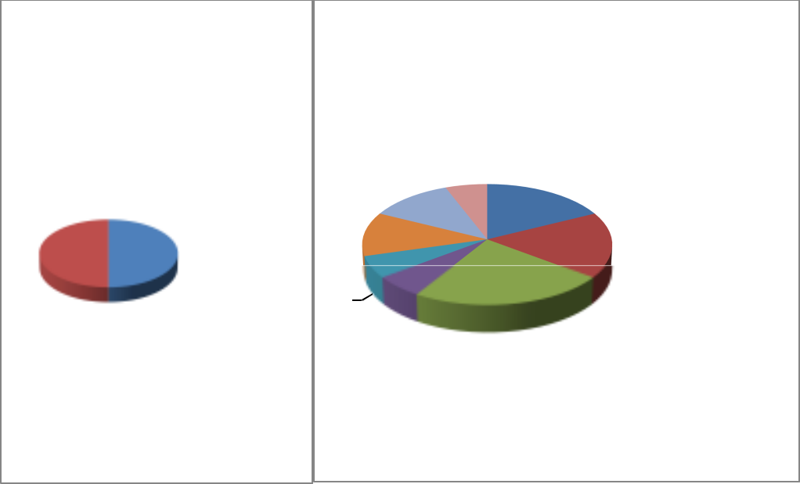

Pine Street Vine Street

 |  |  |  |  |  |  |  | 6% |  | <1900
 |  |  |  |  |  |  | 12% | 6% |  | 1900-1909
 |  |  | 1940- |  |  |  | 12% | 17% |  | 1910-1919
 |  |  |  |  |  |  | 12% | 18% |  | 1920-1929
50% | 50% | 1949 |  |  |  |  | 12% | 18% |  | 1920-1929
 |  |  | 1950- |  | 6% |  |  | 23% |  | 1930-1939
 |  |  |  | 1959 |  | 6% |  |  |  | 1940-1949
 |  |  |  |  |  |  |  |  |  | 1950-1959
 |  |  |  |  |  |  |  |  |  | 1970-2009

27

Land-Use and Building Condition Survey Report – Poplar Bluff, MO

2012-
2013

Chart 31: Age of Buildings for Poplar, Second, Moran and Maple Streets
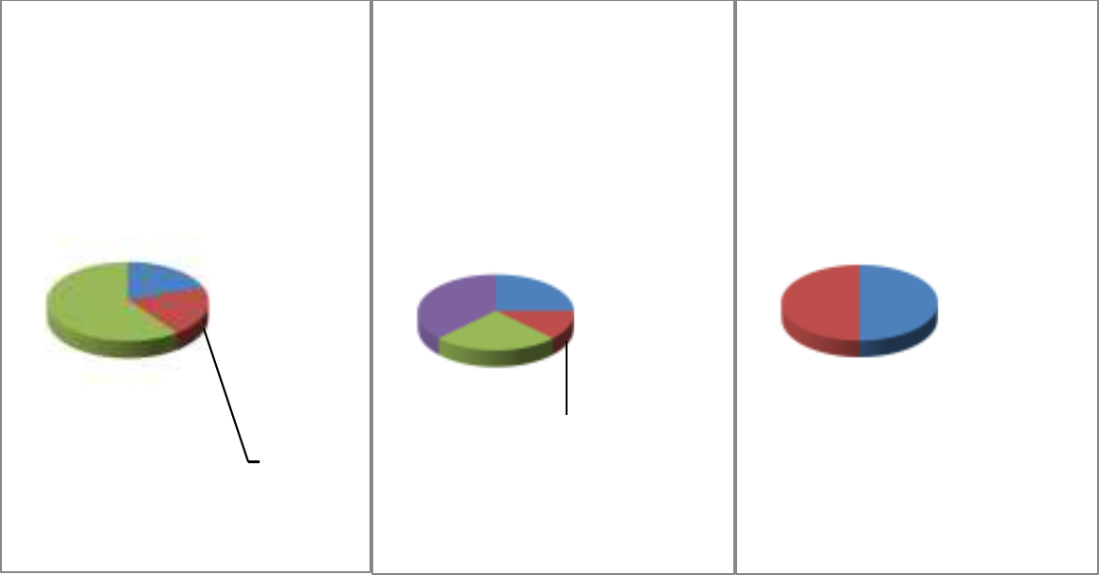

 | Poplar Street |  |  |  |  |  | Second Street |  |  |  |  | Moran/Maple Streets
 |  |  |  |  |  |  |  |  |  |  | 1920-
 |  |  |  |  |  |  |  |  |  |  | 1929
 | 20% |  |  | 1910- |  |  |  |  |  |  | 1940-
 |  |  |  | 1917 |  |  | 0% | 25% |  |  | 1940- |  |  | 1920-
 |  |  |  | 1917 | 38% |  | 0% |  |  |  | 1949
 |  |  |  | 1950- |  |  |  |  |  |  | 1950- | 50% 50% | 1929
 |  |  |  | 1959 |  |  |  |  |  |  | 1950- |  |  | 1970-
 |  |  |  | 1959 |  |  |  |  |  |  | 1959
60% |  |  |  | 1970- |  |  |  |  |  |  | 2009
 |  | 2009 |  |  |  | 25% |  |  |  |  | 1960-
 |  |  |  |  |  |  |  |  |  | 1969
 |  |  |  |  |  |  |  |  | 12%
 |  | 20% |  |  |  |  |  |  |  |  | 1970-
 |  |  |  |  |  |  |  |  |  | 2009

Chart 32: Age of Buildings for Main and Broadway Streets
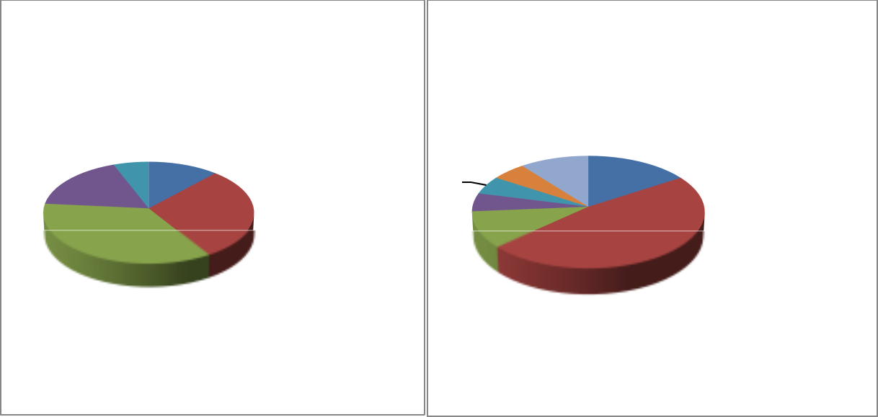

Main Street Broadway Street

6% 0% 12% |  | 1900-1909 | 5% | 11% |  | 1910-1919
6% 0% 12% |  | 1900-1909 | 5% | 11% |  | 1920-1929
18% |  | 1910-1919 | 5% | 16% |  | 1930-1939
18% |  | 1920-1929 | 5% |  |  | 1930-1939
29% |  | 1920-1929 | 5% |  |  | 1930-1939
29% |  | 1920-1929 | 11% |  |  | 1940-1949
35% |  | 1930-1939 | 11% | 47% |  | 1940-1949
1950-1959
1940-1949
1960-1969
1960-1969
1970-2009

28

Land-Use and Building Condition Survey Report – Poplar Bluff, MO

2012-
2013

Chart 33: Age of Buildings for Overall District
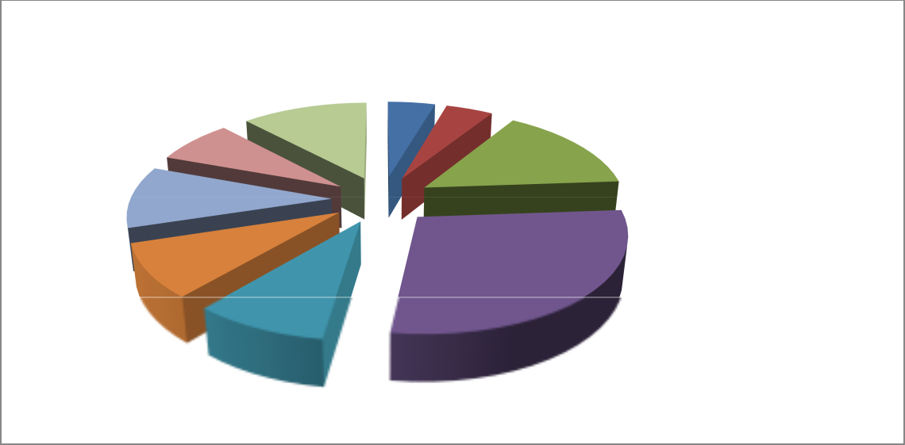

 | Age of Buildings
 | 5% |  | <1900
12% | 5% |  | <1900
12% | 5% |  | 1900-1909
7% | 15% |  | 1900-1909
 | 15% |  | 1910-1919
10% |  |  | 1910-1919
10% |  |  | 1920-1929
9% |  |  | 1930-1939
9% | 28% |  | 1940-1949
9% |  |  | 1950-1959

1960-1969

1970-2009

Building Height Analysis

Building height was established by in-field survey. The data does not take into consideration the basement level of buildings. The charts below demonstrate an analysis of the building heights by streets. The average height for the overall district is also calculated. A substantial majority (41%) of buildings within the study area are one-story in height. Less common are three-stories at 10% of all buildings.

Chart 34: Building Heights for Pine, Vine and Poplar Streets.
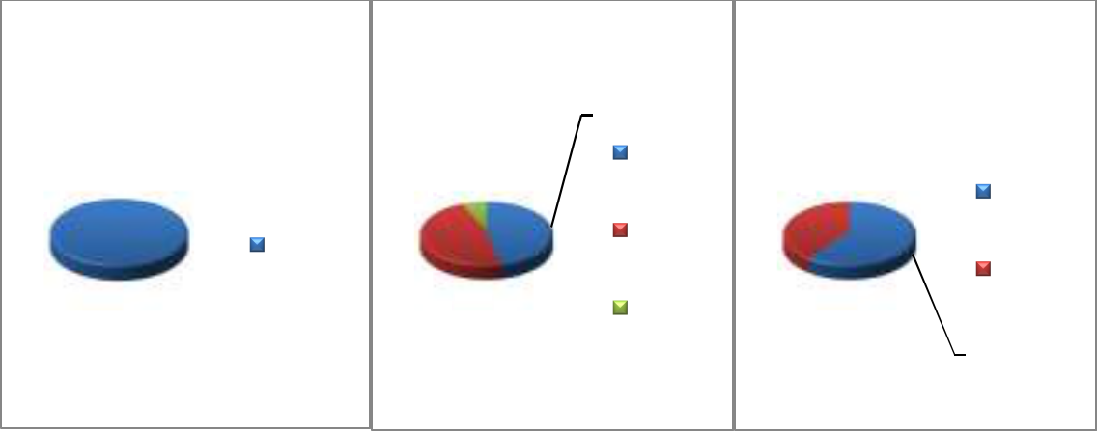

Pine Street |  | Vine Street | Poplar Street
 |  | 46%
 |  | 1 Story
 |  | 7% | 1 Story
 |  | 40% | 1 Story
 | 1 Story | 2
 | 1 Story | Stories
 |  | Stories | 2
 |  | 47% | 2
100% |  | 47% | Stories
100% |  | 3 | Stories

Stories | 60%

29

Land-Use and Building Condition Survey Report – Poplar Bluff, MO

2012-
2013

Chart 35: Building Heights for Second, Main and Broadway Streets
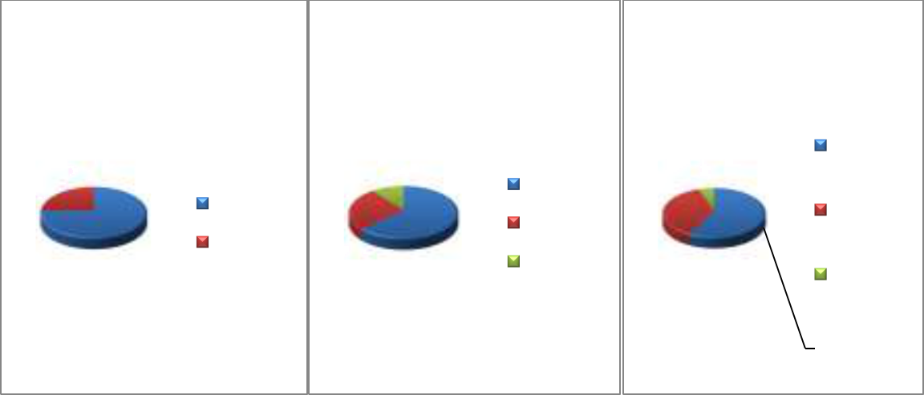

Second Street Main Street Broadway Street

 |  |  | 1 Story
25% | 11% | 1 Story | 5%
25% | 26% | 1 Story | 37%
 | 1 Story | 2 Stories | 2
 |  | 2 Stories | Stories
 | 2 Stories |  | Stories
 | 75% | 63% 3 Stories | 3 Stores
 |  |  | 58%

Chart 36: Building Heights for Moran and Maple Streets and Study Area Total
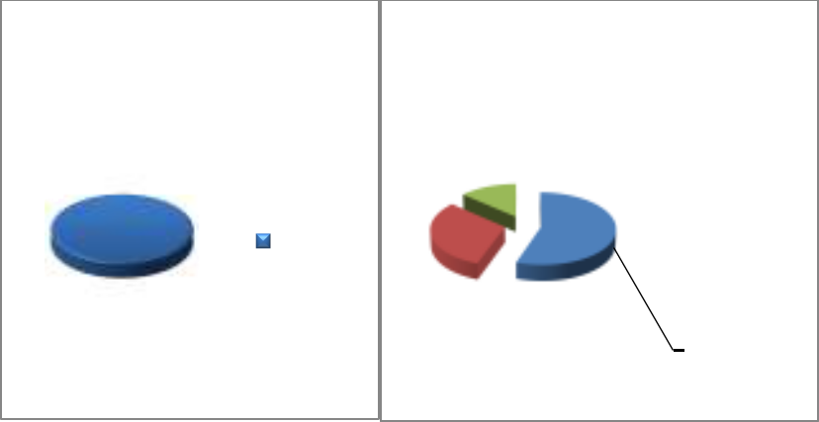

Moran/Maple Streets |  | Study Area Total
 |  | 14%
1 Story |  |  |  | 1 | Story
1 Story | 31% |  |  | 2 | Stories
100% | 31% |  |  | 3 Stories
 |  | 55%

Building Types

The study area is comprised of stand-alone and attached property type buildings. Survey findings found 70 percent of the district contains “attached” property type buildings. Attached buildings are very common in historic commercial districts. The chart below summarizes the percentage of stand-alone and attached property types.

30

Land-Use and Building Condition Survey Report – Poplar Bluff, MO

2012-
2013

Chart 37: Percentage of Building Types
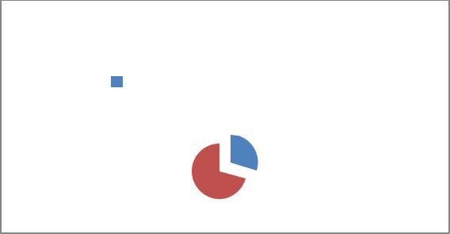

Building Types

Stand-alone |  | Attached

30%

70%

Exterior Wall Cladding

As summarized in the chart below, 53 percent of the buildings are clad in brick. This percentage does not include those brick buildings whose facades have other wall cladding materials mixed with the brick wall cladding. Under the category “Brick Mixed,” buildings with brick cladding mixed with either metal, vinyl, wood, concrete and enamel panels are listed. Buildings within in the district that have been covered in metal slip covers, wood siding, etc., indicate a time when property owners felt the brick facades of their buildings needed to be updated or more modernize to keep up with the style at the time. However, there are some buildings constructed originally with vinyl siding in the district. The building located at 420 Maple Street is an example of a modern building originally clad in vinyl siding. While the consultant did not provide the dates of façade remodels, the chart provides an understanding of which streets underwent the most façade changes and what was the most common material used to change the façade. The chart takes into account not only the façade but the buildings as a whole. Brick wall cladding is the most prevalent at 53 percent and vinyl being the less common at only one percent

31

Land-Use and Building Condition Survey Report – Poplar Bluff, MO

2012-
2013

Chart 38: Exterior Wall Cladding for Study Area


Exterior Wall Cladding

 | 1% |  | 3% 1%
 | 4% |  | 3% 1% |  |  |  |  | Brick
 | 9% |  |  |  |  |  |  | Brick Mixed
 |  |  |  |  |  |  |  | Stucco/Dryvit
 |  |  |  |  |  |  |  | Concrete
 | 29% |  |  | 53% |  |  |  | Metal
 |  |  |  |  |  |  |  | Wood
 |  |  |  |  |  |  |  | Vinyl
Chart 39: Exterior Wall Cladding for Pine, Vine and Poplar Streets
 | Pine Street |  |  | Vine Street |  |  |  | Poplar Street
 |  |  |  |  | Brick
 |  |  | 7% ^{7%} |  | Brick |  | 20% | Brick
 | Brick |  |  |  | Brick |  | 20%
 | Brick |  |  |  | Mixed |  | 20%
 | Brick |  | 6% |  | Mixed
50% | 50% |  |  |  | Stucco/ |  |  | Stucco
50% | 50% |  |  | 60% | Stucco/ |  |  | / Dryvit
 | Brick |  |  | 60% | Dryvit |  |  | / Dryvit
 | Mixed |  |  |  | Dryvit
 | Mixed |  | 20% |  | Concrete |  | 20% | Metal
 |  |  |  |  | Wood |  |  | 60%
Chart 40: Exterior Wall Cladding for Second, Broadway and Main Streets
Second Street |  |  | Broadway Street |  |  |  | Main Street
11% | 17% |  |  | Brick |  | 10% |  | Brick
 | Brick |  | 50% | Brick |  |  | 37% | Brick
 |  |  | 50% | Mixed |  |  |  | Mixed
89% | Wood | 33% |  | Mixed |  | 53% |  | Mixed
 |  |  |  | Stucco/ |  |  |  | Concrete
 |  |  |  | Dryvit
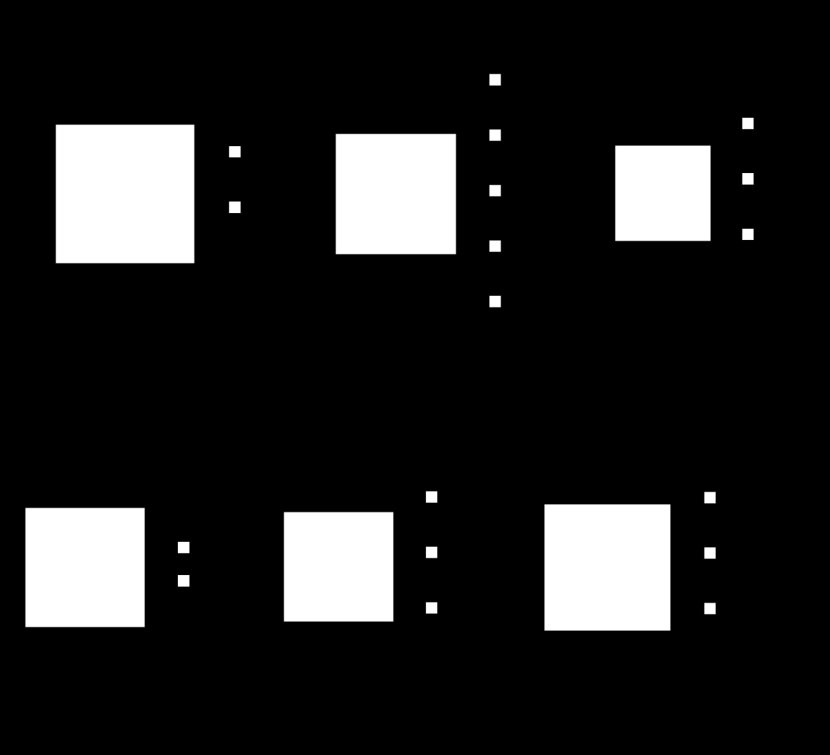
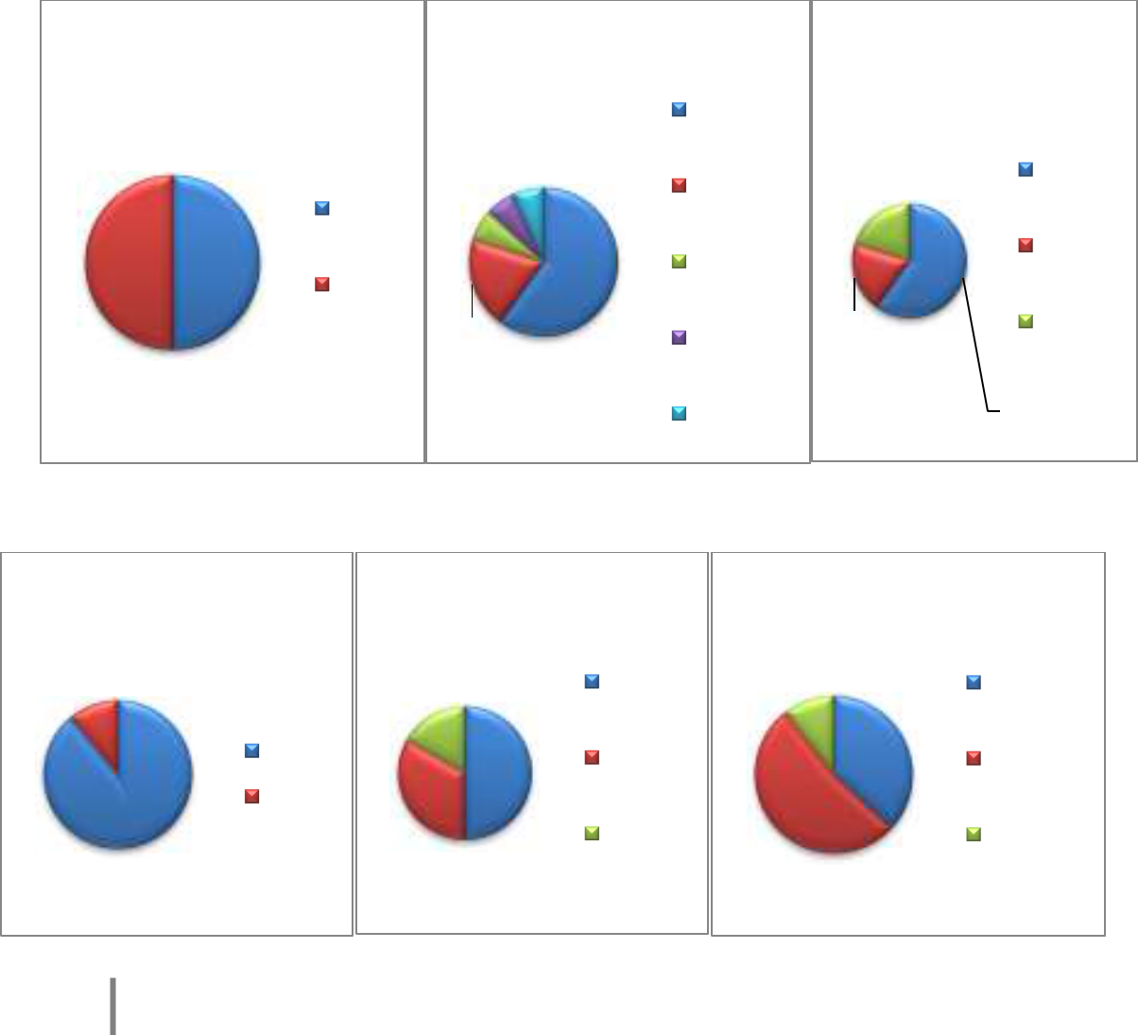

32

Land-Use and Building Condition Survey Report – Poplar Bluff, MO

2012-
2013

Analysis of Existing Building Conditions

As mentioned in the Methodology Section of this report, the survey form was designed to include definitions, to rate building conditions. The overall building condition was based on the total score of the exterior building element conditions and interior building conditions (when allowed) completed by a visual assessment.

Overall findings of the survey revealed that approximately 17 percent of the surveyed buildings are in good condition. The average building condition score is 25 of a possible 36; therefore, the average property shows some signs of deterioration. Buildings were automatically scored a 3 in categories which were not applicable to the individual building. For instance a building was given a 3 if no trim or gutters existed on the building instead of no score. If no score was given, the rating would have been reduced unfairly. However, it is recommended to those buildings without gutters and downspouts to install these items for the overall well-being of the building. Noticeably, properties rated as excellent and good are in the minority, and the survey discovered no dilapidated properties and only one property rated in poor condition. Please see individual survey forms for total score on each building.

33

Land-Use and Building Condition Survey Report – Poplar Bluff, MO

2012-
2013

The following map represents the building conditions in the study area.

Chart 41: Building Condition Map
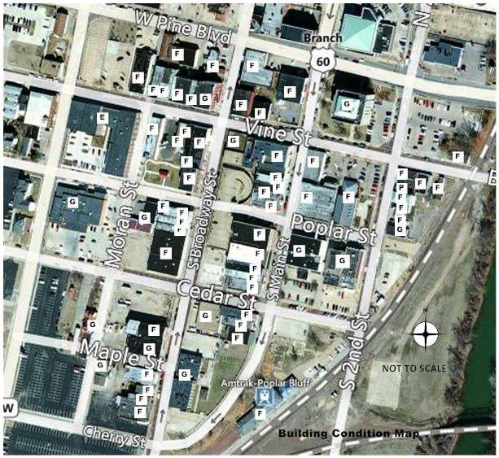

E – Excellent

G - Good

F – Fair

P - Poor

34

Land-Use and Building Condition Survey Report – Poplar Bluff, MO

2012-
2013

Chart 42: Overall Building Condition for Study Area (zero percent of buildings were dilapidated)


Overall Building Condition for Study Area

 |  |  |  |  | 1% |  |  |  |  |  | 0% | ^{2%}17% |  |  |  |  |  |  |  |  |  |  |  | Excellent
 |  |  |  |  |  |  |  |  |  |  |  |  |  |  |  |  |  |  |  |  |  |  |  | Good
 |  |  |  |  | 80% |  |  |  |  |  |  |  |  |  |  |  |  |  |  |  |  |  |  | Fair
 |  |  |  |  |  |  |  |  |  |  |  |  |  |  |  |  |  |  |  |  |  |  |  | Poor
Chart 43: Building Condition for Pine, Vine and Poplar Streets |  |  |  |  |  |  |  |  |  |  |  |  |  |  |  |  |  |  |  |  |  |  |  | Dilapidated
Pine Street |  |  |  |  |  |  |  |  |  |  | Vine Street |  |  |  |  |  |  |  |  | Poplar Street
 |  | Fair |  |  |  |  |  |  |  | Excellent |  |  |  | Good |  | Fair |  |  |  |  |  | Good |  |  |  | Fair
 |  |  |  |  |  |  |  |  |  |  |  | 20% |  |  |  |  |  |  | 25%
 |  |  |  |  |  |  |  |  |  |  | 40%
100% |  |  |  |  |  |  |  |  |  |  |  | 40% |  |  |  |  |  |  | 75%
Chart 44: Building Condition for Second and Main Streets
 |  |  |  | Second Street |  |  |  |  |  |  |  |  |  |  |  | Main Street
 |  |  |  | Good |  | Fair |  |  | Poor |  |  |  |  |  |  |  |  | Good |  | Fair
11% |  |  |  |  | 11% |  |  |  |  |  |  |  |  |  |  |  |  |  | 5%
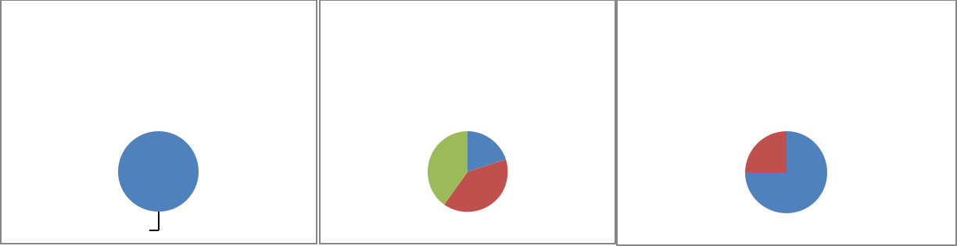
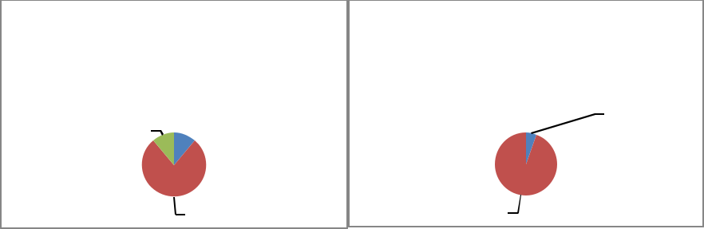

78% 95%

Chart 45: Building Condition for Broadway, Moran and Maple Streets
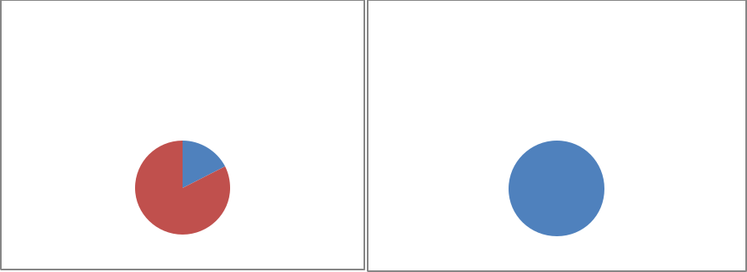

Broadway Street |  |  |  |  | Moran/Maple Streets
 |  | Good |  | Fair |  |  | Good
18%
 |  |  |  |  | 100%
82%

35

Land-Use and Building Condition Survey Report – Poplar Bluff, MO

2012-
2013

Interior Conditions

The data for interior conditions in the survey area is very limited. The consultant was not able to gain access to several of the buildings or was not allowed to tour the interiors to rate the condition. The consultant was able to rate 19 of the 68 the buildings surveyed; the consultant was only allowed access to one building’s second level. The chart below summarizes the interior rating of those 19 spaces.

Chart 46: Overall Interior Condition Rating of Study Area (19 of 68 Buildings)
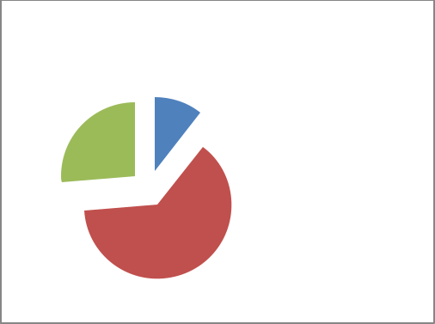

Interior Condition Rating

 | 11%
26% |  |  | Excellent
 |  |  | Good
 | 63% |  | Fair

Deterioration by Occupancy Status

Properties owned by the City of Poplar Bluff and non-profits, in general, are well maintained with the exception of 400 S. Main Street. However, the non-profit organization who owns the property is seeking funding to work on the rehabilitation of the property. In addition, the one multi-family property (430 Vine Street) within the study area is well-maintained. Vacant buildings were discovered to be overall in fair condition at 85 percent, and occupied properties on average are fair condition at 67percent.

Chart 47: Deterioration by Occupancy Status for Overall Study Area
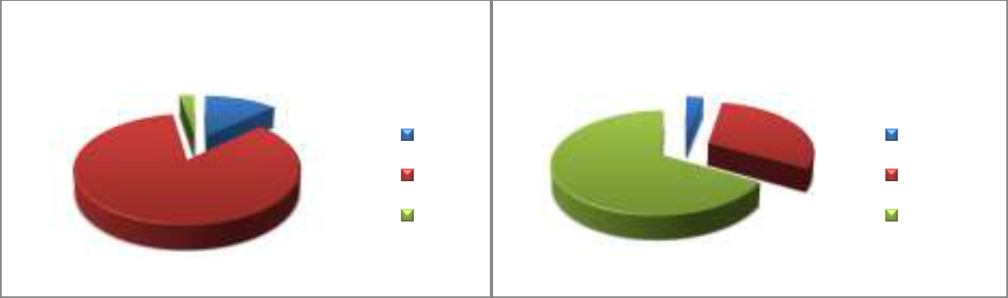

Vacant Building Condition |  | Occupied Building Condition
2% | 13% | 3%
 | Good | 30% | Excellent
85% | Fair | 67% | Good
 | Poor |  | Fair

36

Land-Use and Building Condition Survey Report – Poplar Bluff, MO

2012-
2013

Vacant Buildings

Located within the study area, 53 percent of buildings surveyed are vacant, boarded-up or appear to be vacant (percentage total included partial vacant and unknown occupancy). These properties appear to be throughout the study area. While the survey did not find a large number of completely board-up buildings there were some buildings with windows boarded-up on the upper and lower levels, or resize windows that have been infilled with various materials.

Chart 48: Vacant and Occupied Buildings for the Study District
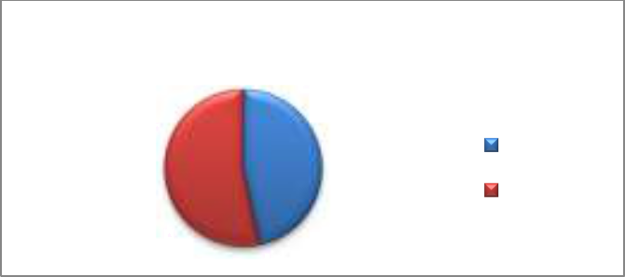

Vacant and Occupied Buildings

 | 47% | Occupied
53% |  | Vacant

Chart 49: Vacant Buildings Data by Level, and Space
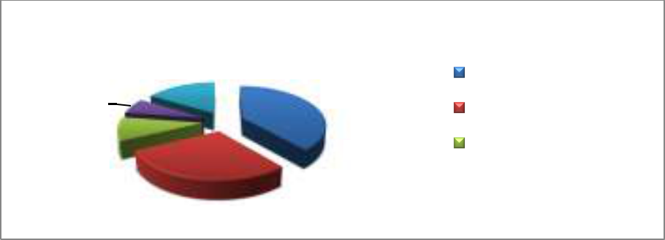

Vacant Builidngs

 | 16% | Vacant
6% | 39% | Partial Vacant

Vacant Upper level
10% _{29%}
Unknown Lower Level

Unknown Upper Level

Locally owned properties account for 42 percent of all deteriorated properties and absentee-owned properties account for42 percent. Butler County owns 12 percent of the vacant properties.

37

Land-Use and Building Condition Survey Report – Poplar Bluff, MO

2012-
2013

Chart 50: Vacant Buildings by Ownership
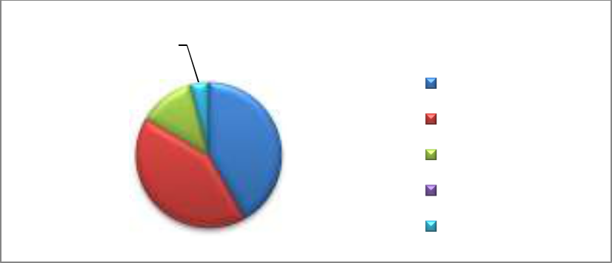

4% | Vacant by Ownership
12% ^{0%} | Local Owner
 | Absentee
42%
 | Butler County
42% | City of Poplar Bluff
 | Non-Profit

*Percentage totals include vacant lower level, vacant upper level, unknown, and partially vacant; City of Poplar Bluff owns zero % percent of vacant buildings within the study area

Control of Litter and Vegetation

Overall the control of litter and vegetation is generally adequate to good throughout the 27 blocks of the study area. Few properties have a high coverage area of vegetation while others have minor coverage. Most of the litter around buildings (vacant or occupied) and vacant lots is minor.

Below are examples of poor control of vegetation within the study area.
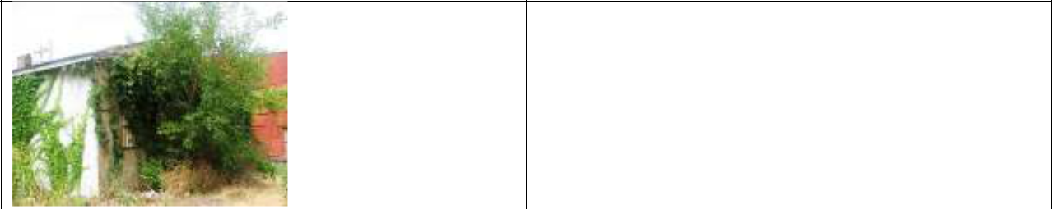

An example of a rear elevation completely overgrown, with a side elevation exhibiting high vegetation growth.
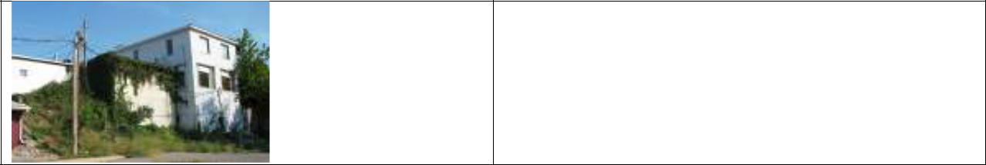

An example of a rear/side elevation showing high vegetation growth.

38

Land-Use and Building Condition Survey Report – Poplar Bluff, MO
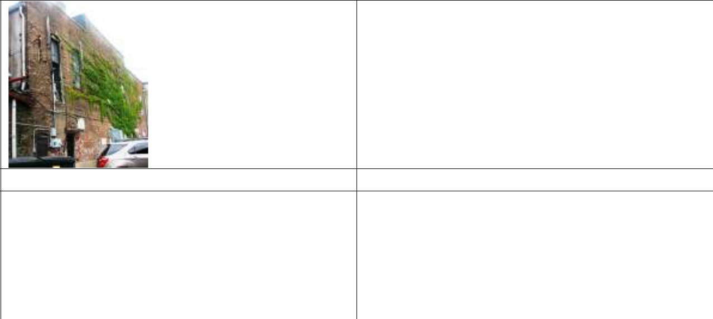
2012-
2013

An example of vegetation growth expanding out to adjoining buildings.
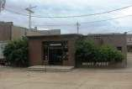

An example of minor overgrowth that is easily managed with trimming the landscape hedges.

Vacant Lots

Overall the study area has a low percentage of vacant lots. There are nine vacant developed lots. For the most part, the vacant lots are adequately maintained. However, one vacant lot at 303 S. Broadway Street (south of the parking garage) which houses trash dumpsters. It is recommended the trash dumpsters, if to remain on the lot, should be enclosed and not has overflowing trash. The lid of the dumpsters should always remain closed to guard against rodents. Since the in-field survey was conducted in July, the original number of vacant developed lots has increased by one. One building has recently been demolished by Butler County on South Second Street; it is included in the overall total. Ownership of vacant lots is both public and privately owned.

Public Spaces

For the purpose of this study, public spaces are defined as a public park. There are two public spaces located within the 27 block study area. Both spaces are owned by the City of Poplar Bluff. One space is a small park-like green space (Poplar Street) with sitting areas for the public to enjoy. While conducting the survey, the consultant noted several people having lunch and walking their dogs in the park or having coffee in the morning hours. The other public space is located at the corner of Broadway and Cedar Street. The city took a vacant developed lot and converted it into a skateboard park for the youth of the community.

39

Land-Use and Building Condition Survey Report – Poplar Bluff, MO

2012-
2013

Parking Area Analysis

Throughout the CX-3, Central Commercial, Mixed-Use District, parking is provided in various forms and is owned by a mixture of entities. Summarized in the chart below is a detailed analysis by approximate acreage of the parking areas by type and ownership.

The vast majority of parking lots (62 percent) within the study area are owned by public entities (county, and city owned). However, one of the county owned parking lots is not for public parking, while the city owned parking lots are for public utilization. While the parking lot that serves the U.S. Post Office on Poplar Street is for public use, it is privately owned. Only 28 percent of parking lots are for private use; for employees or business clientele. On-street parking for the public can be found on all streets located in the study area. The on-street parking does provide for handicapped parking throughout the district.

Parking types located within the study include surface lots (open parking lots), structured parking lot (parking garage), and on-street parking (parking spaces provided on the street).

Chart 51: Parking Acreage by Parking Lot Type and Ownership

Type and Total | District Total |  |  | Private |  |  | Public |  |  |  | Non-Profit
Approximate
acreage
Surface Lot Area | 4.885 |  |  | 1.529 |  |  | 2.811 |  |  |  | .545
Structured Lot Area | .680 |  |  | 0 |  |  | .680 |  |  |  | 0
Total Parking Area | 5.565 |  |  | 1.529 |  |  | 3.491 |  |  |  | .545
Chart 52: Parking Lots by Ownership
 |  | Parking Lots by Ownership
 | 3% | 12% |  |  |  |  |  |  | Private
 |  | 28% |  |  |  |  |  |  | Non-Profit
 |  |  |  |  |  |  |  |  | Public
 | 47% |  |  |  |  |  |  |  | Public -Employee
 |  | 10% |  |  |  |  |  |  | Public Structured
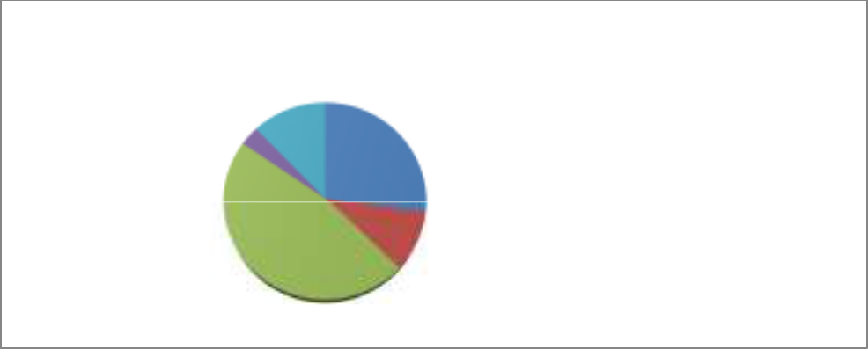

40

Land-Use and Building Condition Survey Report – Poplar Bluff, MO

2012-
2013

Chart 53: Parking Lot Use Map
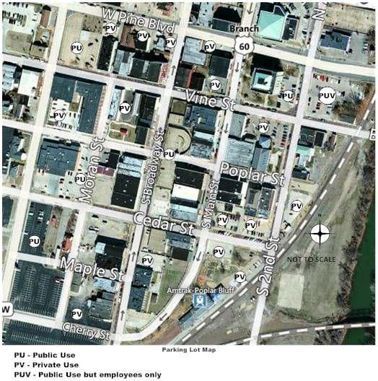

Historic Assets

Historic Buildings Analysis

The National Historic Preservation Act of 1966 created the National Register of Historic Places, to be overseen by the United States Department of Interior. This Act stated it is the guiding principle of the federal government to nurture the preservation of the United States cultural resources through partnerships with states, local governments and the private sector. The National Register of Historic Places (NRHP) is the official national list of historic properties in America worthy of preservation and is maintained by the National Park Service in the U.S. Department of the Interior. The NRHP listing include sites, buildings, structures, objects and

41

Land-Use and Building Condition Survey Report – Poplar Bluff, MO

2012-
2013

districts that are significant in national, state or local history, architecture, archaeology, engineering and culture. Properties listed on the NRHP are recognized for their historic significance and maybe eligible for tax credits and incentives. Being listed on the NRHP also allows for particular considerations of a project funded by federal funds.

Furthermore, the Act paved the way for the federal government and states to form a partnership, and each state established a state historic preservation program. Missouri founded the State Historic Preservation Office in 1968, being one of the first states to do so.

The City of Poplar Bluff established a Historic Preservation Commission in 1988 by city ordinance. The Historical Preservation Commission is a nine member municipal board made up of seven members appointed by the mayor and a member of the city council and the city planner as non-voting members. The commission works to maintain the city's Certified Local Government status and works with the State Historic Preservation Office. This Commission is staffed by the Planning Department. The Commission meets on the second Wednesday of the month in the City Council Chambers.

The Commission purpose is to help to identify historic, archaeological and architectural characteristics of Poplar Bluff, which represent elements of the city's cultural, social, economic and architectural history; to designate landmarks, historic places and districts and to educate the public on matters of preservation. Commissioners are appointed for three year terms and may serve three terms.

National Register Parcels

The information presented in the chart below summarize the number of properties listed in the National Register of Historic Places either as an individual listing or as part of a district. Additionally, the tables below does account for properties located within a National Register district but are non-contributing properties within the designed district. Contributing properties are those buildings which add to the historic significance of the district, whereas, non-contributing properties do not add to the historic significance of the district. There are a total of 17 parcels located in a National Register District and four parcels affiliated with individual listings. The CX-3, Central Commercial, Mixed-Use District is designated as a local commercial historic district as well. The differences between a National Register District and a Local Historic District are summarized below:

National Register District – A National Register District is part of the National Register of Historic Places. The National Register of Historic Places is the list of individual buildings, sites, structures, objects, and districts, deemed important in American history, culture,

42

Land-Use and Building Condition Survey Report – Poplar Bluff, MO

2012-
2013

architecture, or archaeology. It is a federal designation and is administered by the Secretary of the Interior through the Missouri State Historic Preservation Office. If there is no federal or state involvement in a project (such as funding or tax credits) and no pertinent local regulations (such has a local historic district or local landmark), then listing in the National Register of Historic Places does not in any way limit an owner’s handling of the property.

Local Historic District – A local historic district is an entire area or group of historic buildings/resources judged significant to the city's historic fabric that are protected by public review. A local district may be comprised of downtown commercial areas, main streets, and residential districts. Typically, local historic districts are much more effective at preventing inappropriate changes than a National Register District. In a local historic district, a locally appointed Historic Preservation Commission (HPC) reviews proposed changes to exterior architectural features visible from a public way. For instance, if a building addition or a change to exterior wall surface is proposed in a local historic district, the property owner must submit an application to the HPC. The HPC holds a public meeting and makes a determination on whether the proposed changes are appropriate. If the proposed changes are judged appropriate, the HPC issues a certificate, allowing the work to begin.

43

Land-Use and Building Condition Survey Report – Poplar Bluff, MO

2012-
2013

Chart 54: Historic Designation of Buildings in the Study Area by Listing and Streets

Historic | Pine St. | Vine St. | Poplar St. | Cedar St. | Second | Main St. | Broadway | Moran St.
Designation |  |  |  |  | St. |  | St.
Individual | 0 | 0 | 0 | 0 | 0 | 3 | 0 | 1
District - | 0 | 9 | 0 | 0 | 0 | 0 | 5 | 0
Contributing
District – | 0 | 2 | 0 | 0 | 0 | 0 | 2 | 0
Non-
Contributing
Total | 0 | 11 | 0 | 0 | 0 | 3 | 7 | 1
*Data for the table above was obtained from National Register of Historic Places nominations.

Properties located within the study area listed in the National Register of Historic Places are as follows:

Poplar Bluff Commercial Historic District (NR 12/01/1994), Vine and S. Broadway Streets; 14 contributing, 4 non-contributing

Butler County Courthouse (NR 12/01/1994), 100 N. Main Street

Wright-Dalton-Bell-Anchor Department Store Building (NR 12/01/1994), 201-205 S. Main Street

St. Louis-San Francisco Railroad Depot (NR 12/01/1994), 303 Moran Street

St. Louis, Iron Mountain and Southern Railroad Depot (12/01/1994), 400 S. Main Street

44

Land-Use and Building Condition Survey Report – Poplar Bluff, MO

2012-
2013

The following map indicates properties listed in the National Register of Historic Places and properties eligible for rehabilitation tax credits.

Chart 55: National Register of Historic Places Map
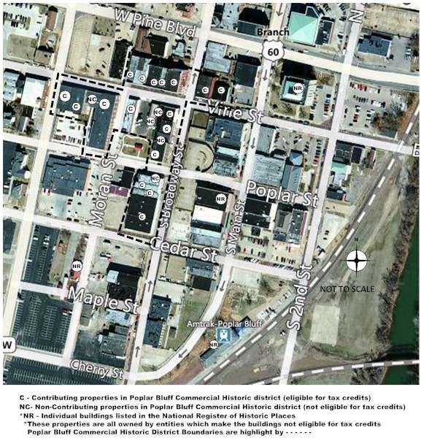

It is recommended that two buildings within the study area be evaluated for National Register of Historic Places eligibility. Those two buildings are 206 Poplar Street and 200 S. Main Street. Also recommended for evaluation is the 100, 200, 300 blocks of S. Main Street as a potential National Register District. These properties should be evaluated to determine if the buildings are considered eligible for listing in the National Register of Historic Places and if the properties

45

Land-Use and Building Condition Survey Report – Poplar Bluff, MO

2012-
2013

meet the National Register Criteria for Evaluation. This process consists of examining the property’s age, integrity, and significance.

Downtown Revitalization and Poplar Bluff

In recent years, there has been a push for revitalization of historic downtowns. With more communities actively engaged in the revitalization and economic development of their downtowns, there have been several studies completed on downtown revitalization. There is not just one reason or one agenda to revitalize a downtown. It does not matter if the town is large or small, what the community history is or what the current trend is; downtown revitalization and economic development has several goals or agendas. These reasons are:

Focal point for sense of place Tourist activity center

Historic core of community

Majority of locally-owned businesses Majority of locally-operated businesses Prominent employment center

Concentrated business center

Significant service and retail center

Significant tax base, including property and sales Public and private investment

Localized public service and government center Downtown reflection of life

Downtown residential living Natural business incubator

Maximize existing municipal capital investments (existing roads, sewer, sidewalks, etc.)

Poplar Bluff, like so many downtown areas in the United States, began an extended period of decline in its downtown core starting approximately around the 1960s. While the nucleus of commercial activity had been primarily located in the study area, it shifted out to the west section of town when the popularity of the automobile altered the traditional way of shopping to a more modern mode of shopping. The automobile allowed people to travel to do their shopping and conduct business. This resulted in the nucleus of commercial activity to transfer from the downtown core area to the west. Over time, more decline occurred with development of strip commercial areas. The end result was a vicious cycle which caused businesses in the downtown district to close or relocated to the new bustling commercial area in the west section of town. When businesses close in one section of town, it is generally followed by a

46

Land-Use and Building Condition Survey Report – Poplar Bluff, MO

2012-
2013

decline in population of the immediate area, as people move to where the action usually is located. This is followed by a decline in tourism and visitors to the downtown district.

Slowly, the vicious cycle turns into a revitalization cycle but this new cycle did not get its start until recent years. An essential component in the revitalization of Poplar Bluff’s downtown district is offers a “sense of place.” The study area is an area of town that conveys the historic significance of the community and is expressed through the buildings located within these blocks. The historic buildings and the “sense of place” embrace an appreciation of endurance and creates optimism for the Poplar Bluff community in an economically difficult time, for the downtown commercial core is still present and still has activity with a longer lifespan than other commercial sectors in the community. While the commercial sector west of town is more active than study area, it has not yet experienced a lifespan as long-lasting or time-honored as the district in the study area.

Downtown revitalization does not happen overnight nor does it happen over a few months, instead it takes careful planning, and a community working together. According to Don Rypkema, principle of Place Economics (http://www.placeeconomics.com/resources/speeches) and a leading authority of downtown revitalization, there are 12 components of successful downtown revitalization. Those steps are:

- Leadership (Institutional support for downtown and a comprehensive plan);

- Comprehension (Understanding the importance of downtown);

- Management (Organization and comprehensive approach to supervision of revitalization of the downtown);

- Partnerships (Partnerships with economic sectors and participation from property owners, tenants, those with a vested interest);

- Public Sector Participation (Public improvements, Mixed-use of buildings, and reinvestment);

- Community Orientation (Functional and economic diversity, sense of community ownership, non-economic activities);

- Diversity (Economic mixture, arts and cultural events, business diversity);

- Differentiation (Define downtown, what are the key resources, historic preservation of downtown);

- Pedestrian Orientation (Pedestrian traffic);

- Market Sensitivity (Guided by customers and market needs);

- Incrementalism (Gradual economic and physical change, no quick fixes, various catalysts for change);

47

Land-Use and Building Condition Survey Report – Poplar Bluff, MO

2012-
2013

It is important to understand the revitalization of The CX-3, Central Commercial, Mixed-Use District will not happen with a “quick fix.” While Poplar Bluff may not currently meet all of the above mentioned 12 steps, Poplar Bluff is heading in the right direction and is already working toward the 12 steps. One of the significant steps the City of Poplar Bluff has taken is establishing the 27 blocks in the study area as the CX-3, Central Commercial, Mixed-Use District and a Local Commercial Historic District; as well as, conducting this Land-use and Building Condition study. In addition, through the DREAM program, the city underwent several reviews and studies: Destination Assessment, Downtown Strategic Plan, and Organizational Structure Review. The city is working towards laying the foundation to start the revitalization and economic development of its downtown core.

Business and Economic Development

The most difficult challenge for a community can be to tackle the restructuring of its downtown commercial district. Downtown commercial districts are interdependent on several circumstances outside of the district’s jurisdiction. Many of these circumstances are local economic conditions, highway patterns-fluctuating function of commercial centers. Poplar Bluff, like so many communities in Missouri, has experienced over the past several decades a development of substantial retail and office space on its perimeter. Often the supplies of retail and services type businesses surpass the current demand. This creates a competition for dollars, not just in retail sales but also sales tax as more people order on-line and pull tax dollars away from the local economy. The competition for dollars has resulted in an increase in existing building stock of underutilized and deteriorated spaces in the CX-3, Central Commercial, Mixed-Use District.

The community of Poplar Bluff has strong support for the downtown revitalization project, from the local government, Downtown Poplar Bluff organization, and private sector.

The Main Street Approach and Principles

The Downtown Poplar Bluff organization is an aspiring Missouri Main Street Community member. The National Main Street program has had incredible success repositioning downtown neighborhood commercial districts.

Main Street

Established in 1980, the National Main Street Center (NMSC), was created by the National Trust for Historic Preservation. Through the NMSC, the Main Street Approach has been utilized to re-establish the places and enterprises that generate sustainable, vibrant communities. The NMSC has spearheaded a network across the United States including more than 2,000 programs and leaders to use the Main Street approach to revitalize their downtown communities. The NMSC

48

Land-Use and Building Condition Survey Report – Poplar Bluff, MO

2012-
2013

national network is comprised of 37 statewide programs (including Missouri), seven citywide programs, and two regional programs. The above and following information was obtained from National Main Street (http://www.preservationnation.org/main-street/).

Main Street Four Point Approach

The Main Street Approach is a preservation-based economic development tool that aids communities to revitalize downtown and neighborhood business districts by leveraging local assets – from historic, cultural, and architectural resources to local enterprises and community pride. The Main Street Four Point Approach includes; organization, promotion, design, and economic restructuring. Under these umbrella topics all downtown concerns can be addressed.

Organization is the instrument by which people build consensus and cooperation by creating partnerships among a variety of groups that have a stake in the commercial district. The Organization committee work together to identify areas of common interest and select strategies for moving forward;

Promotion has an overall goal to create a positive image that will regenerate community pride and develop consumer and investor trust in the district. It helps to define an image for the downtown and markets that image to people within and outside of the community.

Design works toward getting the district into uppermost physical shape, creating an inviting atmosphere through attractive window displays, parking areas, building improvements, streetscapes and landscaping;

Economic Restructuring works toward strengthening a community’s existing economic base while also expanding and diversifying it. By helping existing businesses expand and recruiting new businesses to respond to today’s market, the Main Street program helps convert unused spaces into productive properties and sharpens the competitiveness of business enterprises.

49

Land-Use and Building Condition Survey Report – Poplar Bluff, MO

2012-
2013

The Eight Principles of Main Street

The Eight Principles of the Main Street program is the guide that has helped the Four Point Approach be successful, it is a methodology that differs from other redevelopment strategies. The Eight Principles are as followed:

Comprehensive: It does not focus on only one issue but instead considers the interrelationship of many issues. A single project will not revitalize a downtown or commercial neighborhood. An ongoing series of plans is vital to build community support and create lasting progress.

Incremental: Revitalization is best achieved through small steps before taking larger ones. Small projects make a big transformation. Small projects validate that “things are happening” in the district and refine the skills and confidence the program will need to undertake more complex projects.

Self-help: Revitalization of your downtown is done locally. The success of the revitalization of your downtown is directly proportional to the commitment and leadership applied locally. Local leadership can create long-term success by nurturing and demonstrating community involvement and commitment to the revitalization effort.

Partnerships: Both the public and private sectors must work together and have a vital interest in the district and thrive to achieve common goals, as well as each must recognize the strengths and weaknesses of the other;

Identifying and capitalizing on existing assets: Commercial districts must build upon the assets that make them unique, not to depend on external solutions for downtown;

Quality: Downtown must emphasize quality in every aspect of the revitalization program. This includes, storefront designs to promotional campaigns to educational programs. Downtown should concentrate on quality projects over quantity;

Change: Once the disbelievers turn into advocates, the attitude toward downtown will turn around. Changing community attitudes and habits is essential to bring about commercial district revitalization. A carefully planned Main Street program will help shift public perceptions and practices to support and sustain the revitalization process;

Implementation: To be successful, Main Street must demonstration noticeable results that can only be achieved through the completion of projects. Recurrent visible transformations in the appearance and activities of the commercial district will strengthen the perception of positive change.

The Downtown Poplar Bluff organization is practicing the Four Point Approach and working to apply the Eight Principles. As with most aspiring Missouri Main Street communities,

50

Land-Use and Building Condition Survey Report – Poplar Bluff, MO

2012-
2013

Poplar Bluff needs more people from the community to become involved to help revitalize its downtown.

Summary of Land-use Existing Conditions

The study of the district’s existing conditions revealed a number of notable features that warrant attention. The first impression of the CX-3, Commercial/Residential Mixed Use District is a mid-size, typical linear business corridor that is common among many small towns across Missouri. One benefit of the commercial district is this commercial area has a quantity of distinctly traditional downtown characteristics. This is demonstrated by a development configuration which comprises a mixture of small, moderate, and a few large sized properties, compatible building heights, side-line to side-line building arrangements (attached buildings), reasonably sized street width and sidewalk dimensions, original brick paved streets, moderate linear dimension of individual city blocks, and a harmonizing atmosphere of buildings. Furthermore, the traditional character of the district is bolstered as a result of the particular blend of commercial retail and services, public services establishments and the accessibility of on-street and off-street parking throughout the study area.

The survey results show that commercial square footage use is the most common in the district at 42 percent, over public, non-profit, multi-family. When broken downtown in commercial retail and commercial services, professional office and services are more prevalent in the study area with each having 21 percent of commercial use for a total of 42 percent over retail at only 18 percent. It is important for a commercial district to have more retail businesses. Retail businesses attract more customers to the district, generate more pedestrian shopping and generate more tax dollars. The study area does not appear to have an obvious focal point that entices shoppers to the commercial district. Within the district boundaries there is no single anchor store that would assist as a lure for people, more importantly, which can draw other retail or eating establishments that believe they can draw ample customers from individuals shopping at the anchor store. Though, Myrtle’s Place does draw a lot of customers to the district and seems to have a steady business, it is located on the perimeter of the study area. This does not mean the downtown district cannot in the future have focal point or anchor store. Once an anchor store is established, others retails stores will be attracted to the area. In addition, the district does not encompass an assortment of stores that fosters window-shopping and as such would serve as a catalyst for pedestrian traffic throughout the commercial district.

While the district does have a few mixed-use buildings, it has the potential to create a more vibrant and active district. The Vine Street Apartments is a noteworthy addition to the district,

51

Land-Use and Building Condition Survey Report – Poplar Bluff, MO

2012-
2013

generating residents for the downtown area. A successful commercial district should be balanced with in residential living.

The in-field surveyed revealed very few businesses had installed smoke detectors and only two buildings had fire sprinkler systems. Only a few buildings had hot and cold running water. Several businesses only had cold running water. Source for heating and cooling buildings in the study area is a mixture of electric, gas, HVAC, gas furnaces, and window air conditioning units. Approximately 11 buildings had exterior egress from the upper levels. While there were only a few buildings that had ADA entrances by official building code standards, the in-field survey revealed approximately 15 buildings whose entrances were near level with the sidewalk that might allow for ADA access, but not by official building code standards.

Vacant buildings account for 53 percent of the district, a high percentage for any downtown. However, vacant buildings while being seen as a negative can also be a positive as it presents opportunities for new businesses to open in the district and allow for the chance to create a more diversified retail and service based district. There are very few vacant lots in the study area. These lots can bring future opportunities for the district to expand for commercial space or for green space/parks.

The majority of buildings are locally owned at 65 percent. One-story buildings are most prevalent in the district and comprise 55 percent of the district. The most common building construction time period in the district is 1920 – 1929, making up 28 percent of all buildings. A few of the buildings were constructed prior to 1900 and all are located on Vine Street, as well as, the most recent building constructed in 2009 as part of the Vine Street Apartments. The above mentioned information is helpful as it provides insight on how much of the district properties are locally owned. Property owners, who live locally, tend to feel they are move invested into a community in which they live, than a property owner who resides outside of the community. It is important document the area that holds the oldest grouping buildings, and also note the ages of building throughout the district as it is a record of how the district grew, changed and expanded over time.

Generally, the physical character of the study area is characterized by a number of buildings whose facades have been remodeled over time creating an atmosphere of conflicting design elements and concealing potential architectural features which would enrich the district as a whole.

Overall, the survey results indicate 81 percent of buildings are in fair condition with only one building in excellent condition (430 Vine Street) and 17 percent considered in good condition.

52

Land-Use and Building Condition Survey Report – Poplar Bluff, MO

2012-
2013

Conversely, the majority of the buildings in the study area indicate some degree of deterioration. There are no “dilapidated” buildings in the study area. Deteriorated buildings exhibit problems across a variety of physical and structural elements, such as windows, doors, wall cladding, roofs, mortar cracks and missing mortar, and gutters. Several buildings are not equipped with gutters and downspouts; it is highly recommended these building install these items in the future for the well-being of the building. While buildings were not scored lower for this not having gutters and downspouts, the overall ratings of the condition of buildings would have been lower if scored for the absent of gutters and downspouts. Several buildings may have received a higher score if the condition of the roof would have been known. A few of the properties in the study area have excessive amounts of overgrown vegetation but the majority of buildings are generally free of vegetation. Buildings or vacant lots that have excessive amounts of overgrown vegetation can create a negative image. Buildings covered in vegetation tend to develop maintenance issues. Overall, the district reflects a positive image when it comes to the issue of vegetation and landscaping.

The survey results revealed that 59 percent of the parking lots are publically owned with an additional three percent for public employee parking. Private parking makes up 28 percent of the district with a smaller percentage of parking lots owned by non-profits. While the parking garage on Broadway Street provides several parking spaces, it is not utilized to its full potential. The consultant noted during the one week of the in-field survey on average the parking garage was utilized by 6 to 10 vehicles a day. Employees of 105-107 Broadway utilized the parking garage but few others working or visiting the area did. Overall, feedback the consultant received when random individuals were asked about the parking garage was they it felt was not as safe as parking on the street. The city could install better lighting to address this issue. Some businesses provided parking to their employees behind the buildings, but the parking space behind buildings is very limited and not truly designated as a parking area.

Sidewalks in the survey area are in good to fair condition. The consultant noted sidewalks did provide ADA ramps from the street level. The existing “cobra-head” light fixtures located throughout the study area are more akin to industrial or highway lighting. While these light fixtures function as necessary lighting for the area, the fixtures do not harmonize with the historic atmosphere of the study area. The in-field survey revealed overhead electric/telephone cable/wiring with electric hook-up to buildings located on the façade, as well as electric meters. Mechanical equipment, such as electrical wire, telephone wires, and electric meters are a necessary part of a building and city infrastructure but it would be more appealing if these items were installed at the rear of a building in a more inconspicuous place.

53

Land-Use and Building Condition Survey Report – Poplar Bluff, MO

2012-
2013

The in-field survey revealed some public benches and trash receptacles and a bicycle rack located in the skateboard park. These elements are a great addition to the district. In the future, consideration should be made to add more benches, and trash receptacles. There are no informational kiosks in the study area.

The district does hold two public open spaces. One is a small park like setting on Poplar Street with a pavilion and table. The consultant noted it being utilized every day during the in-field survey. The other public space is the recent addition of a skateboard park on the corner of Broadway and Cedar Streets. This public space will help to draw the youth of the community to the district.

One-way and two-way streets are present in the study area. Main and Broadway Streets (north-south bound) are one-way streets. According to the Pedestrian and Bicycle Information Center (http://www.pedbikeinfo.org), which is funded by the Federal Highway Administration, generally, in downtown areas, two-way traffic is preferable for business enticement and redevelopment interests. It is important to balance the functional aspects of streets with their role as part of the public domain. Generally, the overall goal is to design streets that address all modes of transportation and serve the community at all times. Communities throughout the country are reverting one-way streets back to two-way to permit enhanced access to businesses and residences, as well as generate a safer circulation system for both motorist and pedestrians. Advantages of two-way streets are they incline to give rise to slower traffic due to “friction.” Two-way streets likewise reduce the potential for multiple-threat crashes that occur on multi-lane, one-way streets. Moreover, two-way streets are safer for pedestrians, provide more watchful drivers and pedestrians and characteristically “calm” traffic which is sought-after in historic downtowns. A nearby community, Cape Girardeau, a few years after researching one-way v. two-way streets, returned Main Street in the historic district back to a two-way street and traffic flowed more naturally after the change was implemented.

Recommendations and Development Strategy

The Land-Use and Building Condition Survey study is intended to assist as an overall guide for the physical, economic and social development of the CX-3, Commercial/Residential Mixed Use District of Poplar Bluff. The study was designed to help guide the development of the downtown commercial district in a method that encourages safety, preservation of historic resources, revitalization, and general welfare of the overall community of Poplar Bluff. The following development objectives and recommendations are the result of the findings from the study. These objectives and recommendations also serve as the basis for discussion with the stakeholders (City of Poplar Bluff, Downtown Poplar Bluff, and property and business owners)

54

Land-Use and Building Condition Survey Report – Poplar Bluff, MO

2012-
2013

regarding the direction that the alternative development scenarios section of this document. The development objectives and recommendations are not in any defined order as to how the city should implement the following:

- Establish a heightened sense of community pride in the CX-3, Commercial/Residential Mixed Use District by establishing a cohesive and appealing commercial district.

- Build upon and expand the “Downtown Strategic Plan” created by the DREAM Initiative to make it more of a comprehensive and coordinated long-range plan to guide the growth, development, and physical improvements that are necessary to ensure the continued vitality of the CX-3, Commercial/Residential Mixed Use District.

- Make sure the infrastructure of the district is adequate to meet the current and future needs of all the businesses and residences.

- Create an environment that encourages downtown living through the establishment of housing diversity and access to amenities.

- Respect the CX-3, Commercial/Residential Mixed Use District as a cultural destination for the community and support initiatives to promote and enhance this distinction.

- Establish a prioritized list of improvements for the district that would be implemented over a period of time.

- Establish architectural and streetscape design guidelines for the district.

- Increase retail activity within the study area through the following actions:

  - Recruit more retail businesses;

  - Generate more customer traffic;

  - Enhance signage within the district;

  - Enhance the exterior appearance of buildings.

- Improve the physical appearance of the district through comprehensive and integrated streetscape enhancement, façade enhancement, building rehabilitations, and associated physical improvements.

- Safeguard the preservation and appropriate rehabilitation of unique historic architecture of the district while encouraging compatible development within the district.

- Promote the cooperation of merchants, business owners, property owners, residents, non-profits, Butler County, City of Poplar Bluff, and Poplar Bluff Downtown organization in the overall revitalization of the study area.

- Encourage private and public investment in the commercial district.

- Promote uses and activities that will generate vitality to the district, as well as increased pedestrian presence and increased residential growth.

- Enhance the use of existing parking facilities. Install additional lighting in parking areas, especially the parking garage. Encourage business owners and employees to utilize the

55

Land-Use and Building Condition Survey Report – Poplar Bluff, MO

2012-
2013

parking garage on Broadway Street. It is important that the demand generated by future retail activity can be met in a method that encourages patronage of the businesses in the district, as well as preventing business owners and their employees from blocking key parking locations, such as on-street parking. Establish more effective parking signage for the public for the public parking located on Fifth and Vine Streets.

- Establish a more marketable name for the CX-3, Commercial/Residential Mixed Use District, such as “The Downtown Poplar Bluff District.”

- Encourage the removal of boarded-up windows and the removal of security bars on windows or doors. Security bars often sends a message to customers, potential new business recruits and residents the area is unsafe.

- Install wayfinding and informational kiosks.

- Continue to work toward becoming a certified Missouri Main Street Community.

- Recruit more full-service restaurants.

- Recruit more cafes and coffee shops.

- Promote downtown activities and events. Create public events for certain Friday or Saturday evenings of the month, for instance in a First Saturday Street Fair (during the summer) or Second Friday of the month a Farmer’s Market or First Friday Live Music or Arts. Host antique car shows, boat shows, or antique shows (located in vacant spaces).

- Create a diverse retail market such as:

- Casual apparel aimed at all age groups;

- Jewelry stores, especially lower to moderately priced and handmade items;

- Hobby, craft, or toy stores;

- Floral and plant stores;

- A range of art galleries and decorative home goods shops;

- Bookstores, selling new and used books;

- General store carrying everyday items for people working and shopping in the area;

- Smaller electronic and household accessories store;

- A spa in conjunction with a nail salon or tanning salon;

- Specialty food store in conjunction with a full-service restaurant/café/deli that offers a variety of prepared foods appealing to time-pressed workers to carry out for dinner;

- A laundromat in conjunction with a eating establishment that offers deli style food, Wi-Fi access and television, for those who reside in the district;

- Shops or eating establishments providing Wi-Fi access;

- Bakery or ice cream shop.

56

Land-Use and Building Condition Survey Report – Poplar Bluff, MO

2012-
2013

- Banners can provide an element of color to the district and may be used to identify the district, special events, or an area of special interest.

- Decorate and light the storefront windows of vacant buildings while they are awaiting new tenants; local volunteer organizations adopt vacant storefronts for decorating or local business owners loan items for display; promote and showcase the district in vacant storefronts;

- Concentrate on providing and reinforcing pedestrian linkages to the district, and offering bike paths, and public transit.

- Foster improved enforcement of private property maintenance according to the adopted codes with regards to vegetation, litter, and building conditions.

- Install more traditional design lighting in keeping with the historic character of the district.

Overall, Poplar Bluff has many of the fragments needed for successful revitalization and economic development. What has been absent, but now completed are a proper zoning ordinance , land-use and building condition survey and the following studies/plans provided by the DREAM Initiative; a strategic plan, destination assessment, and organizational structure review. With the support of the City of Poplar Bluff and Poplar Bluff Downtown organization, as well as public/private support and investment, the CX-3, Commercial/Residential Mixed Use District can work towards a successful revitalization and economic development.

57

Land-Use and Building Condition Survey Report – Poplar Bluff, MO

2012-
2013

Resources

Cultural Heritage Tourism. http://www.culturalheritagetourism.org/

Missouri Main Street. http://www.momainstreet.org/

Missouri State Historic Preservation Office. http://www.dnr.mo.gov/shpo/

Missouri State Historic Preservation Office, Tax Credit Information.

http://www.dnr.mo.gov/shpo/taxcrdts.htm

National Main Street. http://www.preservationnation.org/main-street/

National Railway Historical Society. http://www.nrhs.com/

National Trust for Historic Preservation. http://www.preservationnation.org/

National Transportation Enhancements Clearinghouse. http://www.ta-clearinghouse.info/index

Pedestrian and Bicycle Information. http://www.pedbikeinfo.org/

Project for Public Spaces: What Do People Do Downtown? How to Look at Main Street Activity.

Washington, D.C.: National Main Street Center, National Trust for Historic Preservation, 1981.

Preservation Briefs. The National Park Service Technical Preservation Services.

http://www.nps.gov/tps/how-to-preserve/briefs.htm.

Reconnecting America. http://www.reconnectingamerica.org/who-we-are/

Jandl, H. Ward. “Rehabilitating Historic Storefronts,” Preservation Briefs 11, Washington, DC: Technical Preservation Services, National Park Service 1982. http://www.cr.nps.gov/hps/tps/briefs/brief11.htm

Rypkema, Donovan D. The Economics of Historic Preservation: A Community Leader's Guide, National Trust for Historic Preservation, 2 edition, 2005.

Rypkema, Donovan D. Feasibility Assessment Manual for Reusing Historic Buildings. National Trust for Historic Preservation, 2007.

Rypkema, Donovan D. Place Economics. http://www.placeeconomics.com/

58

Land-Use and Building Condition Survey Report – Poplar Bluff, MO

2012-
2013

Secretary of the Interior's Standards for the Treatment of Historic Properties. http://www.nps.gov/hps/tps/standguide/

Walkable Communities. http://www.walkable.org

59

