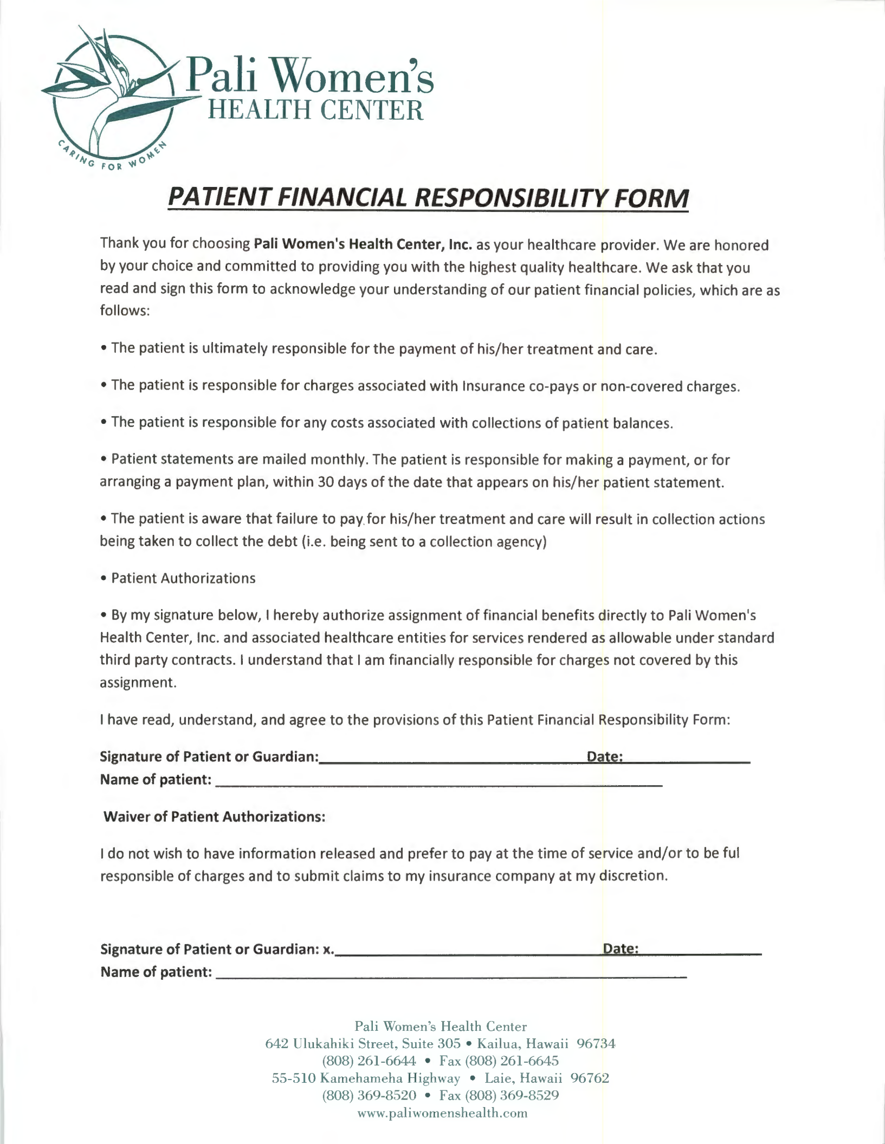

PATIENT FINANCIAL RESPONSIBILITY FORM

Thank you for choosing Pali Women's Health Center, Inc. as your healthcare provider. We are honored by your choice and committed to providing you with the highest quality healthcare . We ask that you read and sign this form to acknowledge your understanding of our patient financial policies, which are as follows:

- The patient is ultimately responsible for the payment of his/her treatment and care .

- The patient is responsible for charges associated with Insurance co-pays or non-covered charges.

- The patient is responsible for any costs associated with collections of patient balances.

- Patient statements are mailed monthly. The patient is responsible for making a payment, or for arranging a payment plan, within 30 days of the date that appears on his/her patient statement.

- The patient is aware that failure to payfor his/her treatment and care will result in collection actions being taken to collect the debt (i .e. being sent to a collection agency)

- Patient Authorizations

- By my signature below, I hereby authorize assignment of financial benefits directly to Pali Women's Health Center, Inc. and associated healthcare entities for services rendered as allowable under standard third party contracts. I understand that I am financially responsible for charges not covered by this assignment.

I have read, understand, and agree to the provisions of this Patient Financial Responsibility Form:

Signature of Patient or Guardian=----------------=0-=a~te...,:...._ ______

Name of patient: --------------------------

Waiver of Patient Authorizations:

I do not wish to have information released and prefer to pay at the time of service and/or to be ful responsible of charges and to submit claims to my insurance company at my discretion .

Signature of Patient or Guardian: x. _______________~D:sa~te=...:...._ ______

Name of patient: ---------------------------

Pali Women's Health Center

642 Ulukahiki Street, Suite 305 • Kailua, Hawaii 96734

(808) 261-6644 • Fax (808) 261-6645

55-510 Kamehameha Highway • Laie, Hawaii 96762

- 369-8520 • Fax (808) 369-8529 www. paliwomenshealth .com

