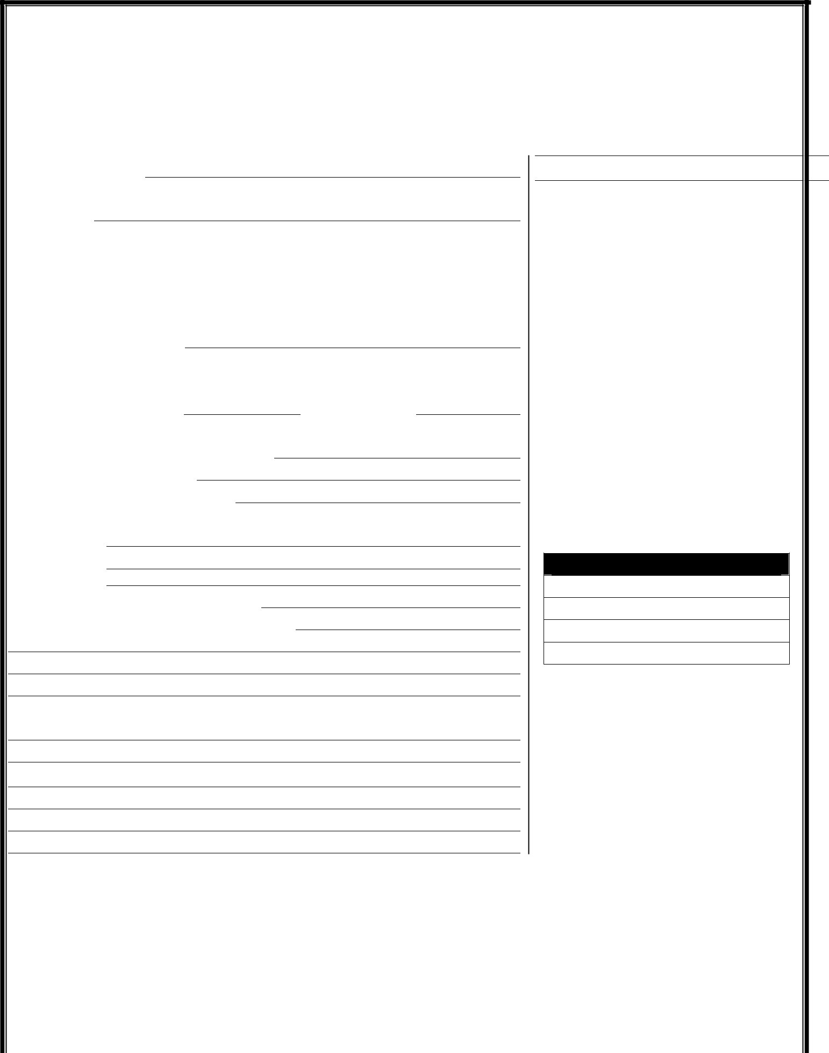
COMMERCIAL LEASE APPLICATION

Landlord/Lessor: |  |  |  |  | Date of Application:
Location of Leased Premises:
Center |  |  | Suite # |  |  | S.F.

Business Name:

Name of Person who will sign lease:

Person 1:

 | (First) |  |  | (Middle) | (Last)
Street Address:
City |  |  |  | State |  | Zip
Phone Number (Work): |  |  | ( | )
Phone Number (Home): |  |  | ( | )
Phone Number (Mobile): |  |  | ( | )

E-mail Address:
Driver’s License No. |  |  | State of Issuance:
Social Security Number: |  |  | Date of Birth:

Is your business a corporation, LLC or other entity? Yes No

- If yes, what form of business entity?

- Federal Tax ID Number:

- State in which entity formed?

- Names of Person(s) who will Guarantee Lease

- Person 1:

- Person 2

(Will need to fill out a separate form unless married)

Proposed use of premises?

Experience in business (please describe):

COMMERCIAL RENTAL HISTORY

Present Address:

Rent □ Own □ Rent/Payment

Conditions and Information

All pages of this lease application must be signed by all persons who will sign the lease agreement. Additional tenant information is on page 2.

The completing of this application by Tenant and the acceptance of this application by Landlord creates no obligation of Landlord to approve the application.

This application will be approved or rejected usually within five (5) days of being submitted to landlord. However, there is no obligation of Landlord to notify tenant unless the application is approved.

If this application is approved, Tenant must make the security deposit and sign the lease before the tenancy begins.

The information provided herein shall be kept confidential and will only be used by Landlord, and its agents to determine approval of Tenant’s application.

For Landlord’s Use Only

Rent Amount:

Deposit:

Date Lease to begin:

End of Lease:

Rent □ Own □ Rent/Payment From/To:

Previous Address:

(Continued on Page 2)

By your signature hereon, you agree that the information disclosed by you herein is true, complete and accurate to the best of your knowledge, and you agree that the information disclosed by you herein is material to the potential Lessor’s decision with respect to granting or denying your application to enter into a lease.

Signed: ______________________________________ Date: ____________________

- 1 -


CREDIT REFERENCE (current or former landlords, banks, vendors, etc.)

 | Name:
 | Address:
 | City State Zip
 | Contact: |  |  |  |  |  |  |  |  | Phone:
 | CURRENT MONTHLY INCOME
 | Name/Source |  |  |  | Amount |  |  |  |  | Name/Source |  | Amount

CURRENT MONTHLY EXPENSES

Creditor Amount Creditor Amount

ASSETS | VALUE | SOURCE | LIABILITIES | AMOUNT | CREDITOR
Cash on Hand & in Banks |  |  | Accounts Payable
Savings Accounts |  |  | Notes Payable to Banks
IRA/Retirement Accounts |  |  | Auto Payments
Accounts Receivable |  |  | Other Installment Accounts
Insurance Cash Surrender |  |  | Loans on Life Insurance
Stocks & Bonds |  |  | Mortgages on Real Estate
Real Estate |  |  | Unpaid Taxes
Automobiles |  |  | Other Liabilities
Other Personal Property |  |  | Other Liabilities
Other Assets
Other Assets |  |  | TOTAL LIABILITIES:
Other Assets
TOTAL ASSETS: |  |  | NET WORTH:

CONSENT TO CREDIT CHECK

I, ___________________________________________, the undersigned applicant(s) authorize

landlord, _________________________, or his/her/their agent to order and review my/our credit and

criminal history and investigate the accuracy of the information contained in the application. I/We further authorize all banks, employers, creditors, credit card companies, references, and any and all other persons to provide to Landlord any and all information concerning my/our credit.

Signed: ______________________________________ Date: ____________________

- 2 -

