Recording requested by (name):
[Name(s) of new owners]

When recorded mail to and mail tax statements to:

[Name(s) of new owners]

[Mailing Address of new owners] [Mailing Address of new owners] [Mailing Address City, State, ZIP]
Name of person recording the Affidavit-Death of. Trustee
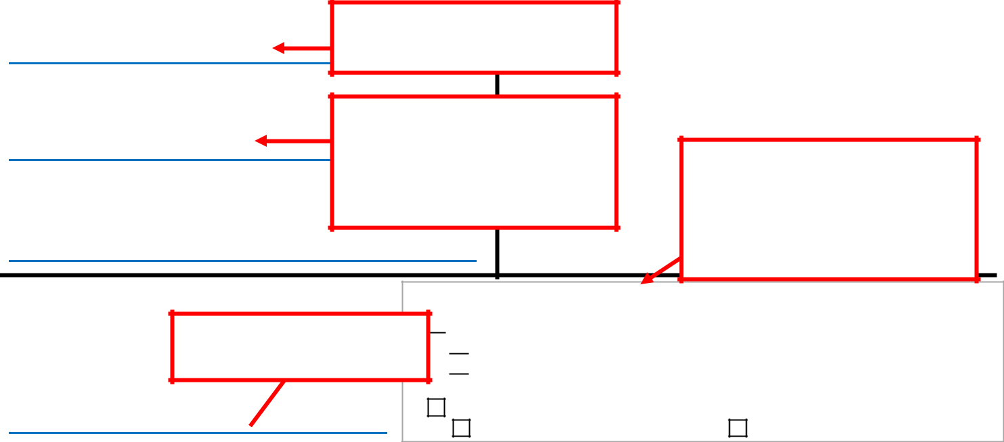

Name and address of person who should receive. the stamped copy of this document when recorded, .and tax statements from. now on.

.

Recorder’s Use Only

1/1/2018: In addition to standard fees, a new $75 fee is charged for recording documents unless an exemption applies. See back of sheet for more info.

AFFIDAVIT – DEATH OF

TRUSTEE This can be found on the current deed or the tax bill.

Assessor’s Parcel No. (APN):

[Assessor’s Parcel No. ] .

[Name of person signing affidavit]

Declaration of Exemption From Gov’t Code § 27388.1 Fee

Transfer is exempt from fee per GC § 27388.1(a)(2):
recorded concurrently “in connection with” transfer subject to DTT

recorded concurrently “in connection with” a transfer of residential dwelling to an owner-occupier
Transfer is exempt from fee per GC 27388.1(a)(1):

Fee cap of $225.00 reached | Not related to real property

, of legal age, being first duly sworn, deposes and says:

- [Name of deceased owner as spelled in death certificate] , the decedent mentioned in the attached certified copy of Certificate of Death, is the same person as [Name of deceased owner as spelled

in trust documents], named as Trustee in the Declaration of Trust dated [date trust was signed] executed by [Name(s) of trustors(s) on trust documents] as Trustor(s).

- At the time of the decedent’s death, decedent was the record owner, as Trustee, of certain real property commonly known as (address) [property street address] , which property is described in a Deed which was executed by [trustor(s) on property deed transferring to

trust] | as Grantor(s) on [date current deed was signed] |  |  |  |  |  |  |  |  | and recorded on [date
current deed was recorded] |  |  |  |  |  | as Instrument No. [Inst. No., if used] |  |  |  |  | in Book/Reel
[Book or Reel No., if used] |  |  |  |  | , Page/Image [Page or Image No., if used] , of the Official
Records of [County] |  |  |  |  |  |  | County, California.


3. The legal description of said property is as follows

[Enter legal description as written on deed. If you prefer, type (or photocopy) the description on a separate page labeled “Exhibit A,” attach it, and enter “See Exhibit A” in this space].

and


Copy this

from the

deed

which put

the

property

into the

trust.

- I am the named successor Trustee under the above-referenced Trust, which was in effect at the time of the death of the decedent mentioned in Paragraph 1, above, and which has not been revoked, and I hereby consent to act as such.
- There is no federal estate tax as the result of the death of the decedent mentioned in Paragraph 1, above.

I declare under penalty of perjury, under the laws of the State of California, that the foregoing is true and correct.

Dated [Date of Signature]

Sign in front of Notary Public
____________________________________________

(Signature of declarant)

[Name of person signing affidavit]


(Type or print name of declarant)

Note: Sacramento does not use Instrument Numbers. Some counties use Instrument Number as well as, or instead of, the Page/Image and Book/Reel numbers. Fill in whatever is on the Current deed.

saclaw.org | 1/25/18

AFFIDAVIT –DEATH OF TRUSTEE

Please note: Additional forms may be required, such as a “Change of Ownership Statement: Death of Real Property Owner” or others. Visit www.assessor.saccounty.net/DeathOfRealPropertyOwner/ Pages/default.aspx for info.

NEXT STEPS:

- Sign the Affidavit in front of a notary public.

- Fill out the Preliminary Change of Ownership Report (PCOR). This form is required by the Assessor's Office. You can download a copy for Sacramento at www.assessor.saccounty.net. Each county has its own form; contact the assessor in the county where the property is located.

- Record the Affidavit and file the PCOR at the Recorder’s Office in the county where the property is located. If you attached the property description (instead of typing it out), be sure to include the attachment when you record the Affidavit.

- Fees: There are two fees: a filing fee (currently $20/first page plus $3/additional page in Sacramento) and a $75 Building Homes and Jobs Act fee. Current Sacramento fees are available at the Sacramento County Recorder's website at www.ccr.saccounty.net/Pages/Fees.aspx.

You may qualify for an exemption from the $75 Building Homes and Jobs Act fee. If you do, be sure to claim the exemption on page 1 of your document, or you will be charged regardless. For more information on this in each California county, visit the California Land Title Association’s information page at www.clta.org/page/SB2CountyDocs.

FOR MORE INFORMATION

- Sacramento County Clerk-Recorder's Office http://www.ccr.saccounty.net/

- Sacramento County Assessor's Office http://www.assessor.saccounty.net/

Sacramento County Public Law Library
609 9th Street, Sacramento, CA 95814
916-874-6012
www.saclaw.org

saclaw.org | 1/25/18

