

Employee Satisfaction Survey Report

Fiscal Year 2014

(February, 2014)

2014 Employee Satisfaction Survey Report

 |  |  |  |  |  | Table of Contents
 |  | Section |  |  |  |  |  | Page
1. | Executive Summary |  |  |  |  | 2
2. | Results Overview |  |  |  |  | 4
3. | Employee Feedback
 |  |  | i. |  | General Job Satisfaction |  | 6
 |  |  | ii. |  | Work Conditions |  | 7
 |  |  | iii. |  | Communication |  | 8
 |  |  | iv. |  | Supportive Work Environment |  | 9
 |  |  | v. |  | Overall Satisfaction |  | 10
 |  |  | vi. |  | Division Designators |  | 11
 |  |  | vii. |  | Supervisory/Non—Supervisory |  | 11
 |  |  | viii. |  | What is Working Well at ADE? |  | 12
 |  |  | ix. |  | What Can ADE Improve? |  | 14

031714 (FINAL) | 1

2014 Employee Satisfaction Survey Report

Executive Summary

The enclosed report is a summary of Employee Satisfaction Survey results for the Arizona Department of Education. The purpose of the assessment is to measure employee satisfaction on current work culture, and to identify issues, problems and opportunities for improvement from employees’ perspective. This assessment is a critical component in guiding the department to achieve goals and objectives in the following Key Result Areas (KRA):
- Provide support services to schools to influence higher student achievement;
- Enhance efficiency and effectiveness to reduce administrative burdens on schools;
- Provide outstanding services that will promote great schools, excellent teachers, and successful students;

- Create a great place to work that produces competent, dedicated and empowered professionals to support schools.

Feedback from the 2013 survey was used in defining the ADE Strategic Plan goals, objectives and strategies in each of the key result areas listed above. As a result, a number of initiatives were implemented to improve process efficiency and customer service, as well as to maximize available resources. Some initiatives were carry-overs, continuing the work initiated in FY 2012-2013. Focused efforts included:

- Streamlined comprehensive grants management structure and system;

- Initiation of a plan to implement the Arizona Education Learning Assessment System (AELAS), to provide teachers, school administrators, students, parents, and policy makers information to inform instruction in the classroom and policy decisions;

- Increase in the scope of ADE-wide collaboration in awareness, training and implementation of Arizona’s

College and Career Ready Standards (AZCCRS);
- Focus on building management skills (bi-monthly Leadership Development sessions and Book Club);

- Increase in (internal) training classes offered to ADE employees;

- Improving timeliness, frequency and quality of communication to employees, including periodic Town Hall sessions, legislative updates, and newsletters.

Additionally, the cross-functional Work Culture Team has refined its focus on improvement opportunities in support, communication, and collaboration. The following were initiated (or carry-overs) in response to 2013 feedback, with a focus on making ADE a “great place to work”:

- Monthly, confidential employee suggestion/feedback system;

- REACH events revised to incorporate more interactive components, increase employee engagement in activities, and increase number of employees involved in producing the events;

- Employee appreciation fund-raising and engagement activities (extra wear jeans/team shirt days, ADE staff and family golf tournament);
- Increase in SECC participation, with $33,843 raised (29% employee participation – up from 8% in 2011);

- “Ask SADIE” monthly advice column;

- Formal awards and informal recognition.

Employee ratings in 2014 demonstrate an increase from 2013 ratings in all but three components measured in the survey. Overall satisfaction rating of ADE as a “great place to work” increased from

3.73 in 2013, to 3.88 in 2014. Net top box ratings (percent rating “Poor” subtracted from percent rating “Outstanding”), increased from 19.9% in 2013, to 31.1% in 2014.

Feedback from this 2014 Survey will be reviewed by the Leadership Team in the March 2014 Strategic Planning Session. It will be a critical piece in determining new/revised objectives to be included in ADE and Division plans for FY 2014-2015, to address issues raised. Group-specific survey results will be provided to Divisions and Sections for the purpose of defining Section and Unit objectives for FY 2014-2015, to address the most pertinent employee issues identified in their respective survey summaries. In addition, feedback will be reviewed by the cross-functional Work Culture Team, to help identify strategies for further improvements in ADE work culture.

031714 (FINAL) | 2

2014 Employee Satisfaction Survey Report

Data Collection Process

The data collection process for the 2014 assessment entailed distribution of a confidential, online survey to all ADE employees (including all management levels, total 541 employees). Respondents were asked a series of questions (closed and open-ended), designed to reveal consensus of opinion on issues, problems, what is currently working well and improvement opportunities. The response rate for the 2014 survey was 68% (367/541). By comparison, the 2013 response rate was 69% (361/522); the 2012 response rate was 70% (373/536), and the 2011 response rate was 75% (383/512).

To gain work group-specific data and information, designations regarding respondent work groups were once again reconfigured, based on changes in group sizes. This specificity will allow for targeted information to be sent by Section or Unit. The expectation is that each area will build on what has been identified as “working well”, and develop strategies to address issues that have been defined as improvement opportunities.

Data Analysis

Data analysis was accomplished using statistical analysis graphically presented, using the Pareto method to identify changes and/or critical areas needing attention. Pareto was also applied for conducting analysis of the stated opinions about what is currently working well, and opportunities for improvement (problems, issues and causes), for finding the changes that will lead to the greatest benefits. Use of this prioritization method helps to identify the most significant items among many and is useful where numerous possible courses of action are competing for attention. This method helps to prioritize where action and/or process changes should be focused.

Data Presentation

For comparison purposes, charts provide results for 2012, 2013, and 2014. Additionally, tables provide comment summaries for 2013 and 2014 surveys, with numbers indicating frequency of comments. Data in charts for categories 1—4 (General Job Satisfaction; Work Conditions; Communication; Supportive Work Environment) are presented as average scores. Data results for category 5 (Overall Satisfaction) are expressed as percentage of total respondents in order to determine net “top box” rating of ADE as a place to work (net top box is calculated by subtracting the percentage rating “Poor” from the percentage rating “Outstanding”).

Data in charts for categories 6 and 7 (Division and Supervisory/Non-Supervisory) reflect number of respondents (the percent of respondents by group is presented in the “Results Review” beginning on page 4, item #6). Data in charts for questions 8 and 9 (“What is working well at ADE?” and, “What can ADE improve?”) reflect the frequency of comments for each category.

Tables under charts for all categories/questions (except 6 and 7) provide comparative listings of 2013 and 2014 comments for their respective graphs. For ease of comparison, comments for questions 8 and 9 are listed in the same order that 2013 results were published.

031714 (FINAL) | 3

2014 Employee Satisfaction Survey Report

Results Review

A general review of ratings and comments is provided below. Ratings in all areas but three increased from 2013 (“My supervisor assigns work fairly” had no change; “My immediate supervisor creates a supportive work culture” and, “My Deputy Associate (DAS) creates a supportive work culture” declined slightly). Rating averages and comments support that a number of improvements have occurred since the 2013 survey was administered. While comments from 2013 and 2014 share similarities, in some areas they have narrowed, more specifically targeting areas still needing improvement. As with last year, the intent is to involve all work groups and staff levels to drive improvement efforts and subsequently increase all ratings.

- General Job Satisfaction: Ratings in all areas of this category improved from 2013 ratings, with the most significant increases in “Receive training to do job well” 3.77 in 2013 to 3.90 in 2014), and perception of ADE valuing ideas on work-related problems (3.81 in 2013 to 3.93 in 2014). As with last year, comments regarding training focused mostly on the need for job-specific training. The number of comments regarding the need for ADE to value employee ideas decreased from last year. (Additionally, there were a number of comments related to value of input under “Working Well” this year, while there were no positive comments in this area in the 2013 survey.)

- Work Conditions: Ratings for all but one category in this section rose somewhat (“My supervisor assigns work fairly” had no change from 2013). While the rating for promotions based on qualifications (and “State benefits”) increased the most in this category, promotions remains the lowest rated area in this category (3.40 in 2013, 3.49 in 2014). In addition to numerous, strongly worded comments provided that indicate dissatisfaction with the fairness of the promotion process, several comments were submitted regarding disparities in fairness, discrimination, and accountability in workload.

- Communication: Ratings for all three communication areas rose slightly from 2013 ratings. Comments mirrored many provided in 2013. Specific comments were provided under this category for ensuring consistent and timely information flows top-down, and improving/increasing communication within and between Units/Divisions. In addition, communication was cited in various categories in the last two items of the survey, “Working Well” and “What Can ADE Improve?”.

- Supportive Work Environment: Although “Support from supervisor” received the overall highest rating in this category, the rating declined (4.18 in 2013 to 4.14 in 2014). There was also a slight decline in “DAS support” (4.00 in 2013, 3.97 in 2014). “Recognition” rating continues to improve (3.69 in 2012, 3.73 in 2013, and 3.81 in 2014). There has been a steady, significant increase in perception ratings for “support for participation in education & PD”—from a 2012 rating of 3.81, to 3.89 in 2013, to 4.08 in 2014. “Associate support” saw a modest increase, and ratings on “Executive Team support” rose from 3.81 in 2013 to 3.92 in 2014 (both items were revised after the 2012 survey, so no comparison ratings for 2012 are available). Comments regarding limited visibility, and contact with staff were cited in both years as needing improvement.

- Overall Satisfaction: The “net top box” percentage of respondents rating ADE “Outstanding” as a place to work (subtracting percent rating “Poor” from percent rating “Outstanding”) rose to 31.1% in 2014 (19.9% in 2013, 12.3% in 2012). Comments most cited within this category focused on improving management competence, and providing more support to staff.

031714 (FINAL) | 4

2014 Employee Satisfaction Survey Report

- Division Designators: 68% of ADE staff responded to the 2014 survey (69% in 2013). In the

2011 survey, groups were broken out by Division. To obtain more specific, meaningful feedback for driving work culture improvement ADE-wide and within Sections/Units, the 2012, 2013, and 2014 surveys listed more specific, smaller group designators. To protect confidentiality, groups with fewer than 14 members were combined. Participation breakdown by group for 2014 was:

  - Administration - includes Executive Staff, Innovative Learning, Office of Communications, Human Resources, Cross-Division Leadership Initiative, Organizational Development, State Board & Investigations: 76%

  - Adult Education: 65%
  - Assessment: 91%
  - Building Operations: 56%
  - Business and Finance - includes Audit: 74%
  - Career and Technical Education (CTE): 60%
  - Exceptional Student Services (ESS) – includes 21st Century Community Learning Centers (CCLC): 81%

  - Grants Management: 36%
  - Health and Nutrition (H&N): 67%

  - High Academic Standards for Students (HASS) - includes K-12, Race to the Top and Early Childhood: 91%

  - (Various) Highly Effective Schools (HES) – includes Homeless, Refugee, African American, Migrant, Native American Education & Outreach programs: 53%

  - Highly Effective Teachers and Leaders (HETL): 62%
  - Information Technology (IT): 48%
  - Office of English Language Acquisition Services (OELAS): 87%
  - Policy Development and Government Relations: 38%
  - Research & Evaluation: 71%
  - School Improvement: 60%
  - Title I – includes School Safety & Prevention (SS&P): 68%

- Supervisory/Non-Supervisory: Participation by supervisory/non-supervisory was:
  - Supervisory: 23.5% in 2013, 23.5% in 2014 (no change)
  - Non-Supervisory: 76.5% in 2013, 76.5% in 2014 (no change)

- Working well at ADE: In 2014, respondents once again cited Support most frequently (69 in 2013, 84 in 2014). In 2013, comments within “Support” specifically cited overall culture, flex schedules and five other categories. In 2014, the most often cited area of improvement in this category was overall culture (increase of 20 comments from 2013). Subsequent most-cited comment areas for 2014 included: Leadership/Direction (56 in 2013, 33 in 2014); Communication (39 in 2013, 26 in 2014); Staff (20 in 2013, 26 in 2014), and Collaboration (25 in 2013, 23 in 2014).

- ADE improvement opportunities: In 2014, the category receiving the greatest number of comments was Support (84 in 2013, 88 in 2014). In 2013 and 2014, comments in “Support” focused more on management/employee relationship (with focus on providing training/developing competence). Subsequent most-cited comment areas for 2014 included: Resources (51 in 2013, 50 in 2014); Compensation (32 in 2013, 30 in 2014); and Process Efficiency (20 in 2013, 24 in 2014).

As in previous surveys, several of the categories for improvement fall under management’s purview and as such merit a concentrated focus. Judging from comments, the majority of employees are eager to partner with management in developing a high-performance work culture that is based on respect, accountability, professionalism, competence, and teamwork.

031714 (FINAL) | 5

2014 Employee Satisfaction Survey Report

Employee Feedback
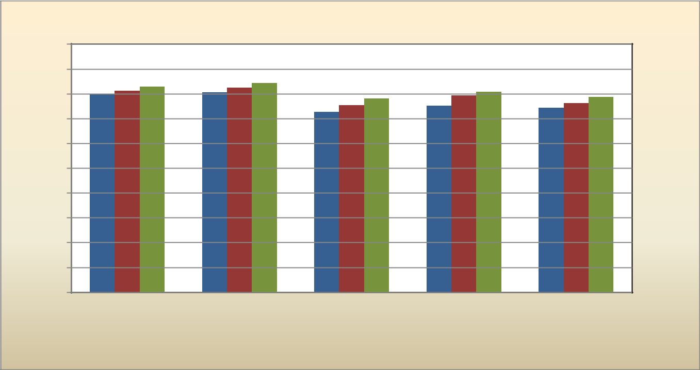

Average Rating (5-point scale)

5

4.5

4

3.5

3

2.5

2

1.5

1

0.5

0

General Job Satisfaction

_{4.00} 4.06 ^{4.14} | _{4.03} 4.12 ^{4.21} | _{3.77} 3.90 |  | 3.96 ^{4.04} | 3.93
 |  | _{3.77} 3.90 | 3.76 | 3.71 ^{3.81} | 3.93
 | 3.63 | _{3.77} 3.90 | 3.76 | 3.71 ^{3.81}

2012

2013

2014

Overall job | Opportunity to | Receive training | ADE support for | ADE values my ideas
satisfaction | learn & do | to do job well | training to improve | on work-related
 | new things |  | skills | issues

Rated Items
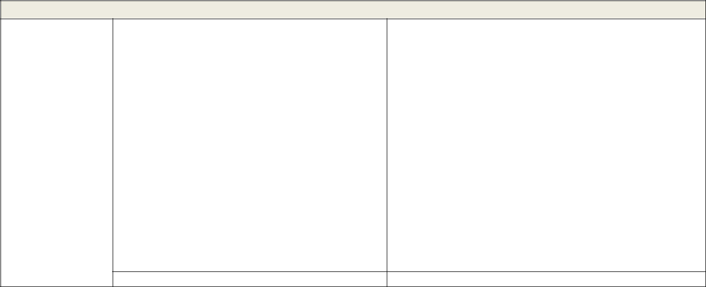

General Job Satisfaction—Comments Summary

 | 2013 (46 Total) | 2014 (34 Total)
Working Well: | Enjoy support of Unit/Section/Division | Enjoy support of Unit/Section/Division leadership (4)
 | leadership (7) | General improvements (3)
 | General improvements (4)
 | Training (3)
Improvement | Develop and provide job-specific training for | Develop and provide job-specific and technical training
Opportunities: | new & current staff; provide professional | for new & current staff; provide support for participation
 | development opportunities (8) | in professional development opportunities (7)
 | Employee input not valued; limited opportunity | Employee input not valued, as demonstrated by lack of
 | to apply experience, expertise (15) | action or follow-up on employee feedback; limited
 |  | opportunity to apply experience, expertise (9)
 | Leadership improve culture of support at | Leadership improve culture of support at Section/Unit
 | Section/Unit level (6) | level, provide more growth opportunities (8)

Miscellaneous (3)

Miscellaneous (3)

031714 (FINAL) | 6

2014 Employee Satisfaction Survey Report
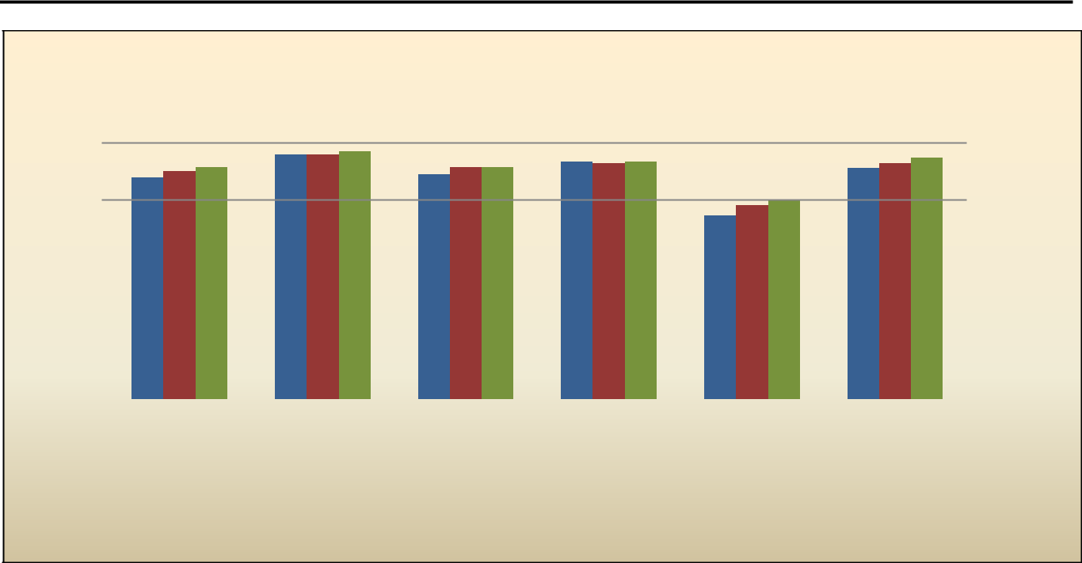

Work Conditions

Average Rting (5-point scale)

5

4.5

4

3.5

3

2.5

2

1.5

1

0.5

0

 |  | 4.00 ^{4.07} | 4.29 | 4.29 | 4.35 | 4.07 | 4.16 | 4.13 4.16 |  |  | 4.14 | 4.23
 | 3.89 | 4.00 ^{4.07} |  |  | 3.95 4.07 | 4.07 | 4.16 | 4.13 4.16 |  | 4.06 | 4.14
 |  |  |  |  |  |  |  |  | 3.22 | 3.40 ^{3.49}

I have the proper | I feel safe | Supervisor assigns | ADE does not | Promotions are | Overall
tools & | at work | work fairly | tolerate | based on | satisfaction with
equipment to do |  |  | discrimination | qualifications | State benefits
my job

Rated Items

2012

2013

2014

Work Conditions—Comments Summary
 | 2013 (76 Total) | 2014 (65 Total)
Working Well: | Benefits (1) | Benefits (2)
 |  | Garage safety improvements (2)
Improvement | Promotions often not based on qualification, | Promotions often not based on qualification, more
Opportunities: | more of “who you know”; limited opportunities | of “who you know”; limited opportunities (16)
 | (21)
 | Favoritism displayed; hold everyone | Perceptions of favoritism and/or discrimination;
 | accountable to the same standard in | hold everyone accountable to the same standard
 | performance, behavior, workload (14) | in performance, behavior, workload (12)
 | Not happy with changes to State benefits— | Concerns re. changes in annual leave and
 | ASRS, Dental, Medical, Vacation (11) | benefits deductions (5)
 | Increase salaries(4) | Provide COLA; correct disparity in salaries (6)
 | Provide technology, equipment, support to do | Provide more portable devices, technology
 | the job (13) | support; improve systems, vpn, storage capacity;
 |  | provide basic office equipment (14)
 | Reinstate badges, provide parking security (5) | General safety improvements (4)
 | Miscellaneous (7) | Miscellaneous (4)

031714 (FINAL) | 7

2014 Employee Satisfaction Survey Report
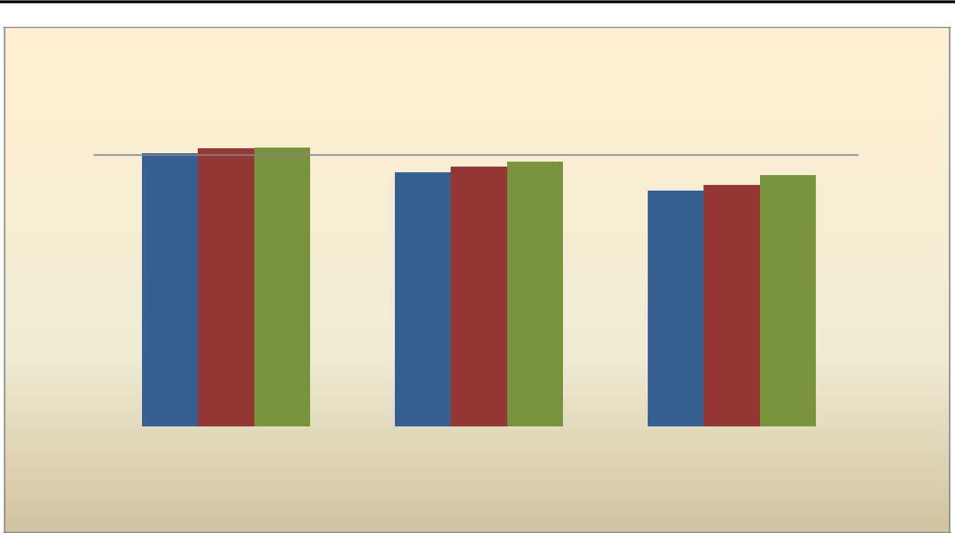

Communication

Average Rating (5-point scale)

5

4.5

4

3.5

3

2.5

2

1.5

1

0.5

0

 | 4.02 | 4.09 | 4.10 |  | 3.89
 | 4.02 |  |  | 3.82 | 3.89
 |  |  | 3.74 | 3.82 | 3.89 |  | 3.69
 |  |  | 3.74 |  | 3.47 | 3.55 | 3.69

I understand clearly what I receive adequate feedback Necessary information is

is expected of me at work on my work communicated effectively
and in a timely manner

Rated Items

2012

2013

2014

Communication—Comments Summary
 | 2013 (40 Total) | 2014 (40 Total)
Working Well: | Good communication from my supervisor (3) | Good communication from my supervisor (2)
 | Facilities doing a great job with Central move | Enjoy the ADE Insider (1)
 | communication (1)
Improvement | Division/Section/Unit Management: (12) | Division/Section/Unit Management: (16)
Opportunities: | • Share information at staff meetings (Unit, | • Ensure all staff receive a consistent message at
 | Section) to ensure all receive a consistent | the same time; provide opportunities for staff to
 | message at the same time; provide | give input; ensure the flow of top-down information
 | opportunities for staff to give input (9) | (12)
 | • Implement regular feedback systems that | • Implement regular feedback systems that include
 | include ratings and constructive feedback (3) | ratings and constructive feedback (4)
 | Provide clear, consistent expectations (4)
 | Limited communication from/with Executive | Limited communication from/with Executive Team;
 | Team; decisions made in isolation contribute | decisions made in isolation contribute to crises (5)
 | to crises (7)
 | Improve timeliness of information (3) | Improve timeliness of information (4)
 | Improve cross-Unit/Division communication | Improve effectiveness of ADE-wide and cross-
 | (responsiveness, timeliness, information- | Unit/Division communication and information-
 | sharing; eliminate “over-communication from | sharing (12)
 | some programs) (7)
 | Miscellaneous(3)

031714 (FINAL) | 8

2014 Employee Satisfaction Survey Report
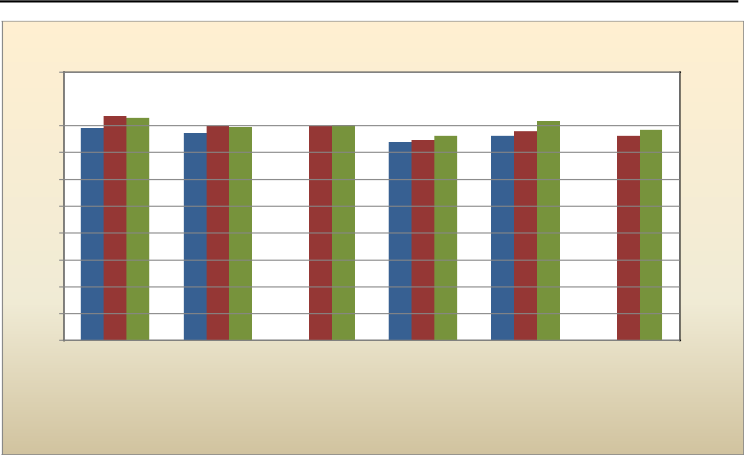

Supportive Work Environment

Average Rating (5-point scale)

5

4.5

4

3.5

3

2.5

2

1.5

1

0.5

0

3.95 | ^{4.18} 4.14 |  | 4.00 | 3.97 | 4.00 ^{4.01} |  |  | 3.89 ^{4.08}
3.95 |  | 3.86 | 4.00 | 3.97 | 4.00 ^{4.01} | 3.81 | 3.81 | 3.89 ^{4.08} | 3.81 | 3.92
 |  | 3.86 |  |  | 3.69 ^{3.73} | 3.81 | 3.81 |  | 3.81

2012

2013

2014

My supervisor | My DAS creates a | My | I receive recognition | ADE supports my | The Executive Team
creates a supportive | supportive work | Associate/Division | for my work when I | participation in | shows support for
work culture | culture | Leader creates a | deserve it | education & PD | employees*
 |  | supportive work
 |  | culture*

Rated Items

*Items revised after 2012 - no comparison available


Supportive Work Environment—Comments Summary
 |  | 2013 (58 Total) |  | 2014 (40 Total)
Working Well: | Positive, supportive (12) |  | Positive, supportive (6)
 | • | Supervisor (4) | • | Strong Unit/Division support (3)
 | • | Deputy Associate (4) | • | General support (2)
 | • | Associate (1) | • | Executive Team (1)
 | • | Executive Team (3)
Improvement | Executive team lacking presence/contact with |  | Executive team lacking presence/disconnected from
Opportunities: | staff, support for cross-agency collaboration |  | staff (6)
 | (8)
 | Supervisor displays favoritism, creates |  | Supervisor displays favoritism, lacks administrative
 | negative environment (5) |  | and intrapersonal skills (3)
 | DAS lacks competence, sincerity; displays |  | DAS absent/disconnected from employees and the
 | favoritism (9) |  | work (8)
 | Associate lacking presence, contact with staff |  | Miscellaneous comments regarding Associate
 | (8) |  | relationship with staff (4)
 | Demonstrate support for training/PD by
 | providing consistency across Units in
 | opportunities, tuition reimbursement, funding
 | and time (9)
 | Provide recognition (4) |  | General support and recognition inconsistently
 |  |  | provided (7)
 | Miscellaneous (3) |  | Miscellaneous (6)

031714 (FINAL) | 9

2014 Employee Satisfaction Survey Report
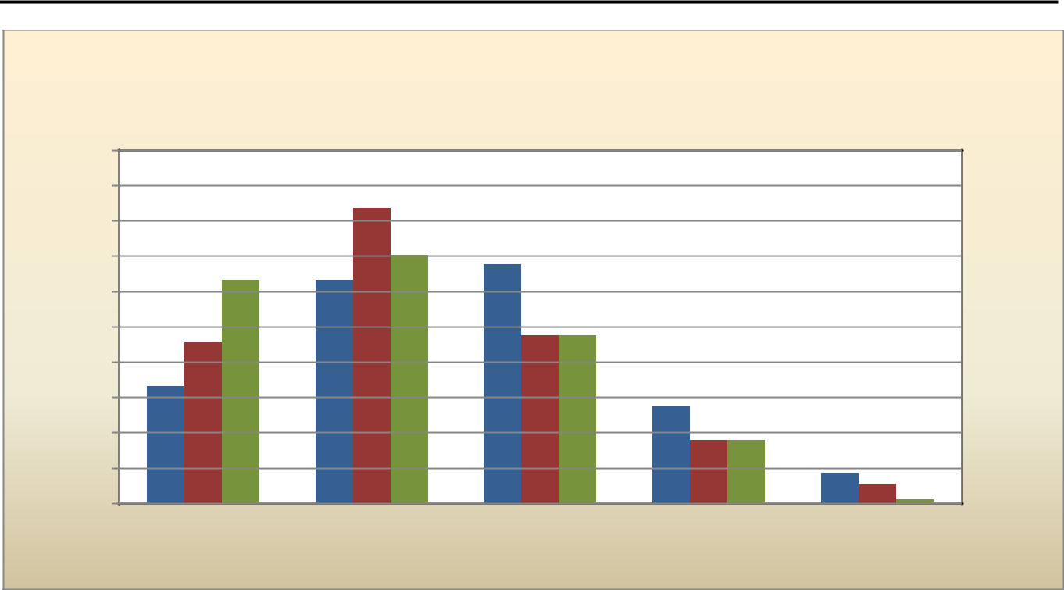

Overall Satisfaction

Percent Rating for Each Category

50

45

40

35

30

25

20

15

10

5

0

2012 average - 3.43. "Net Top Box" - 12.3%

2013 average - 3.73. "Net Top Box" - 19.9%

2014 average - 3.88. "Net Top Box" - 31.1%

41.8

35.1 _{33.8}
31.6 31.6

22.7 | 23.8 | 23.7

16.6
13.7

8.9 9.0
^{4.3} 2.8
0.5

Outstanding Above Average Average Needs Improvement Poor

Rating Categories

2012

2013

2014

 |  | Overall Satisfaction—Comments Summary
 |  | 2013 (54 Total) | 2014 (47 Total)
Working Well: | Overall culture is outstanding (6) |  | Great work environment, approaching
 | Enjoy my job and working at ADE (5) |  | outstanding (6)
 | Changes in program management have been |  | Appreciate Division/group leadership and upper
 | positive (3) |  | management (6)
 |  |  | Enjoy my job and the challenging work (3)
Improvement | Raise skill levels in managing people and effective |  | Raise skill levels in managing people and effective
Opportunities: | teams to increase productivity and creative |  | teams to increase productivity and creative
 | collaboration (14) |  | collaboration (13)
 | • Increase knowledge, competence of top levels |  | • Increase knowledge, competence of top levels
 |  | (through DAS level) in the work needed, | (through DAS level) in the work needed,
 |  | leadership and decision-making skills (6) | leadership and decision-making skills (7)
 | • Supervisor creating negativity in Unit (3) |  | • Need management (all levels) to hold everyone
 | • Lacking direction, presence from Executive Team |  | accountable to the same standard of service and
 |  | (2) | productivity; needs to start at the top (4)
 | • Need management (all levels) to hold everyone |  | • Improve management communication skills and
 |  | accountable to the same standard of service and | consistency in messaging (inside and external to
 |  | productivity (3) | ADE) (2)
 | No raises/COLA; salaries low. Need equitable
 | balance of work and pay (11)
 | Improve consistency in support for staff, ADE- |  | Improve consistency in support for staff, ADE-
 | wide (14) |  | wide (14)
 | • Culture change is perceived as negative regarding |  | • Many cultural improvements still needed; need
 |  | support, satisfaction; looking elsewhere for | leadership to value employee expertise and input;
 |  | employment (7) | reduce turnover (9)
 | • | Increase resources/training (4) | • Provide more compensation and growth
 | • | Provide more telecommuting/flex options (3) | opportunities (3)
 |  |  | • Increase resources/training (2)
 | Miscellaneous (1) |  | Miscellaneous (5)
031714 (FINAL) |  |  | 10

2014 Employee Satisfaction Survey Report
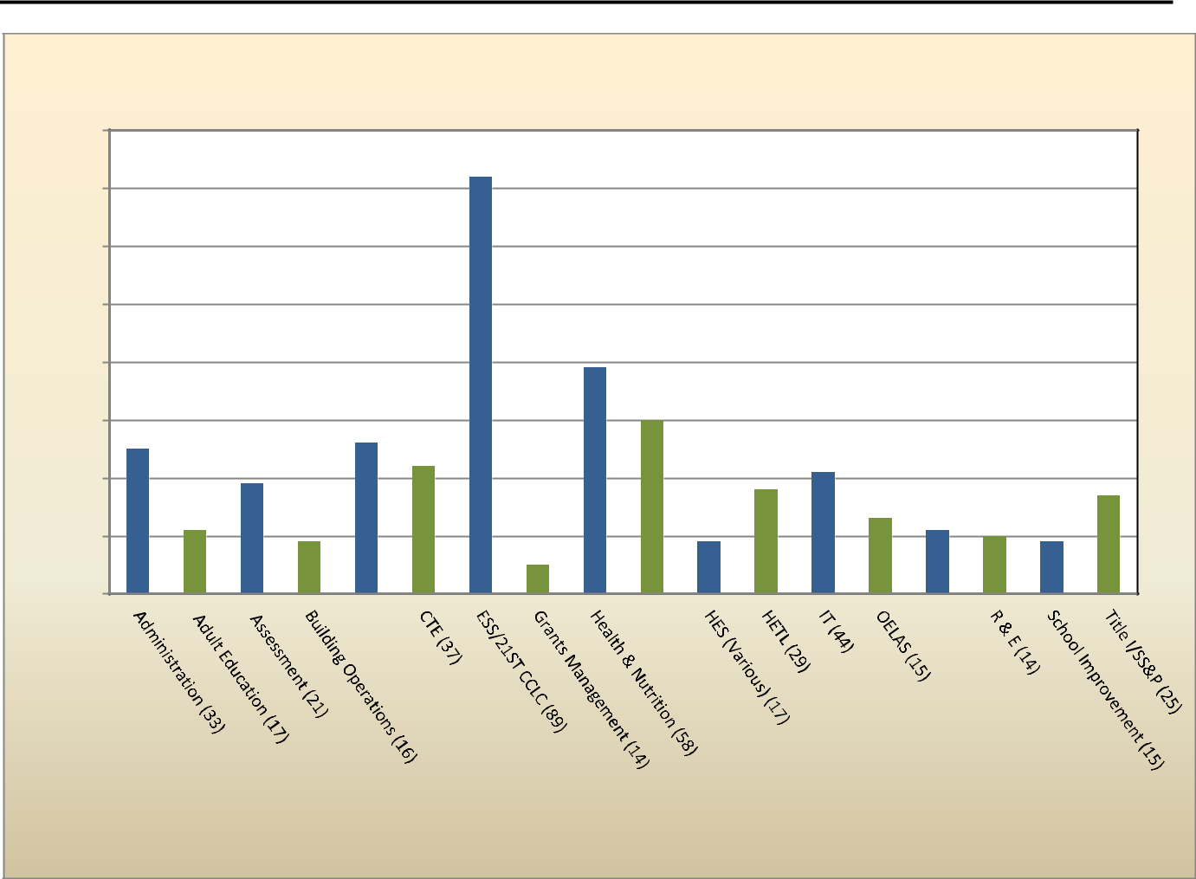

2014 Division Designators

(Since group designators were changed slightly each year, no comparisons available)

 | 80
 |  |  |  | 72
Group | 70
Group | 60
by
Responding | 50
Responding | 40 |  |  | 39
Responding |  |  |  | 30
Number |  |  |  | 30
Number | 30 | 25 |  | 26
Number |  | 25 |  | 22
Number |  |  | 19 | 22 | 21
Number |  |  | 19 | 18 | 21
Number | 20 |  | 19 | 18 |  |  |  | 17
 | 20 |  |  |  | 13
 |  | 11 |  |  | 13 | 11 | 10
 |  | 11 | 9 | 9 |  | 11 | 10 | 9
 | 10 |  | 9 | 9 |  |  |  | 9
 | 10 |  |  | 5
 | 0

Designators with Group Population
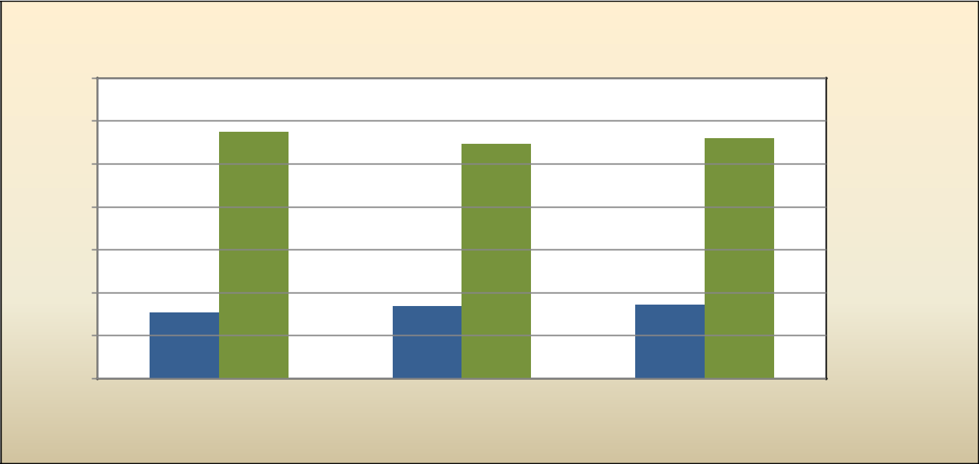

Supervisory/Non-Supervisory Designation

Number of Respondents

350

300

250

200

150

100

50

0

287 | 273 | 280

77 | 84 | 86

2012 2013 2014

Year

Supervisory

Non-Supervisory

031714 (FINAL) | 11

2014 Employee Satisfaction Survey Report
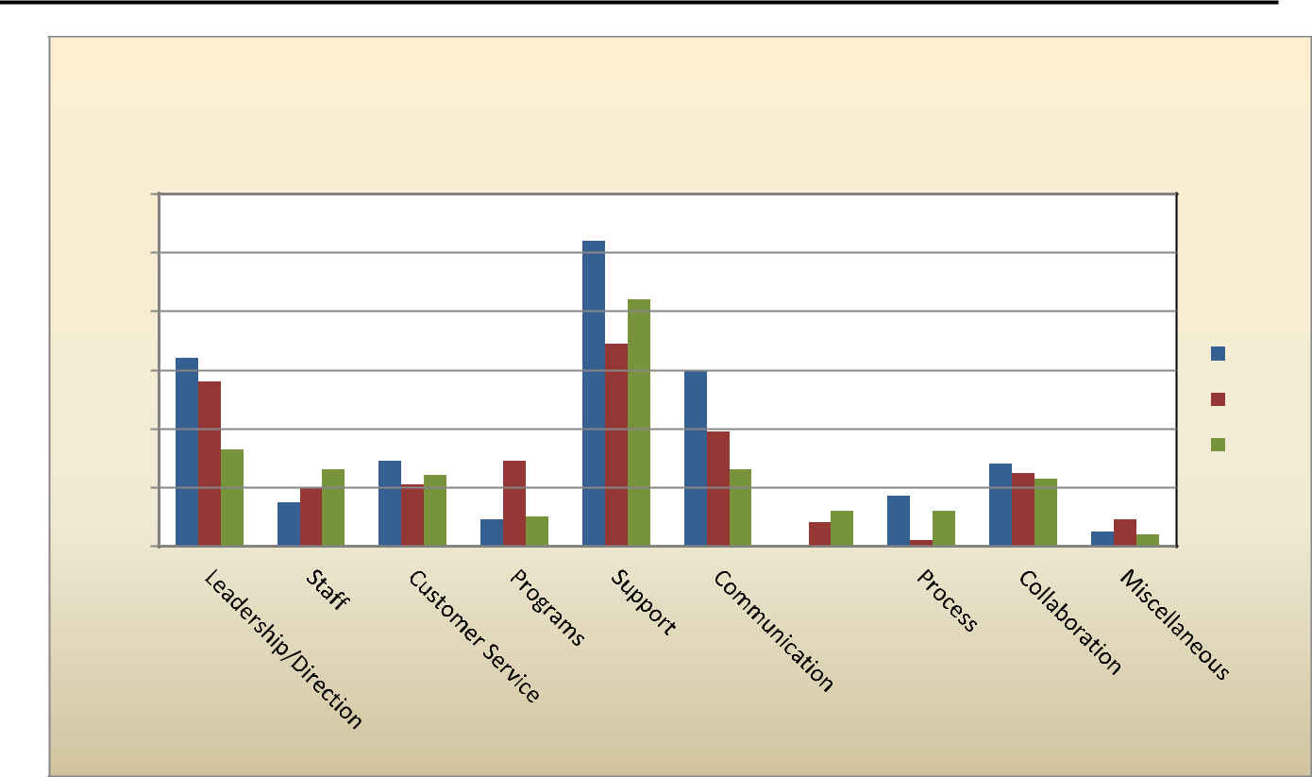

 |  |  |  | What Is Working Well at ADE?
 |  |  |  |  |  | 2012 - 331 Comments
 |  |  |  |  |  | 2013 - 278 Comments
 |  |  |  |  |  | 2014 - 254 Comments
Frequency | 120 |  |  |  |  | 104
Frequency | 100 |  |  |  |  | 84
Frequency | 80 |  |  |  |  | 69
Comment |  | 64 |  |  |  | 69
Comment |  | 64 |  |  |  | 60 |  |  |  |  | 2012
Comment |  | 56 |  |  |  | 60 |  |  |  |  | 2012
Comment | 60 | 56 |  |  |  |  |  |  |  |  | 2012
Comment |  |  |  |  |  | 39 |  |  |  |  | 2013
Comment | 40 | 33 |  |  |  | 39
Comment | 40 | 33 | 29 |  | 29 |  |  |  | ²⁸25₂₃
 | 40 | 33 | 29 |  | 29 |  |  |  | ²⁸25₂₃ |  | 2014
 |  | 26 | 29 | 24 | 29 | 26 |  |  | ²⁸25₂₃ |  | 2014
 |  | 20 | 21 |  |  |  | 17
 | 20 | 15 |  |  | 10 | ₈ 12 | 17 | 12
 | 20 | 15 |  | 9 | 10 | ₈ 12 |  | 12 |  | 9
 | 20 |  |  | 9 | 10 | ₈ 12 |  | 12 | 5 | 9 | 4
 |  |  |  |  |  | 0 |  | 2 | 5 |  | 4
 | 0
 |  |  |  |  |  | Response Categories

What is Working Well at ADE?—Comments Summary

 |  | 2013 (278 Total) |  | 2014 (254 Total)
 | Leadership/Direction (56) |  | Leadership/Direction (33)
 | • | Division/Unit Management is supportive, leadership improving | • Executive Team is creating a supportive culture; listening to
 |  | (22) | • | employees to improve work environment (15)
 | • Executive Team is creating a supportive culture and focus on |  | • | Division/Unit Management is supportive, encouraging; (14)
 |  | service, students (22) | • | General (4)
 | • Clear direction and focus on shared Vision, Mission, goals (12)
 | Staff (20) |  | Staff (26)
 | • | Supportive, pleasant, collaborative (13) | • | Supportive, pleasant, collaborative (13)
 | • Dedicated, competent, knowledgeable (7) |  | • Dedicated, competent, knowledgeable (13)
 | Customer Service (21) |  | Customer Service (24)
 | • | KYSO focus ADE-wide (10) | • | Strong support of students and educators (14)
 | • | Technical Assistance (7) | • | KYSO focus (5)
 | • | Commitment to strengthening relationship (4) | • | Increase in collaborative relationships (5)
 | Programs (29) |  | Programs (10)
 | • | Facilities improvements at Jefferson, service & communication | • | IT responsiveness & support (4)
 | • | with Central move (10) | • | Government Relations & Policy updates (2)
 | • | IT responsiveness & support (9) | • | Various Units (4)
 | • | Various Units (four mentioned) (9)
 | Support (69) |  | Support (84)
 | • | Overall culture (19) | • | Overall culture (39)
 | • | Flex schedules, telecommuting (16) | • | PD, growth opportunities (13)
 | • | PD, training opportunities (10) | • | Flex schedule (10)
 | • | Input valued (8) | • | Resources (10)
 | • | REACH events (7) | • | Input valued (6)
 | • | Casual Fridays (6) | • | REACH events (3)
 | • | Resources (3) | • | Casual Fridays (3)
031714 (FINAL) |  |  |  | 12

2014 Employee Satisfaction Survey Report

What is Working Well at ADE?—Comments Summary, continued

 | 2013 (274 Total) |  | 2014 (254 Total)
Communication (39) |  | Communication (26)
• More communication from management, all levels (11) |  | • Improvements in communication from management, all levels;
• Opportunities to provide input (7) |  |  | appreciate Town Hall sessions (9)
• General comments; communication improving (21) |  | • Improving communication within and between work groups (7)
 |  | • General improvements ADE-wide (10)
Compensation & Benefits (8) |  | Compensation & Benefits (12)
• | Benefits are good | • Incentive pay a step in the right direction (5)
 |  | • Benefits are good (5)
 |  | • | Miscellaneous (2)
Process (2) |  | Process (12)
• | Grants management | • Various program improvements (8)
• | FERPA standards | • | General streamlining/improvements (4)
Collaboration (25) |  | Collaboration (23)
• ADE-wide, focus on/commitment to collaboration (11) |  | • ADE-wide, focus on/commitment to collaboration (12)
• | Cross-Division (9) | • | Cross-Division (8)
• | Within Sections/Units (5) | • | Within Sections/Units (3)
Miscellaneous (9) |  | Miscellaneous (4)

031714 (FINAL) | 13

2014 Employee Satisfaction Survey Report
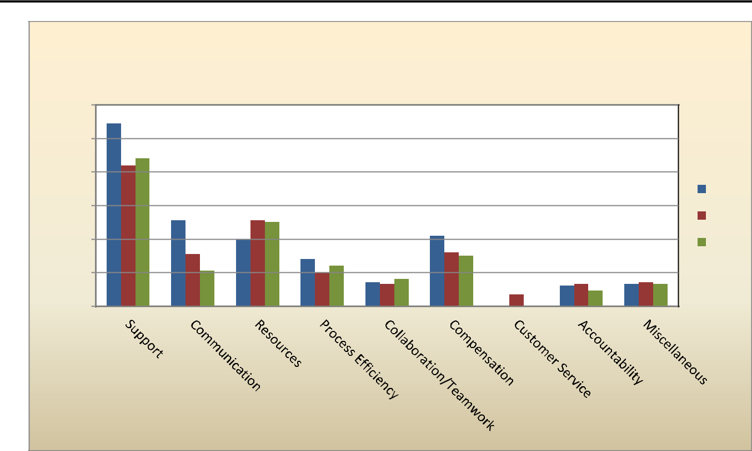

 |  |  |  | What Can ADE Improve?
 |  |  |  | 2012 - 309 Comments
 |  |  |  | 2013 - 265 Comments
 | 120 |  |  | 2014 - 251 Comments
 | 120 | 109
Frequency | 100 | 84 | 88
Frequency | 80
Frequency |  |  |  |  |  |  |  |  |  | 2012
Comment |  |  |  |  |  |  |  |  |  | 2012
Comment | 60 |  | 51 | 5150 |  |  |  |  |  | 2013
Comment |  |  |  | 40 | 42 |  |  |  |  | 2013
Comment | 40 |  | 31 | 28 | ³²30 |  |  |  |  | 2014
 |  |  | 21 | 20 | 24
 | 20 |  |  |  | 1413¹⁶ | 7 | 1213 | 9 | 1314 | 13
 |  |  |  |  |  | 7 | 0
 | 0
 |  |  |  | Response Categories

What Can ADE Improve?—Comments Summary

 |  | 2013 (265 Total) |  |  | 2014 (251 Total)
 | Support (84) |  |  | Support (88)
 | • | Improve management/staff relationship (32) |  | • | Improve management/staff relationship (30)
 |  | o Executive Team connect with/be visible to Staff; improve |  |  | o Provide management skills training to all
 |  | planning, time management skills; model and hold others |  |  | management levels (10)
 |  | accountable to present an image that represents ADE |  |  | o Develop knowledge and competence in all
 |  | Vision, Mission (12) |  |  | management levels (9)
 |  | o Develop knowledge and competence in all management |  |  | o Provide better direction and improve communication,
 |  | levels (10) |  |  | flow of information to staff (7)
 |  | o Model/create a supportive work culture (6) |  |  | o Increase Executive Team support (4)
 |  | o Provide interpersonal skills & management training to |  | • | Provide training options (expand orientation; webinars;
 |  | supervisors; develop ability to empower staff (4) |  |  | instructor-led classes; PD opportunities) (15)
 | • Provide training options (23) |  |  | • | Provide culture of support at all levels, expand outreach,
 | • Provide culture of support; value staff input (18) |  |  |  | morale, engagement activities (13)
 | • Base promotions on merit (6) |  |  | • | Improve fairness (22)
 | • Provide opportunity to telecommute (5) |  |  |  | o Base growth/promotion on qualifications, merit (15)
 |  |  |  |  | o Ensure equity in workloads (7)
 |  |  |  | • Provide opportunity to flex, telecommute (4)
 |  |  |  | • | Miscellaneous (4)
 | Communication (31) |  |  | Communication (21)
 | • | Improve communication ADE-wide (17) |  | • | Improve/increase timely communication (especially on key
 | • | Improve communication within Unit/Section/Division (7) |  |  | initiatives) from Executive Team, and ensure regular flow
 | • | Management ensure regular flow of information gets to staff | (5) | • | of information gets to staff (6)
 | • Improve/increase communication from Executive Team (2) |  |  | • | Improve communication within Unit/Section/Division (5)
 |  |  |  | • | Improve cross-Division communication (5)
 |  |  |  | • | General communication improvements, ADE-wide (5)
031714 (FINAL) |  |  |  |  | 14

 |  | 2014 Employee Satisfaction Survey Report
 |  | What Can ADE Improve?—Comments Summary, continued
 |  | 2013 (263 Total) |  |  | 2014 (251 Total)
 | Resources (51) |  | Resources (50)
 | • | Improve/update facilities (13) | • Improve technology and IT support (30)
 | • Improve technology and IT support (15) |  |  | o Technology and systems (17)
 | • | Upgrade equipment (9) | • | o | Service and support (13)
 |  |  | • | Improve/update facilities (20)
 |  |  |  | o General (office space, split sites) (8)
 |  |  |  | o Jefferson – general improvements (7)
 |  |  |  | o Jefferson – cafeteria (5)
 | Process Efficiency (20) |  | Process Efficiency (24)
 | • Coordinate, streamline and standardize processes to improve |  | • Improve efficiency of internal service processes:
 |  | services to field (10) |  | o Surveys, use of data collection (7)
 | • Improve efficiency of internal service processes (Procurement, |  |  | o | Standardize, streamline ADE processes (5)
 |  | Travel, HR) (10) |  | o | Travel (4)
 |  |  |  | o | Procurement (3)
 |  |  |  | o | Meetings (3)
 |  |  |  | o | MAP (2)
 | Collaboration and Teamwork (13) |  | Collaboration and Teamwork (16)
 | • Continue improvements ADE-wide (10) |  | • Implement more formal structure, opportunities for
 | • Develop more collaboration between Units and Sections (3) |  |  | collaboration between programs (10)
 |  |  | • Develop more collaboration ADE-wide (6)
 | Compensation (32) |  | Compensation (30)
 | • Provide COLA to all staff |  | • Provide raises/COLA to all staff (28)
 |  |  | • | Miscellaneous benefits (2)
 | Customer Service (7) |  | Customer Service (0)
 | • Focus on learning, service, school outcomes
 | Accountability (13) |  | Accountability (9)
 | • Management hold staff accountable for performance and |  | • Management hold staff accountable for performance and
 |  | behavior standards (6) |  | behavior standards (7)
 | • Management should be held accountable for behavior and |  | • General accountability, ADE-wide (2)
 |  | performance (4)
 | • General accountability, ADE-wide (3)
 | Miscellaneous (14) |  | Miscellaneous (13)

031714 (FINAL) | 15

