Fin-150 Construction Draw Schedule
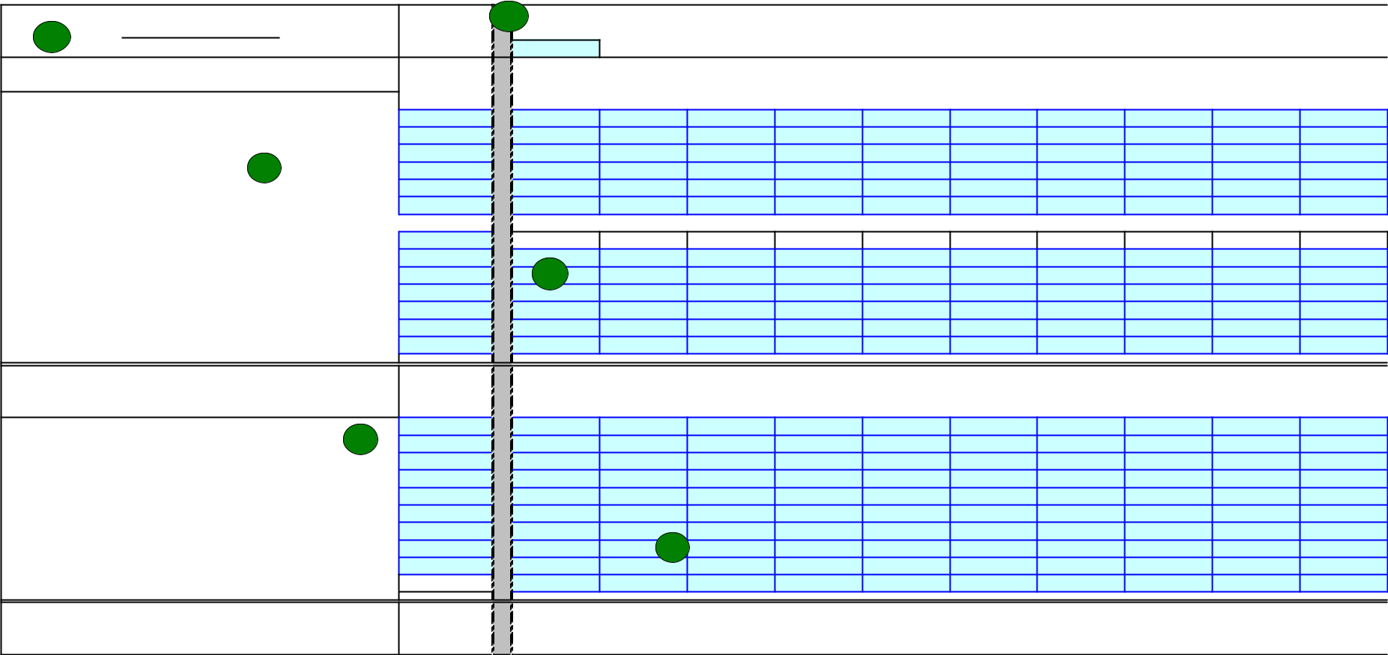

 | Project Name 07-150-HT |  | 2. | Closing | Draw | Draw | Draw | Draw | Draw | Draw | Draw | Draw | Draw
1. |  |  | 2013 | Draw | 2 | 3 | 4 | 5 | 6 | 7 | 8 | 9 | 10
1. |  |  | TOTAL | Jun-06 | Jul-06 | Aug-06 | Sep-06 | Oct-06 | Nov-06 | Dec-06 | Jan-07 | Feb-07 | Mar-07
Sources of Funds
Equity
Federal LIHTC Equity |  |  | $3,500,000 | $50,000 |  |  |  |  |  |  | $75,000
State LIHTC Equity |  |  | $1,350,000 | $25,000 |  |  |  |  |  |  | $75,000
Federal Historic Rehab Equity |  | 3.
State Historic Rehab Equity |  | 3.
General Partner Equity
Other (Describe)
Debt
Construction Loan (Describe) |  |  | $4,950,000 | $625,000 | $360,417 | $360,417 | $380,417 | $380,417 | $380,417 | $155,417 | $380,417 | $380,417 | $380,417
Permanent Loan (Describe) |  |  | $900,000 | 4.
Soft Loan 1 (Describe) |  |  |  | 4.
Soft Loan 2 (Describe)
Soft Loan 3 (Describe)
Deferred Developer Fee |  |  | $65,000
AHAP Loan (If Applicable) |  |  | $225,000 |  |  |  |  |  |  | $225,000
Total Draw |  |  |  | $700,000 | $360,417 | $360,417 | $380,417 | $380,417 | $380,417 | $380,417 | $530,417 | $380,417 | $380,417
Uses of Funds (2013 Development Budget Line Item)
Acquisition (37a,37b,38,29a) |  | 5. | $300,000 | $300,000
Construction (1-9,22) |  | 5. | $4,000,000 |  | $333,333 | $333,333 | $333,333 | $333,333 | $333,333 | $333,333 | $333,333 | $333,333 | $333,333
Arch/Eng. (11-15) |  |  | $200,000 | $150,000 | $4,167 | $4,167 | $4,167 | $4,167 | $4,167 | $4,167 | $4,167 | $4,167 | $4,167
Contingency (33) |  |  | $200,000 |  |  |  | $20,000 | $20,000 | $20,000 | $20,000 | $20,000 | $20,000 | $20,000
SoftCosts (18-20a,26-28a,29b-31,34-35) |  |  | $75,000 | $50,000
Financing Costs (16c,17,20b,21,23,24,32,41a,41b,42,43,45) |  |  | $300,000 | $25,000 | $22,917 | $22,917 | $22,917 | $22,917 | $22,917 | $22,917 | $22,917 | $22,917 | $22,917
Reserves (44,46,47) |  |  | $200,000 | $100,000 | 6.
Development Fee (40a,40b) |  |  | $750,000 | $75,000 | 6. |  |  |  |  |  | $150,000
Other (36,48) |  |  | $15,000
Construction Loan Repayment |  |  | $4,950,000
Total |  |  |  | $700,000 | $360,417 | $360,417 | $380,417 | $380,417 | $380,417 | $380,417 | $530,417 | $380,417 | $380,417
% of TDC Spent |  |  |  | 11.59% | 17.56% | 23.52% | 29.82% | 36.12% | 42.42% | 48.72% | 57.50% | 63.80% | 70.10%


Construction Interest Estimation | 7.
Construction Loan Amount

Interest Rate

Outstanding Loan Amount

Interest

Final Draw Construction Interest

$4,950,000

6.50%

Total

$193,984

2013 Budget

$195,000

Jun-06 | Jul-06 | Aug-06 | Sep-06 | Oct-06 | Nov-06 | Dec-06 | Jan-07 | Feb-07 | Mar-07
 | $625,000 | $985,417 | $1,345,833 | $1,726,250 | $2,106,667 | $2,487,083 | $2,642,500 | $3,022,917 | $3,403,333
 | $3,385 | $5,338 | $7,290 | $9,351 | $11,411 | $13,472 | $14,314 | $16,374 | $18,435
$0 | $0 | $0 | $0 | $0 | $0 | $0 | $0 | $0 | $0
0% | 13% | 20% | 27% | 35% | 43% | 50% | 53% | 61% | 69%

Page 1

Fin-150 Construction Draw Schedule

 |  |  |  |  | Draw | Draw | Draw | Draw | Draw | Draw | Draw | Draw | Draws after
 | Project Name 07-150-HT |  |  | 2013 | 11 | 12 | 13 | 14 | 15 | 16 | 17 | 18 | 18 Months |  | DRAW
 |  |  |  | TOTAL | Apr-07 | May-07 | Jun-07 | Jul-07 | Aug-07 | Sep-07 | Oct-07 | Nov-07 8. | DATE? |  | TOTALS
Sources of Funds
Equity
Federal LIHTC Equity |  |  |  | $3,500,000 |  |  |  | $3,375,000 |  |  |  |  |  |  | $3,500,000
State LIHTC Equity |  |  |  | $1,350,000 |  |  |  | $1,250,000 |  |  |  |  |  |  | $1,350,000
Federal Historic Rehab Equity |  | 3. |  |  |  |  |  |  |  |  |  |  |  |  |  | $0
State Historic Rehab Equity |  | 3. |  |  |  |  |  |  |  |  |  |  |  |  |  | $0
General Partner Equity |  |  |  |  |  |  |  |  |  |  |  |  |  |  |  | $0
Other (Describe) |  |  |  |  |  |  |  |  |  |  |  |  |  |  |  | $0
Debt |  |  |  |  |  |  |  |  |  |  |  |  |  |  | $4,850,000
Construction Loan (Describe) |  |  |  | $4,950,000 | $380,417 | $405,417 | $380,417 | $0 | $0 | $0 | $0 | $0 | $0
Permanent Loan (Describe) |  |  |  | $900,000 |  |  |  | $900,000 |  |  |  |  |  |  | $900,000
Soft Loan 1 (Describe) |  |  |  |  |  |  |  |  |  |  |  |  |  |  | 9. | $0
Soft Loan 2 (Describe) |  |  |  |  |  |  |  |  |  |  |  |  |  |  | 9. | $0
Soft Loan 3 (Describe) |  |  |  |  |  |  |  |  |  |  |  |  |  |  |  | $0
Deferred Developer Fee |  |  |  | $65,000 |  |  |  | $65,000 |  |  |  |  |  |  |  | $65,000
AHAP Loan (If Applicable) |  |  |  | $225,000 |  |  |  |  |  |  |  |  |  |  | $225,000
Total Draw |  |  |  |  | $380,417 | $405,417 | $380,417 | $5,590,000 | $0 | $0 | $0 | $0 |  |  | $6,040,000
Uses of Funds (2013 Development Budget Line Item) |  |  |  |  |  |  |  |  |  |  |  |  |  |  | $300,000
Acquisition (37a,37b,38,29a) |  |  |  | $300,000
Construction (1-9,22) |  |  |  | $4,000,000 | $333,333 | $333,333 | $333,333 |  |  |  |  |  |  |  | $4,000,000
Arch/Eng. (11-15) |  |  |  | $200,000 | $4,167 | $4,167 | $4,167 |  |  |  |  |  | 10. |  | $200,000
Contingency (33) |  |  |  | $200,000 | $20,000 | $20,000 | $20,000 |  |  |  |  |  |  |  | $200,000
SoftCosts (18-20a,26-28a,29b-31,34-35) |  |  |  | $75,000 |  | $25,000 |  |  |  |  |  |  |  |  |  | $75,000
Financing Costs (16c,17,20b,21,23,24,32,41a,41b,42,43,45) |  |  |  | $300,000 | $22,917 | $22,917 | $22,917 |  |  |  |  |  |  |  | $300,000
Reserves (44,46,47) |  |  |  | $200,000 |  |  |  | $100,000 |  |  |  |  |  |  | $200,000
Development Fee (40a,40b) |  |  |  | $750,000 |  |  |  | $525,000 |  |  |  |  |  |  | $750,000
Other (36,48) |  |  |  | $15,000 |  |  |  | $15,000 |  |  |  |  |  |  |  | $15,000
Construction Loan Repayment |  |  |  | $4,950,000 |  |  |  | $4,950,000
Total |  |  |  |  | $380,417 | $405,417 | $380,417 | $5,590,000 | $0 | $0 | $0 | $0 |  |  | $6,040,000
% of TDC Spent |  |  |  |  | 76.39% | 83.11% | 89.40% | 100.00% | 100.00% | 100.00% | 100.00% | 100.00%
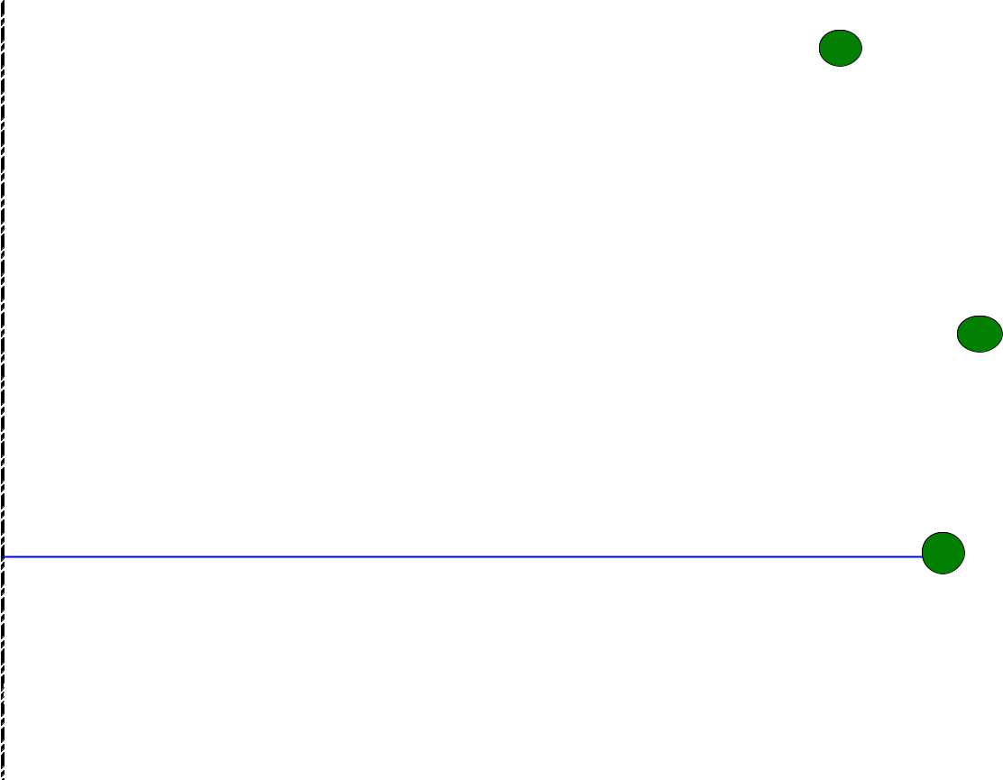

Construction Loan Drawn

$4,950,000


11.

Differece B/W Budget + Draws $0

$0

$0

$0

$0

$0

$0

$0

$0

Construction Interest Estimation | 7.
Construction Loan Amount | $4,950,000 |  | Apr-07 | May-07 | Jun-07 | Jul-07 | Aug-07 | Sep-07 | Oct-07 | Nov-07 | DATE?
Interest Rate |  | 6.50%
Outstanding Loan Amount |  | Total | $3,783,750 | $4,164,167 | $4,569,583 | 0 | $0 | $0 | $0 | $0 | $0
Interest |  | $193,984 | $20,495 | $22,556 | $24,752 | $0 | $0 | $0 | $0 | $0 | $0
Final Draw Construction Interest |  |  | $0 | $0 | $0 | $26,813 | $0 | $0 | $0 | $0 | $0
 |  | 2013 Budget | 76% | 84% | 92% | 0% | 0% | 0% | 0% | 0% | 0%
 |  | $195,000

Page 2

Fin 150 Construction Draw Schedule Overview and Instructions

Form 150 is intended to provide a reasonable estimate of the construction draws based on the information available at the time of firm submission and again at closing. It is only a tool for both owner and lender to think about the estimated timing and amount of construction draws and will help to appropriately size the construction loan prior to closing.

General:

- Blue shaded cells require user input.

- If you need help filling out Form 150 or you feel that the spreadsheet doesn’t adequately or accurately reflect what you would like to show, please contact your assigned underwriter.

- Enter the project name and assigned MHDC number (if known).

- Enter the month that the project is expected to close.

- Enter the amounts from the 2013 in the blue shaded cells for the corresponding sources of funds. If the name of the source needs to be changed or a source requires a description, please change where appropriate. If the project will feature AHAP credits structured as equity as opposed to a loan, please indicate so in the equity section under “Other”.

- Enter into these cells the amount of sources available to pay draw requests for that given month. The amount of construction loan required to be drawn will be automatically calculated.

- The blue cells should include the total of the line item numbers shown in parentheses for each category as they are listed on your 2013.

- The blue cells should show the estimated draw and what category is being paid for each month.

- The construction interest estimation uses the rate entered into the blue shaded cell and the construction loan drawn calculated above to come up with an amount of construction interest that would be due. The purpose is only to compare to the budgeted 2013 construction interest amount. The calculated amount and the budgeted amount should be the same or at least very similar.

- If there are draws that will be requested or items paid after 18 months from closing, please enter the total of all requests in the appropriate cells and include the date for the last draw after 18 months. Deferred developer fee paid should not be considered for this column.

- This column will total the sources that are drawn as shown on the draw schedule. This number should match the sources listed on 2013.

- This column will total the funds used as shown on the draw schedule. This number should match the sources listed on 2013.

- This cell will total the amount of construction loan drawn as it is automatically calculated by the spreadsheet. The amount of construction loan that should be shown under the 2013 total column (and on the 2013) should be approximately, if not the same, as the amount automatically calculated.

Page 3

