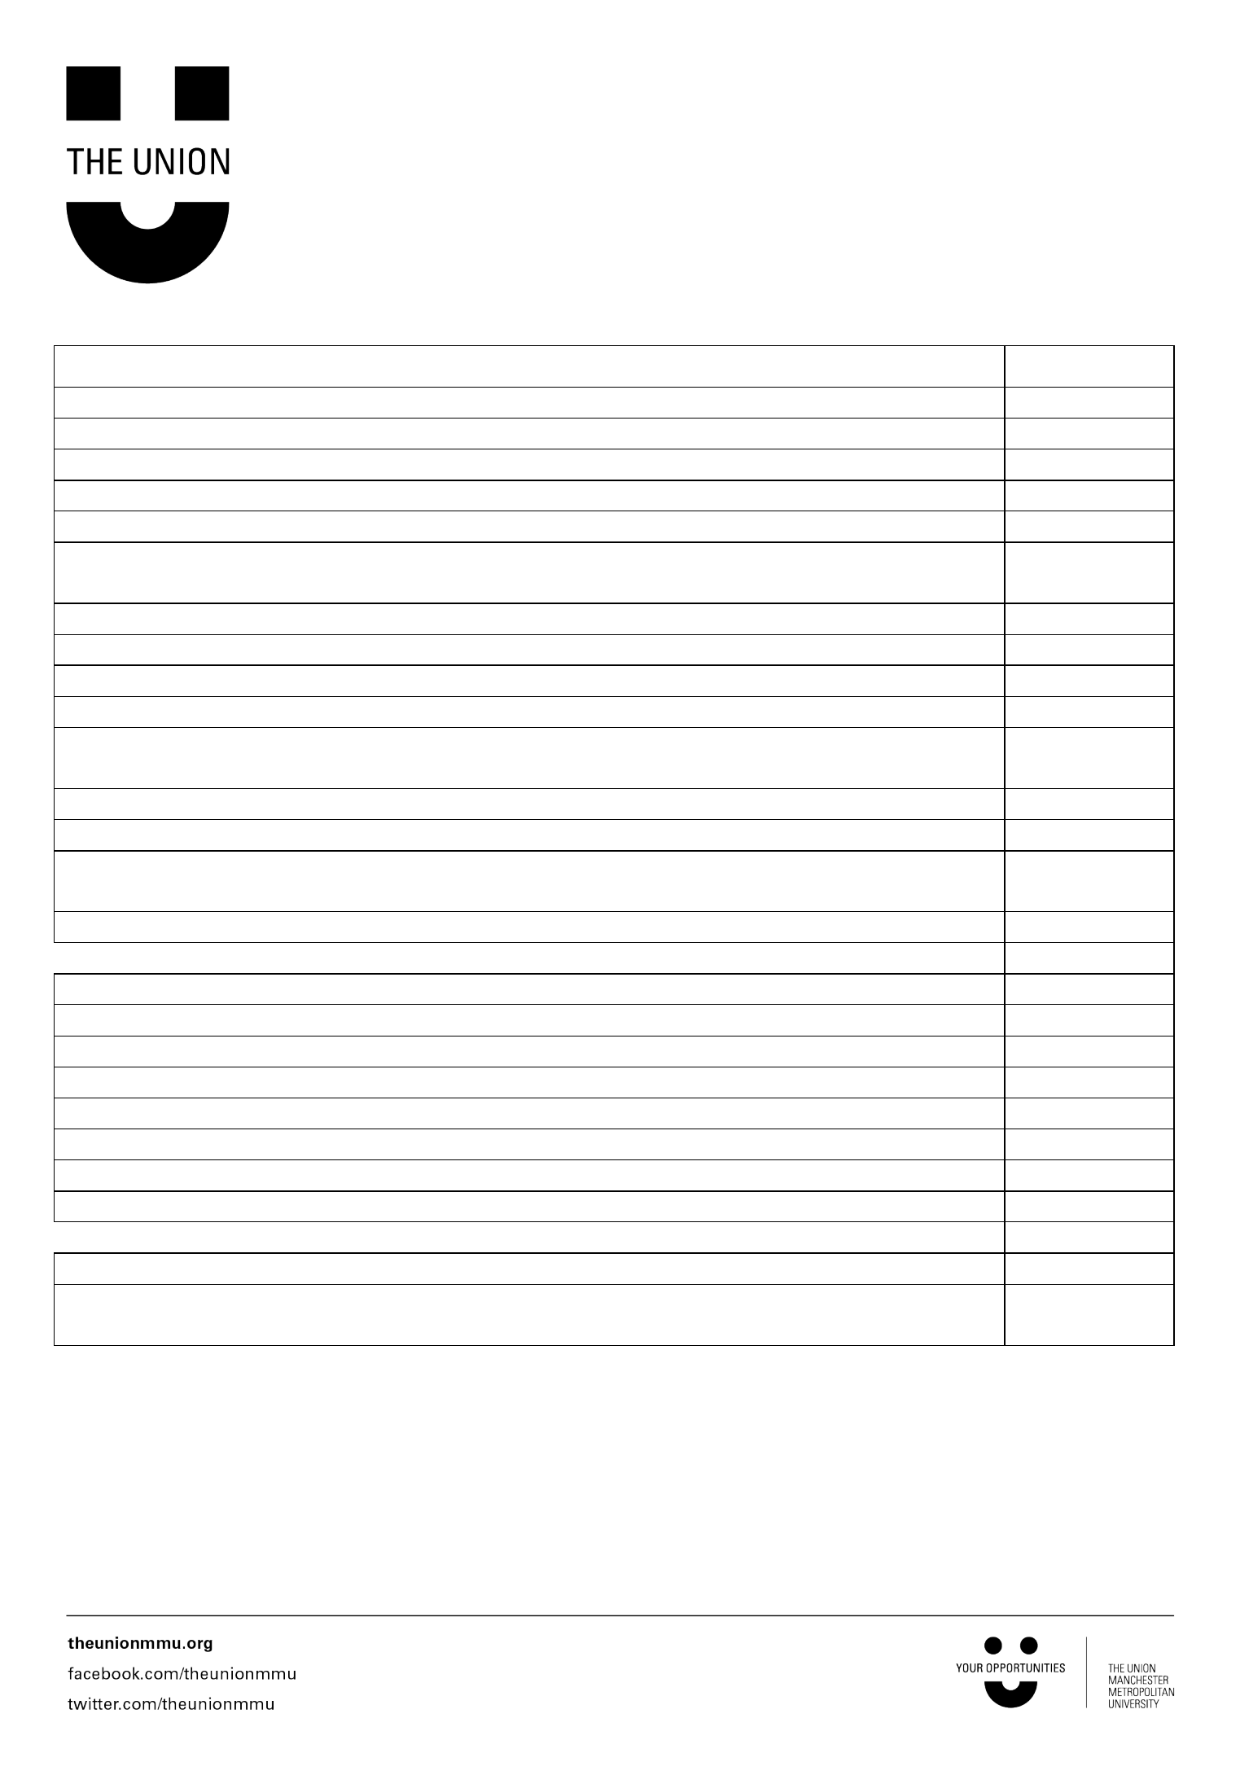
Fundraising event checklist

Tick off the actions when you’ve completed them
Pre-event:
1. | Choose charity to fundraise for
2. | Decide on event/activity
3. | Produce budget: fundraising target vs. materials, equipment etc.
4. | Decide on time and date of event
- Contact charity to advise of fundraiser and see if they can offer support/ideas (materials, poster etc.)
6. Book venue (if applicable)

7. Check insurance of venue covers event (if applicable)

8. Write risk assessment

9. Arrange hire of equipment (if applicable)

- Book pop up stall through facilities with at least two weeks’ notice (if applicable)
11. Complete food hygiene certificate through Futures (if applicable)

12. Promotion of event – posters, social media, networks

- Check back with venue to confirm booking and arrangements a few days before (if applicable)
14. Write event schedule and volunteer briefing notes (if applicable)

1. Take all materials to venue

2. Event set up (e.g. set out cake sale stall)

3. Brief volunteers (if applicable)

4. Welcome attendees – hopefully take lots of donations!

5. Oversee event and deal with any immediate problems

6. Post-Event:

7. Count all monies taken during event (at least two people present)

8. Clear up – leave the venue tidy.
Post event:

1. Take money to students union

- Event review – think about what went well and what you’d do differently next time.

For help and advice contact the Opportunities department:

Tel: 0161 247 2211

Email: volunteering@mmu.ac.uk

Twitter: @VolunteeringMMU

