DERBYSHIRE SURVEYORS


- Glumangate Chesterfield
S40 1TX

Office: 01246 559 951

BUILDING SURVEY REPORT
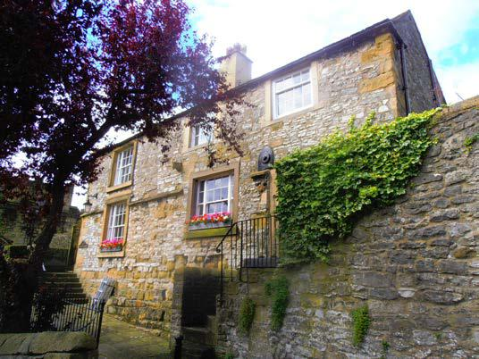

Property Address

For

Mr and Mrs XXXX

Inspected on:

2012

[Our Ref:]
Sample House, Sample Road, Sample

Making the most of your report

This form of survey report has been designed in line with comments from our customers. Our aim is to provide advice and information on your proposed new home, its construction, the materials used and its condition in a format that is clear and easy to understand.

A plain English style

We try wherever possible to use a plain English style and avoid jargon, but we do need sometimes to use technical terms to describe parts of the building. Before you start to read the report, take a look at the “House Illustration” and “Glossary of Building Terms” in the APPENDIX. This will help you understand some of the technical terms in the report. We would of course be pleased to discuss any aspect of the report with you further.

Advice on repairs and faults

The construction style of the building and the defects found by the surveyor are shown in the Survey Report.

The Surveyor’s Overall Assessment is provided in the SUMMARY section at the start of the report. Not only does this give a clear and definite view of what needs to be done, it is an ideal format for you to give to a contractor if you need estimates for some or all of the repairs.

Extra construction facts

In the APPENDIX we incorporate general advice for each part of the structure. This will give you some background knowledge of main materials and construction used. They have been selected because they are relevant to this property and reading them will give you a better assessment of the repairs recommended in the report.

Useful general maintenance notes are included in APPENDIX 4. You will find Essential Guidance for your Survey Report in APPENDIX 5. Please read your report carefully and feel free to contact our surveyor to discuss any matters.

Daniel Elliott, BSc(Hons) MRICS
Director
Derbyshire Surveyors

2
Sample House, Sample Road, Sample

CONDITION RATINGS 1,2 & 3

What everyone wants to know is how significant any defect is and whether repairs need to be dealt with now, or can the work wait until after occupation – for each repair: we tell you how urgent and significant it is. Where repair or further investigation is required, the appropriate advice about what action to take is provided at the end of the section

CONDITION RATINGS | DEFINITION
1 | Satisfactory Repair: Considered to be in an acceptable state of
 | repair and condition taking into account the age of the property.
 | No repair is required.
2. | Maintenance Required: Considered by the surveyor to be in a
 | generally acceptable condition but requires some routine
 | maintenance and repair which is considered normal for a
 | property of this age and character. These defects or
 | shortcomings would be taken into account by a reasonable
 | buyer and seller when agreeing a purchase price.
3. | Urgent Repair or Further Investigation Needed: Defects or
 | shortcomings that are an actual or developing threat to the
 | fabric of the building or to personal safety. Repair or further
 | investigation is required immediately. These defects may affect
your decision to purchase and the price that you pay for the property.

Remember this is just a guide but it should help you prioritise the repairs listed. Take special note of items with a condition rating 3 as further investigation may be needed by a specialist contractor. You are strongly advised to obtain quotations before exchange of contracts for any item given a rating of 2 or 3.

3
Sample House, Sample Road, Sample

CONTENTS

SUMMARY

Property
Brief Overall Assessment
Review of Findings
Valuation
Environmental Matters
Matters for your Legal Adviser

INSTRUCTION

SURVEY REPORT

Constructional Principles & Structural Risks
Exterior
Interior
Services
Grounds

APPENDIX

1 – General Advice
2 – House Illustration
3 – Glossary of Building Terms
4 – General Maintenance Notes
5 – Essential Guidance
6 – Terms and Conditions of Engagement

4
Sample House, Sample Road, Sample

SUMMARY

PROPERTY

Property address

Address

Address

Address

Property type

A substantial two storey detached house with single detached garage.

The property is believed to be classified as a listed building and your attention is drawn to information at the end of this report.

Year built

Circa 1100.

Accommodation

Ground floor: Entrance hall, dining room, drawing room, sitting room, cloakroom, kitchen, store, utility room.

First floor: Landing, five bedrooms, three bathrooms, separate w/c.

Outbuildings: Basic attached store and single detached garage.

External: There is a small enclosed yard to the front with a good sized enclosed garden to the rear.

Location

The property is situated in an established residential area approximately 400 yds from XXXX centre. The property is situated close to a number of good local amenities.

Orientation

The front of the property faces approximately south. All directions and room locations in this report are given as facing the front of the property, with the church to the rear and XXXX centre to the right hand side.

The Site and Surrounding Area

The property is located on a good sized plot which appears reasonably elevated in relation to surrounding ground levels. The site is relatively flat.

Tenure

It has been assumed that the property is being sold on a freehold basis with vacant possession on completion of sale.

Whilst the property was unoccupied during our inspection, it was fully furnished with floors fully covered throughout.

Floor area

362 m2.

Insurance reinstatement cost

For insurance purposes a minimum fee reinstatement value will be in the region of £860,000 (Eight hundred and sixty thousand

5

Sample House, Sample Road, Sample

pounds)

BRIEF OVERALL ASSESSMENT

The property is formed by a substantial period detached house located within a highly desirable setting. The property benefits from good sized accommodation, as well as good sized grounds and a detached garage.

It is understood that the property forms one of the oldest dwellings within XXXX, with parts believed to have been originally constructed approximately 800 years ago. Whilst we have noted a number of defects which will require future attention, we feel that most of these are completely typical for the property’s type and age. Any person wanting to purchase an historic building of this type, will have to budget for a certain amount of repair and maintenance. Whilst most issues within this report relate to general modernisation and maintenance, there are a couple of structural defects which will require fairly immediate attention. These can be summarised as follows:

1, The timber ground floors require improved ventilation and possible replacement.

2, The roof structure requires timber treatment and structural repair.

3, Whilst rising dampness is commonly found within properties of this type and age, there are a couple of aspects of penetrating dampness caused by weathered external elevations and high external ground levels.

4, The heating and electrical installations will require upgrade.

It is important that the report should be considered in its entirety before proceeding with your purchase. Whilst we do not attempt here to reiterate all of the points contained in the main body of the report, the following review of findings may be of assistance.

The legal enquiries should also be noted in full and all enquiries should be completed prior to legal commitment to purchase.

The property was constructed many years ago and therefore will not comply with modern regulations and standards in numerous respects. This does not, however, mean that the building is not fit for habitable purposes.

You are made aware in the report of certain risk areas relevant to the property, which have not been fully investigated at this stage. You proceed to purchase in full knowledge of these risks. You are made aware that in circumstances where essential repairs or works by specialists are not carried out further deterioration and damage may occur with subsequent

6

Sample House, Sample Road, Sample

increased risk and increased costs.

Where further investigations have been recommended in this report, it is very important that you pursue these matters before proceeding with the purchase, since they may reveal the need for substantial expenditure. If you are appraised of these costs before exchange of contracts, then at least you will have the opportunity to renegotiate the purchase price.

7
Sample House, Sample Road, Sample

REVIEW OF FINDINGS

Element | Condition | Rating
Constructional Principles | Maintain shrubs and trees. | 1
Chimney Stacks | Consider general future maintenance. | 1
Main Roof Coverings | Maintain. Consider replacing concrete tiles. | 2
Secondary Roof Coverings | Future maintenance to flat roof. | 1
Roof Drainage | Maintain and improve disposal. | 2
Eaves, Fascias & Soffits | N/A | N/A
Main Walls | Future maintenance to stone and pointing. | 2
Sub Floor Ventilation | Improve sub floor ventilation. | 3
Damp Proof Course | Future damp proofing and tanking systems needed. | 3
Windows, Doors & Joinery | Overhaul windows and doors. Consider replacements. | 2
Exterior Decorations | Re-decorate in conjunction with repairs and replacements. | 2
Main Roof Construction | Engineer to establish strengthening and repair to roof frame. | 3
Ceilings | Future plaster repairs. | 1
Walls, Partitions & Plasterwork | Future plaster repairs. | 1
Fireplaces, Flues & Chimneys | Check flues. Cap and ventilate redundant flue. | 2
Floors | Expose and repair timber ground floors. | 3
Dampness | Consider rising, penetrating and condensation dampness. | 2
Timber Defects | Repairs of rotten timber. Treat timbers for beetle infestation. | 3
Basements & Cellars | Remove timber benching. Improve ventilation. | 2
Internal Joinery | Treat staircase timbers and improve hand rail. | 2
Sanitary Fittings | Modernise bathroom fittings. | 2
Interior Decorations | Budget for re-decoration. | 2
Drainage | Ideally inspect inaccessible drains. | N/A
Cold Water | Replace lead pipe work and tank. | 2
Gas | Consider some pipe work modernisation. | 1
Electricity | Test and general upgrade. | 3
Heating & Hot Water | Consider replacing heating and hot water system. | 3
Thermal Insulation | Improve insulation within roof. | 2
Garages | Repair roof, joinery and rain water goods. | 2
Permanent Outbuildings | Consider restricted use to outbuilding. | 1
External Areas, Patios, Paths Etc. | General landscaping improvements. | 2
Boundaries & Fences | Maintain boundary walls. | 1

8
Sample House, Sample Road, Sample

VALUATION

£650,000 (Six hundred and fifty thousand pounds)

ENVIRONMENTAL MATTERS

I am not aware of any adverse environmental factors affecting the property.

The property is located within an area where high levels of radon gas emissions have been recorded. This does not affect saleability or value. Further advice is provided towards the end of this report.

MATTERS FOR YOUR LEGAL ADVISER

You should ask your legal adviser to investigate and advise on the following:

Planning

The property has been subject to an extension forming the small flat roofed two storey addition to the rear of the property. The purchasing legal adviser should establish whether all Planning approvals are in place for these works.

The property is Grade II listed. It is understood that the replaced plain concrete tiles to the right hand side of the property were introduced before the property was listed.

Building Regulations

The construction of the two storey extension would also have required building regulation approval. This should again be confirmed prior to purchase.

It should also be ensured that listed building consents are in order.

Roads

It is assumed that the access roads to the right and left hand sides of the property are formed by adopted highways. The purchasing legal adviser should confirm this.

Rights of way

It is understood that the path to the right hand side of the property forms part of the subject building’s Title. There therefore appears to be a pedestrian right of way giving public access to the church. This situation should be clarified prior to purchase.

Drainage

It is assumed that the property is connected to the mains sewer.

Party Wall Etc. Act 1996

Since 1st July 1997, this Act has obliged anyone undertaking works of a structural nature to or near a shared boundary to notify all adjoining owners, irrespective of whether planning permission has been applied for or granted. Such works include the installation of beams, the installation of damp proofing courses, excavating and other structural works.

There are no issues relating to this act at present.

Flying Freeholds

There are no flying freeholds.

9

Sample House, Sample Road, Sample

Service and testing documentation

The purchasing legal adviser should establish whether there are service and testing documentation for the following:

1, The central heating and hot water installation.

2, The electrical installation.

Guarantees

You should check the guarantees for the following:

1, Previous chemical injection damp proofing works.

Where work has been carried out to the property, it is recommended that guarantees are obtained. These should ideally be indemnified against eventualities such as the contractors going out of business, and should cover workmanship as well as materials. Guarantees are worth little if not backed by insurance. Confirmation should also be obtained that the residue of the guarantees will transfer with the ownership of the property.

Other Matters

It is understood that the property was listed in 1970. It appears that the replaced plain concrete tiles had already been installed when the property was listed. However, there appear to have been some alterations since this date, which may not have been given listed building consent. These include construction of the two storey flat roofed extension, re-roofing to the left hand bathroom addition, and rendering to the right hand chimney stack. If listed building consents have not been obtained, the local authority may have some enforcement powers over these works. Your legal adviser should clarify any liability that remains with the property owner.

Signed

………………………………………..

Name and Qualifications

Dan Elliott, BSc(Hons) MRICS

Position

Chartered Surveyor

Office Address.

38 Glumangate, Chesterfield, S40 1TX

Telephone Number

01246 559951

Fax Number

01246 272493

Email

dan@derbyshiresurveyors.com

10

Sample House, Sample Road, Sample

INSTRUCTION

Scope of Instructions

This building survey report has been prepared in accordance with the signed Terms and Conditions of Engagement. It is pointed out that this is a general building survey report on the property and not a Schedule of Condition which would list every minor defect. It is a report intended to give a general opinion as to the condition of the property, and to enable you to plan for future maintenance.

This report has been prepared solely for the benefit of the
named client. No liability is accepted to any third party.
No formal enquiries have been made of the Statutory Authorities

or investigations made to verify information as to the tenure and
existence of rights or easements.

Where work has been carried out to the property in the past, the surveyor cannot warrant that this has been done in accordance with manufacturers' recommendations, British and European Standards and Codes of Practice, Agreement Certificates, and statutory regulations.

Most clients find it useful to read the Summary section at the beginning of the report first, to gain a general 'overview' of the most significant matters. It is, however, essential that the whole report is read and considered in detail.

Prior to exchange of contracts, you should conclude all of the further investigations we have recommended and have these and all the repairs priced so that you are fully aware of the financial commitment you will be entering into when purchasing the property.

A spare copy of the report is provided, which should be passed to your legal adviser with a request that the points mentioned within the report, particularly those under Section 7 (Legal Matters) are researched as necessary, together with the normal searches.

Instruction from

Mr And Mrs XXXX

Date of inspection

The property was inspected on XXX.

Weather

The weather
survey. This

was overcast preceded a

with occasional rain during the period of mainly dry weather

conditions.

Furnished or unfurnished

The property was vacant but fully furnished at the time of our inspection. Floors were fully covered throughout.

Limitations of inspection

Comment cannot be given on areas that are covered, concealed or not otherwise readily visible. There may be detectable signs

11

Sample House, Sample Road, Sample

of concealed defects, in which case recommendations are made in the report. In the absence of any such evidence it must be assumed in producing this report that such areas are free from defect. If greater assurance is required on these matters, it will be necessary to carry out exposure works. Unless these are carried out prior to exchange of contracts, there is a risk that additional defects and consequent repair costs will be discovered at a later date.

The inspection of the services was limited to those areas which are visible. No comment can be made as to the soundness of any services which are not visible. Services have not been tested but where appropriate, specific advice has been made as to the advisability of having the services inspected by a specialist contractor.

It must be accepted that this report can only comment on what is visible and reasonably accessible to the surveyor at the time of inspection.

The property was occupied and furnished at the time of inspection. Most floors were concealed by fitted coverings.

Each room has been inspected in detail. Damp meter readings have been taken where possible without moving heavy furniture. Fitted carpets have not been raised unless reasonably practicable at the edges.

All accessible roof voids where inspected. However, the roof void to the front left hand corner of the building, (to the left hand side of the central chimney stack) could only be viewed on a head and shoulders basis as physical access could not be obtained.

It should also be appreciated that some service pipes and cables are covered and any opening access panels cannot be opened without disturbing decorations. Therefore a full inspection was not possible. Also some service pipework is below flooring, including solid flooring, making inspection impracticable. In such circumstance the discovery of leakages, if any, may not be possible.

Consequently, we are unable to comment fully upon the condition of these concealed areas and therefore you must accept the risk of unseen defects should you wish to proceed without further investigation.
Whilst we were able to lift the corners of several carpets, we were unable to raise any timber floorboards within the property. It was felt that lifting these could cause damage to the property.

It should be appreciated that parts of the property are some 800

12
Sample House, Sample Road, Sample

Information Relied Upon in this Report

Occupancy

years old. Accordingly, such parts of the structure and fabric should not be expected to be ‘as new’ and due regard has to be given to natural deterioration due to the elements and usage. Restoration to a condition ‘as new’ particularly of brickwork, stonework, ironwork, joinery and roofing materials can prove uneconomic. The report has been prepared having due regard to the age and type of the building.

The selling agents have confirmed the agreed purchase price.
They have also stated that the property is Grade II listed.

I understand that the property is single occupancy and during my inspection, I saw no signs of any formal or informal tenancy arrangements.

Date of report XXXX

13

Sample House, Sample Road, Sample

SURVEY REPORT

CONSTRUCTIONAL
PRINCIPLES &
STRUCTURAL RISKS

Description | The constructional principles consider the way in which a
 | property supports vertical and lateral loads through its
 | fabric. It therefore assesses whether the structural parts of
 | the building ie. Walls, floors and roof, will provide adequate
 | strength and rigidity at all times.
 | Although dwellings can be built in a number of different shapes
 | and sizes, all must satisfy constructional principles which will
 | ensure that the building does not fail when built or when
 | reasonable loads are placed upon it.
Constructional Principles | The property is considered to be traditionally constructed. A
 | load-bearing timber roof structure carries the imposed loading
 | down through a mixture of load bearing masonry walls beneath
 | at wall plate and through internal load bearing partitions. The
 | loading is transferred down through what are assumed to be
 | footings/foundations spreading the loading through to the strata
 | beneath.
 | Lateral restraint to the walls is provided by load bearing
 | masonry internal partitions and fixed wall plates and ceiling
 | joists.
Trees | Whilst there are some semi mature trees and shrubs within
 | close proximity to the property, none are thought to pose a
 | significant risk. Nevertheless, all trees and shrubs should be
 | regularly maintained and pruned.
 | There are some mature creeping plants to the front and rear of
 | the property. These again should be maintained and cut back to
 | prevent them from causing damage to the external elevations.
 | ACTION: Maintain and prune all nearby trees, shrubs and
 | creeping | plants.
Structural Movement | The building shows signs of some past structural movement in
 | the form of distortions and bowing to the right hand elevation, as
 | well as noticeable distortions to some internal floors. However,
 | this appears to be longstanding and no indication of a significant
 | current structural problem was found. The movement is typical
 | of a property of this type and age. No signs were found of
 | significant continuing movement.
 | It is important that you should through your insurance
 | company/mortgage provider, ensure that the costs of remedying
 | 14

Sample House, Sample Road, Sample

any serious future structural movement that may occur, is covered by your house insurance policy.
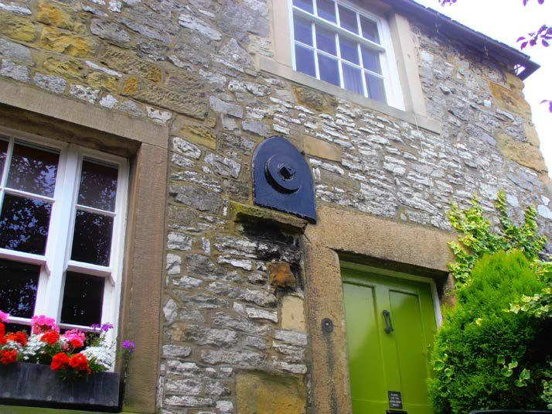

Structural tie to right hand elevation

 | Condition Rating | 1
EXTERIOR
CHIMNEY STACKS
Description | There are four chimney stacks. A slender brick built chimney
 | can be found to the rear of the property, with two stone stacks to
 | the front roof slope. A rendered chimney stack can be found to
 | the right hand roof.
Condition | There are no signs of any significant defects. Old stacks require
 | regular maintenance checks and these should be considered on
 | an annual basis.
 | All of the chimneys are showing general signs of weathering
 | consistent with their age. However, they remain in a structurally
 | sound condition with no need for immediate repair.
 | The chimney to the right hand side of the property appears to
 | have been recently re-rendered. Whilst this chimney is found in
 | good condition, we are unaware of any local authority approvals
 | which have been granted for these re-rendering works. Your
 | legal advisers should establish whether listed building consents
 | were obtained for these repairs.
 | The brick and stone chimney stacks are again showing typical
 | signs of weathering | but remain serviceable. Some general
 | 15

Sample House, Sample Road, Sample
 | deterioration appears to have occurred to the flaunching at the
 | top of the right hand stone chimney. Whilst urgent attention is
 | not yet needed, you should have this chimney repaired when
 | high level maintenance works are next being conducted.
 | Lead flashings have been utilised at the base of the stacks
 | where the chimney meets the roof finishes. These appear to be
 | well fixed and in a serviceable condition. It is essential that
 | flashings are kept in good condition at all times to prevent damp
 | penetration from occurring.
 | The metal flue terminals and clay chimney pots appear to be
 | standing vertically, and are free from obvious defect.
 | ACTION: Minor general maintenance needed to right hand
 | stone stack.
 | Condition Rating |  | 1
MAIN ROOF COVERINGS
Description | The main roof is formed from three individual pitched roofs
 | covered with natural slate and plain concrete tiles.
Condition | Each of the roof slopes appear to be in a serviceable condition
 | showing only general signs of wear and tear. They appear to
 | remain water tight but will require some general attention after
 | occupation.

The natural slate coverings to the left hand side of the property are showing typical signs of weathering but are serviceable. Whilst a felt lining has been utilised above the rear left hand bathroom addition, there is no felt lining to the original roof above bedrooms three, four and five. This therefore means that damp penetration will occur if slates become distorted or damaged. There are a small number of slipped and damaged slates, particularly noticeable to the inward facing slopes. These will need to be re-fixed by a competent roof contractor soon after occupation. There are also a number of slates which have been re- secured using metal strips. This is an indication of nail sickness.

Nail sickness occurs when metal nails which secure the slates in position, corrode to such an extent that the weight of the slate breaks through the corrosion thus allowing the slate to slip. In the short to medium-term, patch repairs can be made on an as and when basis. This can be done by resecuring the slipped slates with metal tingles (tingles are “S'' shaped sections of metal, usually lead, where the top part is hooked over the timber roofing batten). In the medium to long-term, the incidence of

16
Sample House, Sample Road, Sample

slipping slates will increase, as more nails rust through and at that time a decision will have to be made as to whether it would be more cost-effective to take up the slates and re-lay them, using new fixings.
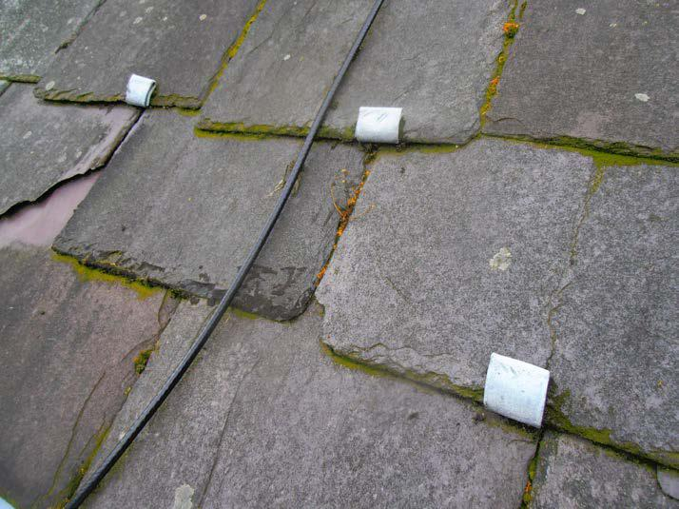

Metal tingles re-securing slates

The amount of previous patch repairs is fairly minimal. The age of the roof will mean that repairs and re-fixing will be encountered on an annual basis, but stripping and re-roofing is not yet justified. The amount of individual repairs is likely to increase over the next 10-15 years, at which stage some re-roofing works may be needed.

The plain concrete tiles to the right hand side of the property are again weathered but remain serviceable. It is understood that this roof was re-covered prior to the property being listed, which partly explains why materials have been used that are not in keeping with the property’s character. These tiles are again serviceable, and have been laid over the top of a felt lining. A small number of damaged tiles were noted, which will need replacement.

There are fairly noticeable distortions in these roof slopes, which have been caused by deterioration to the timber frame beneath. Repairs will be needed to the roof timbers in this part of the building, which will be discussed later within the section titled ‘Main Roof Construction’.

These tiles are not in keeping with the character of the building, and are beginning to deteriorate. Whilst re-roofing is not yet required, you should consider replacing with more traditional materials, such as natural slate, when this roof is replaced.

17
Sample House, Sample Road, Sample

The timber roof frame to this part of the building will require fairly extensive repair and improvement. It would therefore be sensible to consider removing the concrete tiles so that full access can be obtained to all roof timbers. This would then present an ideal time to consider replacing with more traditional materials.

The ridge tiles to the right hand side of the property remain serviceable. However, the mortar bedding and pointing to the ridge tiles on the slate roofs is deteriorating. Some areas are worse than others. In order to reduce the possibility of wind uplift it is recommended that the ridge tiles are lifted, cleaned off and then re-bed on new mortar.

The mortar to the verges (roof edges) is found in a satisfactory condition.

There is an upstanding parapet wall to the front facing gable, which has coping stones laid at a slightly higher level than the roof slopes. Parapet walls are prone to allowing damp penetration. The parapets are found in satisfactory condition, and no significant damp penetration was found. However, the flashings between the parapet wall and adjacent tiles are formed from cement. These flashings will crack over time and should therefore be maintained after occupation. Replacing the flashings with lead would be a good long term improvement.
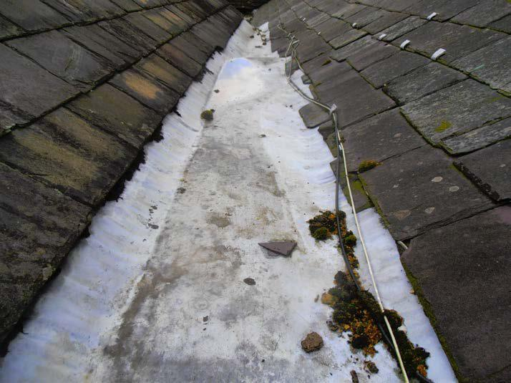

Lead valley

Lead has again been used to the sloping and horizontal valleys. Whilst it is important to keep all valleys clear of leaves and debris, they all appear to be in a serviceable condition at present. Lead is vulnerable to splitting and such details are

18
Sample House, Sample Road, Sample
 | prone to leakage. When repairs are needed they should only be
 | undertaken by an experienced roofing specialist and such
 | repairs can be expensive due to the need to strip back existing
 | roof coverings for access. Valley linings can vary greatly in
 | quality of materials and workmanship.
 | ACTION: Budget for replacing slipped and damaged slates
 | and concrete tiles. Consider re-bedding some ridge tiles.
 | Give consideration to the replacement of the plain concrete
 | tiles.
 | Condition Rating |  | 2
SECONDARY ROOF
COVERINGS
Description | The small two storey extension to the rear has been formed with
 | a concrete flat roof covered with roofing felt.
Condition | Concrete flat roofs are more durable than traditional timber
 | roofs. However, any flat roof is susceptible to leakage and
 | damp penetration. It is therefore important that the felt linings
 | are kept in good condition.
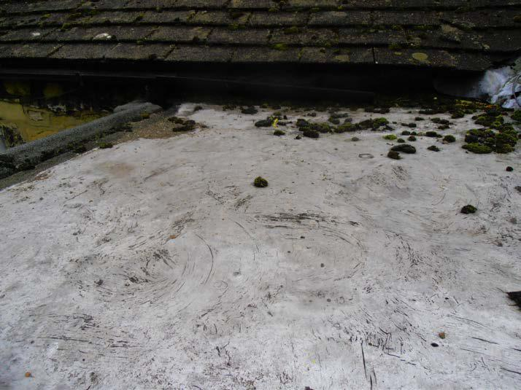

Flat roof surface

Whilst showing general signs of weathering and blistering, the felt finishes remain serviceable.

Felt coverings to flat roofs have limited durability and can require patch repairs at any time. Full stripping and re-felting is normally needed at 10-15 year intervals. Modern elastomeric

19
Sample House, Sample Road, Sample
 | felts are available which have better durability and resistance to
 | splitting than traditional felt and although more expensive,
 | should be specified when seeking estimates for re-felting.
 | When the flat roof is next refurbished, the insulation and
 | ventilation to the roof structure should be checked and upgraded
 | if necessary.
 | Whilst no significant damp penetration or damage was noted,
 | the roof surfaces appear to be at least 10 years old and
 | therefore you should anticipate some repair and possible
 | replacement within the short term.
 | ACTION: Consider the future maintenance of the flat roof.
 | Condition Rating |  | 1
ROOF DRAINAGE
Description | Roof drainage is formed by old cast iron gutters and downpipes
 | located at the perimeter of the roof finishes. These discharge
 | into mainly an underground drainage system.
Condition | Inadequate disposal of rainwater can cause serious problems in
 | a building including damp, timber decay and structural
 | movement. Keeping gutters and downpipes (and the drains to
 | which they connect) clean and in good condition is always
 | important.

It was not raining heavily at the time of inspection. Therefore the water tightness of the joints of the rainwater goods could not be checked. The gutters and downpipes should be observed during rain and any leaking joints resealed or replaced as necessary.

Fittings appear to be free from significant defect with no signs of obvious damage or recent leakage. Nevertheless, routine maintenance is required. All gutters require cleaning out on a regular basis to prevent blockages from occurring. Alignment and joints should also be checked and resealed on an annual basis. Where relevant, gullies should also be checked and cleaned.

The cast iron rain water goods are showing general signs of weathering and rusting. They will therefore require ongoing maintenance during occupation. The age of the fittings means that it is likely that some gutters will leak during heavy downpours. You should not discount some replacements in the future.

Most of the rainwater downpipes terminate into underground 20
Sample House, Sample Road, Sample
 | drains via small gulleys located at the perimeter of the building.
 | Most of the gulleys were found to be partially blocked with
 | leaves and debris, and therefore these will need to be cleared.
 | A single downpipe to the front of the property appears to
 | terminate onto the ground. In order to reduce surface water
 | levels in close proximity to the building, you should ideally alter
 | this situation so that the downpipe terminates directly into an
 | underground drainage system or soak away. This may mean
 | that the existing downpipe to the front of the property is moved
 | or altered.
 | ACTION: Consider general maintenance to the cast iron
 | fittings. | Ideally improve rainwater disposal to the front.
 | Condition Rating |  | 2
EAVES, FASCIAS &
SOFFITS
Description | There are no external roof edge timbers to the main building.
Condition | Not applicable.
 | Condition Rating |  | N/A
MAIN WALLS
Description | The main walls have been constructed from solid stone. These
 | are approximately 500-650mm thick.
Condition | Our inspection of the external surfaces of the main walls was
 | made from ground level with the aid of binoculars, a spirit level
 | and a standard surveyor's ladder. The inspection was also
 | facilitated via readily accessible windows.
 | In a property of this age, it is probable that the foundations are
 | shallow by modern standards and in shrinkable soils such as
 | are found in this area, the risk of structural movement is greater
 | when foundations are shallow. This risk increases as the soil
 | shrinks in hot dry summers. Roots from trees and shrubs can
 | also have a significant contributory effect.
 | The risk of movement can be reduced by both maintaining the
 | drainage in good condition and controlling the growth of trees,
 | shrubs and hedges.
 | The main walls are in satisfactory structural condition, with no
 | signs of significant |  | cracking, settlement or other structural
 | 21

Sample House, Sample Road, Sample

movement in the property.

There are signs of fairly significant bowing and distortion to the right hand elevation. A structural tie bar has been inserted through part of the right hand building, which has been used to try and restrain further outward movement. No signs of recent structural movement were identified, and therefore this movement appears long standing and non progressive.

The external walls are of solid construction. These are structurally robust, but can be prone to problems of rain penetration in severe weather conditions, and condensation can also be greater than with modern cavity walls.

The external elevations appear to be formed from a mixture of lime stone and sand stone. Fairly noticeable weathering has occurred to several sections of sand stone, which is a more fragile material. At present, the level of deterioration is not considered structurally significant. However, the most noticeable weathering was found to the northern elevation around the master bedroom en- suite, which is causing internal damp penetration to occur. You should ask a competent building contractor to provide a quotation for applying an external protective coating or chopping out and replacing the severely weathered stones in full. Any works of this nature should be carried out with local authority approval.
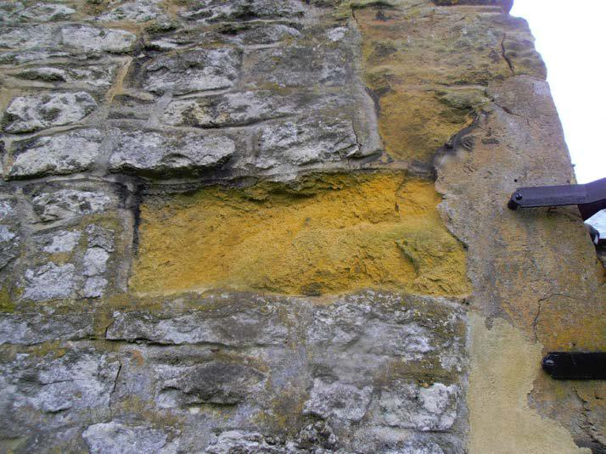

Weathered sand stone

Whilst there are localised areas of weathered mortar pointing between the stone sections, most areas have been previously re-pointed. These re-pointing works have been carried out with a strong sand and cement mortar, which is now starting to crack

22
Sample House, Sample Road, Sample
 | and deteriorate. Traditional stone walls should ideally be re-
 | pointed with lime mortar, which has good elasticity qualities, and
 | therefore allows a certain amount of thermal movement in the
 | stone structure. Sand and cement mortar can also trap moisture
 | within the building. Whilst the property does not yet require
 | complete re-pointing, you should ensure that any future re-
 | pointing is undertaken with a lime mortar. It would also be
 | sensible to budget for a gradual programme of re-pointing, with
 | the existing sand and cement joints being raked out and re-
 | pointed using lime mortar. This could be undertaken one
 | elevation at a time over a period of several years. Such repairs
 | should eliminate further cracking, and could possibly reduce
 | dampness levels internally.
 | The rear extension has been formed from cavity construction,
 | with basic re-constituted stone elevations. |  |  | Again, these
 | materials are not in keeping with the character of the building.
 | Whilst they remain structurally sound, requiring only minor
 | localised re-pointing, you may wish to consider some cosmetic
 | improvements which would make this part of the building look
 | more in keeping with the main dwelling.
 | When re-pointing is carried out it is essential that the joints are
 | raked out sufficiently, usually to a depth of not less than 20 mm
 | so that the new mortar is given sufficient key. Failure to do this
 | can result in the new pointing simply cracking and falling out
 | over a relatively short timescale. The new mortar should not be
 | too weak, but conversely it should not be stronger than the
 | bricks to which it is applied. A common misconception is that
 | mortar requires a large proportion of cement in the mix, but too
 | rich a cement content can cause serious problems. This work
 | should only be entrusted to an experienced bricklayer.
 | ACTION: Consider maintenance and possible replacement
 | to the | weathered sand stone sections and cement mortar
 | pointing.
 | Condition Rating |  | 2
SUB FLOOR VENTILATION
Description | Sub-floor ventilation is necessary to properties with suspended
 | timber floors at ground level. This is to ensure that there is an
 | adequate flow of air beneath the timbers which is important to
 | reduce the risk of rot.
 | There is inadequate ventilation to the suspended timber ground
 | floors.
Condition | Whilst most ground floor areas are of solid construction,
 | suspended timber floors have been used within the dining room
 | 23

Sample House, Sample Road, Sample
 | and drawing room. There do not appear to be any vents in the
 | external elevations, and therefore there is inadequate ventilation
 | beneath the suspended timber floor.
 | The void beneath the suspended timber floor will therefore
 | create conditions that are ideal for timber decay and infestation.
 | As will be discussed later, we also discovered rising dampness
 | to the walls around these rooms, into which the floor joists are
 | likely to be built. There is therefore a significant chance of
 | timber decay in these areas.
 | As will be discussed later, we did notice some spring under foot
 | within the drawing room which indicates concealed rot. It will
 | therefore be necessary to introduce additional sub floor vents
 | around the perimeter of these rooms once the condition of the
 | sub floor timbers has been discovered.
 | A permanent solution to this ongoing risk would be to replace
 | the timber flooring with concrete, incorporating a damp-proof
 | membrane, thus removing both the risk of rot and the need for
 | sub-floor ventilation. This, however, could prove prohibitively
 | costly if the sub-floor void is deep. Also, if the void is deep it
 | can be difficult to achieve satisfactory compaction of fill material.
 | This increases the risk of future floor slab settlement.
 | ACTION: Undertake improvements to the ventilation of the
 | suspended | timber floors.
 | Condition Rating |  | 3
DAMP PROOF COURSE
Description | The property is of an age where walls would not have been
 | constructed with any form of damp proof course. However,
 | parts of the original structure do appear to have been subject to
 | a chemical injection damp proofing system.
Condition | Walls require a damp-proof course to prevent moisture travelling
 | up through the structure which can lead to internal dampness,
 | perished plaster, spoilt decorations and rot in skirting boards
 | and other timbers.

Damp can penetrate if there is no damp-proof course, if the damp proof course has failed, or if the damp-proof membrane in the flooring is not properly bonded to the wall damp-proof course at the edges.

Solid stone walls of this type are susceptible to allowing rising dampness. The use of a hard sand and cement mortar between the stones will further increase the chances of rising dampness. Whilst a chemical injection damp proofing system does appear

24
Sample House, Sample Road, Sample
 | to have been utilised to a number of walls, these systems are
 | very rarely effective in random stone walls and therefore you
 | should disregard these works unless there are insurance
 | backed guarantees available.
 | Evidence of rising dampness was noted internally, which will be
 | discussed later in the report.
 | In most areas, external ground levels are located beneath
 | internal floor levels. However, the road to the left hand side of
 | the property abuts the main building with the road level being
 | approximately 1.5 meters above internal floor area. Moisture
 | from the ground in this area will therefore seep into the building
 | which is presently affecting the western walls within the kitchen,
 | store and utility room. The only way of preventing penetrating
 | dampness is to incorporate an internal tanking system which will
 | take the form of a vertical damp proofing membrane being
 | applied to the inside of the main walls. Any tanking operation is
 | a specialist feature, and should therefore only be undertaken by
 | licensed contractors who offer insurance backed guarantees.
 | ACTION: | Consider the need for future damp proofing
 | improvements, particularly against high external ground
 | levels.
 | Condition Rating |  | 3
WINDOWS, DOORS &
EXTERNAL JOINERY
Description | Windows have been formed by timber framed units. These are
 | single glazed. The doors also comprise timber units.
Condition | The windows are formed by a range of basic casement and
 | sash units which are timber framed and single glazed. All of the
 | windows are showing general signs of weathering and
 | deterioration, and will therefore require maintenance and repair
 | after occupation.

Most of the window frames show general signs of timber softening, but no significant rot was found. The one exception is the window to bedroom two, which does show significant rot to the sill. A fairly substantial repair or replacement will therefore be needed to this window.

The other windows are capable of repair, although such works will include the stripping of existing decorations, patch repairs to softened timber, replacing the glazing beads and perimeter seals, before undertaking re-decoration. We did find that most of the windows could not be easily opened, and several have been painted closed. You will therefore need to ease open each

25
Sample House, Sample Road, Sample

unit which could potentially cause further damage.
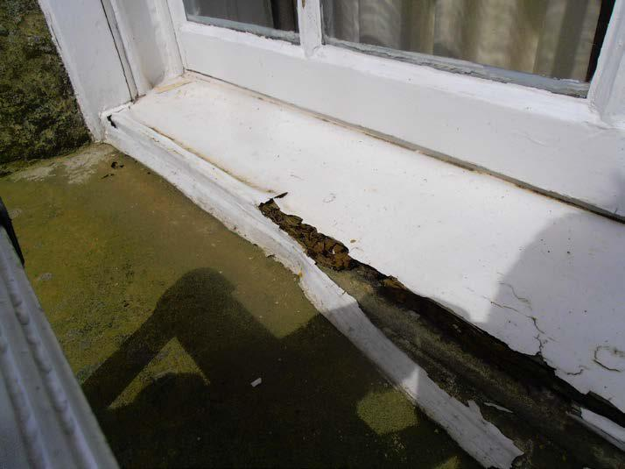

Rotten first floor window

In order to make the sash windows operational, there will also need to be repairs and replacements to the sash mechanisms.

The putty which holds the glass within the frames is beginning to crack. This will allow water to penetrate the timber and cause decay. It is recommended that the cracked putty is carefully chipped out and new putty put in its place.

A number of windows to the rear of the property have been formed with very basic casement units. As with a number of previous alterations, these windows are not necessarily in keeping with the age and character of the building. You may therefore wish to consider replacing these units after consultations with the local authority.

Some of the first floor windows have openings at fairly close proximity to the internal floor level. The glazing to these windows is therefore susceptible to damage, and you should give consideration to replacing with toughened or laminated glass.

If windows are to be repaired, works are likely to be time consuming, and therefore expensive. If replacing, you should ensure that the local authority are aware of any alterations.

The doors appear to be of some age, and are therefore showing general signs of weathering and deterioration. Some of the doors do not fit squarely within their frame, but are capable of being opened and closed. Whilst some general adjustments

26
Sample House, Sample Road, Sample
 | and timber repairs are likely to be needed in the future, there are
 | no significant repairs needed at this time.
 | The door opening to the right hand elevation has been plastered
 | over internally. Whilst the timber door remains in place
 | externally, this is no longer a useable opening. The external
 | timber door in this area is again weathered, but remains
 | serviceable and water tight.
 | ACTION: Obtain quotations for overhauling and repairing
 | weathered | windows and doors. Replace rotten window to
 | bedroom two. Consider replacing basic casement units.
 | Condition Rating |  | 2
EXTERIOR DECORATIONS
Description | External joinery has been decorated with painted finishes.
Condition | All external joinery will need to be re-decorated in conjunction
 | with the repairs noted above.
 | When redecoration is carried out, this should include thorough
 | preparation, including removal of all loose and flaking paint,
 | filling of cracks, and priming bare surfaces prior to the
 | application of undercoat and main finish.
 | The external woodwork will need regular redecoration, typically
 | on a 3-5 yearly cycle depending on the quality of paint or stain
 | coatings, exposure factors, and condition of the surfaces
 | beneath.
 | ACTION: | Consider re-decorating external joinery in
 | conjunction with previous repair works.
 | Condition Rating |  | 2

27
Sample House, Sample Road, Sample

INTERIOR

MAIN ROOF
CONSTRUCTION

Description

The main pitched roof voids were accessed through three separate ceiling hatches located at first floor level. All of the roofs are formed from traditional timber rafter and purlin design, with a mixture of original and replaced timbers. Only the roof voids above the rear left hand bathroom and areas beneath the plain concrete tiles have been formed with a felt lining beneath the roof coverings.

Condition

The small pitched roof void above the rear left hand bathroom is formed from relatively modern construction with modern timbers and a modern felt lining. This part of the roof is found in a satisfactory condition with no signs of significant defect.

In the other accessible roof voids, the roof frame comprises a mixture of original and replaced timbers. Whilst these are presently providing adequate support to the roof coverings, there is fairly noticeable deterioration which will require future repair.

Where replaced timbers have been utilised, these are generally found in a satisfactory condition. The original timbers are showing signs of weathering and deterioration, with some previous rot, and wood boring beetle infestation. There is also fairly noticeable indications of active wood boring beetle infestation which will need to be investigated further.

The roof frame beneath the plain concrete tiles has suffered fairly significant damage caused by noticeable timber decay. The roof void to the rear of the right hand chimney stack has been subject to fairly significant repair including the installation of a number of steel ties. However, these repairs appear to have been carried out in a fairly basic manner, and we cannot guarantee that these ties are fully functional.

This part of the roof has been formed with large original ridge boards at the apex. These ridges have become damaged and distorted with noticeable bowing. Whilst steel clamps have tried to hold the ridge together, this distortion then appears to have caused some outward pushing to the rafters and purlins. Within part of the roof, the purlins have been restrained with metal ties to try and prevent further outward movement. Whilst similar defects appear to have occurred to the front of the chimney stack, no structural repairs have been undertaken.

It is our opinion that these repairs have been carried out in a unsatisfactory manner, and further improvements are needed. It

28

Sample House, Sample Road, Sample

is advised that a structural engineer inspect the roof frame and provide a design scheme for increasing structural support and triangulation. A competent building contractor should then provide a quotation for carrying out these works. Once the roof frame is made structurally sound, all of the accessible roof timbers should be treated for wood boring beetle infestation. Some of the more slender timbers are likely to require replacement, which will include some of the ceiling joists which we noticed to be fairly springy.

Whilst it is possible that these works could be carried out from within the roof void, the removal of the external covering would give the contractor greater access. This may therefore present a perfect opportunity to lift the plain concrete tiles and re-roof.

No comment can be made, however, on the concealed roof timbers. It is possible that these may have suffered decay such as may be caused by an outbreak of dry rot or wet rot, or been weakened from attack by wood-boring beetles. Concealed timbers include the bottom ends of rafters, wall plates and purlin ends. Although the chances of hidden defect do exist, no obvious signs of significant defect were noted in the accessible areas.

There are some further aspects to the roof frame which again require improvement. We noticed that some purlin timbers are poorly supported at their bearing ends and will therefore require improvement. There is also a detail directly above bedroom two where the ends of purlin timbers are supported by a valley board which has become significantly deteriorated. There is therefore inadequate support to the purlins which again will require improvement.

Where felt lining has been used beneath some of the roof coverings, this is generally found in a satisfactory condition.

The underside of the roof is lined with a sarking felt of a hessian reinforced bitumen type. Over the years this will decay where it is dressed out under the bottom roof edges into the gutters. Eventually the felt rots back to a point where any water running down the top of the felt (which is driven in through the roof coverings) can then drop onto the roof edge timbers and cause consequential decay problems. If remedial work is needed this could prove costly as it may involve stripping back the bottom few courses of the roof coverings and battens, splicing in new sections of underfelt, and reinstatement. The provision of safe access for the work also tends to be expensive.

The slate roof above bedrooms three, four and five has no felt lining and therefore this area is more susceptible to rain penetration. Whilst re-roofing is not yet required, you should

29
Sample House, Sample Road, Sample

consider introducing a felt lining beneath these coverings when re-roofing is undertaken in the future.
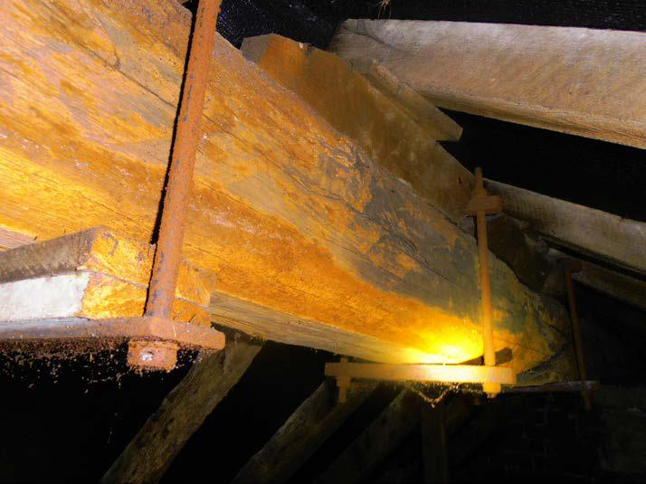

Deteriorated ridge board with partial repairs
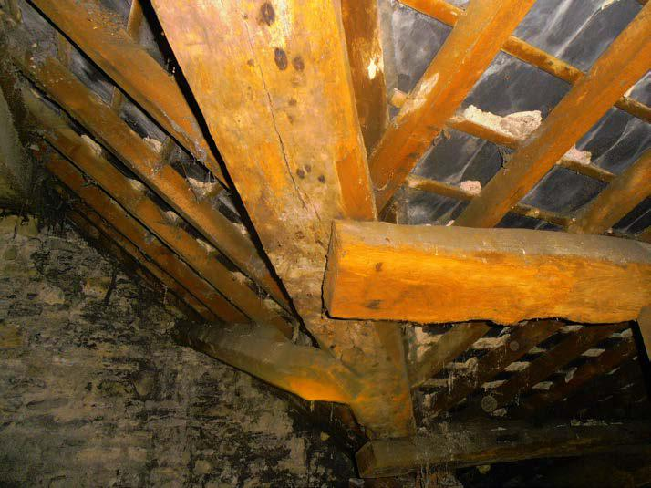

Purlins requiring improved supprt

ACTION: Have a structural engineer provide a scheme of structural improvements to the main roof void. Obtain quotations for these works which may necessitate the removal of external roof coverings.

Condition Rating | 3

30
Sample House, Sample Road, Sample

CEILINGS
Description | The ceilings have been constructed from mixed plaster board
 | and original lath and plaster with mainly plaster skimmed
 | finishes.
Condition | The ceilings have been inspected from within the rooms and
 | also from within the accessible roof space, where random
 | sections of the roof insulation were lifted on a sampling basis.
 | No opening up has been undertaken. The nature of the ceiling
 | materials cannot be ascertained fully without damage being
 | caused.
 | Internal surfaces are mostly concealed by linings and
 | decorations making it difficult to comment on the condition of the
 | plaster. There is a possibility of damaged plaster being found if
 | these finishes are removed after occupation.
 | Before the introduction of plasterboard, lath and plaster ceilings
 | were formed by applying plaster over narrow wooden strips
 | known as laths, fixed to the underside of the ceiling joists. The
 | quality of the plaster was variable, often being reinforced with
 | horse hair. Depending to some extent on the quality of original
 | workmanship, these ceilings are vulnerable to cracking and
 | loosening as they age. Due to the relatively fragile nature of this
 | type of ceiling, failures can occur suddenly, without warning.
 | The risk of failure will increase with time, and you must
 | anticipate the need for future repair and replacement work.
 | A number of the ceilings have already been replaced and it is
 | therefore probable that further replacements will be needed as
 | time goes on.
 | There are a number of cracked and distorted ceilings. These
 | are consistent with the property’s age, but you should bear in
 | mind that re-decoration in any areas may cause plaster damage
 | which will require repair. It can be difficult to undertake patch
 | repairs to lath and plaster ceilings, and therefore if localised
 | damage does occur, it is usually necessary to replace the entire
 | ceiling within that room.
 | ACTION: Consider general future plaster repairs.
 | Condition Rating |  | 2
WALLS, PARTITIONS &
PLASTERWORK
Description | The external walls have been lined internally with traditional
 | plaster finishes. The internal partitions have been constructed
 | from mainly solid masonry with some timber stud framing at first
 | 31

Sample House, Sample Road, Sample

floor level.

Condition

As with the ceilings, the walls and partitions have been inspected from within the rooms and no opening up has been undertaken. The precise composition of the wall structures, linings and finishings cannot be ascertained without exposure works being undertaken.

Internal wall surfaces are mostly plastered or are concealed by linings and decoration. They are in reasonable condition for the property's age.

The plaster finishes are generally found in a condition consistent with their age. As you would expect, there are several areas of loose and hollow plaster which will require future replacement.

Over the years, the bond between plaster and the masonry can become weak and loose. This often occurs around window and door openings that are subject to vibration. Although no significant defects were noted at the time of our inspection, future repairs in these areas cannot be discounted.

The cracked and hollow areas of wall plaster will need cutting back and patch repairs when redecorating, and it is possible that more substantial repairs could be found necessary when existing decorations have been stripped off.

The internal partitions are generally true and structurally sound. We found no evidence of significant structural movement. As is commonly found in properties of this type, it is possible that door edges will need planing from time to time and cracks could appear in adjacent wall surfaces.

As will be discussed later, there is evidence of some penetrating and rising dampness within the property. This has caused general damage to internal plaster finishes, and therefore some replacements are likely to be encountered.

The right hand facing wall within the drawing room has been dry lined. It appears that the wall has been lined with a thin sheet of plywood or similar, with a space between the external surface and masonry wall. This is a very basic repair which has been undertaken to try and mask perished plaster and dampness. At present, the wall remains serviceable but you will find it difficult to decorate and hang pictures etc. If you are considering dry lining in the future, you should ideally dry line with a more durable material such as plaster board, although such works would require permission from the local authority.

With respect to stripping paper from the walls, it should be

32

Sample House, Sample Road, Sample
 |  | noted that steam strippers have been found to cause damage
 |  | to some types of plaster.
 |  | ACTION: Anticipate general future plaster repairs.
 | Condition Rating |  |  | 1
FIREPLACES, FLUES &
CHIMNEY BREASTS
Description | There are four chimney breasts within the property, two of which
 | form open fireplaces within the dining room and drawing room.
 | The sitting room fireplace has been sealed over, and the
 | chimney breast within the utility room is used to take the flue
 | from the central heating boiler.
Condition | The chimney flues were not inspected and it is not possible to
 | comment on the adequacy of the flue linings. If fireplaces are to
 | be used after occupation, all flues should be checked and
properly tested to ensure that they are not blocked and that the linings are sound prior to use. Any gas burning appliances will need a flue lining to prevent gases escaping into the building. If flues are unlined, there is also a possibility of smoke escaping into the building if solid fuel fires are used. It is therefore essential that an appropriate lining is utilised if the fireplaces are to be used after occupation.

Whilst the two open fireplaces do not appear to have been used in recent times, no obvious significant defects were noted in the accessible areas.

Where open fires are used, flues must be regularly swept to remove soot and birds' nests. With older properties this can sometimes dislodge the brickwork between the flues which over the years may have perished due to the action of the acids deposited by flue gases.

Old chimney flues are prone to gradual deterioration and it is possible for smoke and fumes to escape through gaps in the mortar joints, often at floor level or in roof spaces where the surfaces are unplastered. It has been known for smoke to permeate between adjoining dwellings. No tests have been made but if this problem occurs, it will need to be rectified. There are modern specialist techniques for restoring old flues by lining with concrete, which can be done without disturbing the structure. Such specialist work, however, is expensive.

The sealed chimney breast within the sitting room again appears to be in a satisfactory condition with no sign of significant defect. Any fireplaces which are to remain sealed should ideally be ventilated. Vents need to be fitted to sealed

33
Sample House, Sample Road, Sample
 | fireplaces in order to provide ventilation to the flues. This is
 | required in order to prevent condensation occurring within the
 | redundant chimney breast which in turn could cause damage to
 | flue linings, plaster finishes and decorations.
 | The flue serving the central heating boiler will be discussed later
 | in this report.
 | ACTION: Ideally inspect the flues to the two open
 | fireplaces | prior to use. Consider capping and ventilating the
 | redundant flue within the sitting room.
 | Condition Rating |  | 2
FLOORS
Description | The ground floor is mainly of solid construction with suspended
 | timber floors within the dining room and drawing room. The first
 | floor is of traditional suspended timber design with large original
 | floorboards laid across timber joists.
Condition | It should be noted that there are practical limitations on the
 | inspection of floors, whether bare or covered by fitted coverings
 | and furniture.

Floorboards have not been lifted within this property, as it was felt this could cause damage. In cases where floorboards could not be lifted only a general comment can be made, and complete assurance cannot be given that there are no concealed defects.

Most of the ground floor accommodation is formed from solid construction. Where the corners of carpets could be raised back, or the surfaces are exposed, there appear to be a mixture of old screed finishes, original clay quarry tiles, stone flags and some timber parquet flooring. The floors are a little uneven in places, but appear to remain structurally sound. High damp meter readings were recorded throughout all accessible areas, which indicate that all of the solid floors have been constructed without a damp proof membrane.

The use of a damp proof membrane beneath a solid floor is a fairly modern building technique, and therefore dampness within old traditional solid floors is common. This does not represent a significant structural issue, but can cause damage to perishable floor coverings (such as carpets) and can also allow dampness to track into the lower parts of adjoining walls. Whilst taking up all floors and re-laying with modern materials would alleviate this problem, it is felt that this would be destroying part of the heritage of the building and therefore such works are not advised. They would also be unlikely to be approved by the

34
Sample House, Sample Road, Sample

Conservation Officer. It is therefore our opinion that you should adequately protect any perishable floor coverings with water resistant underlays.
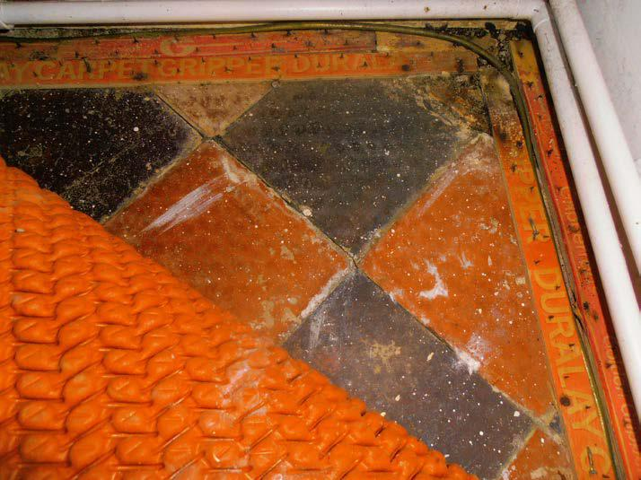

Old quarry tiled floor

The suspended timber ground floors within the dining room and drawing room are in need of some attention. Whilst they appear to remain structurally sound at present, there is fairly noticeable spring underfoot to parts of the drawing room. We have already mentioned that these floors have inadequate sub floor ventilation. The structural joists are also likely to be built into walls affected by dampness. There is therefore a significant risk of timber decay to the structural joists.

It is advised that the floors be exposed after occupation, by removing carpets and carefully lifting a number of floorboards. A sub floor inspection could then be undertaken to establish the level of timber decay. Whilst we are unable to confidently determine the level of works needed, it would be sensible to budget on a worst case scenario and therefore obtain quotations for replacing or strengthening all parts of the floors. Any new floor joists should be sat on joist hangers which separate the timber sections from the damp masonry walls. If the floor void is not too deep, you may wish to consider replacing these areas with solid flooring.

The floors at first floor level are again uneven and distorted, but this is typically found in many properties of this type and age. The distortions appear to have been caused by previous long standing movement in the building and not by any recent significant structural defect.

35
Sample House, Sample Road, Sample
 | Where the corners of carpets could be raised, floor boards have
 | become worn and damaged. Some general repairs and
 | possible localised replacements will be needed as these floors
 | are exposed after occupation.
 | ACTION: Budget for exposing and repairing/replacing floor
 | structure | to the dining room and drawing room. Budget for
 | general repairs and replacements to worn floorboards.
 | Condition Rating |  | 3
DAMPNESS
Inspection | Tests were conducted with an electronic moisture meter at
 | appropriate positions throughout the property (except where
 | impermeable surface finishes, furniture, fitted cupboards and
 | stored goods prevented access to take readings.
Rising Damp | Rising dampness is caused by the natural effect of moisture
 | from the ground rising up through a structure by means of
 | capillary action. This will occur where there is failure or lack of a
 | damp proof course. Rising dampness will inevitably lead to
 | spoilt decorations, defective plaster, and rot to timbers, and
 | creates an unhealthy environment in which to live.

Tests were conducted with an electronic moisture meter at appropriate positions throughout the property (except where impermeable surface finishes, furniture, fitted cupboards and stored goods prevented access to take readings).

High damp meter readings were recorded to the base of internal walls throughout much of the ground floor accommodation. This has been caused by lack of an affective damp proof course. Rising dampness in a property of this age and type is common as the original construction did not take account of the affects of rising dampness.

Whilst previous remedial damp proofing works appear to have been undertaken, these are rarely effective in random stone built walls, and therefore would not normally be considered to be a suitable repair. Apart from the possible risk of timber decay to adjoining timber floors within the dining room and drawing room, (discussed earlier) the only other associated defects with rising dampness are causing discolouration and damage to low level plaster finishes and adjoining timbers such as skirting boards and architraves.

It is our opinion that the only suitable long term solution for preventing dampness in a property of this age is to dry line internal walls with a damp proof membrane between the internal

36
Sample House, Sample Road, Sample
 | plaster finishes and masonry walls. This would mean re-
 | plastering almost all ground floor areas, which will be disruptive
 | and expensive. These works would also require approval from
 | the local authority. In properties of this age, most owners would
 | normally accept that dampness exists, therefore budgeting for
 | ongoing maintenance during occupation.
 | Accordingly, a decision has to be made whether to accept and
 | live with the problem of dampness, together with the associated
 | risks, or to carry out further investigations. The dampness, if left
 | untreated, may cause damage to the fabric of the building.
 | If this risk is unacceptable, further investigations should be
 | carried out by commissioning a report from a specialist damp-
 | proofing contractor who is to be a member of the British Wood
 | Preserving and Damp-Proofing Association. Any work carried
 | out should have the benefit of an insurance backed guarantee.
 | The use of a sand and cement mortar as external pointing can
 | prevent the solid stone walls from allowing dampness to
 | evaporate. It would therefore be sensible to budget for raking
 | out mortar joints and re-pointing with a lime mortar which should
 | reduce some of the moisture levels.
 | ACTION: | Accept the affects of rising dampness or
 | consider | remedial works.
Penetrating Damp | Solid external walls can be prone to rain penetration. Leaking
 | gutters and driving rain can cause rainwater to soak through the
masonry. Persistent water penetration can cause damage to plaster and decorations, as well as timber decay. The risk can be minimised by maintaining gutters and downpipes in good condition.

Minor localised damp penetration will be encountered from time to time in a property of this type and age. You should therefore ensure that all external detailing (around windows, mortar joints and rainwater goods) are kept in good condition at all times.

We did notice some damp penetration to the rear facing elevation within the master en suite. This is likely to have been caused by the fairly weathered condition of sand stone walling in this part of the building. Whilst it is possible that the external stone work can be coated, you may need to consider replacing the severely weathered stone sections.

Further penetrating dampness was noted to the western elevation forming the kitchen, store and utility room. This has been caused by high external ground levels, with the adjoining road being situated approximately 1.5 above internal floor level. Natural moisture from the ground will therefore seep into the

37
Sample House, Sample Road, Sample

building. The only way of preventing penetrating dampness in this area is to lower external ground levels or provide an internal tanking system. As external ground is formed by a public highway, it is unlikely that any external alterations will be allowed. You should therefore consider an internal tanking system which will take the form of a vertical damp proof membrane being fixed to the inside face of the wall. You should also construct a small drain at the base of this tanking system so that any moisture running down the external face of the membrane is taken away from the building. Tanking systems are a specialist technique and should therefore only be carried out by specialist contactors who provide an insurance backed guarantee.

 | ACTION: Undertake external repairs and consider internal
 | tanking | system.
Condensation | No indications of any problems with condensation were noted.
 | However, condensation may be a problem for one occupier
 | where it was not for the pervious one. It can often be controlled
 | by careful management of heating and ventilation rather than by
 | physical works.
 | The control of condensation involves maintaining surface
 | temperatures above the dew point (the humidity related
 | temperature at which water vapour turns into moisture), and the
 | provision of adequate thermal insulation and proper ventilation.
 | Unfortunately, the modern emphasis on draught proofing
 | reduces ventilation in dwellings, increasing the risk of
 | condensation.
 | The extent of condensation in a dwelling will depend not only on
 | its orientation and construction, but on variable factors such as
 | weather conditions, lifestyle, and how the property is heated and
 | ventilated. It is essential that moisture producing rooms, such as
 | kitchens, bathrooms and utilities, are adequately heated and
 | ventilated at all times to prevent future problems.
 | Improvements are needed to the ventilation arrangements in
 | this property which could be achieved by mechanical extract
 | ventilation, particularly to those areas where excessive humidity
 | is likely to be created, such as bathrooms, kitchens and
 | bedrooms. Passive ventilation fitted to window frames can help
 | to disperse humidity, but additional measures may prove
 | necessary. Adequate heating and ventilation will help to keep
 | condensation to a minimum.
 | ACTION: | Consider improving ventilation within kitchen
 | and bathrooms.
 | Condition Rating |  | 2
 |  | 38

Sample House, Sample Road, Sample

TIMBER DEFECTS

Description

We have inspected all accessible timbers for damage and decay. We are, however, unable to comment on the condition of hidden timbers which have not been inspected.

It is our experience that in older properties, there are likely to be timbers incorporated within the structure which have over the years deteriorated from possible wood boring infestation penetrating or rising damp and can be a cause of potential problems. Without opening up the structure it is not possible to comment in any detail on such timbers. When buying a property of this age and type it is a potential hazard which should be borne in mind when calculating future maintenance costs.

The possibility of having to carry out localised treatment and repair should not be discounted.

Wet Rot

Wet rot is usually associated with neglect or poor detailing in buildings, occurring in timbers which are definitely wet, or having a persistent moisture content in excess of around 20%. Wet rot can occur in internal as well as external timbers. It is often limited in extent and does not extend beyond damp timbers. In addition to external joinery exposed to the weather, areas particularly at risk include timbers built into damp walls, and floors beneath leaking sanitary fittings. Damp roof timbers and ground floor timbers are also vulnerable.

It should be noted that some timbers may be built into the external walls and therefore, it is essential to maintain the walls in as dry a condition as possible. If the walls are allowed to become damp, then the dampness will transfer to the timbers, which can cause rot damage.

As discussed previously, there is localised timber decay to external joinery. There is also likely to be some concealed decay within the ground floor structure forming the dining room and drawing room. These areas will therefore need to be exposed and repaired after occupation. These matters have been dealt with previously in the report.

Wood Boring Beetle

There are a number of exposed timbers which have been subject to previous wood boring beetle infestation. Exposed timber beams and some floorboards have suffered historic activity. However, it appears likely that a number of roof timbers are still suffering from active infestation. This has caused fairly significant damage to a number of timbers. There is also localised infestation to the underside of some stair timbers.

Our inspection was restricted by the fitted floor coverings. There is a possibility of wood-boring insect attack in a property

39

Sample House, Sample Road, Sample
 | of this age. Without fully removing the floor coverings it is
 | impossible to establish whether there is active infestation
 | affecting the timbers.
 | It will therefore be necessary for all roof and stair timbers to be
 | inspected by a specialist contractor, who should provide a
 | quotation for treating with an insurance backed guarantee. As
 | and when other timbers are exposed, such as when carpets are
 | removed, you should also have timbers investigated and
 | treated.
 | Unless all of the timbers have been fully treated, there is a risk
 | of active wood-boring beetle infestation.
 | ACTION: Have all roof timbers inspected and treated by a
 | specialist | timber treatment company.
Dry Rot | Dry rot is a fungus which develops in damp timber usually under
 | conditions of dampness and inadequate ventilation. The fungus
 | does not like light and often grows between materials where
 | light is excluded. This characteristic can conceal an outbreak at
 | the development stage. Poorly ventilated, damp sub-floor and
 | roof voids are places at high risk from dry rot attack.
 | The fungus produces strands which can extend for several
 | metres over and through such materials as plasterwork and
 | brickwork, allowing secondary outbreaks to occur. It is possible
 | for a dry rot outbreak to pass between adjoining dwellings.
 | Eradication can be difficult, disruptive and expensive to achieve.
 | There were no indications of dry rot in this property.
 | Condition Rating |  | 3
BASEMENTS & CELLARS
Description | There is a stone vaulted cellar located beneath the drawing
 | room, with access from a staircase which leads up to the
 | entrance hall.
Condition | The walls and floor of the cellar are damp due to their location
 | below ground level. Damp proofing will be difficult to achieve
 | and is unlikely to be cost effective.

No significant defects were noted, but its use will be restricted. The cellar accommodation should be capable for use for storage purposes provided adequate ventilation is maintained.

There appears to be reasonable levels of ventilation provided around the edges of a small timber hatch which protrudes through the right hand elevation of the property. In order to increase ventilation into the cellar, you should consider the

40
Sample House, Sample Road, Sample

merits of replacing this timber hatch with a door that includes an air vent.

There are no timber elements forming the structure to the cellar. The masonry walls, ceiling and floor are found in a structurally sound condition. There are some timber benches within the cellar which have become rotten at their base. Such situations can lead to the development of dry rot, and therefore these timber benches should be removed and disposed of. You should ensure that any perishable items or materials are adequately protected from the damp masonry structure.
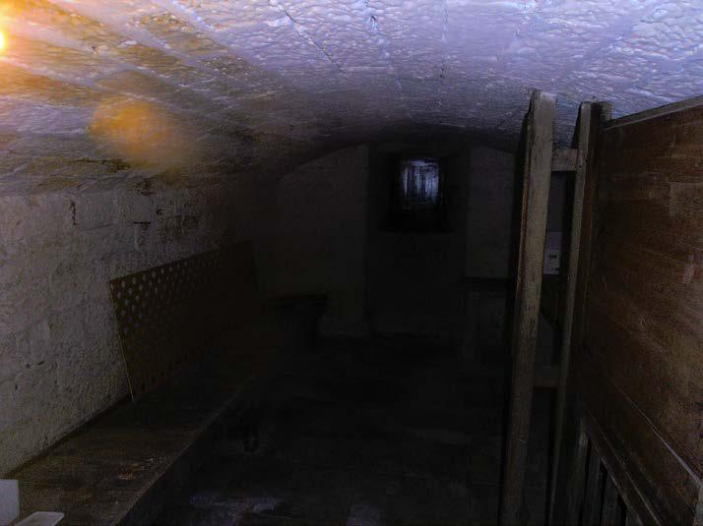

 |  |  | Vaulted cellar
 | ACTION: Remove timber benching and improve ventilation.
 | Condition Rating |  | 2
INTERNAL JOINERY
Description | Internal joinery is typical of a property of this type and age and
 | whilst serviceable, does show general effects of wear and tear.
 | Although there are no significant defects, there will be a need for
 | some expenditure on this item.
Interior Doors | The internal doors are of traditional timber construction.
 | A number of the doors are of considerable age and are
 | therefore showing typical signs of deterioration.

These are found in a serviceable condition with no significant defects noted. Some doors require minor adjustment and some

41
Sample House, Sample Road, Sample

 | ironmongery will require general repair in the next couple of
 | years.
 | Considering the age of the doors, they remain generally
 | serviceable. You should not discount the need for some
 | replacements during occupation.
Staircases | The staircase appears to be of traditional construction formed by
 | timber treads and risers.
 | The staircase is fully carpeted, preventing a detailed
 | examination, but appears serviceable, and there is a satisfactory
 | handrail.
 | In keeping with the age of the staircase, there are some springy
 | treads underfoot. We also noticed very minor wood boring
 | beetle infestation to the underside of some of the staircase
 | timbers (accessible from within the cellar stairwell). You should
 | ideally have the underside of the staircase treated for beetle
 | infestation when the roof investigations are being undertaken.
 | You should also not discount having to replace some timber
 | treads in the future.
 | The handrail to the side of the staircase does not serve all parts
 | of the stair. Again this may require improvement.
 | ACTION: Treat underside of staircase for wood boring
 | beetle | infestation.
Built In Kitchen Fittings
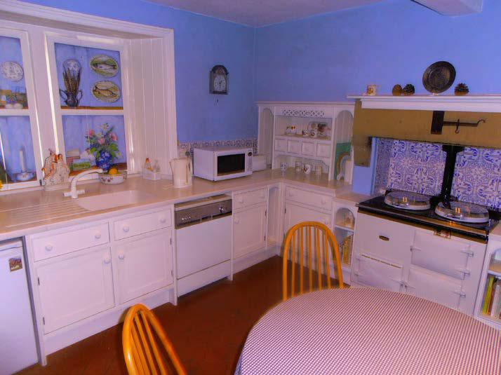

Basic kitchen

No inspection has been made of built-in appliances. If the condition of these is important to your purchase, then they must

42
Sample House, Sample Road, Sample

 | be fully serviced and tested by an appropriate engineer before
 | exchange of contracts.
 | It should be remembered that we have not taken out any of the
 | kitchen appliances and cannot verify the adequacy of
 | connections. Leaks can occur at any time between the date of
 | survey and your taking occupation. If leaks are found when you
 | take up occupation, you should not assume that they were
 | visible, accessible, or indeed in existence at the time of survey.
 | Any such leaks should be promptly rectified. Removal of
 | appliances can reveal or cause defects in plasterwork and
 | services. This must be accepted when proceeding with your
 | purchase.
 | The kitchen in formed by fairly basic and dated veneered base
 | and wall units. Whilst they appear to remain generally
 | serviceable, they are of a fairly basic standard and therefore
 | many purchasers would consider modernisation.
 | ACTION: Consider modernising kitchen fittings.
Other Joinery | The provision of general storage cupboards is appropriate to the
 | scale of the dwelling.
 | A number of built in cupboards can be found within the living
 | accommodation. These are basic and worn but remain generally
 | serviceable.
 | The skirting boards and architraves are again found to be worn
 | consistent with |  | age. Whilst future maintenance and
 | improvement may be needed, no obvious significant defects
 | were apparent during our inspection.
 | Condition Rating |  | 2
SANITARY FITTINGS
Description | Fairly basic sanitary fittings can be found within the ground floor
 | cloakroom, and three first floor bathrooms.
Condition | All of the sanitary fittings are of fairly basic and dated design.
 | The fittings within the two bathrooms towards the rear left hand
 | corner of the building are more dated than the other fittings, but
 | all are showing general signs of weathering and deterioration.
 | Whilst they appear to remain serviceable, many purchasers
 | would give serious consideration to their replacement within the
 | short term.

It is very important to ensure that the seals to the sanitary appliances, in particular baths and showers, are maintained in good condition to avoid water penetration to the floors below,

43
Sample House, Sample Road, Sample
 | which could result in serious decay problems developing. As a
 | precautionary measure it would be advisable to open up, by
 | removing panels as necessary, to check the condition of the
 | floors beneath these fittings.
 | With respect to showers generally, they should be regularly
 | cleaned, including the heads, to prevent the harbouring of
 | bacteria such as Legionella.
 | ACTION: Consider modernising dated bathroom fittings.
 | Condition Rating |  | 2
INTERIOR DECORATIONS
Description | The internal areas have been decorated with painted and
 | papered finishes.
Condition | Overall the property is in a generally average and acceptable
 | decorative condition. Nevertheless, a number of areas will
 | require re-decoration in the short term.
 | Expect some further attention to be required when existing
 | fittings and furnishings have been removed.
 | It should be noted that stripping of existing decorations will carry
 | a risk of bringing down areas of loose plaster. In this connection
 | it is worth noting that steam strippers which have recently
 | become popular have been found to cause substantial damage
 | to some types of wall and ceiling plasters.
 | ACTION: Budget for general re-decoration.
 | Condition Rating |  | 2

44
Sample House, Sample Road, Sample

SERVICES

DRAINAGE
Description | The property is believed to be connected to a mains drainage
 | system.
Condition | Our inspection of the drainage system was limited to readily
 | accessible chambers. The underground pipes could not be
 | seen. The absence of any obvious problems does not
 | necessarily mean that the concealed parts are free from defect.
 | In the absence of a full inspection by a drainage specialist, you
 | must accept the risk of such defects existing.
 | There are no accessible drainage inspection chambers on site.
 | We are therefore unable to comment on the condition of the
 | underground drains. Whilst there are no obvious above ground
 | defects or smells, you should be aware that our inspection has
 | been significantly restricted.
 | Inevitably the drains will have deteriorated during the life of the
 | building, and it is possible that they are leaking or damaged.
 | Unless the drains are tested by a specialist contractor, we
 | cannot confirm that the drains are completely free from defect,
 | although no significant damage was seen in the accessible
 | areas.
 | Above ground drainage is formed by a number of cast iron and
 | plastic waste stacks and pipes. Although the cast iron sections
 | are showing signs of rusting and deterioration, all above ground
 | drainage pipes appear serviceable. When replacing kitchen and
 | bathroom fittings, you should also consider modernising and
 | replacing external waste pipes.
 | ACTION: Consider having a specialist drainage contractor
 | inspect the underground drains.
 | Condition Rating |  | N/A
COLD WATER
Description | Mains water is connected to the property.
 | We were unable to locate the external stop tap, and therefore
 | the Vendors should be asked to provide details of its
 | whereabouts prior to purchase. There are two internal stop taps
 | located within the utility room and ground floor cloakroom.
Condition | The majority of plumbing to ground and first floor kitchen and
 | sanitary fittings is formed by older copper pipe work. However,
 | 45

Sample House, Sample Road, Sample

we did discover evidence of old lead pipes serving bathroom fittings towards the rear left hand corner of the property. Lead can be considered a health risk in some hard water areas, and therefore you should budget for replacing all lead pipe work soon after occupation.

As there is lead within accessible parts of the property, you should also budget for lead pipes within presently concealed areas. A competent plumbing contractor will therefore need to expose all areas of plumbing, and budget for replacements. As a worst case scenario, you would be sensible to budget for complete re-plumbing if you are considering replacing kitchen and bathroom fittings.
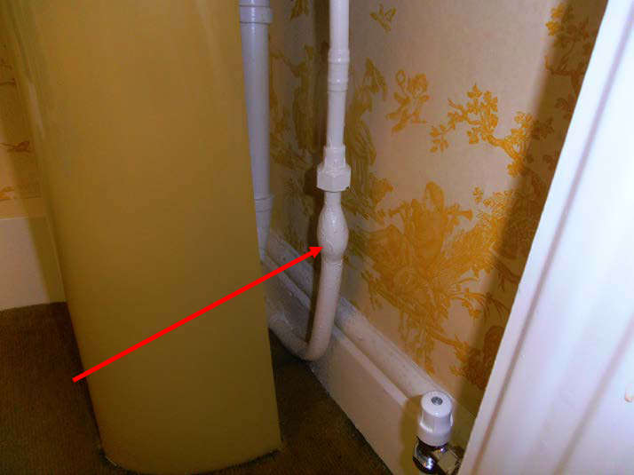

Lead plumbing to bathroom

The mains water supply pipe beneath the stop tap within the ground floor cloakroom is also formed from lead. Whilst it is less important to replace an underground lead supply pipe, this should also be considered as a future improvement. You should be aware that replacing a mains supply pipe will involve taking up external paving, and require a connection into the main supply which will involve the local water authority. The supply to the stop tap within the utility room is formed from replaced plastic.

There appears to be a cold water storage tank located within the main roof void. This tank is located within the small roof void to the front left hand corner of the building, which could not be physically accessed. We were therefore unable to make a close inspection of this tank. From our head and shoulders inspection, the tank has only minimal insulation and will therefore require improvement after occupation. If the tank is formed by a

46
Sample House, Sample Road, Sample

galvanised metal unit, it will need replacement.

ACTION: Budget for replacing lead pipe work and cold water storage tank.

 | Condition Rating | 2
GAS
Description | The property is connected to a mains gas supply. The meter is
 | located within the utility room.
Condition | The accessible parts of the gas installation and pipework appear
 | to be in a satisfactory condition with no obvious signs of
 | significant fault or damage.
 | All gas appliances service pipe work, ventilation and flues
 | should be checked and serviced annually by a Gas Safe
 | registered engineer. Unless proof of recent servicing for all gas
 | appliances can be found, they should all be inspected by a
 | qualified contractor prior to occupation.
 | The meter and adjoining pipe work is of some age but no signs
 | of leakage or damage were found. You should contact your gas
 | supplier to establish whether they would be willing to modernise
 | the meter and supply pipe work.
 | There is no electrical earth bonding to the gas meter, and
 | therefore this will require improvement.
 | Condition Rating | 1
ELECTRICITY
Description | The property is connected to a mains electrical supply. The
 | meter is located within the external meter box. There are two
 | consumer units located within the ground floor store and
 | entrance hall.
Condition | The property appears to have been subject to fairly extensive
 | electrical modernisation at some stage in the past 20 years.
 | The consumer units are formed by relatively modern fittings
 | which comprise circuit breakers and a residual current device.
 | This is a modern system designed to protect the users from
 | electric shock. | RCCB's are extremely sensitive and
 | consequently occasional tripping of switches will occur,
 | effectively shutting down the affected circuit. It can often result
 | when a light bulb fails, or it may be the result of a defective
appliance such as a washing machine or refrigerator. When this happens, the 'trip-switch' has to be reset. If this occurs with any

47
Sample House, Sample Road, Sample

frequency, an electrician should be instructed to investigate.
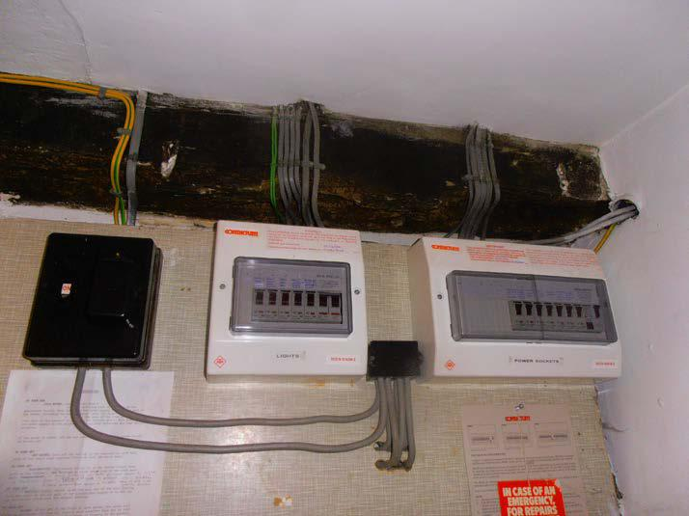

Consumer units

Accessible electrical wiring is formed by plastic sheathed cable, although this wiring appears to be of some age. We also noticed that some of the consumer units and electrical sockets are fitted on timber elements (such as skirting boards) which could potentially pose a fire risk. There is also a lack of electrical earth bonding.

It is impossible to fully assess the condition of an electrical installation on the basis of a visual inspection only. There are many factors relating to the adequacy of electrical installations which can only be identified by a test which covers matters relating to resistance, impedance and current, etc.

It is therefore essential that the purchasing legal adviser check to see whether recent test certificates are in place. Without such proof, we are unable to comment fully on the installations serviceability and therefore a specialist test by a NICEIC contractor should be obtained prior to purchase.

Where testing or indeed any work is carried out to the electrical installation, we recommend that you use a contractor who is affiliated to the NICEIC.

We also noticed that there were only a minimal number of electrical sockets within some rooms. You should establish the number and positioning of electrical sockets, so that the electrical contractor can establish whether some re wiring will be needed.

48
Sample House, Sample Road, Sample
 | ACTION: You should have the installation tested by a
 | NICEIC | contractor if no recent test certificates are available.
 | Condition Rating |  | 3
HEATING & HOT WATER
Description | Central heating is provided by the floor mounted boiler located
 | within the utility room. Hot water is stored within an old copper
 | cylinder located within the bathroom.
Condition | The central heating boiler is formed by a fairly old floor mounted
 | gas fired unit located within the utility room. The boiler utilises a
 | vertical flue which extends within the chimney breast. The
 | accessible parts of the flue within the utility room appear to be
 | formed from asbestos cement.
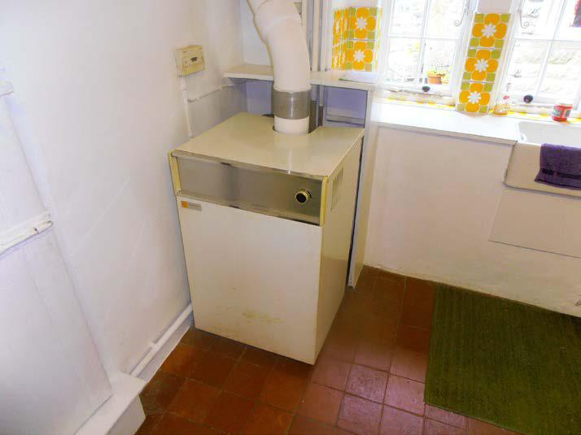

Old floor mounted boiler

Radiators are also formed by a number of old pressed steel units which are showing varying signs of weathering. No significant leaks or corrosion were found.

The central heating boiler was operated during our inspection, and we noticed that some radiators were found to be warmer than others. We are therefore unable to confirm whether the boiler and heating system is serviceable. This heating system would normally be considered to be reaching the end of its serviceable life, and therefore you should budget for fairly extensive replacements after occupation. Until the system is replaced, you will need to obtain clarification from a specialist heating engineer to establish what works are needed to make

49
Sample House, Sample Road, Sample
 | the system fully operational.
 | Whilst there was an adequate flow of hot water to each of the
 | kitchen and bathroom fittings, the hot water cylinder is again of
 | some age and showing general signs of corrosion. The cylinder
 | is not fitted with a thermostat, which could potentially pose a
 | dangerous situation if the boiler thermostat failed. The
 | expansion tank within the roof space would again benefit from
 | improved insulation and a fitted cover.
 | If you intend to retain this heating system for any period of time,
 | you should have it inspected and serviced by a qualified heating
 | engineer prior to purchase. Otherwise you should budget for
 | complete replacement.
 | ACTION: Budget for extensive replacements to the heating
 | and hot | water system.
 | Condition Rating |  | 3
THERMAL INSULATION &
VENTILATION
Description | Properties of this type are inherently less thermally efficient than
 | a brand new property, particularly because lower levels of
 | insulation in walls and roofs, less efficient heating systems and
 | older glazing.
Condition | All of the windows and doors are single glazed. Whilst replacing
 | with double glazed units would increase thermal efficiency, it is
 | possible that the listed building officer would not agree to these
 | improvements.
 | The roof space has been insulated with 50 mm fibreglass
 | quilting. Current recommendations are that a 300 mm thickness
 | be provided and therefore it is recommended that the present
 | thickness be increased as necessary.
 | The solid stone external walls would not meet current Building
 | Regulations standards for thermal insulation but will provide
 | reasonably good insulation. Their considerable thickness
 | means that they have high thermal capacity, i.e. the stonework
 | will take a long while to warm up in comparison with modern
 | lightweight building materials but once warm, will act as a heat
 | reservoir.
 | ACTION: Improve insulation within the roof voids.
 | Condition Rating |  | 2
 | 50

Sample House, Sample Road, Sample

GROUNDS

GARAGES

Description

There is a single detached garage.

Condition

The garage is found in a satisfactory condition with no signs of structural defect. However, there will be a need for some general repair and improvement after occupation.
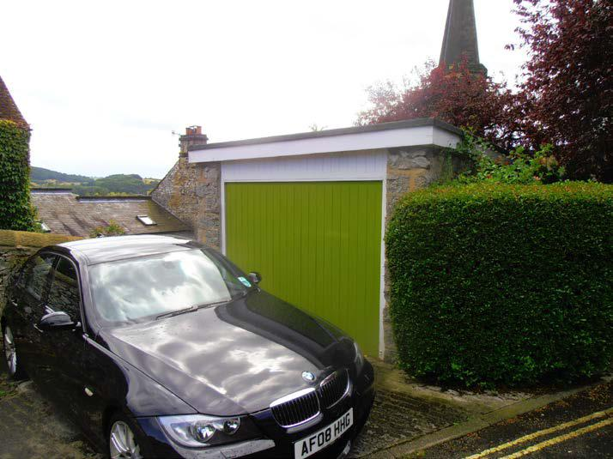

Detached garage

The masonry walls to the garage remain serviceable. However, the felt covered flat roof has become old and blistered. There is heavy moss growth to the flat roof, which will increase the chances of failure. Whilst we found no signs of significant damp penetration to the ceiling beneath, you should budget for replacements soon after occupation.

Joinery to the garage has again become weathered and will require future improvement.

Rainwater goods serving the garage are formed from asbestos cement. These will again require replacement, which should only be undertaken by a licensed asbestos removal company. Airborne asbestos cement fibres can be damaging to health.

ACTION: Budget for repairs and replacements to the garage roof, joinery and rainwater fittings.

Condition Rating | 2

51

Sample House, Sample Road, Sample

PERMANENT
OUTBUILDINGS

Description | Timber buildings such as sheds and summer houses are
 | considered as temporary buildings and are beyond the scope of
 | the report. They have not been inspected.
 | There is a very basic store attached to the side of the utility
 | room.
Condition | The outbuilding is found in a serviceable condition with no signs
 | of significant damage. Some general maintenance and upgrade
 | works will be required in the future but it appears suitable for its
 | purpose at present.
 | In its present form, this outbuilding will have only restricted use.
 | There is very minimal ventilation, and no windows. The floors
 | and walls are also damp as part of the structure is located
 | beneath external ground level. It should be treated partly in the
 | same way as a cellar, unless you consider improvements.
 | ACTION: Consider restricted use of the basic outbuilding.
 | Condition Rating |  | 1
EXTERNAL
AREAS/PATIOS/PATHS/
DRIVEWAYS ETC.
Description | There is a small enclosed yard to the front. It is understood that
 | the path and small triangular lawned area to the right hand side
 | also forms part of the subject Title. Whilst a road abuts the left
 | hand side of the property, there is a good sized enclosed garden
 | to the rear.
Condition | The grounds and boundaries show no evidence of significant
 | defects. It is always sensible, when purchasing any property, to
 | be sure about the ownership of individual boundaries and
 | responsibility for their maintenance. You are advised to check
 | with your Legal Advisers.

The site is relatively level and reasonably elevated with no apparent danger from flooding.

There are uneven and worn stone flags to the front of the property. This was particularly evident around the base of creeping plants which has caused some surface damage. General making good will be needed after occupation.

Paved paths to the side and rear have become worn but also remain serviceable. Paths and drives will inevitably wear and

52
Sample House, Sample Road, Sample

become distorted with time. Although serviceable at present, some future maintenance and repair should be anticipated.

It is understood that the path to the right hand side of the property is owned by the subject property. There is therefore an apparent public right of way into the church. This should be clarified by your legal adviser.
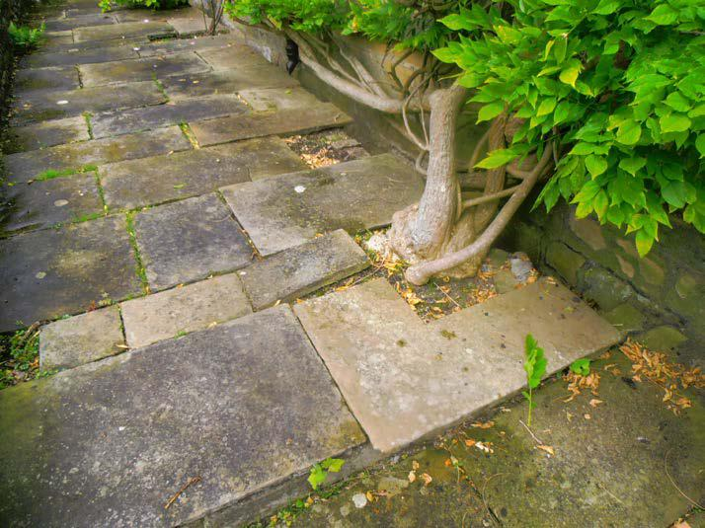

 |  |  | Damage to paving at front
 | ACTION: | Consider |  | general | minor | landscaping
 | improvements.
 | Condition Rating |  | 2
BOUNDARIES & FENCES
Description | Boundaries are generally formed by masonry walls.
Condition | Most of the boundaries are adequately defined and found in a
 | serviceable condition. Liability for the maintenance of all
 | boundaries should be clarified by your legal Advisers.

Some general maintenance and repair works will be required after occupation, but no significant damage was noted at the time of our inspection.

All accessible masonry walls appear to be in a structurally sound condition. Some general weathering and deterioration was noted, and therefore future maintenance should be anticipated.

53
Sample House, Sample Road, Sample

Any boundaries that support an increased ground level on one side are known as retaining structures. Retaining walls often suffer from structural movement and damp related deterioration. Repairs tend to be expensive and therefore such walls should be maintained in a good condition at all times.

There are large retaining walls to either side of the rear garden. In order to preserve the condition of these walls, you should consider maintenance within the next 2 years. It would therefore be sensible to consider re-pointing these walls within this time period.
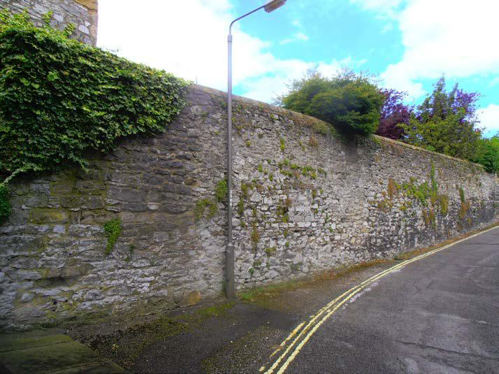

Large retaining walls

ACTION: Consider general maintenance to boundaries.

Condition Rating | 1

54
Sample House, Sample Road, Sample

GENERAL
ENVIRONMENTAL
FACTORS

Noise Disturbance

The proximity of the church will obviously have some impact on the subject property.

Means of Escape

Fire is always a danger but we see no abnormal risks in this property. It is recommended that a fire drill is agreed with all occupants and regularly practised so that they know what to do in the event of a fire. Further advice can be obtained from the local fire and rescue service.

We did notice a lack of smoke detection within the property. This should be considered as an improvement soon after occupation.

Hazardous Materials

There is a possibility of asbestos cement components to the boiler flue and rainwater fittings serving the garage.

Although the manufacture of asbestos based building materials has now generally ceased, many products containing asbestos can still be found on and within buildings. These can include roofing felt, roof sheetings and slates, thermoplastic floor tiles, Artex surface coatings, ceiling tiles, fireproof linings, roof edge verges and eaves soffits, soil and vent pipes, drainpipes, hoppers and waste pipes, gutters and downpipes. Asbestos waste has also been found in lofts and floors, sometimes installed by owners as insulation.

Problems arise, however, when asbestos based materials need to be removed for reasons such as maintenance or repair, and when alterations are made to a building. Depending on the function of the material, certain notifications have to be given, followed by removal, by registered operatives, to disposal sites allocated specifically for this type of contaminated waste. Asbestos removal is expensive due to the substantial safety precautions which have to be taken.

Asbestos is a hazardous material and removal is expensive. Safe removal of asbestos requires trained expertise and we recommend that such work should only be done by a licensed asbestos removal contractor. There are regulations controlling the removal and disposal of certain types of asbestos. If you require further information as to the register of licensed contractors you should consult the local environmental health officer.

Depending on its condition, asbestos cement found on and within domestic property can, in many cases, be left alone without causing any undue risk to the occupants. This,

55

Sample House, Sample Road, Sample

however, is strictly on the basis that the material is left undisturbed and unbroken, thus avoiding release of fibres. It is also normally advisable to have the surfaces sealed and it would be sensible for them to be marked to indicate the presence of asbestos.

Having regard to the age of the property it is possible that the paintwork contains lead, and suitable precautions should be taken when rubbing down and redecorating these surfaces.

Security

There are only very basic locks to the doors with no locks to most of the windows. You should therefore consider improvements after occupation.

Radon

The National Radiological Protection Board has identified the area in which the property is situated as one in which, in more than 1% of dwellings, the level of radon gas entering the property is such that remedial action is recommended. It is not possible in the course of a building survey to determine whether radon gas is present in any given building as the gas is invisible and odourless. Tests can be carried out to assess the level of radon in a building. At a small charge, test instruments and results are available by post from the National Radiological Protection Board. The minimum testing period is 3 months. The National Radiological Protection Board strongly advise against using shorter term testing instruments as they can give misleading results. If tests have not been carried out it is recommended that they are. Compared to the total value of the property, the cost of carrying out remedial measures is relatively inexpensive.

Flooding

There is no likelihood of flooding under normal conditions.

Listed Building

The building is understood from selling agent to be listed as “being of Architectural or Historical Interest”. Your Legal Advisers will confirm this, and will be able to explain the implications of owning a Listed Building. Please note that it is particularly important to take specialist advice if any repair work or alteration is needed.

The owner of a listed building has substantial responsibilities in terms of proper maintenance, and no alterations either internally or externally should be made without first checking the need for listed building consent from the local planning authority, who may have very specific restrictions. Maintenance of the building fabric and attached details, as well as outbuildings, boundary walls and other items, would be included in such matters and if there is any doubt, the planning officer should be consulted.

The local authority can issue a listed building enforcement notice requiring the correction of any unauthorised alteration or

56

Sample House, Sample Road, Sample

extension works, if they consider that the works adversely affect the character of the building. We have not investigated whether any works requiring consent have received the necessary consent and therefore recommend that your legal adviser should make all necessary enquiries. If there is any doubt, the local planning authority should be consulted before exchange of contracts.

Planning application nearby

We are unaware of any significant proposals in the immediate vicinity.

Other environmental factors

No other significant adverse environmental factors are known.

Old mine works

This is not a mining area.

Clay sub soil

It is possible that the property is built on ground which contains an amount of clay. Clay soils can shrink and swell, depending on the levels of rainfall in a period of time.

This will make it particularly important to maintain drains in good condition at all times. No trees should be planted close enough to the building to dry out the sub soil.

Mature trees should not be removed without specialist advice. This is because of the risk of ‘heave’ – if a tree is removed it will no longer take moisture from the ground which can cause a clay sub soil to swell, potentially damaging drains and foundations. The advice of an aboriculturalist (tree surgeon) should be sought on the future management of mature trees.

High Voltage Electricity

There are no items of high voltage electrical supply equipment in close proximity to the property.

57

Sample House, Sample Road, Sample

APPENDIX 1

GENERAL ADVICE

58
Sample House, Sample Road, Sample

GENERAL INFORMATION

MAIN ROOF
Pitched Roofs

- A pitched roof is the name given to any roof with an angle of pitch greater than 10 degrees. Such roofs can be covered with a wide choice of material but, with residential property, tile, slate or thatch are the principle ones.

- The actual angle of the roof slope has to be right for the chosen roof material whilst the roof construction (i.e. the timberwork) must be designed to bear not only the weight of the covering but also the extra weight of rain, snow and wind, etc. If the design of the timberwork is wrong the roof timbers may deflect and water penetration is likely to occur.

- Where the edges of a roof butt up against brickwork or a chimney, etc. it is necessary to insert seals known as soakers or flashings. These are ideally formed in lead but in older properties cement mortar or concrete is often used as a cheaper alternative. These eventually crack and leak.

- Where two roof slopes join (often at right angles), a valley junction is created. These valleys can be formed with tiles or they can be lined in materials such as lead, zinc or glass fibre. The only way valley gutters can work effectively is to have them cleaned out on a regular basis even although access is often difficult. If you do not clean out valley gutters, leaks are very likely.

OTHER ROOFS
Flat Roofs

- It is impossible to predict accurately the life of a flat roof. Even if the external materials appear sound, a minor puncture in the covering material can cause problems beneath (often out of sight). Reports that predict the likely life of a flat roof should be viewed with caution, although we often attempt to give a general guide to be helpful.

- Flat roofs have always been considered a part of residential house design. Traditionally they were used on small or secondary areas. From the 1960’s onward, large flat-roofed areas were brought into use but these days we try to minimise flat roof areas and create pitch roofs where possible since most flat roofs are troublesome to some extent or other.

- A flat roof is defined as a roof as having a slope less than 10 degrees. To enable the rainwater to run off its surface, the flat roof must be laid with some slope and if this is too shallow water will collect in puddles on the surface. Such puddles or “ponding” can cause the roof to deteriorate. Damage can also be caused to the substructure under the covering.

- Most flat roofs are not designed for walking on and chippings pressed underfoot can cause punctures in the roofing material. Walkway tiles can, however, be purchased and bedded down when a walkway route is needed.

- Many problems with flat roofs occur on the edges of the roof or in the junctions with walls or nearby roof slopes. Any vertical edging or flashing often indicates a better than average attention to detail. Felt upstands and edge kerbs are very often torn and need careful and regular attention and checking.

- The best designed flat roofs will incorporate modern levels of insulation and will also contain sufficient ventilation to reduce the risk of rot in concealed structural timbers. Being realistic the majority of flat roofs are not built this way and are therefore prone to problems developing out of sight.

- Although felt in one form or another is the most common material found on modern flat roofs, there are others including lead, copper, zinc, fibreglass and asphalt.

59
Sample House, Sample Road, Sample

COVERINGS
Thatched Coverings

- Thatch is one of the oldest techniques still used in building construction today. There are two main materials used – water reed and wheat straw. Water reed is more durable, lasting up to 80 years approximately. Wheat straw comes as either long straw (lasting up to 25 years approximately) or combed wheat reed (which can last up to 40 years).

- The speed at which a thatch roof deteriorates is difficult to judge. Generally, the further west a property is, the faster its thatch deteriorates due to the wetter climate. The quality of the thatching material and the slope of the roof also affect the life of a thatch.

- The steeper the roof slope, the longer the thatch is likely to last. Thatched roofs should never be less than 45º and sometimes can be steeper. It is common for thatched roofs to need patching or replacement of the ridge which is likely to be needed every 10-15 years.
- Fire is a well known risk with thatch. Electrical wiring needs to be checked regularly and ideally a spark arrestor should be fitted to the top of the chimney to prevent sparks and materials falling onto the thatch. It is always good practice to have the chimney lined. Smoke detectors and fire extinguishers are essential additions within the property.

Slate Coverings

- Slate can last anything up to 100 years or more depending on quality, source, thickness, and the skill with which it was cut.
- Natural slates are formed by very thin layers of rock being bonded together. Poorer quality slates may contain impurities which react with water and force the layers apart. This “delaminating” is common on the underside of the slates.

- Slates are held by nails fixed via holes drilled either close to one end or at the centre. It is quite common for slates to split when being fixed but then be left in place, only to slip later. Nails inevitably corrode in time and slates start to slip. This is known as “nail sickness”. Take not of this if it is listed in Section 3 Roof, as it will mean that you face ongoing maintenance. You can identify where slates have already been re-set as they are usually held in place by lead or copper clips, known as tingles. Old slates often shale to a degree whereby their effectiveness is very limited.
- Problems with slate roofs have led some owners to apply a coating over the whole of the covering. This should never be considered an appropriate repair. It can make the roof watertight for a few years. It will certainly mean that complete renewal of the roof will be necessary, as good slates when over-coated cannot be reused. It is also likely to cause condensation problems as the roof stops breathing.

- Traditionally, slate roofs were not underfelted and, this allows the slates to breathe. This practice still has its supporters, but generally, underfelting is considered as important with a slate roof as with a tiled roof. The underfelt provides a secondary protection against leaks if the slates are breached.

- There are various proprietary coatings available which are applied to the underside of old slate roofs. Whilst these do undoubtedly provide a short term repair, the medium or long term merits of such a system are untested and a lot of surveyors believe these under spraying systems to have a limited life.

Clay Tiles

• Clay tiles come in all shapes and sizes ranging from flat (plain) tiles to those which overlap at the edges and form vertical rolls on the roof slope. Clay Tiles have been used widely for many years, although since the post-second world war period, concrete tiles have tended to have been used as an alternative.

- By nature a clay tile is not impervious to moisture and, as it ages, some water enters into the tile. This can lead to damage of the tile surface (lamination) when the moisture freezes and

60
Sample House, Sample Road, Sample

breaks off the face of the tile itself, both internally and externally. Where this is visible, beware – ongoing maintenance is needed.

- Tiles are either nailed onto roofing battens or hung onto the battens by means of nibs which are formed in their upper edge. Most manufacturers recommend that even tiles with nibs are nailed at regular intervals to prevent them being lifted by the wind. Corrosion of nail fixings is commonplace (known as nail sickness) and will mean ongoing maintenance. Due to the method of manufacture, tiles are often not flat, which allows water to be blown or drawn up between them and can cause dampness inside, especially if the roof is an unlined one. In time the nibs can shale away.

- Occasionally old wood pegs or aged random nails are found on very elderly roofs.

- If you are considering recovering a roof, do take advice before changing the covering material.

- There are various proprietary coatings available which are applied to the underside of old clay tiled roofs. Whilst these do undoubtedly provide a short term repair, the medium or long term merits of such a system are untested and most surveyors believe these under spraying systems to have a limited life.

Concrete Tiles

- Concrete tiles are reckoned to last at least 50 years. The general performance of concrete tiles is impressive, though they can be prone to lose surface colour which shows up replacement tiles.

- Sometimes a powdery “efflorescence” can be seen under the tiles. This is simply salts contained in some earlier concrete tiles emerging due to heat and dampness over a period of years. Eventually the tiles’ nibs can be eroded away, though this is likely to take many years.

- Certain tile shapes (especially pantiles) have an open void in them which needs sealing at gutter/base level mainly to prevent birds nesting under tiling and causing damage. It is often difficult to tell from ground level whether these seals are in place and it is always sensible to carry out a check whenever a property is being maintained or painted. Modern patent eaves level seals also allow important ventilation.

- In the course of time concrete tiles can become brittle.

RAINWATER GOODS

- Inadequate disposal of rainwater can cause serious problems in a building including damp, timber decay and structural movement. Keeping gutters and downpipes (and the drains to which they connect) clean and in good condition is always important.

- Gutters and downpipes are traditionally made in cast iron but with modern property, plastic is generally used. In addition, however, we frequently survey properties with asbestos, lead, tin or aluminium as alternatives. All gutters need to be laid to a slope in order to enable rainwater to run to a downpipe outlet. Guttering should always be fixed so that it catches as much water flow as possible from the roof above. Guttering systems frequently run on an inter-neighbour basis with semi-detached or terraced homes.

- Metal fittings are particularly prone to corrode and joints often fail. They need regular checks and maintenance if they are to be preserved.

- Traditionally downpipes discharge over open gulleys but today many downpipes are taken directly into the underground drainage system without an access gulley. This can cause problems for cleaning.

61
Sample House, Sample Road, Sample

CHIMNEYS

- Chimney stacks can be built in a variety of shapes heights and sizes, often elaborate for architectural purposes. However, the flues within the stacks are formed in one of two ways. Older houses have flues with a rendered internal face that can often fail and erode, causing smoke and fumes to escape and also causing general inefficiency. More modern properties have continuous liners that are effective for solid fuel and other fuels. Some old properties have flues which are just not adequate for modern use.

- Flue soundness and efficiency in older homes must never be assumed. Proper smoke tests are normally required to check flue soundness. If necessary old flues can be lined in order to bring them up to modern standards.

EXTERNAL WALLS

Stone Walls

- Stone is described according to the manner in which it is prepared and laid. The two main categories are known as ashlar and rubble. When stones are squared to a regular size and have smooth faces, they are known as ashlar. Rubble comprises stones of differing sizes which are either laid at random (a crazy paving appearance) or they can be laid roughly in courses.

- Many of our stone buildings are made of stone which is very aged and may have been re-cycled from previous buildings. Some types of stone are harder and more durable than others

- Frost is a major problem with some stones softening as water penetrates the surface and freezes, causing the surface to break off and at the same time allowing more water to penetrate into the core of the wall causing more damage.

- Poor repairs to stone work and the pointing between the stones can cause ongoing problems and it is always sensible to take the advice of a stone mason to ensure that repairs are appropriate.

- Because stone walls are generally thick, there is a popular conception that they are solid from inside to out. This is not always the case and the core of the wall is often filled with rubble and general debris.

Solid Brickwork

- Until the mid-1930’s most domestic property in this country was built in solid construction. This means that the bricks are laid in such a way that they run through the depth of the wall from inside to out and as a consequence this can permit damp to travel through the wall onto the internal surfaces. Generally a wall which is exposed to heavy driving rain will be more susceptible to damage than one which is sheltered.

- Areas under window sills tend to be more susceptible to water damage than other wall areas.

- In order to minimise the risk of damp penetration, the outside pointing and brickwork should be kept in as good a state as possible. Modern coatings are available to apply to solid brickwork to help weatherproof them but these do not always look attractive. They can cause problems if damp breaks through the coating and gets behind the weatherproofing.

- Heat loss tends to be greater through solid wall construction than it is through a cavity wall. A solid wall with a rendered finish can perform well if the render is maintained in a sound state.

- It tends to be inevitable that houses with solid wall detail suffer on occasions from condensation problems.

62
Sample House, Sample Road, Sample

- Many older and inter-war built houses have projecting bays as a feature of the wall design. Often the upper storey bay wall is not built in brick at all but in timber – generally without any insulation.

Cavity Walls

- This is the normal form of construction found on houses from the mid-1930’s to the present day, although many older houses have a variation of the same form of wall detail.

- As the name implies, cavity walls are constructed with two leaves of brick or block work – with a cavity between. The benefits of the cavity are that the wall cannot let water through its depth whilst the air in the cavity offers improved insulation standards.

- The outer and inner leaves of a cavity wall are usually stabilised with ties made of galvanised steel or plastic.

- In some cases, the ties which hold the outer and inner leaves together begin to rust. At first, they expand causing the outer leaf to bow and eventually may collapse. Cavity wall tie failure is more common in older houses (prior to 1980) and is often known to be a problem in particular areas. We will alert you to potential maintenance regarding cavity wall ties if there are visible signs of problems or if we are aware of previous problems in nearby properties.

- Even though cavity construction is effective, water can sometimes penetrate the outer skin of the wall. Cavity trays should be inserted over window and door openings to catch this water. There should be drainage channels left through the mortar joints from these trays although they are frequently omitted.

- Brick is the most common form of outside finish on a cavity wall. Frost often attacks older bricks causing the surface to break off. This is known as “spalling”. Repair work is possible but costly if the job is to be done properly and the best approach is to cut out the failed bricks and replace them.

- It is common to see salty stains, particularly on new brickwork. They are of no structural significance and can be brushed off or left to be dispersed by weather action over a period of time.

- A rendered finish or some form of cladding applied to the outside of a modern cavity wall often indicates that both leaves of the wall are of block without any brick content.

Rendering

- Modern cement render can be inappropriate for old buildings because it is incompatible with the construction of most old buildings and can cause or accelerate serious decay. Modern buildings generally depend on an impervious outer layer and cavities to keep out moisture. By contrast, old buildings tend to rely on their porous nature ('breathability') to allow water absorbed by the fabric to evaporate back out

- The use of an impervious Portland cement render in place of a traditional lime-based covering restricts evaporation. Hairline cracks form due to the mortar being more rigid than the wall. These then draw in water that becomes trapped in the fabric. Timber-framed and earth constructed buildings in particular can suffer major structural damage if moisture builds up behind a cement rendering.

- It is generally a mistake not to replace render. There is a good chance that the building was rendered originally. Even if it was not, the rendering may have been applied at a later date as necessary protection against the weather.

- When a cement render has been removed, re-rendering should be delayed for a short period to allow drying out if the underlying fabric is saturated. Additionally, any areas of decayed backing must be made sound before the new render is applied to prevent its early failure.

63
Sample House, Sample Road, Sample

WINDOWS, DOORS AND EXTERNAL JOINERY
Windows

- Traditionally windows were constructed in wood and generally old timber tends to be better than new timber and hardwood is more long lived than softwood.

- Increasingly wooden windows are being replaced with man made materials. During the 1970’s and early 1980’s aluminium units set in hardwood frames were very popular. Many of these windows, however, have become temperamental in the way they open and close. These days uPVC is the most commonly used material for replacement units and if looked after and if of a good standard these windows perform well.

- With PVC windows it is important to keep the material as clean and dry as possible and to maintain the mastic seals around the frames in a good state to help prevent any damp penetration. Regular maintenance of the window mechanisms tends to be necessary. Failure of the rubber seals and bushes tends to occur. It is vital to check whether any current guarantees are in force.

- With increased importance being paid within the building industry to insulation standards the quality of glazing has improved over the years, but many houses still have comparatively “ordinary” single glazed windows whilst some high quality triple glazed units are sometimes found.

- Unfortunately many double glazed windows suffer from failure causing the glass to mist over and the only solution is to replace the glazing. This type of failure can occur without warning. There are some indications that the average life of a sealed double glazing unit is some ten years only.

- Some houses built between 1920 and 1960 had steel framed windows. These are prone to rusting and as the metal corrodes and expands, the windows can become twisted or buckled and panes crack or break. This type of material also creates a cold surface which can lead to a high level of condensation.

- Lead light windows may look pretty, but they are troublesome to clean and do weaken with age.

Doors

- External softwood doors are the cheapest to fit, but the least durable. Unless very regularly decorated they will decay. Hardwood doors are better. Aluminium or uPVC replacement units are claimed to be the most efficient of all.

- The raised sill sections used with uPVC doors are vulnerable to foot damage.

DAMP PROOF COURSES

- A damp-proof course (DPC) is a waterproof layer built into, or formed within, the walls to prevent ground dampness from rising.
- Virtually every urban property built in the last 120 years or so will have some sort of damp proof course in its wall. Many materials are in use, some being better and longer lived than others. The majority of the houses built in the last 60 years or so has a felt or pick based damp proof course along with blue brickwork. Before then slate or bitumen were frequently used. Many older houses have no built-in anti-damp protection.

- In order that a DPC can perform properly its line ought always to be at least two clear courses of brick above paths or garden surfaces. Whenever a lesser distance exists, the DPC can become ineffective and internal dampness can occur.

- Many older buildings suffer dampness due to inadequate damp proofing measures. The installation of a modern injection system (often identified by a series of drill holes in the brickwork) together with associated internal replastering can remedy such dampness. All

64
Sample House, Sample Road, Sample

damp proofing work ought to be dealt with by a competent and recognized specialist firm who can issue a valid guarantee. Internal replastering is an essential part of most damp proofing schemes.

INTERNAL WALLS AND PARTITIONS

- Traditional, internal walls have always been built in solid materials (brick or block), or timber. Contrary to popular belief, timber walls can be load bearing.

- Modern houses often have lightweight non-load bearing thin partition walls especially at first floor level.
- All these different wall types give differing standards of noise and thermal insulation.

- Many wooden or partition walls are difficult to use to support heavy fixings or pictures. Special fixings are generally available for most wall types.

- Many modern homes have a dry lined (plasterboard type) finish to walls which may not easily accept heavy fixtures, but the system is effective and plaster shrinkage problems are minimised.

- In older properties, the walls are often lined with board to disguise or overcome problems of poor plaster, damp and insulation. This can be effective but long term problems can still arise.

FLOORS
Solid Floors

- Solid floors are normally made up with a concrete slab laid on a hardcore base. The hardcore helps spread the load evenly over the soil beneath and protects the concrete from chemicals in the soil. To achieve a floor that does not settle, hardcore needs to be well compacted. If the floors should subside, repair work is possible but can be costly.

- Concrete slabs are typically around 150mm thick and have a thin top layer (screed) which gives a level base for the floor finish (tile, carpet etc). Sometimes the slab is just smoothed off to provide a finishing surface without a screed.

- Solid floors should include a damp proof membrane (dpm). This is usually either a liquid bitumen coat or a layer of polythene or bitumen sheet. The dpm reduces moisture coming up through the floor by capillary action, though it does not resist direct water pressure. Poor workmanship on site often means that a dpm is torn or laid with gaps or laid with gaps which become damp spots later.

- In older properties original floors tend not to have a dpm and often suffer from dampness. These floors are often an important feature of the property and if the level of dampness is felt not sufficient to warrant lifting and re-laying the floor surface to include a dpm, these floors tend to be left and the damp lived with. However these floors should not be surfaced with any impermeable covering such as vinyl or rubber-backed carpet (and ideally should be left exposed).

Timber Floors

- Suspended timber floors have been used for many years without great design changes. Most problems result from under-sizing of the joists or poor conditions at the end support (bearing), or poor sub-ground ventilation.

- Joists bearing into solid walls (usually pre-World War II) can rot, particularly if the wall is exposed to prevailing winds and rain soaks through the brick or stonework.
- Very often, joists are cut or notched, to allow pipes and wiring to run under floorboards. There are clear regulations which now restrict what can be done, but all too often mistakes are made, sometimes resulting in the floor becoming springy. If the surveyor suspects this fault we will suggest further investigation is made.

65
Sample House, Sample Road, Sample

- To prevent joists twisting, strutting is inserted usually some halfway along its length. Strutting is usually made with pieces of timber which are nailed between two joists at right angles to their length. When they are omitted the floor can become uneven or springy.

- When surveying a building it is rarely possible to carry out a full level of sub-floor checks and the surveyor will base their view on such inspection as is readily possible.
- More recent properties often have sheet chipboard/man made board flooring in place of more traditional floorboards. Because these materials can be laid in large panels, removal to access services can result in a very squeaky floor developing since the sheets are rarely properly re-fixed. The material tends to disintegrate on prolonged exposure to moisture and problems often occur near showers or washing machines in particular.

CEILINGS
Lath and Plaster Ceilings

- Most modern ceilings are made of plasterboard, but up to World War II a plaster mix was applied onto thin strips of wood called laths. (In very old properties reeds or straw were often used to strengthen to material). The strength of this type of ceiling depends on how well the plaster keys into the laths. When the plaster starts to pull loose from the laths, it often becomes widespread and repair of a small crack can soon become a large repair. Vibration and noise can often be a cause of a lath and plaster ceiling to fail. The installation of central heating can also cause old plaster to simply dry out so much that it cracks and fails.

- It is not uncommon for old lathed ceilings to be covered over with a variety of materials and finishes. Over boarding in modern plasterboard is a common solution to a troublesome ceiling.

- Lathed ceilings are heavy and can fall unexpectedly if damaged!

Plasterboard Ceilings

- For nearly 50 years now plasterboard has replaced the use of lath and plaster in most ceiling construction. Boards come in a variety of thickness and in general are relatively maintenance free.

- Joints between boards are most commonly covered by tape. Hairline cracking along the joints, however, is not uncommon though relatively simple to fill and redecorate or lining paper can be applied prior to a decorative finish.

- Dampness is a problem for plasterboard which is made up of a plaster centre covered by heavy paper on both sides. When moist, the paper covering deteriorates and the plaster content generally swells and crumbles. Replacement is then normally necessary.

- Artex or similar textured finishes are popular but these are not easy to repair to a good standard.

DAMPNESS
Damp & Timber Treatment – Guarantees

- Very often in older properties we find that previous damp and timber treatments have been carried out and are subject to guarantees.

- Particular care needs to be exercised in respect of wood-rot, woodworm/beetle and damp guarantees.
- A guarantee will normally only cover those areas specifically treated, and this is normally identified in the original report, specification and plan.

- It is important that such documents are made available to you and your legal adviser.

66
Sample House, Sample Road, Sample

- Insurance protection is sometimes available for un-treated areas.

TIMBER DEFECTS
Timber Defects

- As a general word of caution, in older properties of this type, it is our experience that there are likely to be timbers within the structure which have deteriorated over the years due to possible wood-worm/beetle infestation, damp or other reasons, and may be decayed and a cause of potential problems in the future.

GAS

- As with electricity, defects can be life-threatening and are even harder to detect. We can form some impression of the attention given to the gas installation by the appearance of the fittings and will note concerns in Section 4. That apart it is essential that every property which is provided with gas has a test and service every year. If a test is overdue, arrange one immediately. Make sure that the contractor you instruct on any gas matters has a current registration with CORGI. If the surveyor considers that further investigations are needed he will say so.

- All gas appliances and flues must be subject to an annual check and test.

- Surface run gas pipes both inside and out must be treated with care to avoid damage.

WATER SUPPLY AND PLUMBING

Pipework & Tanks

- Most pipework in a building is concealed within the structure and fabric and we can only form an opinion based on the exposed parts of the installation.

- Copper tube is the most popular material used but in many new installations plastic is becoming increasingly popular as a cost effective alternative.
- In many older houses we still find old lead or galvanised piping, especially on the underground supply pipe. Some homeowners consider lead pipes to be a health risk. Old underground pipes can leak for many years undetected or suddenly burst unexpectedly. Replacing underground/floor pipes can be costly and disruptive.

- Water tanks come in a variety of shapes and sizes but plastic is the preferred modern material. In older properties we find older galvanised steel or cement asbestos tanks and ideally these should now be replaced.

HOT WATER INSTALLATION, BOILERS, CONTROL EQUIPMENT, SPACE HEATING, ETC.

- The ability of any central heating system to sufficiently heat all areas required depends on the efficiency of the boiler and the size and efficiency of the pipe runs and radiators. In order to tell accurately whether a central heating system is adequate, Heating Engineers have to carry out a series of calculations involving size of radiators, room and window sizes, capacity of the boiler etc. For this degree of assessment, a Heating Engineers’ involvement is essential.

- Modern combination boilers are increasingly popular, but they may produce limited amounts of hot water for bathing with poor levels of pressure.

FOUL AND SURFACE WATER
Drains

- Foul drains are those taking waste from inside the building – WC, bath, kitchen, etc

- Below ground drainage systems must fulfil two functions in order to avoid problems:

67
Sample House, Sample Road, Sample

  - they must discharge waste efficiently into the main sewer
  - they must avoid foul smells escaping near to the property

- A correct slope (fall) is required to all drainage runs. Where gradients are too shallow, matter can build up and drains will need to be rodded on a regular basis. It is for this reason that the building regulations insist that an inspection chamber is provided where ever drains change direction or gradient. In some cases, small access gullies known as rodding eyes are provided.

- One of the most common causes of problems in drains is damage caused by tree roots which get into drains in search of water. We will advise you if there are likely problems in this regard, though it is important not to plant shrubs or trees close to drainage runs.

- Many houses of all ages have drain runs which are not as watertight as they should be. This can only be determined by the carrying out of a formal test which is not part of a Building Survey inspection.

- It is a good practice to regularly flush through drains with hot soapy water.

68
Sample House, Sample Road, Sample

APPENDIX 2

SKETCH TO ILLUSTRATE
BUILDING TERMS

69
Sample House, Sample Road, Sample
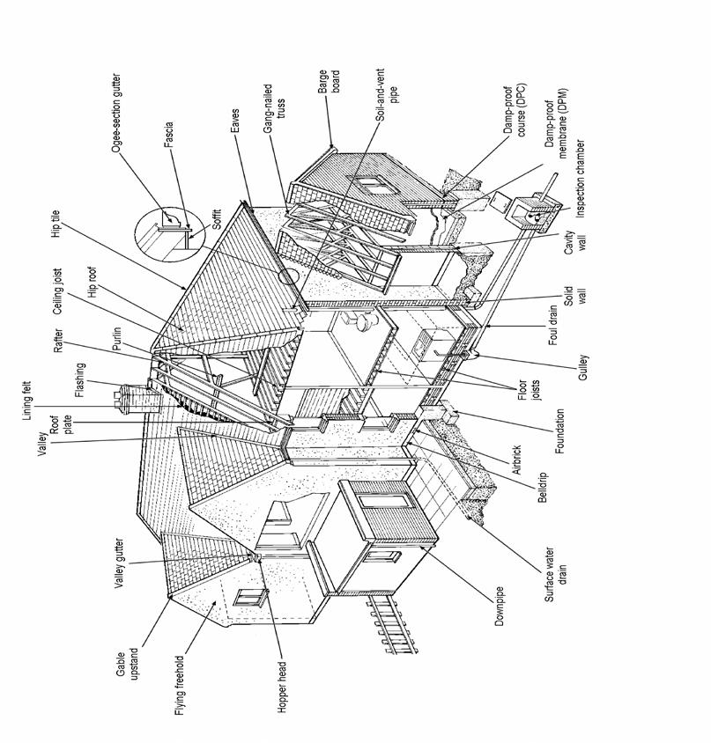

70
Sample House, Sample Road, Sample

APPENDIX 3

GLOSSARY OF BUILDING
TERMS

71
Sample House, Sample Road, Sample

GLOSSARY OF BUILDING TERMS

Aggregate

Pebbles, shingle, gravel, etc used in the manufacture of concrete, and in the construction of "soakaways".

Air Brick

Perforated brick or metal/plastic grille used for ventilation, especially to floor voids (beneath timber floors) and roof spaces.

Architrave

Joinery moulding around window or doorway.

Asbestos

Fibrous mineral used in the past for insulation. Can be a health hazard - specialist advice should be sought if asbestos is found.

Asbestos Cement

Cement with 10-15% asbestos fibre as reinforcement. Fragile - will not bear heavy weights. Hazardous fibres may be released if cut or drilled.

Ashlar

Finely dressed natural stone: the best grade of masonry

Asphalt

Black, tar-like substance, strongly adhesive and impervious to moisture.
Used on flat roofs and floors.

Barge Board

See "Verge Board".

Balanced Flue

Common metal device normally serving gas appliances which allows air to be drawn to the appliance whilst also allowing fumes to escape (see also "Fan Assisted Flues").

Batten

Thin lengths of timber used in the fixing of roof tiles or slates.

Beetle Infestation

(Wood-boring insects: eg woodworm) Larvae of various species of beetle which tunnel into timber causing damage. Specialist treatment normally required. Can also affect furniture.

Benching

Smoothly contoured concrete slope beside drainage channel within an inspection chamber. Also known as "Haunching".

Bitumen

Black, sticky substance, related to asphalt. Used in sealants, mineral felts and damp proof courses.

Breeze Block

Originally made from cinders ("breeze") - the term now commonly used to refer to various types of concrete and cement building blocks.

Carbonation

A natural process affecting the outer layer of concrete. Metal reinforcement within that layer is liable to early corrosion, with consequent fracturing of the concrete.

Cavity Wall

Standard modern method of building external walls of houses comprising two leaves of brick or blockwork separated by a gap ("cavity") of about 50mm (2 inches).

72

Sample House, Sample Road, Sample

Cavity Wall Insulation

Filling of wall cavities by one of various forms of insulation material:

Beads: Polystyrene beads pumped into the cavities. Will easily fall out if the wall is broken open for any reason.

Fibreglass: Can lead to problems if becomes damp.

Foam: Urea formaldehyde form, mixed on site, and pumped into the cavities where it sets. Can lead to problems of dampness and make investigation/replacement of wall ties more difficult.

Rockwool: Inert mineral fibre pumped into the cavity.

Cavity Wall Tie

Metal device bedded into the inner and outer leaves of cavity wall. Failure by corrosion can result in the wall becoming unstable - specialist replacement ties are then required.

Cesspool

A simple method of drainage comprising a holding tank which needs frequent emptying. Not to be confused with "Septic Tank".

Chipboard

Also referred to as "Particle Board". Chips of wood compressed and glued into sheet form. Cheap method of decking to flat roofs and (with formica or melamine surface) furniture, especially kitchen units. Also commonly used on floors. Tends to swell if moisture content increased.

Collar

Horizontal timber member intended to restrain opposing roof slopes.
Absence, removal or weakening can lead to roof spread.

Combination Boiler

Modern form of gas boiler which activates on demand. With this form of boiler there is no need for water storage tanks, hot water cylinders, etc but are complex and more expensive to repair. Water supply rate can be slow.

Coping/Coping Stone

Usually stone or concrete, laid on top of a wall as a decorative finish and to stop rainwater soaking into the wall.

Corbel

Projection of stone, brick, timber or metal jutting out from a wall to support a weight.

Cornice

Ornamental moulded projection around the top of a building or around the wall of a room just below the ceiling.

Coving

Curved junction piece to cover the join between wall and ceiling surfaces.

Dado Rail

Wooden moulding fixed horizontally to a wall, about 1 metre (3ft 4in) above the floor, originally intended to protect the wall against damage by chair backs.

73

Sample House, Sample Road, Sample

Damp Proof Course

Layer of impervious material (mineral felt, PVC, etc) incorporated into a wall to prevent dampness around windows, doors, etc. Various proprietary methods are available for damp proofing existing walls including "electro-osmosis" and chemical injection.

Damp Proof Membrane

Usually polythene, incorporated within ground floor slabs to prevent rising dampness.

Deathwatch Beetle

Serious insect pest in structural timbers, usually affects old hardwoods with fungal decay already present.

Double Glazing

A method of thermal insulation usually either:

Sealed unit: Two panes of glass fixed and hermetically sealed together; or

Secondary: In effect a second "window" placed inside the original window.

Dry Rot

A fungus which attacks structural and joinery timbers, often with devastating results. Can flourish in moist, unventilated areas.

Eaves

The overhanging edge of a roof at gutter level.

Efflorescence

Salts crystallised on the surface of a wall as a result of moisture evaporation.

Engineering Brick

Particularly strong and dense type of brick, sometimes used as a damp proof course. Usually blue in colour.

Fan Assisted Flues

Similar to "Balanced Flue" but with fan assistance to move air or gases.

Fibreboard

Cheap, lightweight board material of little strength, used in ceilings or as insulation to attics.

Fillet

Mortar used to seal the junction between two surfaces, ie between a slate roof and a brick chimney stack.

Flashing

Thin sheet material used to prevent leakage at a roof joint. Normally metal (lead, zinc or copper).

Flaunching

Contoured cement around the base of cement pots, to secure the pot and to throw off rain.

Flue

A smoke duct in a chimney, or a proprietary pipe serving a heat producing appliance such as a central heating boiler.

Flue Lining

Metal (usually stainless steel) tube within a flue - essential for high output gas appliances such as boilers. May also be manufactured from clay and built into the flue.

74

Sample House, Sample Road, Sample

Foundations

Normally concrete, laid underground as a structural base to a wall; in older buildings may be brick or stone.

Frog

A depression imprinted in the upper surface of a brick, to save clay, reduce weight and increase the strength of the wall.

Gable

Upper section of a wall, usually triangular in shape, at either end of a ridged roof.

Ground Heave

Swelling of clay subsoil due to absorption of moisture; can cause an upward movement in foundations.

Gulley

An opening into a drain, normally at ground level, placed to receive water, etc from downpipes and waste pipes.

Haunching

See "Benching". Also term used to describe the support to an underground drain.

Hip

The external junction between two intersecting roof slopes.

Inspection

Chamber

Commonly called "manhole"; provides access to a drain comprising a chamber (of brick, concrete or plastic) with the drainage channel at its base and a removable cover at ground level.

Jamb

Side part of a doorway or window (see also “reveals”).

Joist

Horizontal structural timber used in flat roof, ceiling and floor construction. Occasionally also metal.

Landslip

Downhill movement of unstable earth, clay, rock, etc often following prolonged heavy rain or coastal erosion, but sometimes due entirely to subsoil having little cohesive integrity.

Lath

Thin strip of wood used as a backing to plaster.

Lintel

Horizontal structural beam of timber, stone, steel or concrete placed over window or door openings.

Longhorn Beetle

A serious insect pest mainly confined to the extreme south east of England, which can totally destroy the structural strength of wood.

LPG

Liquid Petroleum Gas (or Propane). Available to serve gas appliances in areas without mains gas. Requires a storage tank.

Mortar

Traditionally a mixture of lime and sand. Modern mortar is a mixture of cement and sand. Used for bonding brickwork, etc.

Mullion

Vertical bar dividing individual lights in a window.

Newel

Stout post supporting a staircase handrail at top and bottom. Also, the central pillar of a winding or spiral staircase.

75

Sample House, Sample Road, Sample

Oversite

Rough concrete below timber ground floors.

Parapet

Low wall along the edge of a flat roof, balcony, etc.

Pier

A vertical column of brickwork or other material, used to strengthen the wall or to support a weight.

Plasterboard

Stiff "sandwich" of plaster between coarse paper. Now in widespread use for ceilings and walls.

Pointing

Smooth outer edge of mortar joint between bricks, stones, etc.

Powder Post Beetle

A relatively uncommon pest which can, if untreated, cause widespread damage to structural timbers.

Purlin

Horizontal beam in a roof upon which rafters rest.

Quoin

The external angle of a building, or, specifically, bricks or stone blocks forming that angle.

Rafter

A sloping roof beam, usually timber, forming the carcass of a roof.

Random Rubble

Primitive method of stone wall construction with no attempt at bonding or coursing.

Rendering

Vertical covering of a wall either plaster (internally) or cement based (externally), sometimes with pebbledash, stucco or Tyrolean textured finishes.

Reveals

The side faces of a window or door opening (see also “jambs”).

Ridge

The apex of a roof.

Riser

The vertical part of a step or stair.

Rising Damp

Moisture soaking up a wall from below ground, by capillary action causing rot in timbers, plaster decay, decoration failure, etc.

Roof Spread

The thrust of a badly restrained roof structure (see "Collar") causing outward bowing of a wall.

Screed

Final, smooth finish of a solid floor; usually mortar, concrete or asphalt.

Septic Tank

Drain installation whereby sewage decomposes through bacteriological action, which can be slowed down or stopped altogether by the use of chemicals such as bleach, biological washing powders, etc.

Settlement

General disturbance in a structure showing as distortion in walls, etc, usually as the result of the initial compacting of the ground due to the loading of the building.

76

Sample House, Sample Road, Sample

Shakes

Naturally occurring cracks in timber; in building timbers, shakes can appear quite dramatic, but strength is not always impaired.

Shingles

Small rectangular pieces of wood used on roofs instead of tiles, slates, etc.

Soaker

Sheet metal (usually lead, zinc or copper) at the junction of a roof with a vertical surface of a chimney stack, adjoining wall, etc. Associated with flashings which should overlay soakers.

Soffit

The under-surface of eaves, balcony, arch, etc.

Solid Fuel

Heating fuel, normally coal, coke or one of a variety of proprietary fuels.

Spandrel

Space above and to the sides of an arch.

Stud Partition

Lightweight, sometimes non-loadbearing wall construction comprising a framework of timber faced with plaster, plasterboard or other finish.

Subsidence

Ground movement possibly as a result of mining activities, clay shrinkage or drainage problems.

Subsoil

Soil lying immediately below the top soil, upon which foundations usually bear.

Sulphate Attack

Chemical reaction, activated by water, between tricalcium aluminate and soluble sulphates. Can cause deterioration in brick walls, concrete floors and external rendering.

Tie Bar

Heavy metal bar passing through a wall, or walls, to brace a structure suffering from structural instability.

Torching

Mortar applied on the underside of roof tiles or slates to help prevent moisture penetration. Not necessary when a roof is underdrawn with felt.

Transom

Horizontal bar of wood or stone across a window or top of door.

Tread

The horizontal part of a step or stair.

Trussed Rafters

Method of roof construction utilising prefabricated triangular framework of timbers. Now widely used in domestic construction.

Underpinning

Methods of strengthening weak foundations whereby a new, stronger foundation is placed beneath the original.

Valley Gutter

Horizontal or sloping gutter, usually lead or tile lined, at the internal intersection between two roof slopes.

Ventilation

Necessary in all buildings to disperse moisture resulting from bathing,

77

Sample House, Sample Road, Sample

cooking, breathing, etc, and to assist in prevention of condensation.

Floors: Necessary to avoid rot, especially dry rot, achieved by air bricks near to ground level.

Roofs: Necessary to disperse condensation within roof spaces; achieved either by air bricks in gables or ducts at the eaves.

Verge

The edge of a roof, especially over a gable.

Verge Board

Timber, sometimes decorative, placed at the verge of a roof; also known as a "Barge Board".

Wainscot

Wood panelling or boarding on the lower part of an internal wall.

Wallplate

Timber placed at the eaves of a roof to take the weight of the roof timbers.

Wet Rot

Decay of timber due to damp conditions. Not to be confused with the more serious "Dry Rot".

Woodworm

Colloquial term for beetle infestation; usually intended to mean Common Furniture Beetle, by far the most frequently encountered insect attack in structural and joinery timbers.

78

Sample House, Sample Road, Sample

APPENDIX 4

GENERAL MAINTENANCE

NOTES

79
Sample House, Sample Road, Sample

GENERAL MAINTENANCE NOTES

These notes are provided as a guide to enable you to inspect your property on a regular basis, to help keep it in good order. They must not be considered to be definitive or fully comprehensive. Regular maintenance inspections and prompt repair of any defects noticed will help keep your repair costs to a minimum. If neglected they may lead to more expensive repairs.

You should look at:

The Roofs

- Check that all the tiles and slates are in good order and replace any that are cracked, slipped or damaged. Ensure that the mortar pointing at the roof edges is kept in good condition.

Flat Roofs

- Make sure that the chippings remain evenly laid. If cracked or bubbled areas are noticed, have these repaired immediately.

Lead and Mortar Flashings

- Lead flashing should lay properly, mortar fillets should be free from cracks. Mortar fillets are not fully satisfactory and are best replaced with lead.

Guttering

- Should run to the downpipe heads at an even slope and be free from splits and cracks. Replace or repair missing or defective sections immediately to protect the property. Clean out the gutters regularly to remove weeds, leaves and granite chippings. Gutter joints do deteriorate with age and the need for resealing must be anticipated from time to time.

Downpipes

- Check that the junctions of the gutters to the downpipes are in good order and also the joints between the downpipes and the underground piping at ground level. If any downpipes discharge over gulley grids, clear and maintain brick surrounds to stop debris blocking the gulleys.

- Replace or repair missing or defective sections immediately.

Chimneys

- Keep chimney pots in good order and ensure they are securely joined to the top of the chimney. Keep the brickwork mortar joints in good condition. If you notice any cracking of the brickwork have it repaired at once.

- If television aerials have been fixed to the chimney ensure that they are properly secured.

80
Sample House, Sample Road, Sample

External Joinery (incl. Gutter and Barge Boards, Verge Cappings and Snow Boards)

- Keep in good repair and well decorated.

Outside Walls

- Keep the brickwork, mortar joints in good order. Poor maintenance of brick pointing leads to damp penetration and damage to the brick surface.

- Make sure the mortar joint protecting the damp proof course is keep in good condition.

- Keep the joints between the window and door frames and the brickwork in good watertight condition with pliable mastic sealant.

- Make sure that the mortar around the waste pipes is in good condition.

- Keep soil and paths at least 150mm below the level of the floors inside to prevent penetrating dampness.

- If there are air bricks, make sure they are in good order and free from blockage.

- If the walls are mortar rendered, make sure it is not cracked or loose. Water will get behind poor rendering leading to dampness. All cracked or loose areas should be repaired or replaced.

- Regularly redecorate any painted walls or timber boarded areas.

Windows and Doors

- Periodically inspect the frames and repair any timbers affected by wet rot. Regular painting helps avoid timber going rotten.

- Replace cracked and broken panes of glass and renew loose or missing putties before redecoration to avoid wet rot in the frames.

- Replace broken sash cords and window catches.

Inside the Loft

- Make a regular inspection to check for signs of leaks which can lead to wet or dry rot taking hold. Carry out any necessary repairs immediately.

- Check the chimney brickwork for heat cracks.

- Make sure the roof timbers are not broken, split or affected by rot.

- Clean out water tanks, maintain ball valves and keep tanks and pipes properly insulated and covered.

- Insulate the loft if this has not been done. Do not insulate right up to the eaves or below the water tanks. Make sure the electrical cables are not covered by the insulation.

- Look for wood-boring beetle flight holes and if in any doubt have a specialist firm make an inspection.

- Check ceilings under flat roofs for any signs of leaks and repair affected areas immediately.

Plumbing, Heating and Electrics

- Ensure that the external and internal stopcocks are readily available in an emergency.

81
Sample House, Sample Road, Sample

- Keep the plumbing pipework in good condition and periodically clean out the traps to baths, sinks and wash basins.

- Have the central heating appliances annually serviced by a CORGI registered contractor.

- Do not make any alterations to the electrical wiring without qualified advice. Amateur repairs and additions can lead to failure of the circuits, fire and risk of electric shock.

- It is advised that the electrical installation is checked by the Electricity Board at least every five years as cables and fittings deteriorate with age.

Decorations

- Internally, keep the ceilings, walls and woodwork in good decorative condition.

- External paintwork should not be left more than four years without redecoration.

Drainage

- Periodically lift the manhole covers and have the drains cleaned out if necessary. Keep manhole covers and surrounding mortar in good condition.

- If you have a septic tank; have it pumped out at least once a year.

In the Garden

- Keep the hedges, walls, fences, gates, paths and driveways in good order.

- Keep soil, shrubs and trees away from outside walls. Shrubs and trees can break drainage pipes and potentially cause subsidence.

- Cut back wall creepers regularly as they can destroy the mortar joints between brickwork, stonework, etc encourage dampness and insects and block gutters.

Outbuildings/Garages

- Check the roofs, gutters, downpipes and walls as suggested for the house.

- Regularly redecorate timber surfaces.

- Keep door hinges and locks well oiled. Regularly clean out sliding door channels.

82
Sample House, Sample Road, Sample

APPENDIX 5

ESSENTIAL GUIDANCE

83
Sample House, Sample Road, Sample

ESSENTIAL GUIDANCE FOR YOUR SURVEY REPORT

- If you have any questions about this report please contact me.

- It is important that you discuss the contents of this report with your conveyancer.

- To make sure you are properly covered tell your conveyancer to check existing guarantees and maintenance contracts e.g. central heating, damp and timber treatments, double glazing etc. Remember I have not tested any services.

- If I have mentioned such things as planning permissions, building regulations, listed building consents, freeholder consents, title restrictions, road and sewer bonds etc. tell your conveyancer to advise you further.

- If I have mentioned contaminated land tell your conveyancer to check what steps have been taken to deal with any possible contamination.

- If you are going to extend, after or improve the property you should get advice from the Local Authority.

- Defects or issues may have been highlighted and you should get your own independent advice. You may require reports and estimates and I suggest you use a contractor with an insurance backed guarantee and who is preferably a member of a trade organisation.

- When investigating the full extent of any defects I have reported, your contractor may go beyond the scope of the standard inspection e.g. by lifting carpets or floorboards and this may reveal more serious problems. Repairs or maintenance to the upper parts of the building may involve the use of expensive scaffolding.

- Central heating systems and heating appliances should be tested before you buy the property and then on a regular basis.

- Information and testing of electrical systems can be obtained from a qualified member of N.I.C.E.I.C on 020 7564 2323 or the ECA on 020 7313 4800.

- Testing of gas appliances can only be carried out by a ‘Gas Safe’ registered specialist. For further advice and names telephone 01256 372200.

- Advice on asbestos can be obtained from the Environmental Health Department at your Local Authority. You should be aware public perception of the possible health risks of asbestos may affect the value and future saleability of the property.

- For your own safety, smoke alarms, carbon monoxide detectors etc. should be fitted and regularly tested.

- Advice on radon can be obtained from the the health protection agency. Information and advice on radon can be obtained free of charge from the Health Protection Agency at Chiltern, Didcott, Oxfordshire, OX11 0RQ or www.hpa.org.uk.

84
Sample House, Sample Road, Sample

- If I have mentioned flooding, advice can be obtained on 0845 9881188 (England, Wales & Scotland) and 02890 253430 (Northern Ireland).

- No responsibility whatsoever is accepted by Derbyshire Surveyors to any third party and this report should not be relied upon for any commercial purposes or any other use without Derbyshire Surveyors written authority.

- A copy of this report can be made available in large print, Braille or audio.

85
Sample House, Sample Road, Sample

APPENDIX 6

TERMS AND CONDITIONS OF

ENGAGEMENT

86
Sample House, Sample Road, Sample

Building Survey

Terms and Conditions of Engagement

General Terms

- Introduction

1.1. This document sets out the contractual terms upon which the Surveyor will advise the Client by means of a written report as to his or her opinion of the visible condition and state of repair of the Property.
1.2. The individual carrying out the inspection and providing advice will be a chartered surveyor.

1.3. The Surveyor will use all of the care and skill to be reasonably expected of an appropriately experienced chartered surveyor.

- Content of the Report

In accordance with these terms the Surveyor will report upon:

2.1. the main aspects of the Property including assessing the site/location, the design, structural framework, fabric and services;
2.2. the grounds, boundaries and environmental aspects considered to affect the Property; .
2.3. any requirements for further investigation arising from the inspection.

- Delivery of the Report

3.1. The Report is to be delivered by the date agreed or at such later date as is reasonable in the circumstances.
3.2. The Surveyor will send the Report to the Client's address (or other agreed address) by first class post for the sole use of the Client. The Client agrees to keep the Report confidential disclosing its contents only to the Client's professional Advisers. In particular (but without limit) the Client must not disclose the whole or any part of the Report to any person (other than a professional Adviser) who may intend to rely upon it for the purpose of any transaction.

- Payment of Fees

The Client will pay the Agreed Fee, any Additional Fees, any VAT and any agreed disbursements prior to the issue of the report

- Assumptions

Unless otherwise expressly agreed the Surveyor while preparing the Report will assume that:

5.1. the property (if for sale) is offered with vacant possession;

5.2. the Property is connected to mains services with appropriate rights on a basis that is known and acceptable to the Client; and
87
Sample House, Sample Road, Sample

5.3. access to the Property is as of right upon terms known and acceptable to the Client.

Scope of the inspection

5.4. Generally

5.4.1. The Surveyor will consider his or her advice carefully but is not required to advise on any matter the significance of which in relation to the Property is not apparent at the time of inspection from the inspection itself.

5.4.2. The Surveyor will inspect diligently but is not required to undertake any action which would risk damage to the Property or injury to him- or herself

5.4.3. The Surveyor will not undertake any structural or other calculations.

5.5. Accessibility

5.5.1. The Surveyor will inspect as much of the internal and external surface area of the building as is practicable but will not inspect those areas which are covered, unexposed or not reasonably accessible from within the site, or adjacent public areas.

5.5.2. The Surveyor is not required to move any obstruction to inspection including, but not limited to, furniture and floor coverings.

5.6. Floors

5.6.1. The Surveyor will lift accessible sample loose floorboards and trap doors, if any, which are not covered by heavy furniture, ply or hardboard, fitted carpets or other fixed floor coverings. The Surveyor will not attempt to cut or lift fixed floorboards without express permission of the owner.

5.7. Fixed covers or housings

5.7.1. The surveyor will not attempt to remove securely fixed covers or housings without the express permission of the owner.

5.8. Roofs

5.8.1. The Surveyor will inspect the roof spaces if there are available hatches which are not more than three metres above the adjacent floor or ground. Where no reasonable access is available, the roof spaces will not be inspected. Similarly, outer surfaces of the roof or adjacent areas will be inspected using binoculars, but will be excluded if they cannot be seen.

5.9. Boundaries, grounds and outbuildings

5.9.1. The inspection will include boundaries, grounds and permanent outbuildings but will not include constructions or equipment with a specific leisure purpose including, without limit, swimming pools or tennis courts.

5.10. Services

5.10.1. The Surveyor will carry out a visual inspection of the service installations where accessible. Drainage inspection covers will be lifted where they are accessible and it is safe and practicable to do so. No tests of the service installations will be carried out unless previously agreed, although general overall comments will be made where possible and practicable. The Surveyor will report if it is considered that tests are advisable.

88
Sample House, Sample Road, Sample

5.11. Areas not inspected

5.11.1. The Surveyor will identify any areas which would normally be inspected but which he or she was unable to inspect.

5.12. Flats or maisonettes

5.12.1. Unless otherwise agreed, the Surveyor will inspect only the subject flat and garage (if any), the related internal and external common parts and the structure of the building or particular block in which the subject flat is situated. Other flats will not be inspected. The Surveyor will state in the Report the limits of access and/or visibility in relation to the common parts and structure. The Surveyor will

state whether he or she has seen a copy of the lease and, if not, the assumptions as to repairing obligations on which he or she is working.

5.13. Environmental and other issues.

5.13.1. Particular noise and disturbance affecting the Property will only be noted if it is significant at the time of the inspection or if specific investigation has been agreed between the Surveyor and the Client and confirmed in writing.

5.13.2. The Surveyor will report on any obvious health and safety hazards to the extent that they are apparent from elements of the Property considered as part of the inspection

- Hazardous Materials

6.1. Unless otherwise expressly stated in the Report, the Surveyor will assume that no deleterious or hazardous materials or techniques have been used in the construction of the Property. However, the Surveyor will advise in the Report if, in his or her view, there is likelihood that deleterious material has been used in the construction and specific enquiries should be made or tests should be carried out by a specialist.

6.2. Subject to clause 6.2 the Surveyor, based upon a limited visual inspection, will note and advise upon the presence of lead water supply pipes.

6.3. The Surveyor will advise in the Report if the Property is in an area where, based on information published by the National Radiological Protection Board, there is a risk of radon. In such cases the Surveyor will advise that tests should be carried out to establish the radon level.

6.4. The Surveyor will advise if there are transformer stations or overhead power lines which might give rise to an electro- magnetic field, either over the subject Property or visible immediately adjacent to the Property. The Surveyor is not required to assess any possible effect on health or to report on any underground cables.

6.5. Asbestos was commonly used in building materials up to the end of the 20th century, by which time it became a banned substance. Asbestos is not usually harmful unless the fibres can be released into the air by it becoming damaged or showing signs of wear. It is not possible to identify whether asbestos fibres are contained in a building material without a specialist test. Because asbestos was used in such a wide diversity of materials it is impossible to identify all the materials that may contain asbestos and it is beyond the scope of this report to test for asbestos. If you are concerned then you should commission a test for asbestos, which can be arranged on your behalf.

89
Sample House, Sample Road, Sample

6.6. This report will not identify moulds that could be harmful to health. If mould is present at the time of inspection then it will be recorded and you will need to arrange your own test.

- Ground Conditions

7.1. The Surveyor will not be required to comment upon the possible existence of noxious substances, landfill or mineral extraction, or other forms of contamination.

- Consents, approvals and searches

8.1. The Surveyor will be entitled to assume that the Property is not subject to any unusual or onerous restrictions, obligations or covenants which apply to the Property or affect the reasonable enjoyment of the Property.
8.2. The Surveyor will be entitled to assume that all planning, Building Regulations and other consents required in relation to the Property have been obtained. The Surveyor will not verify whether such consents have been obtained. Any enquiries should be made by the Client or the Client's legal advisers. Drawings and specifications will not be inspected by the Surveyor unless otherwise previously agreed

8.3. The Surveyor will be entitled to assume that the Property is unaffected by any matters which would be revealed by a Local Search and replies to the usual enquiries, or by a Statutory Notice, and that neither the Property, nor its condition, its use or its intended use, is or will be unlawful.

- Insurance rebuilding cost assessment

9.1. The Surveyor will provide an insurance rebuilding cost assessment only if this is agreed at the time of taking instructions. Building insurance cost assessments will be calculated using the current edition of the BCIS Guide to House Rebuilding Costs.

- Additional Services

10.1. The Surveyor will provide, for an additional fee, such additional services as may be specified in the Specific Terms or are agreed between the Surveyor and the Client and confirmed by the Surveyor in writing.

- Miscellaneous

11.1. In the event of a conflict between these General Terms and the Specific Terms, the Specific Terms prevail.
11.2. Unless expressly provided, no term in the agreement between the Surveyor and the Client is enforceable under the Contracts (Rights of Third Parties) Act 1999 by any person other than the Surveyor or the Client
11.3. Where the Client has instructed the Surveyor to make investigations which cause damage to the Property on the basis that the Client has obtained the owner's consent, the Client will indemnify the Surveyor against any loss or cost arising.

11.4. Dispute Resolution In the event that the Client has a complaint regarding the standard of service he or she has received, a formal complaints handling procedure will be followed. A copy of the Surveyor's complaints handling procedure is available upon request. Using the Surveyor's complaints handling procedure will not affect the Client's legal rights

90
Sample House, Sample Road, Sample

11.5. The Client may only rely upon the Surveyor's advice and Report for purposes described in the Particulars or communicated to the Surveyor in writing prior to the agreement of the Fee and if the client wishes to rely upon such advice and Report for any other purpose he or she may only do so with the written consent of the Surveyor.

91

