The Yale Law Journal Company, Inc.

What Performance Entitles a Real Estate Broker to Commission. The New York Law Author(s): Lee J. Perrin

Source: The Yale Law Journal, Vol. 23, No. 4 (Feb., 1914), pp. 339-355

Published by: The Yale Law Journal Company, Inc.

Stable URL: https://www.jstor.org/stable/785014

Accessed: 05-08-2019 11:02 UTC

JSTOR is a not-for-profit service that helps scholars, researchers, and students discover, use, and build upon a wide range of content in a trusted digital archive. We use information technology and tools to increase productivity and facilitate new forms of scholarship. For more information about JSTOR, please contact support@jstor.org.

Your use of the JSTOR archive indicates your acceptance of the Terms & Conditions of Use, available at https://about.jstor.org/terms


The Yale Law Journal Company, Inc. is collaborating with JSTOR to digitize, preserve and extend access to The Yale Law Journal

This content downloaded from 111.93.31.52 on Mon, 05 Aug 2019 11:02:45 UTC
All use subject to https://about.jstor.org/terms

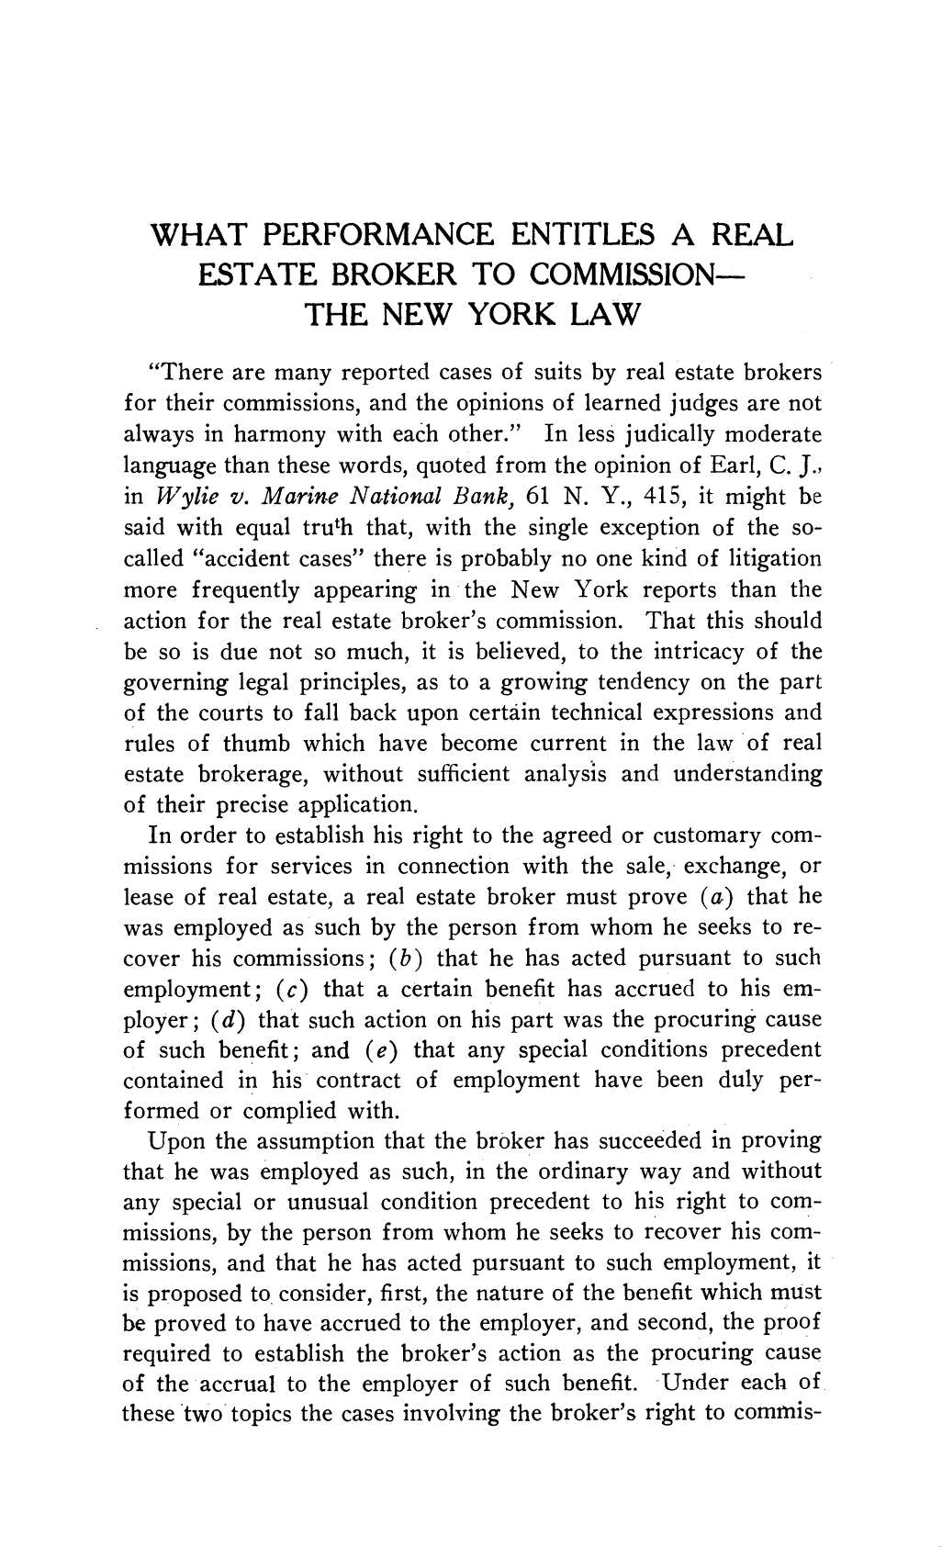

WHAT PERFORMANCE ENTITLES A REAL

ESTATE BROKER TO COMMISSION

THE NEW YORK LAW

"There are many reported cases of suits by real estate b for their commissions, and the opinions of learned judges

always in harmony with each other." In less judically m

language than these words, quoted from the opinion of Ea

in Wylie v. Marine National Bank, 61 N. Y., 415, it m

said with equal truth that, with the single exception of

called "accident cases" there is probably no one kind of li

more frequently appearing in the New York reports tha

action for the real estate broker's commission. That this should

be so is due not so much, it is believed, to the intricacy of the

governing legal principles, as to a growing tendency on the part of the courts to fall back upon certain technical expressions and

rules of thumb which have become current in the law of real

estate brokerage, without sufficient analysis and understanding

of their precise application.

In order to establish his right to the agreed or customary com-

missions for services in connection with the sale, exchange, or lease of real estate, a real estate broker must prove (a) that he

was employed as such by the person from whom he seeks to re-

cover his commissions; (b) that he has acted pursuant to such employment; (c) that a certain benefit has accrued to his em-

ployer; (d) that such action on his part was the procuring cause

of such benefit; and (e) that any special conditions precedent

contained in his contract of employment have been duly per-

formed or complied with.

Upon the assumption that the broker has succeeded in proving

that he was employed as such, in the ordinary way and without any special or unusual condition precedent to his right to com-

missions, by the person from whom he seeks to recover his com-missions, and that he has acted pursuant to such employment, it

is proposed to consider, first, the nature of the benefit which must

be proved to have accrued to the employer, and second, the proof

required to establish the broker's action as the procuring cause of the accrual to the employer of such benefit. Under each of

these two topics the cases involving the broker's right to commis-

This content downloaded from 111.93.31.52 on Mon, 05 Aug 2019 11:02:45 UTC
All use subject to https://about.jstor.org/terms

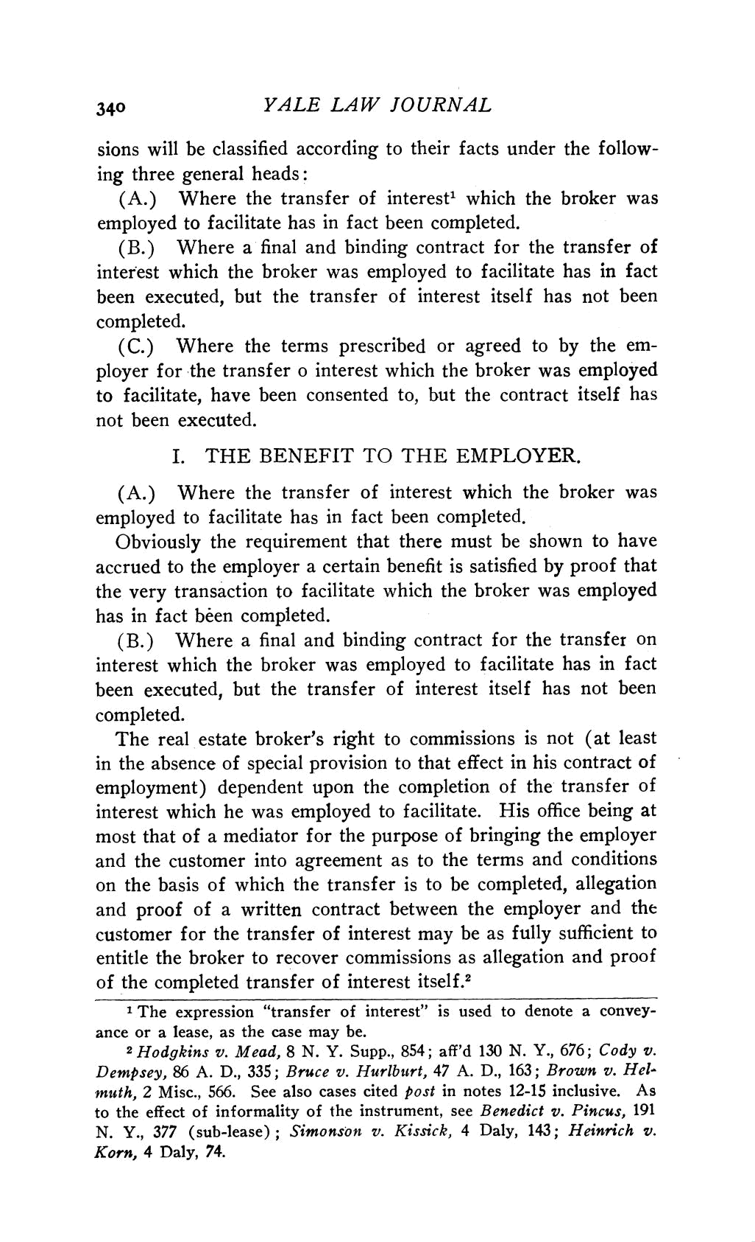
₃₄₀ YALE LAW JOURNAL

sions will be classified according to their facts under

ing three general heads:

(A.) Where the transfer of interest1 which the

employed to facilitate has in fact been completed.

(B.) Where a final and binding contract for the tra

interest which the broker was employed to facilitate

been executed, but the transfer of interest itself ha

completed.

(C.) Where the terms prescribed or agreed to by the em-

ployer for the transfer o interest which the broker was employed

to facilitate, have been consented to, but the contract itself has

not been executed.

I. THE BENEFIT TO THE EMPLOYER.

(A.) Where the transfer of interest which the b

employed to facilitate has in fact been completed.

Obviously the requirement that there must be show

accrued to the employer a certain benefit is satisfied by p

the very transaction to facilitate which the broker wa has in fact been completed.

(B.) Where a final and binding contract for the tra

interest which the broker was employed to facilitate

been executed, but the transfer of interest itself has

completed.

The real estate broker's right to commissions is not (at least

in the absence of special provision to that effect in his contract of

employment) dependent upon the completion of the transfer of interest which he was employed to facilitate. His office being at most that of a mediator for the purpose of bringing the employer and the customer into agreement as to the terms and conditions on the basis of which the transfer is to be completed, allegation

and proof of a written contract between the employer and the

customer for the transfer of interest may be as fully sufficient to

entitle the broker to recover commissions as allegation and proof

of the completed transfer of interest itself.2

1 The expression "transfer of interest" is used to denote a convey-

ance or a lease, as the case may be.

2Hodgkins v. Mead, 8 N. Y. Supp., 854; aff'd 130 N. Y., 676; Cody v. Dempsey, 86 A. D., 335; Bruce v. Hurlburt, 47 A. D., 163; Brown v. Hel-muth, 2 Misc., 566. See also cases cited post in notes 12-15 inclusive. As
to the effect of informality of the instrument, see Benedict v. Pincus, 191

N. Y., 377 (sub-lease); Simonson v. Kissick, 4 Daly, 143; Heinrich v.

Korn, 4 Daly, 74.

This content downloaded from 111.93.31.52 on Mon, 05 Aug 2019 11:02:45 UTC
All use subject to https://about.jstor.org/terms
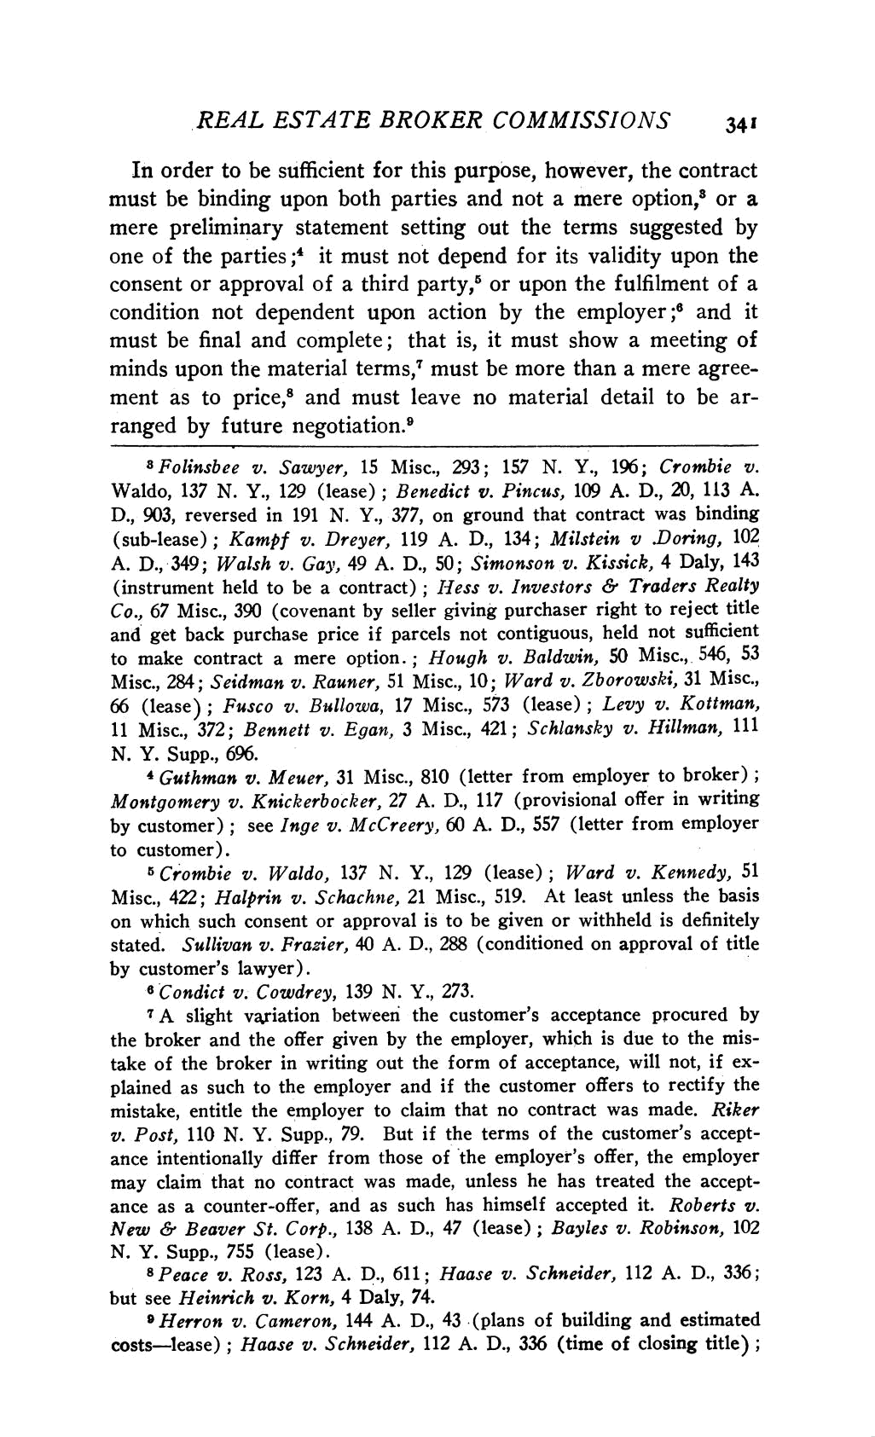
REAL ESTATE BROKER COMMISSIONS ₃₄₁

In order to be sufficient for this purpose, however, the

must be binding upon both parties and not a mere op

mere preliminary statement setting out the terms sug one of the parties ;4 it must not depend for its validity consent or approval of a third party,5 or upon the fulfi

condition not dependent upon action by the employer must be final and complete; that is, it must show a m

minds upon the material terms,7 must be more than a mer

ment as to price,8 and must leave no material detai

ranged by future negotiation.9

8Folinsbee v. Sawyer, 15 Misc., 293; 157 N. Y., 196; C

Waldo, 137 N. Y., 129 (lease); Benedict v. Pincus, 109 A. D.,

D., 903, reversed in 191 N. Y., 377, on ground that contract w

(sub-lease); Kampf v. Dreyer, 119 A. D., 134; Milstein v .Dor A. D., 349; Walsh v. Gay, 49 A. D., 50; Simonson v. Kissick, (instrument held to be a contract); Hess v. Investors & Tra

Co., 67 Misc., 390 (covenant by seller giving purchaser right to and get back purchase price if parcels not contiguous, held no

to make contract a mere option.; Hough v. Baldwin, 50 Mis

Misc., 284; Seidman v. Rauner, 51 Misc., 10; Ward v. Zborows

66 (lease); Fusco v. Bullowa, 17 Misc., 573 (lease); Levy v
11 Misc., 372; Bennett v. Egan, 3 Misc., 421; Schlansky v. H

N. Y. Supp., 696.

4 Guthman v. Meuer, 31 Misc., 810 (letter from employer

Montgomery v. Knickerbocker, 27 A. D., 117 (provisional offer

by customer); see Inge v. McCreery, 60 A. D., 557 (letter from

to customer).

5 Crombie v. Waldo, 137 N. Y., 129 (lease); Ward v. Ke

Misc., 422; Halprin v. Schachne, 21 Misc., 519. At least unle

on which such consent or approval is to be given or withheld is

stated. Sullivan v. Frazier, 40 A. D., 288 (conditioned on appro by customer's lawyer).

6 Condict v. Cowdrey, 139 N. Y., 273.

7A slight variation between the customer's acceptance pro

the broker and the offer given by the employer, which is due take of the broker in writing out the form of acceptance, will plained as such to the employer and if the customer offers to

mistake, entitle the employer to claim that no contract was v. Post, 110 N. Y. Supp., 79. But if the terms of the custome

ance intentionally differ from those of the employer's offer, t

may claim that no contract was made, unless he has treated ance as a counter-offer, and as such has himself accepted it.

New & Beaver St. Corp., 138 A. D., 47 (lease); Bayles v. Robi

N. Y. Supp., 755 (lease).

8 Peace v. Ross, 123 A. D., 611; Haase v. Schneider, 112 A

but see Heinrich v. Korn, 4 Daly, 74.

9 Herron v. Cameron, 144 A. D., 43 (plans of building and

costs-lease); Haase v. Schneider, 112 A. D., 336 (time of closi

This content downloaded from 111.93.31.52 on Mon, 05 Aug 2019 11:02:45 UTC
All use subject to https://about.jstor.org/terms
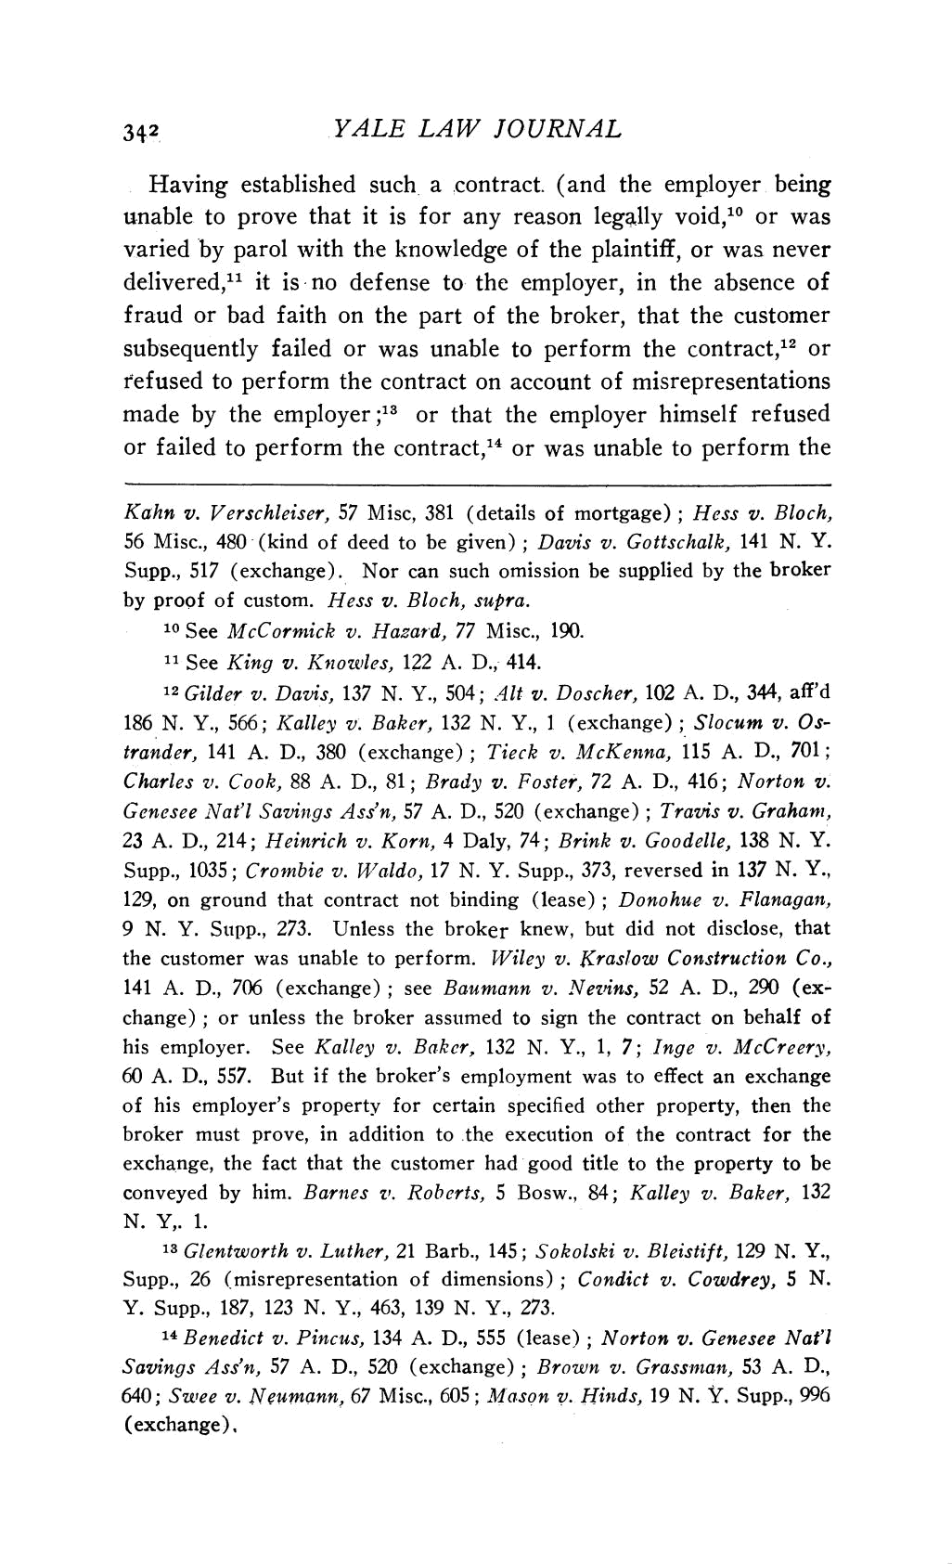
_{34?2} YALE LAW JOURNAL

Having established such a contract. (and the employer unable to prove that it is for any reason legally void,10

varied by parol with the knowledge of the plaintiff, or

delivered,1l it is no defense to the employer, in the ab

fraud or bad faith on the part of the broker, that the c

subsequently failed or was unable to perform the contr

refused to perform the contract on account of misrepres

made by the employer;13 or that the employer himself

or failed to perform the contract,14 or was unable to per

Kahn v. Verschleiser, 57 Misc, 381 (details of mortgage); Hess 56 Misc., 480 (kind of deed to be given); Davis v. Gottschalk,

Supp., 517 (exchange). Nor can such omission be supplied by th

by proof of custom. Hess v. Bloch, supra.

10 See McCormick v. Hazard, 77 Misc., 190.

11 See King v. Knowzles, 122 A. D., 414.

12 Gilder v. Davis, 137 N. Y., 504; 41t v. Doscher, 102 A. D.,

186 N. Y., 566; Kalley v. Baker, 132 N. Y., 1 (exchange); Slocu trander, 141 A. D., 380 (exchange); Tieck v. McKenna, 115 A. Charles v. Cook, 88 A. D., 81; Brady v. Foster, 72 A. D., 416;

Genesee Nat'l Savings Ass'n, 57 A. D., 520 (exchange); Travis v. 23 A. D., 214; Heinrich v. Korn, 4 Daly, 74; Brink v. Goodelle, Supp., 1035; Crombie v. Waldo, 17 N. Y. Supp., 373, reversed in

129, on ground that contract not binding (lease); Donohue v. Flanagan,

9 N. Y. Supp., 273. Unless the broker knew, but did not disclose, that the customer was unable to perform. Wiley v. Kraslow Construction Co.,

141 A. D., 706 (exchange); see Baumann v. Nevins, 52 A. D., 290 (ex-

change); or unless the broker assumed to sign the contract on behalf of

his employer. See Kalley v. Baker, 132 N. Y., 1, 7; Inge v. McCreery,

60 A. D., 557. But if the broker's employment was to effect an exchange

of his employer's property for certain specified other property, then the broker must prove, in addition to the execution of the contract for the exchange, the fact that the customer had good title to the property to be
conveyed by him. Barnes v. Roberts, 5 Bosw., 84; Kalley v. Baker, 132

N. Y,. 1.

13 Glentworth v. Luther, 21 Barb., 145; Sokolski v. Bleistift, 129 N. Y.,

Supp., 26 (misrepresentation of dimensions); Condict v. Cowdrey, 5 N.

Y. Supp., 187, 123 N. Y., 463, 139 N. Y., 273.

14 Benedict v. Pincus, 134 A. D., 555 (lease); Norton v. Genesee Nat'l

Savings Ass'n, 57 A. D., 520 (exchange); Brown v. Grassman, 53 A. D.,

640; Swee v. Neumann, 67 Misc., 605; Mason v. Hinds, 19 N. Y. Supp., 996

(exchange),

This content downloaded from 111.93.31.52 on Mon, 05 Aug 2019 11:02:45 UTC
All use subject to https://about.jstor.org/terms

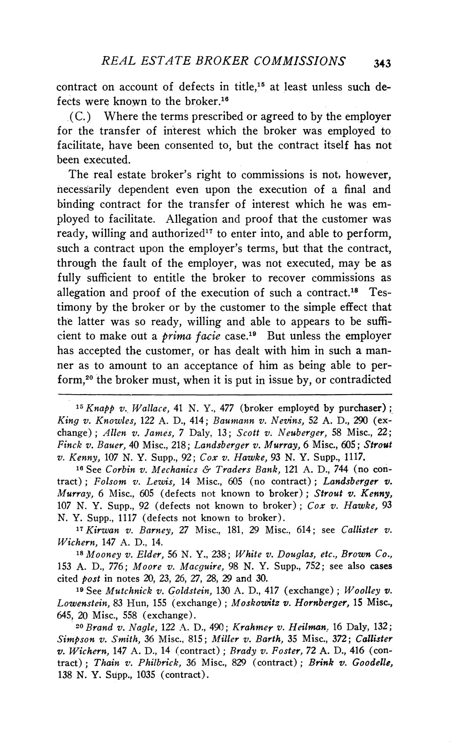
REAL ESTATE BROKER COMMISSIONS ₃₄₃

contract on account of defects in title,15 at least unless such de-

fects were known to the broker.16

(C.) Where the terms prescribed or agreed to by the employer

for the transfer of interest which the broker was employed to

facilitate, have been consented to, but the contract itself has not

been executed.

The real estate broker's right to commissions is not, however,

necessarily dependent even upon the execution of a final and

binding contract for the transfer of interest which he was em-

ployed to facilitate. Allegation and proof that the customer was

ready, willing and authorized17 to enter into, and able to perform,

such a contract upon the employer's terms, but that the contract, through the fault of the employer, was not executed, may be as fully sufficient to entitle the broker to recover commissions as

allegation and proof of the execution of such a contract.18 Tes-

timony by the broker or by the customer to the simple effect that

the latter was so ready, willing and able to appears to be suffi-cient to make out a prima facie case.l9 But unless the employer

has accepted the customer, or has dealt with him in such a man-

ner as to amount to an acceptance of him as being able to per-

form,20 the broker must, when it is put in issue by, or contradicted

15 Knapp v. Wallace, 41 N. Y., 477 (broker employed by purchaser) ;

King v. Knowles, 122 A. D., 414; Baumann v. Nevins, 52 A. D., 290 (ex-change); Allen v. James, 7 Daly, 13; Scott v. Neuberger, 58 Misc., 22;

Finck v. Bauer, 40 Misc., 218; Landsberger v. Murray, 6 Misc., 605; Strout v. Kenny, 107 N. Y. Supp., 92; Cox v. Hawke, 93 N. Y. Supp., 1117.

16 See Corbin v. Mechanics & Traders Bank, 121 A. D., 744 (no con-tract); Folsom v. Lewis, 14 Misc., 605 (no contract); Landsberger v.

Murray, 6 Misc., 605 (defects not known to broker); Strout v. Kenny, 107 N. Y. Supp., 92 (defects not known to broker); Cox v. Hawke, 93
N. Y. Supp., 1117 (defects not known to broker).

17 Kirwan v. Barney, 27 Misc., 181, 29 Misc., 614; see Callister v.

Wichern, 147 A. D., 14.

8 Mooney v. Elder, 56 N. Y., 238; White v. Douglas, etc., Brown Co.,

153 A. D., 776; Moore v. Macguire, 98 N. Y. Supp., 752; see also cases

cited post in notes 20, 23, 26, 27, 28, 29 and 30.

19 See Mutchnick v. Goldstein, 130 A. D., 417 (exchange); Woolley v. Lowenstein, 83 Hun, 155 (exchange); Moskowitz v. Hornberger, 15 Misc.,
645, 20 Misc., 558 (exchange).

o0 Brand v. Nagle, 122 A. D., 490; Krahmer v. Heilman. 16 Daly, 132; Simpson v. Smith, 36 Misc., 815; Miller v. Barth, 35 Misc., 372; Callister v. Wichern, 147 A. D., 14 (contract); Brady v. Foster, 72 A. D., 416 (con-
tract); Thain v. Philbrick, 36 Misc., 829 (contract); Brink v. Goodelle,

138 N. Y. Supp., 1035 (contract).

This content downloaded from 111.93.31.52 on Mon, 05 Aug 2019 11:02:45 UTC All use subject to https://about.jstor.org/terms

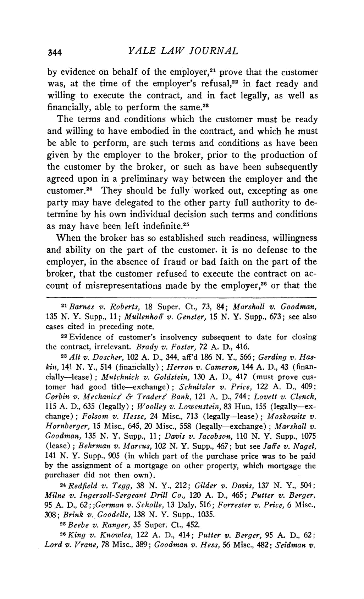
₃₄₄ YALE LAW JOURNAL

by evidence on behalf of the employer,21 prove that the

was, at the time of the employer's refusal,22 in fact re

willing to execute the contract, and in fact legally, a

financially, able to perform the same.28

The terms and conditions which the customer must be

and willing to have embodied in the contract, and which

be able to perform, are such terms and conditions as ha

given by the employer to the broker, prior to the produ

the customer by the broker, or such as have been subse

agreed upon in a preliminary way between the employer

customer.24 They should be fully worked out, excepting

party may have delegated to the other party full authori termine by his own individual decision such terms and co as may have been left indefinite.25

When the broker has so established such readiness, will

and ability on the part of the customer, it is no defens

employer, in the absence of fraud or bad faith on the par broker, that the customer refused to execute the contrac count of misrepresentations made by the employer,26 or

21 Barnes v. Roberts, 18 Super. Ct., 73, 84; Marshall v. Goo

135 N. Y. Supp., 11; Mullenhoff v. Genster, 15 N. Y. Supp., 673; cases cited in preceding note.

22Evidence of customer's insolvency subsequent to date for

the contract, irrelevant. Brady v. Foster, 72 A. D., 416.

23 Alt v. Doscher, 102 A. D., 344, aff'd 186 N. Y., 566; Gerdin

kin, 141 N. Y., 514 (financially); Herron v. Cameron, 144 A. D., 4 cially-lease); Mutchnick v. Goldstein, 130 A. D., 417 (must prove

tomer had good title-exchange); Schnitzler v. Price, 122 A. D., 409;

Corbin v. Mechanics' & Traders' Bank, 121 A. D., 744; Lovett v. Clench,

115 A. D., 635 (legally); Toolley v. Lowenstein, 83 Hun, 155 (legally-ex-change); Folsom v. Hesse, 24 Misc., 713 (legally-lease); Moskowitz v. Hornberger, 15 Misc., 645, 20 Misc., 558 (legally-exchange); Marshall v. Goodman, 135 N. Y. Supp., 11; Davis v. Jacobson, 110 N. Y. Supp., 1075

(lease); Behrman v. Marcus, 102 N. Y. Supp., 467; but see Jaffe v. Nagel, 141 N. Y. Supp., 905 (in which part of the purchase price was to be paid
by the assignment of a mortgage on other property, which mortgage the purchaser did not then own).

24Redfield v. Tegg, 38 N. Y., 212; Gilder v. Davis, 137 N. Y., 504;

Milne v. Ingersoll-Sergeant Drill Co., 120 A. D., 465; Putter v. Berger,

95 A. D., 62;;Gorman v. Scholle, 13 Daly, 516; Forrester v. Price, 6 Misc., 308; Brink v. Goodelle, 138 N. Y. Supp., 1035.

25 Beebe v. Ranger, 35 Super. Ct., 452.

26King v. Knowles, 122 A. D., 414; Putter v. Berger, 95 A. D., 62; Lord v. Vrane, 78 Misc., 389; Goodman v. Hess, 56 Misc., 482; Seidman v.

This content downloaded from 111.93.31.52 on Mon, 05 Aug 2019 11:02:45 UTC
All use subject to https://about.jstor.org/terms

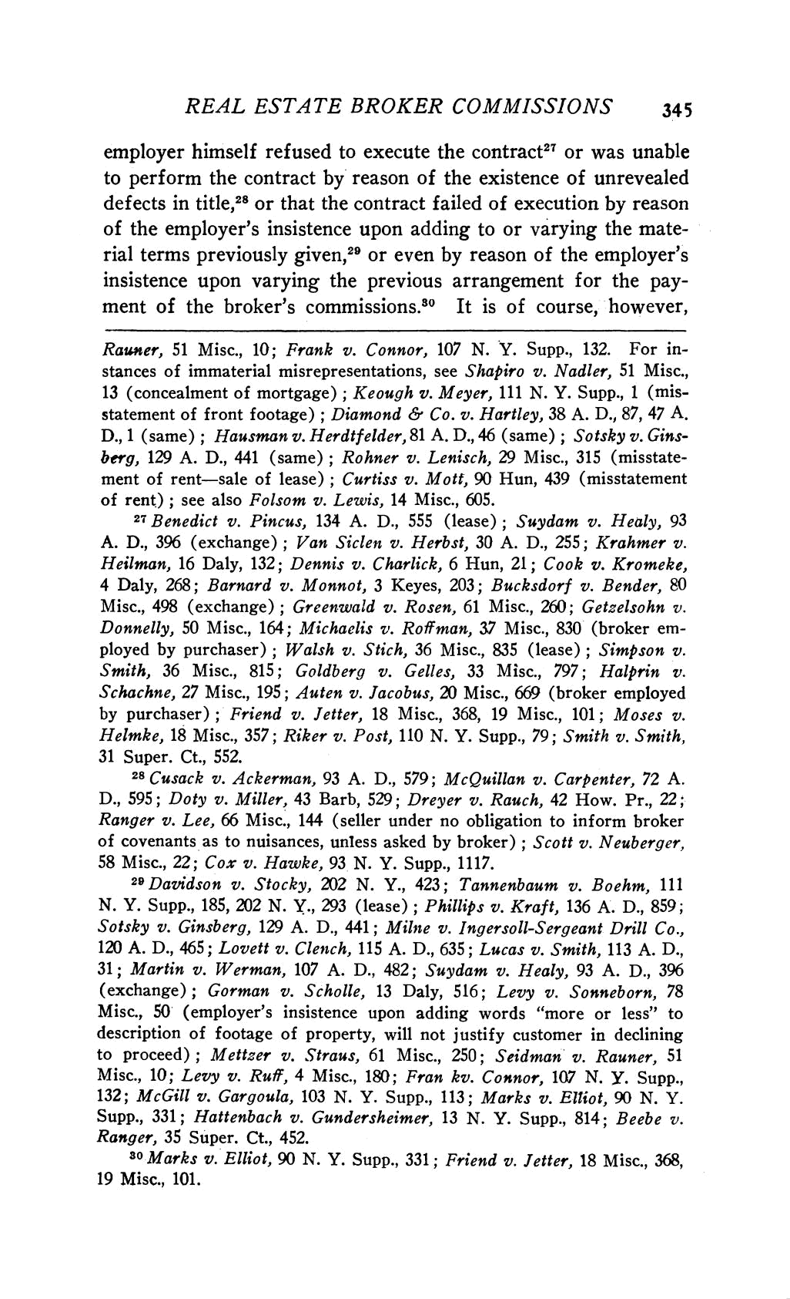
REAL ESTATE BROKER COMMISSIONS ₃₄₅

employer himself refused to execute the contract27 or to perform the contract by reason of the existence of

defects in title,28 or that the contract failed of execution

of the employer's insistence upon adding to or varying

rial terms previously given,29 or even by reason of the em

insistence upon varying the previous arrangement fo

ment of the broker's commissions.80 It is of course, however,

Rauner, 51 Misc., 10; Frank v. Connor, 107 N. Y. Supp., 132. For in-

stances of immaterial misrepresentations, see Shapiro v. Nadler, 51 Misc., 13 (concealment of mortgage); Keough v. Meyer, 111 N. Y. Supp., 1 (mis-

statement of front footage); Diamond & Co. v. Hartley, 38 A. D., 87, 47 A.

D., 1 (same); Hausman v. Herdtfelder, 81 A. D., 46 (same); Sotsky v. Gins-

berg, 129 A. D., 441 (same); Rohner v. Lenisch, 29 Misc., 315 (misstate-

ment of rent-sale of lease); Curtiss v. Mott, 90 Hun, 439 (misstatement of rent); see also Folsom v. Lewis, 14 Misc., 605.

27 Benedict v. Pincus, 134 A. D., 555 (lease); Suydam v. Healy, 93 A. D., 396 (exchange); Van Siclen v. Herbst, 30 A. D., 255; Krahmer v.

Heilman, 16 Daly, 132; Dennis v. Charlick, 6 Hun, 21; Cook v. Kromeke,

4 Daly, 268; Barnard v. Monnot, 3 Keyes, 203; Bucksdorf v. Bender, 80 Misc., 498 (exchange); Greenwald v. Rosen, 61 Misc., 260; Getzelsohn v.

Donnelly, 50 Misc., 164; Michaelis v. Roffman, 37 Misc., 830 (broker em-

ployed by purchaser); Walsh v. Stich, 36 Misc., 835 (lease); Simpson v.

Smith, 36 Misc., 815; Goldberg v. Gelles, 33 Misc., 797; Halprin v.

Schachne, 27 Misc., 195; Auten v. Jacobus, 20 Misc., 669 (broker employed

by purchaser); Friend v. Jetter, 18 Misc., 368, 19 Misc., 101; Moses v.

Helmke, 18 Misc., 357; Riker v. Post, 110 N. Y. Supp., 79; Smith v. Smith,

31 Super. Ct., 552.

28 Cusack v. Ackerman, 93 A. D., 579; McQuillan v. Carpenter, 72 A. D., 595; Doty v. Miller, 43 Barb, 529; Dreyer v. Rauch, 42 How. Pr., 22; Ranger v. Lee, 66 Misc., 144 (seller under no obligation to inform broker of covenants as to nuisances, unless asked by broker); Scott v. Neuberger, 58 Misc., 22; Cox v. Hawke, 93 N. Y. Supp., 1117.

29Davidson v. Stocky, 202 N. Y., 423; Tannenbaum v. Boehm, 111

N. Y. Supp., 185, 202 N. Y., 293 (lease); Phillips v. Kraft, 136 A. D., 859; Sotsky v. Ginsberg, 129 A. D., 441; Milne v. Ingersoll-Sergeant Drill Co., 120 A. D., 465; Lovett v. Clench, 115 A. D., 635; Lucas v. Smith, 113 A. D.,

31; Martin v. Werman, 107 A. D., 482; Suydam v. Healy, 93 A. D., 396

(exchange); Gorman v. Scholle, 13 Daly, 516; Levy v. Sonneborn, 78

Misc., 50 (employer's insistence upon adding words "more or less" to

description of footage of property, will not justify customer in declining

to proceed); Mettzer v. Straus, 61 Misc., 250; Seidman v. Rauner, 51

Misc., 10; Levy v. Ruff, 4 Misc., 180; Fran kv. Connor, 107 N. Y. Supp.,

132; McGill v. Gargoula, 103 N. Y. Supp., 113; Marks v. Elliot, 90 N. Y.

Supp., 331; Hattenbach v. Gundersheimer, 13 N. Y. Supp., 814; Beebe v.
Ranger, 35 Super. Ct., 452.

80Marks v. Elliot, 90 N. Y. Supp., 331; Friend v. letter, 18 Misc., 368,
19 Misc., 101.

This content downloaded from 111.93.31.52 on Mon, 05 Aug 2019 11:02:45 UTC
All use subject to https://about.jstor.org/terms

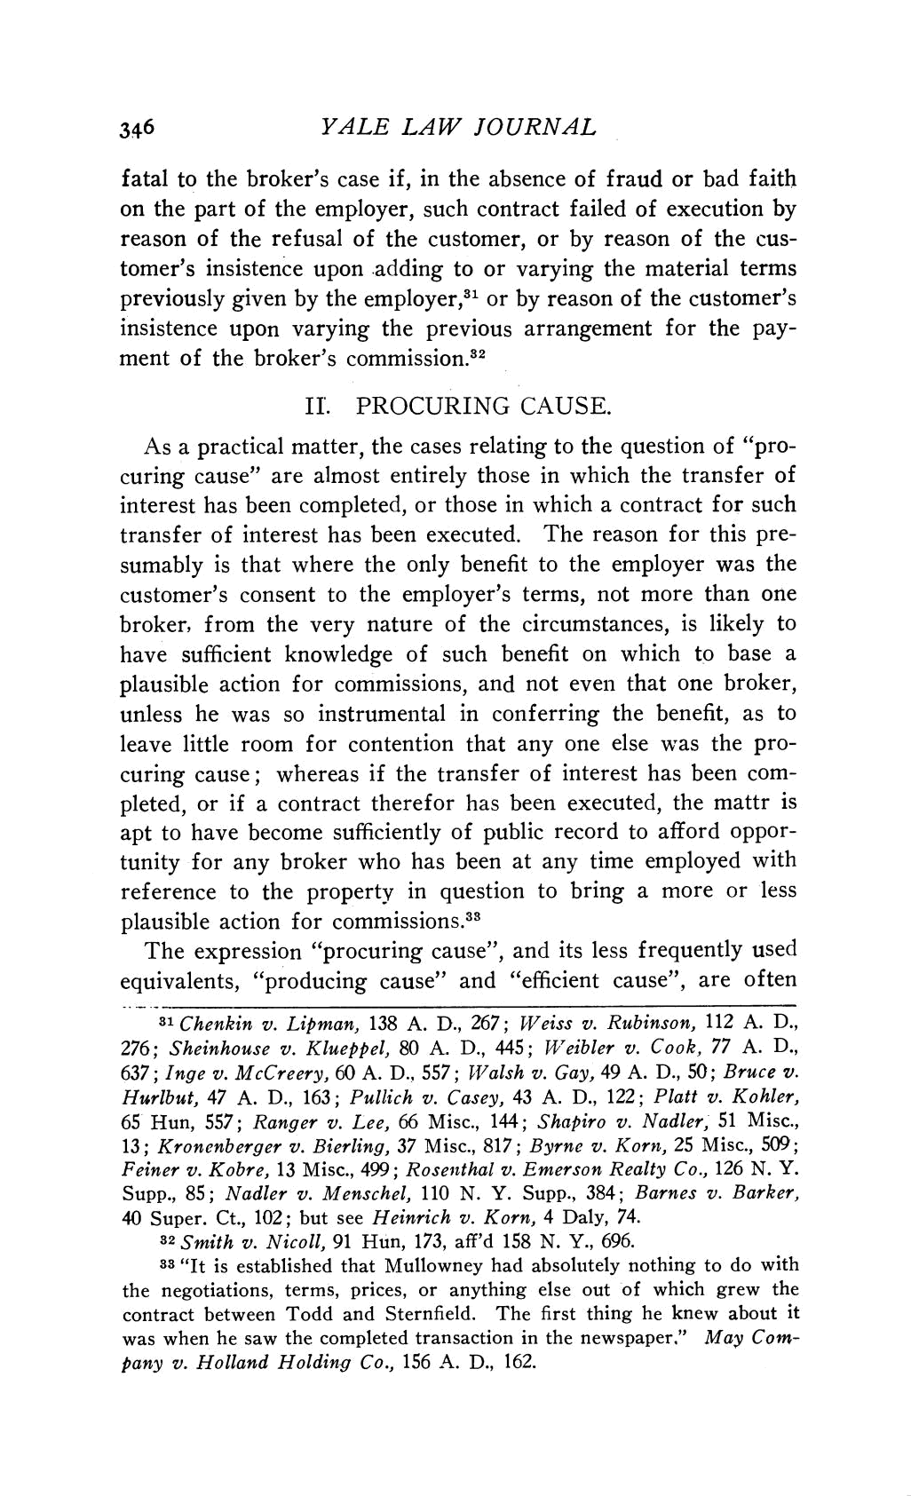
346 YALE LAW JOURNAL

fatal to the broker's case if, in the absence of fraud o on the part of the employer, such contract failed of e

reason of the refusal of the customer, or by reason

tomer's insistence upon adding to or varying the mate

previously given by the employer,31 or by reason of the

insistence upon varying the previous arrangement fo

ment of the broker's commission.82

II. PROCURING CAUSE.

As a practical matter, the cases relating to the que curing cause" are almost entirely those in which th interest has been completed, or those in which a con

transfer of interest has been executed. The reason

sumably is that where the only benefit to the emp

customer's consent to the employer's terms, not m broker, from the very nature of the circumstanc have sufficient knowledge of such benefit on whi plausible action for commissions, and not even tha unless he was so instrumental in conferring the b leave little room for contention that any one else curing cause; whereas if the transfer of interest h

pleted, or if a contract therefor has been executed, apt to have become sufficiently of public record to tunity for any broker who has been at any time em

reference to the property in question to bring a m

plausible action for commissions.33

The expression "procuring cause", and its less fre equivalents, "producing cause" and "efficient cause

31 Chenkin v. Lipman, 138 A. D., 267; Weiss v. Rubins

276; Sheinhouse v. Klueppel, 80 A. D., 445; Weibler v. Co

637; Inge v. McCreery, 60 A. D., 557; Walsh v. Gay, 49 A.

Hurlbut, 47 A. D., 163; Pullich v. Casey, 43 A. D., 122; P 65 Hun, 557; Ranger v. Lee, 66 Misc., 144; Shapiro v. Na

13; Kronenberger v. Bierling, 37 Misc., 817; Byrne v. Kor Feiner v. Kobre, 13 Misc., 499; Rosenthal v. Emerson Realt Supp., 85; Nadler v. Menschel, 110 N. Y. Supp., 384; Barn 40 Super. Ct., 102; but see Heinrich v. Korn, 4 Daly, 74.

32 Smith v. Nicoll, 91 Hun, 173, aff'd 158 N. Y., 696.

33 "It is established that Mullowney had absolutely noth

the negotiations, terms, prices, or anything else out of contract between Todd and Sternfield. The first thing h

was when he saw the completed transaction in the newspa

pany v. Holland Holding Co., 156 A. D., 162.

This content downloaded from 111.93.31.52 on Mon, 05 Aug 2019 11:02:45 UTC
All use subject to https://about.jstor.org/terms

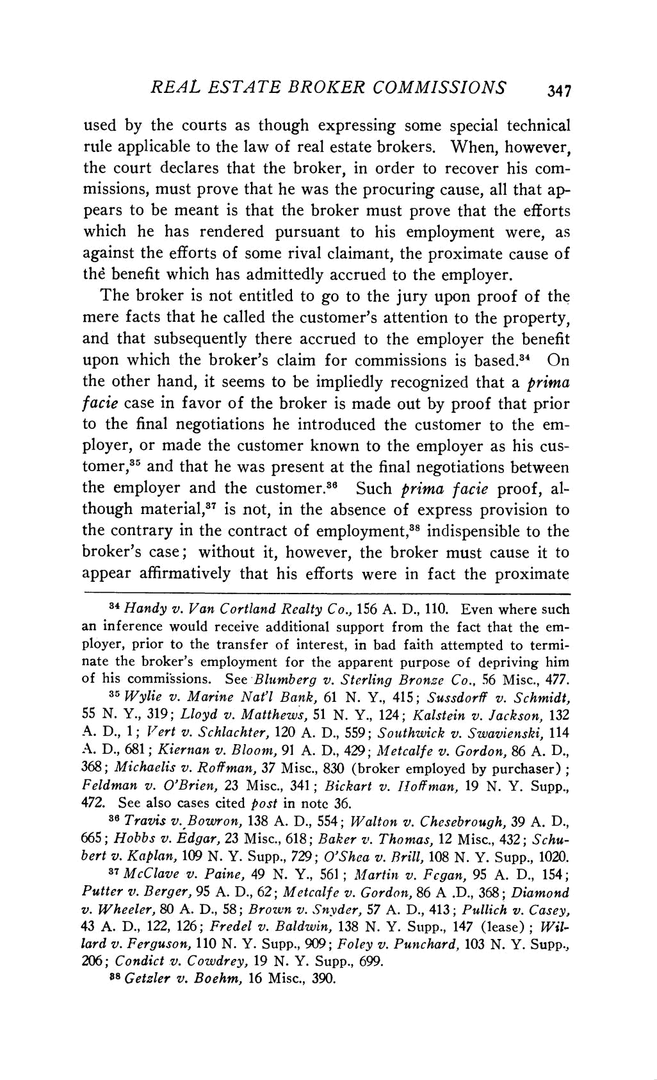
REAL ESTATE BROKER COMMISSIONS ₃₄₇

used by the courts as though expressing some special t

rule applicable to the law of real estate brokers. When, the court declares that the broker, in order to recover h missions, must prove that he was the procuring cause, al pears to be meant is that the broker must prove that th

which he has rendered pursuant to his employment

against the efforts of some rival claimant, the proximate

thd benefit which has admittedly accrued to the employer.

The broker is not entitled to go to the jury upon proo

mere facts that he called the customer's attention to the pro

and that subsequently there accrued to the employer the

upon which the broker's claim for commissions is based

the other hand, it seems to be impliedly recognized that facie case in favor of the broker is made out by proof t to the final negotiations he introduced the customer to ployer, or made the customer known to the employer as

tomer,35 and that he was present at the final negotiations b

the employer and the customer.3 Such prima facie p

though material,37 is not, in the absence of express pro

the contrary in the contract of employment,38 indispensibl

broker's case; without it, however, the broker must cau

appear affirmatively that his efforts were in fact the p

34 Handy v. Van Cortland Realty Co., 156 A. D., 110. Even w

an inference would receive additional support from the fact th ployer, prior to the transfer of interest, in bad faith attempted nate the broker's employment for the apparent purpose of depri

of his commissions. See Blumberg v. Sterling Bronze Co., 56 M 35 Wylie v. Marine Nat'l Bank, 61 N. Y., 415; Sussdorff v. S
55 N. Y., 319; Lloyd v. Matthews, 51 N. Y., 124; Kalstein v. Jac A. D., 1; Vert v. Schlachter, 120 A. D., 559; Soztthwick v. Swavi A. D., 681; Kiernan v. Bloom, 91 A. D., 429; Mletcalfe v. Gordon 368; Michaelis v. Roffman, 37 Misc., 830 (broker employed by p Feldman v. O'Brien, 23 Misc., 341; Bickart v. IToffman, 19 N.

472. See also cases cited post in note 36.

36 Travis v. Bowron, 138 A. D., 554; Walton v. Chesebrough, 665; Hobbs v. Edgar, 23 Misc., 618; Baker v. Thomas, 12 Misc., 4 bert v. Kaplan, 109 N. Y. Supp., 729; O'Shea v. Brill, 108 N. Y. Su
37 McClave v. Paine, 49 N. Y., 561; Martin v. Fcgan, 95 A.

Putter v. Berger, 95 A. D., 62; Metcalfe v. Gordon, 86 A .D., 368 v. Wheeler, 80 A. D., 58; Brown v. Snyder, 57 A. D., 413; Pullich
43 A. D., 122, 126; Fredel v. Baldwin, 138 N. Y. Supp., 147 (lea

lard v. Ferguson, 110 N. Y. Supp., 909; Foley v. Punchard, 103 N 206; Condict v. Cowdrey, 19 N. Y. Supp., 699.
88 Getzler v. Boehm, 16 Misc., 390.

This content downloaded from 111.93.31.52 on Mon, 05 Aug 2019 11:02:45 UTC
All use subject to https://about.jstor.org/terms

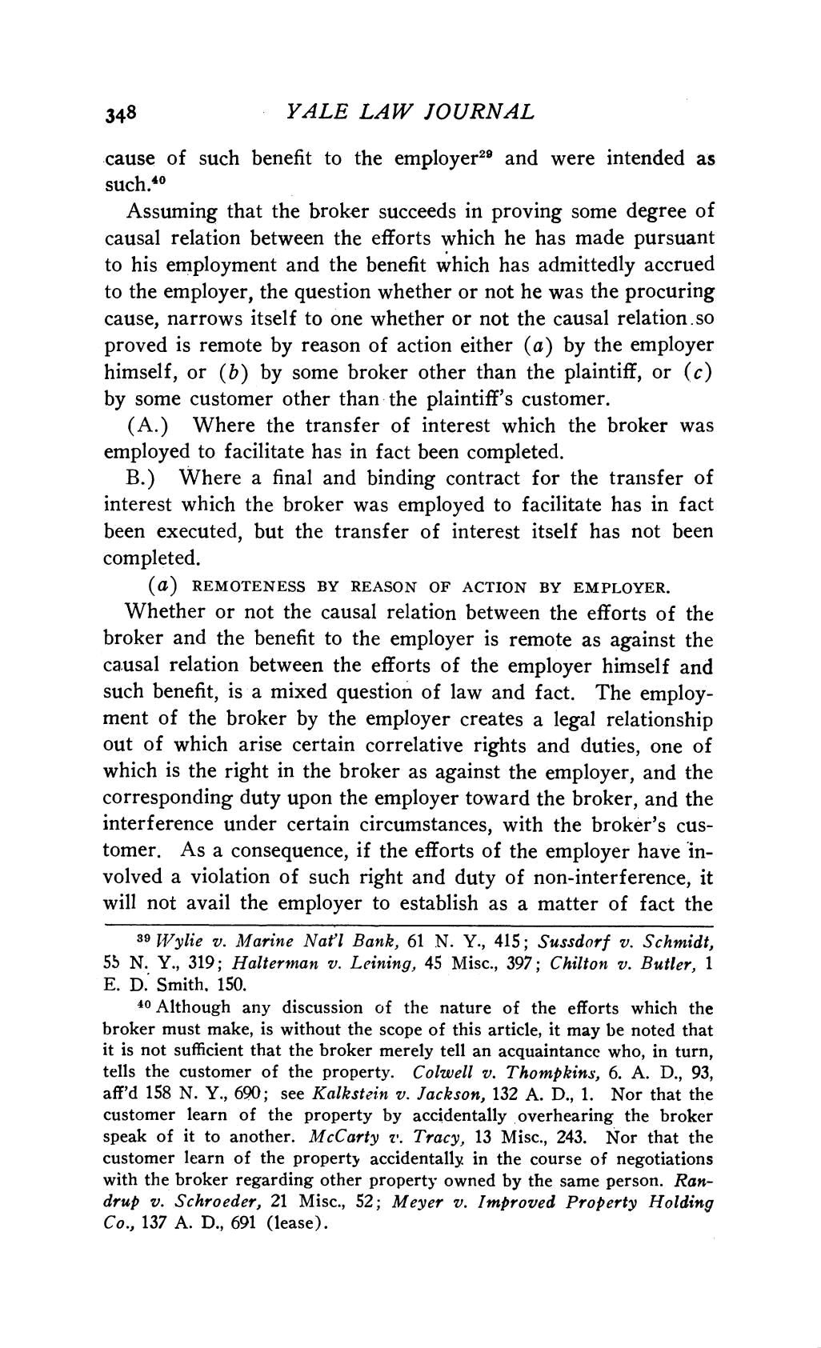
₃₄₈ YALE LAW JOURNAL

cause of such benefit to the employer29 and were int

such.40

Assuming that the broker succeeds in proving some

causal relation between the efforts which he has mad

to his employment and the benefit which has admitte

to the employer, the question whether or not he was the

cause, narrows itself to one whether or not the causal

proved is remote by reason of action either (a) by th himself, or (b) by some broker other than the plaint

by some customer other than the plaintiff's customer.

(A.) Where the transfer of interest which the br

employed to facilitate has in fact been completed.

B.) Where a final and binding contract for the tr

interest which the broker was employed to facilitate h

been executed, but the transfer of interest itself has

completed.

- REMOTENESS BY REASON OF ACTION BY EMPLOYER. Whether or not the causal relation between the efforts of the

broker and the benefit to the employer is remote as against the causal relation between the efforts of the employer himself and
such benefit, is a mixed question of law and fact. The employ-ment of the broker by the employer creates a legal relationship out of which arise certain correlative rights and duties, one of

which is the right in the broker as against the employer, and the

corresponding duty upon the employer toward the broker, and the

interference under certain circumstances, with the broker's cus-tomer. As a consequence, if the efforts of the employer have in-volved a violation of such right and duty of non-interference, it
will not avail the employer to establish as a matter of fact the

39 Wylie v. Marine Nat'l Bank, 61 N. Y., 415; Sussdorf v. Schmidt,

55 N. Y., 319; Halterman v. Leining, 45 Misc., 397; Chilton v. Butler, 1

E. D. Smith. 150.

40 Although any discussion of the nature of the efforts which the

broker must make, is without the scope of this article, it may be noted that it is not sufficient that the broker merely tell an acquaintance who, in turn,
tells the customer of the property. Colwell v. Thompkins, 6. A. D., 93, aff'd 158 N. Y., 690; see Kalkstein v. Jackson, 132 A. D., 1. Nor that the customer learn of the property by accidentally overhearing the broker

speak of it to another. McCarty v. Tracy, 13 Misc., 243. Nor that the

customer learn of the property accidentally in the course of negotiations

with the broker regarding other property owned by the same person. Ran-

drup v. Schroeder, 21 Misc., 52; Meyer v. Improved Property Holding

Co., 137 A. D., 691 (lease).

This content downloaded from 111.93.31.52 on Mon, 05 Aug 2019 11:02:45 UTC
All use subject to https://about.jstor.org/terms

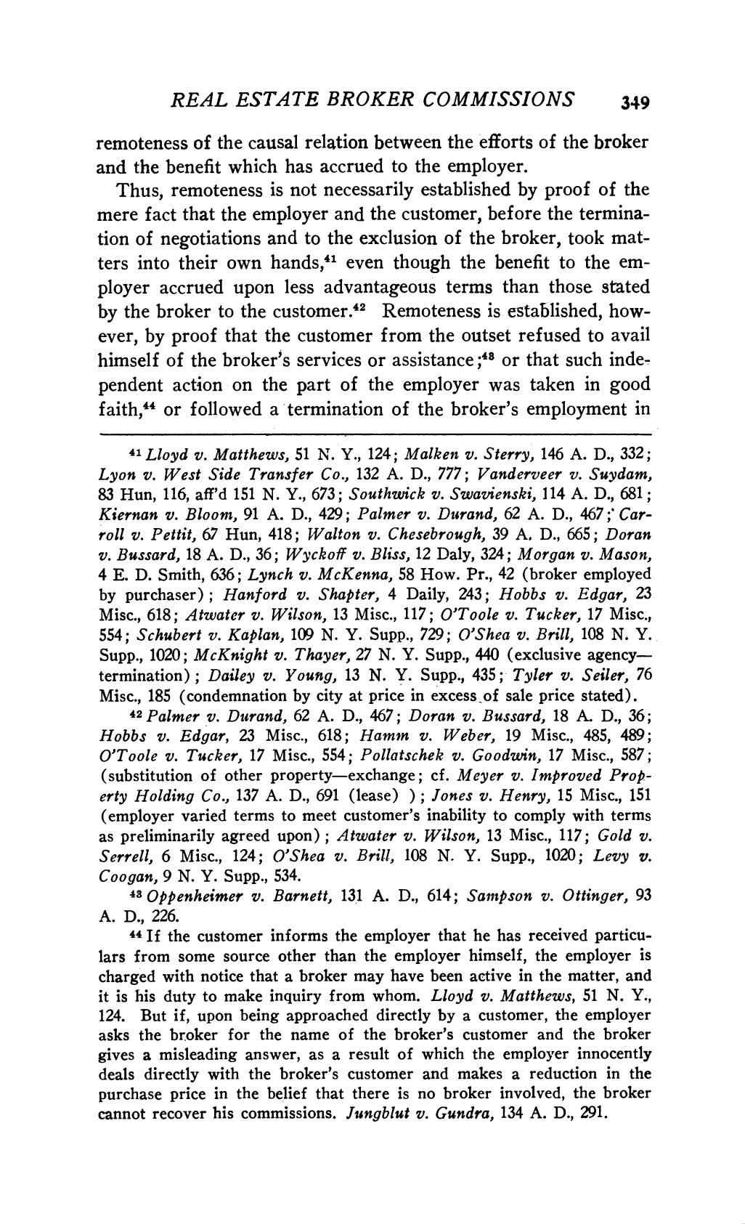
REAL ESTATE BROKER COMMISSIONS 349

remoteness of the causal relation between the efforts of th

and the benefit which has accrued to the employer. Thus, remoteness is not necessarily established by pro

mere fact that the employer and the customer, before the

tion of negotiations and to the exclusion of the broker, ters into their own hands,41 even though the benefit t

ployer accrued upon less advantageous terms than thos

by the broker to the customer.42 Remoteness is establis ever, by proof that the customer from the outset refus
himself of the broker's services or assistance ;48 or that suc

pendent action on the part of the employer was taken

faith,44 or followed a termination of the broker's emplo

41 Lloyd v. Matthews, 51 N. Y., 124; Malken v. Sterry, 146

Lyon v. West Side Transfer Co., 132 A. D., 777; Vanderveer

83 Hun, 116, aff'd 151 N. Y., 673; Southwick v. Swavienski, 114

Kiernan v. Bloom, 91 A. D., 429; Palmer v. Durand, 62 A. D.,

roll v. Pettit, 67 Hun, 418; Walton v. Chesebrough, 39 A. D., 6 v. Bussard, 18 A. D., 36; Wyckoff v. Bliss, 12 Daly, 324; Morgan 4 E. D. Smith, 636; Lynch v. McKenna, 58 How. Pr., 42 (broker

by purchaser); Hanford v. Shapter, 4 Daily, 243; Hobbs v.

Misc., 618; Atwater v. Wilson, 13 Misc., 117; O'Toole v. Tucker

554; Schubert v. Kaplan, 109 N. Y. Supp., 729; O'Shea v. Brill

Supp., 1020; McKnight v. Thayer, 27 N. Y. Supp., 440 (exclusiv

termination); Dailey v. Young, 13 N. Y. Supp., 435; Tyler v. S

Misc., 185 (condemnation by city at price in excess of sale pric 42Palmer v. Durand, 62 A. D., 467; Doran v. Bussard, 18 A.

Hobbs v. Edgar, 23 Misc., 618; Hammn v. Weber, 19 Misc., 485, 489;

O'Toole v. Tucker, 17 Misc., 554; Pollatschek v. Goodwin, 17 Misc., 587;

(substitution of other property-exchange; cf. Meyer v. Improved Prop-erty Holding Co., 137 A. D., 691 (lease) ); Jones v. Henry, 15 Misc., 151

(employer varied terms to meet customer's inability to comply with terms

as preliminarily agreed upon); Atwater v. Wilson, 13 Misc., 117; Gold v.

Serrell, 6 Misc., 124; O'Shea v. Brill, 108 N. Y. Supp., 1020; Levy v.

Coogan, 9 N. Y. Supp., 534.

43 Oppenheimer v. Barnett, 131 A. D., 614; Sampson v. Ottinger, 93

A. D., 226.

44 If the customer informs the employer that he has received particu-

lars from some source other than the employer himself, the employer is

charged with notice that a broker may have been active in the matter, and

it is his duty to make inquiry from whom. Lloyd v. Matthews, 51 N. Y.,

- But if, upon being approached directly by a customer, the employer asks the broker for the name of the broker's customer and the broker gives a misleading answer, as a result of which the employer innocently deals directly with the broker's customer and makes a reduction in the purchase price in the belief that there is no broker involved, the broker cannot recover his commissions. Jungblut v. Gundra, 134 A. D., 291.

This content downloaded from 111.93.31.52 on Mon, 05 Aug 2019 11:02:45 UTC
All use subject to https://about.jstor.org/terms

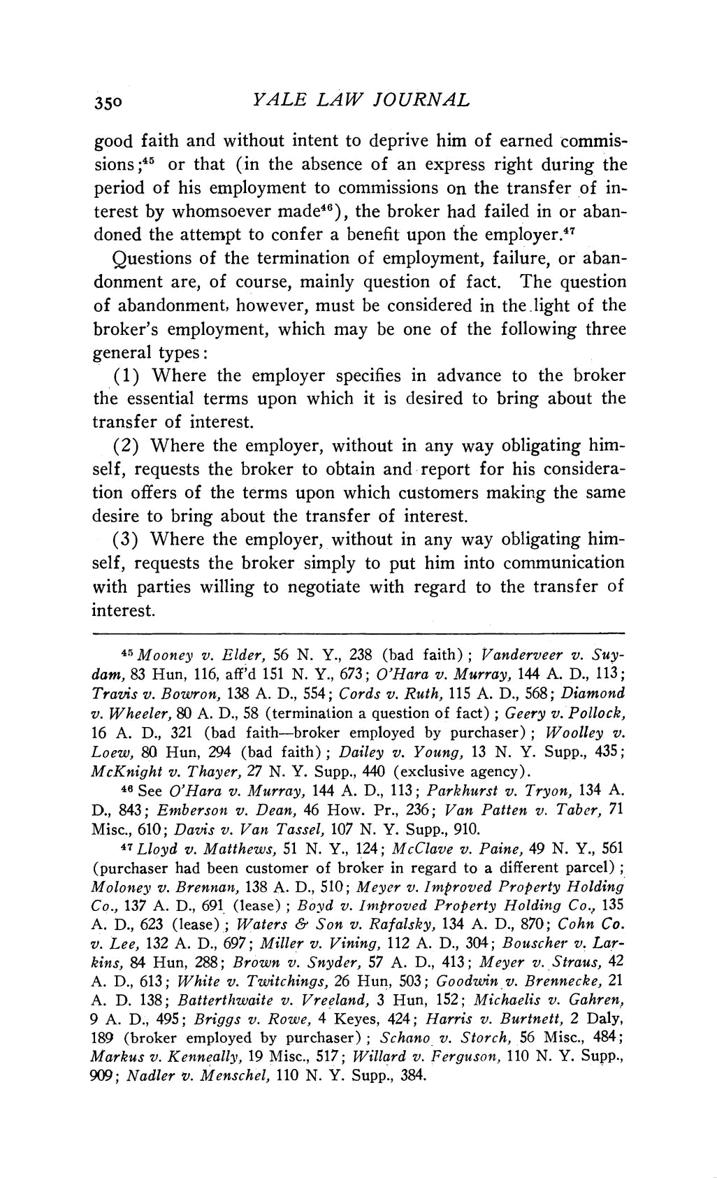
₃₅₀ YALE LAW JOURNAL

good faith and without intent to deprive him of earn

sions;45 or that (in the absence of an express right d

period of his employment to commissions on the tran terest by whomsoever made46), the broker had failed

doned the attempt to confer a benefit upon the employer

Questions of the termination of employment, failur

donment are, of course, mainly question of fact. The

of abandonment, however, must be considered in the l

broker's employment, which may be one of the follo

general types:

- Where the employer specifies in advance to t the essential terms upon which it is desired to bring

transfer of interest.

  - Where the employer, without in any way obligating him-self, requests the broker to obtain and report for his considera-tion offers of the terms upon which customers making the same desire to bring about the transfer of interest.

- Where the employer, without in any way obligating him-self, requests the broker simply to put him into communication with parties willing to negotiate with regard to the transfer of

interest.

45Mooney v. Elder, 56 N. Y., 238 (bad faith); Vanderveer v. Suy-

dam, 83 Hun, 116, aff'd 151 N. Y., 673; O'Hara v. Murray, 144 A. D., 113; Travis v. Bowron, 138 A. D., 554; Cords v. Ruth, 115 A. D., 568; Diamond
v. Wheeler, 80 A. D., 58 (termination a question of fact); Geery v. Pollock,

16 A. D., 321 (bad faith-broker employed by purchaser); Woolley v.

Loew, 80 Hun, 294 (bad faith); Dailey v. Young, 13 N. Y. Supp., 435;

McKnight v. Thayer, 27 N. Y. Supp., 440 (exclusive agency).

46 See O'Hara v. Murray, 144 A. D., 113; Parkhurst v. Tryon, 134 A.

D., 843; Emberson v. Dean, 46 How. Pr., 236; Van Patten v. Taber, 71 Misc., 610; Davis v. Van Tassel, 107 N. Y. Supp., 910.
47 Lloyd v. Matthews, 51 N. Y., 124; McClave v. Paine, 49 N. Y., 561 (purchaser had been customer of broker in regard to a different parcel); Moloney v. Brennan, 138 A. D., 510; Meyer v. Improved Property Holding

Co., 137 A. D., 691 (lease); Boyd v. Improved Property Holding Co., 135 A. D., 623 (lease); Waters & Son v. Rafalsky, 134 A. D., 870; Cohn Co.

v. Lee, 132 A. D., 697; Miller v. Vining, 112 A. D., 304; Bouscher v. Lar-

kins, 84 Hun, 288; Brown v. Snyder, 57 A. D., 413; Meyer v. Straus, 42

A. D., 613; White v. Twitchings, 26 Hun, 503; Goodwin v. Brennecke, 21 A. D. 138; Batterthwaite v. Vreeland, 3 Hun, 152; Michaelis v. Gahren,
9 A. D., 495; Briggs v. Rowe, 4 Keyes, 424; Harris v. Burtnett, 2 Daly,

189 (broker employed by purchaser); Schano v. Storch, 56 Misc., 484;

Markus v. Kenneally, 19 Misc., 517; Willard v. Ferguson, 110 N. Y. Supp., 909; Nadler v. Menschel, 110 N. Y. Supp., 384.

This content downloaded from 111.93.31.52 on Mon, 05 Aug 2019 11:02:45 UTC
All use subject to https://about.jstor.org/terms

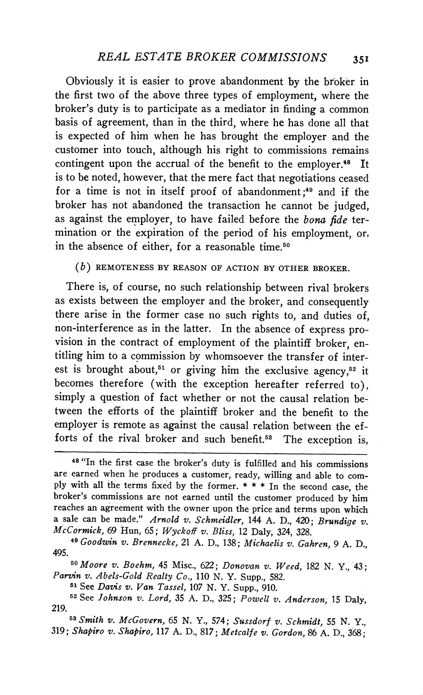
REAL ESTATE BROKER COMMISSIONS ₃₅₁

Obviously it is easier to prove abandonment by the brok

the first two of the above three types of employment, wher broker's duty is to participate as a mediator in finding a com basis of agreement, than in the third, where he has done al

is expected of him when he has brought the employer and

customer into touch, although his right to commissions rem contingent upon the accrual of the benefit to the employer
is to be noted, however, that the mere fact that negotiations ce

for a time is not in itself proof of abandonment;49 and if broker has not abandoned the transaction he cannot be jud
as against the employer, to have failed before the bona fide mination or the expiration of the period of his employment in the absence of either, for a reasonable time.50

(b) REMOTENESS BY REASON OF ACTION BY OTHER BROKER

There is, of course, no such relationship between rival bro as exists between the employer and the broker, and consequ
there arise in the former case no such rights to, and dutie

non-interference as in the latter. In the absence of express vision in the contract of employment of the plaintiff broke

titling him to a commission by whomsoever the transfer of int

est is brought about,5' or giving him the exclusive agency,

becomes therefore (with the exception hereafter referred simply a question of fact whether or not the causal relatio

tween the efforts of the plaintiff broker and the benefit t employer is remote as against the causal relation between th
forts of the rival broker and such benefit.53 The exceptio

48 "In the first case the broker's duty is fulfilled and his commis

are earned when he produces a customer, ready, willing and able to ply with all the terms fixed by the former. * * * In the second cas broker's commissions are not earned until the customer produced b

reaches an agreement with the owner upon the price and terms upon

a sale can be made." Arnold v. Schmeidler, 144 A. D., 420; Brundi

McCormick, 69 Hun, 65; Wyckoff v. Bliss, 12 Daly, 324, 328.

49 Goodwin v. Brennecke, 21 A. D., 138; Michaelis v. Gahren, 9 A
495.

50 Moore v. Boehm, 45 Misc., 622; Donovan v. Weed, 182 N. Y., 43;

Parvin v. Abels-Gold Realty Co., 110 N. Y. Supp., 582.

61 See Davis v. Van Tassel, 107 N. Y. Supp., 910.

52 See Johnson v. Lord, 35 A. D., 325; Powell v. Anderson, 15 Daly,
219.

53Smith v. McGovern, 65 N. Y., 574; Sussdorf v. Schmidt, 55 N. Y., 319; Shapiro v. Shapiro, 117 A. D., 817; Metcalfe v. Gordon, 86 A. D., 368;

This content downloaded from 111.93.31.52 on Mon, 05 Aug 2019 11:02:45 UTC
All use subject to https://about.jstor.org/terms

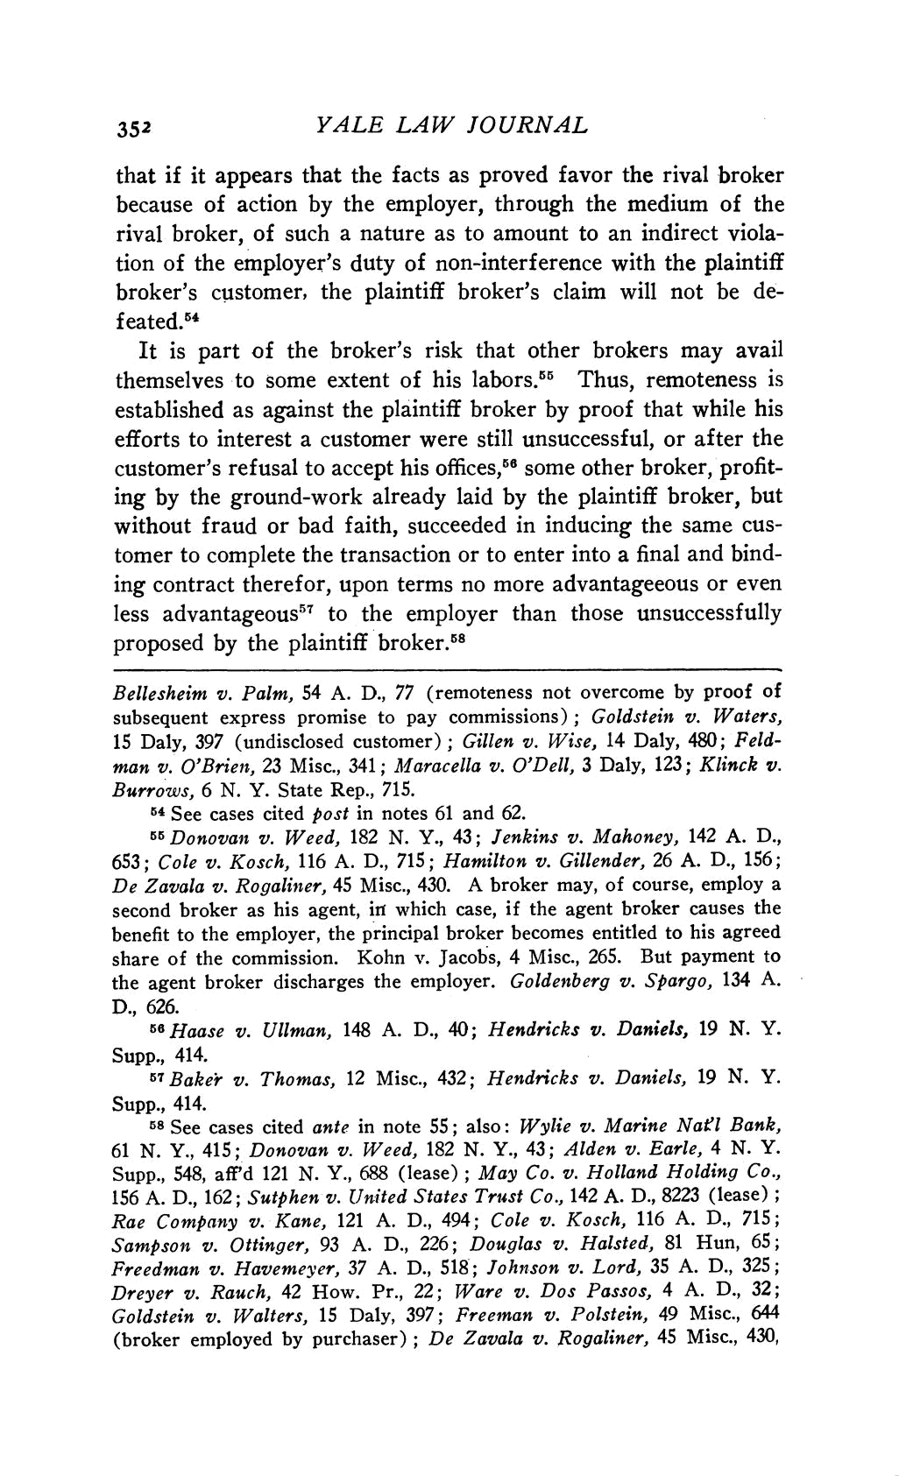
₃₅₂ YALE LAW JOURNAL

that if it appears that the facts as proved favor the

because of action by the employer, through the me rival broker, of such a nature as to amount to an in

tion of the employer's duty of non-interference with th

broker's customer, the plaintiff broker's claim will

feated.54

It is part of the broker's risk that other brokers may avail

themselves to some extent of his labors.55 Thus, remoteness is

established as against the plaintiff broker by proof that while his efforts to interest a customer were still unsuccessful, or after the

customer's refusal to accept his offices,56 some other broker, profit-

ing by the ground-work already laid by the plaintiff broker, but

without fraud or bad faith, succeeded in inducing the same cus-

tomer to complete the transaction or to enter into a final and bind-

ing contract therefor, upon terms no more advantageeous or even

less advantageous57 to the employer than those unsuccessfully

proposed by the plaintiff broker.58

Bellesheim v. Palm, 54 A. D., 77 (remoteness not overcome by proof of

subsequent express promise to pay commissions); Goldstein v. Waters, 15 Daly, 397 (undisclosed customer); Gillen v. Wise, 14 Daly, 480; Feld-

man v. O'Brien, 23 Misc., 341; Maracella v. O'Dell, 3 Daly, 123; Klinck v.

Burrows, 6 N. Y. State Rep., 715.

64 See cases cited post in notes 61 and 62.

55 Donovan v. Weed, 182 N. Y., 43; Jenkins v. Mahoney, 142 A. D., 653; Cole v. Kosch, 116 A. D., 715; Hamilton v. Gillender, 26 A. D., 156;
De Zavala v. Rogaliner, 45 Misc., 430. A broker may, of course, employ a second broker as his agent, irt which case, if the agent broker causes the

benefit to the employer, the principal broker becomes entitled to his agreed

share of the commission. Kohn v. Jacobs, 4 Misc., 265. But payment to the agent broker discharges the employer. Goldenberg v. Spargo, 134 A.

D., 626.

56Haase v. Ullman, 148 A. D., 40; Hendricks v. Daniels, 19 N. Y.

Supp., 414.

57Baker v. Thomas, 12 Misc., 432; Hendricks v. Daniels, 19 N. Y.

Supp., 414.

58 See cases cited ante in note 55; also: Wylie v. Marine Natl Bank, 61 N. Y., 415; Donovan v. Weed, 182 N. Y., 43; Alden v. Earle, 4 N. Y. Supp., 548, aff'd 121 N. Y., 688 (lease); May Co. v. Holland Holding Co.,

156 A. D., 162; Sutphen v. United States Trust Co., 142 A. D., 8223 (lease);

Rae Company v. Kane, 121 A. D., 494; Cole v. Kosch, 116 A. D., 715; Sampson v. Ottinger, 93 A. D., 226; Douglas v. Halsted, 81 Hun, 65;

Freedman v. Havemeyer, 37 A. D., 518; Johnson v. Lord, 35 A. D., 325;

Dreyer v. Rauch, 42 How. Pr., 22; Ware v. Dos Passos, 4 A. D., 32;
Goldstein v. Walters, 15 Daly, 397; Freeman v. Polstein, 49 Misc., 644 (broker employed by purchaser); De Zavala v. Rogaliner, 45 Misc., 430,

This content downloaded from 111.93.31.52 on Mon, 05 Aug 2019 11:02:45 UTC
All use subject to https://about.jstor.org/terms

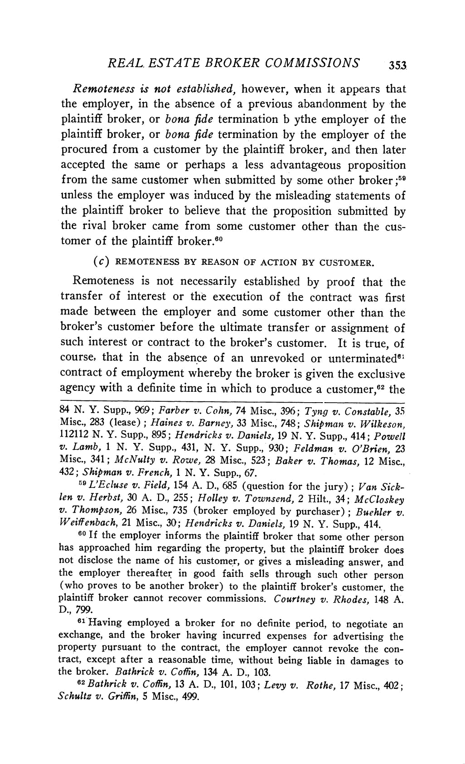
REAL. ESTATE BROKER COMMISSIONS 353

Remoteness is not established, however, when it appea the employer, in the absence of a previous abandonmen

plaintiff broker, or bona fide termination b ythe employer

plaintiff broker, or bona fide termination by the employ procured from a customer by the plaintiff broker, and t
accepted the same or perhaps a less advantageous pro

from the same customer when submitted by some other bro

unless the employer was induced by the misleading statem the plaintiff broker to believe that the proposition subm

the rival broker came from some customer other than

tomer of the plaintiff broker.60

(c) REMOTENESS BY REASON OF ACTION BY CUSTOMER

Remoteness is not necessarily established by proof th transfer of interest or the execution of the contract w

made between the employer and some customer other t

broker's customer before the ultimate transfer or assign such interest or contract to the broker's customer. It is

course, that in the absence of an unrevoked or untermi

contract of employment whereby the broker is given the ex agency with a definite time in which to produce a customer,

84 N. Y. Supp., 969; Farber v. Cohn, 74 Misc., 396; Tyng v. Con Misc., 283 (lease); Haines v. Barney, 33 Misc., 748; Shipman v. W 112112 N. Y. Supp., 895; Hendricks v. Daniels, 19 N. Y. Supp., 41

v. Lamb, 1 N. Y. Supp., 431, N. Y. Supp., 930; Feldman v. O'Br Misc., 341; McNulty v. Rowe, 28 Misc., 523; Baker v. Thomas,

432; Shipman v. French, 1 N. Y. Supp., 67.

59 L'Ecluse v. Field, 154 A. D., 685 (question for the jury); V len v. Herbst, 30 A. D., 255; Holley v. Townsend, 2 Hilt., 34; Mc v. Thompson, 26 Misc., 735 (broker employed by purchaser); Bu Weiffenbach, 21 Misc., 30; Hendricks v. Daniels, 19 N. Y. Supp.,

60 If the employer informs the plaintiff broker that some othe

has approached him regarding the property, but the plaintiff bro

not disclose the name of his customer, or gives a misleading an the employer thereafter in good faith sells through such othe

(who proves to be another broker) to the plaintiff broker's custo

plaintiff broker cannot recover commissions. Courtney v. Rhod
D., 799.

61 Having employed a broker for no definite period, to nego exchange, and the broker having incurred expenses for advert property pursuant to the contract, the employer cannot revoke tract, except after a reasonable time, without being liable in da

the broker. Bathrick v. Coffin, 134 A. D., 103.

62 Bathrick v. Coffin, 13 A. D., 101, 103; Levy v. Rothe, 17 Mis

Schultz v. Griffin, 5 Misc., 499.

This content downloaded from 111.93.31.52 on Mon, 05 Aug 2019 11:02:45 UTC
All use subject to https://about.jstor.org/terms

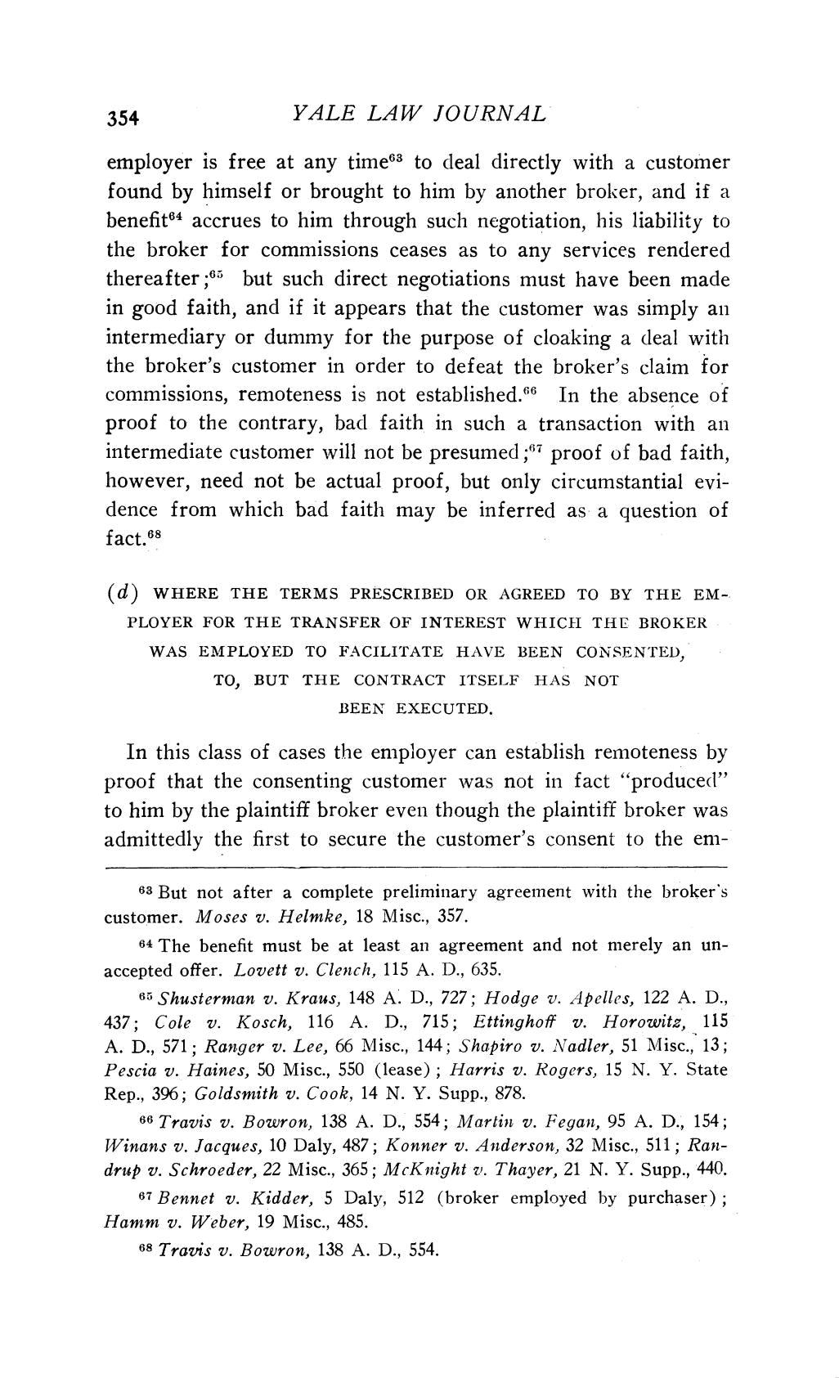
₃₅₄ YALE LAW JOURNAL

employer is free at any time63 to deal directly with

found by himself or brought to him by another brok benefit64 accrues to him through such negotiation, his

the broker for commissions ceases as to any services thereafter;65 but such direct negotiations must have

in good faith, and if it appears that the customer was intermediary or dummy for the purpose of cloaking a

the broker's customer in order to defeat the broker's claim for

commissions, remoteness is not established.66 In the absence of proof to the contrary, bad faith in such a transaction with an
intermediate customer will not be presumed ;67 proof of bad faith,

however, need not be actual proof, but only circumstantial evi-

dence from which bad faith may be inferred as a question of

fact.68

(d) WHERE THE TERMS PRESCRIBED OR AGREED TO BY THE EM-

PLOYER FOR THE TRANSFER OF INTEREST WHICH THE BROKER

WAS EMPLOYED TO FACILITATE HAVE BEEN CONSENTED,

TO, BUT THE CONTRACT ITSELF HAS NOT

BEEN EXECUTED.

In this class of cases the employer can establish r

proof that the consenting customer was not in fa

to him by the plaintiff broker even though the plaint

admittedly the first to secure the customer's cons

63 But not after a complete preliminary agreement wi

customer. Moses v. Helmke, 18 Misc., 357.

64 The benefit must be at least an agreement and not

accepted offer. Lovett v. Clench, 115 A. D., 635. 65 Shusterman v. Kraus, 148 A. D., 727; Hodge v. Apelles, 122 A. D.,

437; Cole v. Kosch, 116 A. D., 715; Ettinghoff v. Horowitz, 115

A. D., 571; Ranger v. Lee, 66 Misc., 144; Shapiro v. Nadler, 51 Misc., 13;

Pescia v. Haines, 50 Misc., 550 (lease); Harris v. Rogers, 15 N. Y. State

Rep., 396; Goldsmith v. Cook, 14 N. Y. Supp., 878.

66 Travis v. Bowron, 138 A. D., 554; Martin v. Fegan, 95 A. D., 154; Winans v. Jacques, 10 Daly, 487; Konner v. Anderson, 32 Misc., 511; Ran-

drup v. Schroeder, 22 Misc., 365; McKnight rv. Thayer, 21 N. Y. Supp., 440.

67 Bennet v. Kidder, 5 Daly, 512 (broker employed by purchaser); Hamm v. Weber, 19 Misc., 485.
68 Travis v. Bowron, 138 A. D., 554.

This content downloaded from 111.93.31.52 on Mon, 05 Aug 2019 11:02:45 UTC
All use subject to https://about.jstor.org/terms

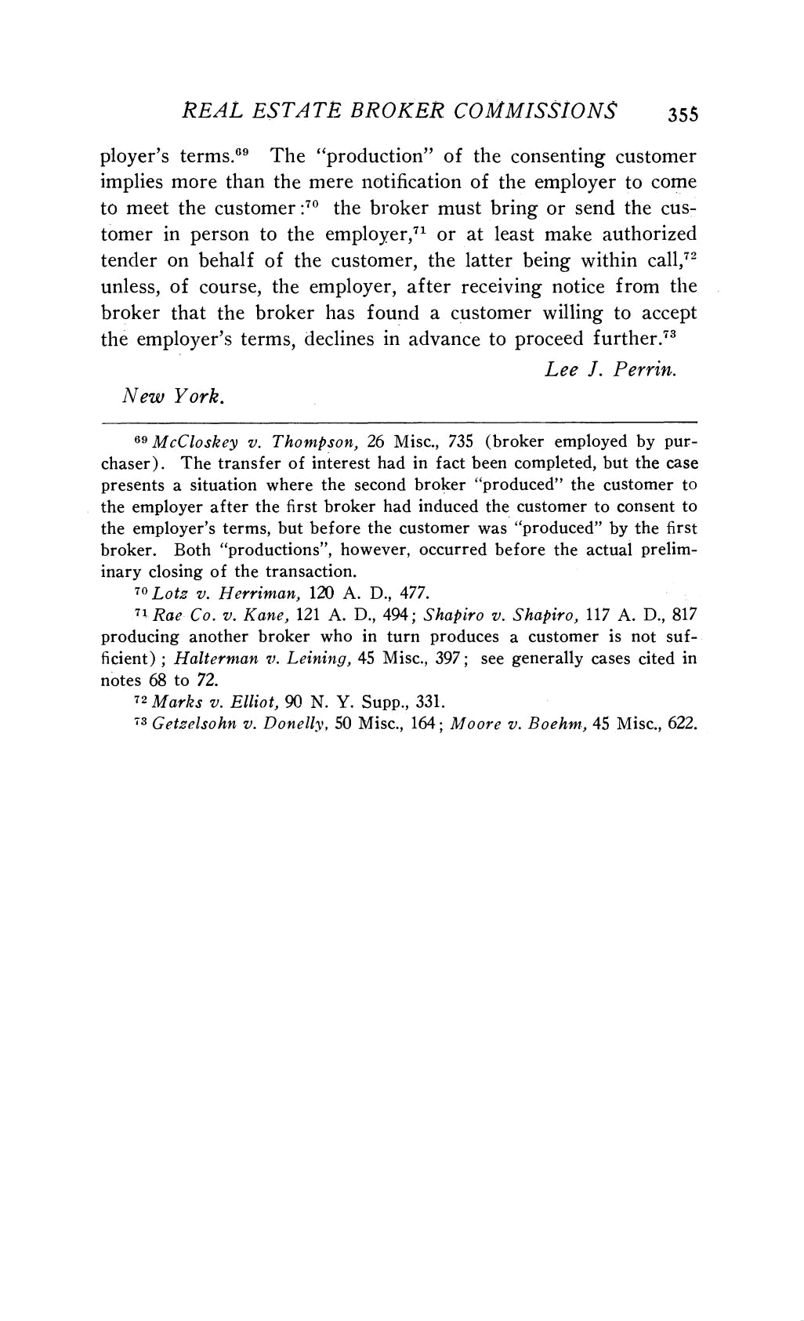
REAL ESTATE BROKER COMMISSIONS 355

ployer's terms.69 The "production" of the consenting cust

implies more than the mere notification of the employer to to meet the customer :70 the broker must bring or send th

tomer in person to the employer,71 or at least make auth

tender on behalf of the customer, the latter being within unless, of course, the employer, after receiving notice fro
broker that the broker has found a customer willing to a

the employer's terms, declines in advance to proceed furthe

Lee J. Perrin.

New York.

69McCloskey v. Thompson, 26 Misc., 735 (broker employed by pur-chaser). The transfer of interest had in fact been completed, but the case presents a situation where the second broker "produced" the customer to

the employer after the first broker had induced the customer to consent to the employer's terms, but before the customer was "produced" by the first

broker. Both "productions", however, occurred before the actual prelim-

inary closing of the transaction.

70 Lotz v. Herriman, 120 A. D., 477.

71 Rae Co. v. Kane, 121 A. D., 494; Shapiro v. Shapiro, 117 A. D., 817 producing another broker who in turn produces a customer is not suf-ficient); Halterman v. Leining, 45 Misc., 397; see generally cases cited in
notes 68 to 72.

72 Marks v. Elliot, 90 N. Y. Supp., 331.

73 Getzelsohn v. Donelly, 50 Misc., 164; Moore v. Boehm, 45 Misc., 622.

This content downloaded from 111.93.31.52 on Mon, 05 Aug 2019 11:02:45 UTC
All use subject to https://about.jstor.org/terms

