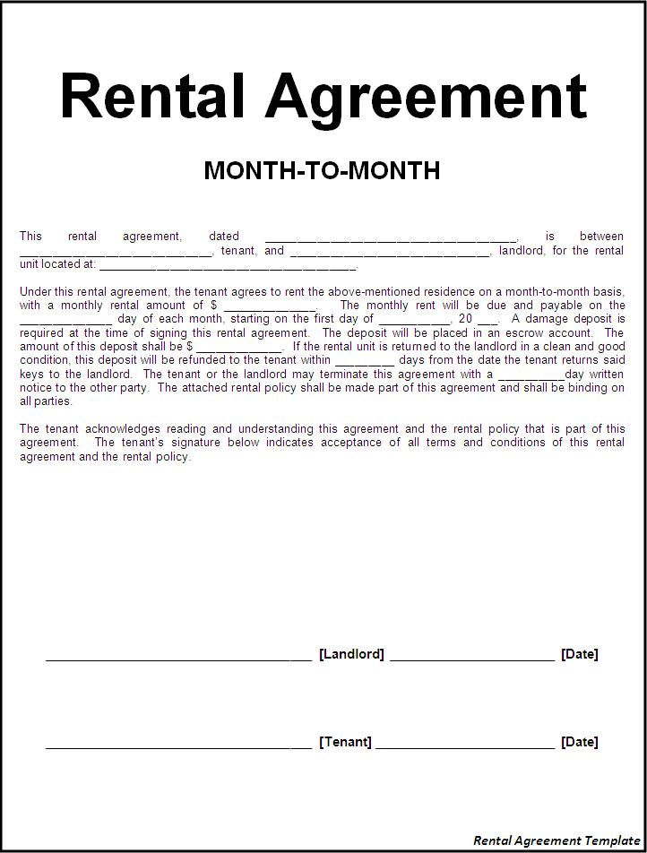
Rental Agreement
MONTH-TO-MONTH
This
rental
agreement,
dated _ tenant, and
is between landlord, for the rental
unit located at:
Under this rental agreement, the tenant agrees to rent the above-mentioned residence on a month-to-month basis, with a monthly rental amount of $
The monthly rent will be due and payable on the day of each month, starting on the first day of
20__. A damage deposit is time of signing this rental agreement. The deposit will be placed in an escrow account. The amount of this deposit shall be $
-- If the rental unit is returned to the landlord in a clean and good condition, this deposit will be refunded to the tenant within__days from the date the tenant returns said keys to the landlord. The tenant or the landlord may terminate this agreement with a
__day written notice to the other party. The attached rental policy shall be made part of this agreement and shall be binding on all parties.
The tenant acknowledges reading and understanding this agreement and the rental policy that is part of this agreement. The tenant's signature below indicates acceptance of all terms and conditions of this rental agreement and the rental policy
[Landlord]
[Date]
[Tenant]
[Date]
Rental Agreement Template

